

Elmeasure India Pvt Ltd
CSS7000 INTERNSHIP REPORT
Submitted by
HEMASHREE S – 20241CAI0193
Under the guidance of,
Ms. Harika P
Assistant Professor
BACHELOR OF TECHNOLOGY
IN
COMPUTER SCIENCE AND ENGINEERING
(Artificial Intelligence and Machine Learning)

PRESIDENCY UNIVERSITY
BENGALURU
AUGUST 2026


PRESIDENCY SCHOOL OF
ARTIFICIAL INTELLIGENCE & ADVANCED COMPUTING
DEPARTMENT OF AI & ROBOTICS
BONAFIDE CERTIFICATE
Certified that this report “Internship at Elmeasure India Pvt Ltd” is a bonafide work of HEMASHREE S (20241CAI0193), who has successfully carried out the internship work and submitted the report for partial fulfilment of the requirements for the award of the degree of BACHELOR OF TECHNOLOGY in PRESIDENCY SCHOOL OF ARTIFICIAL INTELLIGENCE & ADVANCED COMPUTING, AI & Robotics during 2026-2027.
Ms. Harika P  Assistant Professor  Internship Guide  PSAIAC  Presidency University |  | Mr. Anandan B  Assistant Professor  Program Internship Coordinator  PSAIAC  Presidency University
Dr. Geetha Arjunan  Associate Professor  School Internship Coordinator  PSAIAC  Presidency University |  | Dr. Zafar Ali Khan N  Professor & Head of the Department  AI & Robotics  PSAIAC  Presidency University
Dr. Shakkeera L
Dean
PSAIAC
Presidency University
Sl. No | Name of the Examiner |  | Signature
1 | Ms. Harika P



PRESIDENCY SCHOOL OF
ARTIFICIAL INTELLIGENCE & ADVANCED COMPUTING
DEPARTMENT OF AI & ROBOTICS

DECLARATION
I am a student of Pre-Final year B.Tech in COMPUTER SCIENCE AND ENGINEERING (Artificial Intelligence and Machine Learning), at Presidency University, Bengaluru, named, HEMASHREE S, hereby declare that the internship work titled “Elmeasure India Pvt Ltd”, has been independently carried out by me and submitted in partial fulfillment for the award of the degree of B.Tech in COMPUTER SCIENCE AND ENGINEERING during the academic year of 2026-2027. Further, the matter embodied in the internship has not been submitted previously by anybody for the award of any Degree or Diploma to any other institution.

HEMASHREE S
USN: 20241CAI0193
Signature:
PLACE: BENGALURU
DATE:

INTERNSHIP COMPLETION CERTIFICATE
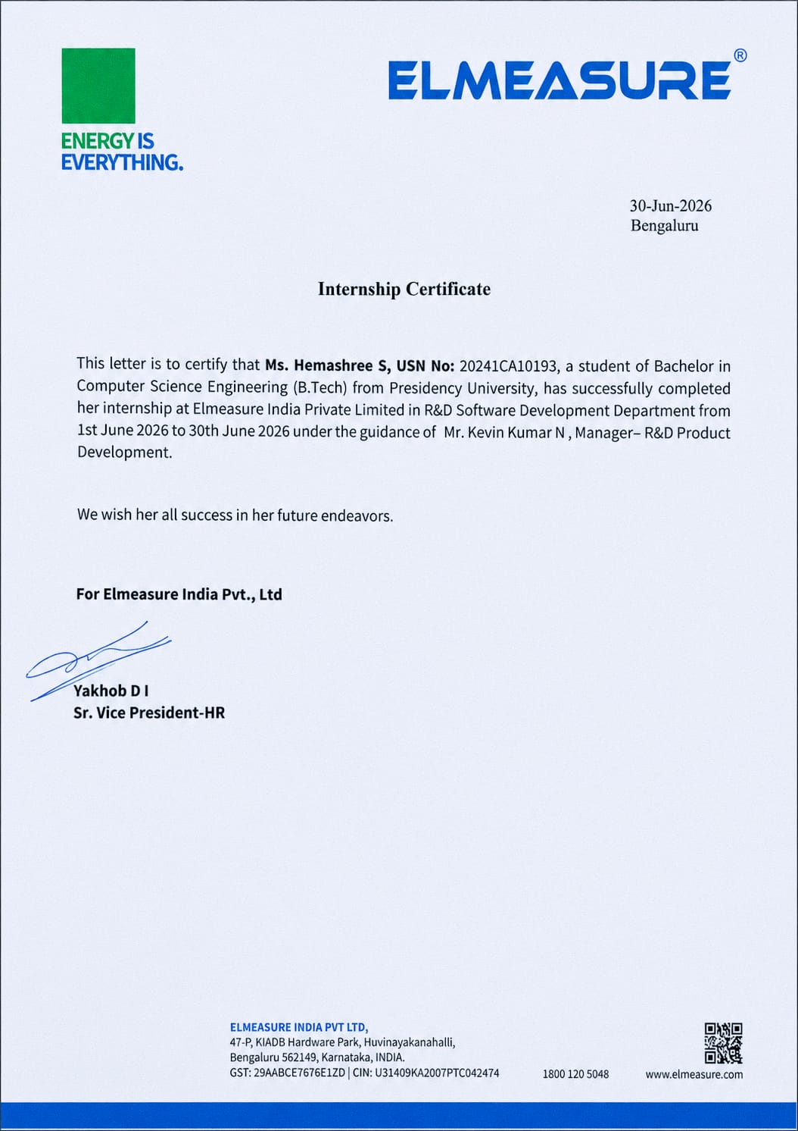Internship Completion Certificate issued by Elmeasure India Pvt Ltd

ACKNOWLEDGEMENT
For completing this internship work, I have received the support and the guidance from many people whom I would like to mention with a deep sense of gratitude and indebtedness. I extend my gratitude to our beloved Chancellor, Pro-Vice Chancellor, and Registrar for their support and encouragement in completion of the internship.
I would like to sincerely thank my internal guide Ms. Harika P, Assistant Professor, Presidency School of Artificial Intelligence & Advanced Computing, Presidency University, for her moral support, motivation, timely guidance and encouragement provided to me during the period of internship work.
I am also thankful to Dr. Zafar Ali Khan N, Professor & Head of the Department, AI & Robotics, Presidency School of Artificial Intelligence & Advanced Computing, Presidency University, for his mentorship and encouragement.
I express my cordial thanks to Dr. Shakkeera L, Dean, Presidency School of Artificial Intelligence & Advanced Computing, Presidency University, for providing the required facilities and intellectually stimulating environment that aided in the completion of my internship work.
I am grateful to Dr. Geetha Arjunan, Associate Professor, School Internship Coordinator, and Mr. Anandan B, Assistant Professor, Program Internship Coordinator, Presidency School of Artificial Intelligence & Advanced Computing, Presidency University, for facilitating problem statements, coordinating reviews, monitoring progress, and providing their valuable support and guidance.
I sincerely thank Elmeasure India Pvt Ltd for providing me the opportunity to undertake this internship, and my industry mentor and the technical team for their continuous guidance, patience and constructive feedback at every stage of the programme.
I am also grateful to the teaching and non-teaching staff of Presidency School of Artificial Intelligence & Advanced Computing and the staff of other departments who extended their valuable help and cooperation. Finally, I thank my parents, family members and friends for their unwavering support and motivation throughout this journey.
HEMASHREE S
USN: 20241CAI0193

TABLE OF CONTENTS

Declaration 3
Internship Completion Certificate 4
Acknowledgement 5
1. Company Overview 7
2. Internship Objectives 9
3. Weekly Activities 10
3.1 Week 1 — Exploration, Testing and Foundations 10
3.2 Week 2 — Python, Selenium and Test Automation 12
3.3 Week 3 — Version Control and SQL Fundamentals 13
3.4 Week 4 — n8n, JavaScript and AI Workflow Automation 14

4. Technologies Learned 16
5. Detailed Project Description 18
6. Challenges Faced 21
7. Outcomes 22
8. Conclusion 23
9. References 24
Project and Reference Links 25

CHAPTER 1 — COMPANY OVERVIEW
1.1 About Elmeasure
Elmeasure India Pvt Ltd is a technology-driven organization that specializes in delivering modern software solutions, end-to-end product testing, business automation and digital transformation services. The company combines technical expertise with practical business understanding to help its clients build, validate and scale reliable software products. Elmeasure operates across multiple verticals, including web application development, manual and automated software testing, workflow automation, and emerging areas such as Artificial Intelligence integration.
With a strong focus on quality, innovation and continuous improvement, Elmeasure follows industry-standard engineering practices such as agile development, version-controlled collaboration, structured testing methodologies and continuous integration. The internal culture encourages experimentation with newer tools and platforms, which makes it an ideal environment for interns and early-career engineers to gain hands-on exposure to real production workflows.
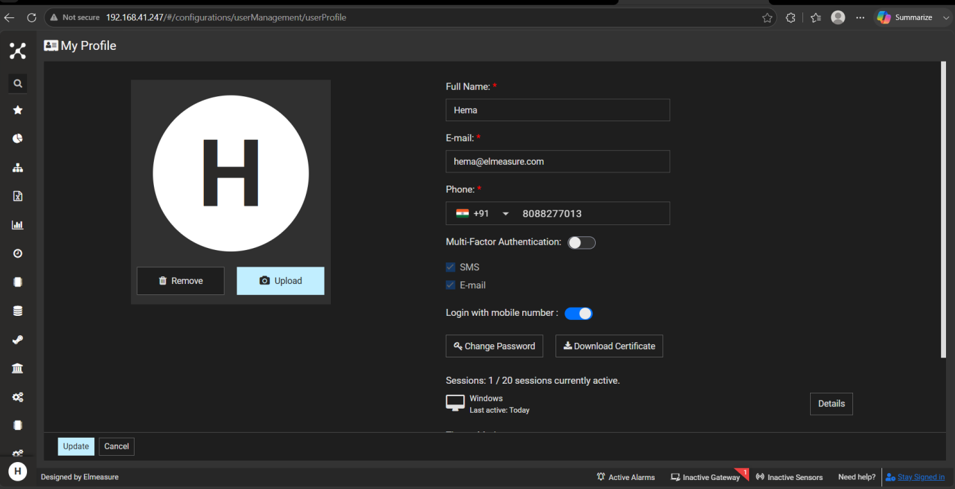Fig. 1.1: Elmeasure official website home page
1.2 Vision and Mission
Vision: To be a trusted technology partner that empowers organizations through reliable, intelligent and automation-driven software solutions.
Mission: To deliver high-quality, scalable and maintainable software products by leveraging modern engineering practices, robust testing frameworks and intelligent automation, while nurturing the next generation of engineers through mentorship and applied learning.

1.3 Core Services
- Web Application Development — building responsive, performant and secure web applications using modern frameworks.
- Software Testing and Quality Assurance — manual testing, automated testing using Selenium and PyTest, and end-to-end functional verification.
- Workflow Automation — designing low-code and no-code automations using platforms such as n8n to streamline repetitive business processes.
- AI Integration — embedding Large Language Models such as Gemini AI into business workflows for personalization, summarization and content generation.
- Dashboards and Reporting — building interactive dashboards that turn raw operational data into actionable insights.

1.4 Work Culture and Learning Environment
The work culture at Elmeasure is collaborative, mentorship-driven and outcome-oriented. Interns are treated as junior team members rather than passive observers. From the first week, each intern is given access to internal tools, real applications and guided assignments. Regular knowledge-sharing sessions, code walkthroughs and demos are conducted to keep everyone aligned with the latest tools and practices.
CHAPTER 2 — INTERNSHIP OBJECTIVES
The purpose of this four-week internship at Elmeasure was to bridge the gap between classroom learning and real-world software engineering through structured, hands-on exposure to industry tools, processes and project workflows, with each week building upon the previous one.
2.1 Primary Objectives
- To understand the end-to-end workflow of a modern technology company, including how products are explored, tested, deployed and monitored.
- To gain practical experience in manual software testing by exploring the Elmeasure web application and identifying real UI and functional defects.
- To learn the fundamentals of test automation using Selenium with Python and apply industry-standard design patterns such as the Page Object Model.
- To acquire working knowledge of professional development tools including PyCharm, Git and GitHub.
- To explore modern workflow automation platforms such as n8n and integrate them with cloud services like Google Sheets, Gmail and Gemini AI.
- To strengthen core computer science fundamentals by revising OSI layers, Object-Oriented Programming, SQL, JavaScript and Python.
2.2 Secondary Objectives
- Develop soft skills such as professional communication, technical documentation, time management and collaborative problem-solving.
- Learn to read and follow technical documentation and apply it to solve practical problems independently.
- Understand the importance of version control, code reviews and the discipline of maintaining a clean Git history.
- Build a portfolio of completed mini-projects and automation scripts on GitHub for future reference and employability.
2.3 Expected Outcomes
By the end of the internship, the trainee was expected to independently write and execute automated test scripts using Selenium and PyTest; design and deploy n8n workflows integrating multiple cloud services; use Git and GitHub confidently; write basic SQL queries; and explain how AI services can be embedded in business automations.
CHAPTER 3 — WEEKLY ACTIVITIES
This chapter presents a week-by-week account of the activities performed, technologies learned and deliverables completed during the internship. Each week was structured around a specific theme, beginning with exploration and foundational concepts and gradually progressing towards applied projects and intelligent automation.
3.1 Week 1 — Exploration, Testing and Foundations
The first week focused on familiarization with the company, its products and the foundational concepts used throughout the programme.
3.1.1 Exploring the Elmeasure Web Application
The internship began with a guided walkthrough of the Elmeasure web application. Every module, navigation flow and user-facing feature was explored systematically to build a mental model of the application. Particular attention was paid to authentication flows, dashboards, navigation menus, form submissions and error messages, which laid the groundwork for subsequent testing exercises.
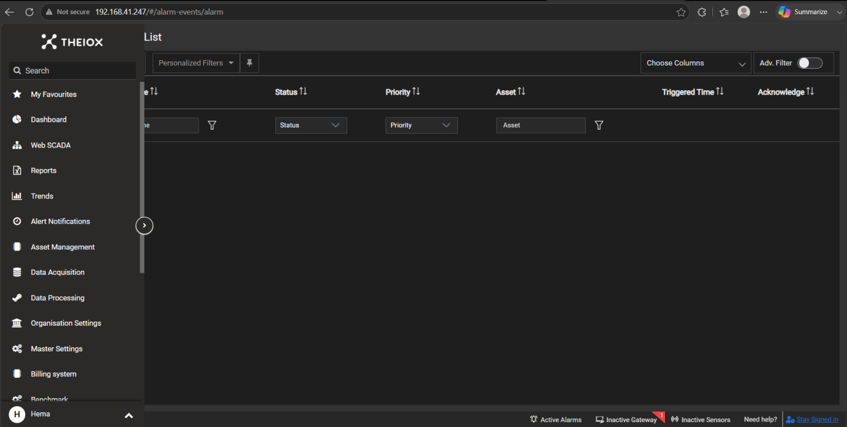Fig. 3.1: Exploring modules of the Elmeasure web application
3.1.2 Website Testing and Bug Identification
The focus then shifted to systematic manual testing. UI-level and functional defects were identified using standard techniques such as boundary value analysis, equivalence partitioning and exploratory testing. Defects related to alignment, broken links, validation messages, button states and inconsistent error handling were documented with reproduction steps and severity levels.
- UI defects: misaligned form fields, inconsistent button colours, overlapping text on smaller viewports.
- Functional defects: validation errors not triggered, incorrect redirection after login, missing confirmation messages.
- Usability issues: unclear error labels, unintuitive navigation paths and missing loading indicators.
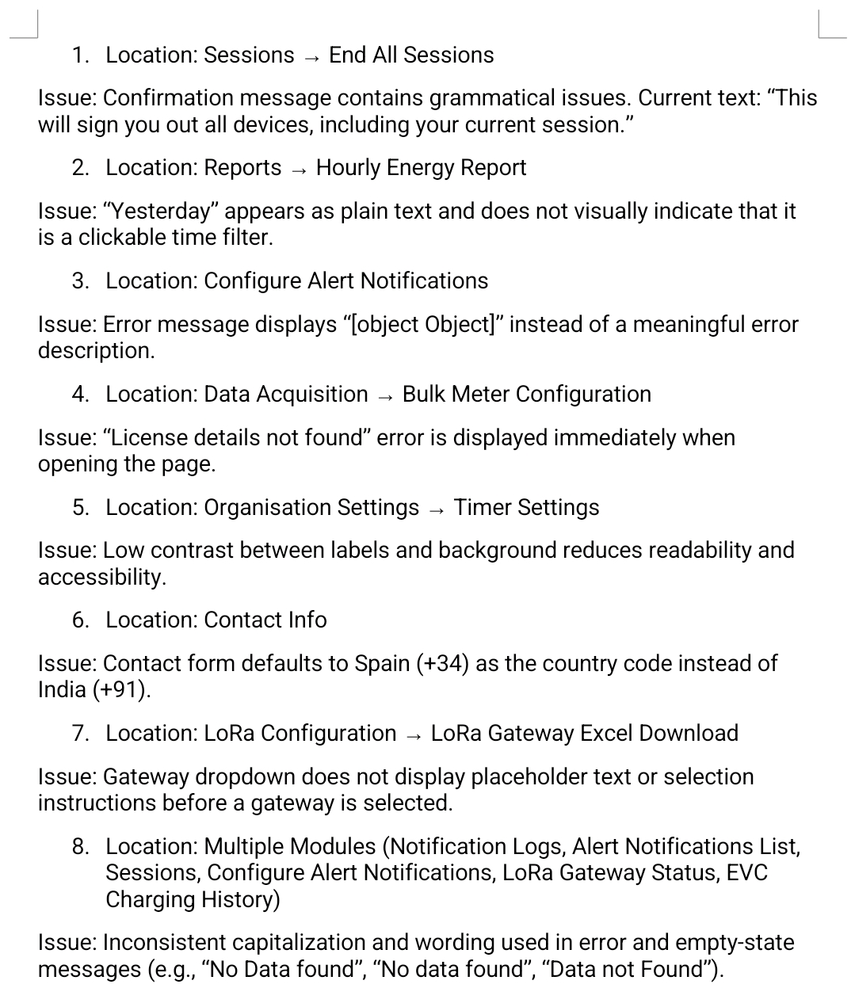Fig. 3.2: Bug report sheet maintained during manual testing

3.1.3 Creating and Configuring Dashboards
Operational dashboards were created to summarize key data points such as user activity, test execution results and process status. The exercise demonstrated how raw data can be transformed into actionable visual insights that drive business decisions.
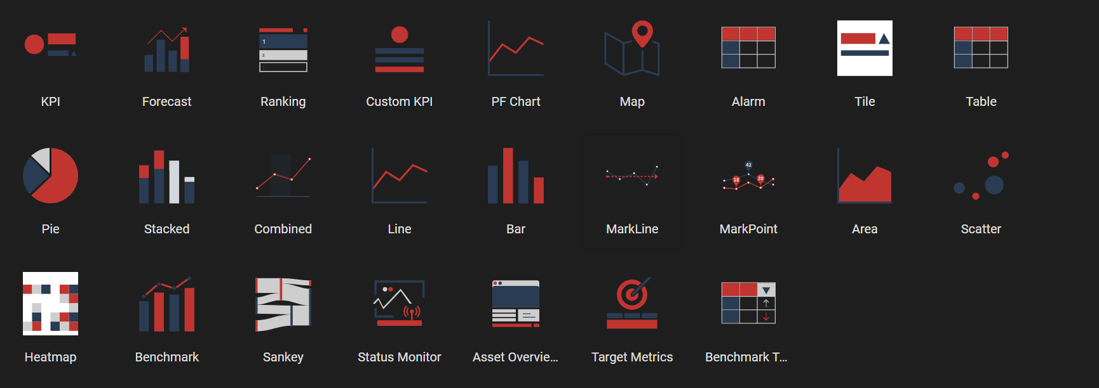Fig. 3.3: Custom dashboard created during Week 1
3.1.4 Installing and Configuring PyCharm
PyCharm was installed and configured as the primary IDE for all Python development during the internship. Configuration included setting up an interpreter, creating virtual environments, structuring the project, installing plugins and integrating the IDE with Git. Code completion, refactoring tools, the integrated terminal and the debugger significantly improved productivity.
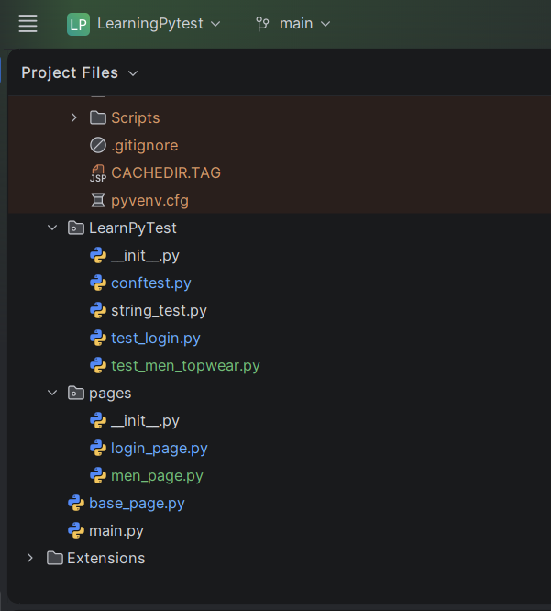
Fig. 3.4: PyCharm IDE configured with a Python project

3.1.5 Networking Fundamentals — OSI Model
The seven layers of the Open Systems Interconnection model were studied along with their responsibilities and associated protocols: Physical (raw bit transmission), Data Link (framing, MAC addressing, error detection), Network (IP addressing and routing), Transport (TCP/UDP, reliable delivery and flow control), Session (connection management), Presentation (formatting, encryption and compression) and Application (HTTP, HTTPS, SMTP, FTP). This understanding later proved useful while debugging Selenium tests and HTTP-based n8n workflows.
3.1.6 Object-Oriented Programming Basics
OOP concepts were revised through small Python examples covering the four pillars — encapsulation, inheritance, polymorphism and abstraction — along with classes, objects, constructors, instance versus class variables and method overriding. A strong grasp of OOP was essential because the Page Object Model used later in test automation depends heavily on object-oriented design.
3.2 Week 2 — Python, Selenium and Test Automation
The second week was dedicated to building hands-on test automation skills using Python and Selenium. By the end of the week a functional automation project had been developed using industry-standard practices, including the Page Object Model and PyTest as the test runner.
3.2.1 Revising Python Fundamentals
The week began with a structured revision of Python covering data types, control flow, functions, modules, file handling, exception handling and the standard library. Emphasis was placed on list comprehensions, decorators, context managers and dependency management using venv and pip.
3.2.2 Learning Selenium with Python
Selenium WebDriver was studied as the standard tool for browser-based test automation. Key topics included installing the Python bindings, understanding browser drivers, locating elements using ID, name, class name, CSS selectors and XPath, and performing actions such as clicks, text entry, navigation and waits.
- Setting up Selenium WebDriver and ChromeDriver.
- Element location strategies and the trade-offs between them.
- Synchronization using implicit, explicit and fluent waits.
- Handling alerts, frames, dropdowns and multiple windows.
- Capturing screenshots on test failure for debugging.

3.2.3 Developing the ShopperStack Login Automation
To consolidate the Selenium learning, an end-to-end login automation was developed for the ShopperStack practice application. The script automated the entire login workflow — launching the browser, navigating to the URL, entering credentials, submitting the form, validating successful login and logging out — covering both positive and negative scenarios with assertions verifying expected outcomes.
3.2.4 Learning the PyTest Framework
PyTest was introduced as a modern test runner. Test discovery, fixtures, parameterization, markers, configuration files and report generation were studied. Compared with the built-in unittest module, PyTest offers concise syntax, powerful fixtures and a rich plugin ecosystem, so the ShopperStack automation was migrated to PyTest for standardized execution and reporting.
3.2.5 Implementing the Page Object Model
To make the automation project maintainable, the Page Object Model design pattern was implemented. Every web page is represented as a Python class that exposes its elements and actions as methods, while test cases interact only with these methods rather than raw locators. The ShopperStack project was refactored into BasePage, LoginPage and HomePage classes with corresponding test files, drastically reducing duplication and making tests resilient to UI changes.
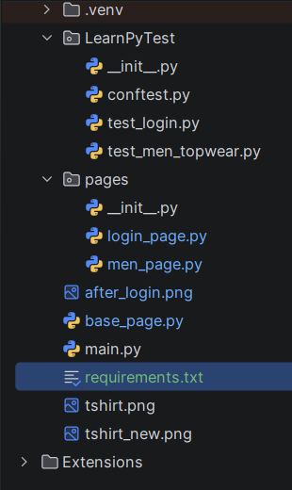
Fig. 3.5: Project folder structure showing the POM implementation

3.3 Week 3 — Version Control and SQL Fundamentals
The third week focused on the engineering hygiene that surrounds professional development: version control with Git and GitHub, and the basics of relational data manipulation with SQL.
3.3.1 Installing and Configuring Git
Git was installed and configured with a global username and email, a default branch name and integration with both PyCharm and the system terminal. The internal model of Git — working directory, staging area and local repository — was studied to build a clear picture of how changes flow through the system.
3.3.2 Creating a GitHub Profile and Publishing Projects
A professional GitHub profile was created with a bio, profile picture and pinned README repository, and SSH keys were generated for secure password-less authentication. The ShopperStack Selenium-PyTest project developed in Week 2 was published as a public repository with a README explaining the purpose, technology stack, installation instructions and usage, along with a .gitignore excluding virtual environments, IDE configuration and cached files.
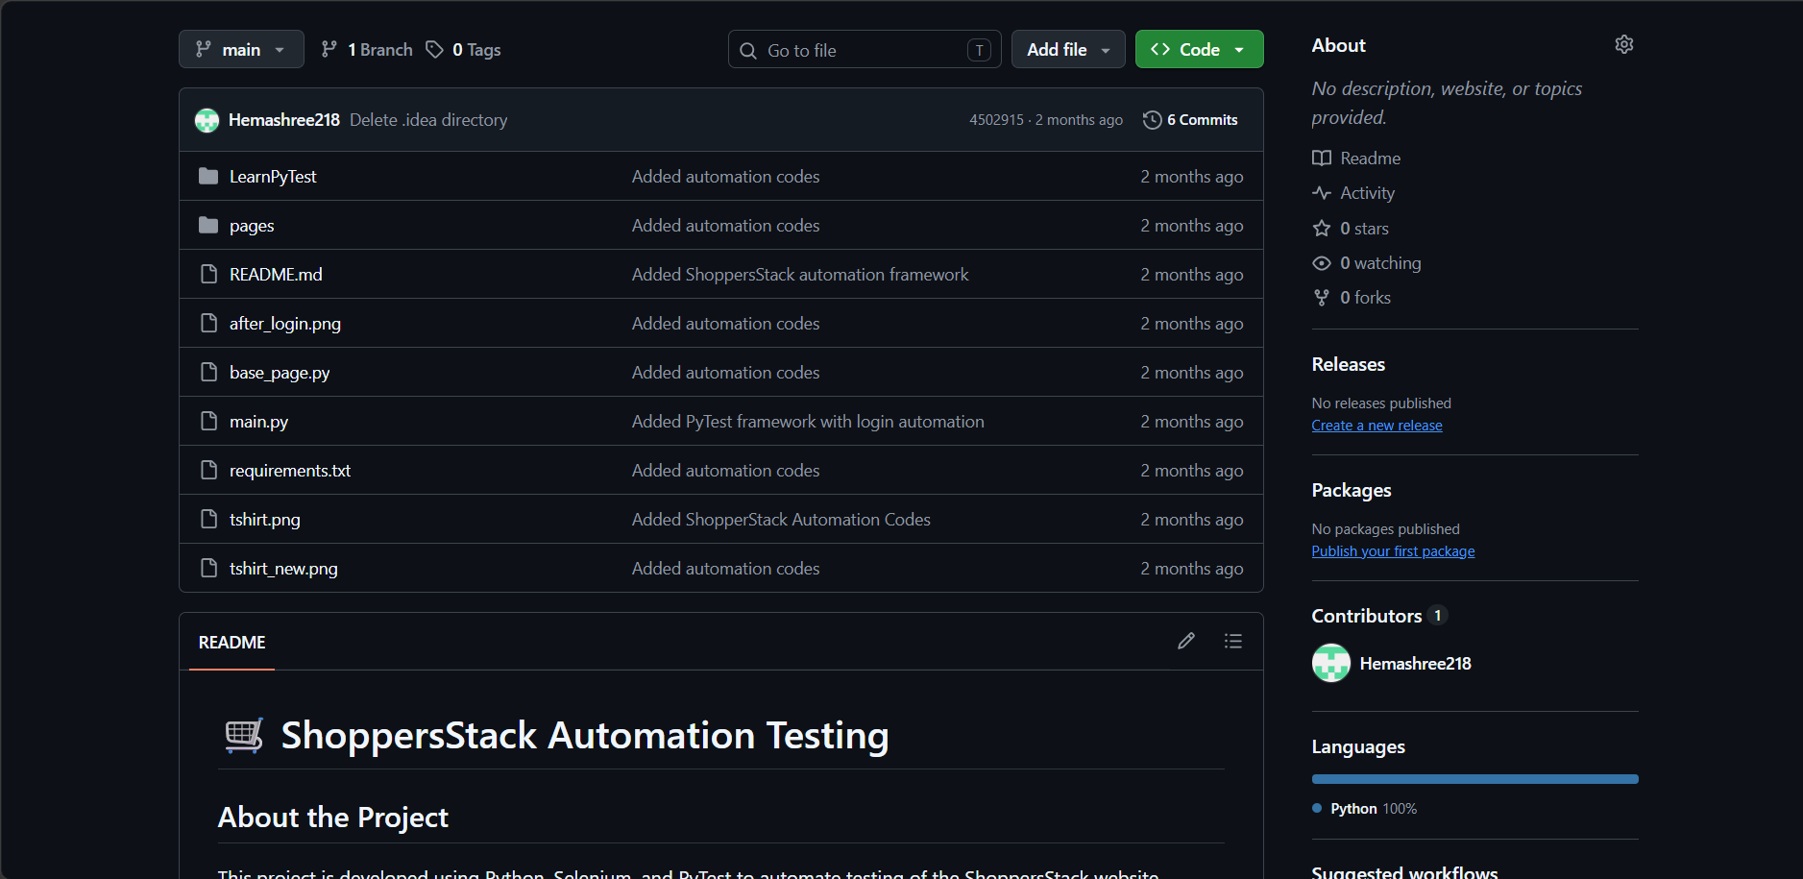Fig. 3.6: Automation project repository published on GitHub
3.3.3 Practicing Git Commands
- git init, git clone — creating and cloning repositories.
- git status, git diff — inspecting changes in the working directory.
- git add, git commit — staging and recording changes.
- git branch, git checkout, git switch — branch management.
- git merge, git rebase — integrating changes from different branches.
- git push, git pull, git fetch — synchronizing with remote repositories.
- git log, git reflog, git stash — reviewing history and shelving work.
3.3.4 Basic SQL Commands
The basics of Structured Query Language were studied, covering Data Definition Language (CREATE, ALTER, DROP, TRUNCATE), Data Manipulation Language (INSERT, UPDATE, DELETE) and Data Query Language (SELECT with WHERE, ORDER BY, GROUP BY and HAVING). Joins (inner, left, right and full outer) and aggregate functions (COUNT, SUM, AVG, MIN, MAX) were practiced. This knowledge is invaluable for both backend development and test data validation.
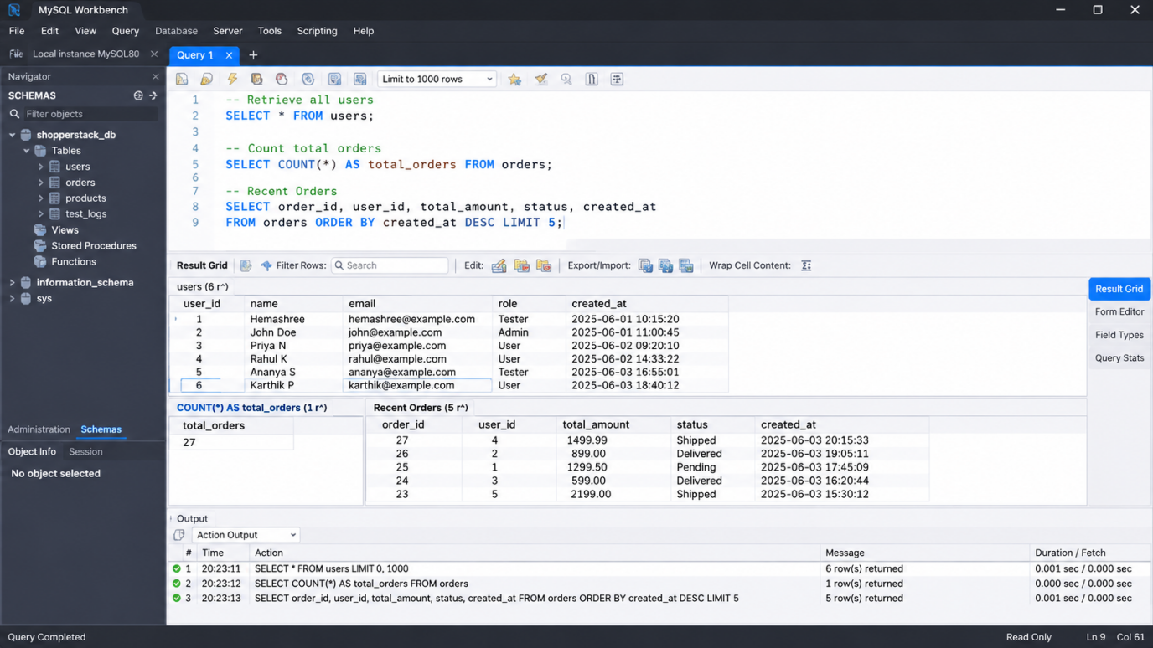Fig. 3.7: SQL queries executed in a database client
3.4 Week 4 — n8n, JavaScript and AI Workflow Automation
The final week focused on workflow automation and the integration of Artificial Intelligence into everyday business processes. The capstone project of the internship — an AI-powered email automation workflow — was built during this week.
3.4.1 Exploring n8n Workflow Automation
n8n is an open-source, node-based workflow automation tool that allows technical and non-technical users to connect different services and automate complex processes without building entire applications from scratch. A free n8n Cloud workspace was created and explored, and concepts such as triggers, nodes, connections, expressions, credentials and executions were studied in detail.
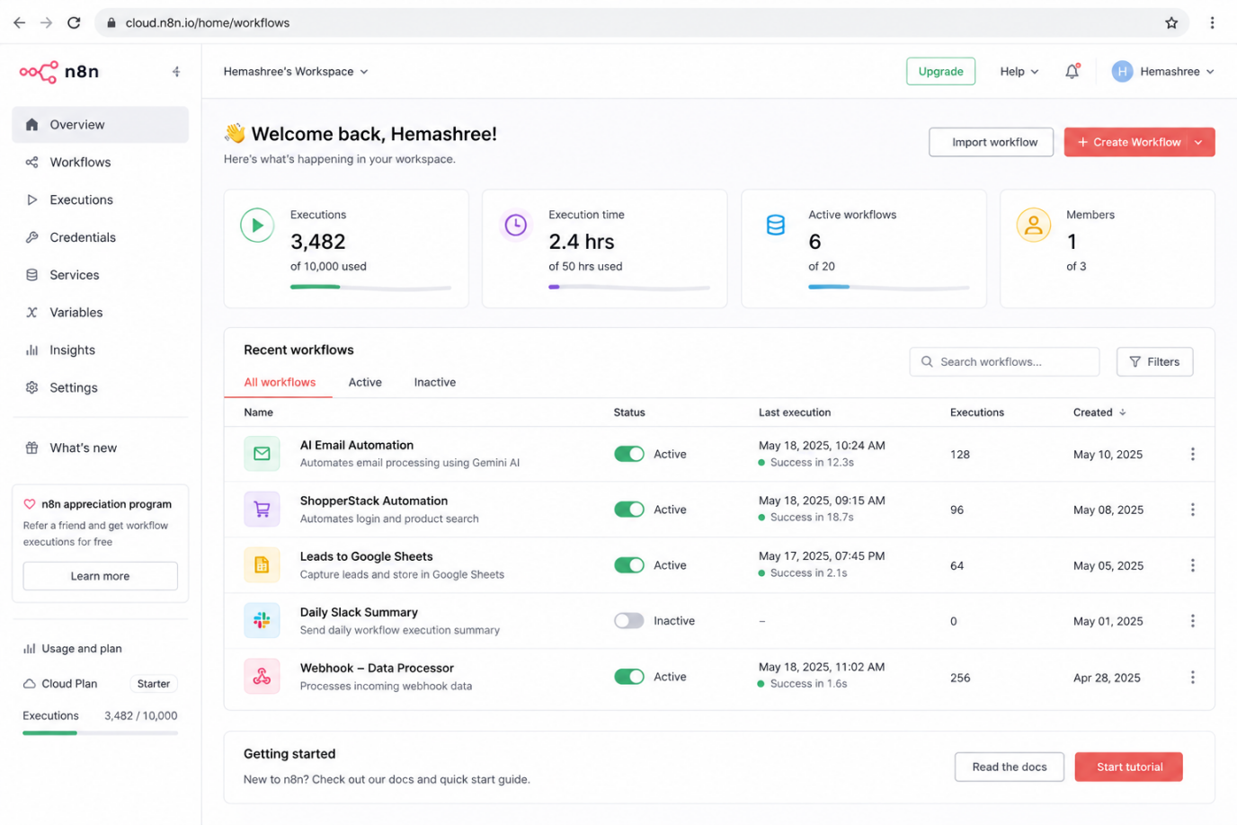Fig. 3.8: n8n Cloud workspace dashboard
3.4.2 JavaScript Basics for Automation
Because n8n allows custom logic inside Function and Code nodes, a focused study of JavaScript was undertaken: variables, data types, operators, arrays, objects, conditionals, loops, functions, arrow functions, template literals, spread and rest operators, JSON parsing and stringification, and basic asynchronous concepts such as promises. The goal was to read and write JavaScript snippets confidently inside automation workflows.
3.4.3 Building the AI-Powered Email Automation Workflow
The capstone project was the design and implementation of an AI-powered email automation workflow using n8n, Google Sheets, Gmail and Gemini AI. The workflow automates the process of sending personalized, AI-enhanced emails to a list of users maintained in a Google Sheet and then updates the delivery status back into the same sheet. A detailed description is presented in Chapter 5.
CHAPTER 4 — TECHNOLOGIES LEARNED
Over the four weeks a wide range of tools, languages, frameworks and platforms were studied and applied. This chapter consolidates them and explains, for each, what it is used for and how it was applied during the programme.
4.1 Programming Languages
Python — the primary programming language throughout the internship. Its concise syntax, large standard library and rich ecosystem of automation libraries made it ideal for writing test scripts, utility code and data-processing snippets. Concepts ranging from control flow to object-oriented design were applied while building the ShopperStack automation project.
JavaScript — studied specifically to support custom logic inside n8n Code and Function nodes. Familiarity with arrays, objects and arrow functions proved sufficient to write expressive transformations between workflow nodes.
SQL — studied as the standard language for relational data manipulation. The ability to read, write and reason about SQL queries is foundational for any software engineer and for validating test data.
4.2 Test Automation Stack
Selenium WebDriver — used to automate real web browsers programmatically; the most widely adopted browser automation tool in the industry and the backbone of countless test suites.
PyTest — used as the test runner. Its concise syntax, powerful fixtures, parameterization and plugin ecosystem make it the de facto standard for Python-based testing.
Page Object Model — not a library but an architectural pattern that separates page representations from test logic. Applying POM made the automation project significantly more maintainable and readable.
4.3 Developer Tools
PyCharm IDE — an integrated environment for writing, debugging and running Python code. Intelligent code completion, refactoring, integrated version control and a powerful debugger increased development speed and reduced errors.
Git and GitHub — Git as the distributed version control system and GitHub as the hosting and collaboration platform. Together they enabled tracking of every change, safe experimentation through branches and public sharing of completed projects.

4.4 Workflow Automation and AI
n8n — an open-source, node-based workflow automation platform that connects services visually, with hundreds of pre-built nodes and support for custom JavaScript where needed.
Google Sheets API — used as a lightweight database for the email automation workflow. The n8n Google Sheets node read user details and updated delivery status, demonstrating how a spreadsheet can act as a simple, accessible data source.
Gmail API — the Gmail node in n8n was used to send personalized emails directly from a configured account, removing the need for a dedicated SMTP server.
Gemini AI — integrated to enhance the content of outgoing emails. The model was prompted with a base template and user context to produce polished, personalized and human-sounding messages.
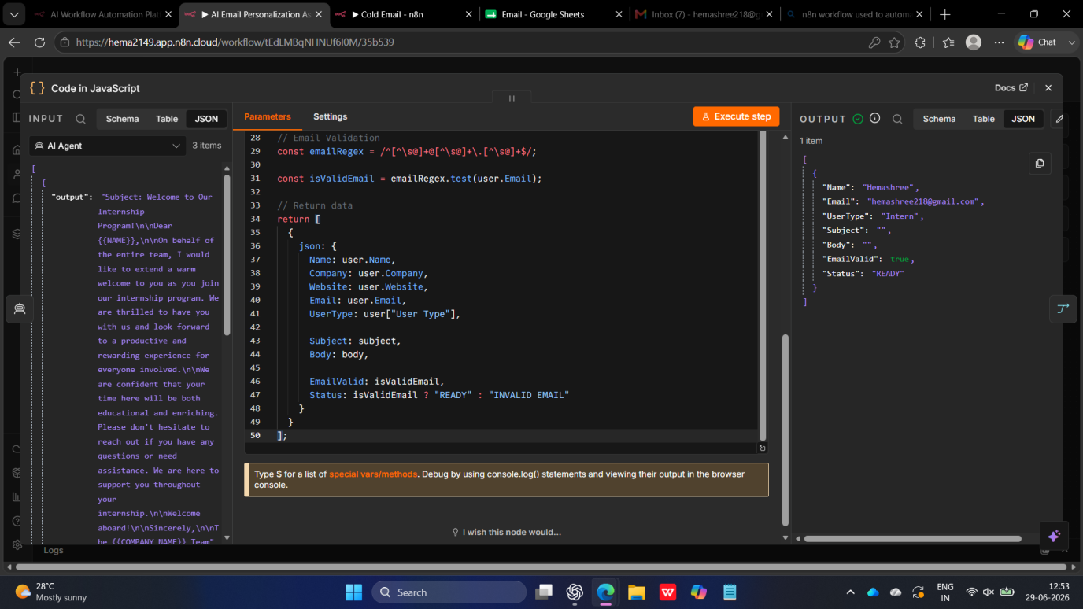Fig. 4.1: n8n credentials configured for Google services and Gemini AI

4.5 Computer Science Fundamentals
In addition to the tools above, foundational topics were revisited and consolidated: OSI layers for understanding network communication, Object-Oriented Programming for designing maintainable code, and SQL fundamentals for working with structured data. These fundamentals tie everything together and form the bedrock on which higher-level tools rest.
CHAPTER 5 — DETAILED PROJECT DESCRIPTION
This chapter describes the two major projects developed during the internship. The first consolidated the test automation skills learned in Week 2, while the second was the Week 4 capstone showcasing the integration of multiple cloud services with Artificial Intelligence.
5.1 Project 1 — ShopperStack Login Automation
5.1.1 Objective
The objective was to automate the login workflow of the ShopperStack practice application using Selenium WebDriver, organize the tests using PyTest and structure the codebase using the Page Object Model, producing a realistic, scaled-down version of a production-grade automation suite.
5.1.2 Tools and Technologies
- Programming language: Python 3.
- Browser automation: Selenium WebDriver with ChromeDriver.
- Test runner: PyTest; design pattern: Page Object Model.
- IDE: PyCharm; version control: Git and GitHub.
5.1.3 Architecture and Folder Structure
The project was organized into clearly separated directories. A pages/ directory contained one Python module per logical page, each exposing high-level methods such as enter_username(), enter_password(), click_login() and is_login_successful(). A tests/ directory contained PyTest test files that imported the page classes, and a conftest.py at the project root defined shared fixtures such as WebDriver setup and teardown.
5.1.4 Workflow
- PyTest discovers the test functions and instantiates the WebDriver fixture.
- The test navigates to the ShopperStack login page using LoginPage methods.
- Credentials are entered through page methods, isolating raw locators from tests.
- The login button is clicked and the resulting page state is asserted.
- On failure, a screenshot is captured automatically for debugging.
- WebDriver is torn down at the end of each test via the fixture.

5.1.5 Outcomes
The project successfully automated multiple login scenarios, including valid login, invalid password, blank fields and malicious SQL-injection-style input. Execution time was reduced from several minutes of manual testing to a few seconds of automated execution. The completed project was pushed to GitHub with a comprehensive README.
5.2 Project 2 — AI-Powered Email Automation Workflow
5.2.1 Objective
The objective of this capstone project was to design and deploy an end-to-end automation that reads a list of users from a Google Sheet, selects an email template based on user type, personalizes the message using placeholders, enhances it using Gemini AI, sends it through Gmail and finally updates the delivery status in the same sheet — all without human intervention beyond updating the input sheet.
5.2.2 Tools and Technologies
- Workflow platform: n8n Cloud; data source: Google Sheets.
- Email delivery: Gmail (OAuth2-authenticated); AI service: Google Gemini AI.
5.2.3 Workflow Architecture
The workflow was modelled as a sequence of n8n nodes, each with a single well-defined responsibility, which makes it easy to read, debug and extend.
- Trigger node — initiates the workflow manually for testing or on a schedule for production runs.
- Google Sheets read node — reads rows containing Name, Email, UserType, Status and Notes.
- Filter / Switch node — routes each user to the appropriate template branch based on user type.
- Template selector (Code node) — loads the matching template containing placeholders.
- Personalization node — replaces placeholders with user-specific values from the sheet row.
- Gmail send node — sends the AI-enhanced email through the Gmail API.
- Google Sheets update node — writes Sent or Failed status and a timestamp back to the sheet.
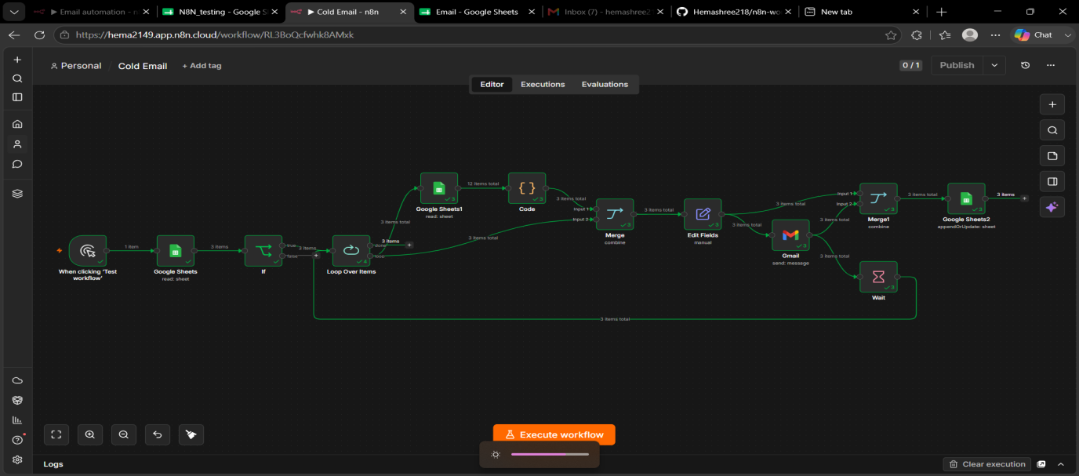Fig. 5.1: Complete n8n workflow with all nodes connected
5.2.4 Execution Flow
When triggered, the workflow pulls all pending user rows from the input sheet. Each row flows through the pipeline independently: the Switch node routes users by type, the Code node injects the right template, placeholders are substituted, and Gemini AI rewrites the message into a polished, personalized email. The Gmail node sends the message and the update node records the outcome. The process takes a few seconds per user, and the input sheet acts as both source of truth and live status tracker.
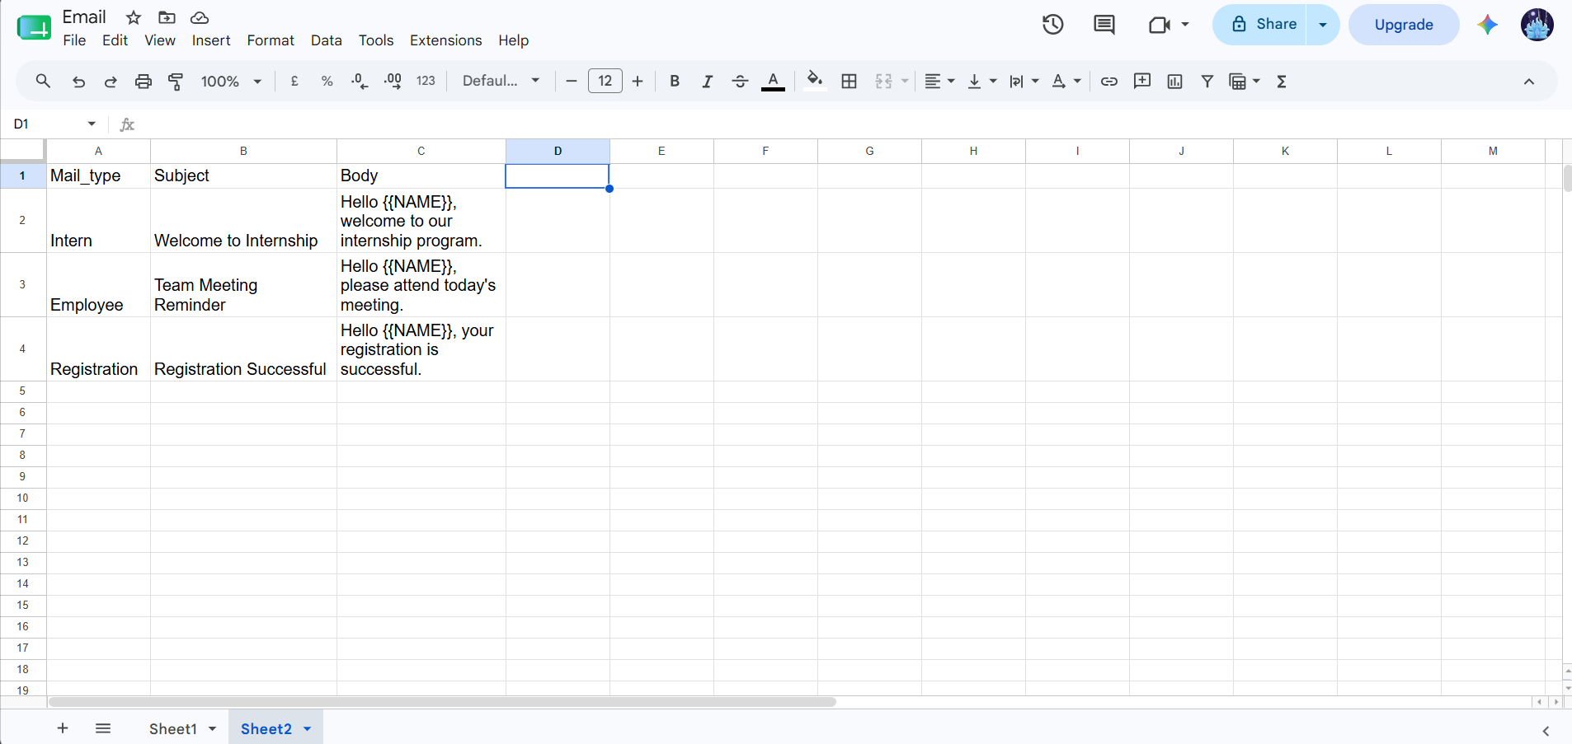Fig. 5.2: Input Google Sheet and delivered email
5.2.5 Outcomes
The completed workflow demonstrated how a non-trivial business process can be automated end-to-end using a low-code platform and a Large Language Model, with no traditional backend code required. It successfully sent personalized AI-enhanced emails to multiple users and accurately updated delivery status in the input sheet. The same pattern can be adapted to marketing campaigns, customer onboarding and transactional notifications.
CHAPTER 6 — CHALLENGES FACED
Like any engineering effort, the internship presented several challenges, each an opportunity to learn debugging techniques and to seek help effectively.
6.1 Synchronization Issues in Selenium
Web pages load asynchronously, so early tests failed with NoSuchElementException when the script interacted with elements before they existed. Replacing time.sleep() calls with explicit WebDriverWait conditions made the tests faster and more reliable.
6.2 Browser and Driver Version Mismatches
Selenium requires the driver version to match the installed browser, and several runs failed initially due to a Chrome and ChromeDriver mismatch. Using the webdriver-manager package to manage the correct driver automatically eliminated this manual upkeep.
6.3 Refactoring to the Page Object Model
Migrating a flat test script to the Page Object Model required rethinking the structure — which methods belonged to which page, designing a clean BasePage and avoiding leaking Selenium objects into tests. A few iterations with mentor feedback produced a maintainable codebase.
6.4 Git Branching and Merge Conflicts
Early Git practice led to merge conflicts and accidental commits on the wrong branch, reinforcing the importance of checking the branch before committing, pulling the latest changes before starting work and writing meaningful commit messages.
6.5 n8n Credentials and OAuth Setup
Connecting n8n to Google services required OAuth credentials from the Google Cloud Console — enabling APIs, configuring the consent screen and entering redirect URIs correctly. An opaque first-attempt error was resolved by following the official documentation.
6.6 Designing Reliable AI Prompts
Producing on-brand emails from Gemini AI required iterating on the prompt, as early prompts were too formal, too generic or ignored placeholders. Adding clear instructions, an example and explicit constraints improved output quality and consistency.
CHAPTER 7 — OUTCOMES
The internship produced tangible and intangible outcomes that mark a meaningful step towards becoming an industry-ready software engineer.
7.1 Technical Outcomes
- A ShopperStack login automation suite built with Selenium, PyTest and POM, hosted publicly on GitHub.
- An AI-powered email automation workflow on n8n integrating Google Sheets, Gmail and Gemini AI.
- Hands-on familiarity with PyCharm, Git, GitHub and the developer toolchain.
- A documented bug report sheet from manual testing of the Elmeasure application.
- Custom dashboards summarizing key operational metrics.
- Stronger grasp of OSI layers, OOP, SQL, Python and JavaScript fundamentals.
7.2 Professional Outcomes
- Exposure to industry-grade practices: version control, code review hygiene and structured testing.
- Improved technical communication through documentation and README files.
- Ability to learn new tools independently from official documentation.
- Confidence in tackling unfamiliar problems by breaking them into smaller pieces.
7.3 Personal Outcomes
- Improved time management, discipline and ability to meet deadlines.
- Greater self-awareness about strengths, gaps and areas for further specialization.
- A clearer view of career paths in test automation, workflow automation and AI-augmented engineering.
7.4 Deliverables Summary
- ShopperStack login automation suite (public GitHub repository).
- AI-powered email automation workflow (n8n Cloud workspace).
- Bug report sheet covering the Elmeasure web application.
- Operational dashboards configured during Week 1.
- This internship report documenting the entire journey.
CHAPTER 8 — CONCLUSION

The four-week internship at Elmeasure was a valuable experience that successfully bridged the gap between academic theory and real-world software engineering practice. Each week was structured to build upon the previous one, beginning with foundational concepts and exploration, advancing through hands-on test automation and version control, and culminating in a modern AI-powered workflow automation project.
Exposure to industry-standard tools such as PyCharm, Selenium, PyTest, Git, GitHub, n8n and Gemini AI was immensely useful. Equally important were the engineering practices surrounding these tools: writing maintainable code through the Page Object Model, maintaining a clean Git history, documenting every project with clear README files and approaching new problems with curiosity rather than fear. These habits, more than any single tool, distinguish a professional engineer from a beginner.
The capstone project demonstrated how a non-trivial real-world business process can be designed, built and deployed end-to-end using a low-code platform combined with modern AI services. It illustrated a direction in which software engineers act as system designers and integrators, composing intelligent solutions out of well-defined building blocks rather than writing every line of code from scratch.
The mentorship, structured guidance and collaborative culture at Elmeasure played a major role in the success of this internship. The willingness of the team to share knowledge, review work and answer questions made the learning experience smooth and enjoyable. The lessons learned during these four weeks — both technical and professional — will continue to guide my work as I move forward in my career.
In summary, the internship delivered on its stated objectives, enhanced my confidence, broadened my technical horizon and provided a strong launchpad for future learning. I am sincerely grateful to Elmeasure and to Presidency University for this opportunity, and I look forward to applying these skills in upcoming academic and professional endeavours.
CHAPTER 9 — REFERENCES
- Selenium with Python — Official Documentation. https://selenium-python.readthedocs.io/
- PyTest — Official Documentation. https://docs.pytest.org/
- Python Programming Language — Official Site. https://www.python.org/
- Git — Official Documentation. https://git-scm.com/doc
- GitHub Documentation. https://docs.github.com/
- n8n Workflow Automation — Official Documentation. https://docs.n8n.io/
- Google Workspace APIs (Sheets and Gmail). https://developers.google.com/workspace
- Google Gemini AI — Official Documentation. https://ai.google.dev/
- PyCharm IDE by JetBrains. https://www.jetbrains.com/pycharm/
- Page Object Model — Selenium Documentation. https://www.selenium.dev/documentation/test_practices/encouraged/page_object_models/
- OSI Reference Model — ISO/IEC 7498-1, International Organization for Standardization.
- Object-Oriented Programming Concepts — Python Official Tutorial: Classes. https://docs.python.org/3/tutorial/classes.html
PROJECT AND REFERENCE LINKS

This page consolidates the important links related to the projects, repositories and resources produced during the internship.

Item | Link
GitHub profile | Hemashree218/Elmeasure_Internship
ShopperStack automation repository | Hemashree218/Pytest-Practice
AI email automation workflow (n8n) | Hemashree218/n8n-workflows

