Blinkit Analysis:

Python: Load & Explore Data

Python is used only to load and explore the dataset.
Install pandas
pip install pandas
Load and Explore
df=pd.read_csv('BlinkIT_Clean.csv')
print(df.head()) # Display first 5 rows
print(df.shape) # Check dataset size (rows, columns)
print(df.columns) # View all column names
print(df.dtypes) # Check data types of each column
Expected Output
print(df.dtypes)
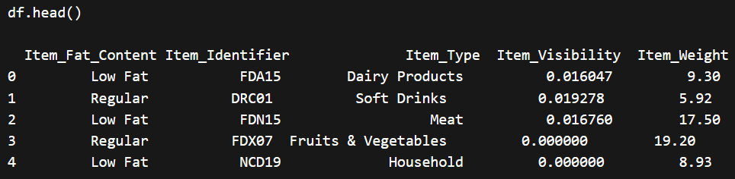

print(df.shape)
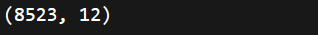

print(df.columns)
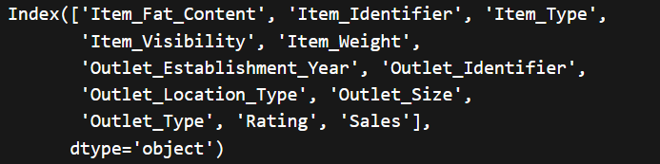

print(df.dtypes)
