**PROJECT TITLE**

**AI-Powered Ultrasound Diagnosis:**

**Fetal Health and Condition Detection**

**PROBLEM STATEMENT:**

This project aims to develop a deep learning-based system that analyzes ultrasound images to classify fetal health conditions such as normal growth, malnutrition (IUGR), and heart abnormalities. Using TensorFlow, Keras, and Streamlit, the model will provide real-time predictions to support early diagnosis—especially in settings with limited access to expert radiologists.

**OBJECTIVE**

* Build an AI model to check fetal health from ultrasound images.
* Classify images as **Normal**, **Mild Risk**, or **Severe Risk**.
* Help doctors detect problems early with more accuracy.
* Show which part of the image influenced the AI’s result using Grad-CAM.
* Make the diagnosis process faster and more reliable.

**DATASETS:**

* The dataset has **ultrasound images of unborn babies (fetuses)**.
* Images are grouped into three health categeroies

**1.Normal**

**2.Mild risk**

**3.Severe Risk**

* All images are in **.jpg** or **.png** format.

‣ Resize images to a fixed size (e.g.,224*224 pixels)

‣ Normalize the image values to make them easier for the model to understand  
‣ Apply data augmentation (like rotating and flipping) to improve learning.

**METHODOLOGY:**

1. Data Collection
2. Data Preprocessing
3. Model Building
4. Training and Validation
5. Model Evaluation
6. Explainable AI (Grad-CAM)
7. Deployment (Optional)

**TOOLS AND TECHNOLOGIES:**

1. Python
2. TensorFlow / Keras
3. OpenCV / PIL
4. NumPy / Pandas
5. Matplotlib / Seaborn
6. Grad-CAM
7. Google Colab / Jupyter Notebook
8. Git & GitHuB

**ARCHITECTURE**

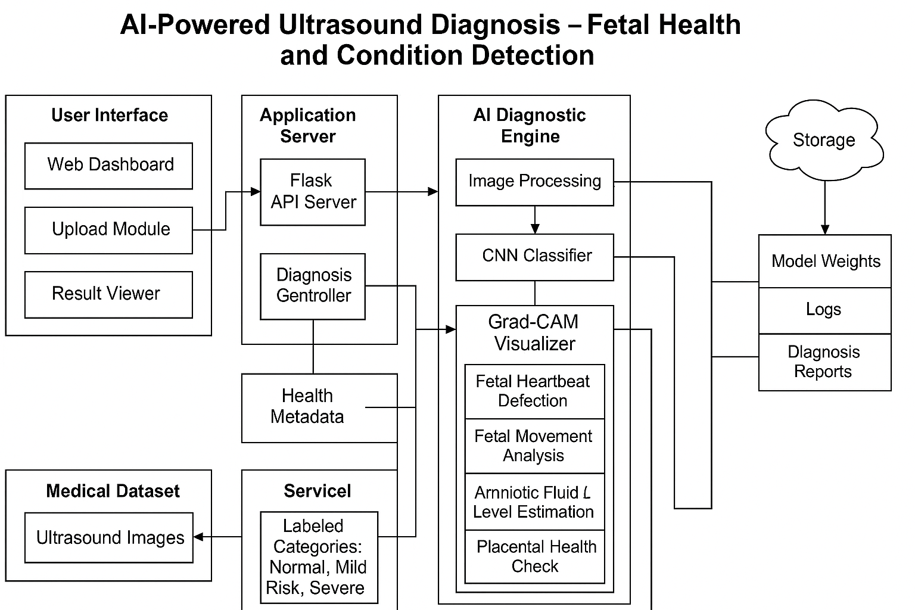

**UML DIAGRAMS:**

**Use Case Diagram**

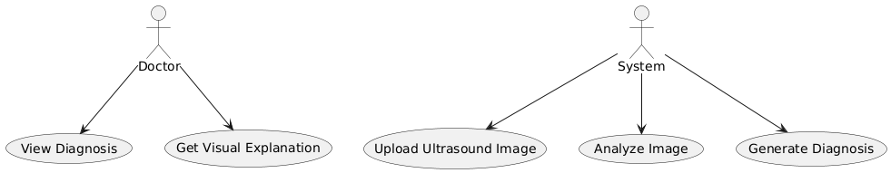

**Class Diagram**

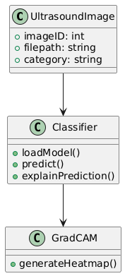

**Object Diagram**

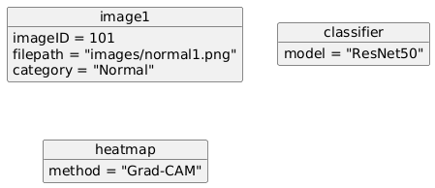

**Component Diagram**

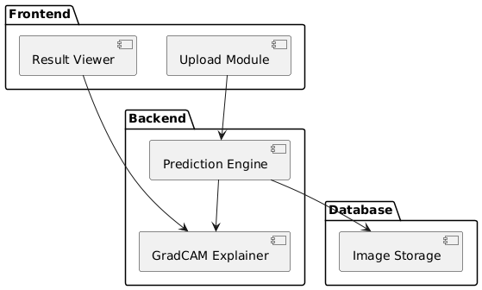

**Deployment Diagram**

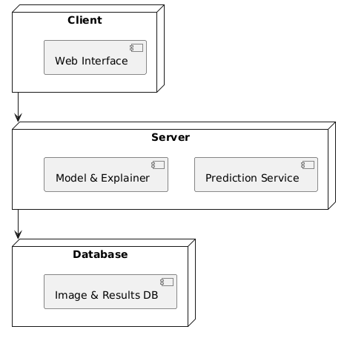

**Package Diagram**

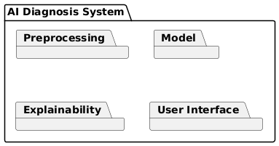

**Composite Structure Diagram**

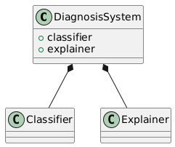

**Profile Diagram**

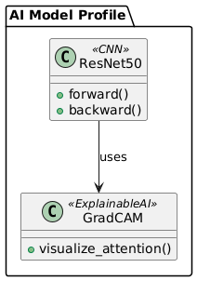

**State Machine Diagram**

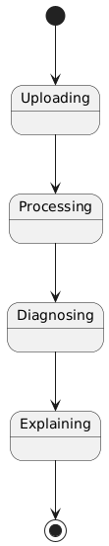

**Activity Diagram**

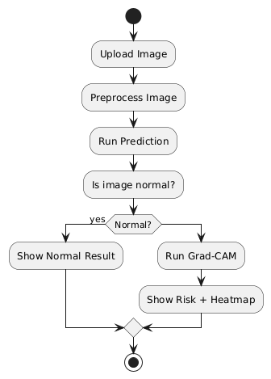

**Sequence Diagram**

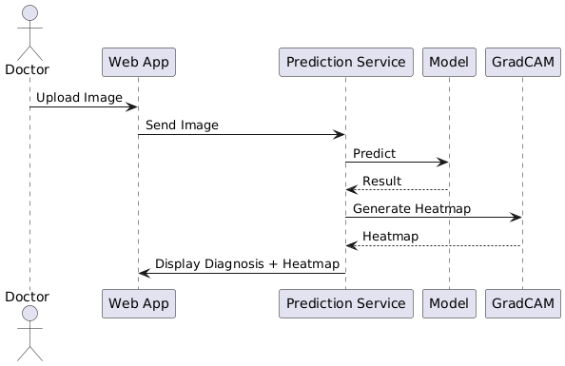

**Communication Diagram**

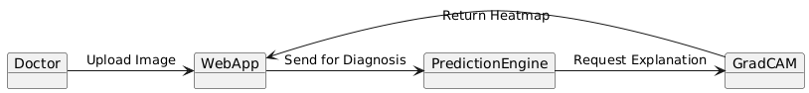

**Interaction Overview Diagram**

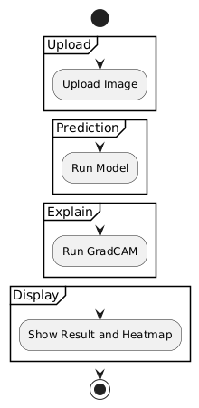

**System Workflow**

1. User Uploads Ultrasound Image

2. Image Preprocessing

3. Model Predicts Fetal Health Class

4. Interpret result

5. Output Prediction and precautions

**Sample Results**

**NORMAL:**

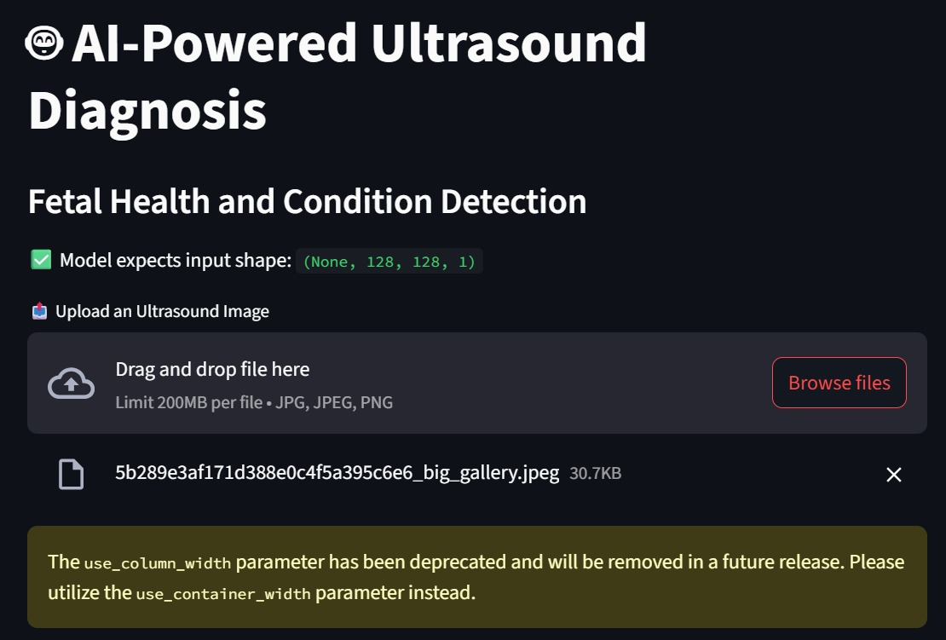

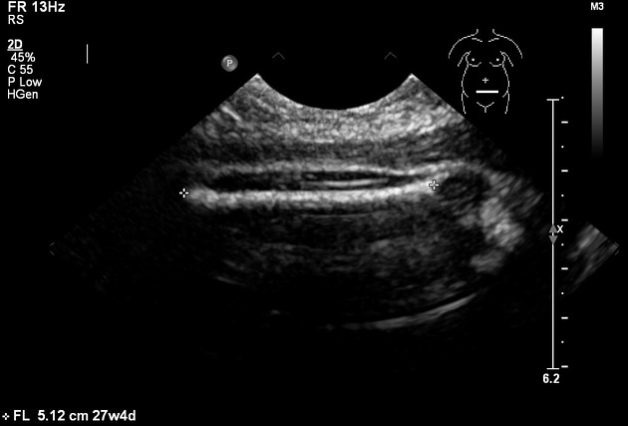

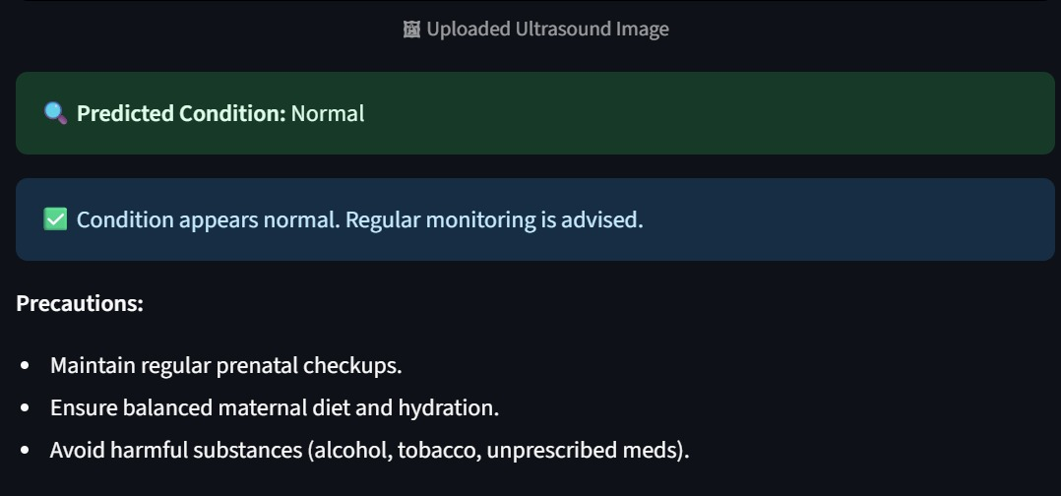

**HEART ABNORMALITY:**

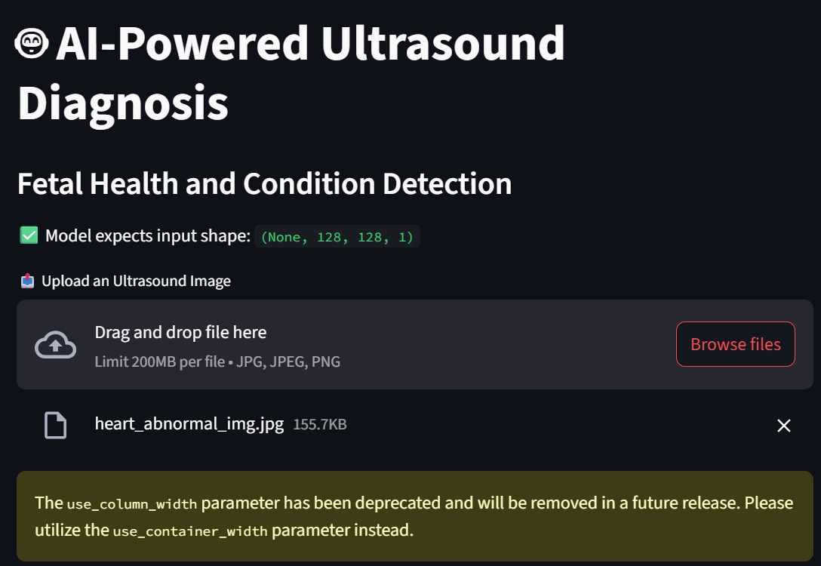

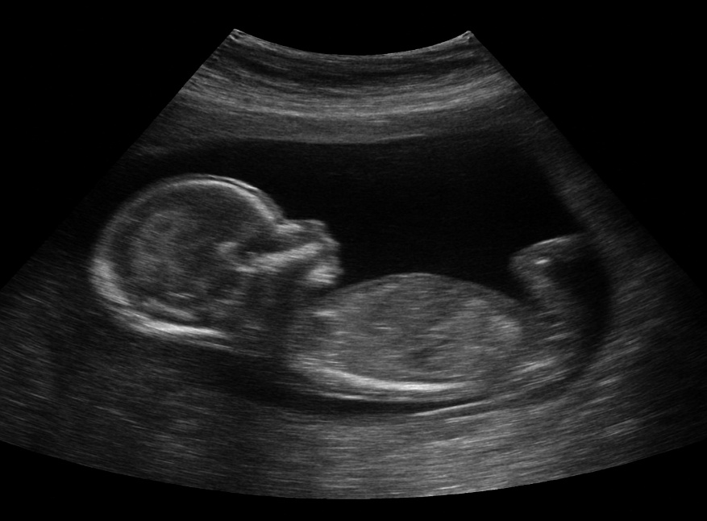

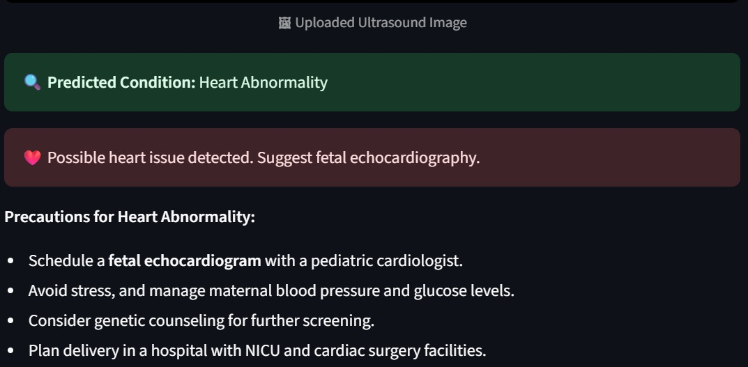

**Errors**

