**Water Quality Analysis**



|  |  |
| --- | --- |
| Team Member 1 | Nandhini M 19886B0ED0C87919C114C9DDDC5C9560 |
| Team Member 2 | Hemasri R 785ED556BB0F30280674CEFE0CA02567 |

|  |  |
| --- | --- |
| Department | AI&DS – III |
| College Name | Adhi College Of Engineering And Technology |
| Domain Name | Data Analytics with Cognos |

**Problem Statement :**

The project involves analyzing water quality data to assess the suitability of water for specific purposes, such as drinking. The objective is to identify potential issues or deviations from regulatory standards and determine water potability based on various parameters. This project includes defining analysis objectives, collecting water quality data, designing relevant visualizations, and building a predictive model.

**Introduction:**

In this phase, we have prepared and analyzed the water quality dataset to ensure it is suitable for subsequent analysis and modeling. Our primary objectives were to handle missing values, address outliers, visualize parameter distributions, understand correlations between variables, and identify potential deviations from water quality standards.

**Research Anomaly Detection Techniques :**

* Conduct an extensive review of anomaly detection techniques and algorithms. Consider both traditional statistical methods and machine learning-based approaches.
* Evaluate the suitability of each technique for identifying unusual patterns in water quality parameters.

**Data preprocessing:**

Prepares the water quality dataset for anomaly Detection. This process involves handling the missing values , Outlier Detection and Treatment and data visualization in the dataset.

The code for the data preprocessing of the water quality dataset is given below ,

**Handling missing values:**

We are Identified and addressed missing values in the dataset.

Missing data are also observed in the below code:

import pandas as pd

import numpy as np

from google.colab import drive

drive.mount("/content/drive")

# Load the dataset

data = pd.read_csv('/content/drive/MyDrive/water_potability.csv')

# Check for missing values

missing_values = data.isna().sum()

print(missing_values)

# Remove rows with any missing values

data = data.dropna()

# Impute missing values with the mean of each column

data = data.fillna(data.mean())

# Interpolate missing values linearly

data = data.interpolate(method='linear')

# Check for missing values after handling

missing_values = data.isna().sum()

print(missing_values)

# Save the processed dataset

data.to_csv('processed_dataset.csv', index=False)

import pandas as pd

from google.colab import files

# Save the DataFrame with extracted features to a CSV file

data.to_csv('processed_dataset.csv', index=False)

files.download('processed_dataset.csv')

**Outlier detection and treatment:**

We Detected outliers in the dataset, focusing on parameters that could significantly impact water quality assessment, such as pH, hardness.

The code for the outlier detection of the water quality dataset is given below,

from google.colab import drive

drive.mount('/content/drive')

Mounted at /content/drive

import pandas as pd

import numpy as np

import matplotlib.pyplot as plt

import seaborn as sns

data = pd.read_csv('/content/drive/MyDrive/processed_dataset.csv')

# Create a box plot to visualize outliers

plt.figure(figsize=(8, 6))

sns.boxplot(x=data["ph"])

plt.title(f'Box Plot for {"ph"}')

plt.xlabel("ph")

plt.show()

plt.figure(figsize=(8, 6))

sns.boxplot(x=data["Hardness"])

plt.title(f'Box Plot for {"Hardness"}')

plt.xlabel("Hardness")

plt.show()

summary_stats = data.describe()

print(summary_stats)

[ ]

summary_stats = data.describe()

print(summary_stats)

account_circle

[ ]

summary_stats = data.describe()

print(summary_stats)

account_circle

**Output:**

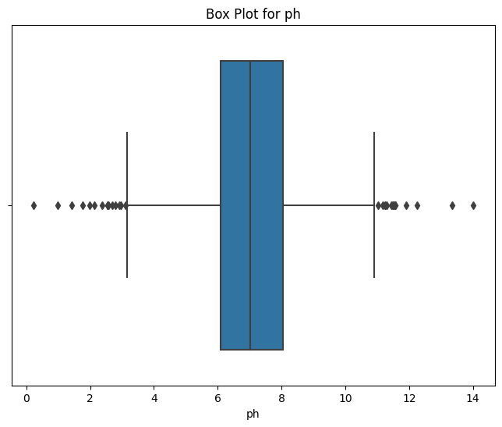

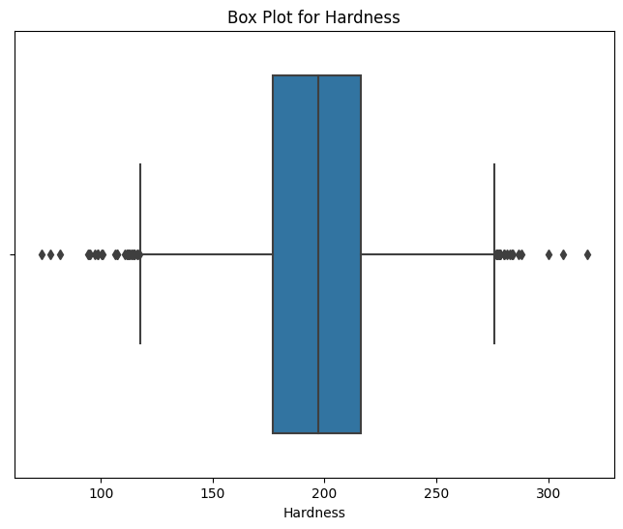

**Data Visualization:**

We Visualized parameter distributions to understand the central tendencies and spread of the data. We have distribution using the box plot to find the ph and hardness.

**Code:**

plt.figure(figsize=(12, 6))

sns.set(style='whitegrid')

sns.histplot(data=data, x='p', bins=20, kde=True)

plt.title('pH Distribution')

plt.xlabel('pH')

plt.ylabel('Frequency')

plt.show()

# Explore correlations between parameters

correlation_matrix = data.corr()

plt.figure(figsize=(10, 8))

sns.set(style='white')

sns.heatmap(correlation_matrix, annot=True, cmap='coolwarm')

plt.title('Correlation Heatmap')

plt.show()

# Scatter plot to visualize relationships

plt.figure(figsize=(10, 6))

sns.scatterplot(data=data, x='Hardness', y='Chloramines', hue='Potability')

plt.title('Hardness vs. Chloramines')

plt.xlabel('Hardness')

plt.ylabel('Chloramines')

plt.show()

**Output:**

