# Empathy Map

Ideation Phase

Empathize & Discover

Date: 20 june2025

Team ID:LTVIP2025TMID43376

Project Name: Pattern Sense: Classifying Fabrics Using Deep Learning

Maximum Marks: 4 Marks

## Empathy Map :

An empathy map is a simple, easy-to-digest visual that captures knowledge about a user’s behaviours and attitudes. It is a useful tool to help teams better understand their users. Creating an effective solution requires understanding the true problem and the person who is experiencing it. The exercise of creating the map helps participants consider things from the user’s perspective along with his or her goals and challenges.

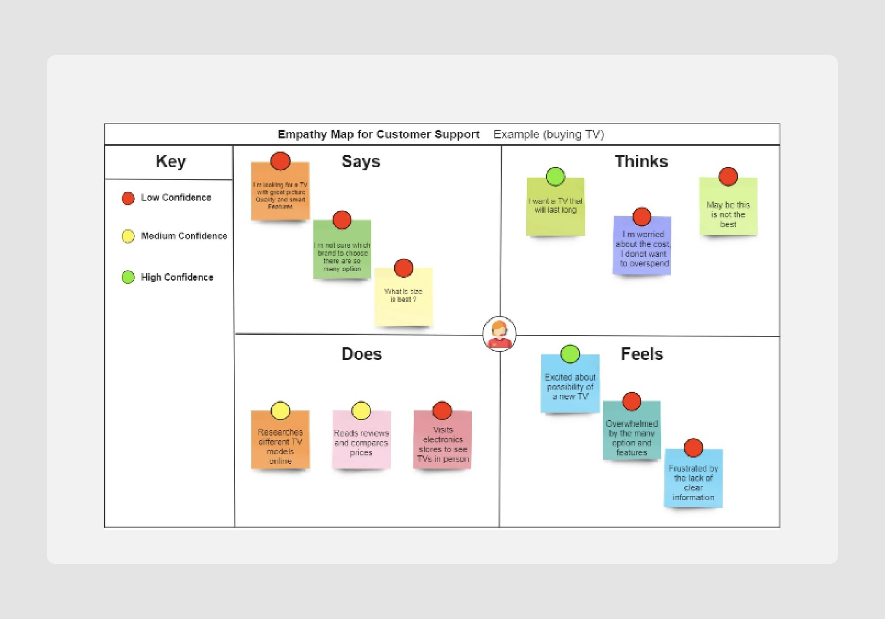

Reference: https://www.mural.co/templates/empathy-map-canvas