FINAL PROJECT REPORT
MBAI 5100: Business Analytics
Group Members:
Hemaswi Gorrela - 101037597
Qian Yang - 101033621
Ngan Nguyen Le Thu - 101037583
Wan-Ting Chang - 101037722

TABLE OF CONTENTS
1. Introduction and Definition of the Business Problem 2
2. Description of the Data 2
2.1 Data Source 2
3. Data Readiness and Preparation for Analysis 3
4. Proposed Analysis 4
4.1 Train–Test Split 4
4.2 Multiple Linear Regression 5
4.3 Model Performance Evaluation 5
4.4 Extreme-Case Stability Testing 6
5. Expected Results 7
5.1 OLS Regression Summary for Predicting Ticket Price 7
5.2 OLS Regression Summary for Predicting Sales Revenue 8
5.3 Logistic Regression Summary for Predicting Odds of Purchasing Again 9
5.4 Predicting Ticket Sales (Number of Persons per Transaction) 11
5.5 Predicting Sales Revenue per Transaction 13
5.5 Simulating Total Revenue for 500 Customers 14
6. Conclusion 16
7. Recommendations for the Cinema 16
8. Future Works 17
REFERENCES 19

1. Introduction and Definition of the Business Problem
Accurate forecasting of ticket sales and revenue is crucial for cinema organizations. Movie theaters must manage showtimes, staffing levels, pricing strategies, and marketing efforts, all of which depend on understanding customer behavior and predicting future demand. However, ticket purchases can vary widely depending on customer demographics, movie genre preferences, seating choices, pricing differences, and group size. These variations make it difficult for cinema managers to estimate demand and allocate resources effectively.
The business question addressed in this project is:
How can we predict the future ticket sales and revenue of different movies in a cinema based on historical data of sales, and pricing trends?

2. Description of the Data
The dataset used in this project was retrieved from Kaggle (Sarder, 2023) and contains detailed information on cinema ticket sales and customer behavior.

2.1 Data Source
- Dataset title: Cinema Hall Ticket Sales and Customer Charts
- Source: Kaggle
- Original author: Sarder, H. (2023)
- Link: https://www.kaggle.com/datasets/himelsarder/cinema-hall-ticket-sales-and-customer-behavior/data
2.2 Variables Included
- Age: Age of the customer making the purchase
- Ticket_Price: Price of the ticket purchased
- Movie_Genre: Category of the movie (e.g., Action, Comedy, Horror)
- Seat_Type: Seating choice (VIP, Premium, Regular)
- Number_of_Person: Indicates whether the customer attended alone or with a group
- Purchase_Again: Customer’s indication of whether they would return (Yes/No)
- Ticket_ID: Unique identifier for each transaction
This dataset enables analysis of customer demographics, behavior patterns, revenue factors, and retention trends. The transaction-level detail supports predictions related to both ticket sales volume and revenue.
2.3 Comparison to Similar Studies
A related project by Apala et al. (2013) focused on predicting box office performance using social media engagement data from platforms such as Twitter and YouTube. Their study aimed to classify movies as hits or flops based on public sentiment. In contrast, the current project uses customer-level transaction data, offering deeper insight into real purchasing behavior rather than online popularity. This approach supports operational decision-making within cinema organizations rather than general movie success prediction.

3. Data Readiness and Preparation for Analysis
3.1 Does the Data Support the Project Goals?
Yes, the existing data supports the project’s main objectives.
However, it does not include time-based variables such as day of the week, holidays, or showtimes. While these would enhance forecasting accuracy, the dataset is still sufficient to build baseline predictive models for sales and revenue trends.

The full code and dataset used in this analysis can be found here: https://drive.google.com/drive/folders/1jof3mp23a1LrXfF8ivJYRS9dK3KgMAp2?usp=drive_link

3.2 Data Cleaning and Preprocessing Steps
The following steps were completed to prepare the dataset for analysis:
- Loading the dataset: The raw Excel file was imported using Pandas.
- Checking for missing values: A completeness check showed no missing values in any column.
- Final dataset shape after validation: 1440 rows × 7 columns
- Cleaning “Number_of_Person”: Replaced non-numeric label “Alone” with the value 1
- Converted the column to integer type: Creating a new variable: Sales_Revenue. Calculated as: Ticket_Price × Number_of_Person. Provides a direct measure of revenue per transaction.
- Encoding categorical loyalty variable: Converted “Purchase_Again” from Yes/No to 1/0 for modeling.
- Removing irrelevant fields: Dropped “Ticket_ID” because it does not contribute to prediction
- Saving the cleaned dataset: Exported the processed file as cinema_hall_ticket_sales_cleaned.xlsx
These cleaning steps ensure that the dataset is fully structured, numerically consistent, and ready for further analysis such as regression modeling, forecasting, or classification.

4. Proposed Analysis

4.1 Train–Test Split
Used sklearn’s train_test_split(test_size=0.30) to divide the data into training and validation sets. Since the dataset consists of individual ticket transactions, separating 70% of them for training and 30% for testing allows us to evaluate whether our models generalize well across different customer segments and booking conditions. Movie tickets also have natural variability (different genres, customer ages, ticket prices), so validation on unseen data is crucial.

4.2 Multiple Linear Regression
- Built several OLS regression models using demographic variables (Age, Number_of_Person), behavioral variables (Purchase_Again), and categorical predictors (Movie_Genre, Seat_Type).
- Pricing Model: Predicted Ticket_Price to examine whether customer characteristics influence cinema pricing.
- Revenue Model: Predicted Sales_Revenue to quantify how ticket price, group size, seat type, and movie genre contribute to total revenue.
- Compared alternative model specifications (with and without Purchase_Again) to evaluate improvements in predictive accuracy.
Cinema operations depend heavily on both pricing strategy and revenue dynamics.Regression allows managers to understand: whether customers with certain attributes pay more or less, and which factors: ticket price, group size, seat type, or genre have the greatest impact on revenue. By modeling both outcomes, the analysis provides a comprehensive view of how customer behaviors and cinema offerings shape financial performance.

4.3 Model Performance Evaluation
- Computed RMSE, MSE, calculated R² on validation predictions
- Compared predicted vs actual ticket prices
Ticket prices range widely depending on seat level and movie type. These error metrics show whether demographic and behavioral predictors meaningfully explain price variation.

4.4 Extreme-Case Stability Testing
- Creating a synthetic customer: Max age,Max ticket price,Max group size,Chosen genre + seat type
- Comparing predicted revenue to the dataset’s highest observed revenue
Cinema revenue sometimes comes from very large group purchases or premium seating. This test checks whether the model behaves reasonably for high-revenue scenarios.
4.5 Logistic Regression
- Predicting likelihood of returning (Purchase_Again = 1)
- Using age, price sensitivity, and genre preference as predictors
Understanding repeat customers is vital for cinema loyalty strategies. Logistic regression links attributes (age, price sensitivity, genre preferences) to repeat purchase probability, enabling theaters to target promotions more effectively.
4.6 Classification Threshold Evaluation
- Thresholds from 0.1–0.9
- Measuring accuracy for each
- Selecting the best operational cutoff
The cinema dataset has imbalanced Purchase_Again outcomes. Testing thresholds helps determine the best rule for identifying high-likelihood returning customers, improving marketing targeting.
Together, these techniques allow us to fully leverage the cinema ticket dataset: modeling revenue, customer behavior, group size patterns, pricing strategy, and repeat-purchase likelihood. The methods are appropriate because they align directly with the dataset’s structure and answer key business questions faced by cinema managers.

5. Expected Results

5.1 OLS Regression Summary for Predicting Ticket Price
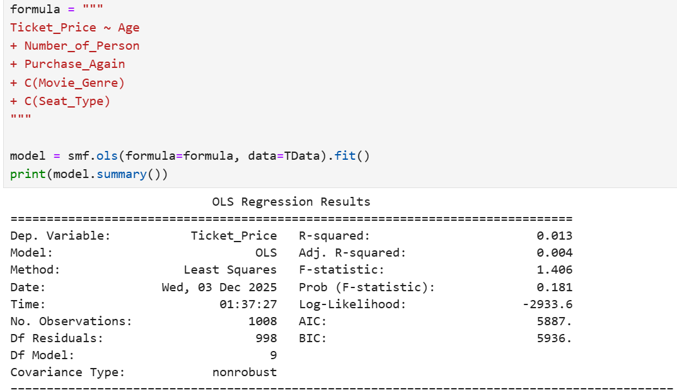This figure presents the OLS regression summary for predicting Ticket_Price using demographic, behavioral, and booking-related variables, including Age, Number_of_Person, Purchase_Again, Movie_Genre, and Seat_Type. The model performs poorly, with an R-squared value of 0.013, meaning that only 1.3% of the variation in ticket price is explained by these predictors. The adjusted R-squared (0.004) further confirms that adding multiple variables does not improve the model’s explanatory power. The overall model is statistically insignificant (F-statistic p-value = 0.181), and none of the individual predictors show meaningful significance (all p-values > 0.05).
These results show that ticket prices in this dataset are not influenced by customer age, group size, return intention, or movie and seat choices. Instead, ticket prices appear predetermined and fixed based on the cinema’s pricing policy, likely tied to standardized tiers rather than customer characteristics.
The cinema’s fixed pricing structure is consistent and transparent, as customer characteristics do not influence ticket price. Personalized or demographic-based pricing is not feasible with the current data. To explore dynamic pricing in the future, the cinema would need additional variables, such as showtime, weekday or weekend, holidays, real-time demand. The existing tier-based pricing system is functioning effectively and does not require customer-level customization.

5.2 OLS Regression Summary for Predicting Sales Revenue
We used two models to predict the Sales_Revenue and compare the results.
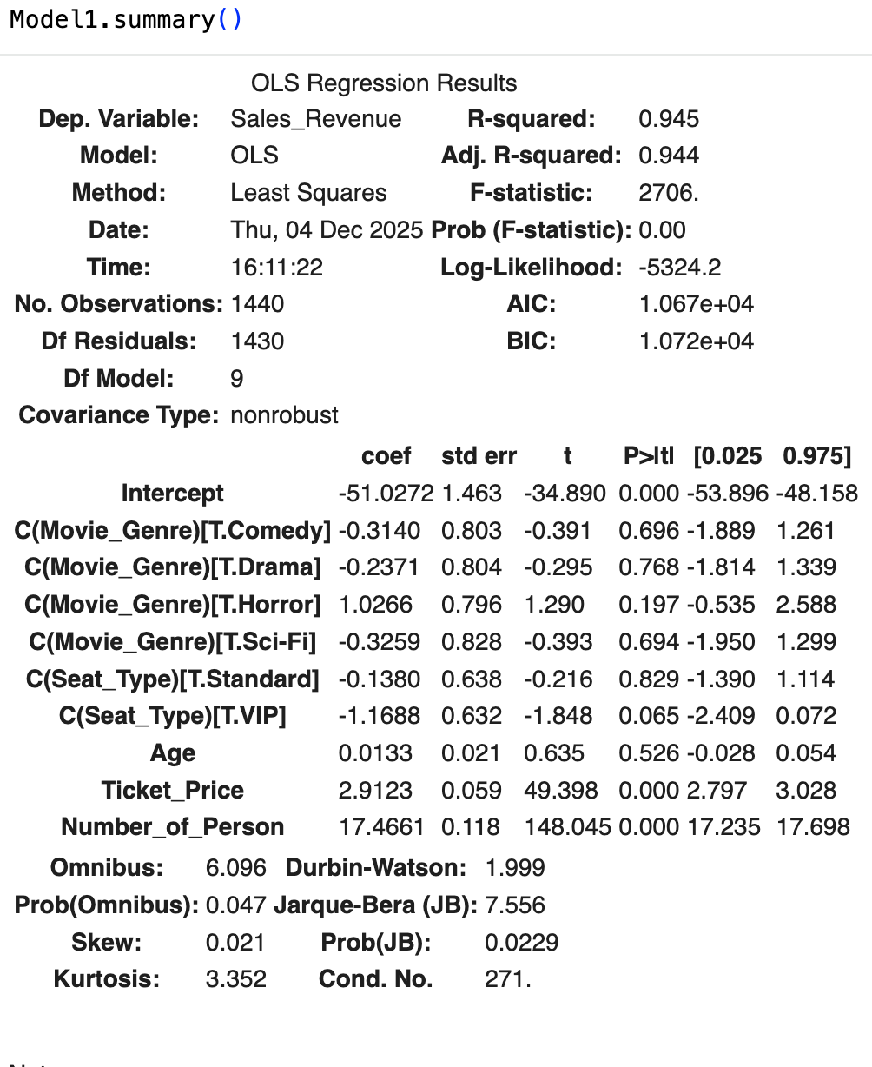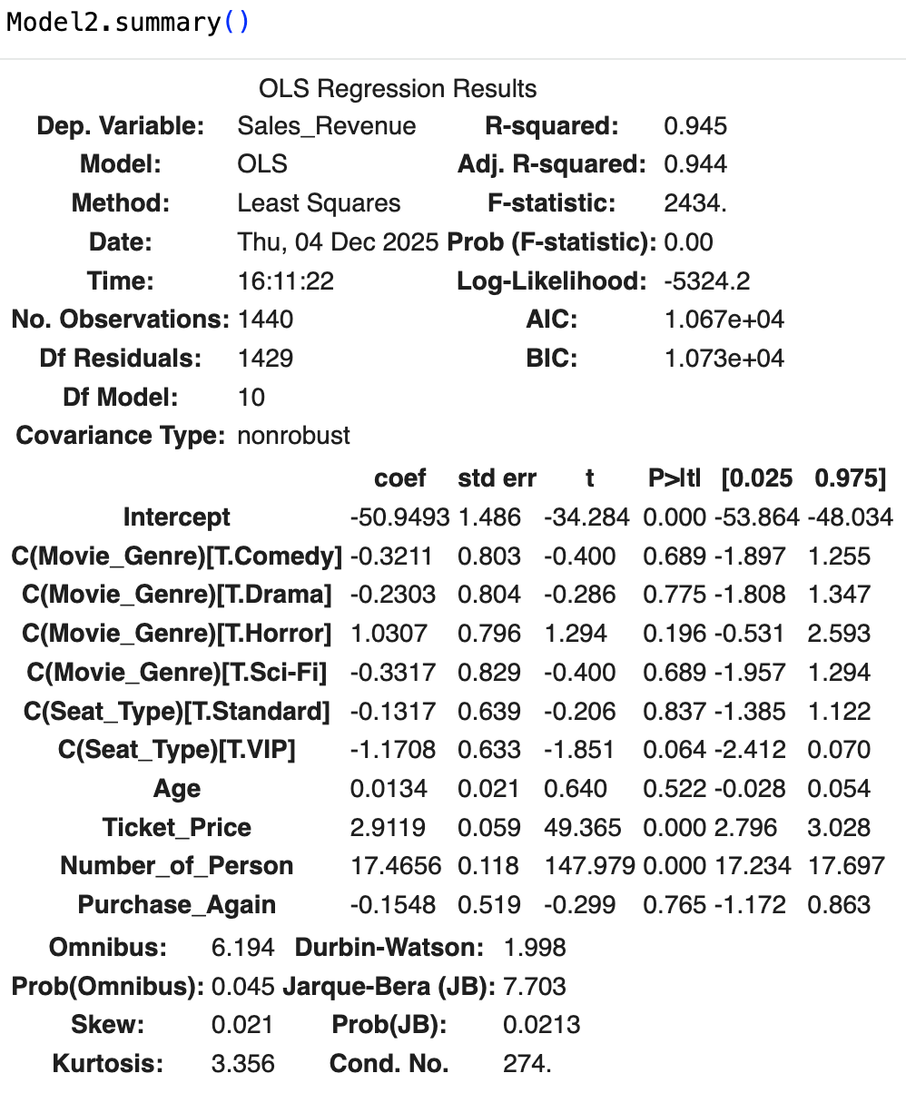

As shown in the two summary figures, Number_of_Person displays the largest coefficient, which aligns with the fact that Sales_Revenue is a direct function of Ticket_Price multiplied by Number_of_Person. Furthermore, among the movie genre categories, Horror is the only genre with a positive coefficient, suggesting a relatively higher contribution to Sales_Revenue compared with the reference group.
The results indicate that Number_of_Person is the strongest driver of Sales_Revenue, as reflected in both summary figures. This finding underscores the substantial impact of attendance volume on overall revenue generation. Given that revenue increases proportionally with the number of attendees, the cinema can benefit from implementing group-based promotions, such as discounted bundle tickets, family packages, or loyalty rewards for larger groups. These strategies can incentivize customers to attend in groups, thereby increasing foot traffic and maximizing revenue per screening.
Additionally, the positive coefficient observed for Horror movies suggests that this genre may attract relatively higher revenue compared with the baseline category. Managers may consider scheduling more Horror screenings during peak periods or pairing them with targeted promotional campaigns to further leverage this demand.
Overall, the analysis highlights opportunities for the cinema to strengthen revenue performance through group-promotion strategies and genre-specific marketing efforts.

5.3 Logistic Regression Summary for Predicting Odds of Purchasing Again
Purchase_Again was analyzed because it is important for the cinema to understand which factors influence whether customers choose to return. Identifying what drives repeat visits can help the cinema develop strategies to encourage customers to come back. Because the outcome variable is a yes/no response, a logistic regression model was used.
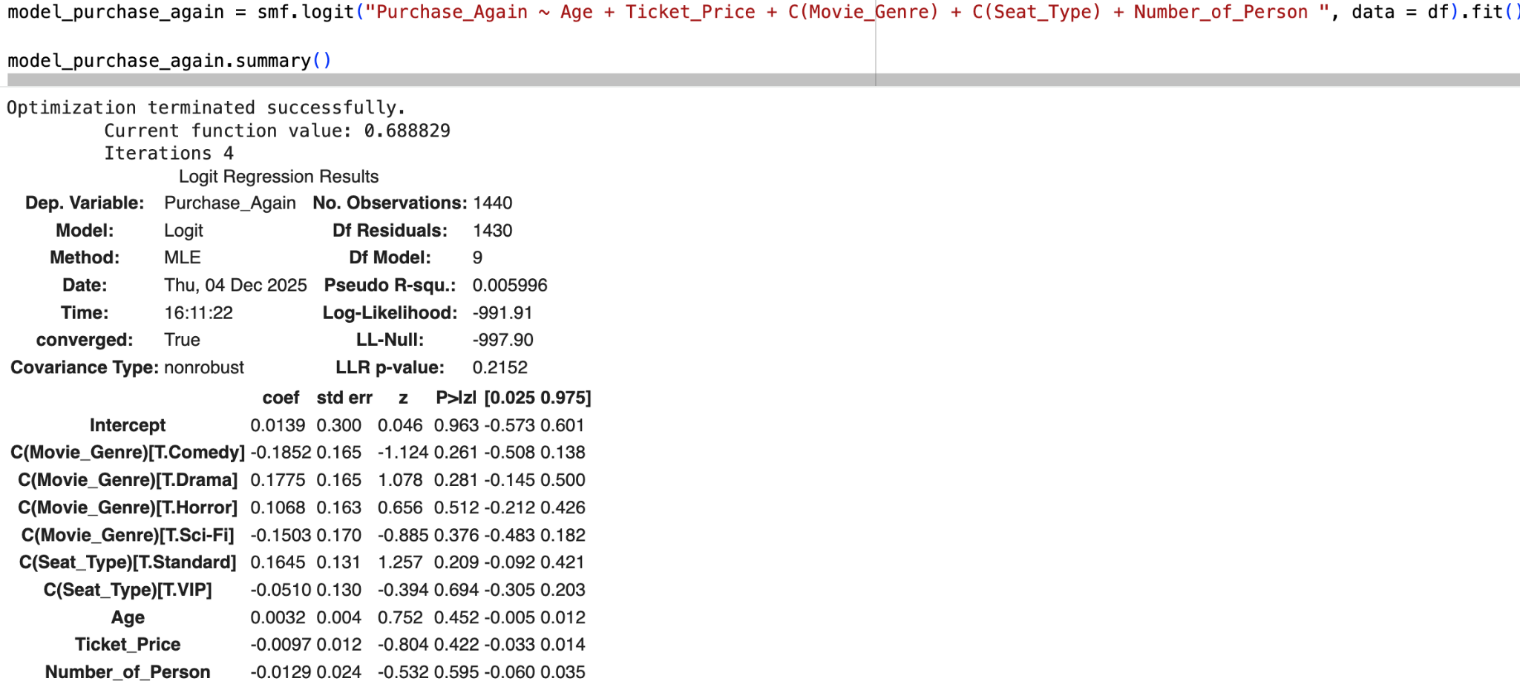

As we can see the p-values are around 0.5, none of them are below 0.05, and the coefficient of all the predicting variables are all very low.
Based on the coefficient results, Drama movies, Standard seats, slightly higher age, and slightly lower ticket price and number of persons appear to be associated with the highest odds of Purchase_Again. We can now predict the odds using these parameter values.

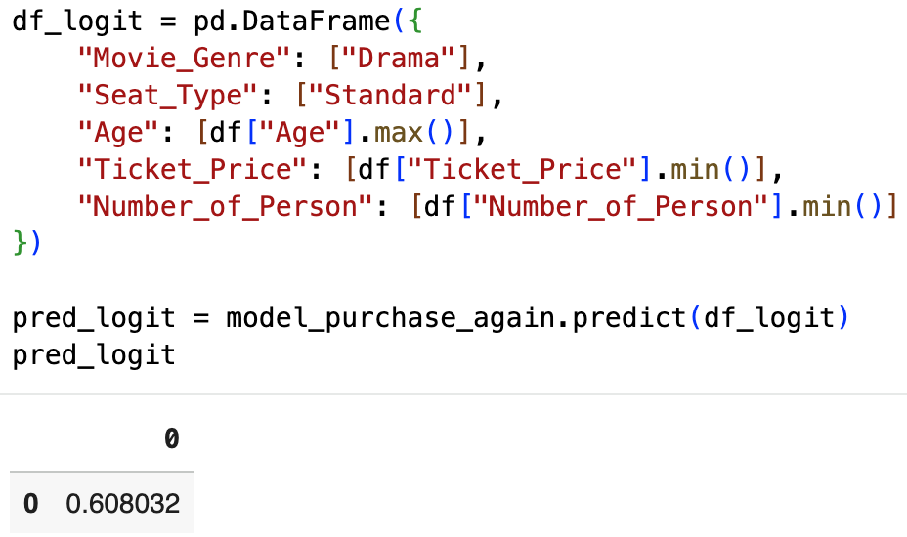
The model predicts a 0.60 probability of Purchase_Again, indicating that customers with these characteristics have a moderately high likelihood of returning. In other words, given the selected parameters, the expected probability of a repeat visit is above average but not guaranteed.

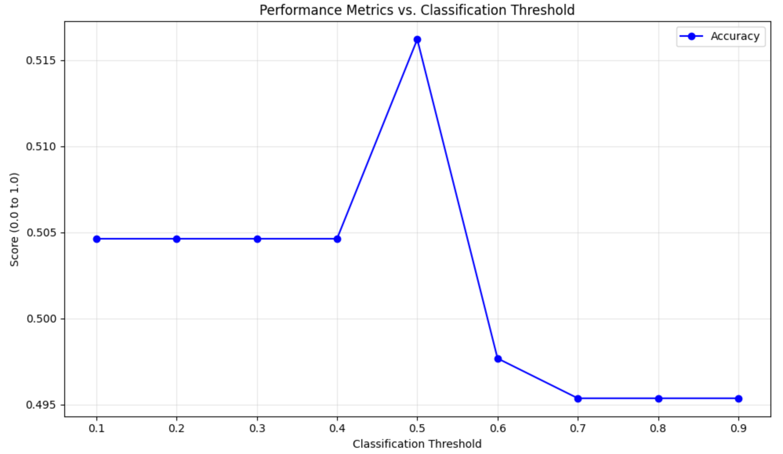
The Logistic Regression model, designed to predict customer repurchase (Purchase_Again), yielded a consistent validation accuracy of 50% across all tested classification thresholds (0.1 to 0.9). This performance is equivalent to random guessing, confirming that the current set of predictor variables—including Age, Ticket_Price, and Movie_Genre—are insufficient to successfully differentiate between customers who will repurchase or not. Nevertheless, using the previously selected parameters to predict Purchase_Again resulted in a probability of 0.6, slightly above the baseline of 0.5, suggesting that the cinema could consider focusing on these factors to potentially enhance ticket sales.

5.4 Predicting Ticket Sales (Number of Persons per Transaction)
To predict the number of tickets purchased per transaction, we first examined the distribution of movie genres and seat types. The analysis showed that VIP seats are the most frequently chosen, while no single movie genre dominates, with Action, Comedy, Drama, Horror, and Sci-Fi being fairly balanced. This suggests that seat type may have more influence on sales than genre.
We built two regression models. Model 1 included only categorical variables: Movie_Genre and Seat_Type. The results showed that seat type significantly affects ticket quantity: Premium and Standard seats have slightly fewer tickets compared to VIP seats. Movie genre, however, does not show a significant effect. The model explains very little variation in ticket sales (R-squared ≈ 0.007) and the validation RMSE was about 2.12 tickets, meaning predictions are on average off by two tickets per transaction.
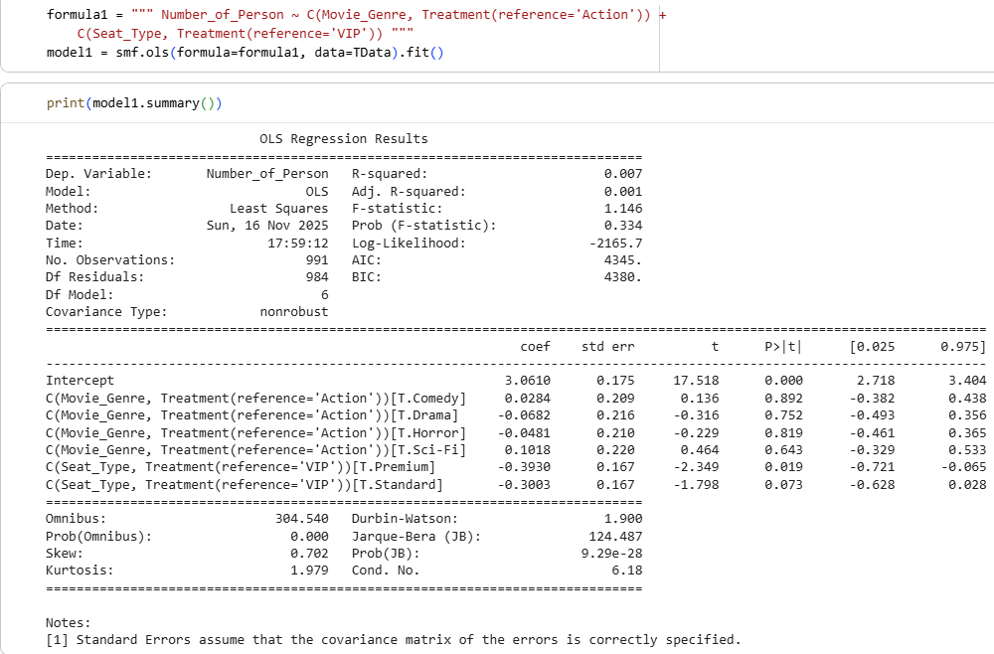

Model 2 added customer characteristics: Age, Ticket_Price, and Purchase_Again, along with the same categorical variables. Results indicated that ticket price has a small negative effect on group size, suggesting that higher prices slightly reduce the number of tickets purchased. Age and repeat purchase behavior were not significant predictors. Seat type remained significant, with VIP seats consistently attracting slightly larger groups. Movie genre again showed minimal effect. This model only slightly improved performance (R-squared ≈ 0.011, RMSE ≈ 2.12), indicating that additional factors would be needed for more accurate prediction.
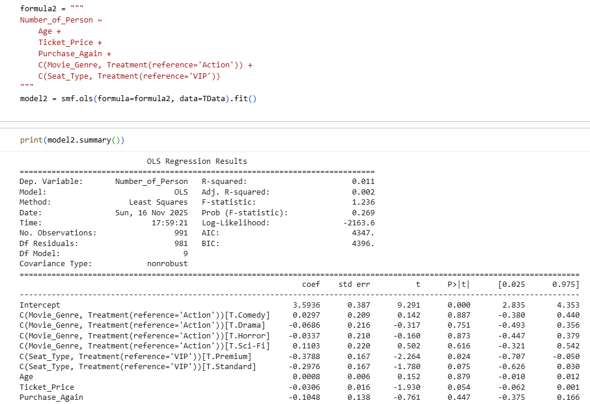
VIP seats tend to encourage slightly larger ticket purchases, so promoting VIP seating or offering packages could increase sales. Ticket pricing should be considered carefully, as higher prices may slightly reduce group size. Since movie genre and customer characteristics have little impact on ticket quantity, management may focus on overall historical sales trends and seat allocation rather than targeting specific genres or age groups. Including additional variables like showtime, day of the week, or promotional campaigns could improve future predictions.

5.5 Predicting Sales Revenue per Transaction
To predict sales revenue per transaction, we used dummy encoding to convert categorical variables (Movie_Genre and Seat_Type) into multiple binary columns so the regression model could handle them numerically. We then applied a linear regression model using these encoded features along with numerical variables, including ticket price and number of people per transaction, to predict Sales_Revenue. The model was trained on the training dataset and validated on a separate validation set.
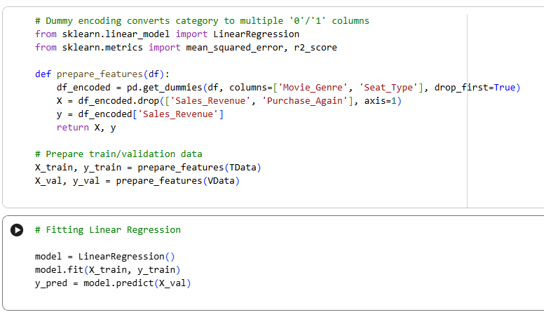
The model performed very well, with a high R-squared of 0.945 and a mean squared error (MSE) of 83.08, showing it can explain most of the variation in sales revenue and make accurate predictions. These results indicate that different factors affect revenue per transaction: larger group sizes generate more revenue, higher ticket prices contribute positively to revenue, and VIP seats consistently produce higher revenue than Premium or Standard seats. Movie genre has a smaller effect compared to these factors.
By understanding how group size, ticket price, and seat type influence revenue, cinema managers can forecast revenue more accurately, optimize seating allocations, adjust pricing strategies, and plan promotions to maximize sales. This analysis provides a direct, data-backed answer to our business question of predicting sales revenue per transaction.

5.5 Simulating Total Revenue for 500 Customers
To estimate the possible total revenue from a group of 500 customers, we performed a Monte Carlo simulation. In this approach, we accounted for uncertainty in ticket prices and group sizes by randomly sampling historical ticket prices and the number of people per purchase from our cleaned dataset. Each trial calculated total revenue as Revenue per customer = Ticket_Price × Number_of_Person, and we repeated this process 1,000 times to generate a range of possible outcomes.
The simulation results showed that the expected total revenue for 500 customers is approximately 24,262, with a standard deviation of about 879. The total revenue ranged from a minimum of 21,090 to a maximum of 27,154, with the middle 50% of outcomes between 23,668 and 24,857. A histogram of the simulation illustrates the distribution, showing that most outcomes are concentrated around the expected value but that variability exists due to differences in group sizes and ticket prices.
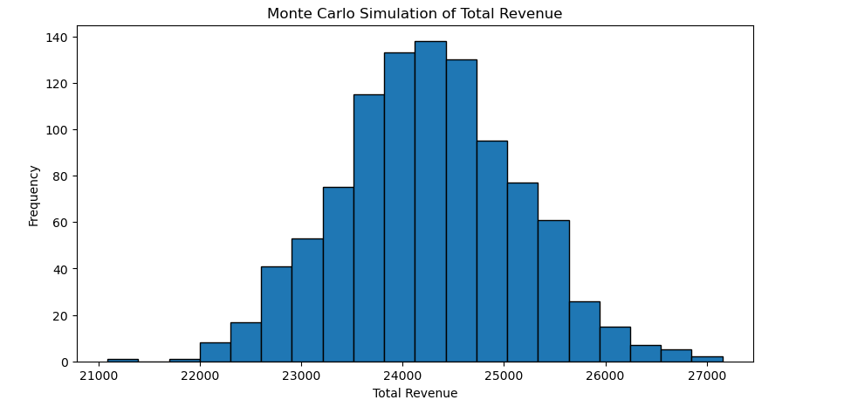
This simulation helps cinema managers understand both the expected revenue and the risk or variation in outcomes. It provides guidance for planning operations, budgeting, and staffing, and helps anticipate best-case and worst-case scenarios. By using historical data, management can make data-driven decisions to maximize revenue while preparing for variability in customer attendance and ticket sales.

6. Conclusion
This study analyzed historical cinema ticket sales and customer behavior to predict ticket quantity, revenue per transaction, and total revenue for a group of customers. Our findings show that seat type and group size are the most important factors influencing sales, while movie genre and customer characteristics such as age or repeat purchase behavior have minimal impact. Linear regression models accurately predict revenue per transaction (R² ≈ 0.945), and Monte Carlo simulations highlight the variability and potential risk in total revenue for groups of customers.
The insights gained provide actionable guidance for the cinema to optimize seat allocation, pricing strategies, and promotions. By focusing on VIP seating, encouraging group bookings, and planning for revenue variability, management can make data-driven decisions to maximize revenue. Future enhancements, such as incorporating time-based features, marketing effects, and advanced modeling techniques, can further improve predictive accuracy and operational planning.
In summary, this analysis demonstrates how historical sales data can be leveraged to support strategic decision-making, revenue forecasting, and risk management in cinema operations.

7. Recommendations for the Cinema
Based on our analysis of historical ticket sales, customer behavior, and revenue simulations, we propose the following recommendations to maximize ticket sales and revenue:
- Promote VIP Seating: VIP seats consistently attract slightly larger groups and generate higher revenue per transaction. Consider offering VIP packages, promotions, or premium experiences to encourage more sales in this category.
- Optimize Pricing Strategy: Ticket price has a small negative effect on group size but directly increases revenue per ticket. Balance pricing to maximize revenue without discouraging attendance. Use dynamic pricing or discounts for group bookings to attract larger parties.
- Focus on Seat Allocation Rather than Movie Genre: Movie genre has minimal impact on the number of tickets per transaction. Allocate screens based on historical sales trends and occupancy rather than assuming certain genres will attract larger groups.
- Plan for Revenue Variability: Monte Carlo simulations show that total revenue can vary due to differences in group size and ticket price. Prepare for fluctuations in revenue by considering staffing, concessions, and promotional campaigns to stabilize income.
- Use Data for Forecasting and Promotions: Leverage the predictive model for revenue to forecast sales for upcoming movies. Simulate different scenarios (e.g., high-demand movies, holidays) to plan marketing campaigns, pricing adjustments, and resource allocation effectively.
- Encourage Group Bookings: Since larger groups drive more revenue per transaction, consider incentives for group bookings, such as bundled tickets, loyalty programs, or discounts for families and friends.

8. Future Works
While our analysis provides valuable insights into ticket sales and revenue, there are several areas for further improvement to enhance predictive accuracy and managerial decision-making:
- Include Time-Based Features: Incorporate showtime, day of the week, and holiday effects to capture patterns in attendance and sales that vary by time.
- Consider Promotions and Marketing Campaigns: Include data on discounts, promotions, or advertising to evaluate their impact on ticket sales and revenue.
- Use Advanced Modeling Techniques: Explore machine learning methods such as decision trees, random forests, or gradient boosting to capture non-linear relationships and interactions between variables.
- Analyze Customer Behavior in More Detail: Incorporate loyalty program data, repeat visits over time, or online engagement metrics to better understand purchase patterns and retention.
- Predict Full Cinema Revenue and Occupancy: Expand simulations to forecast revenue for all movies and screens, considering capacity limits and potential overbooking scenarios.
- Scenario Planning for Risk Management: Use simulations to test best-case, worst-case, and likely scenarios for different customer volumes, ticket prices, and seating configurations to improve operational planning.

Implementing these future enhancements will allow the cinema to make more accurate revenue predictions, optimize pricing and seating strategies, and better manage operational risks.

REFERENCES
Sarder, H. (2023). Cinema hall ticket sales and customer behavior [Data set]. Kaggle. Retrieved from https://www.kaggle.com/datasets/himelsarder/cinema-hall-ticket-sales-and-customer-behavior/data
Apala, K. R., Roy, S., & Choudhury, T. (2013). Prediction of movies box office performance using social media. Retrieved from: https://www.researchgate.net/publication/262249589_Prediction_of_movies_box_office_performance_using_social_media

