
MBAI 5300G
Programming and Data Processing
Final Project
Customer Satisfaction Analysis in Airline Industry
Hemaswi Gorrela, Suneera Shaik, Oreoluwa Akinsanya, Le Thu Ngan Nguyen*
Abstract
This project investigates the key factors influencing airline passenger satisfaction and explores whether passengers can be segmented into meaningful behavioural groups based on service ratings and travel characteristics. Using a publicly available airline satisfaction dataset, the study applied statistical analysis, correlation exploration, satisfaction gap calculations, K-Means clustering, and a Random Forest classifier to uncover the strongest drivers of satisfaction and the distinct passenger segments present in the data. Results show that inflight entertainment, seat comfort, leg-room service, and online boarding are the strongest predictors of satisfaction. Clustering revealed three clear passenger groups: highly satisfied loyal travellers, moderately satisfied flyers with mixed expectations, and dissatisfied long-distance economy passengers. These insights offer practical implications for airlines seeking to enhance service delivery, optimize customer experience strategies, and improve satisfaction outcomes.
Keywords: Passenger satisfaction; clustering; airline service quality; machine learning;, segmentation; Random Forest.

- Introduction
Understanding airline passenger satisfaction is essential for improving travel experiences, enhancing loyalty programs, and strengthening competitive advantages in the aviation industry. The purpose of this project is to identify which service features most influence customer satisfaction and determine whether passengers naturally form distinct behavioral segments based on their service ratings. The study aims to:
- Determine which service feature/ features have a significant impact on customer satisfaction.
- Measure satisfaction gaps between satisfied and unsatisfied travelers.
- Segment passengers based on their behavioral patterns using unsupervised learning.
- Evaluate whether satisfaction can be predicted using machine learning.
These insights can help airlines prioritize improvements, tailor services to different customer groups, and make data-driven operational decisions.
2. Literature Review
Passenger satisfaction has been widely studied in aviation research, with key attributes such as comfort, timeliness, inflight services, and cabin crew performance frequently cited as major determinants (Colin et al., 2022; Anak & Ni 2021). Studies have shown that service quality significantly influences customer loyalty and airline competitiveness. Previous research commonly uses Structural Equation Model (SEM) and smart PLS or logistic regression to examine satisfaction levels.
However, gaps remain in identifying behavioral clusters within passengers using modern machine learning approaches. Most past studies rely on traditional statistical methods and overlook unsupervised segmentation that could reveal deeper behavioral patterns. Additionally, few studies combine correlation analysis, satisfaction gap analysis, clustering, and predictive modeling in one framework. This project addresses these gaps by applying both classical and modern analytical techniques to uncover richer insights into passenger satisfaction dynamics.
- Methodology
The dataset used in this project was obtained from Kaggle's Airline Passenger Satisfaction dataset, containing over 129,000 passenger records of an anonymized airline for confidentiality purposes. This dataset contains 23 columns such as : satisfaction, gender, customer type, age, type of travel, class, flight distance, seat comfort, departure/arrival time convenience, food and drink, gate location, inflight wifi service, inflight entertainment, online support, ease of online booking, on-board service , leg-room service ,baggage handling, check-in service, cleanliness , online boarding, departure delay in minutes, arrival delay in minutes.
  - Data Cleaning
As is the first step of any credible data analysis process, we carefully inspected the data and cleaned what was necessary.
- Null values: Upon inspection we found there were null values, and we removed them. All variables were in their appropriate datatype format (dtype()).
- Standardization: After which we standardized all categorical variables to ensure consistency when carrying out exploratory data analysis.
- Binary encoding: Next, we encoded the ‘Satisfaction’ column which originally contained ‘satisfied’ and ‘dissatisfied’ observations. This is because the survey makes use of a 0-5 rating system and encoding the ‘satisfaction’ column will make statistical analysis such as regression easier later in the analysis. We then transformed the remaining categorical text fields (except Gender, Type of Travel, Class) into numeric 0/1 dummy columns so the dataset is machine‑learning‑ready, while keeping a clean, non‑redundant set of features by dropping one category per variable.
- Outliers: We identified possible outliers but did not drop them because they are real experiences and opinions and removing them would hide the strongest signals about satisfaction and loyalty.
  - Analytical Questions
Prior to starting our exploratory analysis, we first identified some key questions necessary to achieve our overall objective.
- What service features have the most impact on a customer’s satisfaction?
- If a customer is satisfied, why are they disloyal?
- What service features have the most impact on customer loyalty?
- What service features do disloyal customers prioritize?
- What are the expectations of passengers, and are they being satisfied?

  - Analytical Methods
Q1: To identify features that strongly influence passenger satisfaction, we used 3 complementary methods:
- Correlation analysis
- Satisfaction gap analysis
- Random Forest Feature Importance
Each method answers the question from a different angle, and using all three ensures the results are accurate, reliable, and unbiased.
Correlation analysis gives a clear, numeric measure of the relationship (either positive or negative), shows which variables move together with satisfaction, and help narrow the top drivers before further analysis. But correlation alone does not tell the full story. We went further by calculating the difference in average rating (satisfaction gap) between satisfied and dissatisfied passengers, which then revealed which features satisfied customers consistently rated higher, where the biggest gaps are, and which improvements would have the most impact. Random Forest identifies which features the algorithm relies on most to predict satisfaction. It handles complex, non-linear relationships, works well with a large quantity of features, and provides a ranked list of feature importance.

Q2: To understand why satisfied passengers may still be disloyal, we isolated two specific groups: satisfied–loyal and satisfied–disloyal customers. This allowed us to eliminate satisfaction as a confounding variable and focus purely on the factors that differentiate loyalty behavior.
We compared both groups across all service features, delay variables, and demographic distributions. We then conducted a deeper subgroup analysis on young satisfied disloyal passengers to uncover behavioral patterns.
This combination of behavioral segmentation, service rating comparison, demographic profiling, and visualization enabled us to identify the subtle service experiences and demographic characteristics that explain why satisfaction does not always translate into loyalty.
Overall, some of the analytical methods used to answer this question include:
- Subgroup segmentation (Boolean filtering)
- Comparative descriptive statistics
- Service feature gap analysis
- Demographic profiling and age distribution analysis

Q3: To determine which service features, influence customer loyalty, we first applied behavioral segmentation to isolate passengers who were classified as loyal. By narrowing the analysis to this specific group, we were able to examine loyalty-related behaviors without the confounding effects of dissatisfaction. We then conducted descriptive statistical analysis on their service ratings, calculating and ranking feature-wise mean scores to identify which attributes loyal customers consistently value and which areas receive comparatively lower evaluations. This approach highlights the service features that most strongly support loyalty as well as those that may pose a risk to retaining otherwise satisfied passengers. Some methods used includes:
- Behavioral Segmentation.
- Descriptive Statistical Analysis.
- Comparative Data Visualization.

Q4: To identify the service features prioritized by disloyal customers, we first applied behavioral segmentation to isolate all passengers classified as non-loyal. Then, using descriptive statistical analysis, we calculated the average rating for each service feature within this disloyal segment. By ranking these averages from lowest to highest, we highlighted the specific service attributes that disloyal customers value differently or evaluate more critically. Finally, a bar chart visualization made these priority patterns easy to observe and compare. Some methods used includes:
- Behavioral Segmentation.
- Descriptive Statistical Analysis.
- Comparative Data Visualization.

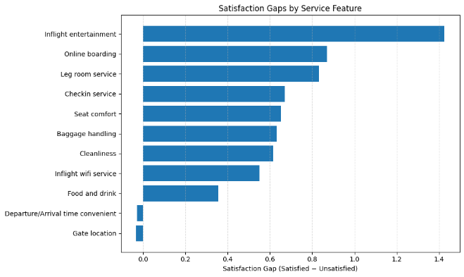
Q5: To understand passenger expectations and determine whether those expectations are being met, we applied K-Means clustering to a wide set of service ratings and travel-related features. By standardizing the data and grouping passengers based on their rating patterns, we uncovered three distinct expectation-based segments. We then profiled each cluster by examining the average service ratings within it. Clusters with lower mean scores indicated passengers whose expectations were not being satisfied, while clusters with consistently high ratings represented passengers whose expectations were being fully met. This unsupervised learning approach allowed us to identify expectation patterns and satisfaction levels across the passenger base. Analytical methods used are:
- Behavioral Clustering (K-Means)
- Feature standardization (Z-score scaling)
- Passenger segmentation (unsupervised learning)
- Cluster profiling (cluster-wise mean feature analysis)
- DATA ANALYSIS
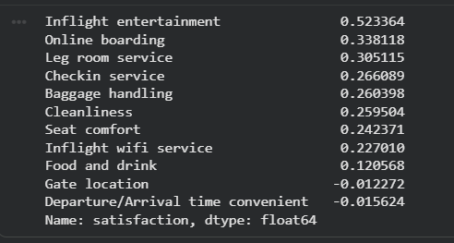
4.1. What service features have the most impact on a customer’s satisfaction?

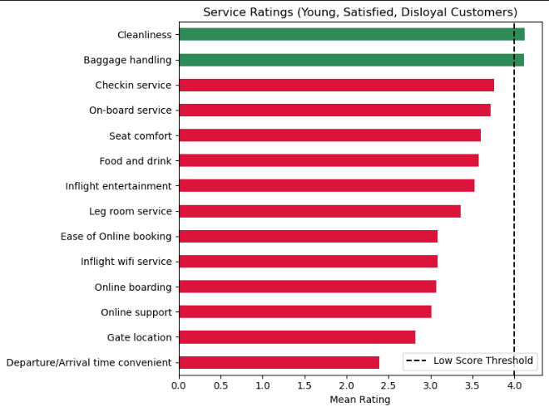
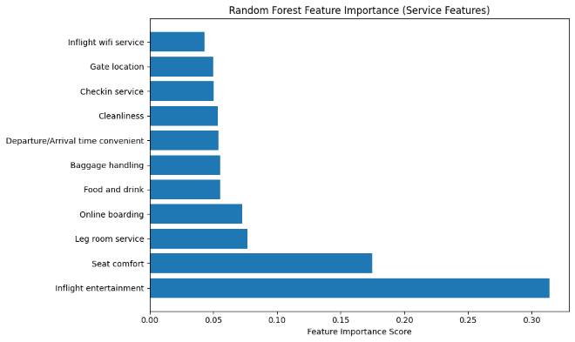

All three methods consistently identify the same top three drivers. This consistency strengthens our conclusion and shows that these features are statistically the strongest determinants of consumer satisfaction.

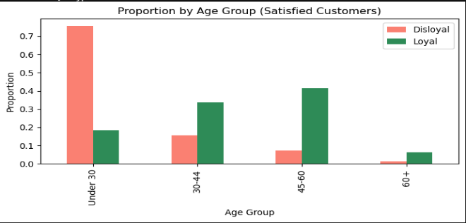
4.2. If a customer is satisfied, why are they disloyal?
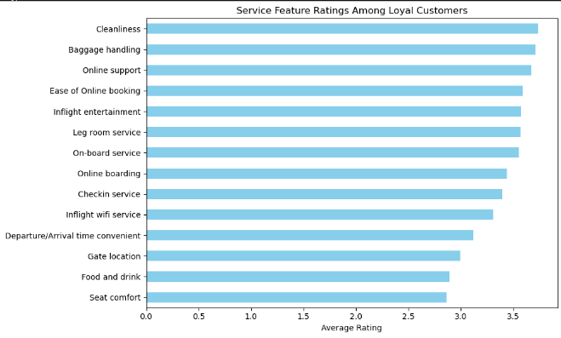
Young passengers make up most of the “satisfied but disloyal” group. Even though they rate the airline positively, their satisfaction is shallow. Only cleanliness and baggage handling score high, while most services fall below the 4.0 mark. This weak satisfaction explains why they easily switch airlines, are price-sensitive, and don’t develop loyalty. Older customers, however, are far more loyal at similar satisfaction levels.
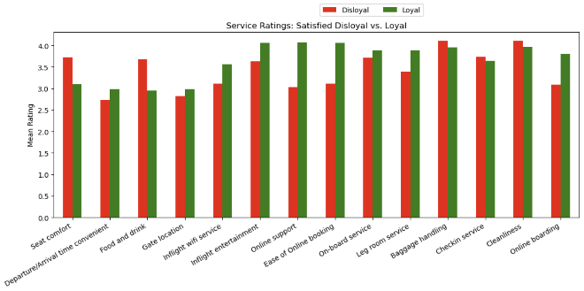
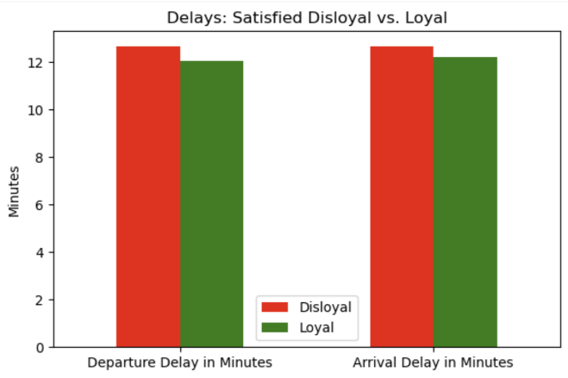
Loyal customers rate almost every service area higher than disloyal ones, especially things like entertainment, online touchpoints, and comfort, while their delays are about the same. So loyalty here is driven much more by service quality than by punctuality. In conclusion, satisfaction doesn’t guarantee loyalty for younger travelers. They need stronger value, rewards, and exceptional service to stay.

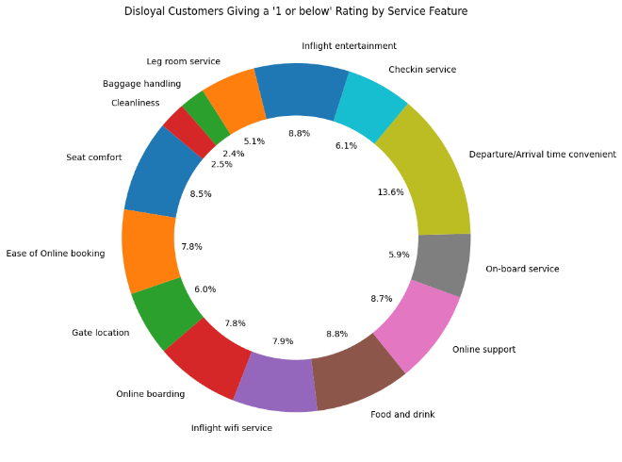
4.3. What service features have the most impact on customer loyalty and what features are disloyal customers most dissatisfied with?

It is not enough to calculate average scores alone because problems often occur in clusters not in isolation. This analysis identifies service features that tend to fail together.

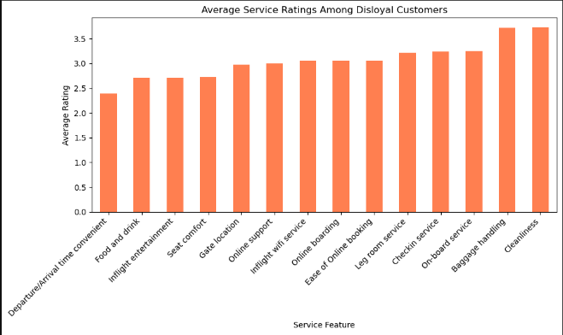
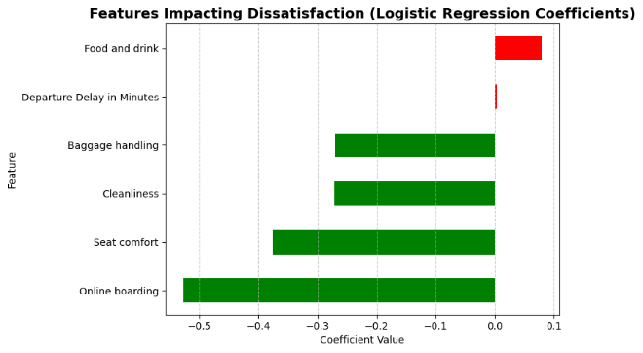

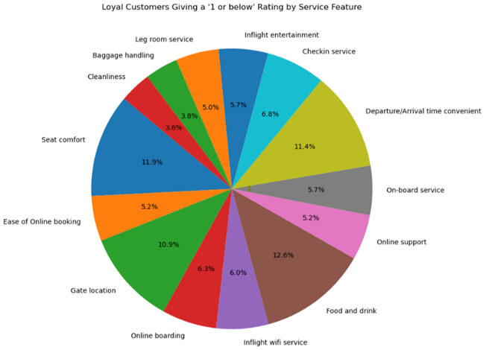
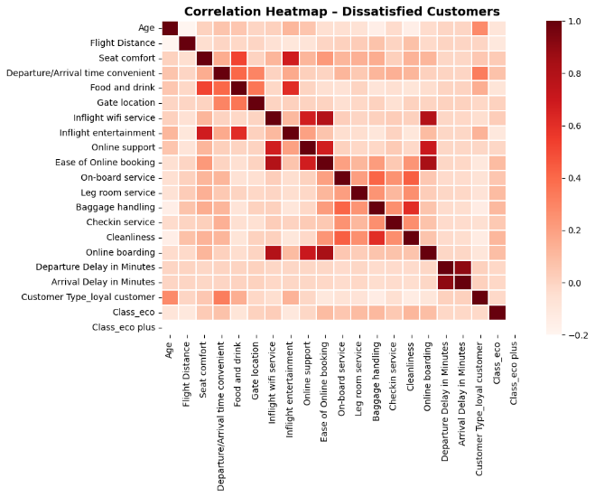
4.4. What are customers’ expectations and are they being met?
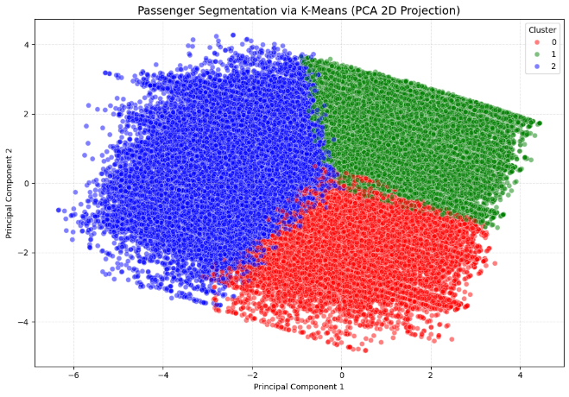

Cluster 1 – Highly Satisfied, Highly Engaged Travelers (Green)
These passengers are genuinely happy with the airline. They rate almost every service feature very highly and show the strongest loyalty (90%). They often fly premium classes and receive (or expect) better service. This is the airline’s ideal customer segment. Easy to retain and highly positive.

Cluster 2 – Moderately Satisfied, High-Expectation Travelers (Blue)
This group is mostly satisfied but not impressed. They give average ratings overall, with noticeable weaknesses in leg room and check-in. They fly economy more often and may have inconsistent experiences. Loyalty is decent (83%), but fragile. They stay only if expectations are met.
This is a “keep improving” segment.

Cluster 0 – Unsatisfied, Service-Critical Passengers (Red)
This cluster is clearly unhappy. They score almost every service low Wi-Fi, entertainment, food, comfort, boarding, and more. They mostly fly economy and on longer routes, where poor service feels worse. Their loyalty rate is lowest (60%).
This is the most at-risk segment, needing urgent service improvement to prevent churn.
- DISCUSSION
5.1 How do our findings help to solve our research question?
The results of the study show distinct trends in how travelers assess the quality of airline services. For the first research question, the analyses repeatedly demonstrated that seat comfort, leg room service, inflight entertainment, check-in service, online boarding, and cleanliness are the strongest indicators of satisfaction. These data reveal that passengers base their overall pleasure on the core in-flight experience and the effectiveness of essential journey operations, whereas peripheral factors such as food and drink or gate placement play a significantly smaller influence.
For the second research question, the data indicated that contentment does not necessarily transfer into loyalty particularly among younger tourists. Passengers under 30 make up the majority of satisfied but disloyal passengers, and although they report satisfactory service, their evaluations for most features fall into the "good but not impressive" bracket. This shows that younger passengers experience a type of shallow or “checkbox satisfaction”—their expectations are met at a basic level but not exceeded enough to attach loyalty. Therefore, their airline choices are influenced more by outside factors than by pleasure alone, such as price sensitivity, convenience, and flexible travel habits.
The final research question focused on what generates loyalty itself. Loyal travelers provided consistently higher evaluations across almost all features, suggesting that loyalty develops from dependable, great service performance rather than exceptional instances of excellence. Disloyal passengers, by contrast, had flat, mid-range scores, indicating that they view the service as adequate but interchangeable with other airlines. They still place a high value on cleanliness and luggage handling, but they don't have a stronger emotional connection. These findings imply that loyalty is complex and depends on sustaining consistently high standards across comfort and process-related factors.
The fourth research question addressed passenger expectations through clustering. The results created three main groups: thrilled loyalists, expectation balancers, and unsatisfied economy fliers. Delighted loyalists have high expectations that are constantly met, whereas expectation balancers experience a mix of strengths and flaws that position them in a transitional middle ground. Dissatisfied economy fliers face the greatest obstacles, frequently due to longer flights and economy seating limits, and their expectations are not being fully realized. These clusters indicate that satisfaction and expectations differ widely across passenger categories, affected by demographics, travel class, and route factors.
5.2 Industry Recommendations
The findings show that while amenities like seat comfort, leg room, and entertainment regularly boost customer happiness, airlines should give priority to enhancing core comfort and the in-flight experience. Equally crucial is managing the entire journey. Efficient check-in, smooth online boarding, and rigorous cleanliness standards all play vital roles in molding perceptions.
Younger passengers, who typically claim satisfaction but stay disloyal, require focused retention efforts. This generation responds more to flexibility, tailored digital experiences, and youth-oriented rewards than to traditional loyalty programs, meaning airlines must change their engagement strategies accordingly.
The clustering outcomes highlight the usefulness of differentiated tactics. Dissatisfied economic travelers need more structural improvements like better seats or clearer communication, delighted loyalists need consistent treatment to keep them loyal, and expectation balancers can be pushed toward loyalty with targeted improvements in a few key areas.
Lastly, segmented satisfaction data should be incorporated into regular airline decision-making. Tracking happiness and loyalty by age, class, and passenger segment provides more meaningful insight than depending on total results alone. At an industry level, the findings encourage increased transparency regarding service standards and comfort indicators, which directly influence both satisfaction and long-term loyalty.
- CONCLUSION
A thorough, data-driven understanding of airline passenger happiness, loyalty behavior, and expectation patterns was provided by this research. Through statistical analysis, machine learning, and clustering, the study demonstrated that satisfaction is influenced most strongly by core comfort and process-related features such as inflight entertainment, seat comfort, leg room, check-in, boarding efficiency, and cleanliness. But contentment by itself does not ensure loyalty, especially for younger travelers who frequently report satisfactory experiences but continue to be disloyal unless they receive outstanding, valued, or personalized service. On the other hand, persistent high performance across several touchpoints is rewarded by loyal customers. The clustering study also showed that there are significant differences in passenger expectations, with happy loyalists, expectation balancers, and unhappy economic travelers all needing distinct service strategies. Overall, the results show clear commercial implications: airlines need to put comfort first, efficiently manage the entire trip, implement value-driven initiatives for young passengers, and customize interventions to meet the demands of different passenger segments.
6.1 Project Successes
To examine a sizable real-world dataset and provide precise and solid responses to every research topic, the project effectively combined descriptive analytics, predictive modeling, and clustering approaches. Beyond summarizing satisfaction levels, the analysis found deeper behavioral patterns such as the “satisfied but disloyal” young segment that traditional measurements generally overlook. Additionally, the investigation produced useful, business-ready insights that airlines may implement right now, exhibiting both analytical rigor and practical relevance.

6.2 Project Limitations
- A major limitation was the absence of timestamps; with time-based data, we could have identified periods where satisfaction rose or fell sharply, providing deeper insight into what drives changes in passenger satisfaction.
- Some service categories are subjective (e.g., seat comfort), leading to differences in perception not captured by the data.
- The analysis assumes satisfaction and loyalty are static, whereas they can shift over time based on external factors (pricing, competitor moves, etc.).

6.3 Future Research Opportunities
Future research could benefit from including pricing, fare type, and competitor data to better explain why people migrate between airlines. Understanding how consumer perceptions evolve over time might also be enhanced by a temporal examination of satisfaction and loyalty trends across seasons or years. Furthermore, adding text-based emotion from customer reviews could improve the numerical results and offer a more comprehensive picture of the traveler experience.
ACKNOWLEDGMENTS
We would like to express our sincere appreciation for our professor, Dr Amin. As well as our fellow classmates. We also acknowledge the use of Python, Tableau, and associated libraries that supported the analysis.
REFERENCES
Devi, A. A. D. T., & Yasa, N. N. K. (2021). role of customer satisfaction in mediating the influence of service quality and perceived value on brand loyalty. International Research Journal of Management, IT and Social Sciences, 8(3), 315–328. https://doi.org/10.21744/irjmis.v8n3.1786

Hussain, R. (2016). The mediating role of customer satisfaction: evidence from the airline industry. Asia Pacific Journal of Marketing and Logistics, 28(2), 234–255. https://doi.org/10.1108/apjml-01-2015-0001

Jana, S. (2020). Airlines Customer satisfaction. Www.kaggle.com. https://www.kaggle.com/datasets/sjleshrac/airlines-customer-satisfaction

Law, C. C. H., Zhang, Y., & Gow, J. (2022). Airline service quality, customer satisfaction, and repurchase Intention: Laotian air passengers’ perspective. Case Studies on Transport Policy, 10(2). https://doi.org/10.1016/j.cstp.2022.02.002

Lucini, F. R., Tonetto, L. M., Fogliatto, F. S., & Anzanello, M. J. (2020). Text mining approach to explore dimensions of airline customer satisfaction using online customer reviews. Journal of Air Transport Management, 83(101760), 101760. https://doi.org/10.1016/j.jairtraman.2019.101760

