Table:student

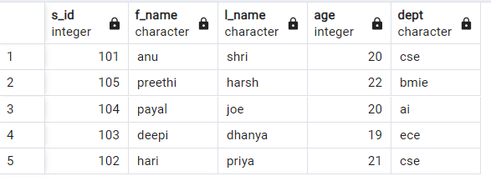

Table:a_dept

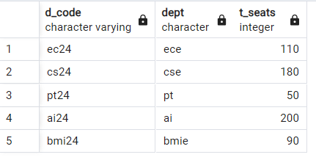  
Table:data

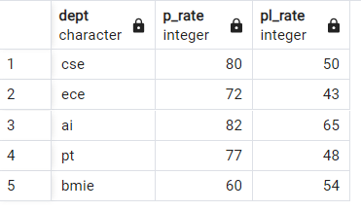

i)Arranging the t_seats in ascending using order by and setting the limit value as 3.

Query(limit)

select d_code,t_seats from a_dept order by t_seats limit 3;

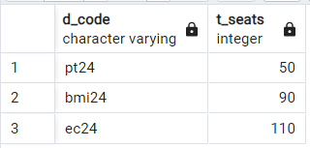

Qyery(rollup)

select s_id,f_name,l_name aggregate from student group by rollup(s_id,f_name,l_name);

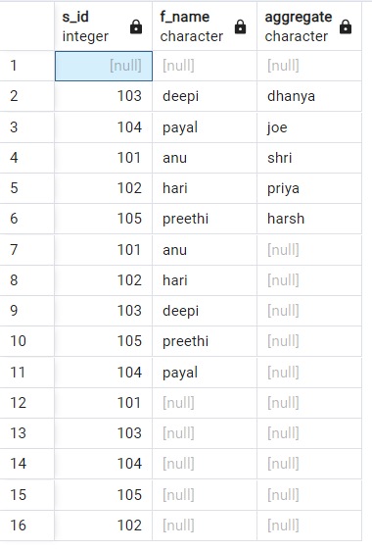

Query(cube)

select s_id,f_name,l_name aggregate from student group by cube(s_id,f_name,l_name);

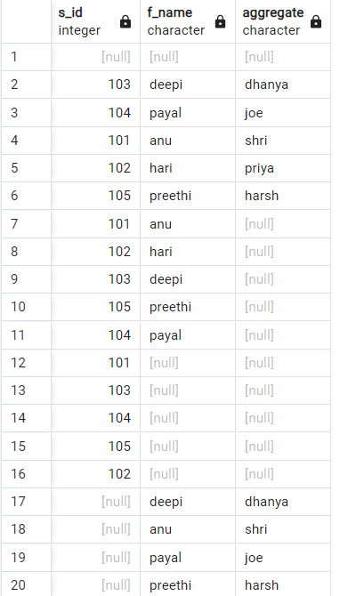

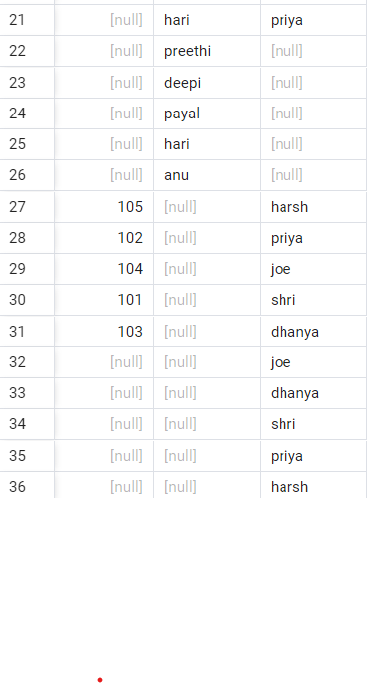

Query(json)

create table info(dept char(10) not null,sub_info json not null);

insert into info(dept,sub_info) values('ece','{"sub":["linear algebra","daa"],"credits":4}');

insert into info(dept,sub_info) values('cse','{"sub":["random variable","os"],"credits":3}');

insert into info(dept,sub_info) values('ai','{"sub":["daa","analog"],"credits":4}');

insert into info(dept,sub_info) values('bmie','{"sub":["bio waste","emw"],"credits":2}');

insert into info(dept,sub_info) values('pt','{"sub":["screen printing","dicrete maths"],"credits":2}');

select*from info;

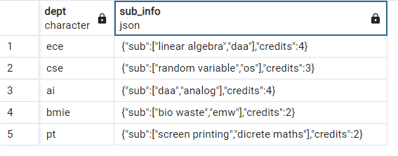

Query(Offset)

select dept from student order by dept offset 3;

