**HTML:**

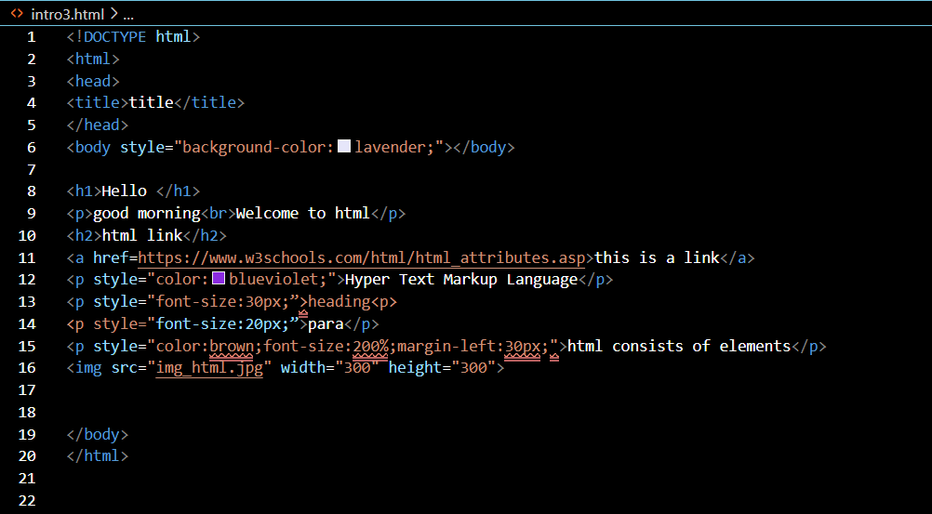

**OUTPUT:**

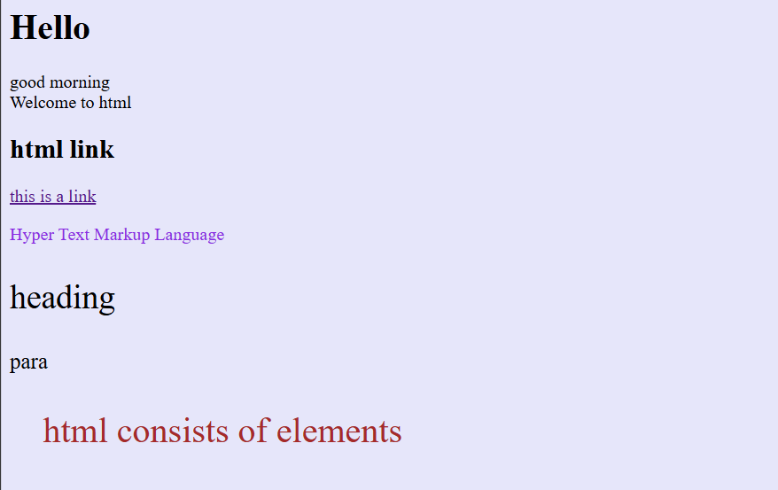

**Leet code:**

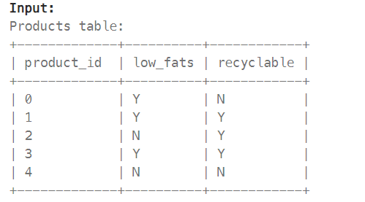



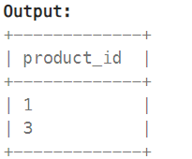

**Query:**

select product_id from Products where low_fats='y'and recyclable='y';

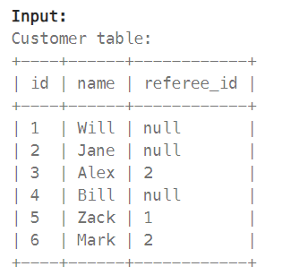

Find the names of the customer that are **not referred by** the customer with id = 2.

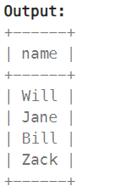

**Query:**

select name from Customer where referee_id!=2 or referee_id is null;

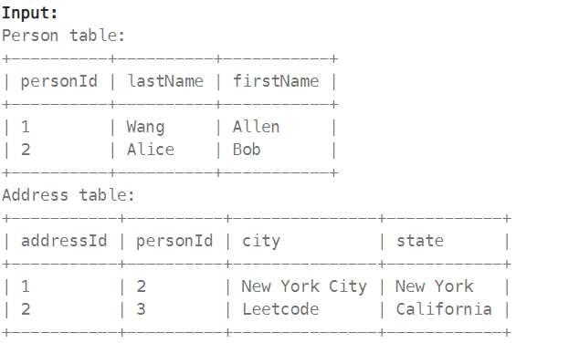

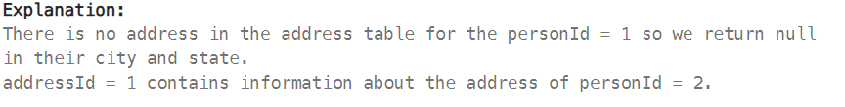

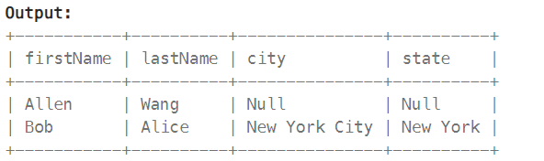

**Query:**

select p.firstName,p.lastName,a.city,a.state from Person as p left join Address as a on p.personId=a.personId;