Object Oriented Programming

23CSE111

LAB MANUAL



Department of Computer Science and Engineering
Amrita School of Engineering
Amrita Vishwa Vidyapeetham, Amaravati Campus

Verified by: Name: A. Hema Vardhan
Roll No : AV.SC.U4CSE24004

Week | Questions | Page No | Date | Sign
1 | i. Download and install Java software  ii. Write a java program to print the message welcome to java programming  iii. Write a java program to print the name, roll no and section of the student |  | 27/01/25
2 | i. To calculate the area of the rectangle  ii. Program to convert the temperature in celsius to Fahrenheit.  iii. Program to calculate the simple interest.  iv. Program to find the largest of three numbers using the ternary operators.  v. Program to find the factorial of the number. |  | 10/02/25
3 | i. Create the java program for the cars with constructor and methods.  ii. Create the java program to withdraw and deposit money in the bank account. |  | 24/02/25
4 | i)write a java program witgh class named “Book” the class should contain various attributes such as “title of the book”, “author”, “year of publication” it should also contain a constructor with parameters which initializes the “title of the book”, “author”, “year of publication” create a method which displays the details of the book that is title of the book, author, year of publication display details of the two books by creating two objects  ii)to create a java class named “MyClass” with a static variable “count of” “int” type, initialized to zero and a constant variable “pi” of type “double” initialized to 3.1415 as attributes of that class define a constructor for myclass that increments the count variable each time an object of my class is created. Finally print the final values of “count” and “pi” |  | 03/03/25
5 | i)create a calculator using the operations including addition, subtraction, multiplication, division using multilevel inheritance and display the desired output  ii)A vehicle rental company wants to develop a system that maintains information about different types of vehicles available for rent the company rents of cars and bike and they need program to store details about each vehicles such as brand and speed a)cars should have additional property's - no.of.doors, seating capacity b)bikes should have property indicating whether they have Gares or not. The system should also include a function to display details about each vehicle and indicate when a vehicle is starting each class should have a constructor  a)which object oriented program is used in the above program? Explain why it is useful in this scenario b)if the company decides to add a new type of vehicle truck. How would modify the above program. Truck should include an additional property capacity in turns Create a show truck details method to display the trucks capacity. Write a constructor for truck that initializes all property iii)Implement the truck class and update the main method to create the truck object and also create an object for car and bike subclassed finally it’s details |  | 10/03/25
6 | i)write a java program to create a vehicle class with a method displayInfo(). Override this method in the car subclass to provide specific information about the car  ii)A college is developing an automated admission system that verifies students eligibility for Undergraduate (UG) and Postgraduate (PG) programs. Each program has different eligibility criteria based on the students percentage in their pervious qualification a)UG admission require a min of 60% b)PG admission requrie a min of 70% iii)create a calculator class with overloaded methods to perform addition: a) add two integers b) add two doubles c) add three integers iv)create a shape class with a method calculate Area() that is overloaded for different shapes (ex: Square, Rectangle) then create a sub class circle that overrides the calculate Area () method for a circle |  | 29/03/25
7 | i)write a java program to create an abstract class Animal with an abstract method called Sound(). Create subclasses Lion and Tiger that extended the Animal class and implement the sound() method to make a specific sound for each animal ii)write a java program to create an abstract class Shape3D with abstract methods calculate Volume() and calculate Surface area(). Create subclasses sphere and cube that extend shape3D class and implement the respective methods to calculate the volume and surface area of the shape iii)write a java program using an abstract class to define a method for pattern printing a)create an abstract class named pattern printing with an abstract method print pattern(int n) and a concrete method to display the pattern title b)Implement two subclasses: a)star pattern b)number pattern c)in the main() method create objects of both subclasses and print the pattern for a given no.of rows |  | 14/04/25
8 | i)write a java program to create an interface shape with getperimeter() method. Create three classes rectangle, circle and triangle the shape interface implement the set perimeter method for each 3 classes  ii)write a java program to create an interface Playable with a method paly() that takes no arguments and return void create 3 classes football, volleyball, and basketball that implements the playable interface and override the play() method to play respective sports.  iii) Write a java program to implement the login system using interfaces |  | 21/04/25
9 | i) Write a java program to create a method that takes integers as parameter and throws n exception if the number is even2) Write a java program to create a method that reads a file and throws an exception if the file is not found  3) Write a java program to handle arithmetic exception using try, catch, finally. 4) Write a java program to stimulate a University System using inner classes. Create an outer class named University with a variable University Name Inside it, define two non-static inner classes 1)Department – With variables like dept Name and dept Code, and a method to display department details  ii) Student- with variables like Student name, student roll no and method to display student details  iii) Create an object for each class and call their methods to display their details along with the university name |  | 26/04/25
10 | i)write a java program to generate a password for a student using his/her initials and age. The password displayed should the string consists of first character, of first name, middle name, last name, with age  ii)design and implement a java program that will do the following operations to this string “Welcome! You are practicing strings concepts” a)covert all alphabets to capital letters and print out the result b)convert all alphabets to lower-case letters and print out the result c)print out the length of the string d)print out the index of concept  iii)Implement a java program using the below array methods a)sorting the elements of an array b)convert the elements into string c)fill the part of the array d)copy the elements of one array into another 4)Implement a java program using below ArrayList methods a) Insert an element at particular index in the array list a) modify an element in the array list.  b)Access an element from the array list.  c)Remove an element from the array list d)clear the elements from the array list. |  | 30/04/25

WEEK-1
PROGRAM-01
AIM: Downloading and installing Java software
PROCEDURE:
Step1:- Open Google chrome and search for java downloads
Step2:- Download java development kit(JDK) from oracle official website.
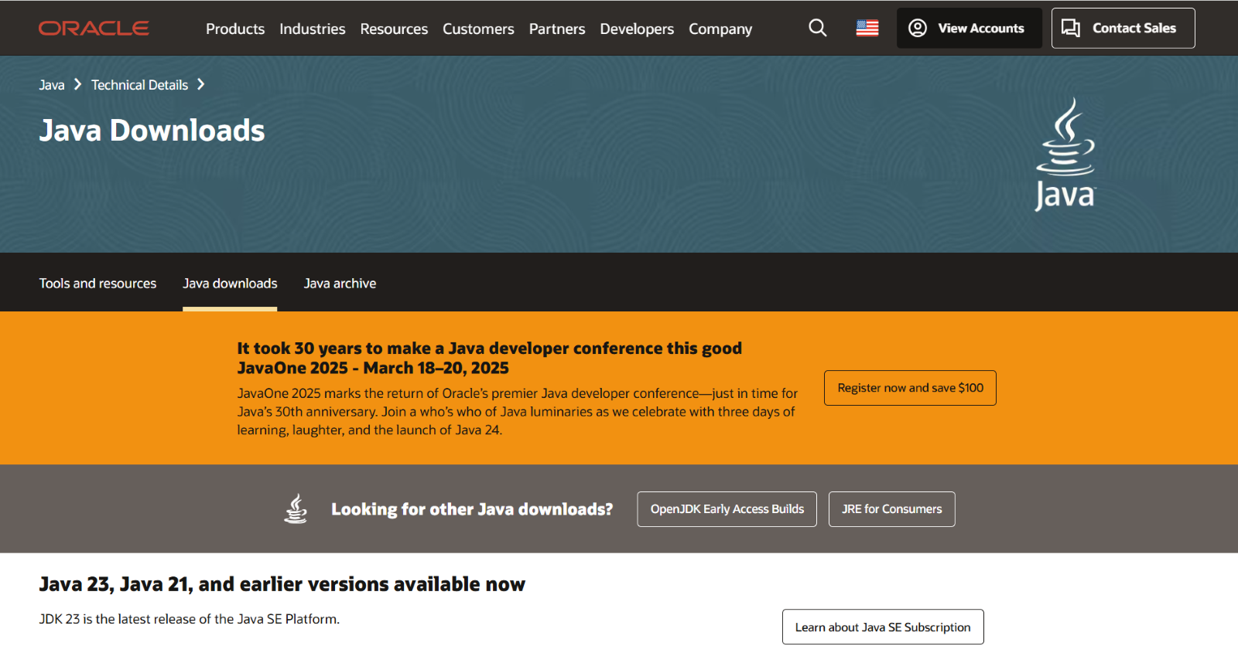
Step3:- Download JDK21.0.6 x64 Installer Windows version.
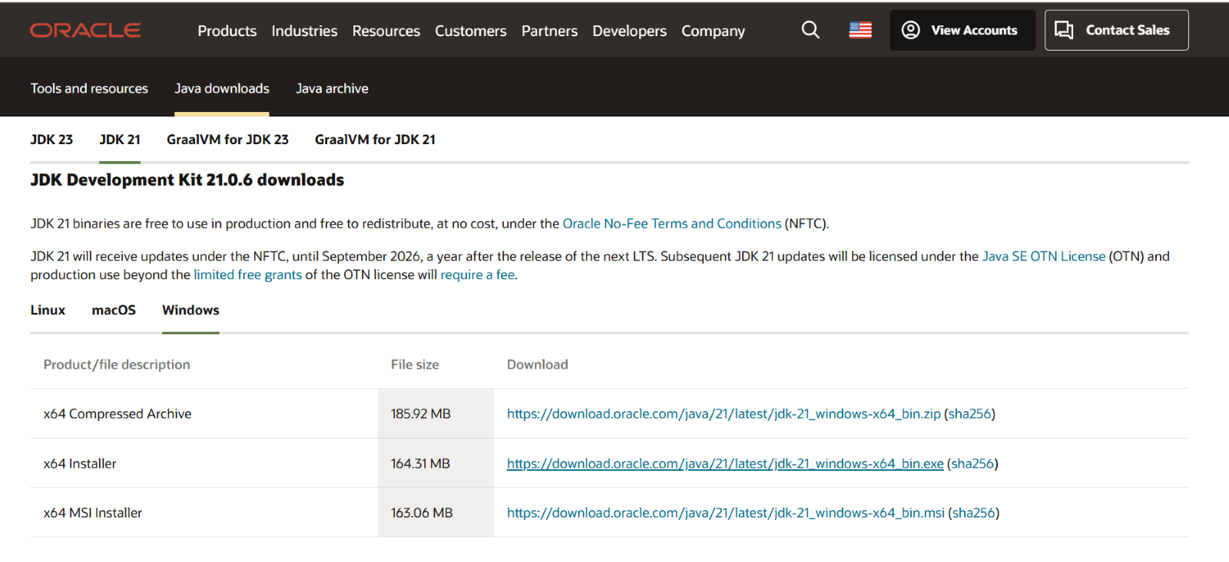
Step-4:-Click on the link provided to download. After downloading install the software into your device.
Step-5:- After installation we need to set environment set variable path of installation.
Step-6:- To set the variable path open files then windows c file then program files then java then jdk-21. Select bin and copy the path.
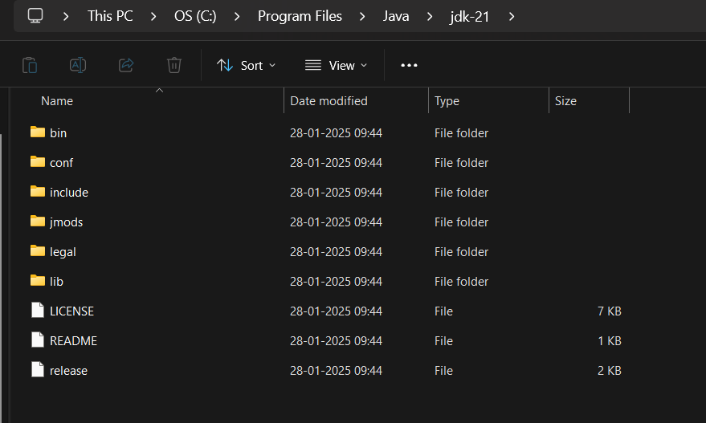
Step-7:- Here now open environmental variables then open system variable. Here we have to paste the copied path in path variable.
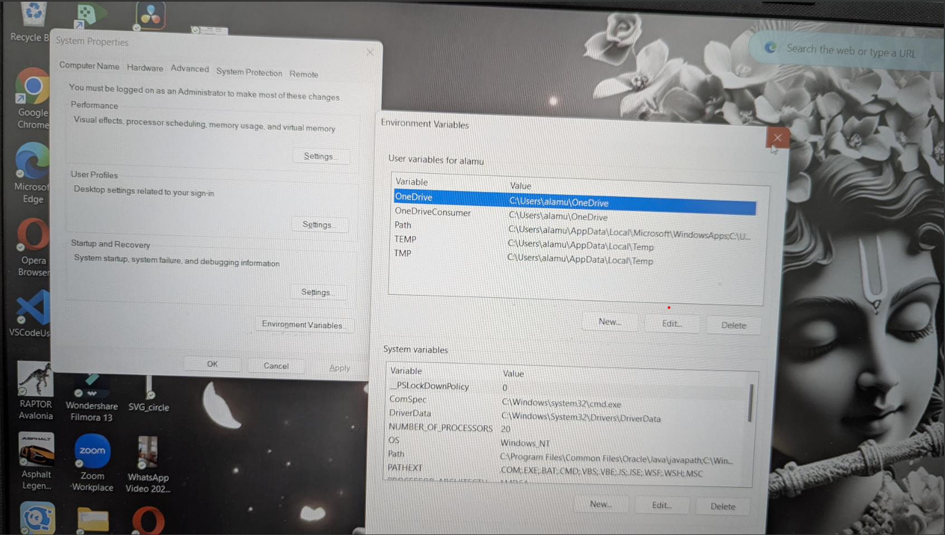

Step-8:- Now java software is installed in your device. Now to check the installed version. Open command prompt
Step-9:-in command prompt type java –version then click on enter
Step-10:-The version is displayed

PROGRAM-02
AIM: Write a java program to print the message "Welcome to java programming”
INPUT:
class Main{
public static void main(String[] args){
System.out.println("welcome to java programming");
}
}
OUTPUT:
PROGRAM-03
AIM: Write a java program that prints name, roll number, section of a student
INPUT:
Class program2{
public static void main(String args[]) {
System.out.println("Name: A.Hema vardhan");
System.out.println("Class: CSE 'A'");
System.out.println("Roll No: 24004")
}
}

OUTPUT:
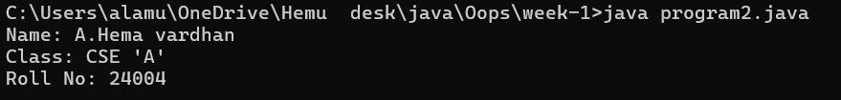
ERRORS:
S.NO | ERROR MESSAGE | ERROR RECTIFICATION
1. | ‘}’ expected | Placing ‘}’ symbol

WEEK-2
PROGRAM-01
AIM:- Write a java program that Find the area of triangle
INPUT:
import java.util.Scanner;
class rec{
public static void main(String[] agrs){
Scanner input = new Scanner(System.in);
System.out.print("Enter the length : ");
int length = input.nextInt();
System.out.print("Enter the breath : ");
int breath = input.nextInt();
int A = length*breath;
System.out.print(A);
}
}
OUTPUT:
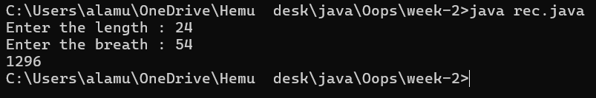
ERRORS:
S.NO | ERROR MESSAGE | ERROR RECTIFICATION
1. | ‘;’ expected | Placing ‘;’ symbol

PROGRAM-02
AIM: Write a java program to find the simple interest
INPUT:
import java.util.Scanner;
class intrest{
public static void main(String[] args){
Scanner input = new Scanner(System.in);
System.out.print("Enter the princpial value ");
float P = input.nextFloat();
System.out.print("Enter the rate of interest value (%) ");
float R = input.nextFloat();
System.out.print("Enter the time value (in Years) ");
int T = input.nextInt();
float S= (P*T*R)/100;
System.out.print("This is the simple intrest value : " + S);
}
}
OUTPUT:
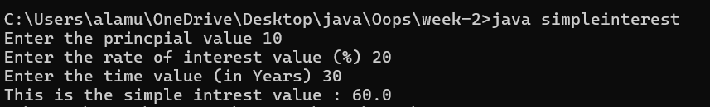
ERRORS:
S.NO | ERROR MESSAGE | ERROR RECTIFICATION
1. | ‘}’ expected | Placing ‘}’ symbol

PROGRAM-03
AIM:- Write a java program to print fibanaci series
INPUT:
import java.util.Scanner;
class fibb{
public static void main(String[] args){
Scanner input = new Scanner(System.in);
System.out.print("Enter the number");
int len = input.nextInt();
int f1 =0;
int f2 =1;
System.out.println("Fibonacci sequence : "+f1);
System.out.println("Fibonacci sequence : "+f2);
for ( int i=1;i<=len;i++){
int f3 = f1+f2;
f1 = f2;
f2 = f3;
System.out.println("Fibonacci sequence : "+ f3);}}}
OUTPUT:
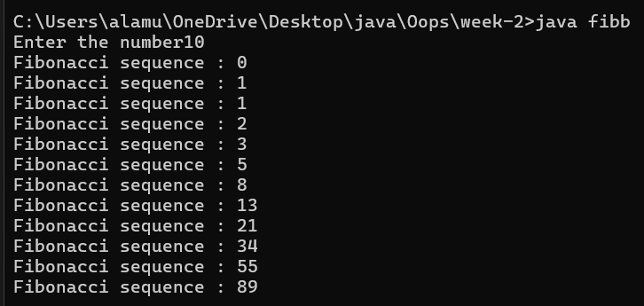
ERRORS:
S.NO | ERROR MESSAGE | ERROR RECTIFICATION
1. | ‘)’ expected | Placing ‘)’ symbol

PROGRAM-04
AIM: Write a java program to find the largest of three numbers.
INPUT:
import java.util.Scanner;
class terminal{
public static void main(String[] args ){
Scanner input = new Scanner(System.in);
System.out.print("Enter the first n value");
int N1 = input.nextInt();
System.out.print("Enter the second n value");
int N2 = input.nextInt();
System.out.print("Enter the third n value");
int N3 = input.nextInt();
int largest = (N1 >= N2) ? ((N1 >= N3) ? N1 : N3) : ((N2 >= N3) ? N2 : N3);
System.out.println("Largest Number: " + largest);}}
OUTPUT:-
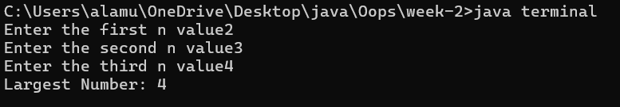
ERRORS:
S.NO | ERROR MESSAGE | ERROR RECTIFICATION
1. | ‘]’ expected | Placing ‘]’ symbol

Program-05
AIM: ) Write a java program to Convert Fahrenheit to Celsius
INPUT:
import java.util.Scanner;
class tem {
public static void main(String[] args ){
Scanner input = new Scanner(System.in);
System.out.print("Enter the Celsius value ");
float C = input.nextFloat();
float F = (9/5)*C+32;
System.out.print("The Fahrenheit value is "+ F);
}
}
OUTPUT:
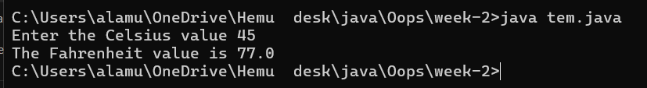
ERRORS:
S.NO | ERROR MESSAGE | ERROR RECTIFICATION
1. | ‘}’ expected | Placing ‘}’ symbol
Program-06
AIM: Write a java program to convert
INPUT:
import java.util.Scanner;
class tem2 {
public static void main(String[] args) {
Scanner input = new Scanner(System.in);
System.out.print("Enter the Fahrenheit value: ");
float F = input.nextFloat();
float C = (F - 32) * (5.0f / 9.0f);
System.out.print("The Celsius value is " + C);
}
}
OUTPUT:
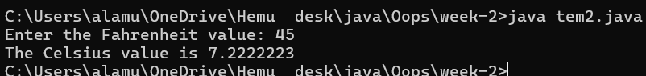
ERRORS:
S.NO | ERROR MESSAGE | ERROR RECTIFICATION
1. | ‘””’ expected | Placing ‘””’ symbol

WEEK-3
PROGRAM-01
AIM: Create the java program to withdraw and deposit money in the bank account.
CLASS DIAGRAM:
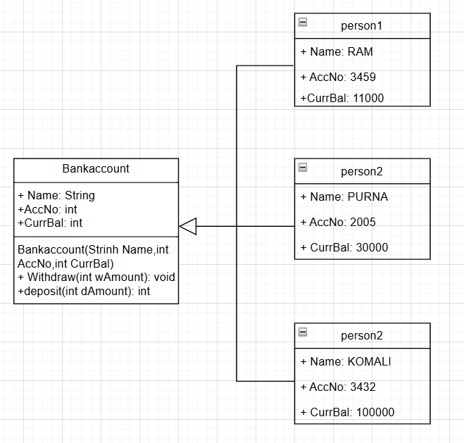
INPUT:
class BankAccount {
String Name;
int AccNO, currbal;
BankAccount(String Name, int AccNO, int currbal) {
this.Name = Name;
this.AccNO = AccNO;
this.currbal = currbal;
System.out.println("The customer details are: " + this.Name + " " + this.AccNO + " " + this.currbal);
}
public void withdraw(int withdrawalAmount) {
if (withdrawalAmount <= currbal) {
currbal = currbal - withdrawalAmount;
System.out.println("Remaining balance: " + currbal);
} else {
System.out.println("Insufficient funds");
}
}
public int deposit(int depositAmount) {
currbal = currbal + depositAmount;
return currbal;
}
public static void main(String[] args) {
BankAccount ram = new BankAccount("ram", 1234, 1000);
ram.withdraw(500); // Example of valid withdrawal
ram.withdraw(500); // Another example of valid withdrawal
int finalAmount = ram.deposit(5001);
System.out.println("Final balance: " + finalAmount);
}
}

OUTPUT:
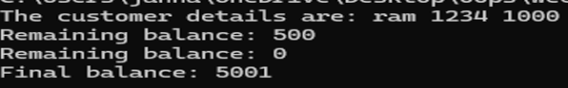
ERRORS:
Error Type | Incorrect Code | Corrected code
Class Name Capitalization | class Bankaccount | class BankAccount (Java follows PascalCase for class names)
Object Naming Issue | BankAccount person-1 (hyphen is not allowed) | BankAccount person1
Missing Semicolon | System.out.println ("Balance is "+ person-1.deposit (50,000)) | System.out.println ("Balance is "+ person1.deposit (50000)); (semicolon added)

PROGRAM-2
AIM: Create the java program for the cars with constructor and methods.
CLASS DIAGRAM:
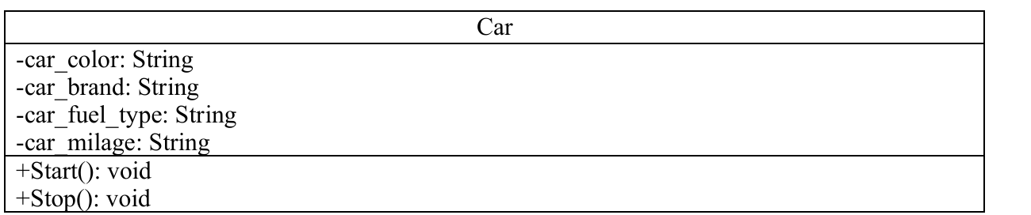
INPUT:
// Corrected Java Code
public class Car {
public String carColour;
public String carBrand;
public String fuelType;
public String mileage;
// Corrected Constructor
public Car(String carColour, String carBrand, String fuelType, String mileage) {
this.carColour = carColour;
this.carBrand = carBrand;
this.fuelType = fuelType;
this.mileage = mileage;
}
public void start() {
System.out.println("Car is started");
}
public void stop() {
System.out.println("Car is stopped");
}
public void service() {
System.out.println("Car is for service");
}
}
class Main {
public static void main(String[] args) {
System.out.println("----------------WELCOME----------------");

// First Car Object
Car car1 = new Car("Black", "Tata", "Petrol", "90");
System.out.println("Our first car is " + car1.carBrand);
System.out.println("Colour is " + car1.carColour);
System.out.println("Its fuel type is " + car1.fuelType);
System.out.println("Its mileage is " + car1.mileage);
car1.start();
car1.stop();
car1.service();
System.out.println(" ");

// Second Car Object
Car car2 = new Car("White", "Toyota", "Petrol", "95");
System.out.println("Our second car is " + car2.carBrand);
System.out.println("Colour is " + car2.carColour);
System.out.println("Its fuel type is " + car2.fuelType);
System.out.println("Its mileage is " + car2.mileage);
car2.start();
car2.stop();
car2.service();
System.out.println(" ");

// Third Car Object
Car car3 = new Car("Blue", "Jaguar", "Diesel", "60");
System.out.println("Our third car is " + car3.carBrand);
System.out.println("Colour is " + car3.carColour);
System.out.println("Its fuel type is " + car3.fuelType);
System.out.println("Its mileage is " + car3.mileage);
car3.start();
car3.stop();
car3.service();
}
}
OUTPUT:

ERRORS:
Error Type | Incorrect Code | Corrected Code
Class Naming Issue | class main{ | class Main{
Incorrect Object Description | "Our first car is "+car3.car_brand; | "Our Third car is "+car3.car_brand;

WEEK-4
PROGRAM-1
Aim: (i) Create the java program for the books by using the constructor and display its details using methods.
CLASS DIAGRAM:

INPUT:
public class Book {
private String title;
private String author;
private int yearOfPublication;

public Book(String title, String author, int yearOfPublication) {
this.title = title;
this.author = author;
this.yearOfPublication = yearOfPublication;
}

public void displayDetails() {
System.out.println("Title: " + title);
System.out.println("Author: " + author);
System.out.println("Year of Publication: " + yearOfPublication);
}

public static void main(String[] args) {

Book book1 = new Book("To Kill a Mockingbird", "Harper Lee", 1960);
Book book2 = new Book("1984", "George Orwell", 1949);

System.out.println("Book 1 Details:");
book1.displayDetails();

System.out.println("\nBook 2 Details:");
book2.displayDetails();
}
}
OUTPUT:
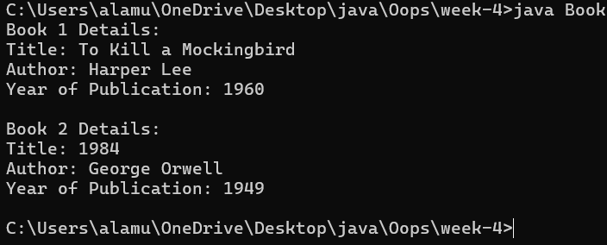
ERRORS:
S.NO | ERROR MESSAGE | ERROR RECTIFICATION
1. | ‘}’ expected | Placing ‘}’ symbol
2. | ‘System’ expected | Placing ‘S’ystem
3. | ‘Book’ expected | Placing ‘B’ook
PROGRAM-2
AIM: Creat a java program with class names”MyClass” with constant variable “pi=3.1415”. Define a constructor for “MyClass”. Finally, print the final values of “count” and “pi” variables.
CLASS DIAGRAM:

INPUT:
public class MyClass {
public static int count = 0;
public static final double pi = 3.1415;

public MyClass() {
count++;
}

public static void main(String[] args) {

MyClass obj1 = new MyClass();
MyClass obj2 = new MyClass();
MyClass obj3 = new MyClass();

System.out.println("Final Count: " + count);
System.out.println("Value of Pi: " + pi);
}
}
OUTPUT:
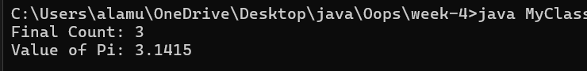

ERRORS:
S.NO | ERROR MESSAGE | ERROR RECTIFICATION
1. | ‘claass’ expected | Placing ‘class’
2. | ‘obj’ expected | Placing ‘obj1’

WEEK-5
AIM: (i) Create the java program for calculator using multi-level inheritance.
CLASS DIAGRAM:

INPUT:
public class Calculator {
public int add(int a, int b) {
int addition = a + b;
return addition;
}
}

class AdvancedCalculator extends Calculator {
public int sub(int a, int b) {
int subtraction = a - b;
return subtraction;
}
}
class ScientificCalculator extends AdvancedCalculator {
public int multi(int a, int b) {
int multiplication = a * b;
return multiplication;
}
}
class SuperCalculator extends ScientificCalculator {
public int div(int a, int b) {
if (b == 0) {
System.out.println("Division by zero is undefined.");
return 0;
} else {
return a / b;
}
}
}
class Main {
public static void main(String[] args) {
SuperCalculator obj = new SuperCalculator();
System.out.println("Addition is: " + obj.add(4, 3));
System.out.println("Subtraction is: " + obj.sub(4, 3));
System.out.println("Multiplication is: " + obj.multi(4, 3));
System.out.println("Division is: " + obj.div(4, 3));
System.out.println("Division by zero test: " + obj.div(4, 0)); // optional test
}
}
OUTPUT:

ERRORS:
S.NO | ERROR MESSAGE | ERROR RECTIFICATION
1. | ‘extends’ expected | Placing ‘extends’ symbol
2. | ‘System’ expected | Placing ‘S’ystem
3. | ‘()’expected | Placing ‘()’

AIM:
(ii) A vehicle rental company wants a system to manage details of vehicles available for rent, including cars, bikes, and trucks. Each vehicle should store basic information such as brand and speed. Cars must include an additional property for the number of doors, while bikes should indicate whether they have gears. The system should also provide a function to display the details of each vehicle and indicate when a vehicle is starting.
CLASS DIAGRAM:
INPUT:
class transport {
protected String model;
protected int maxSpeed;

public transport(String model, int maxSpeed) {
this.model = model;
this.maxSpeed = maxSpeed;
}

public void ignite() {
System.out.println(model + " is now starting...");
}

public void displayInfo() {
System.out.println("Model: " + model);
System.out.println("Top Speed: " + maxSpeed + " km/h");
}
}

class sedan extends transport {
private int doors;

public sedan(String model, int maxSpeed, int doors) {
super(model, maxSpeed);
this.doors = doors;
}

public void displayInfo() {
super.displayInfo();
System.out.println("Doors: " + doors);
}
}

class motorcycle extends transport {
private boolean geared;

public motorcycle(String model, int maxSpeed, boolean geared) {
super(model, maxSpeed);
this.geared = geared;
}
public void displayInfo() {
super.displayInfo();
System.out.println("Geared: " + (geared ? "Yes" : "No"));
}
}
class lorry extends transport {
private int loadCapacity;
public lorry(String model, int maxSpeed, int loadCapacity) {
super(model, maxSpeed);
this.loadCapacity = loadCapacity;
}
public void printTruckInfo() {
super.displayInfo();
System.out.println("Load Capacity: " + loadCapacity + " tons");
}
}

public class rentalsystem {
public static void main(String[] args) {
sedan myCar = new sedan("Audi A4", 220, 4);
motorcycle myBike = new motorcycle("Yamaha MT-15", 140, true);
lorry myTruck = new lorry("Tata Hauler", 100, 12);
System.out.println("\n--- Car Info ---");
myCar.ignite();
myCar.displayInfo();
System.out.println("\n--- Bike Info ---");
myBike.ignite();
myBike.displayInfo();
System.out.println("\n--- Truck Info ---");
myTruck.ignite();
myTruck.printTruckInfo();
}
}
OUTPUT:

ERRORS:
S.NO | ERROR MESSAGE | ERROR RECTIFICATION
1. | ‘[]’expected | Placing ‘[]’ symbol
2. | ‘Systeem’ expected | Placing ‘System’

WEEK-6:
AIM: (i) Write a java program to create a vehicle class with a method display info . Overisde this method in car subclass to provide specific information.
CLASS DIAGRAM:
Vehicle
- Brand: String
- Speed: int
+ vehicle(brand: string
Speed: int)
+start vehicle(): void
+displaydetails():void

INPUT:
class Vehicle {
String car_company;
String car_model;
long car_price;
int seating_capacity;
boolean petrol;

Vehicle(String car_company, String car_model, long car_price, int seating_capacity, boolean petrol) {
this.car_company = car_company;
this.car_model = car_model;
this.car_price = car_price;
this.seating_capacity = seating_capacity;
this.petrol = petrol;
}

void displayInfo() {
System.out.println("Car company: " + car_company);
System.out.println("Car model: " + car_model);
System.out.println("Car price: " + car_price);
System.out.println("Car seating capacity: " + seating_capacity);
System.out.println("Car uses petrol: " + petrol);
} }
class Car extends Vehicle {
Car(String car_company, String car_model, long car_price, int seating_capacity, boolean petrol) {
super(car_company, car_model, car_price, seating_capacity, petrol);
}
}

public class Main {
public static void main(String[] args) {
// Creating a Car object with correct arguments
Car c1 = new Car("Hyundai", "Creta", 1500000, 5, false);
c1.displayInfo();
}
}
OUTPUT:
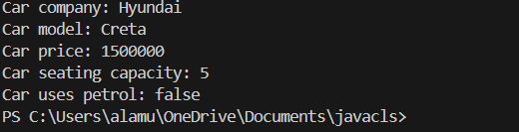
ERRORS:
S.NO | ERROR MESSAGE | ERROR RECTIFICATION
1. | ‘int’expected | Placing ‘int’
2. | ‘this’ expected | Placing ‘this’
IMPORTANT POINTS:
1.Inheritance: The Car class extends the Vehicle class, demonstrating inheritance in Java.
2.Constructor Chaining:The Car class calls the parent constructor using super(car_model, color, fuel_type); to initialize inherited attributes.
3.Method Overriding:The Car class overrides the displayInfo() method from Vehicle and calls super.displayInfo() to reuse the parent method before adding its own output.
4.Incorrect main Class Name:The main method is inside Truck, which is unrelated to Vehicle and Car. The class should be renamed for clarity.
AIM:
(ii) A college is developing an automated admission system that verifies students eligibility for undergraduate (UG) and postgraduate (PG) programs. Each program has different eligibility for UG and PG program qualifications.UG admission requires a minimum of 60% and PG requires a minimum of 70%.
CLASS DIAGRAM:
AutomatedAdmission
- Scanner: scanner
- Name: String
- Percentage : double
- Program: stirng
+ main(args:String[]): void
+takeInput(): void
+checkEligibility(): void
+closeScanner(); void

INPUT:
class Student {
String name;
double percentage;

Student(String name, double percentage) {
this.name = name;
this.percentage = percentage;
}

void studentsInfo() {
System.out.println("Student Name: " + name);
System.out.println("Percentage: " + percentage);
} }
class UG extends Student {
UG(String name, double percentage) {
super(name, percentage);
}
void checkEligibility() {
if (percentage >= 60) {
System.out.println(name + " is eligible for admission in UG.");
} else {
System.out.println(name + " is not eligible for admission in UG.");
} } }
class PG extends Student {
PG(String name, double percentage) {
super(name, percentage);
}
void checkEligibility() {
if (percentage >= 70) {
System.out.println(name + " is eligible for admission in PG.");
} else {
System.out.println(name + " is not eligible for admission in PG.");
} } }

public class AutomatedAdmission {
public static void main(String[] args) {
UG ug = new UG("HEMU", 80);
ug.studentsInfo();
ug.checkEligibility();

PG pg = new PG("SAI", 75);
pg.studentsInfo();
pg.checkEligibility();
}
}

OUTPUT:
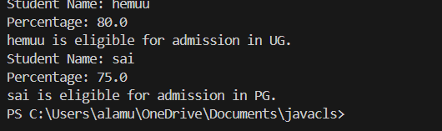
ERRORS:
Code error | Code rectification
1.Scanner nextLine() issue after nextDouble(): After scanner.nextDouble(), the newline character remains in the buffer, causing nextLine() to be skipped.  2.Program type input case sensitivity issue: If the user enters ug or pg in lowercase, it may cause incorrect comparisons. | 1.Add scanner.nextLine(); after nextDouble(); to consume the leftover newline.  2.Use program.toUpperCase() to ensure case-insensitive comparison.
IMPORTANT POINTS:

1.User Input Handling: Uses Scanner to take user input for name, percentage, and program type.
2.Decision Making with Conditions: Uses if-else statements to check eligibility criteria.
3.String Handling: Converts program input to uppercase (toUpperCase()) to handle case variations.
4.Closing Scanner: Properly closes scanner using scanner.close(); to prevent resource leaks.

PROGRAM-3:
AIM: Create a calculator class with overloaded methods to perform addition of:
1. Add two integers
2. Add two doubles
3. Add three integers

CLASS DIAGRAM:

Calculator
+ add(int, int): int
+add(double, double): double
+add(int,int,int): int

CODE:
class Calculator6 {
public int add(int a, int b) {
return a + b;
}

public double add(double a, double b) {
return a + b;
}

public int add(int a, int b, int c) {
return a + b + c;
} }
class Main6 {
public static void main(String[] args) {
Calculator6 calculator = new Calculator6();
System.out.println("Addition of two integers: " + calculator.add(5, 15));
System.out.println("Addition of two doubles: " + calculator.add(5.5, 2.2));
System.out.println("Addition of three integers: " + calculator.add(1, 2, 5));
} }
OUTPUT:

ERRORS:
Code error | Code rectification
1.Method parameters missing spaces. E.g.,”inta, intb”should be “int a, int b”  2.Inconsistent indentation in method bodies | 1. Add proper spacing between parameters: (int a, int b)  2. Fix indentation:  Consistent 4 space o indentation.

IMPORTANT POINTS:
1.Method Overloading: The add method is overloaded with different parameter types and counts, demonstrating compile-time polymorphism.
2.Automatic Method Selection: Java selects the appropriate add method based on the argument types during compilation.

PROGRAM-4:
AIM: Create a shape class with a method to calculate area i.e., overloaded for different shapes eg: Squares, Recatangle. Then create a subclass circle that overrides the calculateArea() method for a circle.
CLASS DIAGRAM:

SHAPE
+ CalculateArea(side:double): double
+CalculateArea(width: double, length: double): double

CIRCLE
+ CalculateArea(radius: double): double

Tools
+main(args:String[]): Void

CODE:
class Shape {
public double calculateArea(double side) {
return side * side;
}

public double calculateArea(double length, double width) {
return length * width;
}
}

class Circle extends Shape {
private double radius;

public Circle(double radius) {
this.radius = radius;
}

public double calculateArea() {
return Math.PI * radius * radius;
}
}

class Tools {
public static void main(String[] args) {
Shape shape = new Shape();
Circle circle = new Circle(5);

System.out.println("Area of square: " + shape.calculateArea(4));
System.out.println("Area of rectangle: " + shape.calculateArea(4, 6));
System.out.println("Area of circle: " + circle.calculateArea());
}
}
OUTPUT:
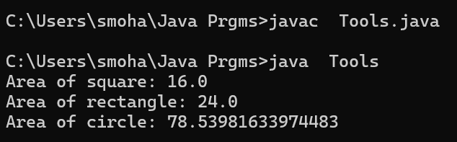

ERRORS:

Code error | Code rectification
1. Method calls in main are missing an object reference (e.g., calculateArea(4) instead of s.calculateArea(4)).  2. Circle class method does not override theparent class method properly. | 1. Use s.calculateArea(4) and c.calculateArea(2) to call the method correctly.  2. Ensure @Override is used, and the method signature should match correctly.

IMPORTANT POINTS:
1.Inheritance: Circle class extends Shape, inheriting its methods.
2.Method Overloading: Shape has multiple calculateArea methods with different parameters.
3.Method Overriding: Circle overrides calculateArea from Shape to implement its own formula.
4.Polymorphism: The overridden method in Circle demonstrates runtime polymorphism.
5.Proper Object Reference: Methods should be called using an object (s.calculateArea(4), c.calculateArea(2)).

Week-7
1Q) Write a Java program to create an abstract class Animal with an abstract method called sound().Create subclass Lion and Tiger that extend the Animal class and implement the sound() method to make specific sound of each animal.
Class diagram:
<<abstract>> animal
+sound():void
Lion
+sound():void
Tiger
+sound():void

Code:
abstract class animals{
abstract void sound();
}
class lion extends animals{
public void sound(){
System.out.println("Lion roars");
}
}
class tiger extends animals{
public void sound(){
System.out.println("Tiger growls");
}
}
class main{
public static void main(String[]args){
System.out.println("Name :A.Hema vardhan");
System.out.println("Roll No : AV.SC.U4CSE24004, Sectio- A");
tiger t = new tiger();
t.sound();
lion l = new lion();
l.sound();
}
}
Output: 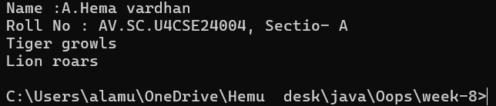

Important points:
1)JVM(java virtual machine) is one which runs our program.
- JVM starts your program by calling the main( ) method from outside your class.
- JVM runs outside our package.
- only public method are accessible from outside a class or package.
- if your main( ) not marked as public ,jam cannot see it and you get an error like above
2Q) Write a Java program to create an abstract class Shape3D with abstract methods calculateVolume() and calculateSurfaceArea(). Create subclasses Sphere and Cube that extend the Shape3D class and implement the respective methods to calculate the volume and surface area of each shape.
Class diagram:
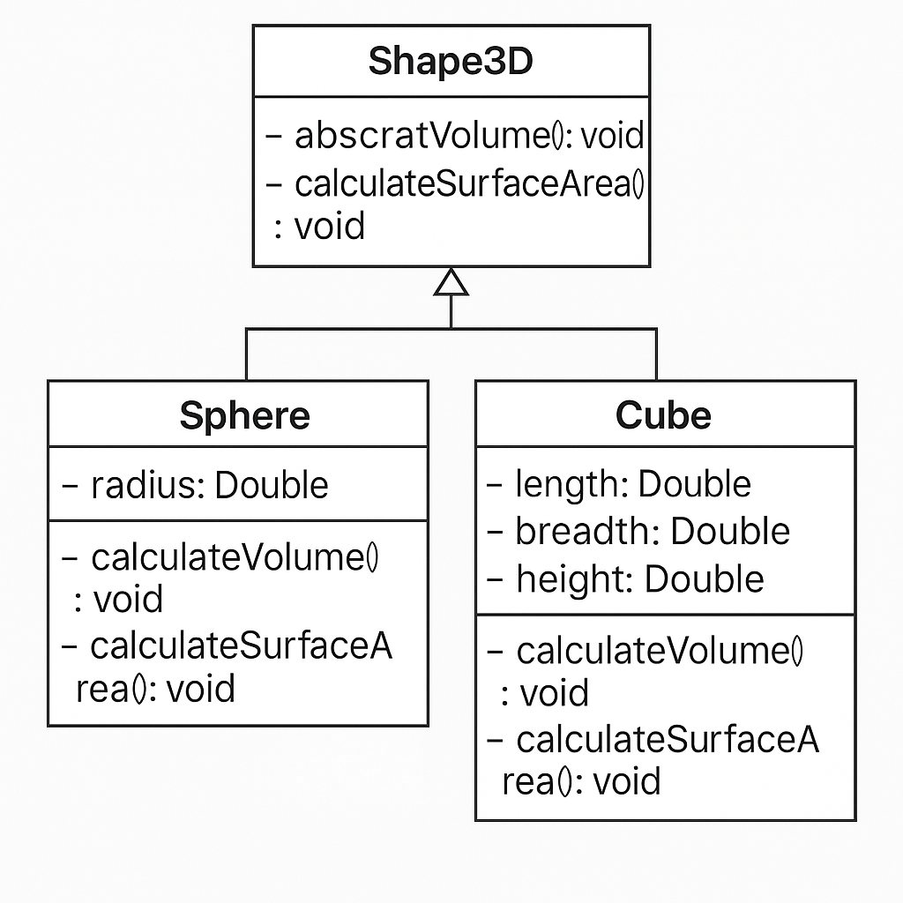
Code:
import java.lang.*;
abstract class shape3D {
abstract double calculateVolume();
abstract double calculateSurfaceArea();
}
class Sphere extends shape3D {
private double radius;
Sphere(double radius) {
this.radius = radius;
}
@Override
double calculateVolume() {
return (4.0 / 3.0) * Math.PI * radius * radius * radius;
}
@Override
double calculateSurfaceArea() {
return 4 * Math.PI * radius * radius;
}
}
class Cube extends shape3D {
private double side;
Cube(double side) {
this.side = side;
}
@Override
double calculateVolume() {
return side * side * side;
}
@Override
double calculateSurfaceArea() {
return 6 * side * side;
}
}
class main {
public static void main(String[] args) {
Sphere s = new Sphere(2.3);
System.out.println("Volume of Sphere: " + s.calculateVolume());
System.out.println("Surface Area of Sphere: " + s.calculateSurfaceArea());

Cube c = new Cube(2.3);
System.out.println("Volume of Cube: " + c.calculateVolume());
System.out.println("Surface Area of Cube: " + c.calculateSurfaceArea());
}
}
Output:
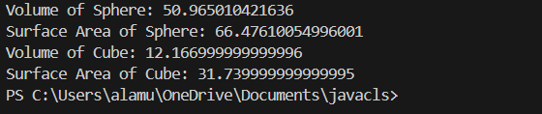
3Q)write a java program using an abstract class to define a method for pattern printing
• Create an abstract class named patternprinter with an abstract method printpattern(int n) and a concrete method to display the pattern title
• Implement two subclasses
1. Star pattern prints a right angle triangle of Star( *)
2. Numberpattern-prints a right angled triangle of increasing numbers
• In the main( ) method ,create objects of both subclasses and print the patterns for a given number of rows Expected output:
Pattern 1:
*
* *
* * *
* * * *
* * * * *
Pattern 2:
1
1 2
1 2 3
1 2 3 4
1 2 3 4 5
Code:
abstract class patternprinter {
abstract void patternprinting(int n);
}
class StarPattern extends patternprinter {
void patternprinting(int n) {
System.out.println("Star pattern");
for(int i=1;i<=n;i++) {
for(int j=1;j<=i;j++) {
System.out.print("*");
}
System.out.println();
}
}
}
class Numberpattern extends patternprinter {
void patternprinting(int n) {
System.out.println("Number pattern");
for(int i=1; i<=n; i++) {
for(int j=1; j<=i; j++) {
System.out.print(j);
}
System.out.println();
}
}
}
public class patternmain {
public static void main (String[] args) {
StarPattern s = new StarPattern();
Numberpattern n = new Numberpattern();
s.patternprinting(5);
n.patternprinting(5);
}
}
Output:
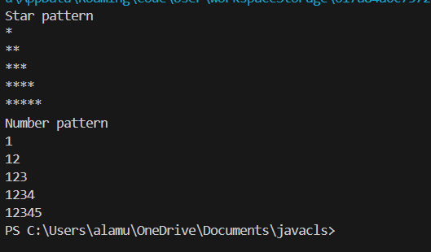
WEEK-8
1Q)Write a Java program to create an interface Shape with the getPerimeter() method. Create three classes Rectangle, Circle, and Triangle that implement the Shape interface. Implement the getPerimeter() method for each of the three classes.
Class diagram:
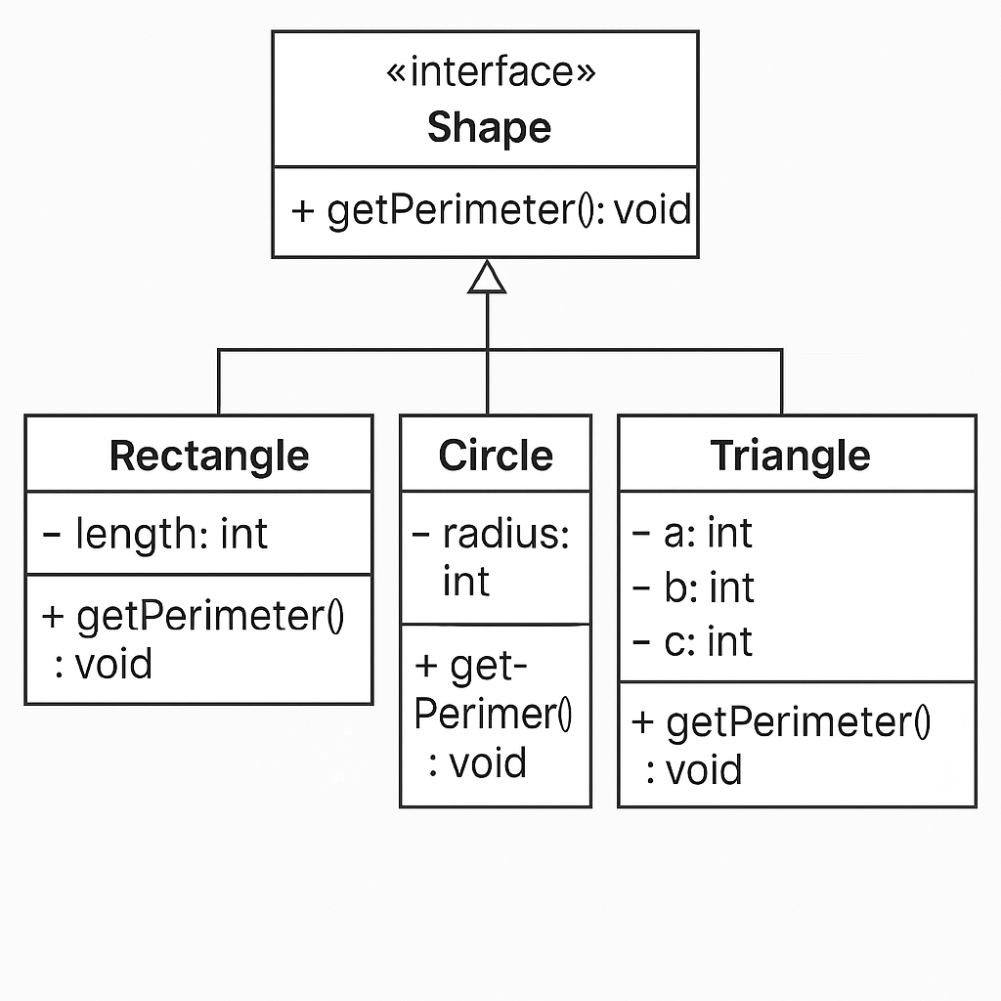
Code:
interface Shape {
double getPerimeter();
}
class Rectangle implements Shape {
private double length;
private double width;
public Rectangle(double length, double width) {
this.length = length;
this.width = width;
}
public double getPerimeter() {
return 2 * (length + width);
}
}
class Circle implements Shape {
private double radius;
public Circle(double radius) {
this.radius = radius;
}
public double getPerimeter() {
return 2 * Math.PI * radius;
}
}
class Triangle implements Shape {
private double a, b, c;
public Triangle(double a, double b, double c) {
this.a = a;
this.b = b;
this.c = c;
}
public double getPerimeter() {
return a + b + c;
}
}
public class perimeter {
public static void main(String[] args) {
Shape rectangle = new Rectangle(5, 10);
Shape circle = new Circle(8);
Shape triangle = new Triangle(4, 5, 6);
System.out.println("Rectangle Perimeter: "+ rectangle.getPerimeter());
System.out.println("Circle Perimeter: "+circle.getPerimeter());
System.out.println("Triangle Perimeter: "+ triangle.getPerimeter());
}
}
Output:
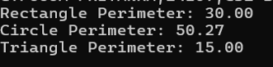
2Q) Write a Java program to create an interface Playable with a method play() that takes no arguments and returns void. Create three classes Football, Volleyball, and Basketball that implement the Playable interface and override the play() method to play the respective sports.
Class diagram:
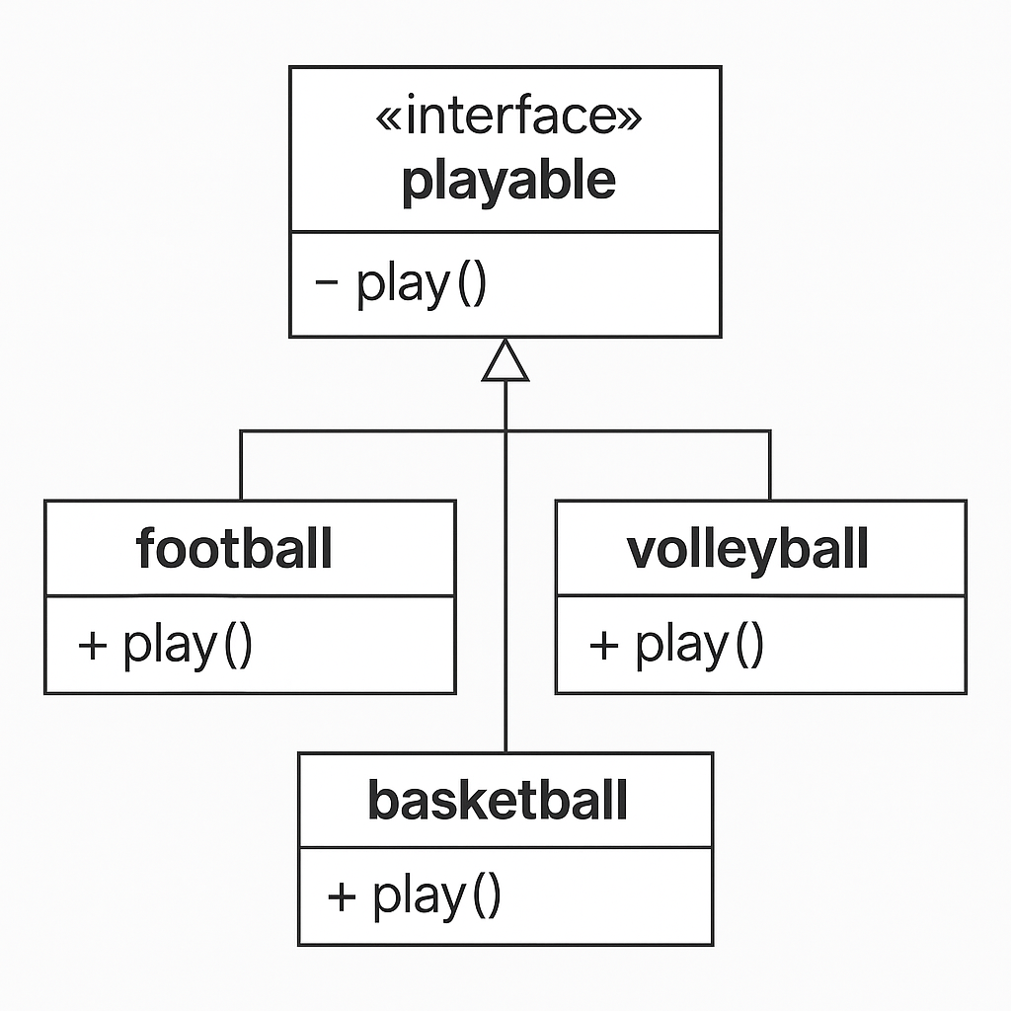
Code:
interface Playable {
void play();
}
class Football implements Playable {
@Override
public void play() {
System.out.println("Playing Football!");
}
}
class Volleyball implements Playable {
@Override
public void play() {
System.out.println("Playing Volleyball!");
}
}
class Basketball implements Playable {
@Override
public void play() {
System.out.println("Playing Basketball!");
}
}
class Main5{
public static void main(String[] args) {
System.out.println("A.Hema vardhan,24004,CSE-A");
Playable football = new Football();
Playable volleyball = new Volleyball();
Playable basketball = new Basketball();
football.play();
volleyball.play();
basketball.play();
}
}
Output:
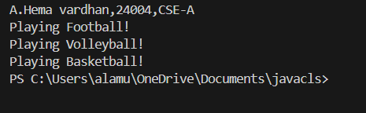
Errors:
Errors | Rectification
Football is not abstract and does not override abstract method play() | Implement the play() method from interface
Playables.java but public class PlayTest | Class PlayTest is public , should be declared in a file named PlayTest.java

Important points:
1.The Playable interface defines the contract (play() method).
2.Each class (Football, Volleyball, Basketball) implements the interface and provides a specific behavior for play().
3.This demonstrates polymorphism using interfaces in Java.

3Q) write a java program to implement a login system using interface.
Class Diagram:
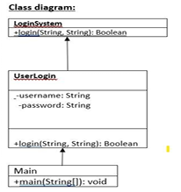
Code:
interface Loginsystem {
boolean user(String username, String password);
}
class UserLogin implements Loginsystem {
private String validUsername;
private String validPassword;

public UserLogin(String validUsername, String validPassword) {
this.validUsername = validUsername;
this.validPassword = validPassword;
}

@Override
public boolean user(String username, String password) {
// Check if the entered username and password match the stored values
return username.equals(validUsername) && password.equals(validPassword);
}
}
public class login {
public static void main(String[] args) {
UserLogin login = new UserLogin("hemu", "pp@123");
String username = "hemu";
String password = "pp@123";
if (login.user(username, password)) {
System.out.println("Login successful!");
} else {
System.out.println("Invalid credentials.");
}}}
Output:
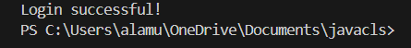
Errors:
Errors | Rectification
“{“ | “{“
“Class” | “class”

Important points:
Interface Login system: This interface defines a contract for any class that wants to implement a login system. It declares a single method user(String username, String password) which takes a username and password as input and returns a boolean indicating whether the login is successful. This promotes abstraction by defining what a login system should do, not how it should do it.

WEEK-09
Program-1
Aim: Write a java program to create a method that takes integers as parameter and throws n exception if the number is even
Class Diagram:
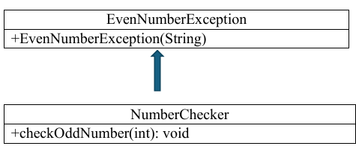
Code:
class EvenNumberException extends Exception {
public EvenNumberException(String message) {
super(message);}}
class NumberChecker {
public static void checkOddNumber(int number) throws EvenNumberException {
if (number % 2 == 0) {
throw new EvenNumberException("Even number not allowed: " + number); } else {
System.out.println("Valid odd number: " + number);
}}
public static void main(String[] args) {
int[] testNumbers = {1, 2, 3, 4, 5, 6};
for (int num : testNumbers) {
try {
checkOddNumber(num);
} catch (EvenNumberException e) {
System.out.println("Caught Exception: " + e.getMessage());
}}}}
OUTPUT:
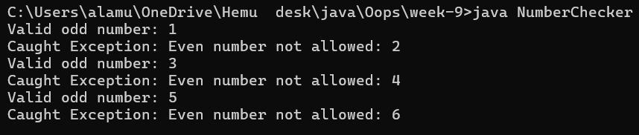
ERRORS:
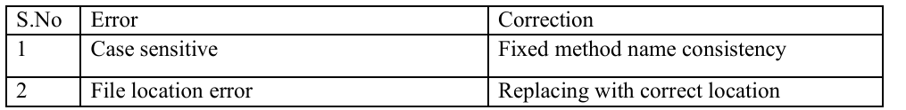

PROGRAM-02
Aim: Write a java program to create a method that reads a file and throws an exception if the file is not found.
Class Diagram:
Code:
import java.io.*;
public class FileReaderExample {
public static void readFile(String fileName) throws FileNotFoundException {
File file = new File(fileName);
if (!file.exists()) {
throw new FileNotFoundException("File not found: " + fileName);
}
try (BufferedReader br = new BufferedReader(new FileReader(file))) {
String line;
System.out.println("Contents of the file:");
while ((line = br.readLine()) != null) {
System.out.println(line);
}
} catch (IOException e) {
System.out.println("An error occurred while reading the file: " + e.getMessage());
}
}
public static void main(String[] args) {
String fileName = "example.txt"; // Change this to a valid file path
try {
readFile(fileName);
} catch (FileNotFoundException e) {
System.out.println("Caught Exception: " + e.getMessage());
}}}
OUTPUT:
ERRORS:
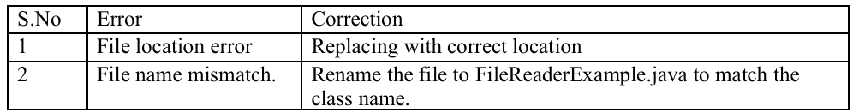

PROGRAM-03
AIM: Write a java program to handle arithmetic exception using try, catch, finally.
Class Diagram:
Code:
class ArithmeticExceptionExample {
public static void main(String[] args) {
int a = 10;
int b = 0;
try {
int result = a / b;
System.out.println("Result: " + result);
} catch (ArithmeticException e) {
System.out.println("Caught ArithmeticException: " + e.getMessage());
} finally {
System.out.println("Finally block executed.");
}
System.out.println("Program continues after exception handling.");
}
}
OUTPUT:
ERRORS:
PROGRAM-04
Aim: Write a java program to stimulate a University System using inner classes.
• Create an outer class named University with a variable University Name
• Inside it, define two non-static inner classes
1)Department – With variables like dept Name and dept Code, and a method to display department details
2) Student- with variables like Student name, student roll no and method to display student details
3) Create an object for each class and call their methods to display their details along with the university name.
Class Diagram:
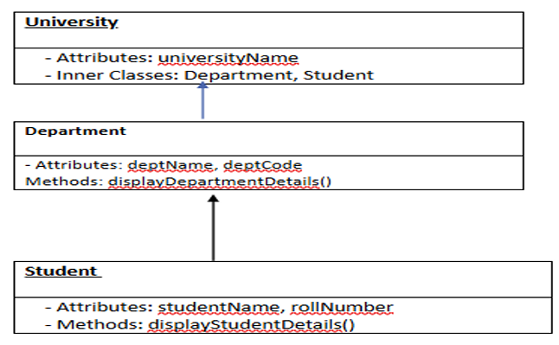
Code:
class University {
private String universityName;
public University(String universityName) {
this.universityName = universityName;
}
public class Department {
private String deptName;
private String deptCode;
public Department(String deptName, String deptCode) {
this.deptName = deptName;
this.deptCode = deptCode;
}
public void displayDepartmentDetails() {
System.out.println("University: " + universityName);
System.out.println("Department Name: " + deptName);
System.out.println("Department Code: " + deptCode);
}
}
public class Student {
private String studentName;
private String rollNo;
public Student(String studentName, String rollNo) {
this.studentName = studentName;
this.rollNo = rollNo;
}

public void displayStudentDetails() {
System.out.println("University: " + universityName);
System.out.println("Student Name: " + studentName);
System.out.println("Roll No: " + rollNo); } }
public static void main(String[] args) {
University university = new University("Amrita Viswa Vidhapeetham University");
University.Department department = university.new Department("Computer Science", "23CSE111");
University.Student student = university.new Student("Hemu", "AV.SC.U4CSE24004");
System.out.println("=== Department Details ===");
department.displayDepartmentDetails();
System.out.println("\n=== Student Details ===");
student.displayStudentDetails();}}
OUTPUT:
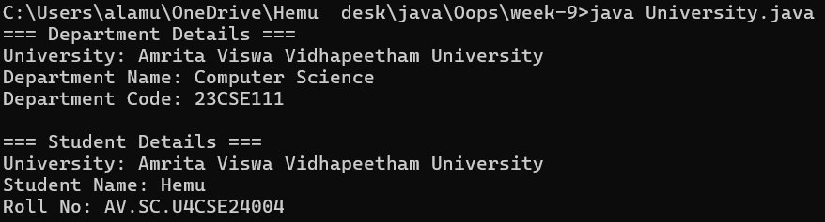

ERRORS:
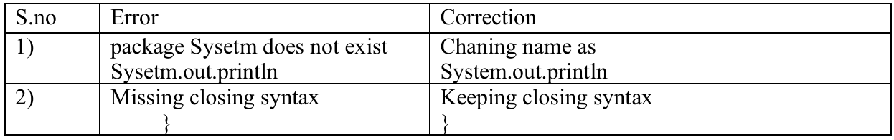
WEEK-10
PROGRAM-01
AIM: write a java program to generate a password for a student using his/her initials and age. The password displayed should the string consists of first character, of first name, middle name, last name, with age.
CLASS DIAGRAM:
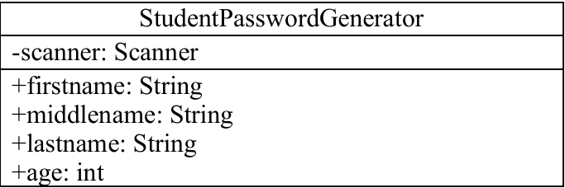
CODE:
import java.util.Scanner;
public class StudentPasswordGenerator {
public static void main(String[] args) {
Scanner scanner = new Scanner(System.in);
System.out.print("Enter First Name: ");
String firstName = scanner.nextLine();
System.out.print("Enter Middle Name: ");
String middleName = scanner.nextLine();
System.out.print("Enter Last Name: ");
String lastName = scanner.nextLine();
System.out.print("Enter Age: ");
int age = scanner.nextInt();
char firstInitial = firstName.charAt(0);
char middleInitial = middleName.charAt(0);
char lastInitial = lastName.charAt(0);
String password = "" + firstInitial + middleInitial + lastInitial + age;
System.out.println("Generated Password: " + password);
}
}
OUTPUT:
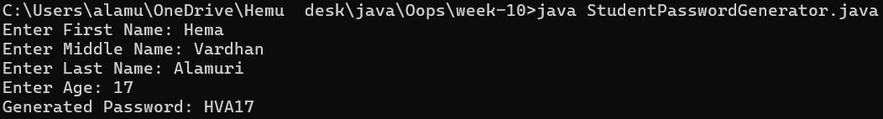
ERRORS:

PROGRAM-02
AIM: design and implement a java program that will do the following operations to this string “Welcome! You are practicing strings concepts”. a)covert all alphabets to capital letters and print out the result.
b)convert all alphabets to lower-case letters and print out the result.
c)print out the length of the string d)print out the index of concept.

CLASS DIAGRAM:
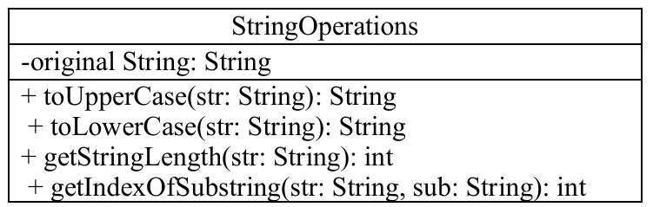
CODE:
class StringOperations {
public static void main(String[] args) {
String text = "Welcome! You are practicing strings concepts";
String upper = text.toUpperCase();
System.out.println("Uppercase : " + upper);
String lower = text.toLowerCase();
System.out.println("Lowercase : " + lower);
int length = text.length();
System.out.println("Length of the string: " + length);
int index = text.indexOf("concept");
if (index != -1) {
System.out.println("Index of 'concept': " + index);
} else {
System.out.println("'concept' not found in the string.");}}}
OUTPUT:
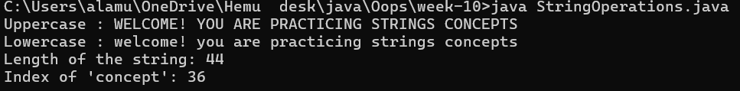
ERRORS:
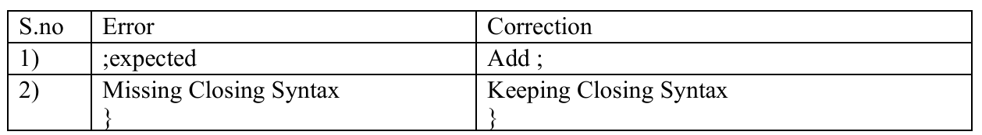
PROGRAM-03
AIM: Implement a java program using the below array methods
a) sorting the elements of an array.
b) convert the elements into string c)fill the part of the array d)copy the elements of one array into another.
CLASS DIAGRAM:
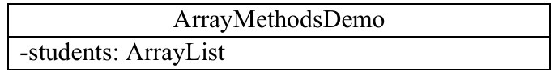
CODE:
import java.util.Arrays;
public class ArrayMethodsDemo {
public static void main(String[] args) {
int[] originalArray = {1, 3, 5, 7, 9, 11, 13, 15};
Arrays.sort(originalArray);
System.out.println("Sorted array: " + Arrays.toString(originalArray));
String arrayAsString = Arrays.toString(originalArray);
System.out.println("Array as string: " + arrayAsString);
Arrays.fill(originalArray, 1, 4, 0); // from index 1 (inclusive) to 4 (exclusive)
System.out.println("Array after partial fill (index 1-3 with 0): " + Arrays.toString(originalArray));
int[] copiedArray = Arrays.copyOf(originalArray, originalArray.length);
System.out.println("Copied array: " + Arrays.toString(copiedArray));
}
}
OUTPUT:
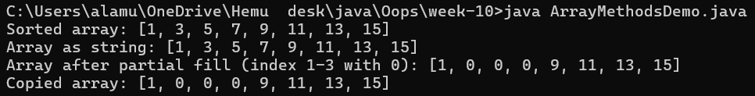
ERRORS:
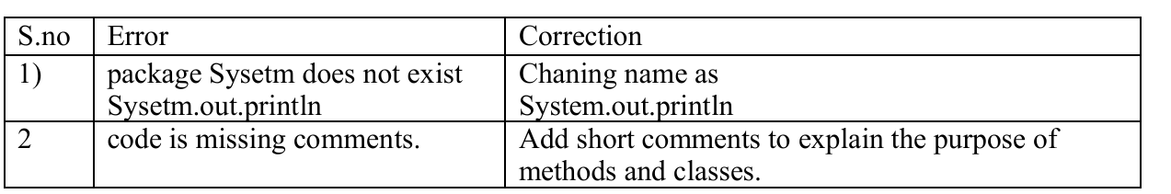
PROGRAM-04
AIM: Aim: Implement a java program using below ArrayList methods
- Insert an element at particular index in the array list
a) modify an element in the array list
b)Access an element from the array list
c)Remove an element from the array list d)clear the elements from the array list
CLASS DIAGRAM:
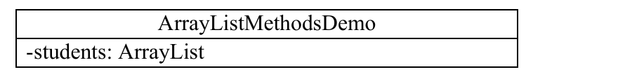
CODE:
import java.util.ArrayList;
public class ArrayListMethodsDemo {
public static void main(String[] args) {
ArrayList<String> students = new ArrayList<>();
students.add("classic");
students.add("Hemu");
students.add("Siva");
students.add("Manikanta");
System.out.println("Original List: " + students);
students.add(2, "Ramu");
System.out.println("After inserting 'Ramu' at index 2: " + students);
students.set(1, "Divi");
System.out.println("After modifying index 1 to 'Divi': " + students);
String studentAt3 = students.get(3);
System.out.println("Element at index 3: " + studentAt3);
students.remove(0);
System.out.println("After removing element at index 0: " + students);
students.clear();
System.out.println("After clearing all elements: " + students);}}
OUTPUT:
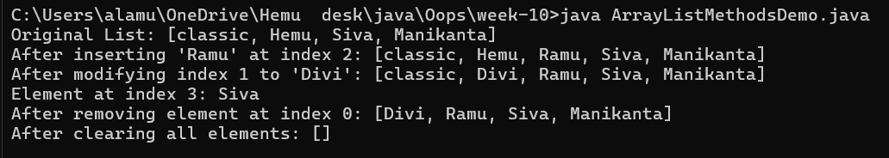
ERRORS:


