Object Oriented Programming

23CSE111



Department of Computer Science and Engineering
Amrita School of Engineering
Amrita Vishwa Vidyapeetham, Amaravati Campus

Verified by: Name: A. Hema Vardhan
Roll NO : AV.SC.U4CSE24004

Week | Questions | Page No | Date | Sign
1 | i. Download and install Java software  ii. Write a java program to print the message welcome to java programming  iii. Write a java program to print the name, roll no and section of the student
2 | i. To calculate the area of the rectangle  ii. Program to convert the temperature in celsius to Fahrenheit.  iii. Program to calculate the simple interest.  iv. Program to find the largest of three numbers using the ternary operators.  v. Program to find the factorial of the number.
3 | i. Create the java program for the cars with constructor and methods.  ii. Create the java program to withdraw and deposit money in the bank account.

WEEK-1
Program-1
Aim:- Downloading and installing Java software
Procedure:-
Step1:- Open Google chrome and search for java downloads
Step2:- Download java development kit(JDK) from oracle official website.
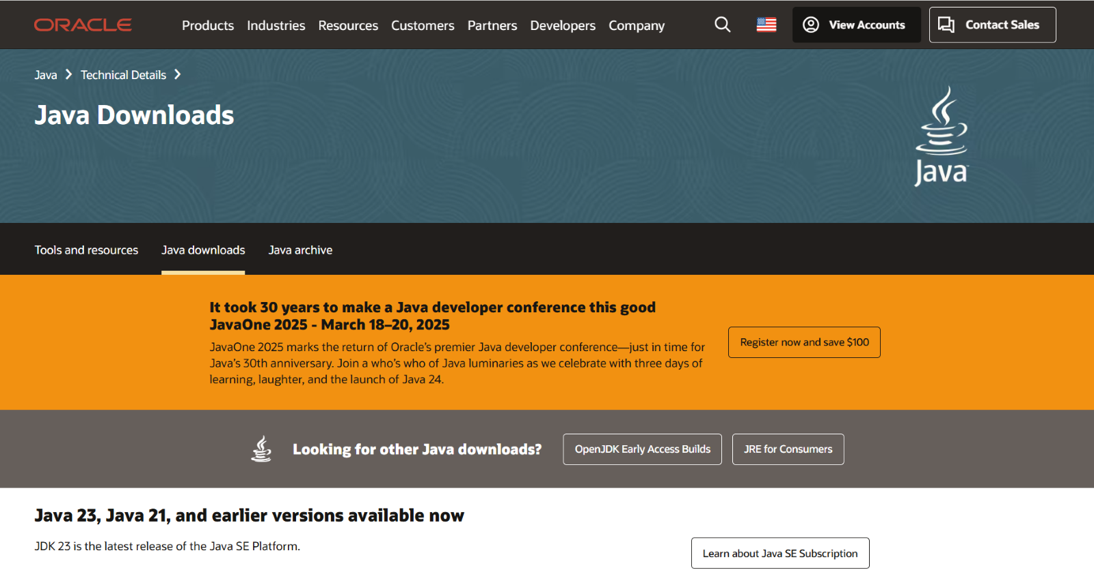
Step3:- Download JDK21.0.6 x64 Installer Windows version.
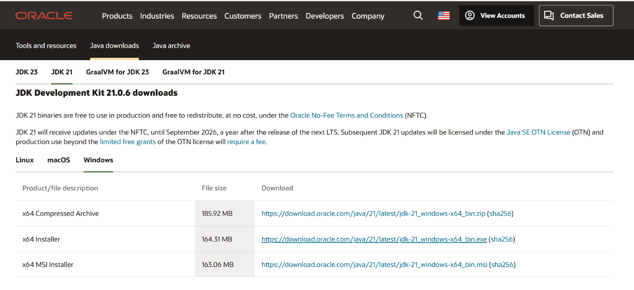
Step-4:-Click on the link provided to download. After downloading install the software into your device.
Step-5:- After installation we need to set environment set variable path of installation.
Step-6:- To set the variable path open files then windows c file then program files then java then jdk-21. Select bin and copy the path.
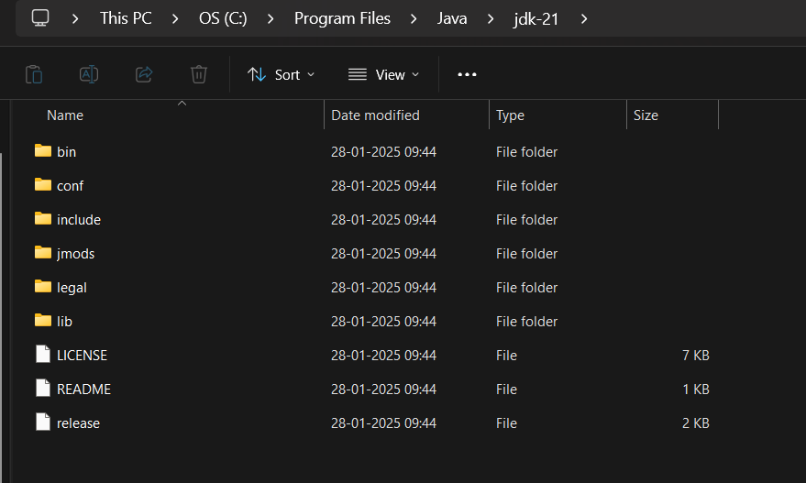
Step-7:- Here now open environmental variables then open system variable. Here we have to paste the copied path in path variable.
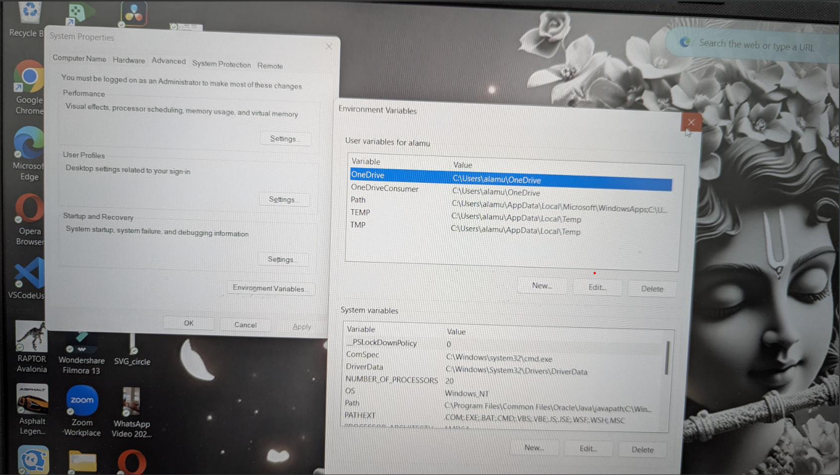

Step-8:- Now java software is installed in your device. Now to check the installed version. Open command prompt
Step-9:-in command prompt type java –version then click on enter
Step-10:-The version is displayed

PROGRAM-2
AIM:-Write a java program to print the message "Welcome to java programming”
INPUT:-
class Main{
public static void main(String[] args){
System.out.println("welcome to java programming");
}
}
OUTPUT:-

PROGRAM-3
AIM:- Write a java program that prints name, roll number, section of a student
INPUT:
Class program2{
public static void main(String args[]) {
System.out.println("Name: A.Hema vardhan");
System.out.println("Class: CSE 'A'");
System.out.println("Roll No: 24004")
}
}

OUTPUT:

ERRORS:
S.NO | ERROR MESSAGE | ERROR RECTIFICATION
1. | ‘}’ expected | Placing ‘}’ symbol

WEEK-2
Program-1
AIM:- Write a java program that Find the area of triangle
INPUT:
import java.util.Scanner;
class rec{
public static void main(String[] agrs){
Scanner input = new Scanner(System.in);
System.out.print("Enter the length : ");
int length = input.nextInt();
System.out.print("Enter the breath : ");
int breath = input.nextInt();
int A = length*breath;
System.out.print(A);
}
}
Output:
ERRORS:
S.NO | ERROR MESSAGE | ERROR RECTIFICATION
1. | ‘;’ expected | Placing ‘;’ symbol

PROGRAM-2
AIM:- Write a java program to find the simple interest
INPUT:
import java.util.Scanner;
class intrest{
public static void main(String[] args){
Scanner input = new Scanner(System.in);
System.out.print("Enter the princpial value ");
float P = input.nextFloat();
System.out.print("Enter the rate of interest value (%) ");
float R = input.nextFloat();
System.out.print("Enter the time value (in Years) ");
int T = input.nextInt();
float S= (P*T*R)/100;
System.out.print("This is the simple intrest value : " + S);
}
}
OUTPUT:
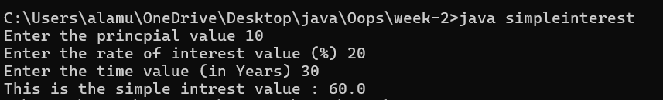
ERRORS:
S.NO | ERROR MESSAGE | ERROR RECTIFICATION
1. | ‘}’ expected | Placing ‘}’ symbol

PROGRAM-3
AIM:- Write a java program to print fibanaci series
INPUT:
import java.util.Scanner;
class fibb{
public static void main(String[] args){
Scanner input = new Scanner(System.in);
System.out.print("Enter the number");
int len = input.nextInt();
int f1 =0;
int f2 =1;
System.out.println("Fibonacci sequence : "+f1);
System.out.println("Fibonacci sequence : "+f2);
for ( int i=1;i<=len;i++){
int f3 = f1+f2;
f1 = f2;
f2 = f3;
System.out.println("Fibonacci sequence : "+ f3);
}
}
}
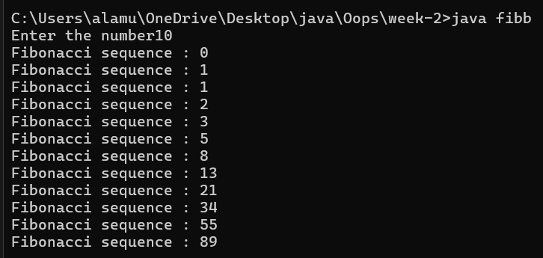
ERRORS:
S.NO | ERROR MESSAGE | ERROR RECTIFICATION
1. | ‘)’ expected | Placing ‘)’ symbol

PROGRAM-4
AIM:- Write a java program to find the largest of three numbers.
INPUT:
import java.util.Scanner;
class terminal{
public static void main(String[] args ){
Scanner input = new Scanner(System.in);
System.out.print("Enter the first n value");
int N1 = input.nextInt();
System.out.print("Enter the second n value");
int N2 = input.nextInt();
System.out.print("Enter the third n value");
int N3 = input.nextInt();
int largest = (N1 >= N2) ? ((N1 >= N3) ? N1 : N3) : ((N2 >= N3) ? N2 : N3);
System.out.println("Largest Number: " + largest);
}
}
OUTPUT:-
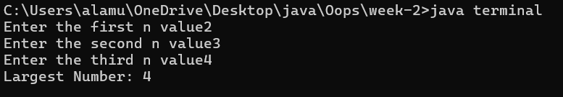
ERRORS:
S.NO | ERROR MESSAGE | ERROR RECTIFICATION
1. | ‘]’ expected | Placing ‘]’ symbol

Program-5
AIM:- ) Write a java program to Convert Fahrenheit to Celsius
INPUT:
import java.util.Scanner;
class tem {
public static void main(String[] args ){
Scanner input = new Scanner(System.in);
System.out.print("Enter the Celsius value ");
float C = input.nextFloat();
float F = (9/5)*C+32;
System.out.print("The Fahrenheit value is "+ F);
}
}
OUTPUT:
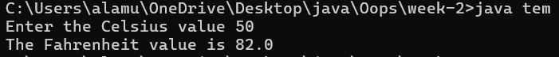
ERRORS:
S.NO | ERROR MESSAGE | ERROR RECTIFICATION
1. | ‘}’ expected | Placing ‘}’ symbol

Program-6
AIM:- Write a java program to convert
INPUT:
import java.util.Scanner;
class tem2 {
public static void main(String[] args) {
Scanner input = new Scanner(System.in);
System.out.print("Enter the Fahrenheit value: ");
float F = input.nextFloat();
float C = (F - 32) * (5.0f / 9.0f);
System.out.print("The Celsius value is " + C);
}
}
OUTPUT:
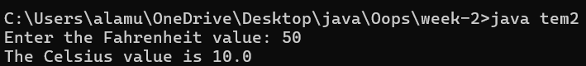
ERRORS:
S.NO | ERROR MESSAGE | ERROR RECTIFICATION
1. | ‘””’ expected | Placing ‘””’ symbol

WEEK-3
PROGRAM-1
AIM: Create the java program to withdraw and deposit money in the bank account.
CLASS DIAGRAM:
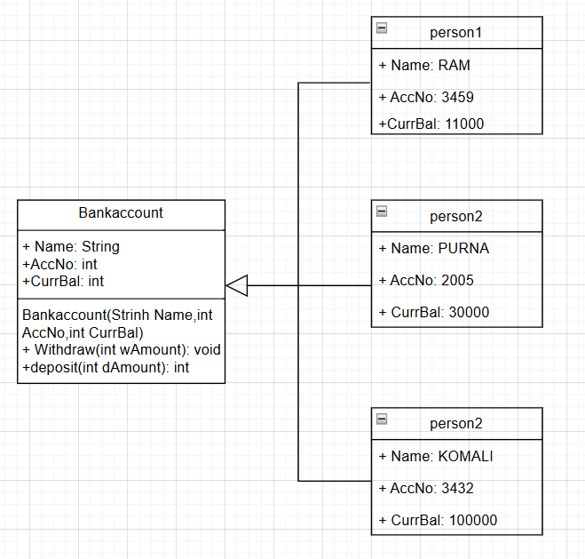
INPUT:
public class BankAccount {
private double balance;

public BankAccount(double initialBalance) {
if (initialBalance >= 0) {
balance = initialBalance;
} else {
System.out.println("Initial balance cannot be negative.");
balance = 0;
}
}

public void deposit(double amount) {
if (amount > 0) {
balance += amount;
System.out.println("Deposited: $" + amount);
} else {
System.out.println("Deposit amount must be positive.");
}
}

public void withdraw(double amount) {
if (amount > 0 && amount <= balance) {
balance -= amount;
System.out.println("Withdrew: $" + amount);
} else if (amount > balance) {
System.out.println("Insufficient balance.");
} else {
System.out.println("Withdrawal amount must be positive.");
}
}

// Method to check the balance
public void displayBalance() {
System.out.println("Current balance: $" + balance);
}

public static void main(String[] args) {

BankAccount account = new BankAccount(1000);
account.displayBalance();
account.deposit(500);
account.withdraw(300);
account.displayBalance();
account.withdraw(1500);
}
}
OUTPUT:
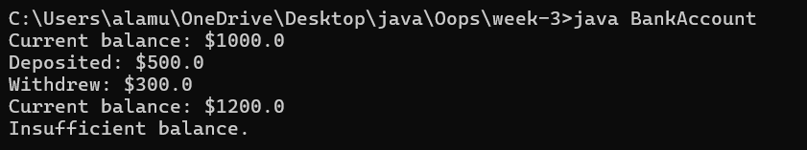
ERRORS:
Error Type | Incorrect Code | Corrected code
Class Name Capitalization | class Bankaccount | class BankAccount (Java follows PascalCase for class names)
Object Naming Issue | BankAccount person-1 (hyphen is not allowed) | BankAccount person1
Missing Semicolon | System.out.println ("Balance is "+ person-1.deposit (50,000)) | System.out.println ("Balance is "+ person1.deposit (50000)); (semicolon added)

PROGRAM-2
AIM: Create the java program for the cars with constructor and methods.
CLASS DIAGRAM:
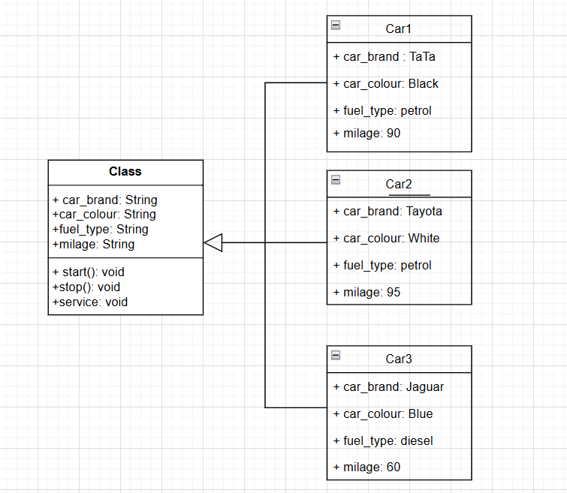
INPUT:
// Corrected Java Code
public class Car {
public String carColour;
public String carBrand;
public String fuelType;
public String mileage;

// Corrected Constructor
public Car(String carColour, String carBrand, String fuelType, String mileage) {
this.carColour = carColour;
this.carBrand = carBrand;
this.fuelType = fuelType;
this.mileage = mileage;
}

public void start() {
System.out.println("Car is started");
}

public void stop() {
System.out.println("Car is stopped");
}

public void service() {
System.out.println("Car is for service");
}
}

class Main {
public static void main(String[] args) {
System.out.println("----------------WELCOME----------------");

// First Car Object
Car car1 = new Car("Black", "Tata", "Petrol", "90");
System.out.println("Our first car is " + car1.carBrand);
System.out.println("Colour is " + car1.carColour);
System.out.println("Its fuel type is " + car1.fuelType);
System.out.println("Its mileage is " + car1.mileage);
car1.start();
car1.stop();
car1.service();
System.out.println(" ");

// Second Car Object
Car car2 = new Car("White", "Toyota", "Petrol", "95");
System.out.println("Our second car is " + car2.carBrand);
System.out.println("Colour is " + car2.carColour);
System.out.println("Its fuel type is " + car2.fuelType);
System.out.println("Its mileage is " + car2.mileage);
car2.start();
car2.stop();
car2.service();
System.out.println(" ");

// Third Car Object
Car car3 = new Car("Blue", "Jaguar", "Diesel", "60");
System.out.println("Our third car is " + car3.carBrand);
System.out.println("Colour is " + car3.carColour);
System.out.println("Its fuel type is " + car3.fuelType);
System.out.println("Its mileage is " + car3.mileage);
car3.start();
car3.stop();
car3.service();
}
}

OUTPUT:
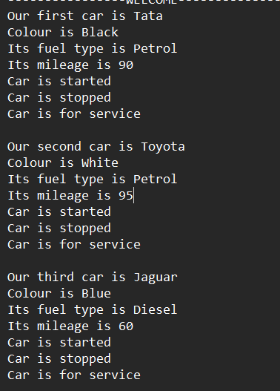
ERRORS:
Error Type | Incorrect Code | Corrected Code
Class Naming Issue | class main{ | class Main{
Incorrect Object Description | "Our first car is "+car3.car_brand; | "Our Third car is "+car3.car_brand;

WEEK-4
PROGRAM-1
Aim: (i) Create the java program for the books by using the constructor and display its details using methods.
CLASS DIAGRAM:
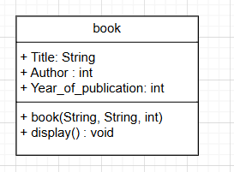
INPUT:
public class Book {
private String title;
private String author;
private int yearOfPublication;

public Book(String title, String author, int yearOfPublication) {
this.title = title;
this.author = author;
this.yearOfPublication = yearOfPublication;
}

public void displayDetails() {
System.out.println("Title: " + title);
System.out.println("Author: " + author);
System.out.println("Year of Publication: " + yearOfPublication);
}

public static void main(String[] args) {

Book book1 = new Book("To Kill a Mockingbird", "Harper Lee", 1960);
Book book2 = new Book("1984", "George Orwell", 1949);

System.out.println("Book 1 Details:");
book1.displayDetails();

System.out.println("\nBook 2 Details:");
book2.displayDetails();
}
}
OUTPUT:
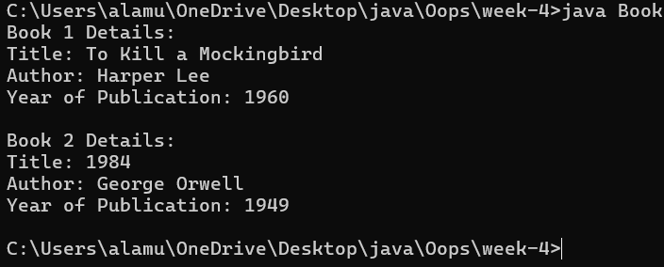
ERRORS:
S.NO | ERROR MESSAGE | ERROR RECTIFICATION
1. | ‘}’ expected | Placing ‘}’ symbol
2. | ‘System’ expected | Placing ‘S’ystem
3. | ‘Book’ expected | Placing ‘B’ook
PROGRAM-2
AIM: Creat a java program with class names”MyClass” with constant variable “pi=3.1415”. Define a constructor for “MyClass”. Finally, print the final values of “count” and “pi” variables.
CLASS DIAGRAM:
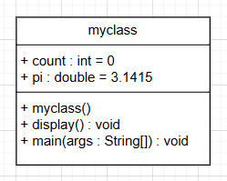
INPUT:
public class MyClass {
public static int count = 0;
public static final double pi = 3.1415;

public MyClass() {
count++;
}

public static void main(String[] args) {

MyClass obj1 = new MyClass();
MyClass obj2 = new MyClass();
MyClass obj3 = new MyClass();

System.out.println("Final Count: " + count);
System.out.println("Value of Pi: " + pi);
}
}
OUTPUT:
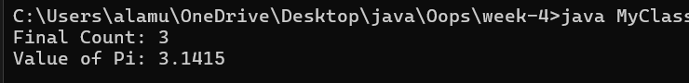

ERRORS:
S.NO | ERROR MESSAGE | ERROR RECTIFICATION
1. | ‘claass’ expected | Placing ‘class’
2. | ‘obj’ expected | Placing ‘obj1’

WEEK-5
AIM: (i) Create the java program for calculator using multi-level inheritance.
CLASS DIAGRAM:
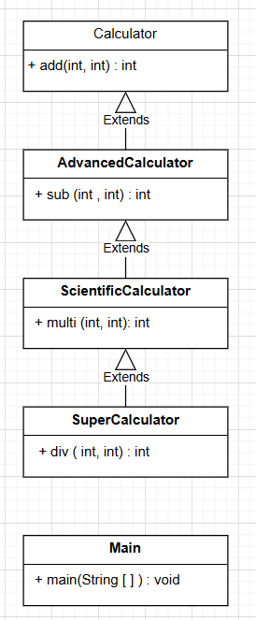
INPUT:
public class Calculator {
public int add(int a, int b) {
int addition = a + b;
return addition;
}
}

class AdvancedCalculator extends Calculator {
public int sub(int a, int b) {
int subtraction = a - b;
return subtraction;
}
}
class ScientificCalculator extends AdvancedCalculator {
public int multi(int a, int b) {
int multiplication = a * b;
return multiplication;
}
}
class SuperCalculator extends ScientificCalculator {
public int div(int a, int b) {
if (b == 0) {
System.out.println("Division by zero is undefined.");
return 0;
} else {
return a / b;
}
}
}
class Main {
public static void main(String[] args) {
SuperCalculator obj = new SuperCalculator();
System.out.println("Addition is: " + obj.add(4, 3));
System.out.println("Subtraction is: " + obj.sub(4, 3));
System.out.println("Multiplication is: " + obj.multi(4, 3));
System.out.println("Division is: " + obj.div(4, 3));
System.out.println("Division by zero test: " + obj.div(4, 0)); // optional test
}
}
OUTPUT:
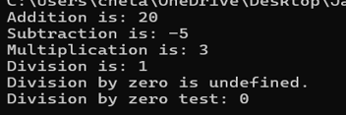
ERRORS:
S.NO | ERROR MESSAGE | ERROR RECTIFICATION
1. | ‘extends’ expected | Placing ‘extends’ symbol
2. | ‘System’ expected | Placing ‘S’ystem
3. | ‘()’expected | Placing ‘()’

AIM:
(ii) A vehicle rental company wants a system to manage details of vehicles available for rent, including cars, bikes, and trucks. Each vehicle should store basic information such as brand and speed. Cars must include an additional property for the number of doors, while bikes should indicate whether they have gears. The system should also provide a function to display the details of each vehicle and indicate when a vehicle is starting.
CLASS DIAGRAM:
INPUT:
class transport {
protected String model;
protected int maxSpeed;

public transport(String model, int maxSpeed) {
this.model = model;
this.maxSpeed = maxSpeed;
}

public void ignite() {
System.out.println(model + " is now starting...");
}

public void displayInfo() {
System.out.println("Model: " + model);
System.out.println("Top Speed: " + maxSpeed + " km/h");
}
}

class sedan extends transport {
private int doors;

public sedan(String model, int maxSpeed, int doors) {
super(model, maxSpeed);
this.doors = doors;
}

public void displayInfo() {
super.displayInfo();
System.out.println("Doors: " + doors);
}
}

class motorcycle extends transport {
private boolean geared;

public motorcycle(String model, int maxSpeed, boolean geared) {
super(model, maxSpeed);
this.geared = geared;
}
public void displayInfo() {
super.displayInfo();
System.out.println("Geared: " + (geared ? "Yes" : "No"));
}
}
class lorry extends transport {
private int loadCapacity;
public lorry(String model, int maxSpeed, int loadCapacity) {
super(model, maxSpeed);
this.loadCapacity = loadCapacity;
}
public void printTruckInfo() {
super.displayInfo();
System.out.println("Load Capacity: " + loadCapacity + " tons");
}
}

public class rentalsystem {
public static void main(String[] args) {
sedan myCar = new sedan("Audi A4", 220, 4);
motorcycle myBike = new motorcycle("Yamaha MT-15", 140, true);
lorry myTruck = new lorry("Tata Hauler", 100, 12);
System.out.println("\n--- Car Info ---");
myCar.ignite();
myCar.displayInfo();
System.out.println("\n--- Bike Info ---");
myBike.ignite();
myBike.displayInfo();
System.out.println("\n--- Truck Info ---");
myTruck.ignite();
myTruck.printTruckInfo();
}
}
OUTPUT:
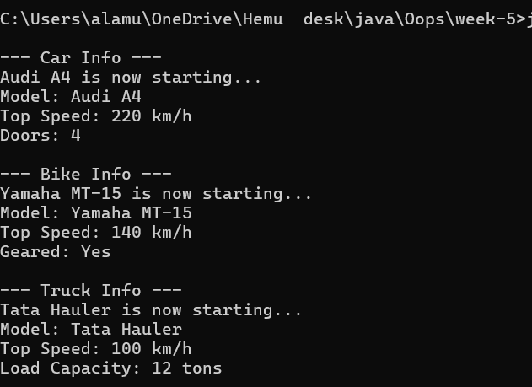

ERRORS:
S.NO | ERROR MESSAGE | ERROR RECTIFICATION
1. | ‘[]’expected | Placing ‘[]’ symbol
2. | ‘Systeem’ expected | Placing ‘System’

WEEK-6:
AIM: (i) Write a java program to create a vehicle class with a method display info . Overisde this method in car subclass to provide specific information.
CLASS DIAGRAM:
Vehicle
- Brand: String
- Speed: int
+ vehicle(brand: string
Speed: int)
+start vehicle(): void
+displaydetails():void

INPUT:
class Vehicle {
String car_company;
String car_model;
long car_price;
int seating_capacity;
boolean petrol;

Vehicle(String car_company, String car_model, long car_price, int seating_capacity, boolean petrol) {
this.car_company = car_company;
this.car_model = car_model;
this.car_price = car_price;
this.seating_capacity = seating_capacity;
this.petrol = petrol;
}

void displayInfo() {
System.out.println("Car company: " + car_company);
System.out.println("Car model: " + car_model);
System.out.println("Car price: " + car_price);
System.out.println("Car seating capacity: " + seating_capacity);
System.out.println("Car uses petrol: " + petrol);
} }
class Car extends Vehicle {
Car(String car_company, String car_model, long car_price, int seating_capacity, boolean petrol) {
super(car_company, car_model, car_price, seating_capacity, petrol);
}
}

public class Main {
public static void main(String[] args) {
// Creating a Car object with correct arguments
Car c1 = new Car("Hyundai", "Creta", 1500000, 5, false);
c1.displayInfo();
}
}
OUTPUT:
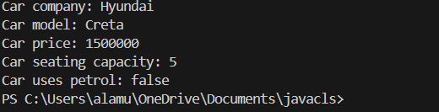
ERRORS:
S.NO | ERROR MESSAGE | ERROR RECTIFICATION
1. | ‘int’expected | Placing ‘int’
2. | ‘this’ expected | Placing ‘this’
IMPORTANT POINTS:
1.Inheritance: The Car class extends the Vehicle class, demonstrating inheritance in Java.
2.Constructor Chaining:The Car class calls the parent constructor using super(car_model, color, fuel_type); to initialize inherited attributes.
3.Method Overriding:The Car class overrides the displayInfo() method from Vehicle and calls super.displayInfo() to reuse the parent method before adding its own output.
4.Incorrect main Class Name:The main method is inside Truck, which is unrelated to Vehicle and Car. The class should be renamed for clarity.
AIM:
(ii) A college is developing an automated admission system that verifies students eligibility for undergraduate (UG) and postgraduate (PG) programs. Each program has different eligibility for UG and PG program qualifications.UG admission requires a minimum of 60% and PG requires a minimum of 70%.
CLASS DIAGRAM:
AutomatedAdmission
- Scanner: scanner
- Name: String
- Percentage : double
- Program: stirng
+ main(args:String[]): void
+takeInput(): void
+checkEligibility(): void
+closeScanner(); void

INPUT:
class Student {
String name;
double percentage;

Student(String name, double percentage) {
this.name = name;
this.percentage = percentage;
}

void studentsInfo() {
System.out.println("Student Name: " + name);
System.out.println("Percentage: " + percentage);
} }
class UG extends Student {
UG(String name, double percentage) {
super(name, percentage);
}
void checkEligibility() {
if (percentage >= 60) {
System.out.println(name + " is eligible for admission in UG.");
} else {
System.out.println(name + " is not eligible for admission in UG.");
} } }
class PG extends Student {
PG(String name, double percentage) {
super(name, percentage);
}
void checkEligibility() {
if (percentage >= 70) {
System.out.println(name + " is eligible for admission in PG.");
} else {
System.out.println(name + " is not eligible for admission in PG.");
} } }

public class AutomatedAdmission {
public static void main(String[] args) {
UG ug = new UG("HEMU", 80);
ug.studentsInfo();
ug.checkEligibility();

PG pg = new PG("SAI", 75);
pg.studentsInfo();
pg.checkEligibility();
}
}

OUTPUT:
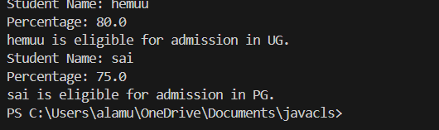
ERRORS:
Code error | Code rectification
1.Scanner nextLine() issue after nextDouble(): After scanner.nextDouble(), the newline character remains in the buffer, causing nextLine() to be skipped.  2.Program type input case sensitivity issue: If the user enters ug or pg in lowercase, it may cause incorrect comparisons. | 1.Add scanner.nextLine(); after nextDouble(); to consume the leftover newline.  2.Use program.toUpperCase() to ensure case-insensitive comparison.
IMPORTANT POINTS:

1.User Input Handling: Uses Scanner to take user input for name, percentage, and program type.
2.Decision Making with Conditions: Uses if-else statements to check eligibility criteria.
3.String Handling: Converts program input to uppercase (toUpperCase()) to handle case variations.
4.Closing Scanner: Properly closes scanner using scanner.close(); to prevent resource leaks.

PROGRAM-3:
AIM: Create a calculator class with overloaded methods to perform addition of:
1. Add two integers
2. Add two doubles
3. Add three integers

CLASS DIAGRAM:

Calculator
+ add(int, int): int
+add(double, double): double
+add(int,int,int): int

CODE:
class Calculator6 {
public int add(int a, int b) {
return a + b;
}

public double add(double a, double b) {
return a + b;
}

public int add(int a, int b, int c) {
return a + b + c;
} }
class Main6 {
public static void main(String[] args) {
Calculator6 calculator = new Calculator6();
System.out.println("Addition of two integers: " + calculator.add(5, 15));
System.out.println("Addition of two doubles: " + calculator.add(5.5, 2.2));
System.out.println("Addition of three integers: " + calculator.add(1, 2, 5));
} }
OUTPUT:

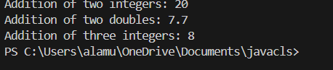

ERRORS:
Code error | Code rectification
1.Method parameters missing spaces. E.g.,”inta, intb”should be “int a, int b”  2.Inconsistent indentation in method bodies | 1. Add proper spacing between parameters: (int a, int b)  2. Fix indentation:  Consistent 4 space o indentation.

IMPORTANT POINTS:
1.Method Overloading: The add method is overloaded with different parameter types and counts, demonstrating compile-time polymorphism.
2.Automatic Method Selection: Java selects the appropriate add method based on the argument types during compilation.

PROGRAM-4:
AIM: Create a shape class with a method to calculate area i.e., overloaded for different shapes eg: Squares, Recatangle. Then create a subclass circle that overrides the calculateArea() method for a circle.
CLASS DIAGRAM:

SHAPE
+ CalculateArea(side:double): double
+CalculateArea(width: double, length: double): double

CIRCLE
+ CalculateArea(radius: double): double

Tools
+main(args:String[]): Void

CODE:
class Shape {
public double calculateArea(double side) {
return side * side;
}

public double calculateArea(double length, double width) {
return length * width;
}
}

class Circle extends Shape {
private double radius;

public Circle(double radius) {
this.radius = radius;
}

public double calculateArea() {
return Math.PI * radius * radius;
}
}

class Tools {
public static void main(String[] args) {
Shape shape = new Shape();
Circle circle = new Circle(5);

System.out.println("Area of square: " + shape.calculateArea(4));
System.out.println("Area of rectangle: " + shape.calculateArea(4, 6));
System.out.println("Area of circle: " + circle.calculateArea());
}
}
OUTPUT:
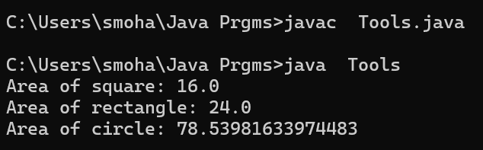

ERRORS:

Code error | Code rectification
1. Method calls in main are missing an object reference (e.g., calculateArea(4) instead of s.calculateArea(4)).  2. Circle class method does not override theparent class method properly. | 1. Use s.calculateArea(4) and c.calculateArea(2) to call the method correctly.  2. Ensure @Override is used, and the method signature should match correctly.

IMPORTANT POINTS:
1.Inheritance: Circle class extends Shape, inheriting its methods.
2.Method Overloading: Shape has multiple calculateArea methods with different parameters.
3.Method Overriding: Circle overrides calculateArea from Shape to implement its own formula.
4.Polymorphism: The overridden method in Circle demonstrates runtime polymorphism.
5.Proper Object Reference: Methods should be called using an object (s.calculateArea(4), c.calculateArea(2)).

Week-7
1Q) creating one superclass Animal and three subclasses, Herbivores, Carnivores, and Omnivores. Subclasses extend the superclass and override its eat() method. Returning the method for the required type of animals.
Class diagram:
<<abstract>> animal
+sound():void
Lion
+sound():void
Tiger
+sound():void

Code:
public class animal {
public void eat() {
System.out.println("animal eats food.");
}
}
class Herbivores extends animal {
@Override
public void eat() {
System.out.println("Herbivore eats only plants.");
}
}
class Carnivores extends animal {
@Override
public void eat() {
System.out.println("Carnivore eats only meat.");
}
}
// Subclass Omnivores
class Omnivores extends animal {
@Override
public void eat() {
System.out.println("Omnivore eats both plants and meat.");
}
}
class test {
public static void main(String[] args) {
animal a = new animal();
animal herbivore = new Herbivores();
animal carnivore = new Carnivores();
animal omnivore = new Omnivores();
a.eat();
herbivore.eat();
carnivore.eat();
omnivore.eat();
}
}
Output: 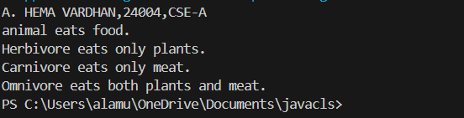

Important points:
1)JVM(java virtual machine) is one which runs our program.
- JVM starts your program by calling the main( ) method from outside your class.
- JVM runs outside our package.
- only public method are accessible from outside a class or package.
- if your main( ) not marked as public ,jam cannot see it and you get an error like above
2Q) Write a Java program to create an abstract class Shape3D with abstract methods calculateVolume() and calculateSurfaceArea(). Create subclasses Sphere and Cube that extend the Shape3D class and implement the respective methods to calculate the volume and surface area of each shape.
Class diagram:

Code:
import java.lang.*;
abstract class shape3D {
abstract double calculateVolume();
abstract double calculateSurfaceArea();
}
class Sphere extends shape3D {
private double radius;
Sphere(double radius) {
this.radius = radius;
}
@Override
double calculateVolume() {
return (4.0 / 3.0) * Math.PI * radius * radius * radius;
}
@Override
double calculateSurfaceArea() {
return 4 * Math.PI * radius * radius;
}
}
class Cube extends shape3D {
private double side;
Cube(double side) {
this.side = side;
}
@Override
double calculateVolume() {
return side * side * side;
}
@Override
double calculateSurfaceArea() {
return 6 * side * side;
}
}
class main {
public static void main(String[] args) {
Sphere s = new Sphere(2.3);
System.out.println("Volume of Sphere: " + s.calculateVolume());
System.out.println("Surface Area of Sphere: " + s.calculateSurfaceArea());

Cube c = new Cube(2.3);
System.out.println("Volume of Cube: " + c.calculateVolume());
System.out.println("Surface Area of Cube: " + c.calculateSurfaceArea());
}
}
Output:
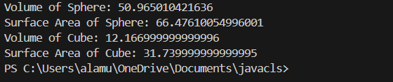
3Q)write a java program using an abstract class to define a method for pattern printing
• Create an abstract class named patternprinter with an abstract method printpattern(int n) and a concrete method to display the pattern title
• Implement two subclasses
1. Star pattern prints a right angle triangle of Star( *)
2. Numberpattern-prints a right angled triangle of increasing numbers
• In the main( ) method ,create objects of both subclasses and print the patterns for a given number of rows Expected output:
Pattern 1:
*
* *
* * *
* * * *
* * * * *
Pattern 2:
1
1 2
1 2 3
1 2 3 4
1 2 3 4 5
Code:
abstract class patternprinter {
abstract void patternprinting(int n);
}
class StarPattern extends patternprinter {
void patternprinting(int n) {
System.out.println("Star pattern");
for(int i=1;i<=n;i++) {
for(int j=1;j<=i;j++) {
System.out.print("*");
}
System.out.println();
}
}
}
class Numberpattern extends patternprinter {
void patternprinting(int n) {
System.out.println("Number pattern");
for(int i=1; i<=n; i++) {
for(int j=1; j<=i; j++) {
System.out.print(j);
}
System.out.println();
}
}
}
public class patternmain {
public static void main (String[] args) {
StarPattern s = new StarPattern();
Numberpattern n = new Numberpattern();
s.patternprinting(5);
n.patternprinting(5);
}
}
Output:
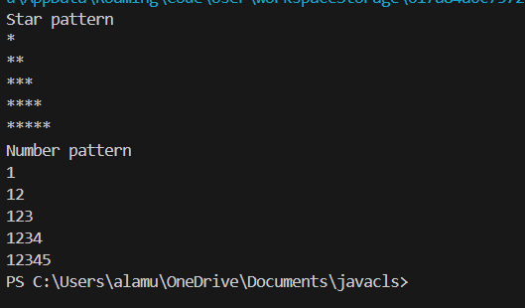

WEEK-8
1Q)Write a Java program to create an interface Shape with the getPerimeter() method. Create three classes Rectangle, Circle, and Triangle that implement the Shape interface. Implement the getPerimeter() method for each of the three classes.
Class diagram:

Code:
interface Shape {
double getPerimeter();
}
class Rectangle implements Shape {
private double length;
private double width;
public Rectangle(double length, double width) {
this.length = length;
this.width = width;
}
public double getPerimeter() {
return 2 * (length + width);
}
}
class Circle implements Shape {
private double radius;
public Circle(double radius) {
this.radius = radius;
}
public double getPerimeter() {
return 2 * Math.PI * radius;
}
}
class Triangle implements Shape {
private double a, b, c;
public Triangle(double a, double b, double c) {
this.a = a;
this.b = b;
this.c = c;
}
public double getPerimeter() {
return a + b + c;
}
}
public class perimeter {
public static void main(String[] args) {
Shape rectangle = new Rectangle(5, 10);
Shape circle = new Circle(8);
Shape triangle = new Triangle(4, 5, 6);
System.out.println("Rectangle Perimeter: "+ rectangle.getPerimeter());
System.out.println("Circle Perimeter: "+circle.getPerimeter());
System.out.println("Triangle Perimeter: "+ triangle.getPerimeter());
}
}
Output:
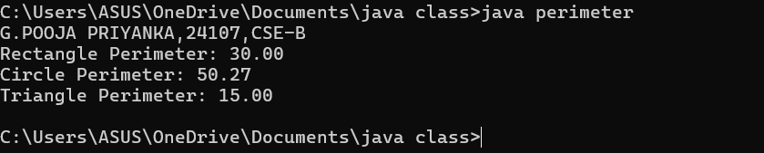
2Q) Write a Java program to create an interface Playable with a method play() that takes no arguments and returns void. Create three classes Football, Volleyball, and Basketball that implement the Playable interface and override the play() method to play the respective sports.
Class diagram:

Code:
interface Playable {
void play();
}
class Football implements Playable {
@Override
public void play() {
System.out.println("Playing Football!");
}
}
class Volleyball implements Playable {
@Override
public void play() {
System.out.println("Playing Volleyball!");
}
}
class Basketball implements Playable {
@Override
public void play() {
System.out.println("Playing Basketball!");
}
}
class Main5{
public static void main(String[] args) {
System.out.println("G.POOJA PRIYANKA,24107,CSE-B");
Playable football = new Football();
Playable volleyball = new Volleyball();
Playable basketball = new Basketball();
football.play();
volleyball.play();
basketball.play();
}
}
Output:
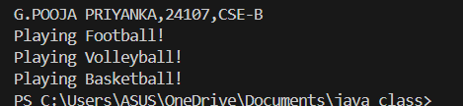
Errors:
Errors | Rectification
Football is not abstract and does not override abstract method play() | Implement the play() method from interface
Playables.java but public class PlayTest | Class PlayTest is public , should be declared in a file named PlayTest.java

Important points:
1.The Playable interface defines the contract (play() method).
2.Each class (Football, Volleyball, Basketball) implements the interface and provides a specific behavior for play().
3.This demonstrates polymorphism using interfaces in Java.
3Q) write a java program to implement a login system using interface.
Code:
interface Loginsystem {
boolean user(String username, String password);
}
class UserLogin implements Loginsystem {
private String validUsername;
private String validPassword;

public UserLogin(String validUsername, String validPassword) {
this.validUsername = validUsername;
this.validPassword = validPassword;
}

@Override
public boolean user(String username, String password) {
// Check if the entered username and password match the stored values
return username.equals(validUsername) && password.equals(validPassword);
}
}
public class login {
public static void main(String[] args) {
UserLogin login = new UserLogin("priya", "pp@123");
String username = "priya";
String password = "pp@123";
if (login.user(username, password)) {
System.out.println("Login successful!");
} else {
System.out.println("Invalid credentials.");
}
}
}

Output:

