Cognizant Deep Skilling - Digital Nurture 4.0
1. ReactJS-HOL

Open Command Prompt:
npm install -g create-react-app
npx create-react-app myfirstreact
cd myfirstreact
code .

src/App.js
import React from 'react';

function App() {
return (
<div>
<h1>Welcome to the first session of React</h1>
</div>
);
}

export default App;

Start the React App:
npm start

Output:
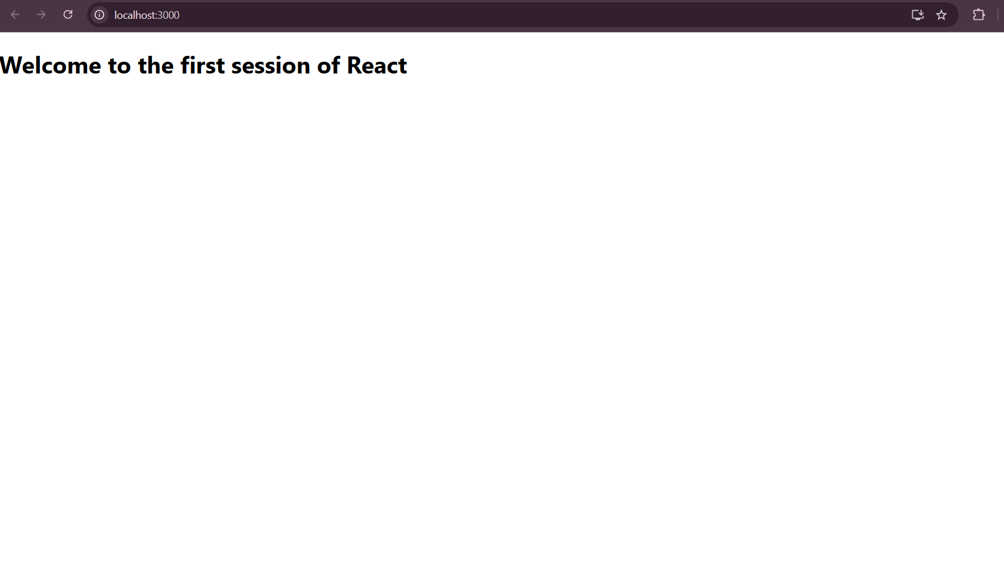
2. ReactJS-HOL

Open Command Prompt:
npx create-react-app StudentApp
cd StudentApp
code .

src/Components/Home.js
import React, { Component } from 'react';

class Home extends Component {
render() {
return (
<div>
<h2>Welcome to the Home page of Student Management Portal</h2>
</div>
);
}
}

export default Home;

src/Components/About.js
import React, { Component } from 'react';
class About extends Component {
render() {
return (
<div>
<h2>Welcome to the About page of the Student Management Portal</h2>
</div>
);
}
}
export default About;

src/Components/Contact.js
import React, { Component } from 'react';

class Contact extends Component {
render() {
return (
<div>
<h2>Welcome to the Contact page of the Student Management Portal</h2>
</div>
);
}
}

export default Contact;

src/App.js
import React from 'react';
import Home from './Components/Home';
import About from './Components/About';
import Contact from './Components/Contact';

function App() {
return (
<div className="App">
<Home />
<About />
<Contact />
</div>
);
}

export default App;
Run the React App:
npm start

Output:
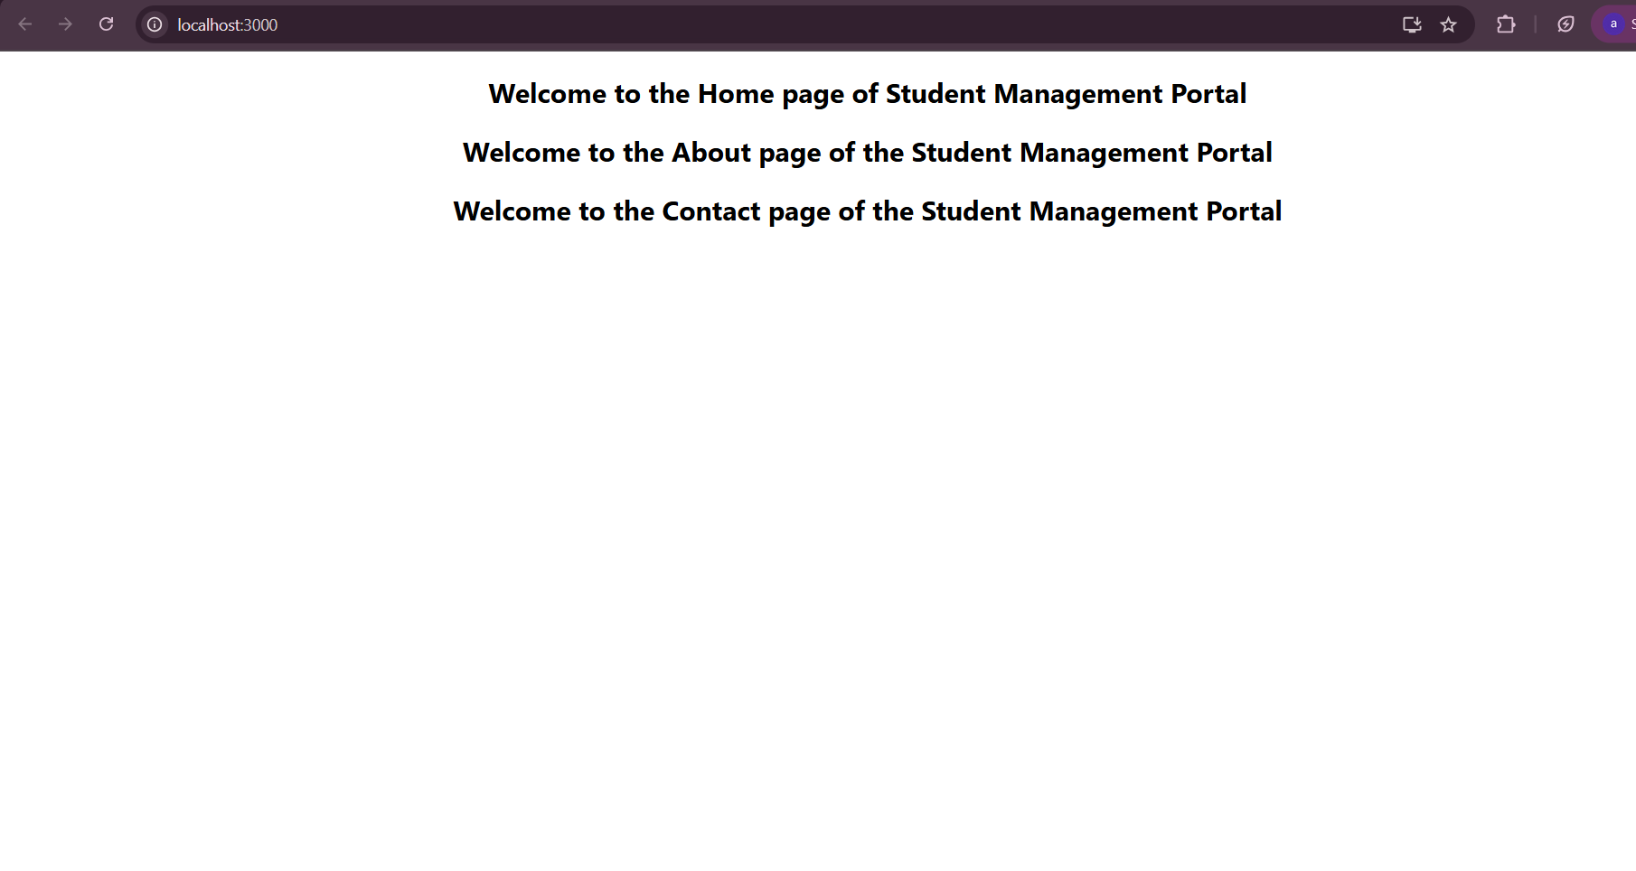
3. ReactJS-HOL

Open Command Prompt:
npx create-react-app scorecalculatorapp
cd scorecalculatorapp
code .

src/Components/CalculateScore.js
import React from 'react';
import '../Stylesheets/mystyle.css';

function CalculateScore(props) {
const average = props.total / props.goal;

return (
<div className="score-card">
<h2>Student Score Details</h2>
<p><strong>Name:</strong> {props.name}</p>
<p><strong>School:</strong> {props.school}</p>
<p><strong>Total Marks:</strong> {props.total}</p>
<p><strong>Subjects:</strong> {props.goal}</p>
<p><strong>Average Score:</strong> {average.toFixed(2)}</p>
</div>
);
}

export default CalculateScore;
src/Stylesheets/mystyle.css
.score-card {
background-color: #f0f8ff;
border: 2px solid #4b9cd3;
padding: 20px;
margin: 30px auto;
width: 60%;
border-radius: 10px;
text-align: left;
box-shadow: 0px 10px rgba(0, 0, 0, 0.1);
}

.score-card h2 {
color: #4b9cd3;
text-align: center;
}

.score-card p {
font-size: 18px;
line-height: 1.5;
}
src/App.js
import React from 'react';
import './App.css';
import CalculateScore from './Components/CalculateScore';

function App() {
return (
<div className="App">
<CalculateScore name="Ajitha R" school="Grace Matric School" total={480} goal={5} />
</div>
);
}

export default App;
Run the React App:
npm start

4. ReactJS-HOL

Open Command Prompt:
npx create-react-app blogapp
cd blogapp
code .

src/Post.js
import React from 'react';

function Post(props) {
return (
<div className="post">
<h2>{props.title}</h2>
<p>{props.body}</p>
</div>
);
}

export default Post;
src/Posts.js
import React, { Component } from 'react';
import Post from './Post';

class Posts extends Component {
constructor(props) {
super(props);
this.state = {
posts: [],
hasError: false,
};
}

// Fetch posts from API
loadPosts = () => {
fetch('https://jsonplaceholder.typicode.com/posts')
.then((response) => response.json())
.then((data) => this.setState({ posts: data }))
.catch((error) => {
console.error('Error fetching posts:', error);
this.setState({ hasError: true });
});
};

// Life cycle method
componentDidMount() {
this.loadPosts();
}

// Catch rendering errors
componentDidCatch(error, info) {
console.error('Caught error:', error);
alert('Something went wrong while rendering the component!');
this.setState({ hasError: true });
}

render() {
if (this.state.hasError) {
return <h2>Oops! An error occurred while displaying posts.</h2>;
}

return (
<div>
<h1>Blog Posts</h1>
{this.state.posts.map((post) => (
<Post key={post.id} title={post.title} body={post.body} />
))}
</div>
);
}
}

export default Posts;
src/App.js
import React from 'react';
import './App.css';
import Posts from './Posts';

function App() {
return (
<div className="App">
<Posts />
</div>
);
}

export default App;
Run the React App:
npm start

Output:
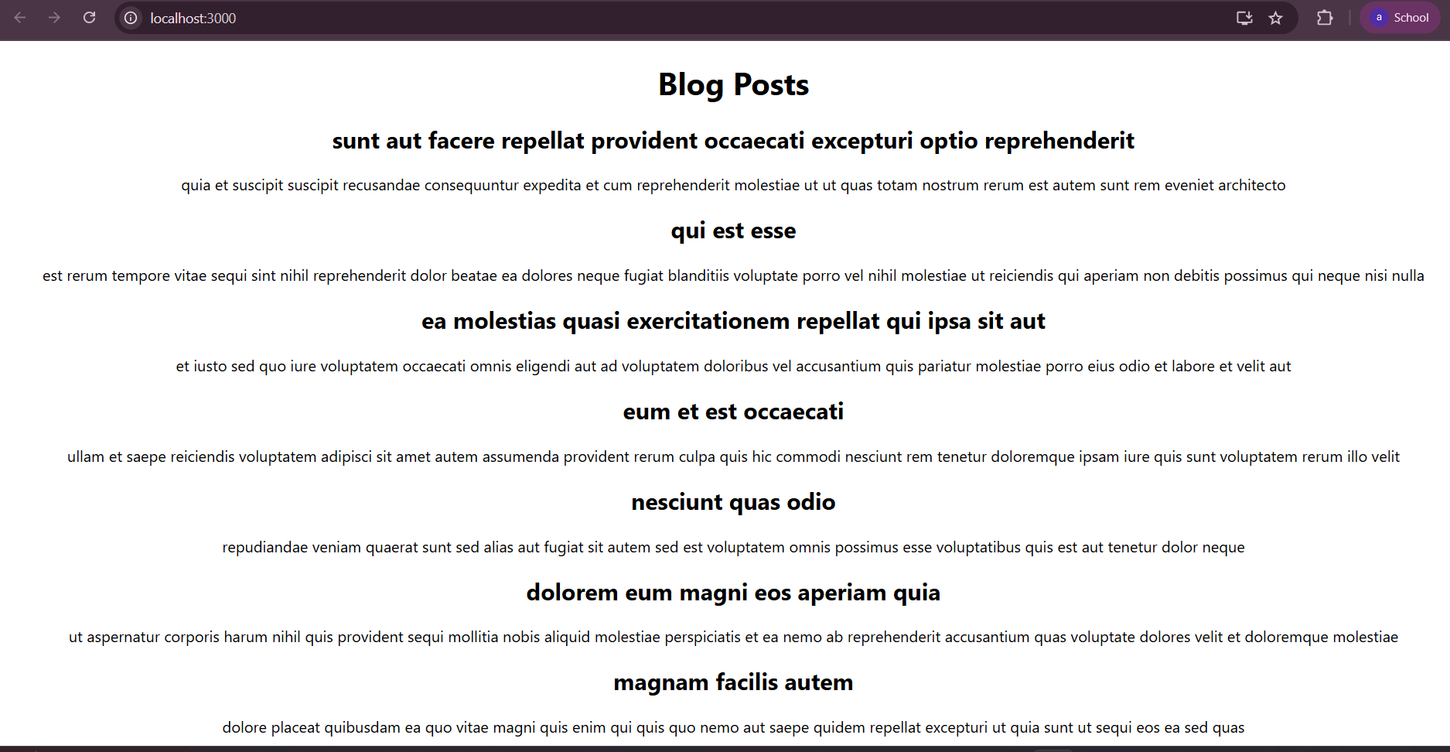

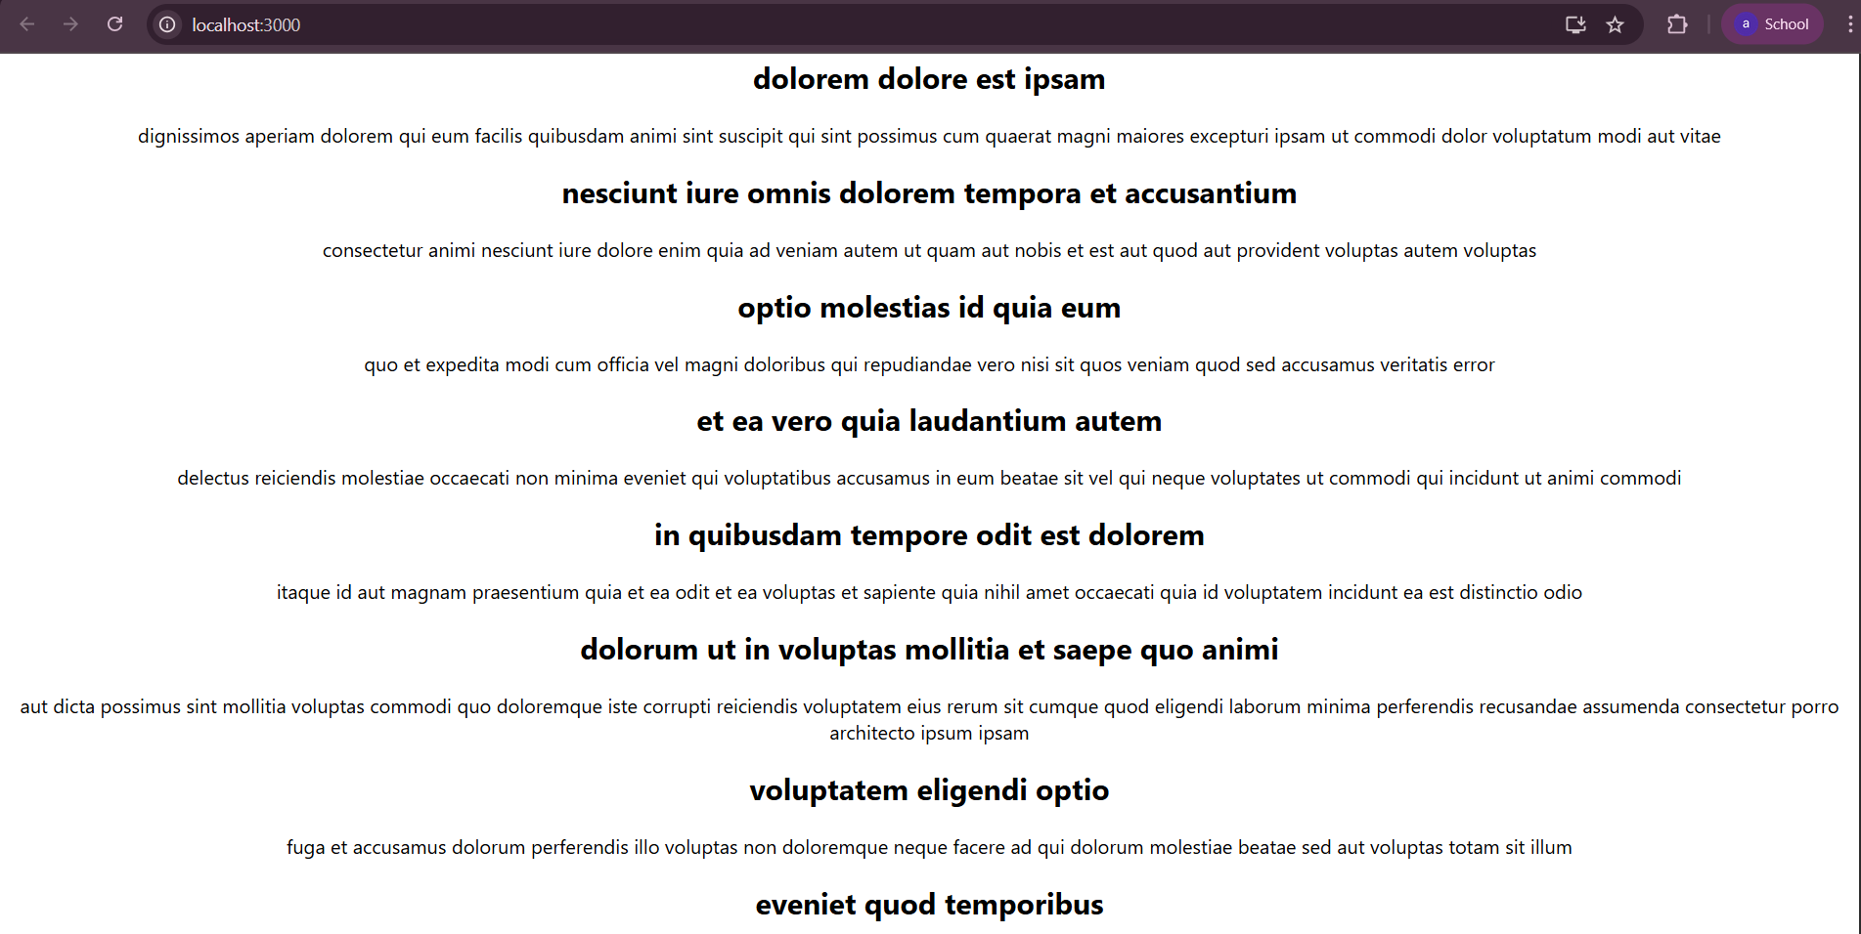

5.ReactJS-HOL
src/App.js
import logo from './logo.svg';
import './App.css';
import { CohortsData} from './Cohort'
import CohortDetails from './CohortDetails';

function App() {

return (
<div>
<h1>Cohorts Details</h1>
{CohortsData.map(cohort => <CohortDetails cohort={cohort}/>)}
</div>
);
}

export default App;

src/ CohortDetails.js
import styles from './CohortDetails.module.css';

function CohortDetails(props) {
return (
<div className={styles.box}>
<h3 style={{ color: props.cohort.currentStatus === 'Ongoing' ? 'green' : 'blue' }}>
{props.cohort.cohortCode} -
<span>{props.cohort.technology}</span>
</h3>
<dl>
<dt>Started On</dt>
<dd>{props.cohort.startDate}</dd>
<dt>Current Status</dt>
<dd>{props.cohort.currentStatus}</dd>
<dt>Coach</dt>
<dd>{props.cohort.coachName}</dd>
<dt>Trainer</dt>
<dd>{props.cohort.trainerName}</dd>
</dl>
</div>
);
}

export default CohortDetails;

src/CohortDetails.module.css
.box {
width: 300px;
display: inline-block;
margin: 10px;
padding: 10px 20px;
border: 1px solid black;
border-radius: 10px;
}

dt {
font-weight: 500;
}

Src/Cohort.js
class Cohort {
constructor(cohortCode,
startDate,
technology,
trainerName,
coachName,
currentStatus) {
this.cohortCode = cohortCode;
this.coachName = coachName;
this.trainerName = trainerName;
this.technology = technology;
this.startDate = startDate;
this.currentStatus = currentStatus;
}
}
const CohortsData =[
new Cohort('INTADMDF10','22-Feb-2022', '.NET FSD', 'Jojo Jose','Aathma', 'Scheduled'),
new Cohort('ADM21JF014','10-Sep-2021', 'Java FSD', 'Elisa Smith','Apoorv', 'Ongoing'),
new Cohort('CDBJF21025','24-Dec-2021', 'Java FSD', 'John Doe','Aathma', 'Ongoing'),
new Cohort('INTADMJF12','22-Feb-2022', 'Java FSD', 'To Be Assigned','Ibrahim', 'Scheduled'),
new Cohort('CDE22JF011','24-Dec-2021', 'Java FSD', 'Emma Swan','Apoorv', 'Ongoing'),
new Cohort('INTADMDF09','22-Feb-2022', 'Dataware Housing', 'Babjee Rao','Aathma', 'Scheduled'),
new Cohort('ADM22DF001','10-Sep-2021', '.NET FSD', 'Marie Curie','Ibrahim', 'Ongoing'),
];
export {Cohort, CohortsData};

Run the React App:
npm start

Output:
