Week 8 – GIT
Task 1 : Git Configuration, Notepad++ Setup, and Initial Commit
Objective :
To configure Git on the local machine, set up Notepad++ as the default editor, create a new Git repository, add a file, and make the first commit.
Step 1 – Check if Git is Installed
Command :
git –version
Explanation :
Displays the installed Git version to confirm Git is available on the system.
Step 2 – Configure Git Username and Email
Commands:
git config --global user.name "hemavarshini_25"
git config --global user.email sivabasker006@gmail.com
Explanation:
Sets your Git identity for commits across all repositories.
Step 3 – Verify Git Configuration
Command:
git config –list
Explanation:
Lists the current Git configuration, including the user name, email, and editor settings.

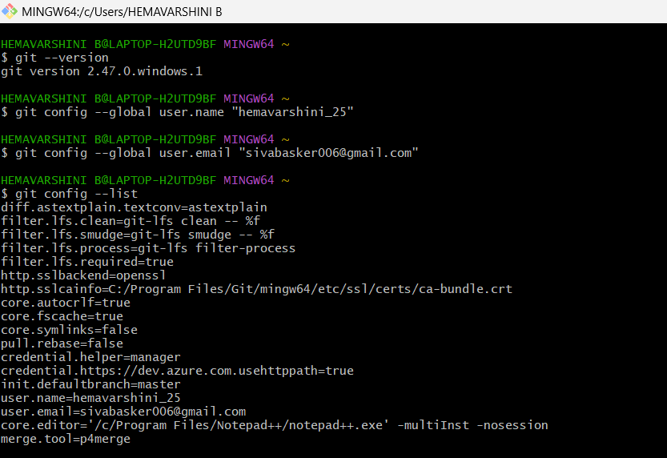
Step 4 – Set Notepad++ as Default Editor
Command :
git config --global core.editor "'/c/Program Files/Notepad++/notepad++.exe' -multiInst -nosession"
Explanation:
Configures Notepad++ as the default editor for commit messages.
Test Command:
git config -e –global
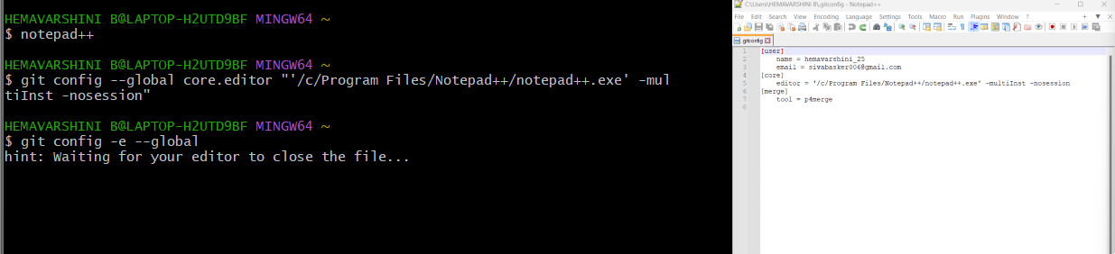

Step 5 – Create a Project Folder
Command:
mkdir GitDemo
Explanation:
Creates a new folder named GitDemo to store the project.
Step 6 – Navigate to the Project Folder
Command:
cd GitDemo
Explanation:
Moves into the GitDemo directory.
Step 7 – Initialize an Empty Git Repository
Command:
git init
Explanation:
Creates a new empty Git repository in the gitd folder.
Step 8 – Create a New File
Command:
notepad welcome.txt
Explanation:
Opens Notepad to create welcome.txt. Add text inside (e.g., Welcome to Git hands-on!) and save.
Step 9 – Check Repository Status
Command:
git status
Explanation:
Shows the state of the working directory. welcome.txt will appear under "Untracked files."
Step 10 – Stage the File
Command:
git add welcome.txt
Explanation:
Adds welcome.txt to the staging area.
Step 11 – Commit the File
Command:
git commit
Explanation:
Opens Notepad++ to enter a commit message. Example:
First Commit
Added welcome.txt
Git demo file

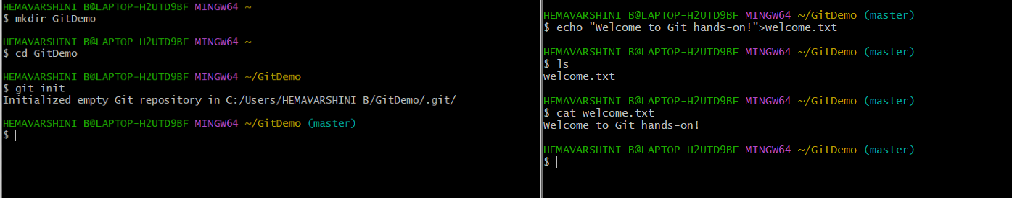

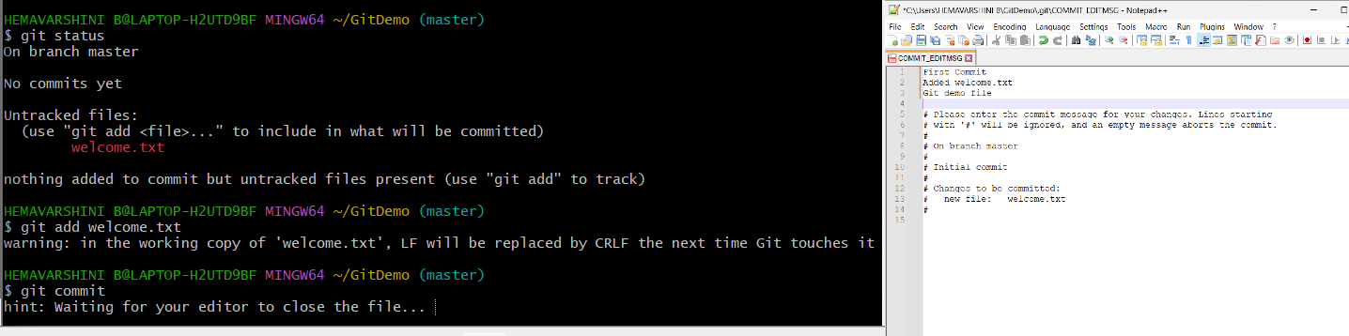

Step 12 – Link with GitLab
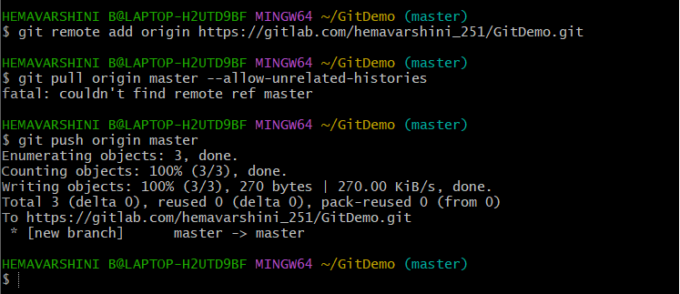
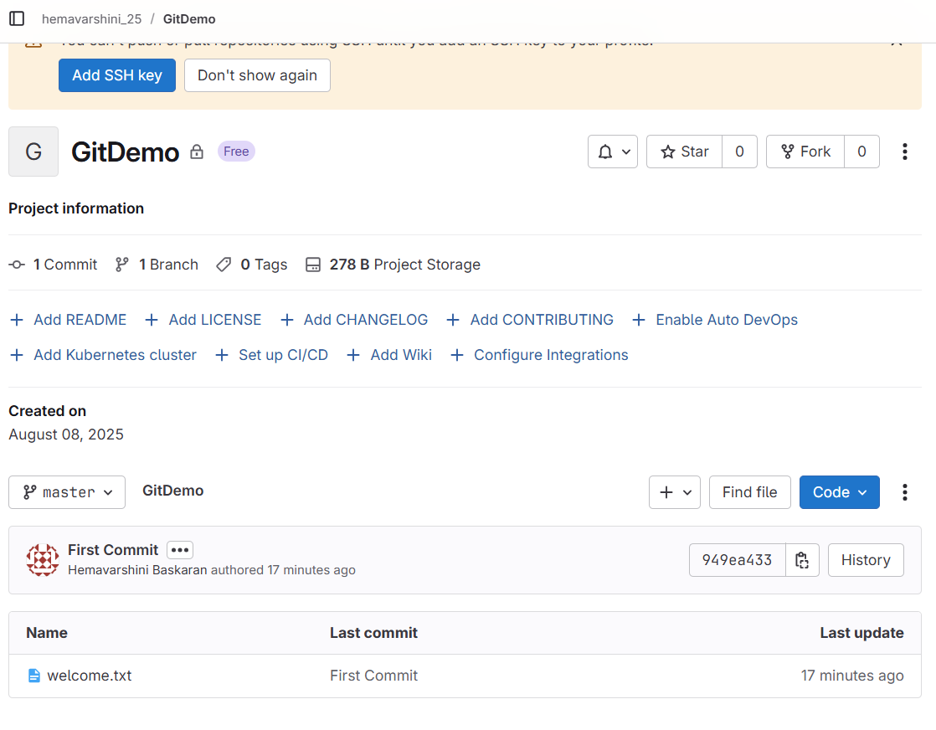

Task 2 – Using .gitignore to Ignore Unwanted Files
Objective:
To learn how to use .gitignore in Git to prevent specific files and folders from being tracked.
Step 1 – Navigate to the Repository
Command:
cd GitDemo
Explanation:
Moves into the local Git repository folder gitd where the .gitignore file will be created.
Step 2 – Create a .log File and a log Folder
Commands:
echo "This is a log file" > debug.log
mkdir log
echo "Folder log content" > log/example.txt
Explanation:
- debug.log is a sample log file.
- log/ is a folder containing a sample text file.
Step 3 – Check Git Status Before Ignoring
Command:
git status
Explanation:
Lists all untracked files. At this point, debug.log and log/example.txt should appear in the output.
Step 4 – Create a .gitignore File
Command:
notepad++ .gitignore
File Content:
*.log
log/
Explanation:
- *.log → ignores all files ending in .log.
- log/ → ignores the log folder and everything inside it.
Step 5 – Save .gitignore and Check Status Again
Command:
git status
Explanation:
Now debug.log and log/ should no longer appear in the untracked list, proving they are being ignored.
Step 6 – Stage and Commit .gitignore
Commands:
git add .gitignore
git commit -m "Added .gitignore to exclude log files and log folder"
Explanation:
Saves the .gitignore file to the repository so that the ignore rules are shared.

Step 7 – Push Changes to Remote Repository
Command:
git push origin master
Explanation:
Uploads the .gitignore file to the GitLab repository. The ignored files (debug.log and log/) will not appear in the remote repo.
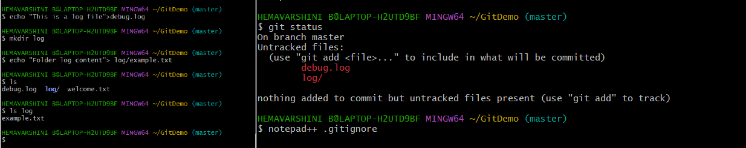

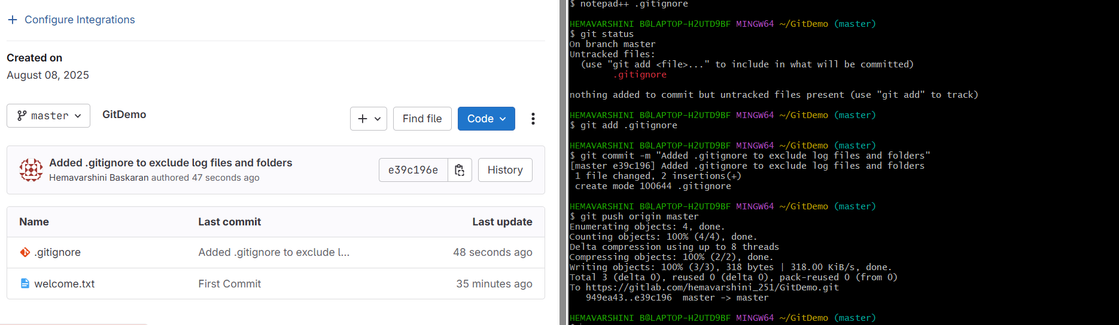

Task 3 – Branching and Merging
Objective:
To learn how to create a new branch, make changes, merge them into the main branch, and use both CLI and visual merge tools.
Part A – Creating and Working on a New Branch
Step 1 – Create a New Branch
Command:
git branch GitNewBranch
Explanation:
Creates a new branch named GitNewBranch from the current branch (master).
Step 2 – List All Local and Remote Branches
Command:
git branch -a
Explanation:
Lists all branches:
- * marks the current branch.
- Remote branches are prefixed with remotes/.
Step 3 – Switch to the New Branch
Command:
git checkout GitNewBranch
Explanation:
Moves your working directory to the GitNewBranch.
Step 4 – Add a New File in the New Branch
Commands:
echo "This is a new feature" > feature.txt
git add feature.txt
Explanation:
Creates feature.txt with sample content and stages it for commit.
Step 5 – Commit the Changes
Command:
git commit -m "Added feature.txt in GitNewBranch"
Explanation:
Commits the staged file to the GitNewBranch.
Step 6 – Check Status
Command:
git status
Explanation:
Verifies that there are no uncommitted changes in the branch.
Part B – Merging Changes
Step 1 – Switch Back to Master
Command:
git checkout master
Explanation:
Switches to the main branch to prepare for merging.
Step 2 – Compare Changes Between Branches
Command:
git diff master GitNewBranch
Explanation:
Shows differences in files between master and GitNewBranch.
Step 3 – View Visual Differences with P4Merge
Command:
git mergetool
Explanation:
Opens P4Merge to visually compare and resolve differences (only if configured).
Step 4 – Merge the Feature Branch into Master
Command:
git merge GitNewBranch
Explanation:
Merges all commits from GitNewBranch into master.
Step 5 – View Commit History After Merge
Command:
git log --oneline --graph --decorate
Explanation:
Shows a compact visual commit history with branch and merge points.
Step 6 – Delete the Merged Branch
Command:
git branch -d GitNewBranch
Explanation:
Deletes the branch locally since it has been merged.
Step 7 – Verify Status
Command:
git status
Explanation:
Ensures the working directory is clean after merging.
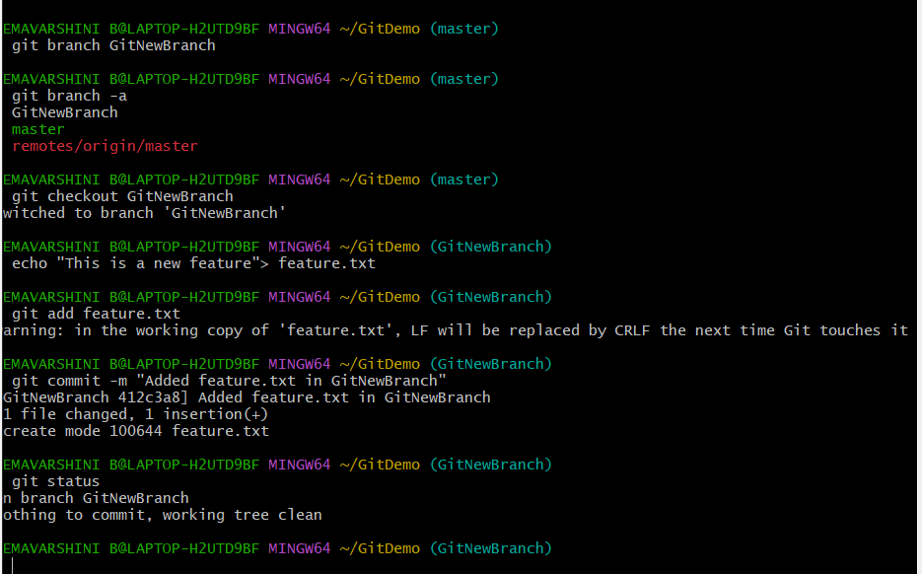
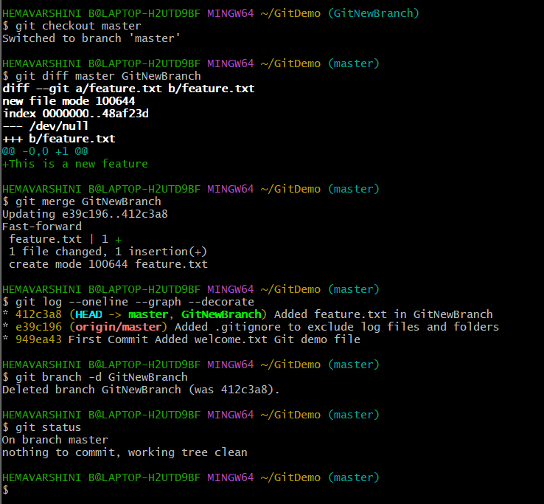
Task 4 – Conflict Resolution during Merge
Objective:
To intentionally create a merge conflict between two branches, resolve it manually or with a merge tool, and complete the merge process.
Part A – Creating the Conflict Scenario
Step 1 – Verify Clean Working Directory
Command:
git status
Explanation:
Checks if there are no pending changes before starting.
Expected Output:
On branch master
nothing to commit, working tree clean
Step 2 – Create a New Branch and Add hello.xml
Commands:
git checkout -b GitWork
notepad hello.xml
Explanation:
Creates a new branch GitWork and opens a file hello.xml to add content.
Sample content:
<message>Hello from GitWork branch</message>
Step 3 – Update hello.xml in GitWork
Commands:
echo "<update>Some update in GitWork</update>" >> hello.xml
git status
Explanation:
Appends additional content to the file and checks the modified status.
Step 4 – Commit the GitWork Changes
Commands:
git add hello.xml
git commit -m "Updated hello.xml in GitWork branch"
Explanation:
Stages and commits changes to GitWork.
Step 5 – Switch Back to Master
Command:
git checkout master
Explanation:
Moves back to the master branch to introduce conflicting changes.
Step 6 – Create a Conflicting hello.xml in Master
Commands:
notepad hello.xml
Add different content:
<message>Hello from master branch</message>
Step 7 – Commit the Master Branch Changes
Commands:
git add hello.xml
git commit -m "Added hello.xml in master"
Part B – Detecting the Conflict
Step 8 – View Both Branches’ Histories
Command:
git log --oneline --graph --decorate --all
Explanation:
Shows that the branches have diverged.
Step 9 – Compare the Files
Command:
git diff GitWork master -- hello.xml
Explanation:
Displays textual differences between the file in both branches.
Step 10 – Merge GitWork into Master
Command:
git merge GitWork
Explanation:
Attempts to merge, causing a merge conflict in hello.xml.
Step 11 – View Conflict Markers
Command:
cat hello.xml
Part C – Resolving the Conflict
Step 12 – Edit File to Resolve Conflict
Command:
notepad hello.xml
Resolved Content Example:
<message>Hello from master and GitWork branch</message>
<update>Some update in GitWork</update>
Step 13 – Stage and Commit Resolved File
Commands:
git add hello.xml
git commit -m "Resolved conflict and merged GitWork to master"

Step 14 – Handle Backup Files from Merge Tool
If hello.xml.orig or other backups exist:
Commands:
echo "*.orig" >> .gitignore
git add .gitignore
git commit -m "Added .orig files to .gitignore"
Step 15 – Delete the Merged Branch
Command:
git branch -d GitWork
Step 16 – Final Log Check
Command:
git log --oneline --graph --decorate
Explanation:
Confirms a clean merge with conflict resolved.

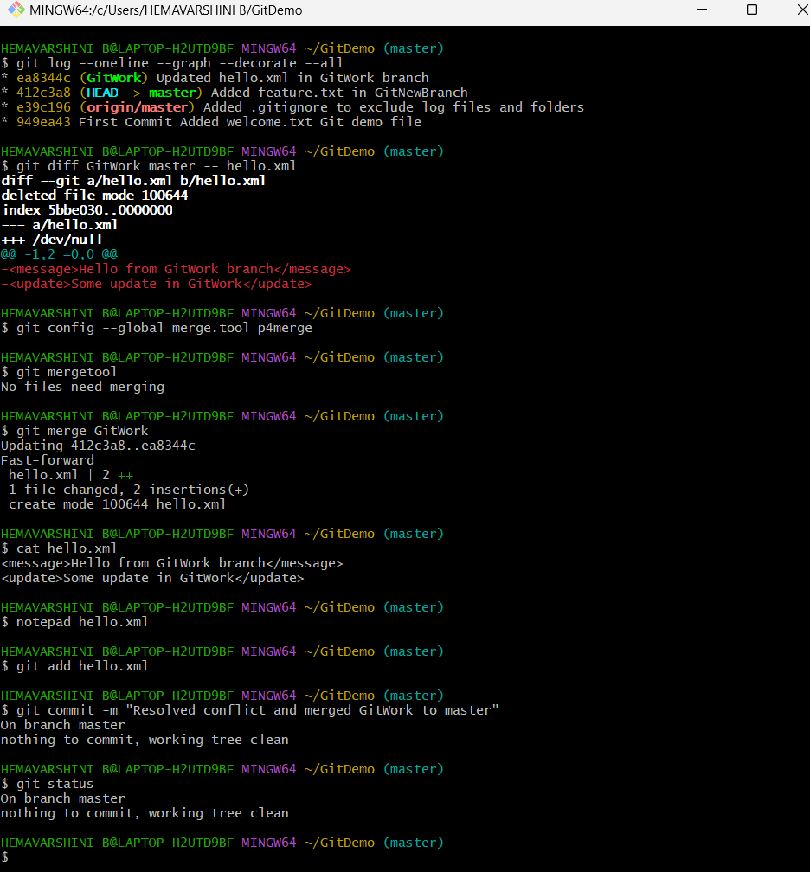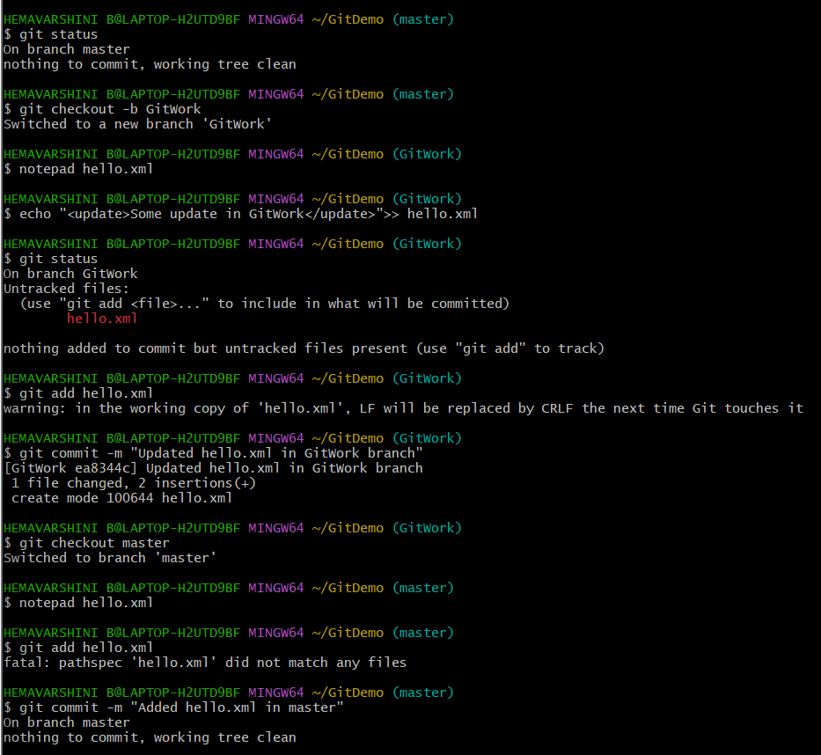
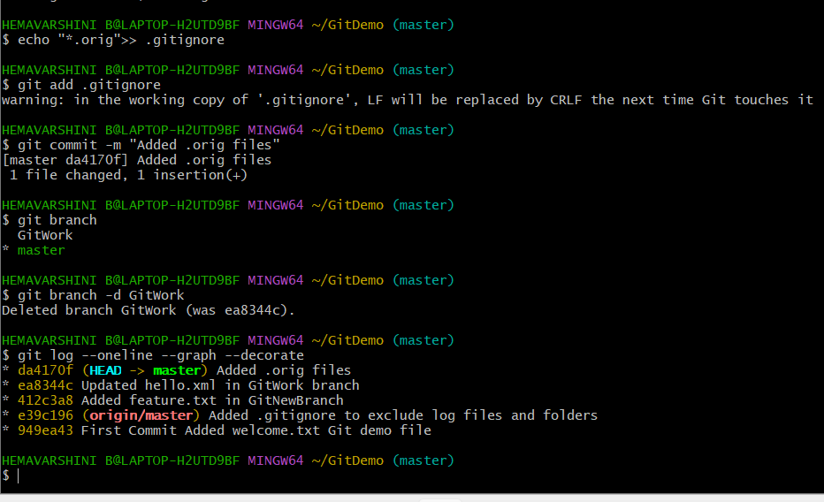

Task 5 – Clean up and Push Back to Remote Git
Objective:
To verify the repository state, pull the latest remote changes, push local changes to the remote repository, and confirm updates.

Step 1 – Verify if master is in a Clean State
Command:
git status
Explanation:
Checks if there are no uncommitted changes before pulling or pushing to remote.
Step 2 – List all Available Branches
Command:
git branch
Explanation:
Lists all local branches.
To also see remote branches:
git branch -a
Step 3 – Pull the Remote Repository to Master
Commands:
git checkout master
git pull origin master
Explanation:
Ensures you’re on master branch and pulls the latest changes from the remote.
If there are unrelated histories, use:
git pull origin master --allow-unrelated-histories
Step 4 – Push Local Changes to Remote
Command:
git push origin master
Explanation:
Uploads local commits from master to the remote repository.
If this is the first push for the branch:
git push -u origin master
Step 5 – Confirm Changes on Remote
Action:
Opened GitLab (or GitHub) repository in a browser.
Check for:
- The files updated in Task 4 (hello.xml, .gitignore, etc.).
- The latest commit message is visible.
- Branch is up to date with origin/master.
