**SERVERLESS IOT DATA PROCESSING** **PHASE 1 PROJECT**

**INTRODUCTION :**

Serverless IoT data processing is an approach that leverages serverless computing resources to analyze and manage data generated by Internet of Things (IoT) devices. Serverless data processing refers to the use of serverless computing technologies and architectures to process, analyze, and transform data without the need to manage traditional server infrastructure. This approach is often associated with cloud computing platforms like AWS Lambda, Azure Functions, Google Cloud Functions, and other similar services

**WORKING :**

1 )**Data Ingestion:** IoT devices collect data and send it to a cloud-based service, such as AWS IoT Core, Azure IoT Hub, or Google Cloud IoT Core.

2 )**Event Trigger:** These cloud services can be configured to trigger serverless functions, such as AWS Lambda, Azure Functions, or Google Cloud Functions, in response to incoming IoT data.

3 )**Data Processing:** Serverless functions process the incoming data. This can include data validation, transformation, aggregation, or even machine learning-based analysis, depending on your specific use case.

4 )**Storage and Database:** Processed data can be stored in a cloud database like AWS DynamoDB, Azure Cosmos DB, or Google Cloud Firestore for further retrieval and analysis.

5 )**Real-time Actions:** Serverless functions can also trigger real-time actions or alerts based on specific conditions detected in the IoT data. For example, sending notifications or activating IoT actuators.

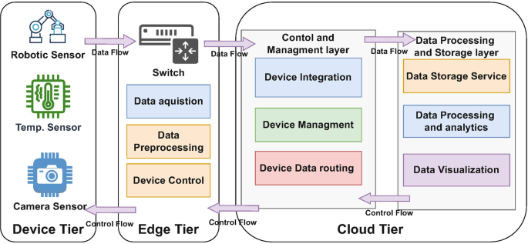

**Benefits of Serverless IoT Data Processing**:

* **Scalability:** Serverless platforms automatically scale based on the volume of incoming IoT data, ensuring efficient resource utilization.
* **Cost-Efficiency:** You only pay for the actual compute resources used during data processing, making it cost-effective for variable workloads.
* **Simplified Management:** Serverless platforms abstract infrastructure management, allowing developers to focus on code and application logic.
* **Fast Development:** Serverless functions can be developed and deployed quickly, accelerating IoT project development.
* **Integration:** Serverless platforms often integrate seamlessly with other cloud services, enabling you to build comprehensive IoT solutions.Keep in mind that while serverless IoT data processing offers many advantages, it may not be suitable for all IoT use cases, particularly those with extremely low-latency requirements or specialized hardware dependencies. It's essential to carefully assess your specific IoT project's needs before choosing your architecture.

**Merits (Advantages) of Serverless IoT Data Processing:**

Serverless platforms automatically scale based on incoming data volume. This ensures that your IoT system can handle variable workloads effectively without manual intervention. With serverless, you pay only for the compute resources used during data processing, making it cost-effective for variable workloads. There are no upfront costs or idle resource expenses. Serverless abstracts much of the underlying infrastructure management, allowing developers to focus on code and application logic. There's no need to provision or maintain servers. Serverless functions can be developed and deployed quickly, accelerating the development of IoT projects. Serverless platforms often integrate seamlessly with other cloud services, making it easier to build comprehensive IoT solutions that utilize databases, storage, messaging, and more.

**Demerits (Disadvantages) of Serverless IoT Data Processing:**

* + **Cold Start Latency:** Serverless functions may experience cold starts, which introduce a delay when the function is invoked for the first time or after being idle for a while. This can be problematic for applications with strict low-latency requirements.
  + **Resource Limitations:** Serverless functions have resource limits in terms of memory, execution time, and storage. Complex IoT processing tasks that exceed these limits may not be suitable for serverless.
  + **Vendor Lock-In:** Using a specific cloud provider's serverless platform can lead to vendor lock-in, making it challenging to migrate to another provider if needed.
  + **State Management:** Serverless functions are typically stateless, meaning they don't retain information between invocations. Managing state or long-running processes may require additional architectural considerations.
  + **Monitoring and Debugging:** Debugging and monitoring serverless functions can be more challenging compared to traditional server-based applications. You may need specialized tools and practices.
  + **Cost Control:** While serverless can be cost-efficient for many workloads, it's essential to monitor and control costs, as unexpected spikes in usage can lead to unexpected bills.
  + **Limited Execution Time:** Serverless platforms impose maximum execution time limits on functions. Long-running processes may need to be broken down into smaller tasks.
  + The suitability of serverless IoT data processing depends on your specific use case, requirements, and constraints. It's essential to carefully assess whether the advantages outweigh the disadvantages in your particular scenario and to design your system accordingly to mitigate potential limitations.

**APPLICATION :**

Serverless IoT data processing can have numerous day-to-day applications across various industries and use cases. Here are some common examples:

* **Smart Homes:** In smart homes, IoT devices like thermostats, cameras, and sensors continuously generate data. Serverless IoT data processing can be used to analyze this data for energy optimization, security monitoring, and home automation.
* **Industrial IoT (IoT):** In manufacturing and industrial settings, IoT sensors and devices monitor machinery, collect data on production processes, and ensure equipment maintenance. Serverless processing can help analyze this data for predictive maintenance, quality control, and process optimization.
* **Agriculture:** IoT sensors in agriculture collect data on soil moisture, weather conditions, and crop health. Serverless processing can help farmers make informed decisions about irrigation, pest control, and crop management.
* **Supply Chain and Logistics:** IoT devices track the movement and condition of goods in supply chains. Serverless processing can help optimize route planning, monitor inventory levels, and provide real-time shipment tracking.
* **Healthcare:** IoT devices, such as wearable fitness trackers and medical sensors, generate health data. Serverless processing can analyze this data for remote patient monitoring, early disease detection, and personalized healthcare recommendations.
* **Environmental Monitoring:** IoT sensors are used to monitor air quality, water quality, and wildlife habitats. Serverless processing can analyze environmental data for pollution control, conservation efforts, and disaster prediction.
* **Retail:** IoT devices in retail settings track customer behavior, inventory levels, and store conditions. Serverless processing can help retailers optimize store layouts, manage inventory, and offer personalized shopping experiences.
* **Smart Cities:** IoT sensors in smart city initiatives monitor traffic, energy usage, waste management, and public safety. Serverless processing can analyze this data to improve traffic flow, reduce energy consumption, and enhance public services.
* **Energy Management:** IoT devices in energy systems track energy consumption, production, and distribution. Serverless processing can optimize energy grids, detect anomalies, and implement demand response strategies.
* **Fleet Management:** IoT sensors in vehicles and logistics fleets provide real-time data on vehicle performance and location. Serverless processing can help optimize routes, manage fuel efficiency, and ensure vehicle maintenance.
* **Financial Services:** IoT devices are used in financial institutions to monitor security, detect fraud, and track customer behavior. Serverless processing can enhance security measures and fraud detection.
* **Sports and Entertainment:** IoT sensors in sports stadiums and entertainment venues can track attendance, crowd movement, and fan engagement. Serverless processing can improve fan experiences and safety.

These are just a few examples, and the possibilities for serverless IoT data processing are vast. The key is to identify specific data sources and processing needs in your industry or application and then design serverless solutions that address those requirements, making day-to-day operations more efficient and data-driven.

**DATA INTEGRATION:**

Smart home devices, such as thermostats, cameras, speakers, and lights, can generate a lot of data that can be used for various purposes, such as optimizing energy efficiency, enhancing security, and improving user experience. However, integrating data from different devices and platforms can be challenging, especially when it comes to ensuring data quality, privacy, and security. In this article, you will learn some of the most effective strategies for integrating data from smart home devices, and how they can help you achieve your data governance goals.

Objectives:

Before you start integrating data from smart home devices, you need to have a clear idea of what you want to achieve with the data, and how it aligns with your overall data governance strategy. For example, do you want to use the data for analytics, automation, personalization, or compliance? How does the data support your business objectives, customer needs, and regulatory requirements? By defining your data integration objectives, you can prioritize the data sources, formats, and quality standards that are relevant for your use cases.

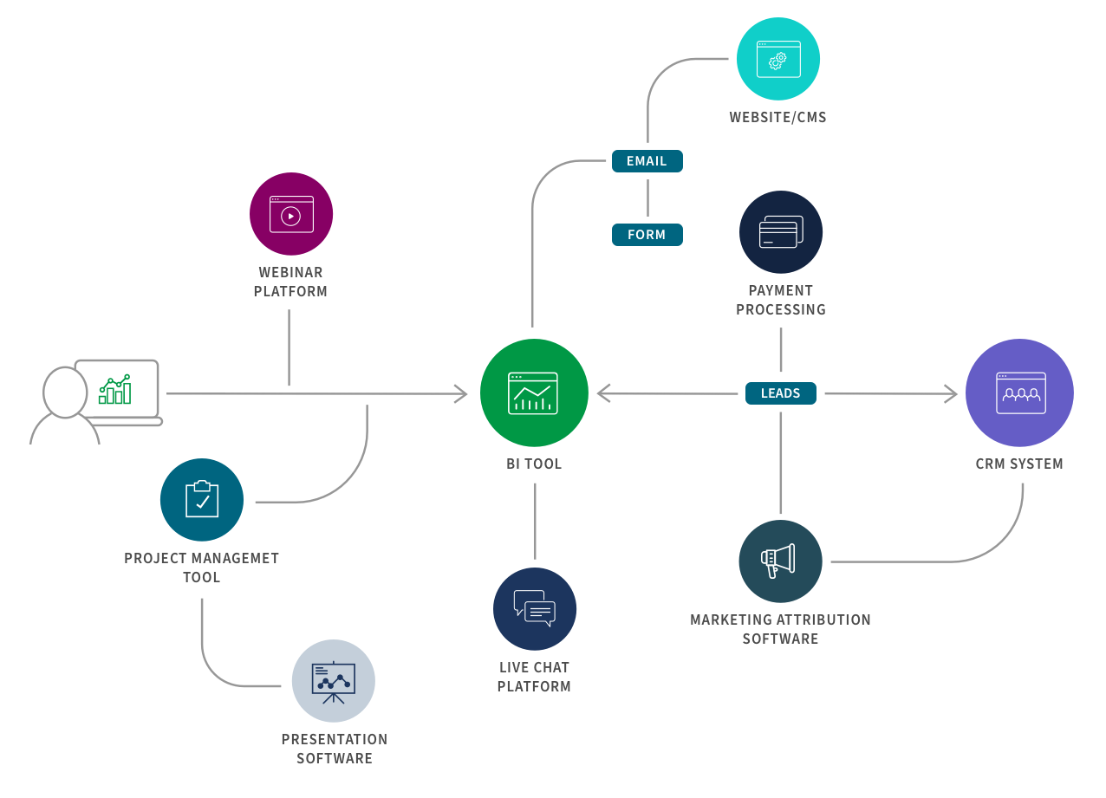

**DATA COLLECTION:**

The IoT data collection system leverages several principles for its proper operation. They include the following ones:

* **Scalability** — robust IoT data collection systems must be scalable enough to gather and store large volumes of data
* **Security** — IoT-based data collection systems must provide top-notch security to prevent data breaches or unauthorized access
* **Interoperability** — IoT data collection systems must be able to gather data from different devices
* **Flexibility** — IoT data collection systems must accept different data formats and adapt to changing requirement

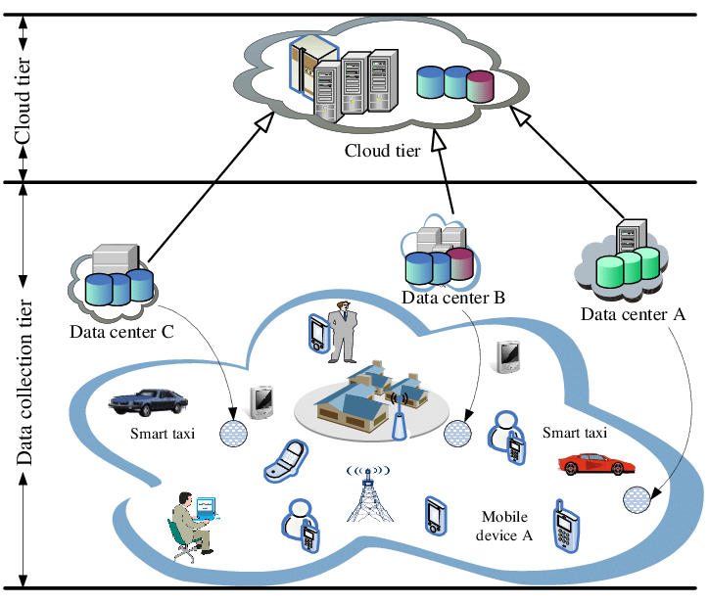

**REAL-TIME PROCESSING:**

Some of the significant challenges that are unique to the real-time performance analysis architecture implementation include:

* Desire to improve overall race time by 3% each year through gradually improving the cyclist's insight into each training event. With that insight, provide the opportunity to improve the results by closely monitoring gaps.
* Provide the opportunity to increase cyclists' momentum by allowing them to review biometrics and strength, and for the coach to guide the team in making appropriate adjustments during the training event or while preparing for the next race.
* Optimize cyclist recovery, exchanges, swapping, and form by allowing the cyclist and coach to review time lapse and series analysis.

This architecture features the ability to:

* Mine large quantities of data and provide easy-to-read reports combining various metrics.
* Provide real-time view of datapoints on a mobile device.
* Provide the ability to quickly process and review the results of a training session immediately after the race.

**AUTOMATION:**

Home automation is the smart management of all aspects related to security, well-being, and comfort of a home or building. Through a set of technologies, different systems are automated, controlled, administered, and optimized. 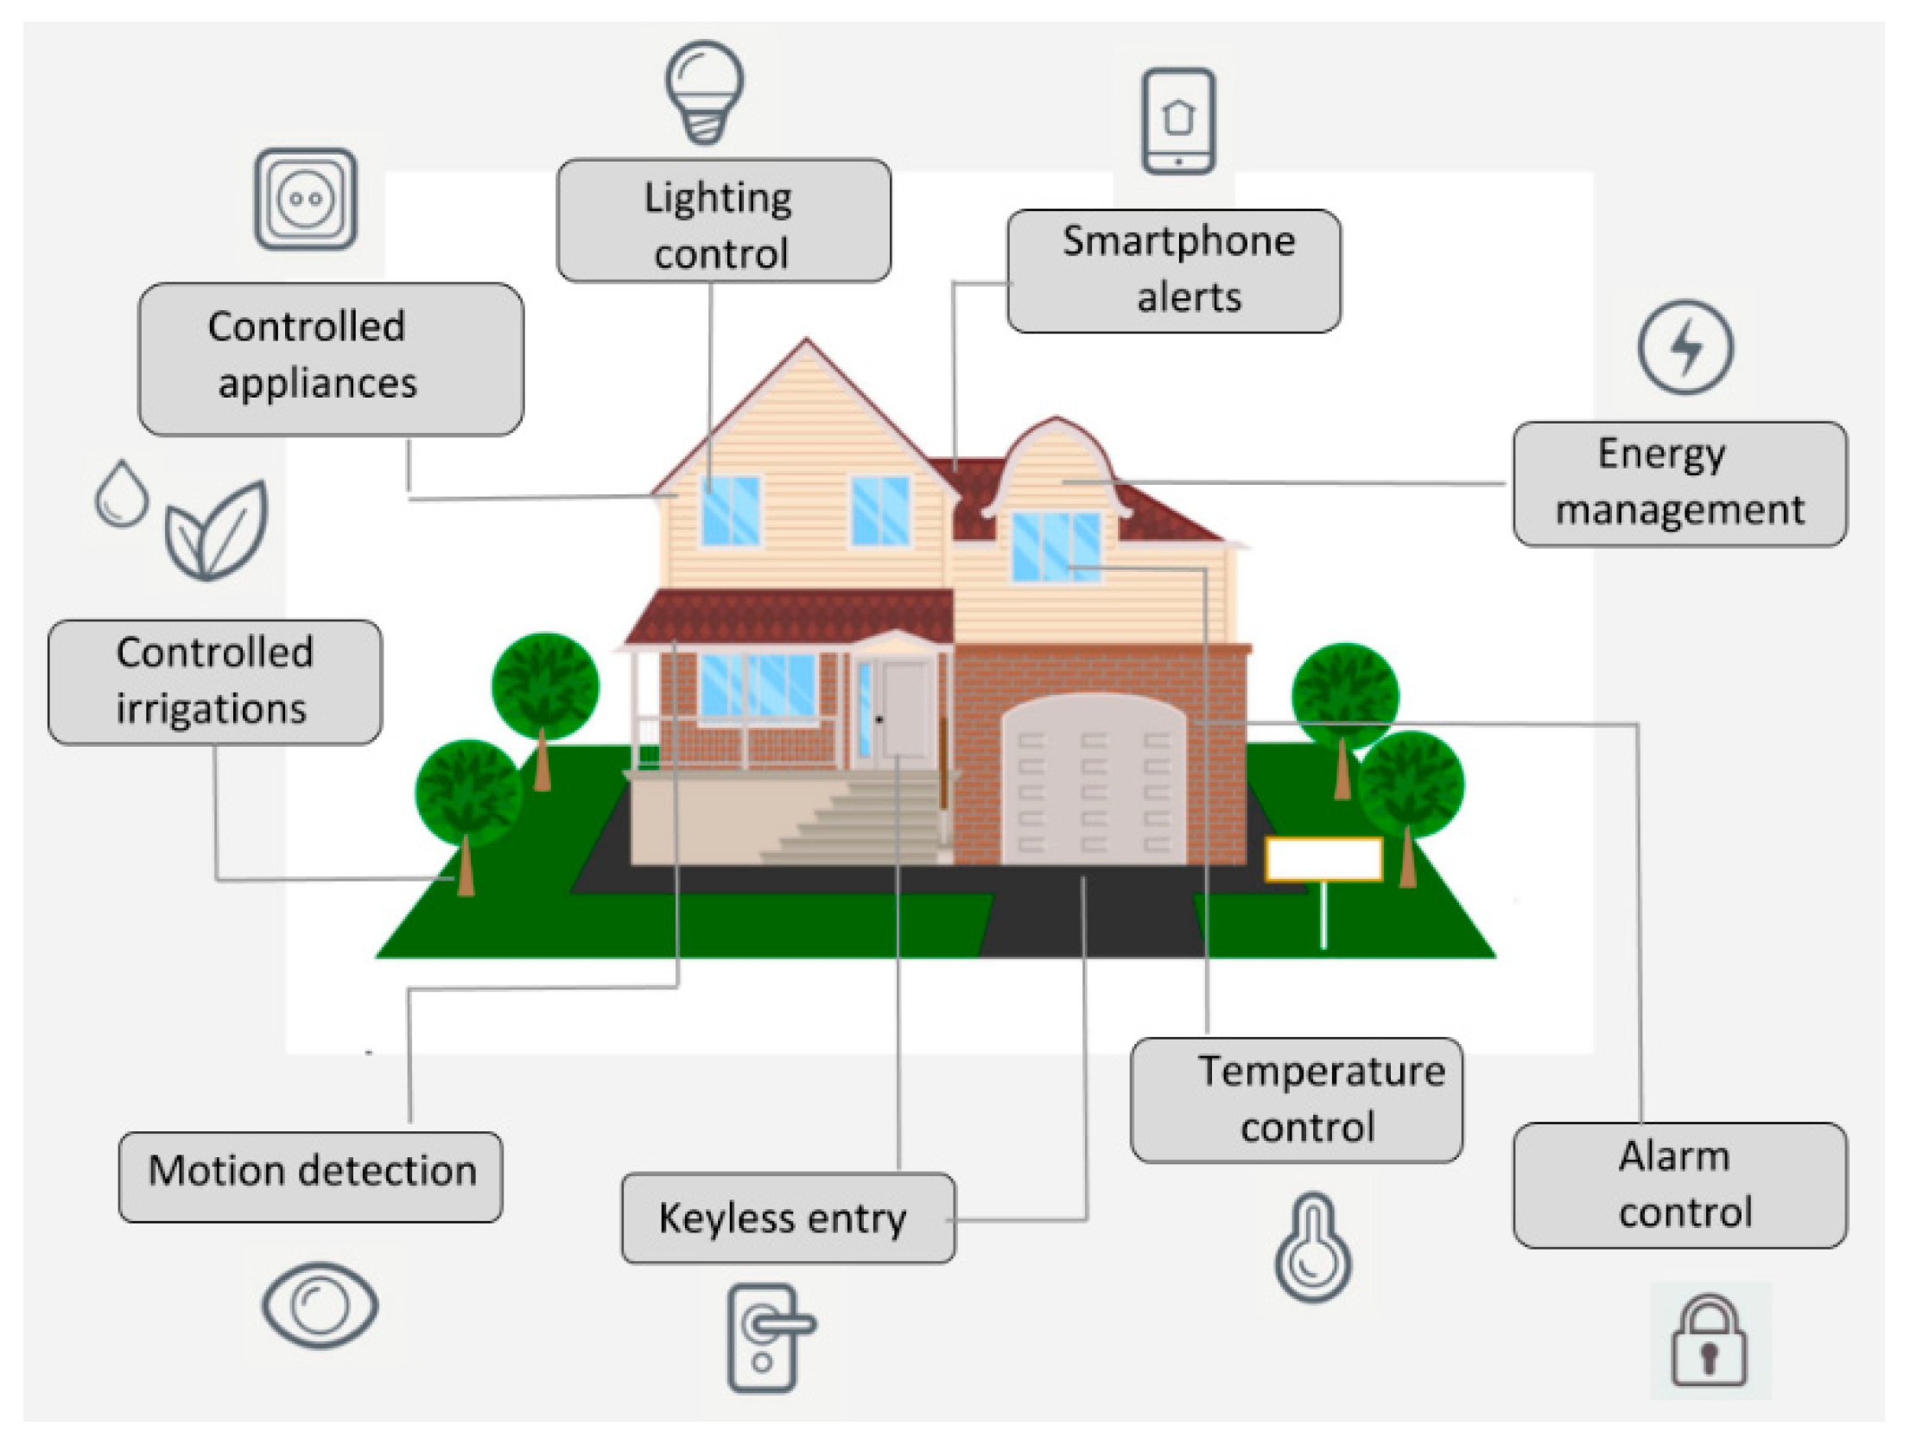

**STORAGE AND ANALYSIS:**

Cloud Storage is a mode of computer data storage in which digital data is stored on servers in off-site locations. The servers are maintained by a third-party provider who is responsible for hosting, managing, and securing data stored on its infrastructure. The provider ensures that data on its servers is always accessible via public or private internet connections.

Cloud analytics describes the application of analytic algorithms in the cloud against data in a private or public cloud to then deliver a result of interest. Cloud analytics involves deployment of scalable cloud

with powerful analytic software to identify patterns in data and to extract new insights.

Cloud analytics is often associated with [artificial intelligence (AI)](https://www.netapp.com/artificial-intelligence/what-is-artificial-intelligence), [machine learning (ML)](https://www.netapp.com/artificial-intelligence/what-is-machine-learning), and [deep learning (DL)](https://www.netapp.com/artificial-intelligence/what-is-deep-learning). And it is commonly used in industry applications such as scientific research in genomics or in oil and gas fields, business intelligence, security, Internet of Things (IoT), and many others. In fact, any industry can benefit from data analytics to improve organizational performance and to drive new value.

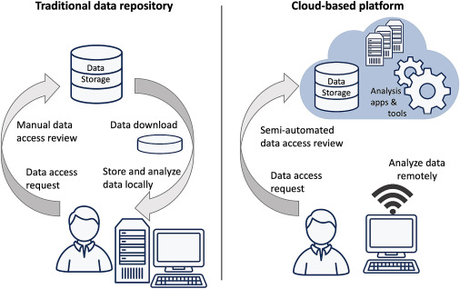

**CONCLUSION:**

Serverless IoT data processing have many applications in our day-to-day life and also leads the smart and comfortable lifestyle. These are survey we collected regarding this project. We will give good effort regarding this.

* Project was carried out by :
* Deepika Mol D.K
* Hemavathi.R
* Saranya.P
* Dharshini.C.S