COURSE INFORMATION: The DIKW Pyramid, Transformation Processes, and Information Quality
Course: Information and Communications Technology (ICT) | Grade: Grade 11 | Unit: Unit 01 - Information Systems and Emerging Technologies
Section: Section 04 - Data, Information, Knowledge, and Wisdom — The DIKW Hierarchy | Textbook: Unit 1, Pages 7–14

SECTION PURPOSE
This section thoroughly explores the theoretical and practical foundation of all Information Technology: the DIKW hierarchy (Data, Information, Knowledge, Wisdom). Students learn how raw unorganized facts are systematically enriched through processing, cognitive understanding, and ethical judgment to support critical decisions in business, governance, and daily life.

LEARNING OBJECTIVES
1. Define each tier of the DIKW hierarchy: Data, Information, Knowledge, and Wisdom.
2. Explain the specific transformation mechanisms (sorting, aggregating, contextualizing, analyzing) that convert data into higher tiers.
3. Evaluate information quality across accuracy, timeliness, completeness, relevance, and accessibility dimensions.
4. Analyze how Ethiopian institutions (Ethio Telecom, National Meteorology Agency, healthcare clinics) ascend the DIKW hierarchy.

MUST-TEACH CONCEPTS

1. Data (The Foundation Tier)
Definition: Raw, unformatted, and unorganized facts, figures, symbols, or observations that carry no inherent meaning or context on their own.
Explanation: Data represents discrete signals or measurements captured from the physical or digital world. Without an explanatory frame of reference, data cannot answer questions or guide action.
How it works: Collected via sensors, keyboards, barcode scanners, or automated transaction logs and stored in raw binary formats.
Example: A standalone sensor recording '24.5' or a telecom switch logging '0911234567, 180, 20261001'.

2. Information (Contextualized Data)
Definition: Data that has been processed, organized, structured, or contextualized so that it becomes meaningful, understandable, and useful to a recipient.
Explanation: Information answers foundational factual questions: 'Who?', 'What?', 'When?', 'Where?', and 'How many?'. It establishes relationships between isolated data points.
How it works: Transformed through processing functions: filtering noise, sorting, aggregating totals, calculating averages, and formatting into tables, reports, or charts.
Example: A monthly Ethio Telecom statement showing total call minutes, data usage in gigabytes, and billing charges in Ethiopian Birr (ETB).

3. Knowledge (Applied Understanding & Patterns)
Definition: The combination of contextualized information, experience, conceptual models, and cognitive rules that enables understanding of 'How' and 'Why'.
Explanation: Knowledge is actionable information synthesized within human minds or AI expert systems. It allows individuals to recognize recurring patterns, interpret causes of events, and predict future outcomes.
How it works: Constructed through cognitive reflection, learning, historical comparison, and expert analysis over time.
Example: A coffee agronomist in Jimma knowing that a temperature rise above 24 °C combined with humidity changes will trigger coffee rust fungal outbreaks in 7 days.

4. Wisdom (Judicious & Ethical Application)
Definition: The highest cognitive tier involving the synthesis of knowledge, experience, ethical values, and foresight to make the best possible decisions in complex situations.
Explanation: Wisdom deals with values, ethics, long-term impact, and unintended consequences. While knowledge asks 'How can we do this?', wisdom asks 'Should we do this, why should we do it, and what are the societal consequences?'.
How it works: Integrates technical feasibility, economic constraints, moral principles, environmental sustainability, and human welfare.
Example: A national ICT policymaker deciding how to balance expensive 5G urban network rollouts with rural 4G broadband subsidies to prevent widening socioeconomic inequality.

DETAILED TEACHING CONTENT

1. The Origin and Structure of the DIKW Hierarchy
The DIKW hierarchy, first formally formulated by information scientist Russell Ackoff in 1989 and expanded by modern computer science, provides the fundamental framework for understanding the nature of information. The relationship is typically depicted as a pyramid: Data forms the broad base, narrowing successively into Information, Knowledge, and Wisdom at the apex.
Each transition up the pyramid adds value and human context while reducing volume. Millions of raw transaction records (Data) condense into thousands of summary lines (Information), which distill into dozens of recognized operational principles (Knowledge), ultimately informing a handful of critical strategic decisions (Wisdom).

2. The Six Essential Attributes of High-Quality Information
Not all information is equally valuable. In professional computer science, the utility of information is evaluated against six standardized quality criteria: Accuracy, Timeliness, Completeness, Relevance, Consistency, and Accessibility.
Accuracy ensures that data is free from calculation and transcription errors. Timeliness guarantees that information arrives while it can still influence decisions—yesterday's weather forecast is useless for planting today. Completeness requires that all necessary parameters (e.g. units, date stamps) are present. Relevance ensures the recipient receives only information pertinent to their task, avoiding information fatigue. Consistency ensures that duplicate reports match across systems, and Accessibility guarantees authorized users can retrieve records without friction.

LMS + TEXTBOOK GAPS
[ADDED GAP] Topic: The 6 Standard Attributes of Information Quality
Source: Grade 11 Student Textbook (Pages 11–13)
Why relevant: The raw LMS text omitted formal information quality criteria (accuracy, timeliness, completeness, relevance, consistency, accessibility), which are mandatory on Ethiopian national exams.
Required content: Teach all 6 information quality dimensions with concrete negative examples (e.g. what happens when a bank balance is outdated vs incomplete).
[/ADDED GAP]
[ADDED GAP] Topic: Russell Ackoff's DIKW Historical Origin and Philosophical Model
Source: Grade 11 Student Textbook (Pages 7–9)
Why relevant: Provides historical academic grounding and explains the exact criteria distinguishing knowledge from wisdom.
Required content: Introduce the 1989 Ackoff model, contrasting factual answers (Information) with causal explanations (Knowledge) and ethical choices (Wisdom).
[/ADDED GAP]

KEY TERMINOLOGY
DIKW Hierarchy: A conceptual model describing the progressive cognitive transformation of raw data into information, knowledge, and wisdom.
Data: Unprocessed, unformatted facts and figures lacking context and inherent meaning.
Information: Data that has been processed, structured, and contextualized to answer factual questions (Who, What, When, Where).
Knowledge: Synthesized information integrated with experience, understanding, and reasoning to explain patterns and causality (How, Why).
Wisdom: The evaluated application of knowledge combined with ethics, values, and judgment to determine the optimal course of action.
Information Quality: The degree to which information meets standards of accuracy, timeliness, completeness, relevance, consistency, and accessibility.

TEXTBOOK FIGURES (SHOW THESE IN THE VIDEO)
Use these official textbook figures as on-screen visuals in the scenes that teach the matching concept. Prefer them over stock footage, and keep the figure caption as on-screen text.
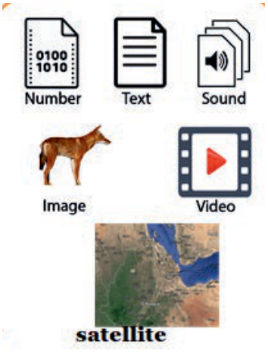
Figure 1.1: Different forms of data (textbook page 8)
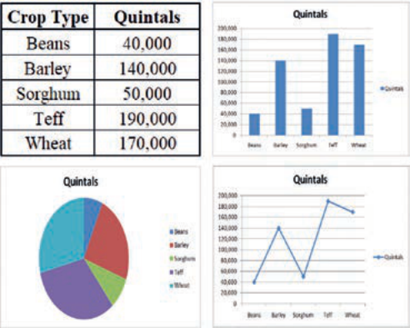
Figure 1.2: Different forms of information representation (textbook page 9)

Figure 1.3: Example of knowledge acquisition (textbook page 10)

Figure 1.4: Wisdom (textbook page 10)
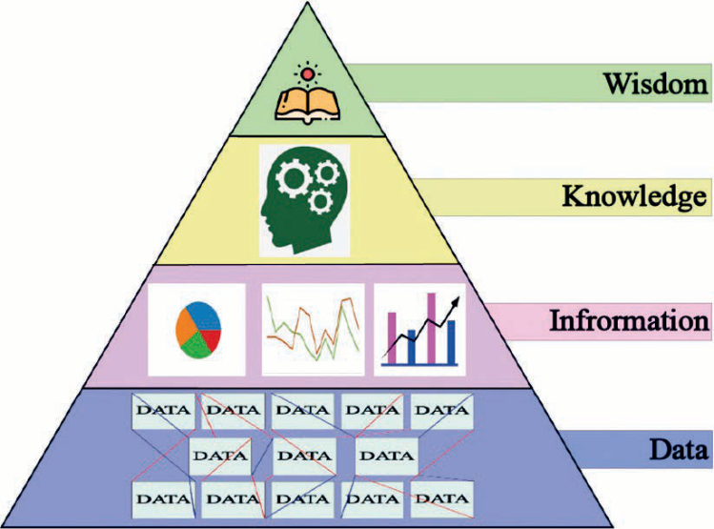
Figure 1.5: Data, Information, Knowledge and Wisdom (textbook page 11)

SECTION SUMMARY
• The DIKW hierarchy represents the four-stage progression: Data → Information → Knowledge → Wisdom.
• Data consists of raw unorganized symbols; Information provides contextual meaning answering Who/What/Where/When.
• Knowledge enables causal understanding of How/Why; Wisdom governs ethical, value-based decisions on What Should Be Done.
• High-quality information must satisfy accuracy, timeliness, completeness, relevance, consistency, and accessibility.

