COURSE INFORMATION: AI Fundamentals, Machine Learning Paradigms, NLP, Robotics, Expert Systems & Ethiopian Innovations
Course: Information and Communications Technology (ICT) | Grade: Grade 11 | Unit: Unit 02 - Hardware & Computer Architecture / Emerging Technologies
Section: Section 04 - Artificial Intelligence & Emerging Paradigms | Textbook: Unit 2, Pages 32–45

SECTION PURPOSE
This comprehensive section introduces students to Artificial Intelligence (AI) and its major sub-disciplines: Machine Learning, Deep Learning, Natural Language Processing, Robotics, and Expert Systems. It provides deep technical explanations of learning paradigms, examines real-world applications in agriculture, medicine, and governance, addresses critical ethical issues like algorithmic bias and data privacy, and highlights pioneering Ethiopian contributions including the Ethiopian Artificial Intelligence Institute (EAII) and iCog Labs.

LEARNING OBJECTIVES
1. Define Artificial Intelligence and differentiate between Narrow (Weak) AI and General (Strong) AI.
2. Compare the three primary machine learning paradigms: Supervised, Unsupervised, and Reinforcement Learning.
3. Explain the internal architecture and operational mechanisms of Expert Systems (Knowledge Base + Inference Engine).
4. Analyze the functions of Natural Language Processing (NLP) with specific application to Ethiopian languages (Amharic NLP).
5. Evaluate ethical, societal, and employment impacts of AI automation within the developing world context.
6. Identify the technological achievements of Ethiopian institutions (EAII, iCog Labs, Sophia robot contributions).

MUST-TEACH CONCEPTS

1. Artificial Intelligence (AI) and Cognitive Simulation
Definition: The branch of computer science focused on building hardware and software systems capable of performing tasks that traditionally require human intelligence.
Explanation: AI systems simulate cognitive capabilities including perception, language comprehension, pattern recognition, reasoning, planning, and adaptive learning from environmental feedback.
How it works: Operates through mathematical models, statistical inference, heuristic search algorithms, and multi-layered neural networks trained on vast datasets.
Example: The Ethiopian AI Institute automated satellite image classifier predicting crop yields across Oromia and Amhara regional states.

2. The Three Machine Learning Paradigms
Definition: The core computational approaches used to train models from data: Supervised Learning, Unsupervised Learning, and Reinforcement Learning.
Explanation: Machine learning fundamentally replaces manual hardcoded rules with statistical algorithms that discover internal mathematical representations directly from data samples.
How it works: Supervised trains on inputs paired with known target labels; Unsupervised identifies hidden clusters in unlabelled data; Reinforcement optimizes an agent's policy through trial-and-error environmental rewards.
Example: Training a spam email filter using 50,000 emails labeled as 'spam' or 'legitimate' (Supervised).

3. Expert Systems Architecture
Definition: A specialized AI program designed to emulate the decision-making and problem-solving abilities of human domain experts in a specific field.
Explanation: Unlike machine learning neural networks that rely on statistical weights, an expert system uses explicit formal human knowledge represented as logical rules (IF-THEN statements) combined with a reasoning engine.
How it works: Consists of two decoupled components: The Knowledge Base (storing verified facts and domain rules) and the Inference Engine (the reasoning algorithm that applies rules to user-submitted case data).
Example: An agricultural expert system where a farmer enters leaf spots and soil moisture, and the system deduces fungal blight and prescribes fungicide dosage.

4. Natural Language Processing (NLP) & Amharic Language Models
Definition: The subfield of AI focused on enabling computers to understand, interpret, manipulate, and generate human written and spoken language.
Explanation: NLP bridges the gap between structured computer code and ambiguous, context-dependent human languages. In Ethiopia, researchers develop specialized NLP tokenizers and acoustic models for Ge'ez script and Ethiopian phonetic nuances.
How it works: Employs morphological analysis, part-of-speech tagging, syntax parsing, semantic embeddings, and transformer neural networks.
Example: Automated Amharic speech-to-text transcription software deployed by EAII for public service hotlines.

DETAILED TEACHING CONTENT

1. The Evolution of Artificial Intelligence: From Rule-Based Systems to Deep Learning
For decades after the birth of computer science, software was constructed through explicit programming: human engineers had to anticipate every scenario and write explicit conditional statements. While effective for payroll calculations and banking ledgers, this approach completely failed for perceptual tasks like recognizing a handwritten letter or understanding spoken Amharic.
Artificial Intelligence revolutionized computing by introducing algorithms that learn mathematical functions directly from experience. Deep learning, which utilizes artificial neural networks composed of dozens or hundreds of stacked layers of synthetic neurons, has allowed computers to achieve superhuman accuracy in image classification, game-playing, and protein structure prediction.

2. The Ethiopian AI Ecosystem: EAII, iCog Labs, and National Impact
Ethiopia has established itself as an active innovator in the African AI landscape. In 2020, the government founded the Ethiopian Artificial Intelligence Institute (EAII) in Addis Ababa, dedicated to advancing AI research in healthcare, agriculture, transport, and national language infrastructure.
EAII researchers utilize satellite imagery coupled with computer vision models to perform nationwide drought monitoring, soil moisture assessment, and early harvest yield forecasting. In parallel, private initiative iCog Labs pioneered advanced robotics software, contributing core AI algorithms to Hanson Robotics' world-famous humanoid robot Sophia. These milestones prove that Ethiopian technologists are creators, not merely consumers, of cutting-edge AI.

3. AI Ethics, Algorithmic Bias, and Societal Responsibility
Because AI models learn patterns from historical data, they inevitably inherit and magnify historical human biases. Algorithmic bias occurs when training data underrepresents certain demographic groups, leading to discriminatory automated decisions in hiring, credit scoring, or facial recognition.
Furthermore, the rapid expansion of AI automation raises profound questions regarding job displacement in administrative and clerical sectors. Ethical AI development demands strict algorithmic transparency, data privacy protections under law, accountability frameworks, and human-in-the-loop oversight for all high-stakes public decisions.

LMS + TEXTBOOK GAPS
[ADDED GAP] Topic: Explicit Architectural Decoupling in Expert Systems
Source: Grade 11 Student Textbook (Pages 38–41)
Why relevant: The LMS mentioned expert systems but omitted the vital architectural separation of the Knowledge Base and Inference Engine, which is a key technical examination question.
Required content: Teach the components of an Expert System: Knowledge Base, Inference Engine (Forward vs Backward Chaining), and Explanation Facility.
[/ADDED GAP]
[ADDED GAP] Topic: Supervised vs Unsupervised vs Reinforcement Learning Comparison
Source: Grade 11 Student Textbook (Pages 34–37)
Why relevant: The three learning paradigms were listed in passing in LMS without their mathematical data requirements, error-correction mechanisms, and standard use cases.
Required content: Provide deep structured comparative teaching on labeled data, clustering, and reward-based agent policies.
[/ADDED GAP]
[ADDED GAP] Topic: Ethiopian AI Innovations: EAII and iCog Labs
Source: Grade 11 Student Textbook (Pages 43–45)
Why relevant: Integrates indigenous technology leadership, showcasing national achievements in robotics and satellite crop monitoring.
Required content: Highlight EAII mandate, agricultural computer vision projects, Amharic NLP models, and iCog Labs contributions to Sophia robot.
[/ADDED GAP]

KEY TERMINOLOGY
Artificial Intelligence (AI): The science and engineering of making intelligent machines and software capable of simulating human cognitive tasks.
Machine Learning (ML): A subfield of AI that develops algorithms capable of learning patterns and making predictions from data without explicit programming.
Deep Learning: A subset of ML based on artificial neural networks with multiple hidden layers that automatically extract hierarchical features from raw data.
Expert System: A knowledge-based AI system that emulates the decision-making ability of a human expert using a Knowledge Base and Inference Engine.
Natural Language Processing (NLP): The branch of AI that enables computers to understand, parse, translate, and generate human languages.
Algorithmic Bias: Systematic and repeatable errors in an AI system that create unfair outcomes, typically stemming from unrepresentative training datasets.

TEXTBOOK FIGURES (SHOW THESE IN THE VIDEO)
Use these official textbook figures as on-screen visuals in the scenes that teach the matching concept. Prefer them over stock footage, and keep the figure caption as on-screen text.
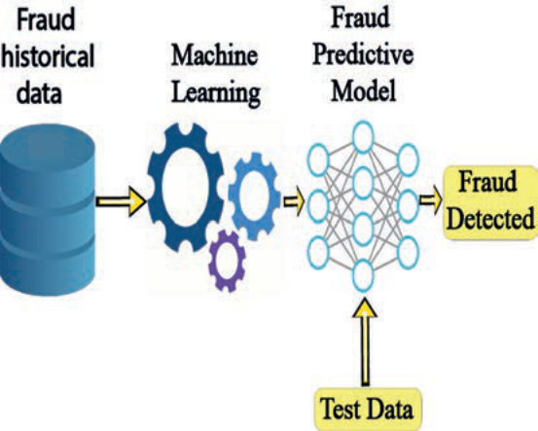
Figure 2.1: Fraud detection using machine learning (textbook page 35)
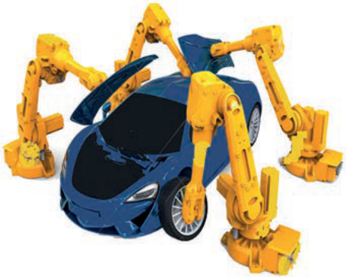
Figure 2.2: Robots in car manufacturing assembly line (textbook page 36)

Figure 2.3: Robot vacuum cleaner (textbook page 36)
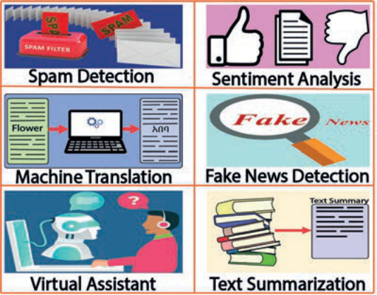
Figure 2.4: Applications of natural language processing (textbook page 37)
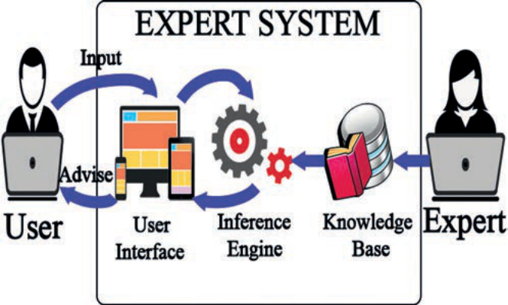
Figure 2.5: Expert system (textbook page 38)

Figure 2.6: Online shopping (textbook page 39)
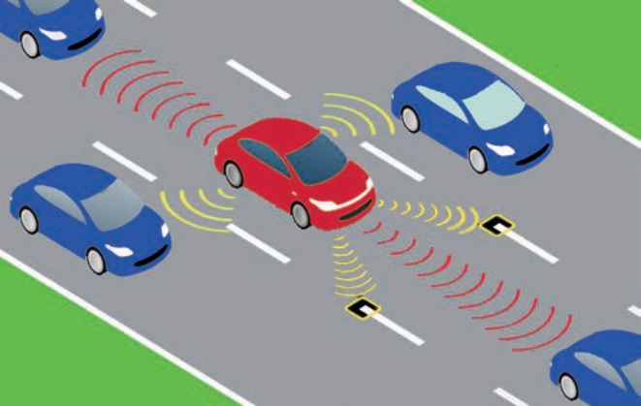
Figure 2.7: Autonomous car (textbook page 40)
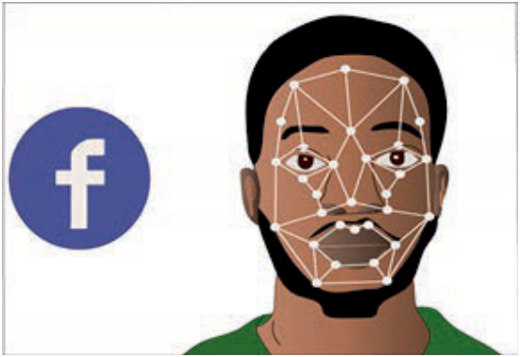
Figure 2.8: Facial recognition using AI (textbook page 40)
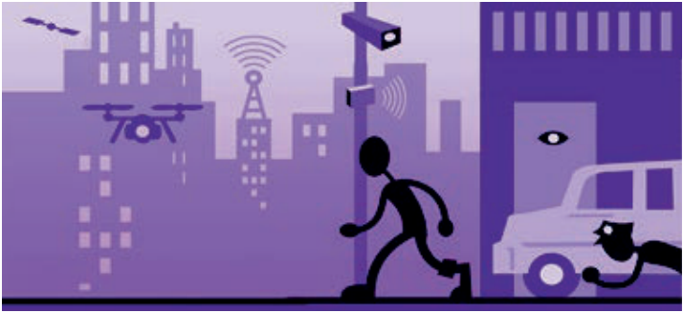
Figure 2.9: AI application in surveillance (textbook page 41)
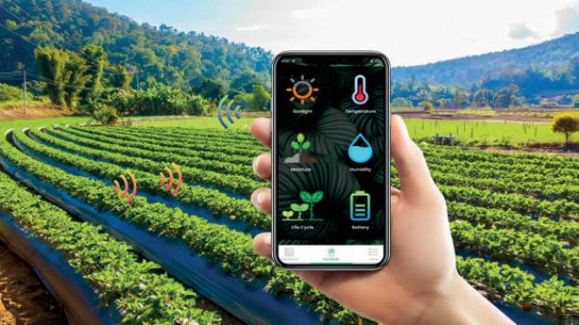
Figure 2.10: AI based agriculture Precision Farming (textbook page 41)

Figure 2.11: Chatbot (textbook page 42)
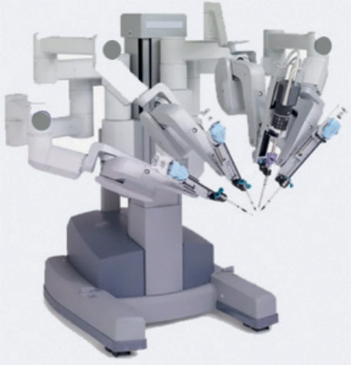
Figure 2.12: AI application in surgery (textbook page 42)
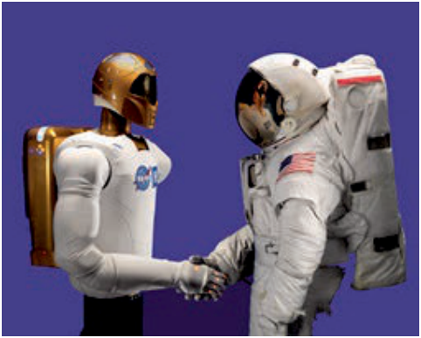
Figure 2.13: Robonaut and an astronaut (textbook page 43)

Figure 2.14: Smart home (textbook page 43)
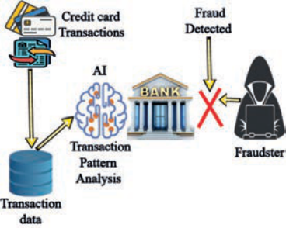
Figure 2.15: Application of AI in banks (textbook page 43)
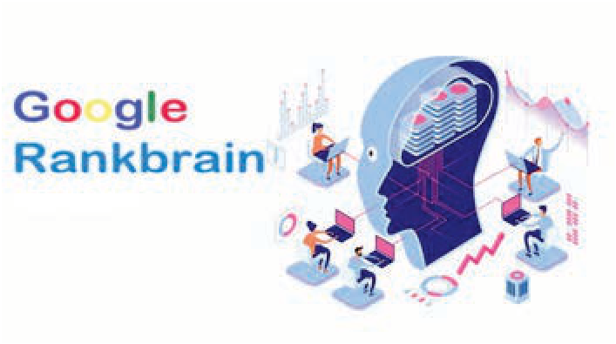
Figure 2.16: Google Rankbrain: Google’s application of AI (textbook page 44)

SECTION SUMMARY
• Artificial Intelligence simulates human perception, learning, reasoning, and problem solving using digital systems.
• Machine learning comprises Supervised (labeled), Unsupervised (unlabeled clustering), and Reinforcement (trial-and-error reward) paradigms.
• Specialized branches include NLP (language understanding), Robotics (physical actuation), and Expert Systems (rule-based deduction).
• Ethiopian institutions like EAII and iCog Labs actively develop localized AI solutions for agriculture, healthcare, and linguistics.
• Responsible deployment requires proactive mitigation of algorithmic bias, privacy risks, and employment displacement.

