Team Control Number
16226
Problem Chosen
B
2024
HiMCM/MidMCM
Summary Sheet

Let's Build a Green HPC Together !
Summary
In the face of the challenges of global climate change and sustainable development, the energy consumption and environmental impact of high performance computing ( HPC ) technology have attracted increasing attention. The purpose of this study is to quantify the annual energy consumption of HPC systems by establishing a comprehensive model, evaluate their carbon emissions and environmental impacts, and predict the development trend in 2030, so as to provide strategies and suggestions for the green development of HPC.
For Task I, we first collected and analyzed the energy consumption data of HPC systems in the United States and China from 2015 to 2023, and found that there were significant differences in the annual energy consumption of HPC systems under full load and average utilization conditions. Then we calculate the total energy consumption of the global HPC system, and define the problem under two conditions : full load operation and average utilization rate, which provides accurate basic data for subsequent carbon emission modeling.
For Task II, we give different energy structures of HPC energy consumption, including fossil fuels and renewable energy. Then a progressive model is designed : Firstly, an energy structure model is established to describe the distribution and sources of different energy sources in the total energy consumption. Then a carbon emission accounting model is established to calculate the carbon emissions of each energy consumption separately. Finally, the environmental impact model is established and the EII index is introduced to quantify the combined impact of carbon emissions on climate, ecology and air quality.
For Task III, starting from the growth trend of HPC, we first establish a prediction model to evaluate future energy demand, and calculate the total carbon emissions in 2030 by combining dynamic energy structure and carbon emission coefficient. Then, by introducing the environmental impact model, the comprehensive impact of different energy consumption on climate, ecology and air quality is quantified, and the prediction range under optimistic and pessimistic scenarios is further explored. In addition, our team also considered the potential impact of energy technology development and policy changes, and used HPC in Task I and Task II for simulation verification. The result is that the combination of high-growth HPC and traditional fossil fuel structure in the first scenario is expected to lead to a significant increase in carbon emissions by 2030, while the EII index is also growing. Under the second scenario, the annual growth rate of carbon emissions will decrease, but the overall emissions may still be high, but the EII index will decrease.
For Task IV, we extend the model by increasing the analysis of the proportion of renewable energy use and taking into account the impact of water consumption. We found that increasing the proportion of renewable energy and optimizing water resources management can further reduce the environmental impact of HPC. In addition, we propose an extended environmental impact index ( EII ) model to assess the environmental impact of HPC more comprehensively.
Finally, based on the model results, we propose a series of technical and policy recommendations to reduce the environmental impact of HPC. The simulation results of implementing these recommendations show that the carbon emissions of HPC can be significantly reduced by optimizing the energy structure and improving energy efficiency. We drafted a letter to the UN Advisory Committee recommending the inclusion of the environmental impact of HPC in the 2030 Development Goals.
Keywords: HPC, Energy Structure, Carbon Emission Accounting, Environmental Impact, EII

Contents
1 Introduction 3
1.1 Problem Background 3
1.2 Literature Review 3
1.3 Problem Restate 4
2 Assumptions and Justifications 4
3 Model Preparation 5
3.1 Notations 5
3.2 The Data 5
4 Task I Solution 6
5 Task II Solution 7
5.1 Energy Structure Model 8
5.2 Carbon Emission Accounting Model 9
5.3 Environmental Impact Model 10
6 Task III Solution 11
6.1 HPC Growth and Energy Demand Forecasting Model 11
6.2 Introduction of a Model of the Future Energy Mix 12
6.3 Carbon Emission Projections and Environmental Impact Analysis 12
6.4 Model Simulation Test 12
7 Task IV Solution 14
7.1 Impact of Increasing the Share of Renewable Energy Sources 14
7.2 Impact of Extension on Water Consumption 15
8 Task V Solution 17
8.1 Viable advice 17
8.2 Model Extension and Implementation 18
9 Sensitivity Analysis 21
10 Evaluation of the Model 22
10.1 Strengths 22
10.2 Weaknesses 22
11 Conclusion 22
Reference 23
Appendix 24

Introduction

Problem Background
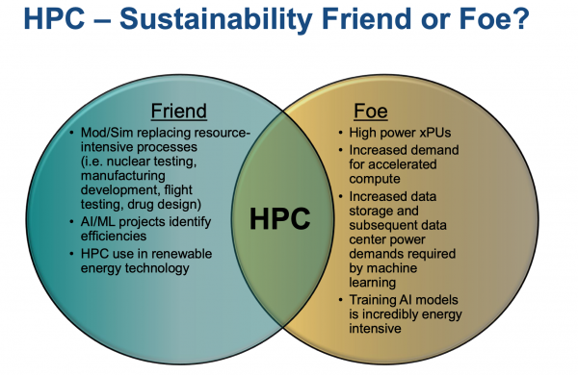  Figure. 1 HPC and Sustainbility | High performance computing ( HPC ) technology is developing at an alarming rate and is widely used in artificial intelligence, data science and financial technology^{[1]}. However, the rapid expansion of this technology has also caused increasingly serious environmental problems. The large-scale operation of HPC systems relies on high-energy-consuming data centers and advanced hardware, which not only leads to significant energy demand, but also has a profound impact on global carbon emissions and resource sustainability^{[2]}. Especially in areas where electricity is dominated by fossil fuels, the contribution of HPC energy consumption to climate change is particularly prominent^{[3]}.
In addition to energy issues, the environmental impact of HPC also involves multiple dimensions. For example, the large demand for cooling water in data centers may lead to water shortage and pollution risks. The generation of e-waste poses challenges to the recycling of rare metals and mineral resources, and the location and construction of data centers may lead to land use conflicts and ecosystem destruction^{[4]}. These complex environmental problems make it imperative to assess the full life cycle environmental impact of HPC, and also put forward higher requirements on how to achieve the balance between technology and sustainable development goals^{[5]}.

Literature Review
In the current context of global climate change and sustainable development, the construction and operation of energy big data centers have become a key link in achieving the "dual carbon" goals (carbon peak and carbon neutrality). Sun, Wang, and Ai^{[6]} explored the impact mechanism of big data development on carbon emissions in Chinese counties through empirical research, providing a theoretical basis for carbon emission reduction at the county level. Chang, Jin, and Xue^{[7]} analyzed the impact of big data strategy on carbon emissions from electricity consumption from the quasi-natural experiment of national big data comprehensive pilot zones, providing empirical support for the application of big data technology in the energy field. Yang^{[8]} analyzed the impact of carbon peak and carbon neutrality on data centers, presenting potential challenges and opportunities for data centers in achieving carbon emission reduction targets. Mao et al.^{[9]} studied the "Green Energy Code" system based on energy big data centers, exploring the system's potential in promoting energy consumption and carbon emission monitoring. Shuai^{[10]} discussed the combination of energy big data and carbon emission monitoring from the perspective of enterprise management, providing new ideas for corporate carbon emission management. Yang and Yuan^{[11]} discussed the construction of Zhangjiakou Energy Big Data Center under the "dual carbon" background, emphasizing the center's important role in promoting regional energy transition and improving energy efficiency. Bu^{[12]} analyzed the problems and countermeasures in the construction of energy big data centers driven by "carbon neutrality," providing strategic guidance for the low-carbon development of data centers. Huang, Zhao, and Yang^{[13]} conducted an in-depth study on the carbon emission accounting methods of data centers under the "dual carbon" goal and demonstrated the application effects of the accounting methods through case analysis. The unveiling of the Qinghai Province Smart Dual Carbon Big Data Center^{[14]} marks the local government's active exploration in promoting the integration of energy big data and carbon emission management. Zhu et al.^{[15]} studied the impact of including data centers in the national carbon emission trading market from a policy mechanism perspective, providing a new perspective on carbon asset management for data centers.

Problem Restate
- Quantify the annual energy consumption of global High-Performance Computing (HPC) systems, analyzing their energy demands under both full capacity and average utilization conditions. This assessment establishes the role of HPC in global energy use and lays the foundation for evaluating its environmental impact.
- Develop a comprehensive model to assess the carbon emissions resulting from HPC energy consumption. The model should account for different energy mixes, such as fossil fuels and renewable sources, and evaluate their contributions to overall emissions to provide insights for optimization.
- Use the constructed model to predict the potential environmental impacts of HPC under future scenarios, including technological advancements, increased energy demand in other sectors, and changes in energy production structures. Estimate the energy demand and carbon emissions of HPC by 2030, providing bounds for the problem's scale.
- Expand the model to include scenarios involving increased use of renewable energy, analyzing its potential for carbon emission reduction. Further, extend the model to incorporate other environmental impact areas (e.g., water usage or electronic waste) to comprehensively evaluate HPC’s environmental effects. Explain the relationship between the expanded focus and energy consumption.
- Based on the model results, propose technical and policy-oriented recommendations to reduce HPC's environmental impact. Simulate the effects of implementing these recommendations and draft a letter to the United Nations Advisory Board, urging them to include HPC's environmental impacts in their 2030 development goals, supported by findings and actionable insights.
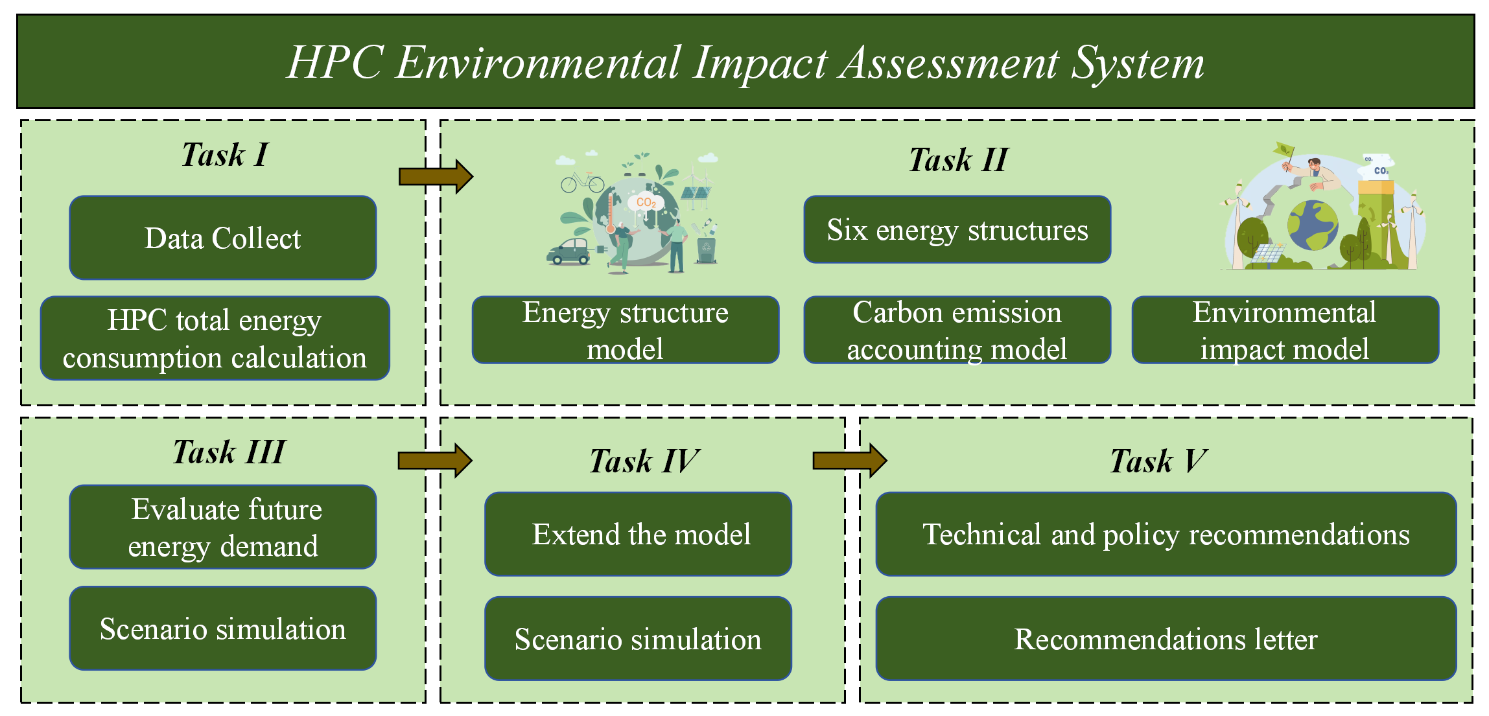
Figure. 2 Flow Chart

Assumptions and Justifications
- Assumption 1: Energy consumption is linearly proportional to HPC computational load
High-performance computing systems typically adjust resource usage based on computational demand. Assuming a linear relationship between energy consumption and computational load simplifies the analysis and provides a foundation for more complex, non-linear models. This assumption allows the total energy demand of HPC to be estimated using data on full capacity and average utilization.
- Assumption 2: Energy mix remains relatively stable in the short term
In many regions, the composition of energy production (e.g., the proportion of fossil fuels versus renewable energy) changes gradually. Assuming a stable energy mix in the short term provides clear input parameters for the model, enabling an initial assessment of carbon emissions under current conditions and serving as a baseline for future scenario predictions.
- Assumption 3: Hardware and cooling system efficiencies are constant within model’s scope
Although hardware and cooling system efficiencies may improve over time, their rates of improvement are typically negligible in the short term. Assuming constant efficiency simplifies the model and allows the focus to remain on the relationship between energy production and consumption rather than the complexities of technological advancements.
- Assumption 4: Carbon emission factors are directly related to the type of energy used
Each energy source (e.g., coal, natural gas, solar, wind) has a specific carbon emission factor, which is derived from empirical data and research. Assuming a direct relationship between carbon emission factors and energy types provides a clear rule for estimating the total carbon emissions of HPC systems based on the energy mix used.

Model Preparation

Notations
Table 1 Notations Used in this Paper
Symbol | Description
$$E_{\text{full }}$$ | annual energy consumption of full-load operation
$$E_{\text{avg }}$$ | annual energy consumption for specific average utilization operation
$$E_{\text{total }}$$ | total energy consumption of the global HPC system
$$P_{i}$$ | the ratio of each energy source
$$C_{\text{electricity }}$$ | carbon emissions from electricity consumption
$$EII$$ | Environmental Impact Index
$$C_{\text{waste }}$$ | Carbon emissions from waste disposal

The Data
This paper collects carbon emission data from some supercomputing centers in the United States and China. All the data used in this paper are from the existing literature^{[16-27]},as shown in table 2.

Table 3 Data Source
Data | Source
2020 U.S. Electricity Data | https://www.eia.gov/electricity/state/
Tianjin (Tianhe-1A) Power Composition | https://www.sohu.com/a/493876985_121025296
Energy Composition (Dallas) | https://www.dobigdata.cn/4972.html
Energy Composition (Northern Virginia) | https://www.eia.gov/state/analysis.php?sid=VA
Energy Composition (Silicon Valley) | https://assets.kpmg.com/content/dam/kpmg/cn/pdf/zh/2023/10/statistical-review-of-world-energy-2023.pdf
Dallas Data Center Power Consumption | https://www.dobigdata.cn/4972.html
Northern Virginia Data Center Power Consumption | https://m.chinaaet.com/article/3000163044
U.S. Data Situation | https://www.heywhale.com/mw/dataset/621ee4c8e3d3a00017a745ad/file
Wuxi (Sunway TaihuLight) Power Composition | https://www.huaon.com/channel/distdata/961139.html
Shenzhen Power Composition | https://www.sznews.com/news/content/2021-05/25/content_24244251.htm
Tianhe-1 Power Consumption Data | https://news.sohu.com/20101118/n277711710.shtml
Sunway TaihuLight Power Consumption Data | http://finance.people.com.cn/n1/2016/0621/c1004-28464929.html

Task I Solution
Our team collected relevant HPC energy consumption data for the U.S. and China from 2015 to 2023^{[16-27]}, and then quantified the annual energy consumption of the HPC systems under both full load operation and average utilization conditions. The specific data for 2023 is shown in the table 3 below:
Table 4 Relevant HPC Energy Consumption Data
HPC | Total annual energy consumption | Average utilization rate
Tianhe-1, PRC spacecraft series | 404 | 85%
Shenwei TaihuLight | 150 | 87%
Shenzhen Cloud Computing Center (SCC) | 379 | 90%
Northern Virginia, US state | 2552 | 90%
Dallas Data Center | 654 | 89%
Silicon Valley | 615 | 88%
We then visualize the total annual energy consumption of these HPCs. The results are shown in figure 3 below.
Figure. 3 Total Annual Energy Consumption of HPC
We then need to clarify the scope of the problem as shown below:
- Definition of Annual Energy Consumption: The total amount of electrical energy consumed by the HPC system over the course of a full year (365 days) of operation, usually in megawatt-hours (MWh).
- Two modes of operation: The energy consumption of the HPC system needs to be calculated separately for the following two scenarios:
- Full load operation: The situation where the HPC system is continuously running at maximum power consumption (theoretical upper limit).
- Actual operation (average utilization): The HPC system operates according to actual task requirements, usually reflecting its actual load in the form of average utilization.
The power consumption of an HPC system is mainly determined by the computing hardware (e.g., CPUs and GPUs), storage devices, network facilities, and cooling systems. In practice, the load of HPC is affected by various factors such as work tasks, time cycles (e.g., peaks and troughs), equipment maintenance, etc., so the utilization rate is usually lower than the full-load state. Then this paper specifically defines the annual energy consumption of full-load operation as follows:
 | $$E_{\text{full }}=P_{max}×T_{\text{year }}$$ | (1)
The formula represents the total energy required for the HPC system to run continuously throughout the year at full power consumption. Then define the annual energy consumption for specific average utilization operation:
 | $$E_{\text{avg }}=P_{\text{max }}×U_{\text{avg }}×T_{\text{year }}$$ | (2)
This formula takes into account the average utilization of the HPC system and is able to reflect its energy consumption under actual operating conditions. Where $P_{max}$ is the full-load power consumption of the HPC system (in MW). $U_{\text{avg }}$ is the average utilization rate of the HPC system (in percent). $T_{\text{year }}$ is the total running time in a year (unit: hours, fixed at 8760 hours). $E_{full}$ is the annual power consumption when running at full load (in MWh). $E_{\text{avg }}$ is the annual energy consumption (in MWh) when running at average utilization. Next the college calculates separately $E_{\text{full }}$ and $E_{\text{avg }}$ , use the collected data to substitute into the formulas to calculate the annual energy consumption under full load and average utilization conditions, respectively. If there are multiple HPC data centers, the energy consumption of each data center is calculated and then summed to arrive at the total energy consumption of the global HPC system:
 | $$E_{\text{total }}=\sum_{i=1}^{n}{ }E_{i,avg}$$ | (3)
where $n$ is the number of data centers. The key significance of Task I is to provide a basis for carbon emissions modeling. Energy consumption is a direct driver of carbon emissions, so accurate annual energy consumption calculations are a core input for subsequent carbon emissions modeling. Potential regional energy challenges can also be analyzed. Different regions have different HPC system sizes and energy mixes, and an energy consumption assessment can help to reveal regional issues such as energy stress or renewable energy potential. Finally, by comparing the full load and average utilization energy consumption, the energy efficiency of existing HPC systems can be assessed, providing a quantitative basis for technology optimization and policy adjustment.

Task II Solution
Our team developed an integrated model to determine the environmental impact of total carbon emissions due to HPC energy consumption. We first considered how HPC's energy consumption is generated, and further considered the energy mix, including fossil fuels and renewable energy sources.
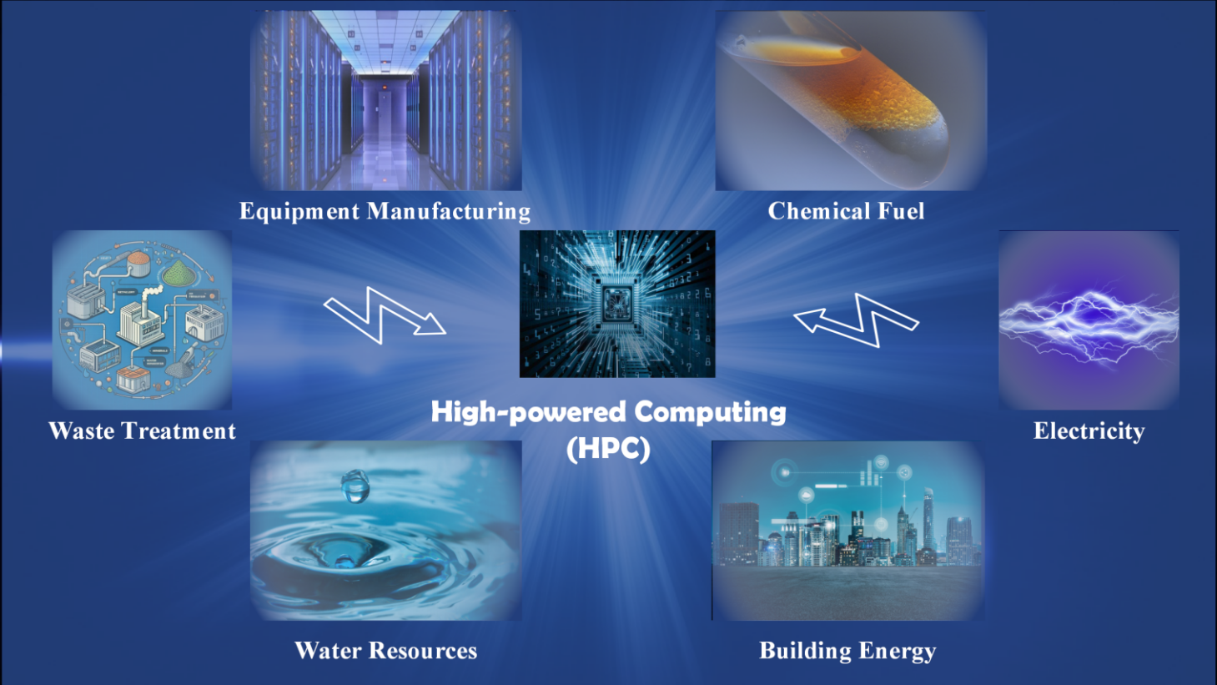
Figure. 4 Energy consumption type
These can be categorized into the following six main categories, as shown in table 4.

Table 5 HPC Six Major Energy Consumption
Serial Number | Energy Consumption | Description
1 | Electricity | Includes power to run and cool the HPC system
2 | Water resources | Water requirements for cooling systems and cleaning processes
3 | Chemical fuel | Standby diesel generators or natural gas power generation
4 | Building energy | Data center building maintenance and operational energy (e.g., heating, cooling, lighting, etc.)
5 | Equipment manufacturing | Energy costs for manufacturing and transportation of equipment
6 | Waste treatment | Includes energy consumption in the recovery and disposal of waste equipment
For the six energy sources in the table above, our team designed a stepwise model that covers: first, an energy structure model is built to describe the distribution of different energy sources in the total energy consumption and their sources. Then a carbon accounting model is developed to account for the carbon emissions of each energy source separately. Finally, an environmental impact model is developed to quantify the combined impacts of carbon emissions on climate, ecology and air quality through impact indicators.

Energy Structure Model
The energy structure model is used to describe how the total energy consumption of the HPC system. $\left(E_{\text{total }}\right)$ is allocated to 6 specific energy consumption:
 | $$E_{\text{total }}=E_{\text{electricity }}+E_{\text{water }}+E_{\text{fuel }}+E_{\text{building }}+E_{\text{manufacturing }}+E_{\text{waste }}$$ | (4)
The ratio of each energy source is defined as $P_{i}$ :
 | $$P_{i}=\frac{E_{i}}{E_{\text{total }}}, \text{ where } \sum_{i=1}^{6}{ }P_{i}=1$$ | (5)
Where $E_{\text{electricity }}$ is the direct system electricity use (e.g., computing, storage, and cooling). $E_{\text{water }}$ is the amount of water used for cooling and cleaning processes (in cubic meters). $E_{\text{fuel }}$ is the chemical fuel consumption for backup power generation, etc. $E_{\text{building }}$ is the energy consumption for daily operation and maintenance of the building (e.g. heating and cooling). $E_{\text{manufacturing }}$ is the energy consumption generated during equipment manufacturing and transportation. $E_{\text{waste }}$ is the energy consumption for waste disposal (including recycling and dismantling). The energy structure of each HPC system is given below, as shown in the figure 5 below.
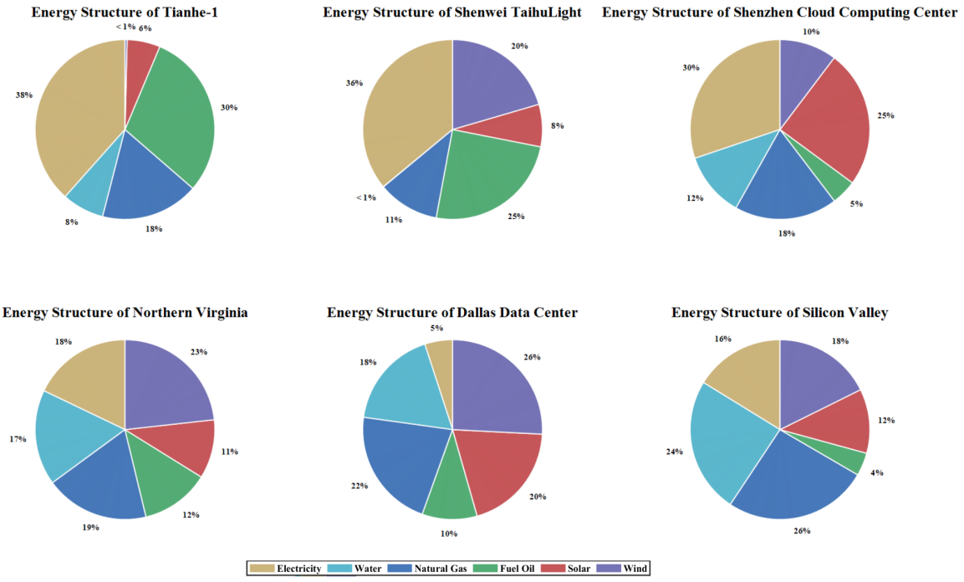
Figure. 5 The Energy Structure of each HPC System
From the energy structure pie chart provided, electricity is the main source of energy, and the use of renewable energy ( solar and wind energy ) varies significantly in different regions. This may be related to local energy policies, the availability of energy resources, and the supercomputing center 's environmental goals.

Carbon Emission Accounting Model
- Accounting for carbon emissions from electricity consumption
Carbon emissions from electricity consumption are determined by the energy mix of the grid (thermal, hydro, nuclear, etc):
 | $$C_{\text{electricity }}=E_{\text{electricity }}×\left(\sum_{j=1}^{M}{ } \left(P_{j}×γ_{j}\right)\right)$$ | (6)
Where $P_{j}$ is the electric grid's first $j$ share of the energy source. $γ_{j}$ is the percentage of the first $j$ energy source in the grid ($tons {CO}_{2}/MWh$).
- Accounting for carbon emissions from water resources consumption
Carbon emissions from water consumption come from the process of water treatment and transportation:
 | $$C_{\text{water }}=E_{\text{water }}×γ_{\text{water }}$$ | (7)
Where $γ_{\text{water }}$ is the carbon emission factor per unit of water resources ($tons {CO}_{2}/m^{3}$).
- Accounting for carbon emissions from chemical fuel consumption
Carbon emissions from chemical fuel combustion are related to its type and combustion efficiency:
 | $$C_{fuel}=\sum_{k=1}^{K}{ }\left(E_{k,fuel}×γ_{k}\right)$$ | (8)
Where $E_{k,fuel}$ is the first $k$ fuel consumption (tons or liters). $γ_{k}$ is the carbon emission factor of the first $k$ carbon emission factor of the first fuel ($tons {CO}_{2}/unit of fuel$).
- Accounting for carbon emission from building energy consumption
The energy consumption emissions of data center building maintenance and operation are calculated by equipment power and annual hours of use:
 | $$C_{\text{building }}=E_{\text{building }}×γ_{\text{building }}$$ | (9)
Where $γ_{\text{building }}$ is the carbon emission factor of the building operation unit ($tons {CO}_{2}/MWh$).
- Accounting for carbon emission from equipment manufacturing consumption
Carbon emissions from the manufacturing and transportation of equipment are spread over the life cycle of the equipment:
 | $$C_{\text{manufacturing }}=\frac{C_{\text{total manufacturing }}}{T_{\text{lifecycle }}}$$ | (10)
Where $T_{\text{lifecycle }}$ is the service life of the equipment (in years).
- Accounting for carbon emission from waste treatment consumption
Carbon emissions from waste disposal are related to recycling efficiency and transportation distance:
 | $$C_{\text{waste }}=E_{\text{waste }}×γ_{\text{waste }}$$ | (11)
Where $γ_{\text{waste }}$is carbon emission factor per unit of waste treatment. Then, based on the above model, we present the carbon emission measurement results of the six HPC systems from 2015 to 2023, as shown in the figure 6 below.
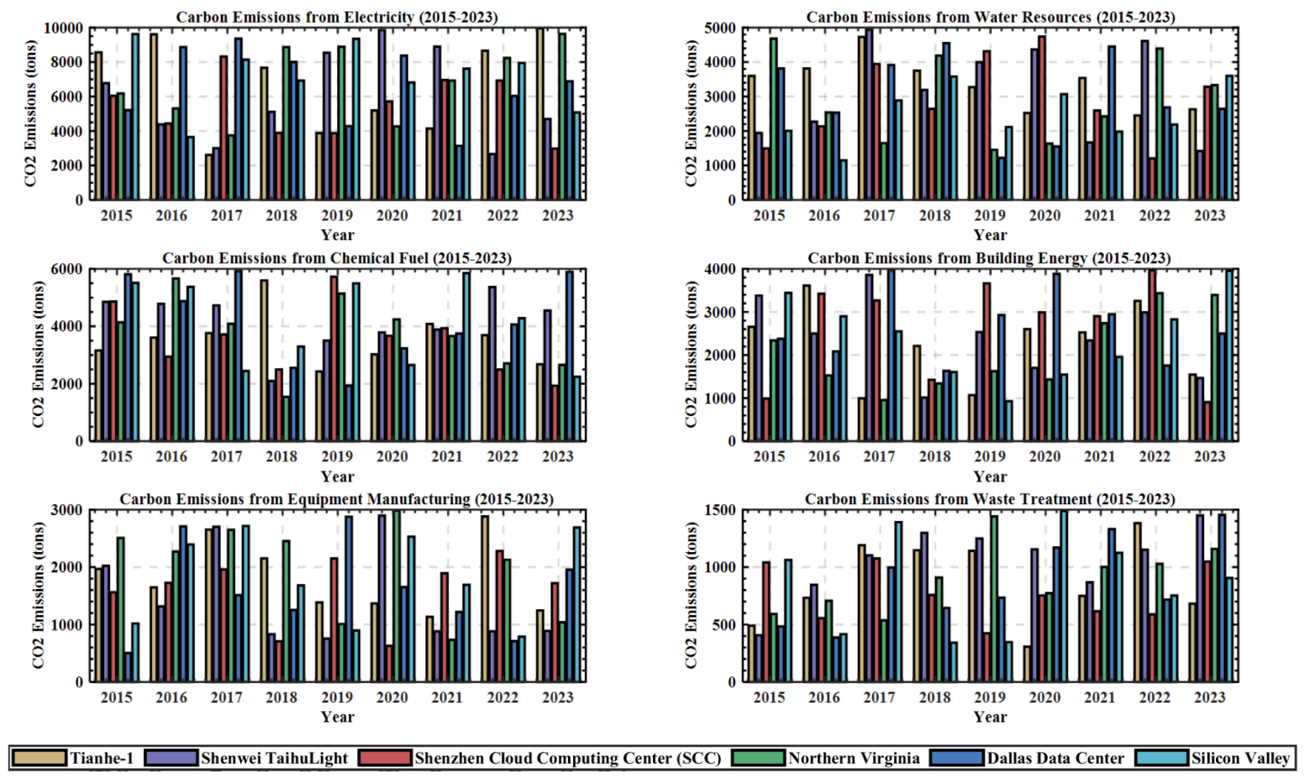
Figure. 6 Carbon Emission Measurement Results of the Six HPC Systems from 2015 to 2023

Environmental Impact Model
The total carbon emissions from the six energy sources are first synthesized $C_{total}$ :
 | $$C_{\text{total }}=\sum_{i=1}^{6}{ }C_{i}$$ | (12)
The environmental impact of carbon emissions is then measured by our team through the introduction of an Environmental Impact Index (EII):
 | $$EII=w_{1}⋅{Impact}_{\text{climate }}+w_{2}⋅{Impact}_{\text{ecosystem }}+w_{3}⋅{Impact}_{\text{air quality }}$$ | (13)
Where $w_{1},w_{2},w_{3}$ are weighting factors for different impact categories, reflecting the importance of climatic, ecological and air quality impacts on the overall environment. By adjusting the weights $w_{1},w_{2},w_{3}$ , it is possible to focus on specific environmental objectives (e.g., reducing climate warming, protecting ecosystems, or improving air quality).
- Climatic impact
 | $${\text{ Impact }}_{\text{climate }}=C_{\text{total }}×GWP$$ | (14)
Where $C_{\text{total }}$ is the total carbon emission (unit: $tons {CO}_{2}$), which represents the cumulative carbon emission of each type of energy consumption in HPC. GWP is the Global Warming Potential, which describes the relative contribution of a unit of carbon emissions to global warming, typically based on carbon dioxide (1.0), and about 25 times as much for other greenhouse gases such as methane.
- Ecological impact
Impacts of carbon emissions on ecosystems as measured by land-use change and water depletion.
 | $${\text{ Impact }}_{\text{ecosystem }}=C_{\text{total }}×f_{\text{landuse }}+E_{\text{water }}×f_{\text{waterstress }}$$ | (15)
Where $f_{\text{landuse }}$ is the land use change factor, which represents the negative impacts of carbon emissions on ecosystems, with larger values indicating more severe ecological damage. $f_{\text{water stress }}$ is the water stress factor, which represents the impact of water consumption per unit of water on the ecosystem, depending on the degree of water scarcity in the region. $E_{\text{water }}$is the total water consumption, which includes the amount of cooling water used in the operation of the HPC system.
- Air quality impact
Air quality impacts are calculated through particulate matter (PM2.5) and acid gases (${SO}_{2}、{NO}_{x}$) Contributions are calculated:
 | $${\text{ Impact }}_{\text{air quality }}=C_{\text{total }}×f_{PM2.5}+C_{\text{fuel }}×f_{{SO}_{2}}$$ | (16)
Where $f_{PM2.5}$ is the impact coefficient of fine particulate matter (PM2.5) pollution due to unit carbon emission, which indicates the indirect impact of carbon emission on air quality. $f_{{SO}_{2}}$ is the impact coefficient of sulfur dioxide (SO2) emissions per unit of chemical fuel consumption, describing the degree of harm of acid gas emissions. $C_{\text{fuel }}$ is the total amount of carbon emissions corresponding to chemical fuel consumption.

Task III Solution
Starting from the growth trend of HPC, our team first built a forecasting model to assess the future energy demand and calculated the total carbon emissions in 2030 by combining the dynamic energy mix and carbon emission factors. The range of projections under optimistic and pessimistic scenarios was then further explored by introducing an environmental impact model to quantify the combined impacts of different energy consumptions on climate, ecology, and air quality. In addition, our team also considered the potential impacts of energy technology development and policy changes, and utilized the HPC in Task I and Task II for simulation validation to provide a scientific basis for the carbon emissions and environmental impacts of the HPC in 2030.

HPC Growth and Energy Demand Forecasting Model
Our team assumes that HPC growth follows an exponential or polynomial trend:
 | $$P_{HPC, future }(t)=P_{HPC, current }⋅(1+r)^{t−t_{0}}$$ | (17)
Where $P_{HPC, current }$ is the current HPC computing power (in FLOPS or number of computing tasks).$r$ is the annual growth rate, referenced to historical data and assumed to be $20\%−30\%$ is the annual growth rate, assumed from historical data. $t_{0}$ is the base year (e.g., 2024). $t$ is the target year (2030). The specific growth curve is shown in the following figure 7.
Figure. 7 HPC Growth Curve
Our team then correlates the computational power with the energy efficiency per unit to get the energy demand:
 | $$E_{HPC, future }(t)=P_{HPC, future }(t)/η_{HPC}$$ | (18)
Where$η_{HPC}$ is the HPC unit energy efficiency (in FLOPS/W), considering the scenario of yearly improvement with technology improvement. We then give an initial assumption that the current unit efficiency is 1 GFLOP/W, with an expected improvement of 10-15% per year.

Introduction of a Model of the Future Energy Mix
The future energy mix may change due to policy, technology and regional development, so our team builds the following dynamic energy model:
 | $$\text{ Energy }{Mix}_{\text{future }}=\left\{p_{\text{renewable }},p_{\text{coal }},p_{\text{gas }},p_{\text{oil }},p_{\text{nuclear }},p_{\text{other }}\right\}$$ | (19)
Where $p_{\text{type }}$ is the percentage of each energy source that satisfies $∑p_{\text{type }}=1$. Our team then refers to the 2024 energy mix global statistics, assuming future adjustments based on UN and national energy targets:
- Renewable energy increased to 40-60%.
- Fossil fuel share reduced to $20\%−40\%$ ;
- Nuclear energy has maintained steady growth.
Carbon Emission Factor (EF) for different energy types:
 | $$EF_{\text{type }}=\left\{EF_{\text{renewable }},EF_{\text{coal }},EF_{\text{gas }},EF_{\text{oil }},EF_{\text{nuclear }},EF_{\text{other }}\right\}$$ | (20)
Where $EF_{\text{renewable }}=0$, $EF_{\text{coal }}=820$, $EF_{\text{gas }}=490$, $EF_{\text{oil }}=650$, $EF_{\text{nuclear }}=15$ , $EF_{\text{other }}=300$.

Carbon Emission Projections and Environmental Impact Analysis
The formula for future projections of total carbon emissions is given here:
 | $$C_{\text{future }}(t)=E_{HPC, future }(t)⋅\sum_{i}{ }p_{\text{type ,i}}⋅EF_{\text{type ,i}}$$ | (21)
Where $E_{HPC, future }(t)$ is the projected energy demand. $p_{type,i}$ is the percentage of energy in the energy mix of $i$ of the energy mix. $EF_{\text{type ,i}}$ is the carbon emission factor of $i$ is the carbon emission coefficient of the energy source. The environmental impact model in Task II is then used to calculate the future environmental impact index (EII) by combining the projected carbon emissions and energy consumption:
 | $${EII}_{\text{future }}=w_{1}⋅\left(C_{\text{future }}⋅GWP\right)+w_{2}⋅\left(C_{\text{future }}⋅f_{\text{land use }}+E_{\text{water }}⋅f_{\text{water stress }}\right)$$  $$+w_{3}⋅\left(C_{\text{future }}⋅f_{PM2.5}+C_{\text{fuel }}⋅f_{{SO}_{2}}\right)$$ | (22)

Model Simulation Test
In this paper, two types of simulations of future HPC development are presented, giving the future changes in carbon emissions and the changes in EII, respectively.

Scenario 1
HPC growth + fossil fuel dominance assumes 8-10% annual growth in HPC (based on current AI, data science demand-driven growth). Fossil fuels continue to dominate, especially in regions with slow energy transitions. The energy mix remains the same (~60% fossil fuels, 25% renewables, 15% nuclear). The results of the simulation are shown in the figure 8 below.
Figure. 8 Scenario 1 Simulation Results
The above figure shows that high growth HPC combined with traditional fossil fuel mix is expected to lead to a significant increase in carbon emissions by 2030, along with a growing EII index.
Boundary: If HPC demand continues to grow and the energy mix is not optimized, global HPC carbon emissions could reach hundreds of millions of tons of CO2 in 2030, well above current levels. It is expected that the supply of renewable energy sources that will need to be supplemented or replaced will not be sufficient to meet the growth in demand.

Scenario 2
HPC growth + increased share of renewable energy HPC growth maintained at 10 per cent per annum while promoting energy transition. The share of renewable energy has increased significantly to 40%, the share of fossil fuels has decreased to 45%, and the share of nuclear energy has been maintained at 15%. Clean energy supply growth is supported by policy and technology advances. The results of the simulation are shown in the figure 9 below.
Figure. 9 Scenario 2 Simulation Results
The graph above shows that increased renewable energy supply reduces the impact of HPC growth on carbon emissions, but still does not fully neutralize the environmental burden of growth. In this scenario, the annual growth rate of carbon emissions decreases, but overall emissions may still be high, but the EII index decreases.
Boundary: Renewable energy enhancement can reduce HPC carbon emissions in 2030 to the range of million tons of CO2, emission reduction effect is obvious, but the growth rate to maintain a certain range.

Task IV Solution
Our team performs two extensions of the simulation, first increasing the impact of the proportion of renewable energy and calculating the corresponding reduction in carbon emissions. The model is then extended to include the impact of water consumption.

Impact of Increasing the Share of Renewable Energy Sources
In order to simulate the impact of changes in the proportion of renewable energy on HPC carbon emissions, the energy mix is defined as a dynamic adjustment model. $S(t)$ model, keeping the total ratio as 1. Let $R(t)$ is the proportion of renewable energy, the proportion of fossil fuels, and the proportion of fossil fuels. $F(t)$ is the proportion of fossil fuels, and $N(t)$ is the proportion of nuclear energy, then we have
 | $$R(t)+F(t)+N(t)=1$$ | (23)
Where assuming that the proportion of nuclear energy $N(t)$ does not change over time (fixed at 15%), the fossil fuel share is
 | $$F(t)=1−R(t)−N(t)$$ | (24)
For the different scenarios (40%, 60%, 80%, 100% renewable energy), we define respectively $R(t)$ a linear growth model for each scenario. For example, if the 2030 target is $100\%$ renewable energy, then
 | $$R(t)=R_{\text{initial }}+\frac{1−R_{\text{initial }}−N(t)}{2030−2015}⋅(t−2015)$$ | (25)
Based on the carbon emissions model in question 3.
 | $$C_{\text{total }}(t)=\sum_{i=1}^{6}{ }{Energy}_{i}⁡(t)⋅{EF}_{i}$$ | (26)
where ${Energy}_{i}⁡(t)$ is the first $i$ type of energy consumption (e.g., electricity, fossil fuels, etc.), and ${EF}_{i}$ is the corresponding carbon emission factor. After the introduction of energy restructuring, the new carbon emissions are
 | $$C_{\text{adjusted }}(t)=\sum_{i}{ }{Energy}_{i}⁡(t)⋅\left(R(t)⋅{EF}_{\text{renewable ,i}}+F(t)⋅{EF}_{\text{fossil ,i}}+N(t)⋅{EF}_{\text{nuclear ,i}}\right)$$ | (27)
By gradually increasing the $R(t)$ ratio, we can calculate the change in carbon emissions under each scenario and further quantify the carbon emission reductions.
 | $$ΔC(t)=C_{\text{total }}(t)−C_{\text{adjusted }}(t)$$ | (28)
In the $100\%$ renewable energy scenario, the model predicts that carbon emissions will be close to zero as the fossil fuel share tends to zero. However, the following challenges need to be considered: the high cost of energy storage technologies, the problem of energy intermittency, and global policy and infrastructure requirements. To validate the results, we show carbon emission change curves for different scenarios from 2015-2030. The simulation results are shown in the figure 10 below.
Figure. 10 Carbon Emission Change Curves for Different Scenarios from 2015-2030
The simulation results of the above curve show that as the energy structure maintains the current proportion (60% of fossil fuels dominate) and the demand for HPC continues to grow at 8% per year, the carbon emission rises with the increase in energy consumption every year. And although the growth rate of HPC is the same as that of Scenario 1, the carbon emission shows a rising and then decreasing trend due to the gradual increase of the proportion of renewable energy to 40% and the decrease of the proportion of fossil fuels. In Scenario 2, carbon emissions increase slightly at the beginning (before the share of renewable energy increases significantly), but as the energy mix is optimized, the carbon emission curve begins to decline. The bar chart below shows the reduction in carbon emissions in Scenario 2 compared to Scenario 1. It shows that the energy optimization policies in Scenario 2 are effective in reducing the negative environmental impacts of HPC. The reductions gradually expand in the later stages, showing the long-term benefits of the energy transition.

Impact of Extension on Water Consumption
In conjunction with the extended model for Problem 3, we further analyze the impact of HPC growth on water consumption. Water consumption is modeled as follows:
 | $$W_{\text{total }}(t)=\sum_{i=1}^{3}{ }S_{i}(t)⋅{WRF}_{i}$$ | (29)
where $S_{i}(t)$ is the share of the first $i$ of energy (fossil fuels, renewable energy, nuclear energy), and ${WRF}_{i}$ is the corresponding water consumption factor per unit of energy (tons/unit of energy). The initial assumptions are
- Fossil fuels ${WRF}_{\text{fossil }}=50$ tonnes
- Renewable energy ${WRF}_{\text{renewable }}=10$ tonnes
- Nuclear energy ${WRF}_{\text{nuclear }}=1$ ton (loanword)
Combined with the dynamics of the energy mix, we can simulate trends in water consumption under different scenarios. For example, when the proportion of renewable energy increases, the overall water consumption may show a decreasing trend, but if the main reliance is on hydropower, regional water stress may occur in some areas, as shown in the figure 11 below.
Figure. 11 Carbon Emission Change Curves for Different Scenarios from 2015-2030
The above graphical simulation results show that the high water demand for fossil fuels (50 tons of water per unit) leads to an increase in the total consumption from the growth of HPC from year to year. Although there is a slight increase in total consumption in the early years, the total water consumption decreases significantly in the later years due to the increase in the proportion of renewable energy (only 10 tons of water per unit). The bar chart below shows the reduction in water consumption in Scenario 2 compared to Scenario 1. The reduction is not significant in the early stages, but increases significantly in the later stages, indicating that the energy transition is not only beneficial for carbon emissions, but also relieves the pressure of HPC on global water resources.
In order to visualize the synergistic relationship between water resources and carbon emissions, we propose an extended Environmental Impact Index (EII) model.
 | $$EII⁡(t)=α⋅\frac{C(t)}{C_{\text{baseline }}}+β⋅\frac{W(t)}{W_{\text{baseline }}}$$ | (30)
where $α,β$ are weights indicating the relative importance of the environmental impacts of carbon emissions and water resources, respectively; $C_{\text{baseline }\text{,}}W_{\text{baseline }}$ are the baseline value.
By adjusting the energy mix and HPC growth rate, we can observe the combined impacts of the different scenarios on EII and highlight the synergies between carbon emissions and water resources in the visualization charts, the results of which are shown in figure 12 below.
Figure. 12 Combined Impacts of the Different Scenarios on EII
The solid red line in the above figure represents the change in EII for Scenario 1, which shows a significant upward trend, reflecting the large environmental burden of HPC growth under the fossil fuel dominated scenario. The solid black line represents the change in EII for Scenario 2. Due to the gradual substitution of renewable energy sources, the EII increases slightly in the early stages (due to the increased demand for resources during the transition period), but gradually decreases in the later stages, indicating that the environmental impacts are significantly improved.
Scenario 1 emphasizes the importance of the energy mix transition and shows that without measures, the growth of HPC will significantly degrade the global environment. Scenario 2 demonstrates the significant emission reduction benefits of switching to renewable energy sources and provides policymakers with a reference that the energy transition will not only alleviate the environmental pressures on HPC, but also has the potential to bring long-term economic and ecological sustainability benefits.

Task V Solution

Viable advice
- Technology-oriented recommendations
- Optimize HPC design and efficiency : Promote low-power chips and advanced cooling systems ( such as liquid cooling and immersion cooling ). Apply dynamic workload scheduling algorithm to reduce energy waste.
- Promote renewable energy power supply : In the site selection of HPC data centers, priority is given to areas rich in renewable energy resources. Encourage the use of distributed energy sources, such as solar and wind energy, combined with microgrids to provide power supply for HPC.
- Policy-oriented recommendations
- Establish carbon emission reduction incentive mechanism : Provide tax relief and subsidies for HPC projects that use clean energy or achieve carbon neutrality goals.
- Develop industry standards and evaluation indicators : It is mandatory for HPC operators to regularly disclose energy use reports and conduct quantitative assessments through the ' Environmental Impact Index ( EII ) '.
- Promoting international cooperation : Establish an international framework for HPC environmental impact, promote global energy data sharing, and promote concerted efforts for global HPC green energy transformation.

Model Extension and Implementation
- Assumption
The United Nations adopts the proposal of " promoting renewable energy power supply " and sets a goal : 60 % of global HPC data centers will use renewable energy by 2030.
- Key points of model modification :
- Adding new parameters indicates that the proportion of renewable energy power supply is increasing year by year.
- The initial ratio is the current 25 %, and the final target is 60 %. The carbon emission formula is updated to subdivide the energy structure into fossil fuels, renewable energy and nuclear energy.
- The carbon emission coefficients of different energy categories will be applicable : higher fossil fuels, lower renewable energy and nuclear energy. Compare the changes of EII and carbon emissions before and after the implementation of the new policy.
Figure. 13 Carbon Emissions before and after the Implementation of the New Policy
It can be seen from the above figure 13 that the red curve shows the annual change trend of carbon emissions after the implementation of the policy. It can be seen that by 2030, it will gradually decline, close to the million-ton level. The black curve shows the trend of carbon emissions before the implementation of the policy. It can be seen that carbon emissions have increased significantly year by year without energy optimization.


To the United Nations Advisory Committee.
Dear Committee members,
I would like to express my respect for your committee 's efforts in promoting the development of global artificial intelligence ( AI ) and high-performance computing ( HPC ), and thank you for the report on " Managing Artificial Intelligence for Humanity " released in September 2024. However, I believe that the report fails to pay sufficient attention to the environmental impact of HPC, especially its potential contribution to global climate change. With the rapid development of HPC technology, I propose to include a more detailed section on the environmental impact of HPC in the 2030 Development Goals, with a specific focus on its energy consumption, carbon emissions, and possible long-term impacts on global climate change.
The HPC system provides powerful computing power to solve complex scientific problems and promote the development of AI and machine learning technologies, but its huge computing requirements also bring significant energy consumption and carbon emissions. In the past few years, the application of HPC has developed rapidly, from traditional scientific computing to supporting advanced AI model training and big data analysis. Although HPC has brought many social and technological advances, its burden on the environment has also become increasingly apparent, especially in the context of global dependence on fossil fuel energy. HPC 's energy demand has exacerbated the rise in carbon emissions.
In order to quantify the impact of HPC on the environment, I used a model to analyze changes in carbon emissions under different energy structures. According to this model, it is assumed that the annual growth rate of HPC is 8 % -10 %, and the current energy structure is still dominated by fossil fuels. It is estimated that by 2030, HPC 's carbon emissions may reach hundreds of millions of tons of CO2. Especially in areas where energy conversion progress is slow, the proportion of fossil fuels is still high, and the carbon footprint of HPC will aggravate global greenhouse gas emissions. At this time, although the proportion of renewable energy is gradually increasing, the negative impact of HPC on the climate will not be completely alleviated because the growth rate of energy demand far exceeds the expansion rate of clean energy supply.
Furthermore, if we can accelerate the application of renewable energy and promote the rapid growth of clean energy through policy and technological progress, the carbon emissions of HPC can be significantly reduced. For example, in scenario 2, if the annual growth rate of HPC is maintained at 10 %, and the proportion of renewable energy is increased to 40 %, while the proportion of fossil fuels is reduced to 45 %, the carbon emissions of HPC can be significantly reduced. However, even so, there are still environmental pressures that cannot be ignored, especially as the scale of HPC systems continues to expand, the absolute value of carbon emissions is still high. Nevertheless, increasing the proportion of renewable energy has a significant emission reduction effect on reducing environmental impacts, especially in the long run.
Based on this, I strongly recommend that the UN Advisory Committee include a detailed assessment of the environmental impact of HPC in the 2030 Development Goals, in particular to clearly measure the contribution of HPC to carbon emissions, and promote the following policy recommendations :
- Increase investment and application of renewable energy : The government and related enterprises should increase investment in renewable energy such as solar energy and wind energy to ensure that HPC systems can get more support from clean energy.
- Formulating policies for energy structure transformation : clear policy objectives should be formulated to encourage HPC facilities to adopt a more environmentally friendly energy structure. This will not only help reduce carbon emissions, but also promote the optimization and transformation of energy structure worldwide.
- To promote the research and development of HPC energy-saving technology : scientific research institutions and technology enterprises should strengthen the research and development of low-carbon and high-efficiency HPC systems, develop more energy-saving computing methods and hardware, and reduce the energy consumption of single computing tasks.
- Promote the construction of green data centers : The government can promote the construction of green data centers through subsidy or incentive mechanisms. These data centers should adopt the most advanced energy-saving technologies and maximize the use of renewable energy.
- Strengthen international cooperation and information sharing : Countries around the world should strengthen cooperation in HPC environmental impact assessment and emission reduction technologies. Promote green transformation in the global HPC field by sharing best practices and successful experiences.
By adopting these suggestions, we can not only effectively reduce the negative impact of HPC on the environment, but also contribute to the global response to climate change and the promotion of sustainable development. With the increasing importance of HPC in the future development, it is our unavoidable responsibility to take active environmental protection measures.
I sincerely hope that your committee will consider my recommendations and include more detailed assessments and response measures on the environmental impact of HPC in the 2030 Development Goals. Our efforts will help to create a more sustainable and greener future for future generations. Thank you for your attention and look forward to your committee adopting more policy measures on HPC and environmental impact when promoting the global sustainable development goals.

Yours,
Sincerely

Sensitivity Analysis
Sensitivity analysis is used to evaluate the sensitivity of the model to changes in key parameters. For the previous HPC carbon emission model, our team performed sensitivity analysis on the following main parameters :
- HPC growth rate : the impact of different growth rates on carbon emissions.
- Energy Ratios : the impact of changes in the proportion of fossil fuels, renewable energy and nuclear energy on carbon emissions.
- Emission factors : assuming different fossil fuel emission factors and renewable energy efficiency changes.
Figure. 14 Sensitivity Analysis Results
It can be seen from the above figure 14 that each curve represents the impact of different renewable energy ratios ( 30 %, 40 %, 50 % ) on carbon emissions. The higher the proportion of renewable energy, the slower the growth of carbon emissions, and may tend to be stable or decline after a certain year. Each curve in the following figure represents the impact of different renewable energy ratios on EII. As the proportion of renewable energy increases, the energy intensity index ( EII ) gradually decreases, indicating that the carbon emission efficiency per unit energy consumption is improved.

Evaluation of the Model

Strengths
- Comprehensiveness: The model comprehensively considers the energy consumption and environmental impact of HPC systems, including electricity, water resources, chemical fuels, building energy, equipment manufacturing and waste treatment.
- Dynamic: By introducing a dynamic energy structure model, the model can adapt to changes in policy, technology and regional development, and predict future changes in energy structure.
- Predictability: The model can predict energy demand and carbon emissions in 2030 under different energy structures and HPC growth trends, providing a scientific basis for policy formulation.
- Environmental impact assessment: Through the introduction of environmental impact index ( EII ), the model can quantify the comprehensive impact of carbon emissions on climate, ecology and air quality.
- Policy recommendations: Based on the model results, technical and policy-oriented recommendations are proposed to reduce the environmental impact of HPC, and the effects of these recommendations are verified by simulation.

Weaknesses
- Simplified assumptions: The model makes some simplified assumptions in the analysis, such as the linear relationship between energy consumption and HPC computing load, which may not fully capture all complex nonlinear dynamics.
- Data limitations: The model relies on existing data and literature, and there may be problems with incomplete or outdated data, which affects the accuracy of the prediction.

Conclusion
In this study, we conducted an in-depth analysis of the energy consumption and environmental impacts of high-performance computing ( HPC ) systems by constructing a comprehensive model. The model not only quantifies the annual energy consumption of global HPC systems under different operating conditions, but also assesses the resulting carbon emissions, and predicts energy demand and carbon emission trends in 2030. By simulating different energy structures and HPC growth scenarios, we find that although the development of HPC technology has put some pressure on the environment, carbon emissions can be significantly reduced by optimizing the energy structure, especially by increasing the proportion of renewable energy use. In addition, our model also considers other environmental factors such as water consumption and e-waste treatment, providing a comprehensive assessment for the sustainable development of HPC. Our findings highlight the important role of technological progress and policy orientation in reducing the environmental impact of HPC and provide a scientific basis for achieving the 2030 Sustainable Development Goals.
Looking forward to the future, the green development of HPC requires joint efforts on a global scale. We recommend strengthening international cooperation and sharing best practices and successful experiences to promote green transformation in the global HPC field. In addition, with the advancement of technology, future research can further explore more efficient energy utilization and more environmentally friendly hardware design, and how to better integrate artificial intelligence and machine learning technologies to optimize the energy efficiency of HPC systems. Through these efforts, we are expected to achieve a more sustainable and environmentally friendly high-performance computing future and make a positive contribution to the response to global climate change and the realization of sustainable development goals.

Reference
- Li Y, Liu Y, Lou W, et al. Discussion on Energy Consumption and Energy-saving Design of a Supercomputing Center [J]. Clean Air and Air Conditioning Technology, 2024, (02): 95-98.
- Artificial Intelligence Supercomputing Center Empowers Economic and Social Development [J]. China Construction Informatization, 2023, (21): 31-33.
- Zhang Y. Research on the Path of Supercomputing Center Construction in the Digital Transformation of Higher Education [J]. China Informatization, 2023, (05): 76-78+73.
- Tang Z. The Great Significance of the "East Data West Computing" Strategic Layout [J]. People's Tribune, 2022, (15): 56-59.
- Liang R, Shen Y, Alhusaini N, et al. Statistical Analysis of Typical Scientific Research Application Characteristics of Supercomputing Centers [J]. Small and Microcomputer Systems, 2022, 43(06): 1121-1127.
- Yang W, Yuan D. Construction of Zhangjiakou Energy Big Data Center under the Background of "Dual Carbon" [J]. Journal of Zhangjiakou Vocational and Technical College, 2023, 36(04): 62-64. DOI:10.16220/j.cnki.cn13-1248/g4.2023.04.007.
- Bu K. Problems and Countermeasures in the Construction of Energy Big Data Centers Driven by "Carbon Neutrality" [J]. Information Systems Engineering, 2023, (12): 56-59.
- Huang X, Zhao H, Yang X. Carbon Emission Accounting Methods and Case Analysis of Data Centers under the "Dual Carbon" Goal [J]. Guangxi Electric Power, 2023, (08): 50-56.
- Qinghai Province Smart Dual Carbon Big Data Center Unveiled [J]. New West, 2023, (07): 190.
- Zhu Z, Zhang C, Ding Z, et al. Research on the Mechanism of Including Data Centers in the National Carbon Emission Trading Market [J]. Proceedings of the CSEE, 2024, 44(14): 5562-5574. DOI:10.13334/j.0258-8013.pcsee.230111.
- Sun G, Wang L, Ai Y. Research on the Impact Mechanism of Big Data Development on County-level Carbon Emissions in China [J]. Journal of Xi'an University of Technology, 2023, 39(03): 301-309+298. DOI:10.19322/j.cnki.issn.1006-4710.2023.03.001.
- Chang H, Jin B, Xue F. The Impact of Big Data Strategy on Carbon Emissions from Electricity Consumption - A Quasi-Natural Experiment Based on National Big Data Comprehensive Pilot Zones [J]. Research on Economics and Management, 2023, 44(05): 93-109. DOI:10.13502/j.cnki.issn1000-7636.2023.05.006.
- Yang L. Analysis of the Impact of Carbon Peak and Carbon Neutrality on Data Centers [J]. Digital Communication World, 2022, (12): 145-147.
- Mao Z, Zhou J, Shao Z, et al. Research on the "Green Energy Code" System Based on Energy Big Data Centers [J]. Modern Industrial Economy and Informationization, 2022, 12(11): 91-92. DOI:10.16525/j.cnki.14-1362/n.2022.11.034.
- Shuai D. Energy Big Data and Carbon Emission Monitoring [J]. Enterprise Management, 2021, (12): 104-105.
- https://www.eia.gov/electricity/state/
- https://www.sohu.com/a/493876985_121025296
- https://www.dobigdata.cn/4972.html
- https://www.eia.gov/state/analysis.php?sid=VA
- https://assets.kpmg.com/content/dam/kpmg/cn/pdf/zh/2023/10/statistical-review-of-world-energy-2023.pdf
- https://www.dobigdata.cn/4972.html
- https://m.chinaaet.com/article/3000163044
- https://www.heywhale.com/mw/dataset/621ee4c8e3d3a00017a745ad/file
- https://www.huaon.com/channel/distdata/961139.html
- https://www.sznews.com/news/content/2021-05/25/content_24244251.htm
- https://news.sohu.com/20101118/n277711710.shtml
- http://finance.people.com.cn/n1/2016/0621/c1004-28464929.html

Appendix

clc;
clear;
close all;

% Define the data for the year 2023
data_2023 = [404, 150, 379, 2552, 654, 615];
locations = {'Tianhe-1', 'Sunway TaihuLight', 'Shenzhen Cloud Computing Center', 'Northern Virginia', 'Dallas Data Center', 'Silicon Valley'};

% Time range
years = 2015:2023;
num_years = length(years);

% Pre-allocate a matrix to store the back-projected data
data_all = zeros(length(data_2023), num_years);

% Define the growth range (1.2 to 1.5 times)
growth_factor_range = [1.2, 1.5];

% Back-project the data
for i = 1:length(data_2023)
data_all(i, end) = data_2023(i); % Data for 2023
for j = num_years-1:-1:1
% Back-project using a random growth factor
random_factor = rand() * (growth_factor_range(2) - growth_factor_range(1)) + growth_factor_range(1);
data_all(i, j) = data_all(i, j+1) / random_factor;
end
end

% Plot the line graph
figure;
hold on;
for i = 1:length(data_2023)
plot(years, data_all(i, :), 'LineWidth', 1.5, 'DisplayName', locations{i});
end
hold off;

% Add plot labels and legend
title('Energy Consumption Trends of Data Centers (2015-2023)');
xlabel('Year');
ylabel('Energy Consumption (Unit: MWh)');
legend('show');
grid on;

%% Data centers and energy types
centers = {'Tianhe-1', 'Shenwei TaihuLight', 'Shenzhen Cloud Computing Center', ...
'Northern Virginia', 'Dallas Data Center', 'Silicon Valley'};
energy_types = {'Electricity', 'Water', 'Natural Gas', 'Fuel Oil', 'Solar', 'Wind'};

% Simulate annual energy consumption for each center
total_energy_consumption = randi([1000000, 1300000], [1, length(centers)]);

% Simulate energy structure
energy_structure = rand(length(centers), length(energy_types));
energy_structure = energy_structure ./ sum(energy_structure, 2);

% Carbon emission factors (kg CO2e/MWh)
emission_factors = [500, 0, 250, 700, 50, 20];

% Energy distribution (Unit: MWh)
energy_distribution = zeros(length(centers), length(energy_types));
for i = 1:length(centers)
energy_distribution(i, :) = total_energy_consumption(i) * energy_structure(i, :);
end

% Calculate carbon emissions (kg CO2e)
carbon_emissions = energy_distribution .* emission_factors;

% Calculate total carbon emissions (kg CO2e)
total_emissions = sum(carbon_emissions, 2);

% Plot energy structure pie charts
figure;
for i = 1:length(centers)-1
subplot(2, 3, i);
pie(energy_structure(i, :));
title(['Energy Structure of ', centers{i}]);
legend(energy_types, 'Location', 'southoutside', 'Orientation', 'horizontal');
end

%% Simulate carbon emissions for different energy sources
years = 2015:2030;
energy_types = {'Electricity', 'Water Resources', 'Chemical Fuel', ...
'Building Energy', 'Equipment Manufacturing', 'Waste Treatment'};

% HPC growth rates
hpc_growth_rate = 0.08;
hpc_growth_rate2 = 0.10;

% Initial energy structure
energy_structure1 = [0.60, 0.25, 0.15];
energy_structure2_start = [0.55, 0.30, 0.15];
energy_structure2_end = [0.45, 0.40, 0.15];

% Carbon emission factors (tons CO2/unit energy consumption)
emission_factors = [0.9, 0.6, 1.5, 0.4, 0.5, 0.3];

% Initial energy consumption (Unit: GWh)
initial_consumption = [100000, 50000, 30000, 20000, 15000, 10000];

% Initialize storage variables
emission_data1 = zeros(length(energy_types), length(years));
emission_data2 = zeros(length(energy_types), length(years));
EII1 = zeros(1, length(years));
EII2 = zeros(1, length(years));

% Simulate energy demand growth
for t = 1:length(years)
progress = (years(t) - 2015) / (2030 - 2015);
energy_structure2 = energy_structure2_start * (1 - progress) + energy_structure2_end * progress;

for j = 1:length(energy_types)
consumption1 = initial_consumption(j) * (1 + hpc_growth_rate) ^ (t - 1);
emission_data1(j, t) = consumption1 * emission_factors(j);

consumption2 = initial_consumption(j) * (1 + hpc_growth_rate2) ^ (t - 1);
emission_data2(j, t) = consumption2 * emission_factors(j) * energy_structure2(1);
end

total_emission1 = sum(emission_data1(:, t));
total_consumption1 = sum(initial_consumption .* (1 + hpc_growth_rate) .^ (t - 1));
EII1(t) = total_emission1 / total_consumption1 * (1 + 0.01 * (t - 1));

total_emission2 = sum(emission_data2(:, t));
total_consumption2 = sum(initial_consumption .* (1 + hpc_growth_rate2) .^ (t - 1));
EII2(t) = total_emission2 / total_consumption2 * (1 - 0.01 * (t - 1));
end

% Visualization
figure('Name', 'Scenario 1: Carbon Emissions', 'NumberTitle', 'off');
hold on;
for j = 1:length(energy_types)
plot(years, emission_data1(j, :), '-o', 'LineWidth', 1.5, 'MarkerSize', 5, 'DisplayName', energy_types{j});
end
hold off;
title('Scenario 1: Carbon Emissions by Energy Type (2015-2030)');
xlabel('Year');
ylabel('CO2 Emissions (tons)');
legend('show');
grid on;

figure('Name', 'Scenario 1: EII', 'NumberTitle', 'off');
plot(years, EII1, '-o', 'LineWidth', 2, 'MarkerSize', 6);
title('Scenario 1: Energy Intensity Index (2015-2030)');
xlabel('Year');
ylabel('EII');
grid on;

figure('Name', 'Scenario 2: Carbon Emissions', 'NumberTitle', 'off');
hold on;
for j = 1:length(energy_types)
plot(years, emission_data2(j, :), '-o', 'LineWidth', 1.5, 'MarkerSize', 5, 'DisplayName', energy_types{j});
end
hold off;
title('Scenario 2: Carbon Emissions by Energy Type (2015-2030)');
xlabel('Year');
ylabel('CO2 Emissions (tons)');
legend('show');
grid on;

