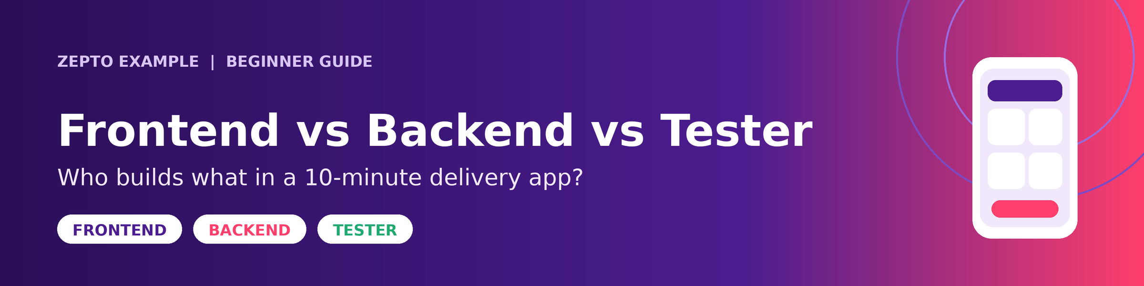
Think of Zepto, the quick-delivery grocery app.

Frontend Developer
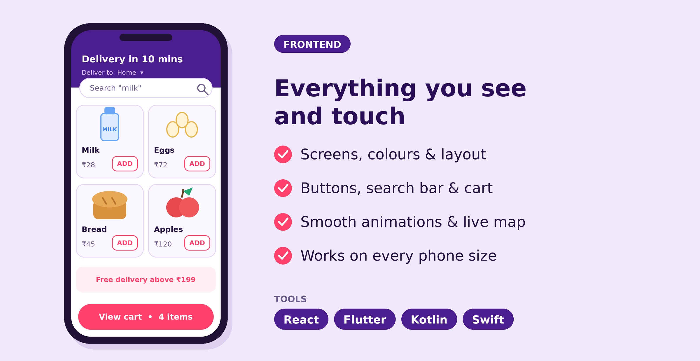
Builds everything you see and touch.
The home screen, product images, search bar, "Add to cart" button, and the live map showing your delivery partner. Their job is to make the app look good, feel smooth, and work well on different phones.
Tools: React, Flutter, Kotlin, Swift

Backend Developer
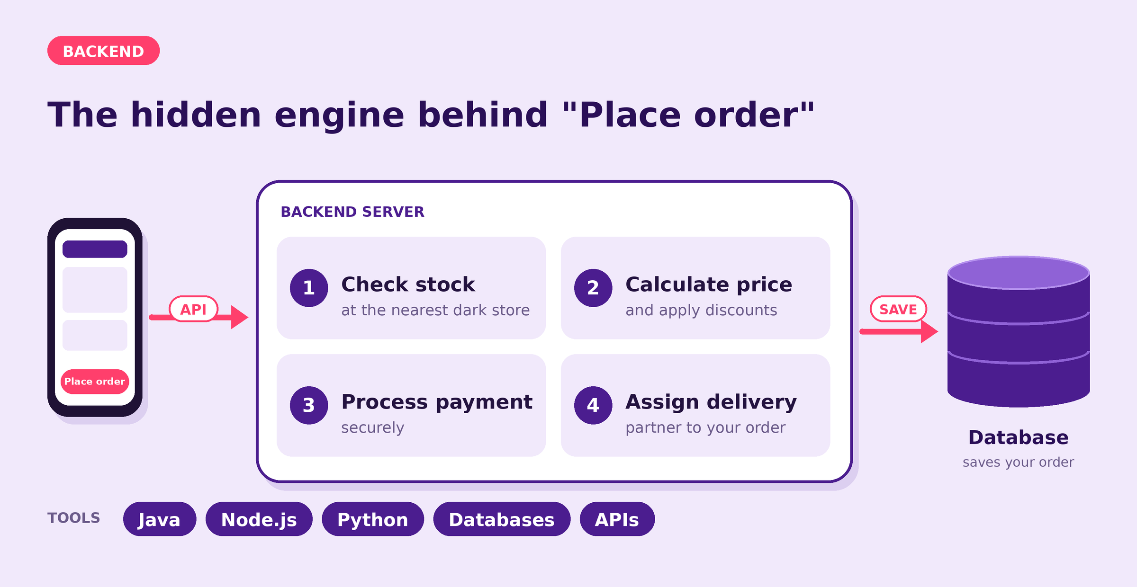
Builds the hidden engine behind the screen.
When you tap "Place order," the backend checks stock at the nearest dark store, calculates the price and discounts, processes your payment, saves the order in a database, and assigns a delivery partner.
Tools: Java, Node.js, Python, databases, APIs

Tester
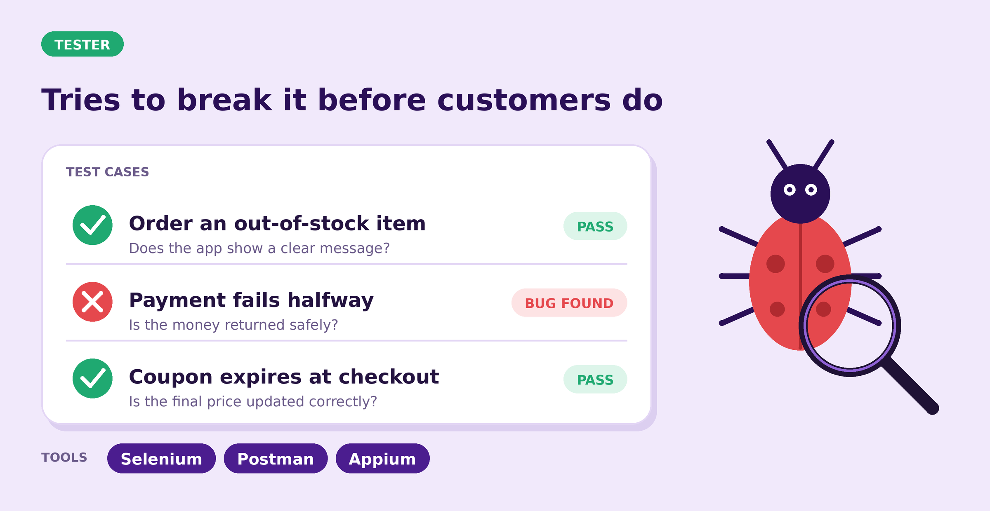
Makes sure everything works before real customers use it.
They try things like:
- What if I order an out-of-stock item?
- What if the payment fails halfway?
- What if the coupon expires while I'm checking out?
They report bugs, and often write automated tests too.
Tools: Selenium, Postman, Appium

Simple Analogy
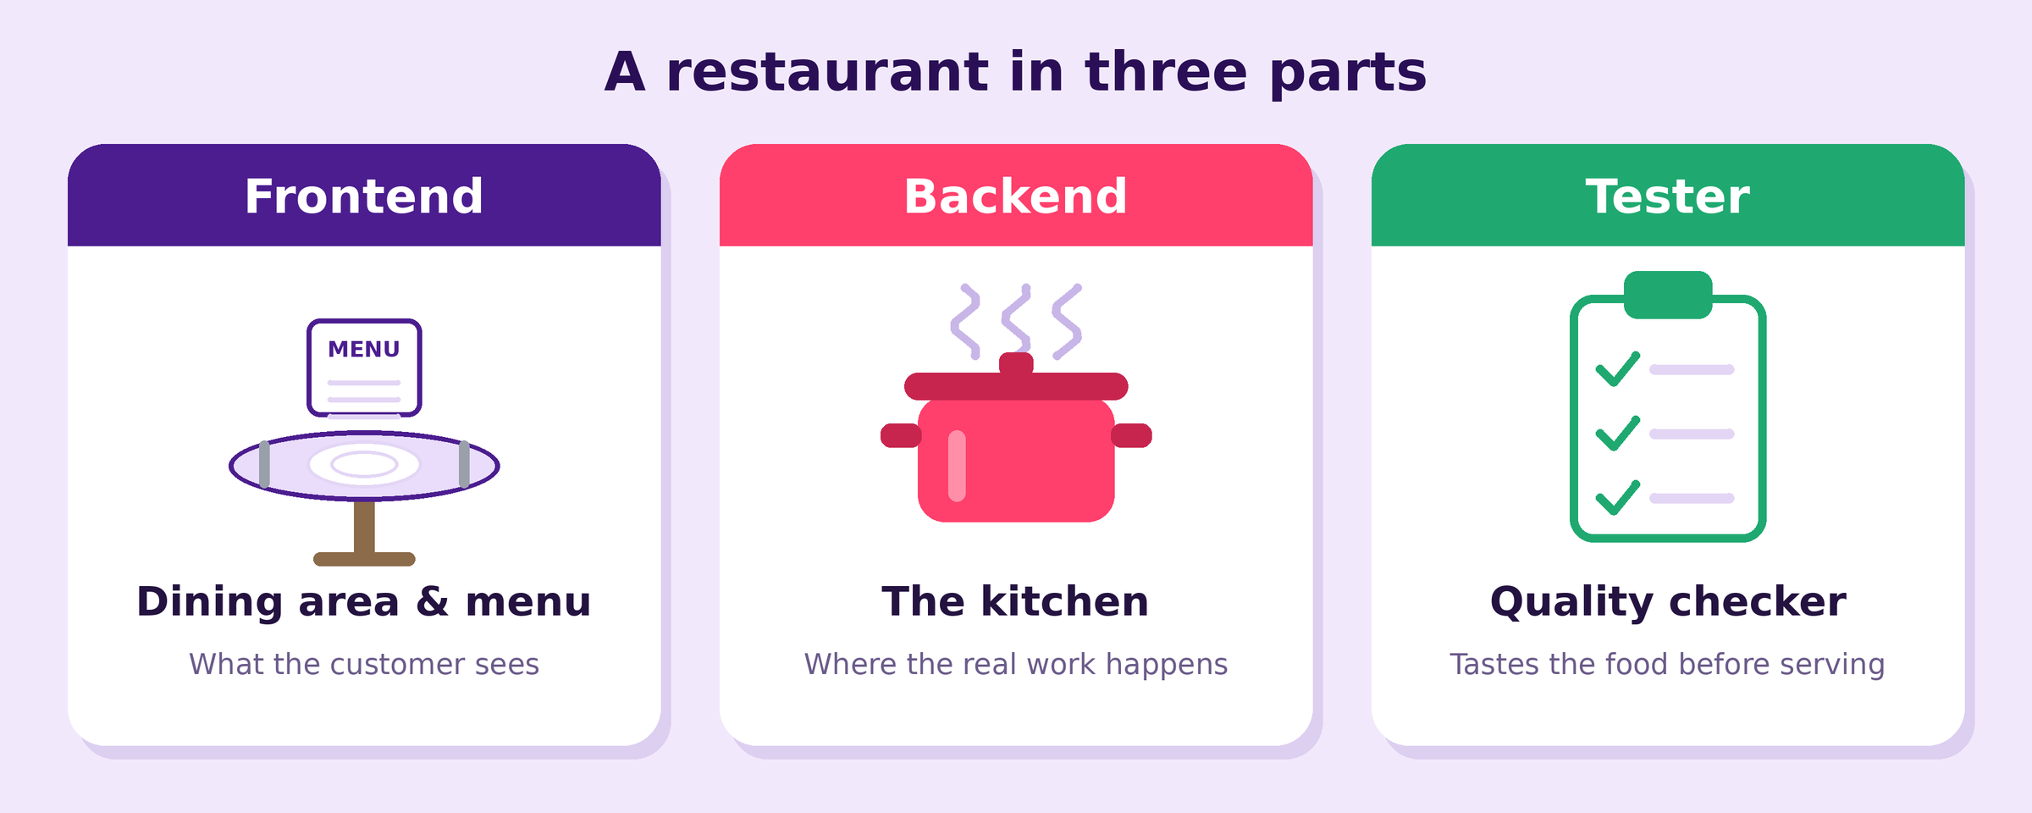
In a restaurant, the frontend is the dining area and menu, the backend is the kitchen, and the tester is the quality checker who tastes the food before it reaches you.

