Wireframe Document
Online Flight Booking Application
Low-fidelity mobile app screens and user flow

1. About This Wireframe
This document shows the layout and flow of a mobile app for searching, booking and managing flights. It covers ten screens, from login to booking management. It is a low-fidelity wireframe: it shows where things go and what they do, not final colours, fonts or images.
- Platform: mobile app, portrait orientation (about 360 x 720 points).
- Fidelity: greyscale layout with one accent colour for primary actions.
- Grey boxes with a cross: placeholders for images or logos (for example, airline logos).
- Red numbered circles: callouts that match the notes under each screen.
- Sample data: routes, fares, names and PNR numbers are made-up examples.

2. User Flow
The main booking path runs from search to payment and confirmation. After booking, users can find the trip in My trips and change or cancel it from Manage booking.
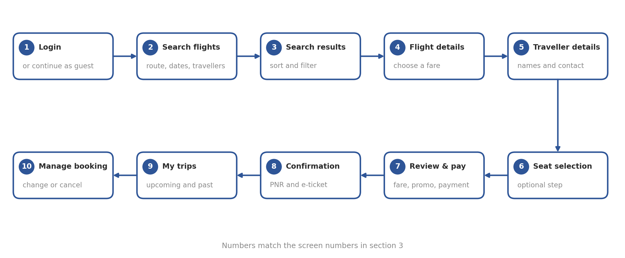

Key flow decisions
- Guests can search and pick a flight without logging in, and sign in before payment.
- Seat selection is optional, so users can skip it and still complete the booking.
- The fare, including extras and promo codes, is shown again on the payment screen before the user pays.
- The Trips tab gives quick access to check-in and booking changes after purchase.

3. Screen Wireframes

3.1 Login and search flights
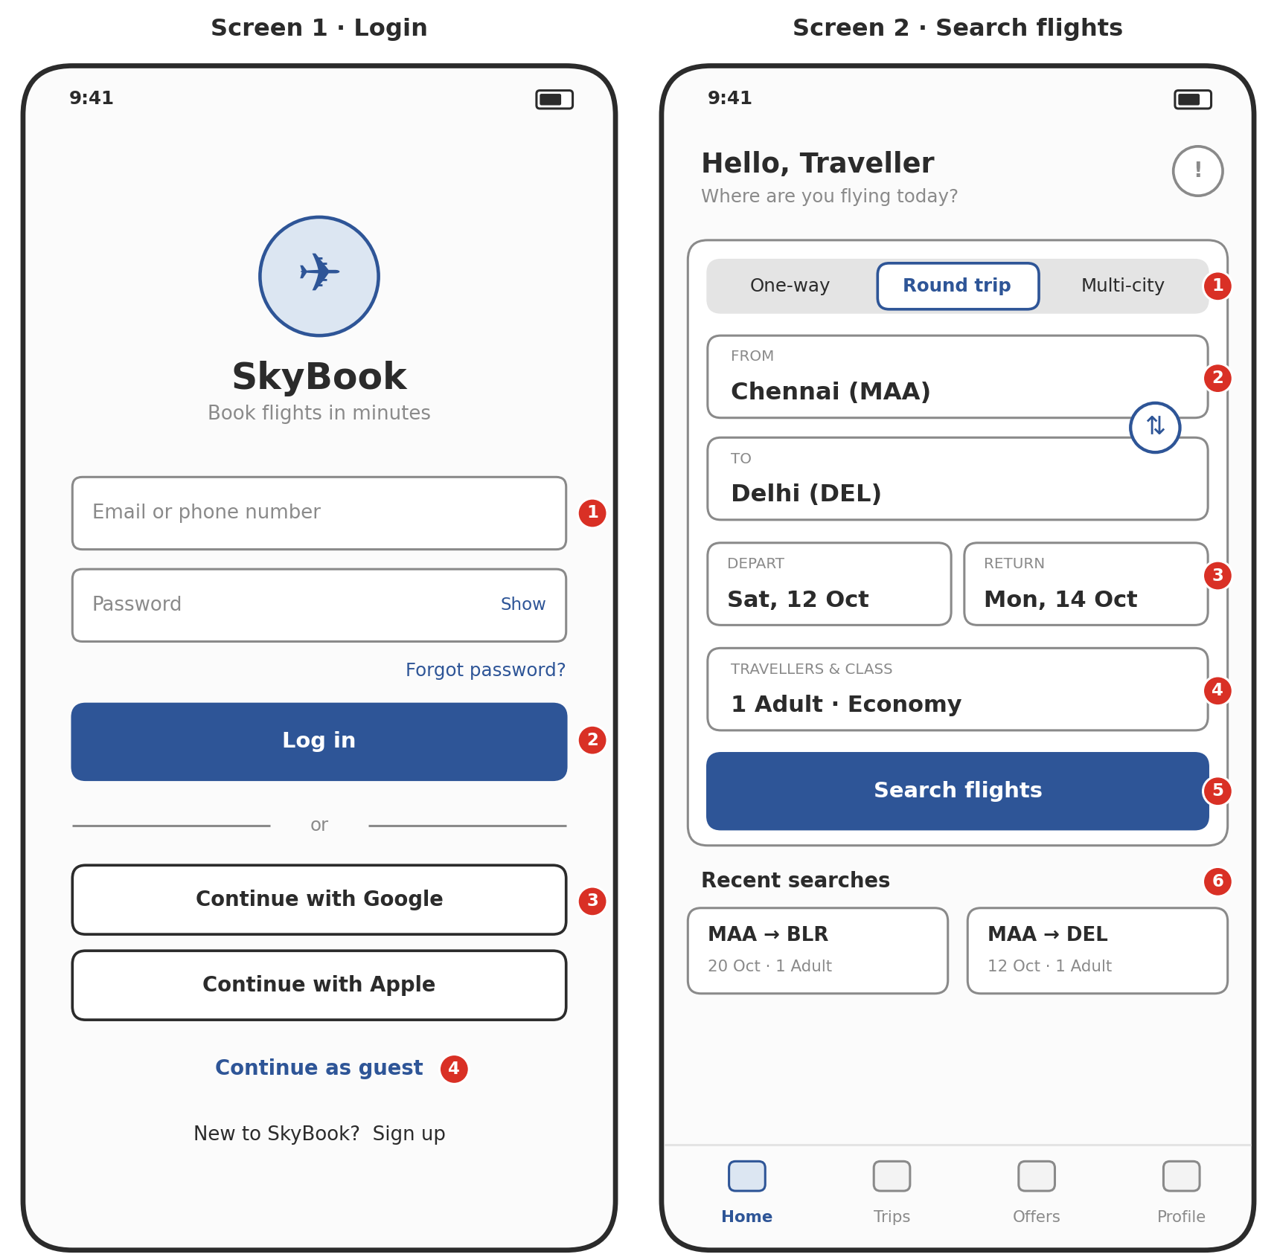
Screen 1 · Login  1. Email or phone and password fields, with a Show option for the password.  2. Primary Log in button. Errors appear under the field that failed.  3. Quick sign-in with Google or Apple.  4. Guests can skip login and sign in later, before payment. | Screen 2 · Search flights  1. Trip type tabs: One-way, Round trip, Multi-city.  2. From and To airports, with a swap button between them.  3. Depart and return date pickers (return hides for one-way).  4. Travellers and cabin class in one selector.  5. Primary Search flights button.  6. Recent searches for one-tap repeat searches.

3.2 Search results and flight details
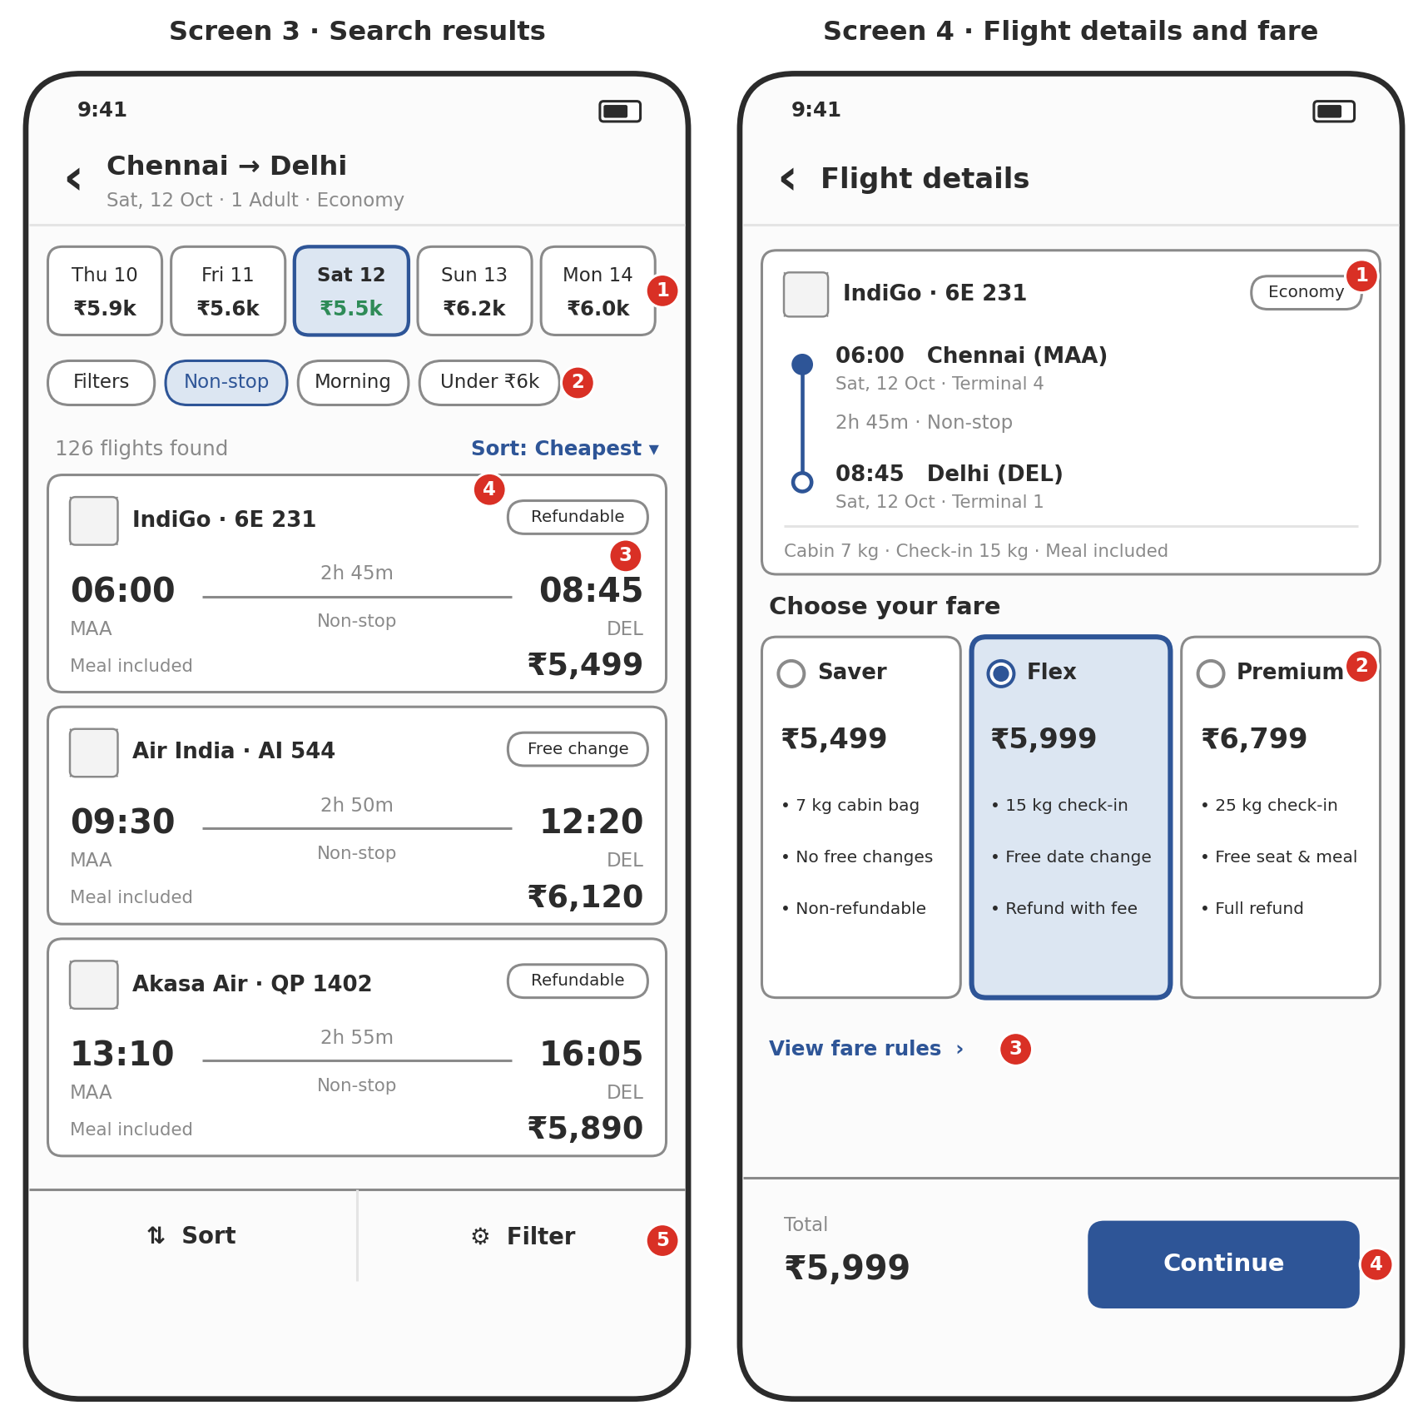
Screen 3 · Search results  1. Date strip with the lowest fare per day, so users can shift dates.  2. Quick filter chips (non-stop, time of day, price) plus a full Filters screen.  3. Flight card: airline, times, duration, stops and price.  4. Tags such as Refundable or Free change help users compare.  5. Sticky Sort and Filter bar stays in reach while scrolling. | Screen 4 · Flight details and fare  1. Itinerary summary: times, airports, terminals, duration and baggage.  2. Fare options as selectable cards (Saver, Flex, Premium) with what each includes.  3. Link to full fare rules, including change and cancellation fees.  4. Sticky total and Continue button update when the fare changes.

3.3 Traveller details and seat selection
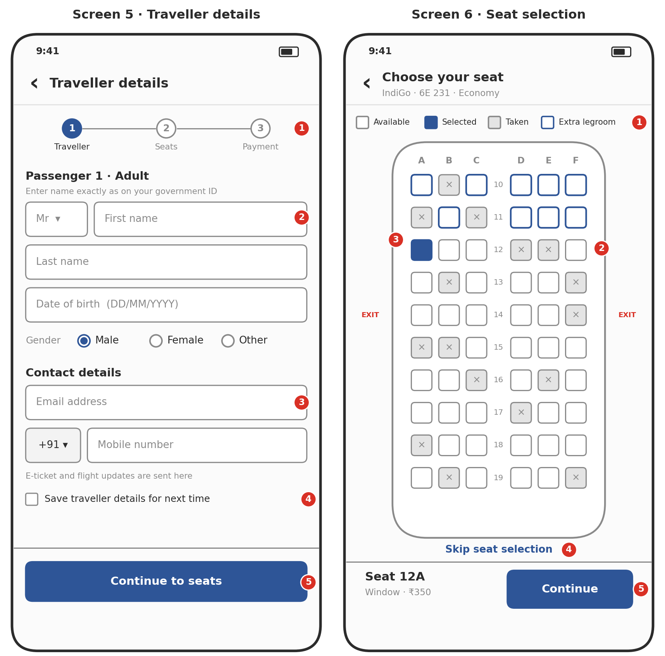
Screen 5 · Traveller details  1. Progress steps show where the user is in the booking.  2. Name fields must match the government ID; one form per traveller.  3. Contact details receive the e-ticket and flight updates.  4. Option to save traveller details for faster future bookings.  5. Continue moves to seat selection. | Screen 6 · Seat selection  1. Legend: available, selected, taken and extra legroom seats.  2. Tap a seat to select it; rows show seat letters and numbers.  3. Selected seat is highlighted; price shows in the bottom bar.  4. Seat selection is optional and can be skipped.  5. Bottom bar shows the chosen seat, its price and Continue.

3.4 Review, payment and confirmation
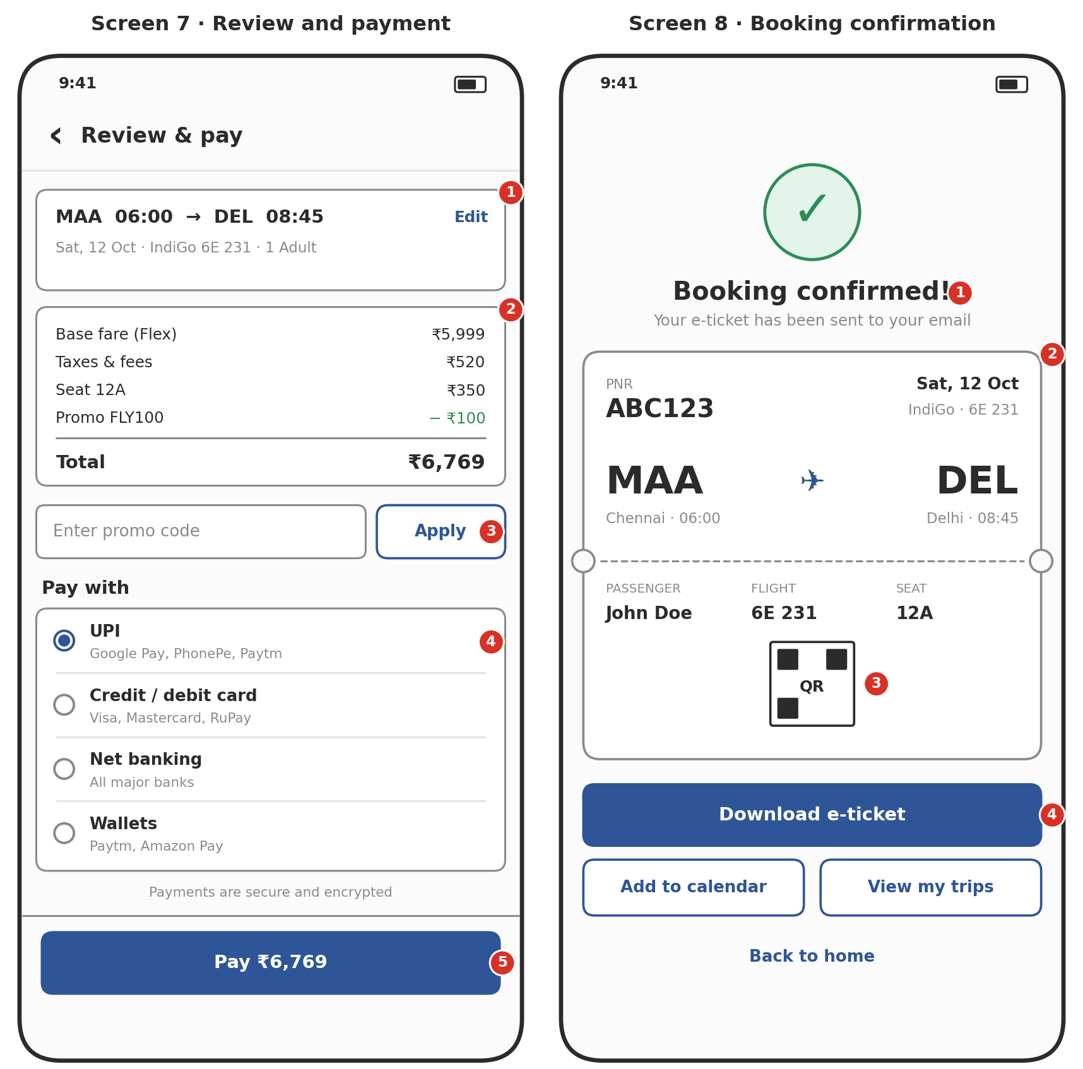
Screen 7 · Review and payment  1. Trip summary with an Edit link back to earlier steps.  2. Fare breakdown: base fare, taxes, seat, promo discount and total.  3. Promo code field with Apply button.  4. Payment methods: UPI, cards, net banking and wallets.  5. Pay button shows the exact amount. | Screen 8 · Booking confirmation  1. Clear success message and where the ticket was sent.  2. Boarding-pass style card with PNR, route, times, passenger, flight and seat.  3. QR code placeholder for the e-ticket.  4. Actions: download e-ticket, add to calendar, view trips, back to home.

3.5 My trips and manage booking
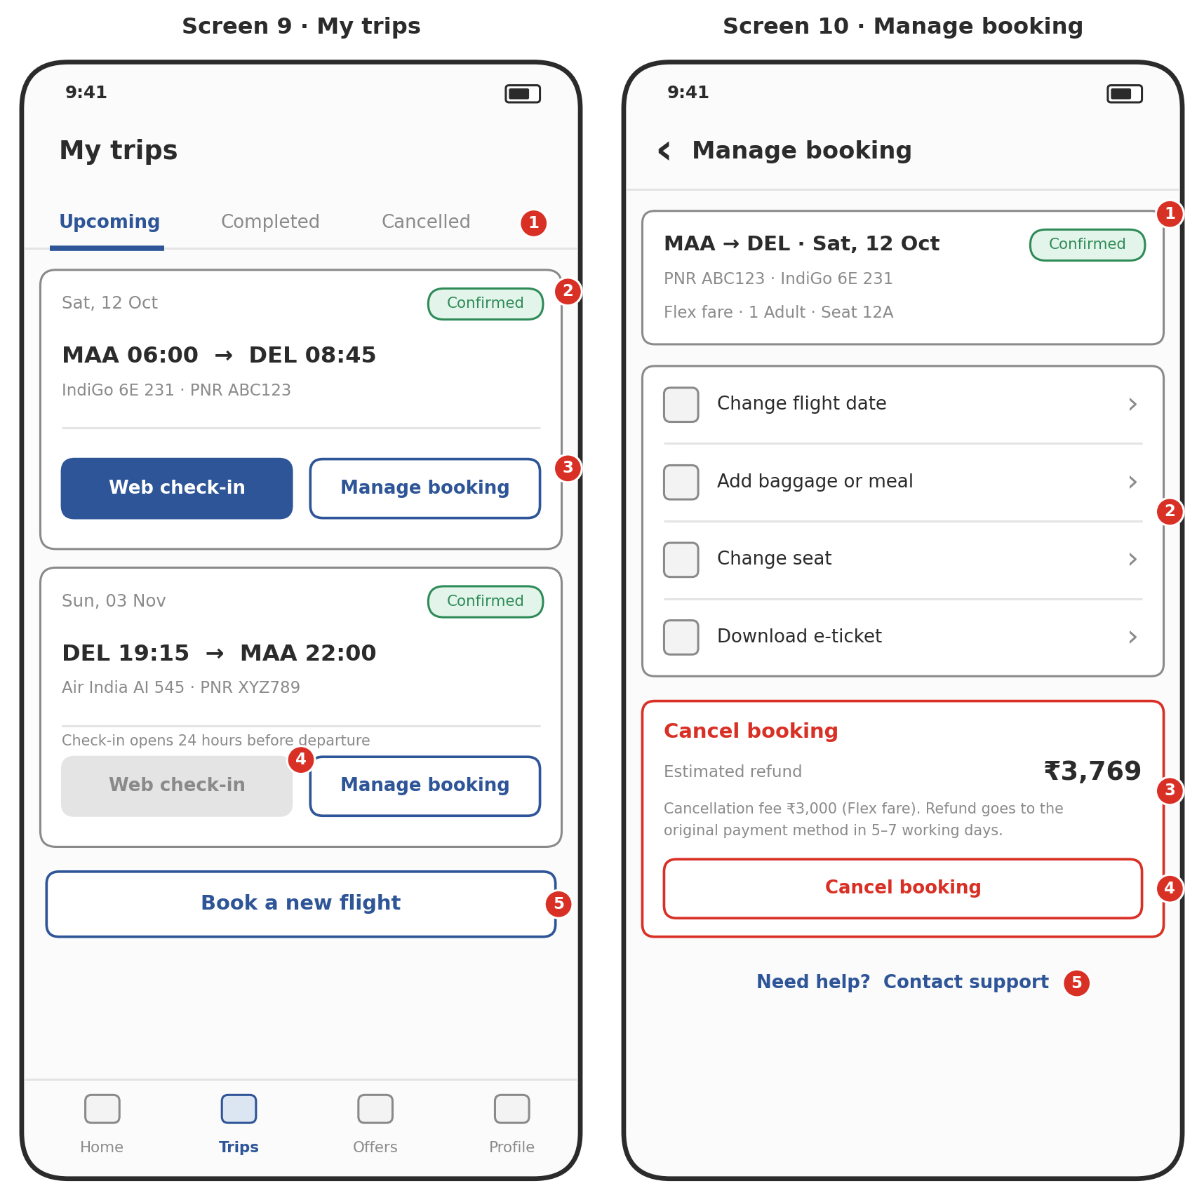
Screen 9 · My trips  1. Tabs separate Upcoming, Completed and Cancelled bookings.  2. Trip card with date, route, flight, PNR and status.  3. Quick actions: web check-in and manage booking.  4. Check-in stays disabled until the check-in window opens.  5. Shortcut to start a new search. | Screen 10 · Manage booking  1. Booking summary with status, PNR, fare type and seat.  2. Change options: date, baggage or meal, seat, and e-ticket download.  3. Refund estimate shown before the user cancels.  4. Cancel button opens a confirmation dialog before anything is cancelled.  5. Help link to customer support.

4. Common Elements and Next Steps

Elements used across screens
- Primary button: one filled button per screen for the main action.
- Sticky bottom bar: used for totals and Continue on the booking steps, so the action is always reachable.
- Bottom navigation: Home, Trips, Offers and Profile on the main screens only.
- Back arrow: top left on every step inside a flow.
- Cards: used for flights, fares, trips and summaries to group related information.

Not shown in these wireframes
- Loading, empty and error states (for example, no flights found or payment failed).
- The full Filters screen, calendar picker and airport search list.
- Multi-city and multi-passenger variations.
- Profile, Offers and Notifications screens.
- Tablet and desktop layouts.

Suggested next steps
- Review the flow with the client or team and note changes.
- Add the missing states and screens listed above.
- Turn the approved wireframes into a clickable prototype.
- Create the high-fidelity visual design with brand colours, fonts and real images.

