DSA0603 Data Handling and Visualization
Slot B
CO2 – Assessment Test 5 (AT2)
Visualization Development Exercise
Instructions:
For each question, write the program in the specified language (R or Python), generate the required visualization, and answer the interpretation sub-questions clearly with justification.
Question 1 — Chart Selection (Topic 1: Directory of Visualizations)
Task: For each scenario below, name the single best chart type from the directory (Amounts / Distribution / Proportion / x–y Relationship / Geospatial / Network / Temporal / Multivariate) and justify your choice in 1–2 sentences. No code required for this question.
1. Comparing total revenue across 6 product categories in one year.
2. Showing how the salary distribution differs across 4 job levels.
3. Showing market share of 5 competing brands.
4. Showing the relationship between advertising spend and sales revenue.
5. Showing monthly website traffic over 3 years.
6. Showing which employees report to which managers in an org.

1. Comparing total revenue across 6 product categories in one year
Chart Type: Bar Chart (Amounts)
Justification:
A bar chart is the best choice for comparing numerical values across different categories. It makes it easy to identify the highest and lowest revenue among the six product categories.
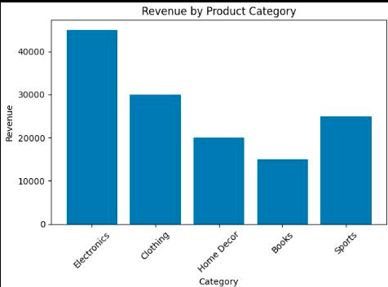

2. Showing how the salary distribution differs across 4 job levels
Chart Type: Box Plot (Distribution)
Justification:
A box plot effectively displays the distribution, median, quartiles, and potential outliers of salaries for each job level, allowing easy comparison between groups.
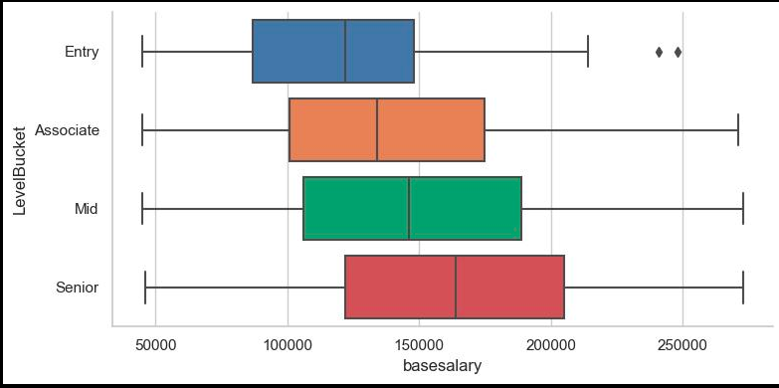

3. Showing market share of 5 competing brands
Chart Type: Pie Chart (Proportion)
Justification:
A pie chart shows how each brand contributes to the whole market, making it suitable for displaying percentage or proportional data.
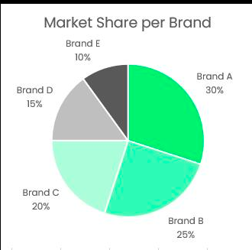

4. Showing the relationship between advertising spend and sales revenue
Chart Type: Scatter Plot (X–Y Relationship)
Justification:
A scatter plot is ideal for examining the relationship between two continuous variables and helps identify trends or correlations between advertising spend and sales.
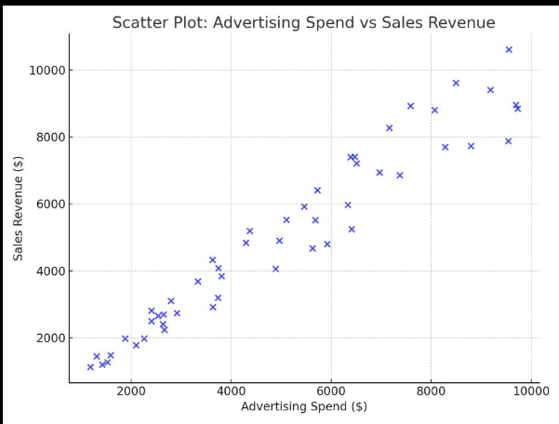

5. Showing monthly website traffic over 3 years
Chart Type: Line Chart (Temporal)
Justification:
A line chart clearly illustrates changes over time, making it easy to observe trends, seasonal patterns, and growth in website traffic across three years.
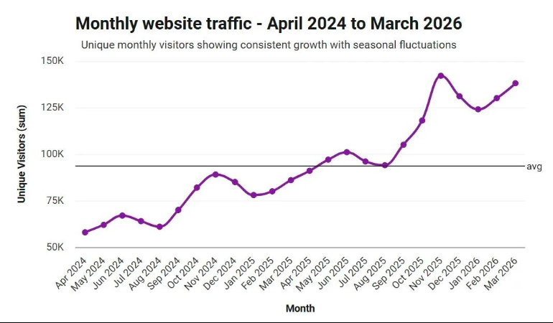

6. Showing which employees report to which managers in an organization
Chart Type: Network Diagram (Network)
Justification:
A network diagram effectively represents hierarchical relationships between employees and managers, clearly showing reporting structures and organizational connections.
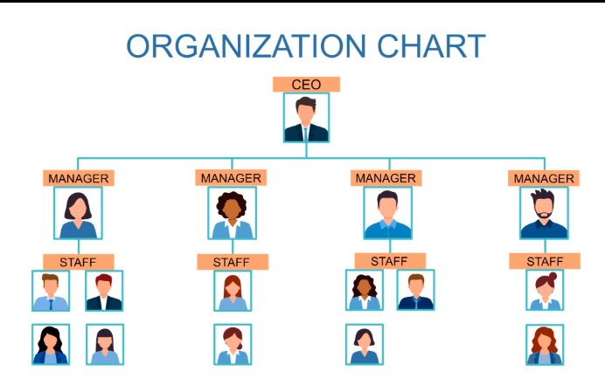

Question 2
Dataset — avg_score.csv
Subject | Average_Score
Mathematics | 72
Science | 68
English | 75
History | 64
Computer Sci | 81

Task:
● Create a vertical bar plot of Average_Score by Subject, sorted in descending order of score. ● Color the bars using a single consistent color; highlight the highest-scoring subject in a different color. ● Add data labels on top of each bar.
Python: use pandas to build the DataFrame and matplotlib.pyplot.bar (or seaborn.barplot). R: use a data.frame and ggplot2::geom_col().

Aim:
To create a vertical bar plot showing the Average Score of each subject using Python (Matplotlib) or R (ggplot2), with the subjects sorted in descending order, the highest-scoring subject highlighted in a different color, and data labels displayed on each bar.

Algorithm:
- Create a dataset containing Subject and Average_Score.
- Load the required library (pandas and matplotlib in Python or ggplot2 in R).
- Store the data in a DataFrame.
- Sort the data in descending order based on Average_Score.
- Assign one consistent color to all bars and a different color to the highest-scoring subject.
- Create a vertical bar chart with Subject on the X-axis and Average Score on the Y-axis.
- Add data labels above each bar.
- Add a suitable title and axis labels.
- Display the chart and interpret the results.
Program:
Python;
import pandas as pd
import matplotlib.pyplot as plt

# Create DataFrame
df = pd.DataFrame({
'Subject': ['Mathematics', 'Science', 'English', 'History', 'Computer Sci'],
'Average_Score': [72, 68, 75, 64, 81]
})

# Sort in descending order
df = df.sort_values(by='Average_Score', ascending=False)

# Colors (highest score highlighted)
colors = ['orange'] + ['skyblue'] * (len(df) - 1)

# Plot
plt.figure(figsize=(8,5))
bars = plt.bar(df['Subject'], df['Average_Score'], color=colors)

# Data labels
for bar in bars:
plt.text(bar.get_x() + bar.get_width()/2,
bar.get_height() + 0.5,
str(bar.get_height()),
ha='center')

plt.title("Average Score by Subject")
plt.xlabel("Subject")
plt.ylabel("Average Score")
plt.ylim(0, 90)
plt.show()
R Code:
library(ggplot2)

# Create Data Frame
df <- data.frame(
Subject = c("Mathematics", "Science", "English", "History", "Computer Sci"),
Average_Score = c(72, 68, 75, 64, 81)
)

# Sort in descending order
df <- df[order(-df$Average_Score), ]

# Create color column
df$Color <- ifelse(df$Average_Score == max(df$Average_Score),
"Highest", "Others")

# Bar Plot
ggplot(df,
aes(x = reorder(Subject, -Average_Score),
y = Average_Score,
fill = Color)) +
geom_col() +
geom_text(aes(label = Average_Score),
vjust = -0.4,
size = 5) +
scale_fill_manual(values = c("Highest" = "orange",
"Others" = "skyblue")) +
labs(title = "Average Score by Subject",
x = "Subject",
y = "Average Score") +
theme_minimal()
Output:
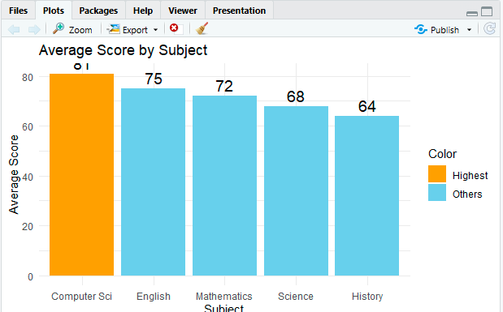

Result:
A vertical bar chart is successfully created with subjects sorted in descending order of average score. Computer Science (81) is highlighted as the highest-scoring subject, while the remaining subjects are displayed in a single consistent color. Data labels clearly indicate the average score of each subject.
Question 3
Dataset — regional_sales.csv
Region | Quarter | Sales_000s
North | Q1 | 120
North | Q2 | 135
North | Q3 | 128
North | Q4 | 150
South | Q1 | 95
South | Q2 | 110
South | Q3 | 105
South | Q4 | 130
East | Q1 | 140
East | Q2 | 138
East | Q3 | 145

East | Q4 | 160
West | Q1 | 80
West | Q2 | 85
West | Q3 | 90
West | Q4 | 100

Task (produce all four views from the same dataset):
1. Grouped bar chart: Sales_000s by Region, grouped by Quarter.
2. Stacked bar chart: same data, stacked by Quarter within each Region.
3. Dot plot: total annual sales per region (sum across quarters), ranked from highest to lowest. 4. Heatmap: Region (rows) × Quarter (columns), color-encoded by Sales_000s.
Python: pandas.pivot_table to reshape; matplotlib/seaborn for grouped/stacked bars, seaborn.heatmap for the heatmap, matplotlib.pyplot.scatter (or plt.plot with markers) for the dot plot.
R: tidyr::pivot_wider where needed; ggplot2::geom_col(position = "dodge") for grouped, position = "stack" for stacked, geom_point() for the dot plot, geom_tile() for the heatmap

Aim:
To visualize regional quarterly sales using different chart types (Grouped Bar Chart, Stacked Bar Chart, Dot Plot, and Heatmap) in order to compare sales performance across regions and quarters.

Algorithm:
- Import the required libraries (pandas, matplotlib.pyplot, and seaborn).
- Create a DataFrame containing Region, Quarter, and Sales_000s.
- Reshape the dataset using a pivot table for grouped, stacked bar charts, and heatmap.
- Create a Grouped Bar Chart to compare quarterly sales across regions.
- Create a Stacked Bar Chart to show the contribution of each quarter to annual regional sales.
- Calculate the total annual sales for each region by summing quarterly sales.
- Sort the totals in descending order and create a Dot Plot.
- Create a Heatmap using the pivot table to visualize sales intensity by region and quarter.
- Display all charts with appropriate titles, labels, and legends.
. Program:
# Install packages (Run once)
install.packages(c("ggplot2", "tidyr", "dplyr"))

# Load libraries
library(ggplot2)
library(tidyr)
library(dplyr)

# Create Data Frame
sales <- data.frame(
Region = c("North","North","North","North",
"South","South","South","South",
"East","East","East","East",
"West","West","West","West"),
Quarter = c("Q1","Q2","Q3","Q4",
"Q1","Q2","Q3","Q4",
"Q1","Q2","Q3","Q4",
"Q1","Q2","Q3","Q4"),
Sales_000s = c(120,135,128,150,
95,110,105,130,
140,138,145,160,
80,85,90,100)
)

#------------------------------------
# 1. Grouped Bar Chart
#------------------------------------
ggplot(sales, aes(x = Region, y = Sales_000s, fill = Quarter)) +
geom_col(position = "dodge") +
labs(title = "Grouped Bar Chart",
x = "Region",
y = "Sales (000s)") +
theme_minimal()

#------------------------------------
# 2. Stacked Bar Chart
#------------------------------------
ggplot(sales, aes(x = Region, y = Sales_000s, fill = Quarter)) +
geom_col(position = "stack") +
labs(title = "Stacked Bar Chart",
x = "Region",
y = "Sales (000s)") +
theme_minimal()

#------------------------------------
# 3. Dot Plot (Total Annual Sales)
#------------------------------------
total_sales <- sales %>%
group_by(Region) %>%
summarise(Total = sum(Sales_000s)) %>%
arrange(desc(Total))

ggplot(total_sales,
aes(x = reorder(Region, -Total), y = Total)) +
geom_point(size = 4, colour = "blue") +
geom_text(aes(label = Total), vjust = -0.6) +
labs(title = "Total Annual Sales by Region",
x = "Region",
y = "Total Sales (000s)") +
theme_minimal()

#------------------------------------
# 4. Heatmap
#------------------------------------
heat_data <- sales %>%
pivot_wider(names_from = Quarter,
values_from = Sales_000s)

ggplot(sales,
aes(x = Quarter, y = Region, fill = Sales_000s)) +
geom_tile(color = "white") +
geom_text(aes(label = Sales_000s), size = 4) +
labs(title = "Regional Sales Heatmap",
x = "Quarter",
y = "Region") +
theme_minimal()

Output:
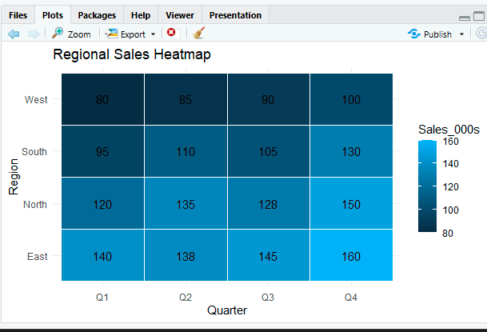

Result:
- Grouped Bar Chart: Compares quarterly sales across regions.
- Stacked Bar Chart: Shows each quarter's contribution to total regional sales.
- Dot Plot: Ranks regions by total annual sales (East > North > South > West).
- Heatmap: Displays sales intensity across regions and quarters, with higher values appearing in darker shades.
Question 4
Dataset — generate synthetically for reproducibility:
Class A: 40 exam scores ~ Normal(mean=70, sd=8)
Class B: 40 exam scores ~ Normal(mean=75, sd=5)
Class C: 40 exam scores ~ Normal(mean=65, sd=12)
Class D: 40 exam scores ~ Normal(mean=80, sd=6)
(Set a random seed of 42 in both Python and R so results are consistent across languages.) Task:
1. Violin plot: exam score distribution by class (all 4 classes on one plot), with an embedded boxplot or median marker.
2. Ridgeline plot: same 4 classes, overlapping density curves, ordered by mean score.
Python: numpy.random.normal to generate data, seaborn.violinplot for the violin plot, joypy.joyplot (or a stacked seaborn/matplotlib kdeplot FacetGrid) for the ridgeline.
R: rnorm() to generate data, ggplot2::geom_violin() for the violin plot, ggridges::geom_density_ridges() for the ridgeline.

Aim:
To generate synthetic exam score data for four classes using a fixed random seed and visualize the score distributions using a Violin Plot and a Ridgeline Plot in R.

Algorithm:
- Set the random seed to 42 for reproducibility.
- Generate 40 exam scores for each class using the normal distribution (rnorm()).
- Combine the generated scores into a single data frame with Class and Score columns.
- Create a Violin Plot with an embedded boxplot to compare score distributions.
- Calculate the mean score for each class and order the classes accordingly.
- Create a Ridgeline Plot using geom_density_ridges() to display overlapping score distributions.
- Add appropriate titles and axis labels.
- Display both plots.
Program:
# Install packages (Run once)
install.packages(c("ggplot2", "ggridges", "dplyr"))

# Load libraries
library(ggplot2)
library(ggridges)
library(dplyr)

# Set random seed
set.seed(42)

# Generate synthetic data
A <- rnorm(40, mean = 70, sd = 8)
B <- rnorm(40, mean = 75, sd = 5)
C <- rnorm(40, mean = 65, sd = 12)
D <- rnorm(40, mean = 80, sd = 6)

# Create data frame
scores <- data.frame(
Class = rep(c("Class A", "Class B", "Class C", "Class D"), each = 40),
Score = c(A, B, C, D)
)

#-----------------------------------
# 1. Violin Plot with Boxplot
#-----------------------------------
ggplot(scores, aes(x = Class, y = Score, fill = Class)) +
geom_violin(trim = FALSE) +
geom_boxplot(width = 0.12, fill = "white") +
labs(title = "Violin Plot of Exam Scores by Class",
x = "Class",
y = "Exam Score") +
theme_minimal()

#-----------------------------------
# 2. Ridgeline Plot
#-----------------------------------

# Order classes by mean score
scores$Class <- reorder(scores$Class,
scores$Score,
FUN = mean)

ggplot(scores,
aes(x = Score,
y = Class,
fill = Class)) +
geom_density_ridges(alpha = 0.7) +
labs(title = "Ridgeline Plot of Exam Scores",
x = "Exam Score",
y = "Class") +
theme_minimal()
Output:
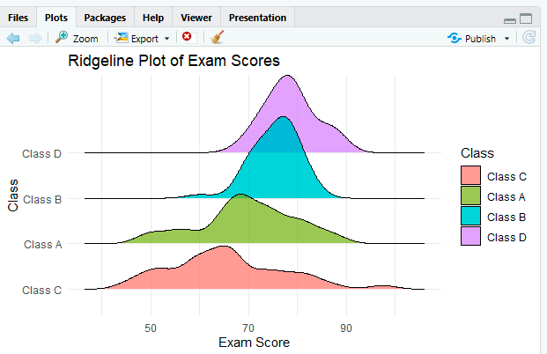

Result:
- The Violin Plot displays the distribution of exam scores for all four classes, with an embedded boxplot showing the median and spread.
- The Ridgeline Plot presents overlapping density curves ordered by mean score, making it easy to compare score distributions across classes.
- Class D
- has the highest average scores, followed by Class B, Class A, and Class C.
Question 5
Dataset: Use a built-in dataset available in both languages.
● Python: seaborn.load_dataset("tips") → use the total_bill column.
● R: the equivalent tips dataset (available via the reshape2 package, or import the same CSV used in Python so results are directly comparable).
Task:
1. Plot a histogram of the chosen continuous variable with 30 bins.
2. Overlay a kernel density estimate (KDE) curve on the same plot.
3. Repeat both, split/colored by the smoker categorical variable, to compare distribution shape across groups. Python: seaborn.histplot(..., kde=True) or matplotlib.pyplot.hist + scipy.stats.gaussian_kde.
R: ggplot2::geom_histogram() combined with geom_density() (use after_stat(density) so scales match), with fill = mapped to smoker for the grouped version.

Aim:
To visualize the distribution of the total_bill variable from the tips dataset using a Histogram with a Kernel Density Estimate (KDE) curve, and compare the distributions for Smokers and Non-Smokers.

Algorithm:
- Load the required libraries (ggplot2 and reshape2).
- Load the tips dataset.
- Create a histogram of the total_bill variable using 30 bins.
- Overlay a density (KDE) curve on the histogram.
- Create another histogram grouped by the smoker variable.
- Overlay separate density curves for smokers and non-smokers.
- Add titles, axis labels, and legends.
- Display the plots.

Program:
# Install packages (Run once)
install.packages(c("ggplot2", "reshape2"))

# Load libraries
library(ggplot2)
library(reshape2)

# Load tips dataset
data("tips")

#-----------------------------------------
# 1. Histogram + KDE (Overall)
#-----------------------------------------
ggplot(tips, aes(x = total_bill)) +
geom_histogram(aes(y = after_stat(density)),
bins = 30,
fill = "skyblue",
color = "black") +
geom_density(color = "red", linewidth = 1.2) +
labs(title = "Histogram with KDE of Total Bill",
x = "Total Bill",
y = "Density") +
theme_minimal()

#-----------------------------------------
# 2. Histogram + KDE by Smoker
#-----------------------------------------
ggplot(tips, aes(x = total_bill, fill = smoker)) +
geom_histogram(aes(y = after_stat(density)),
bins = 30,
alpha = 0.5,
position = "identity") +
geom_density(aes(color = smoker),
linewidth = 1.2) +
labs(title = "Histogram with KDE by Smoker",
x = "Total Bill",
y = "Density",
fill = "Smoker",
color = "Smoker") +
theme_minimal()
Output:
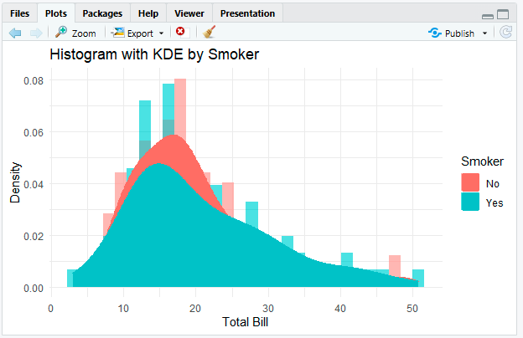

Result:
- The Histogram displays the frequency distribution of total_bill using 30 bins.
- The KDE curve provides a smooth estimate of the distribution shape.
- The grouped histogram and KDE allow comparison between Smokers and Non-Smokers, highlighting differences in the distribution of total bill amounts.
Submission Checklist
● Q1: written chart-type justifications (no code)
● Q2: bar plot — Python + R
● Q3: grouped bar, stacked bar, dot plot, heatmap — Python + R
● Q4: violin plot, ridgeline plot — Python + R
● Q5: histogram + density (overall and grouped) — Python + R
● Each chart has a title, axis labels, and a short written interpretation

