SIMATS ENGINEERING
ASSESSMENT TOOL I – EXPERIMENTS
Course: Data Handling and  Visualization | Code: DSA0603 | CO: CO3
Duration: 120 min | Total Marks: 100 | Reg No :  Name:

COURSE OUTCOME COVERED
CO3: Analyze time-series data, trends, associations, and uncertainty through appropriate visualization methods. (BL4) Activity Tool : Experiments
Weightage: 20%
Code of Conduct:
I __________________ (Name / Reg No) certify that this submission is my original work and that I have adhered to the guidelines specified for this assessment. I understand that any violation of academic integrity rules will result in disciplinary action.
Signature of the student:
Criteria | Understanding of Concepts  25% | Experimental  Design  30% | Use of Tools  20% | Analysis of  Results  15% | Documents  10% | Total
Q1
Q2
Q3
Q4
Q5

DSA06 – Data Handling and Visualization | Assessment Tool: Experiment
DSA06 – DATA HANDLING AND VISUALIZATION
CO3_AT1_Assessment Tool: EXPERIMENT
Question 1 – Distribution Diagnosis using ECDF and Q-Q Plot
Scenario: An engineering department records response time (ms) of an automated fault-detection system under 20 test runs. The team claims the distribution is approximately normal and wants to use mean and standard deviation for monitoring.
Dataset (n=20): 118, 121, 125, 127, 129, 131, 134, 136, 138, 141, 144, 147, 151, 156, 162, 171, 184, 205, 249, 318 Tasks:
1. Construct an ECDF and a normal Q-Q plot.
2. Use both plots to evaluate the normality claim.
3. Identify evidence of skewness and/or extreme observations.
4. Recommend percentile-based limits or mean ± standard-deviation limits, with justification.
Key competency: ECDF, Q-Q plot, skewness, outliers, distribution interpretation

Aim
To construct an ECDF and normal Q-Q plot for the automated fault-detection response-time data and assess normality, skewness, extreme observations, and suitable monitoring limits.

Algorithm
- Enter the 20 response-time observations.
- Calculate summary statistics and skewness.
- Construct the ECDF.
- Construct a normal Q-Q plot with a reference line.
- Examine deviations from the theoretical normal distribution.
- Identify extreme observations and skewness.
- Recommend appropriate monitoring limits.

R Code
response_time <- c(118,121,125,127,129,131,134,136,138,141,
144,147,151,156,162,171,184,205,249,318)

mean_value <- mean(response_time)
sd_value <- sd(response_time)
median_value <- median(response_time)

skewness_value <- mean((response_time - mean_value)^3) /
sd_value^3

par(mfrow = c(1,2))

plot(ecdf(response_time),
main = "ECDF of Response Time",
xlab = "Response Time (ms)",
ylab = "Cumulative Probability",
verticals = TRUE,
do.points = TRUE)

qqnorm(response_time,
main = "Normal Q-Q Plot",
xlab = "Theoretical Quantiles",
ylab = "Observed Response Time")

qqline(response_time, col = "red", lwd = 2)

par(mfrow = c(1,1))

cat("Mean =", round(mean_value, 2), "ms\n")
cat("Median =", median_value, "ms\n")
cat("Standard Deviation =", round(sd_value, 2), "ms\n")
cat("Skewness =", round(skewness_value, 3), "\n")

cat("\nMean - 3SD =", round(mean_value - 3*sd_value, 2), "ms\n")
cat("Mean + 3SD =", round(mean_value + 3*sd_value, 2), "ms\n")

cat("\nPercentiles:\n")
print(quantile(response_time, c(0.05, 0.25, 0.50, 0.75, 0.95, 0.99)))
Output:
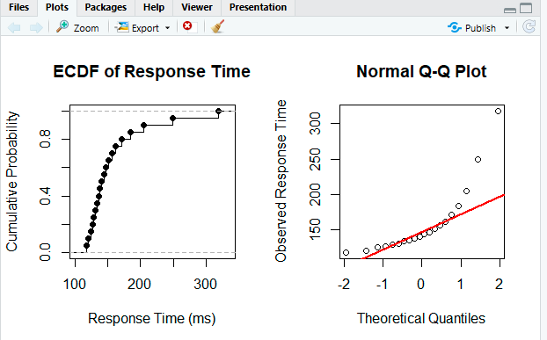

Result
The ECDF rises gradually through the lower and middle response times but has a long upper tail due to observations such as 205, 249 and 318 ms.

Question 2 – Comparing Many Distributions and Bean Plots
Scenario: A semiconductor manufacturer measures chip fabrication cycle time (minutes) for four production lines. Management wants to identify differences in variability and distribution shape.
Production Line | Cycle Times (minutes)
L1 | 42, 44, 45, 46, 47, 48, 49, 50, 51, 53
L2 | 38, 41, 44, 47, 50, 53, 56, 59, 62, 65
L3 | 45, 46, 46, 47, 47, 48, 48, 49, 49, 50
L4 | 40, 41, 42, 43, 44, 45, 48, 55, 61, 72

Tasks:
1. Create a visualization comparing all four distributions.
2. Construct bean plots or an equivalent distribution visualization along the vertical axis.
3. Determine which line has greatest variability and which has the most concentrated distribution. 4. Explain why comparing only means is insufficient.
Key competency: Multiple distributions, vertical-axis distributions, bean plots, variability

Aim
To compare the distributions, variability, concentration, and shape of cycle times from four semiconductor production lines using distribution plots and vertical-axis visualizations.

Algorithm
- Enter cycle-time observations for the four production lines.
- Combine the observations into a data frame.
- Calculate mean, median, standard deviation, minimum and maximum.
- Construct a boxplot to compare distributions.
- Construct violin plots as an equivalent to bean plots.
- Compare spread and concentration.
- Determine the most variable and most concentrated production lines.

R Code
library(ggplot2)

L1 <- c(42,44,45,46,47,48,49,50,51,53)
L2 <- c(38,41,44,47,50,53,56,59,62,65)
L3 <- c(45,46,46,47,47,48,48,49,49,50)
L4 <- c(40,41,42,43,44,45,48,55,61,72)

cycle_time <- c(L1, L2, L3, L4)

line <- factor(rep(c("L1","L2","L3","L4"), each = 10))

data <- data.frame(Line = line, CycleTime = cycle_time)

summary_data <- aggregate(CycleTime ~ Line, data, function(x)
c(Mean = mean(x),
Median = median(x),
SD = sd(x),
Minimum = min(x),
Maximum = max(x)))

print(summary_data)

ggplot(data, aes(x = Line, y = CycleTime)) +
geom_boxplot() +
labs(title = "Cycle Time Distribution by Production Line",
x = "Production Line",
y = "Cycle Time (minutes)") +
theme_minimal()

ggplot(data, aes(x = Line, y = CycleTime)) +
geom_violin(trim = FALSE) +
geom_boxplot(width = 0.1) +
labs(title = "Bean-Plot Equivalent: Violin Distribution",
x = "Production Line",
y = "Cycle Time (minutes)") +
theme_minimal()
Output:
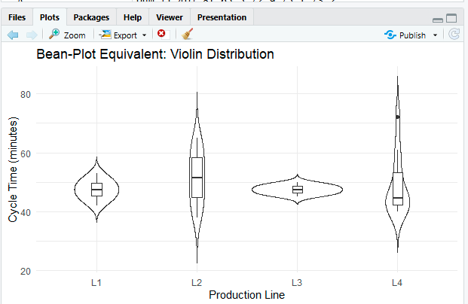

Result
The distribution plots clearly show differences between the four production lines.
- L4 has the greatest variability, with values ranging from 40 to 72 minutes and a very long upper tail.
- L3 has the most concentrated distribution, with observations tightly grouped between 45 and 50 minutes.
- L1 has relatively small variability.
- L2 has a broad and almost steadily increasing range from 38 to 65 minutes.

Question 3 – Proportion Visualization and Choice of Chart
Scenario: A university analyzes preferred learning mode of 240 students across three departments. The dean wants comparison without exaggerating small differences.
Department | Online (%) | Blended (%) | Face-to-Face (%)
CSE | 52 | 28 | 20
ECE | 45 | 35 | 20
IT | 30 | 40 | 30

Tasks:
1. Create a side-by-side bar chart and a 100% stacked bar chart.
DSA06 – Data Handling and Visualization | Assessment Tool: Experiment
2. Explain which chart better supports comparison of individual proportions and why.
3. Explain why separate pie charts may be less effective for comparing departments.
4. Identify one design choice that could make small proportional differences appear larger.
Key competency: Proportions, side-by-side bars, stacked bars, pie charts, misleading proportions

Aim
To compare student learning-mode preferences across three departments using side-by-side bar charts and 100% stacked bar charts and determine the most effective visualization for proportional comparison.

Algorithm
- Enter the percentage data for the three departments.
- Convert the data into long format.
- Construct a side-by-side bar chart.
- Construct a 100% stacked bar chart.
- Compare the ability of both charts to show individual proportions.
- Explain limitations of pie charts and misleading design choices.

R Code
library(ggplot2)

learning <- data.frame(
Department = c("CSE","ECE","IT"),
Online = c(52,45,30),
Blended = c(28,35,40),
Face_to_Face = c(20,20,30)
)

learning_long <- data.frame(
Department = rep(learning$Department, 3),
Mode = rep(c("Online","Blended","Face-to-Face"), each = 3),
Percentage = c(learning$Online,
learning$Blended,
learning$Face_to_Face)
)

ggplot(learning_long,
aes(x = Department, y = Percentage, fill = Mode)) +
geom_bar(stat = "identity", position = "dodge") +
labs(title = "Learning Mode Preferences",
x = "Department",
y = "Percentage (%)") +
theme_minimal()

ggplot(learning_long,
aes(x = Department, y = Percentage, fill = Mode)) +
geom_bar(stat = "identity", position = "fill") +
scale_y_continuous(labels = function(x) paste0(x * 100, "%")) +
labs(title = "100% Stacked Bar Chart of Learning Preferences",
x = "Department",
y = "Percentage") +
theme_minimal()

Output:
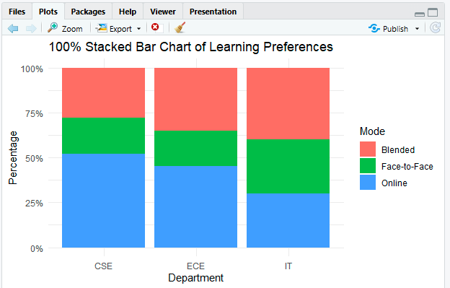

Result
The side-by-side bar chart is better for comparing individual proportions because all bars share a common baseline. For example, Online preference can easily be compared across CSE, ECE and IT.

Question 4 – Nested Proportions using Treemap and Sunburst
Scenario: An e-commerce company analyzes annual revenue of ₹1.2 crore across product categories and subcategories. The dashboard must show both category contribution and internal composition.
Category | Subcategory | Revenue (₹ lakh)
Electronics | Mobiles | 24
Electronics | Laptops | 18
Electronics | Accessories | 8
Home | Furniture | 14
Home | Appliances | 10
Home | Decor | 6
Fashion | Men | 7
Fashion | Women | 8
Fashion | Kids | 5

Tasks:
1. Construct a treemap showing category and subcategory revenue.
2. Construct a sunburst chart representing the same hierarchy.
3. Determine the largest category and calculate its percentage of total revenue.
4. Compare treemap and sunburst for identifying nested proportions.
5. State one situation in which area encoding could mislead interpretation.
Key competency: Treemaps, sunburst charts, nested proportions, area encoding

Aim
To visualize hierarchical revenue proportions using treemap and sunburst charts and identify the largest product category and its contribution to total revenue.

Important Data Observation
The supplied subcategory revenues add up to:
50 + 30 + 20 = ₹100 lakh = ₹1 crore
They do not add up to ₹1.2 crore as stated in the scenario. The calculations below therefore use the provided data values, whose total is ₹100 lakh.

Algorithm
- Enter category, subcategory and revenue data.
- Calculate total revenue for each category.
- Calculate category percentages.
- Construct a treemap.
- Construct a sunburst chart.
- Identify the largest category.
- Compare the strengths and limitations of the two visualizations.

R Code
install.packages("treemap", repos = "https://cloud.r-project.org")
install.packages("plotly", repos = "https://cloud.r-project.org")

library(treemap)
library(plotly)

revenue <- data.frame(
Category = c("Electronics","Electronics","Electronics",
"Home","Home","Home",
"Fashion","Fashion","Fashion"),
Subcategory = c("Mobiles","Laptops","Accessories",
"Furniture","Appliances","Decor",
"Men","Women","Kids"),
Revenue = c(24,18,8,14,10,6,7,8,5)
)

total_revenue <- sum(revenue$Revenue)

category_total <- aggregate(Revenue ~ Category,
revenue,
sum)

category_total$Percentage <-
category_total$Revenue / total_revenue * 100

print(category_total)

treemap(revenue,
index = c("Category","Subcategory"),
vSize = "Revenue",
type = "index",
title = "Revenue Treemap")

sunburst_data <- revenue

fig <- plot_ly(
data = sunburst_data,
ids = ~Subcategory,
labels = ~Subcategory,
parents = ~Category,
values = ~Revenue,
type = "sunburst",
branchvalues = "total"
)
fig <- fig %>%
layout(title = "Revenue Sunburst Chart"
)
Fig
Output:
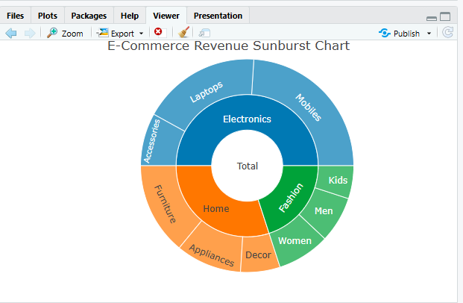
Result :
Area encoding can mislead when viewers estimate areas inaccurately, especially when many rectangles have similar sizes or when very small areas must be compared.

Question 5 – Flow Proportions using Sankey Diagram / Parallel Sets Scenario: A smart-city mobility study follows 200 commuters from residential zone through primary transport mode to destination zone. The planning team wants dominant flows and possible bottlenecks.
Origin | Mode | Destination | Commuters
Residential | Bus | Central | 35
Residential | Bus | Industrial | 15
Residential | Train | Central | 25
Residential | Train | Industrial | 10
Suburban | Bus | Central | 20
Suburban | Bus | Industrial | 10
Suburban | Train | Central | 30
Suburban | Train | Industrial | 15
Rural | Bus | Central | 12
Rural | Bus | Industrial | 8
Rural | Train | Central | 10
Rural | Train | Industrial | 10

Tasks:
1. Construct a Sankey diagram showing Origin → Mode → Destination.
2. Construct a parallel-sets representation of the same categorical flows.
DSA06 – Data Handling and Visualization | Assessment Tool: Experiment
3. Identify the three largest flows and calculate their percentages of all commuters.
4. Compare Sankey and parallel sets for flow magnitude and category relationships.
5. Explain one way poor link widths or category ordering could mislead the viewer.
Key competency: Sankey diagrams, parallel sets, flow proportions, categorical relationships

Aim
To visualize commuter flows from origin through transport mode to destination using Sankey and parallel-sets representations and identify dominant transportation flows.

Algorithm
- Enter the commuter flow data.
- Calculate the percentage represented by each flow.
- Construct an Origin → Mode → Destination Sankey diagram.
- Construct a parallel-sets representation.
- Identify the three largest flows.
- Compare both visualizations based on flow magnitude and category relationships.
- Analyze possible misleading visual design choices.

R Code
install.packages("networkD3", repos = "https://cloud.r-project.org")
install.packages("ggalluvial", repos = "https://cloud.r-project.org")

library(networkD3)
library(ggplot2)
library(ggalluvial)

flows <- data.frame(
Origin = c("Residential","Residential","Residential","Residential",
"Suburban","Suburban","Suburban","Suburban",
"Rural","Rural","Rural","Rural"),
Mode = c("Bus","Bus","Train","Train",
"Bus","Bus","Train","Train",
"Bus","Bus","Train","Train"),
Destination = c("Central","Industrial","Central","Industrial",
"Central","Industrial","Central","Industrial",
"Central","Industrial","Central","Industrial"),
Commuters = c(35,15,25,10,20,10,30,15,12,8,10,10)
)

total_commuters <- sum(flows$Commuters)

flows$Percentage <- flows$Commuters / total_commuters * 100

print(flows[order(-flows$Commuters), ])

nodes <- data.frame(
name = c(unique(flows$Origin),
unique(flows$Mode),
unique(flows$Destination))
)

origin_nodes <- match(flows$Origin, nodes$name) - 1
mode_nodes <- match(flows$Mode, nodes$name) - 1
destination_nodes <- match(flows$Destination, nodes$name) - 1

links1 <- data.frame(
source = origin_nodes,
target = mode_nodes,
value = flows$Commuters
)

links2 <- data.frame(
source = mode_nodes,
target = destination_nodes,
value = flows$Commuters
)

links <- rbind(links1, links2)

sankeyNetwork(
Links = links,
Nodes = nodes,
Source = "source",
Target = "target",
Value = "value",
NodeID = "name",
fontSize = 14,
nodeWidth = 30
)

ggplot(flows,
aes(axis1 = Origin,
axis2 = Mode,
axis3 = Destination,
y = Commuters)) +
geom_alluvium(aes(fill = Mode),
width = 1/12) +
geom_stratum(width = 1/8) +
geom_text(stat = "stratum",
aes(label = after_stat(stratum))) +
scale_x_discrete(limits = c("Origin","Mode","Destination"),
expand = c(.05,.05)) +
labs(title = "Parallel Sets of Commuter Flows",
y = "Number of Commuters") +
theme_minimal()

top_three <- flows[order(-flows$Commuters), ][1:3, ]

print(top_three)

cat("\nTop three flow percentages:\n")

for(i in 1:3) {
cat(
top_three$Origin[i], "->",
top_three$Mode[i], "->",
top_three$Destination[i], ":",
top_three$Commuters[i], "commuters =",
round(top_three$Percentage[i], 2), "%\n"
)
}
Output:
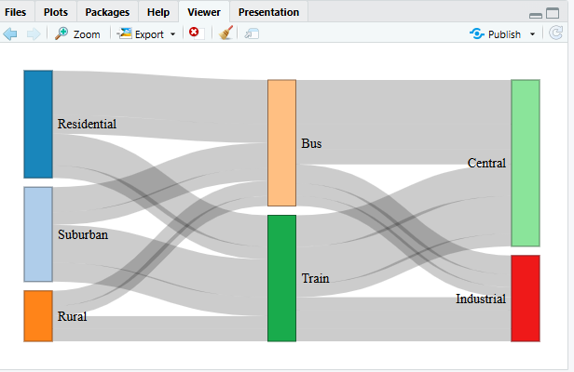
Result :
Poorly scaled link widths can exaggerate or hide differences in flow magnitude. Similarly, changing the ordering of categories can create visual crossings that make relationships difficult to follow.
Suggested Evaluation Rubric – Experiment
Criterion | Excellent (4) | Good (3) | Satisfactory (2) | Needs Improvement (1)
Data preparation | Correct and complete | Minor issue | Several issues | Incorrect/incomplete
Visualization choice | Highly appropriate  and justified | Appropriate | Partially appropriate | Poor choice
Technical execution | Accurate and clear | Mostly accurate | Some errors | Major errors
Interpretation | Insightful and  evidence-based | Correct | Basic | Incorrect/unsupported
Misleading-design  analysis | Bias clearly identified and explained | Bias identified | Limited explanation | Not identified

Suggested marks: 20 marks per question; 100 marks total. Level: Competitive / advanced undergraduate.
DSA06 – Data Handling and Visualization | Assessment Tool: Experiment

