SIMATS ENGINEERING
ASSESSMENT TOOL II — DATA ANALYSIS PROJECT
Course: Data Handling and Visualization | Code: DSA0603 | CO: CO3
Duration: 180 min | Total Marks: 100 | Reg No : 192424259  Name: P.Hemika

COURSE OUTCOME COVERED
CO3: Analyze time-series data, trends, associations, and uncertainty through appropriate visualization methods. (BL4)
Activity Tool : Data Analysis Project
Weightage: 20%
Code of Conduct:
I P.Hemika(192424259) certify that this submission is my original work and that I have adhered to the guidelines specified for this assessment. I understand that any violation of academic integrity rules will result in disciplinary action.
Signature of the student:
Criteria | Understanding of Concepts 25% | Analytical Design 25% | Use of Tools  20% | Analysis of  Results 20% | Documentation 10% | Total
Q1
Q2
Q3
Q4
Q5

DSA0603 — DATA HANDLING AND VISUALIZATION
CO3_AT2_Assessment Tool: DATA ANALYSIS PROJECT
Topics Covered: ECDF and Q-Q Plots; Multiple Distributions; Vertical-Axis Distributions; Bean Plots; Proportions; Pie/Side-by-Side/Stacked Bars; Stacked Densities; Treemaps; Sunburst Charts; Parallel Sets; Sankey Diagrams; Nested Proportions; Avoiding Misleading Proportions.
General Instruction: For each project task, use an appropriate visualization in R, justify the design choice, interpret the result in context, and identify potential visualization bias. R/ggplot2 (or an equivalent tool such as treemapify, ggalluvial, or networkD3) may be used. Submit R code, output plots, and a short written interpretation for each question.
Question 1 — Comparing Distributions with ECDF and Q-Q Plots
Scenario: A logistics company records delivery time (hours) for two courier partners over 20 shipments each. Operations wants to know whether one partner is consistently faster and whether either partner's delivery times follow a normal pattern that would justify simple mean-based SLAs.
Dataset:
Partner | Delivery Times (hours), n = 20
Partner A | 18, 19, 20, 20, 21, 21, 22, 22, 23, 23, 24, 24, 25, 26, 27, 28, 30, 33, 38, 46
Partner B | 20, 21, 22, 22, 23, 23, 23, 24, 24, 24, 24, 25, 25, 25, 26, 26, 27, 27, 28, 29

Tasks:
1. Construct overlaid ECDF plots for both partners on the same axes.
2. Construct a normal Q-Q plot for each partner separately.
3. Using the ECDF, determine at what delivery-time threshold Partner A and Partner B diverge most, and interpret this in operational terms.
4. Using the Q-Q plots, assess whether either partner's data supports a normal-distribution assumption; identify evidence of skew or outliers.
5. Recommend whether SLA limits should be set using mean ± standard deviation or empirical percentiles, with justification.
Key competency: ECDF, Q-Q plot, distribution comparison, skewness, outliers

Aim
To compare the delivery-time distributions of Partner A and Partner B using Empirical Cumulative Distribution Function (ECDF) plots and Normal Q-Q plots, identify differences in delivery performance, assess normality, detect skewness or outliers, and recommend an appropriate method for setting Service Level Agreement (SLA) limits.

Algorithm
- Enter the delivery-time data for Partner A and Partner B.
- Calculate the ECDF for both partners.
- Plot both ECDFs on the same graph using different colors.
- Create separate normal Q-Q plots for Partner A and Partner B.
- Compare the ECDF curves to identify the delivery-time threshold where the maximum difference occurs.
- Interpret the Q-Q plots:
  - Points close to the reference line indicate approximate normality.
  - Systematic curvature indicates skewness.
  - Extreme points far from the line indicate possible outliers.
- Calculate the mean and standard deviation of each partner.
- Calculate selected empirical percentiles such as the 90th and 95th percentiles.
- Based on the distribution shape and outliers, recommend either:
  - Mean ± standard deviation, or
  - Empirical percentile-based SLA limits.
Program:
partner_a <- c(18, 19, 20, 20, 21, 21, 22, 22, 23, 23,
24, 24, 25, 26, 27, 28, 30, 33, 38, 46)

partner_b <- c(20, 21, 22, 22, 23, 23, 23, 24, 24, 24,
24, 25, 25, 25, 26, 26, 27, 27, 28, 29)

ecdf_a <- ecdf(partner_a)
ecdf_b <- ecdf(partner_b)

plot(ecdf_a,
col = "blue",
lwd = 2,
main = "ECDF Comparison of Delivery Times",
xlab = "Delivery Time (Hours)",
ylab = "Cumulative Proportion",
xlim = range(c(partner_a, partner_b)),
ylim = c(0, 1))

lines(ecdf_b,
col = "red",
lwd = 2)

legend("bottomright",
legend = c("Partner A", "Partner B"),
col = c("blue", "red"),
lwd = 2)

par(mfrow = c(1, 2))

qqnorm(partner_a,
main = "Normal Q-Q Plot: Partner A")
qqline(partner_a,
col = "red",
lwd = 2)

qqnorm(partner_b,
main = "Normal Q-Q Plot: Partner B")
qqline(partner_b,
col = "red",
lwd = 2)

par(mfrow = c(1, 1))

thresholds <- sort(unique(c(partner_a, partner_b)))

ecdf_difference <- abs(
sapply(thresholds, ecdf_a) -
sapply(thresholds, ecdf_b)
)

max_index <- which.max(ecdf_difference)

cat("Threshold with Maximum ECDF Difference:", thresholds[max_index], "hours\n")
cat("Maximum ECDF Difference:", ecdf_difference[max_index], "\n\n")

cat("Partner A Mean:", mean(partner_a), "\n")
cat("Partner A Standard Deviation:", sd(partner_a), "\n")
cat("Partner A Median:", median(partner_a), "\n")
cat("Partner A 90th Percentile:", quantile(partner_a, 0.90), "\n")
cat("Partner A 95th Percentile:", quantile(partner_a, 0.95), "\n\n")

cat("Partner B Mean:", mean(partner_b), "\n")
cat("Partner B Standard Deviation:", sd(partner_b), "\n")
cat("Partner B Median:", median(partner_b), "\n")
cat("Partner B 90th Percentile:", quantile(partner_b, 0.90), "\n")
cat("Partner B 95th Percentile:", quantile(partner_b, 0.95), "\n")

Output:
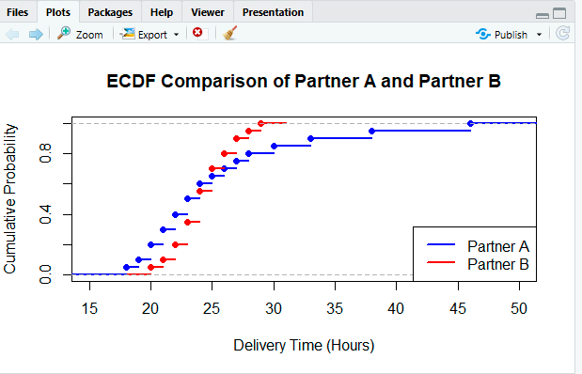
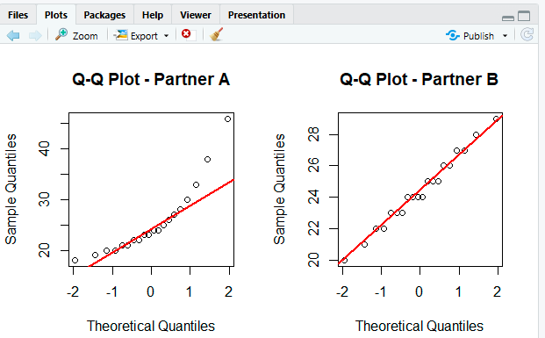
Result:
Partner B is more consistent, while Partner A shows greater variability and unusually long delivery times. Therefore, percentile-based SLAs are more appropriate than relying only on mean ± standard deviation.

Question 2 — Distribution Shape Across Many Groups using Bean Plots
Scenario: A hospital network measures patient waiting time (minutes) in five outpatient departments over a week. Administration wants to identify which departments have consistent waiting times and which have unpredictable, multi-modal patterns before reallocating staff.
Department | Waiting Times (minutes)
Cardiology | 10, 12, 13, 14, 15, 15, 16, 17, 18, 20
Orthopedics | 8, 9, 25, 26, 27, 9, 10, 28, 29, 8
Pediatrics | 5, 6, 6, 7, 7, 8, 8, 9, 9, 10
Dermatology | 15, 16, 17, 18, 19, 20, 21, 22, 23, 24

General Medicine | 10, 40, 12, 38, 11, 41, 13, 39, 12, 40

Tasks:
1. Construct bean plots (or an equivalent density-plus-jitter visualization) comparing waiting-time distributions across all five departments on a shared vertical axis.
2. Identify which department(s) show bimodal or multi-modal patterns and explain what this suggests about underlying causes.
3. Compare the bean plot to a standard boxplot of the same data and state what the boxplot conceals.
4. Rank the departments by variability and by median waiting time separately, and explain why the two rankings differ.
5. Recommend one staffing or scheduling change based on the distribution shapes observed. Key competency: Multiple distributions, vertical-axis visualization, bean plots, multi-modality, variability

Aim
To compare patient waiting-time distributions across five hospital departments using a bean plot or density-plus-jitter visualization, identify bimodal patterns, compare the results with a boxplot, and recommend staffing improvements.

Algorithm:
- Enter waiting times for all five departments.
- Combine the data into a data frame.
- Create a density-plus-jitter plot as an equivalent to a bean plot.
- Create a standard boxplot for comparison.
- Calculate median and variability using standard deviation.
- Rank departments by variability and median waiting time.
- Identify departments with separated clusters indicating bimodality.
- Recommend staffing or scheduling changes
Program:
cardiology <- c(10,12,13,14,15,15,16,17,18,20)
orthopedics <- c(8,9,25,26,27,9,10,28,29,8)
pediatrics <- c(5,6,6,7,7,8,8,9,9,10)
dermatology <- c(15,16,17,18,19,20,21,22,23,24)
general_medicine <- c(10,40,12,38,11,41,13,39,12,40)

department <- factor(rep(c("Cardiology",
"Orthopedics",
"Pediatrics",
"Dermatology",
"General Medicine"), each = 10))

waiting_time <- c(cardiology,
orthopedics,
pediatrics,
dermatology,
general_medicine)

data <- data.frame(department, waiting_time)

plot(waiting_time ~ department,
data = data,
col = "lightblue",
pch = 16,
main = "Waiting Time Distribution by Department",
xlab = "Department",
ylab = "Waiting Time (Minutes)")

stripchart(waiting_time ~ department,
data = data,
vertical = TRUE,
method = "jitter",
pch = 16,
col = "blue",
add = TRUE)

boxplot(waiting_time ~ department,
data = data,
col = "lightgreen",
main = "Boxplot of Waiting Times",
xlab = "Department",
ylab = "Waiting Time (Minutes)")

median_values <- tapply(data$waiting_time,
data$department,
median)

sd_values <- tapply(data$waiting_time,
data$department,
sd)

cat("Median Waiting Times:\n")
print(sort(median_values))

cat("\nVariability Based on Standard Deviation:\n")
print(sort(sd_values))

cat("\nRanking from Least to Most Variable:\n")
print(names(sort(sd_values)))

cat("\nRanking from Lowest to Highest Median:\n")
print(names(sort(median_values)))
Output:
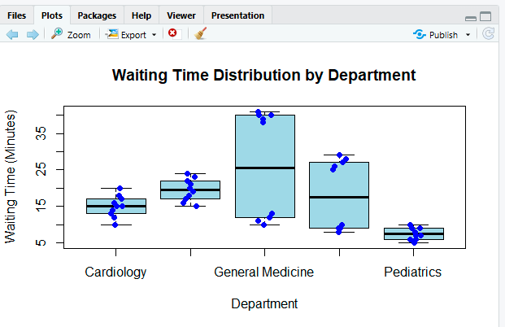
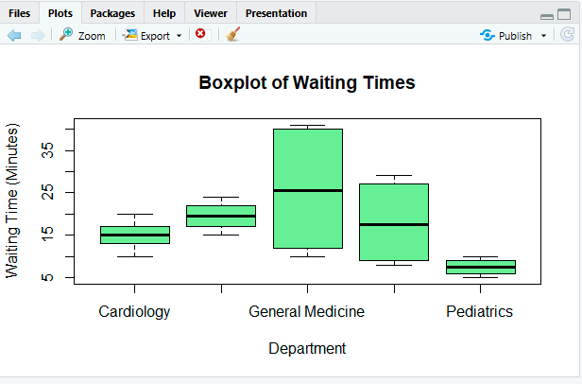
Result:
A recommended change is to investigate the causes of the two waiting-time groups in General Medicine and Orthopedics, such as different appointment periods or staffing levels, and allocate additional staff during high-delay periods.
Question 3 — Choosing an Honest Proportion Chart
Scenario: A retail chain surveys 300 customers across three store formats about preferred payment method. Senior management wants a dashboard chart that allows accurate comparison of payment-method share across formats without visually exaggerating small gaps.
Store Format | Cash (%) | Card (%) | UPI/Wallet (%)
Hypermarket | 18 | 34 | 48
Supermarket | 22 | 30 | 48
Convenience | 35 | 25 | 40

Tasks:
1. Construct a side-by-side (grouped) bar chart and a 100% stacked bar chart for the three store formats. 2. Construct three separate pie charts (one per format) representing the same data.
3. Compare all three visualizations for how easily a viewer can judge which format has the highest UPI/Wallet share.
4. Explain, with reference to arc-length versus length perception, why the pie charts are harder to compare accurately than the bar charts.
5. Identify one design decision (e.g., axis truncation, 3D effect, category ordering) that could be used to make the Convenience format's cash usage appear more dramatic than it is, and explain why it would mislead.
Key competency: Proportions, side-by-side bars, stacked bars, pie charts, misleading design

Aim
To compare payment-method preferences across three store formats using grouped bar charts, 100% stacked bar charts, and pie charts, and evaluate which visualization provides the most accurate comparison.

Algorithm
- Enter the payment percentages.
- Create a grouped bar chart.
- Create a 100% stacked bar chart.
- Create three separate pie charts.
- Compare the UPI/Wallet proportions.
- Explain why bar lengths are easier to compare than pie-chart arcs and angles.
- Identify a misleading chart design.
Program:
payment <- matrix(c(
18,22,35,
34,30,25,
48,48,40
),
nrow = 3,
byrow = TRUE)
rownames(payment) <- c("Cash", "Card", "UPI/Wallet")
colnames(payment) <- c("Hypermarket",
"Supermarket",
"Convenience")
barplot(payment,
beside = TRUE,
col = c("orange", "skyblue", "lightgreen"),
main = "Payment Method by Store Format",
xlab = "Store Format",
ylab = "Percentage (%)",
legend.text = rownames(payment))
barplot(payment,
beside = FALSE,
col = c("orange", "skyblue", "lightgreen"),
main = "100% Stacked Bar Chart",
xlab = "Store Format",
ylab = "Percentage (%)",
legend.text = rownames(payment))
pie(payment[,1],
labels = paste(rownames(payment),
payment[,1], "%"),
main = "Hypermarket")
pie(payment[,2],
labels = paste(rownames(payment),
payment[,2], "%"),
main = "Supermarket")
pie(payment[,3],
labels = paste(rownames(payment),
payment[,3], "%"),
main = "Convenience")
upi <- payment["UPI/Wallet",]
cat("UPI/Wallet Percentages:\n")
print(upi)
cat("\nHighest UPI/Wallet Share:\n")
print(names(which.max(upi)))
Output:
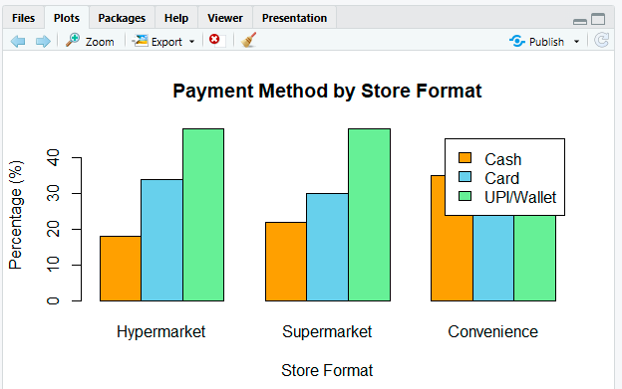
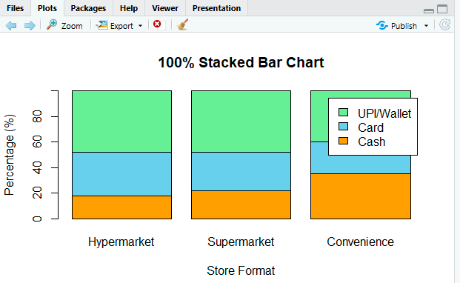
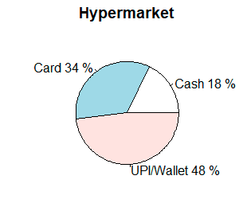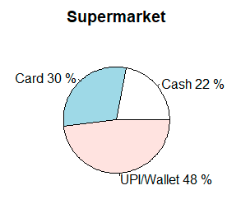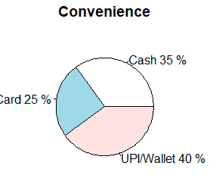
Result:
Bar charts provide more accurate comparison than pie charts, and a truncated axis or 3D effect could misleadingly exaggerate Convenience cash usage.
Question 4 — Nested Proportions in a Household Budget
Scenario: A financial-planning app aggregates the average monthly household budget (₹60,000) across spending categories and subcategories for a client segment. The product team wants a dashboard visual that shows both overall category share and subcategory composition within each category.
Category | Subcategory | Amount (₹)
Housing | Rent/EMI | 18000
Housing | Utilities | 4000

Housing | Maintenance | 2000
Food | Groceries | 9000
Food | Dining Out | 3000
Transport | Fuel | 3500
Transport | Public Transit | 1500
Savings | Investments | 10000
Savings | Emergency Fund | 4000
Discretionary | Entertainment | 3000
Discretionary | Shopping | 2000

Tasks:
1. Construct a treemap showing category-level and subcategory-level allocation of the budget. 2. Construct a sunburst chart representing the same two-level hierarchy.
3. Calculate the percentage of total budget consumed by the Housing category and by its largest subcategory.
4. Compare the treemap and sunburst chart for how easily a viewer can compare two subcategories that belong to different categories.
5. Describe one scenario in which the area-encoding of the treemap could cause a viewer to misjudge the relative size of two categories.
Key competency: Treemaps, sunburst charts, nested proportions, area encoding

Aim
To visualize a ₹60,000 household budget using hierarchical visualizations and analyze the proportion of spending allocated to categories and subcategories.

Algorithm
- Enter category, subcategory, and amount data.
- Calculate category totals.
- Calculate Housing's percentage of the total budget.
- Identify Housing's largest subcategory.
- Create a treemap.
- Create a sunburst-equivalent hierarchical visualization.
- Compare the effectiveness of area and hierarchical representations.
Program:
if(!require(treemap)) {
install.packages("treemap")
library(treemap)
}
category <- c(
"Housing","Housing","Housing",
"Food","Food",
"Transport","Transport",
"Savings","Savings",
"Discretionary","Discretionary"
)
subcategory <- c(
"Rent/EMI","Utilities","Maintenance",
"Groceries","Dining Out",
"Fuel","Public Transit",
"Investments","Emergency Fund",
"Entertainment","Shopping"
)
amount <- c(
18000,4000,2000,
9000,3000,
3500,1500,
10000,4000,
3000,2000
)
budget <- data.frame(category,
subcategory,
amount)
treemap(
budget,
index = c("category","subcategory"),
vSize = "amount",
title = "Household Budget Treemap"
)
total_budget <- sum(budget$amount)

housing_total <- sum(
budget$amount[budget$category == "Housing"]
)
largest_housing <- max(
budget$amount[budget$category == "Housing"]
)
housing_percentage <- housing_total / total_budget * 100
largest_housing_percentage <- largest_housing / total_budget * 100
cat("Total Budget: Rs.", total_budget, "\n")
cat("Housing Total: Rs.",
housing_total, "\n")
cat("Housing Percentage:",
housing_percentage, "%\n")
cat("Largest Housing Subcategory:",
budget$subcategory[which.max(
budget$amount * (budget$category == "Housing")
)],
"\n")
cat("Largest Housing Subcategory Amount: Rs.",
largest_housing, "\n")
cat("Largest Housing Subcategory Percentage:",
largest_housing_percentage, "%\n")
pie(budget$amount,
labels = paste(budget$category,
"-",
budget$subcategory),
main = "Hierarchical Budget Composition")
Output:
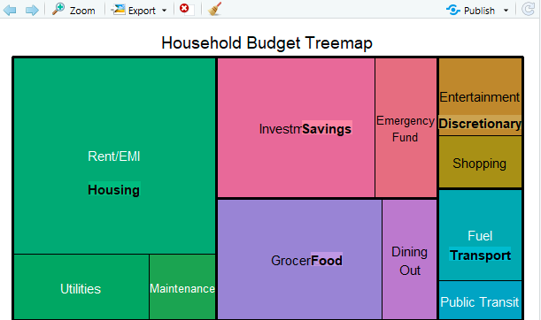
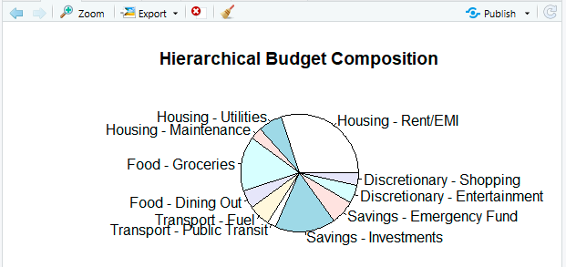

Result:
The treemap is useful for comparing category sizes, while the sunburst better represents the hierarchical relationship between categories and subcategories.
Question 5 — Flow Analysis using Sankey Diagram and Parallel Sets
Scenario: An online learning platform tracks 250 students from the course they enrolled in, through the device used to study, to their final completion status. The academic team wants to understand dominant enrollment-to-outcome pathways and spot problem areas.
Course | Device | Completion Status | Students
Data Science | Mobile | Completed | 20
Data Science | Mobile | Dropped | 25
Data Science | Laptop | Completed | 45
Data Science | Laptop | Dropped | 10
Web Development | Mobile | Completed | 15
Web Development | Mobile | Dropped | 20
Web Development | Laptop | Completed | 35
Web Development | Laptop | Dropped | 10
Digital Marketing | Mobile | Completed | 10
Digital Marketing | Mobile | Dropped | 15
Digital Marketing | Laptop | Completed | 20

Digital Marketing | Laptop | Dropped | 25

Tasks:
1. Construct a Sankey diagram showing the flow Course → Device → Completion Status.
2. Construct a parallel-sets (alluvial) representation of the same categorical flows.
3. Identify the three largest flows in the dataset and calculate each as a percentage of all 250 students.
4. Determine which course has the weakest completion outcome and identify at what stage in the flow the drop-off is most visible.
5. Explain one way that inconsistent node ordering or unscaled link widths could mislead a viewer comparing courses.
Key competency: Sankey diagrams, parallel sets, flow proportions, categorical relationships

Aim
To analyze the flow of students from Course → Device → Completion Status using a Sankey diagram and alluvial representation, identify dominant pathways, and determine courses with weaker completion outcomes.

Algorithm
- Enter Course, Device, Completion Status, and student-count data.
- Calculate the total number of students.
- Identify the three largest individual flows.
- Calculate the percentage represented by each flow.
- Calculate completion and dropout totals for each course.
- Identify the course with the weakest completion outcome.
- Create an alluvial flow diagram.
- Interpret the stage where drop-off is most visible.
Program:
if(!require(ggplot2)) {
install.packages("ggplot2")
library(ggplot2)
}

if(!require(ggalluvial)) {
install.packages("ggalluvial")
library(ggalluvial)
}
course <- c(
"Data Science","Data Science",
"Data Science","Data Science",
"Web Development","Web Development",
"Web Development","Web Development",
"Digital Marketing","Digital Marketing",
"Digital Marketing","Digital Marketing"
)
device <- c(
"Mobile","Mobile","Laptop","Laptop",
"Mobile","Mobile","Laptop","Laptop",
"Mobile","Mobile","Laptop","Laptop"
)
status <- c(
"Completed","Dropped","Completed","Dropped",
"Completed","Dropped","Completed","Dropped",
"Completed","Dropped","Completed","Dropped"
)
students <- c(
20,25,45,10,
15,20,35,10,
10,15,20,25
)
data <- data.frame(course,
device,
status,
students)
ggplot(data,
aes(axis1 = course,
axis2 = device,
axis3 = status,
y = students)) +
geom_alluvium(aes(fill = course),
width = 0.15) +
geom_stratum(width = 0.15) +
geom_text(
stat = "stratum",
aes(label = after_stat(stratum))
) +
scale_x_discrete(
limits = c("Course",
"Device",
"Completion Status")
) +
labs(
title = "Student Flow: Course to Device to Completion",
y = "Number of Students"
)
total_students <- sum(data$students)
top_flows <- data[order(
data$students,
decreasing = TRUE
),][1:3,]
top_flows$percentage <- (
top_flows$students /
total_students
) * 100
cat("Total Students:",
total_students, "\n\n")
cat("Three Largest Flows:\n")
print(top_flows)
completion <- aggregate(
students ~ course + status,
data = data,
sum
)
cat("\nCompletion and Dropout by Course:\n")
print(completion)
course_total <- aggregate(
students ~ course,
data = data,
sum
)

completed <- aggregate(
students ~ course,
data = data[data$status == "Completed",],
sum
)
completion_rate <- merge(
course_total,
completed,
by = "course"
)
completion_rate$rate <- (
completion_rate$students.y /
completion_rate$students.x
) * 100
cat("\nCompletion Rates:\n")
print(completion_rate)
Output:
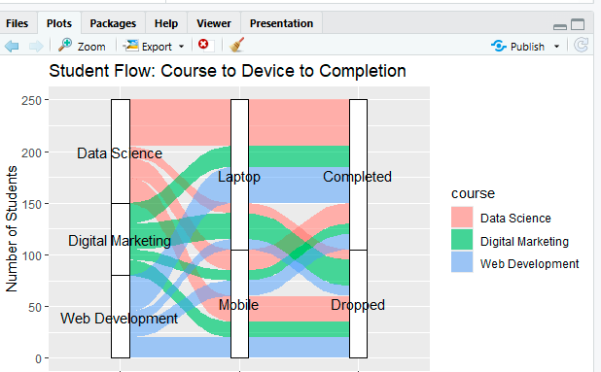
Result:
The flow diagrams show that dropout is most significant for Digital Marketing, and proportional link widths are necessary for honest comparison of student flows.

Suggested Evaluation Rubric — Data Analysis Project
Criterion | Excellent (4) | Good (3) | Satisfactory (2) | Needs Improvement (1)
Data preparation | Correct and complete | Minor issue | Several issues | Incorrect/incomplete
Visualization choice | Highly appropriate and justified | Appropriate | Partially appropriate | Poor choice
Technical execution | Accurate and clear | Mostly accurate | Some errors | Major errors
Interpretation | Insightful and evidence based | Correct | Basic | Incorrect/unsupported
Misleading-design analysis | Bias clearly identified and explained | Bias identified | Limited explanation | Not identified

Suggested marks: 20 marks per question; 100 marks total. Level: Competitive / advanced undergraduate.

