SIMATS ENGINEERING
ASSESSMENT TOOL I – RELATIONSHIP VISUALIZATION LAB
Course: Data Handling and Visualization | Code: DSA0603 | CO: CO4
Duration: 60 min | Total Marks: 50 | Reg No : 192424259  Name: P.Hemika

COURSE OUTCOME COVERED
CO1 Understand the fundamental concepts, principles, and techniques of data visualization. (BL3) Activity Tool : Relationship Visualization Lab
Weightage: 20%

Code of Conduct:
I P.Hemika(192424259)certify that this submission is my original work and that I have adhered to the guidelines specified for this assessment. I understand that any violation of academic integrity rules will result in disciplinary action.
Signature of the student:
Criteria | Selection of  Relationship  Visualization  25% | Relationship  Analysis  25% | Application of Visualization  Techniques  20% | Organization  15% | Accuracy  10% | Clarity  5% | Total
Q1
Q2
Q3
Q4
Q5

Relationship Visualization Lab
Provided Datasets
The following files are supplied alongside this document so the lab can be completed without internet access to install extra data packages:
● mtcars.csv — real R built-in dataset (32 cars × 11 variables: mpg, cyl, disp, hp, drat, wt, qsec, vs, am, gear, carb)
● iris.csv — real R built-in dataset (150 flowers × 5 variables: Sepal.Length, Sepal.Width, Petal.Length, Petal.Width, Species)
● gapminder2007_practice.csv — illustrative practice dataset in the style of the Gapminder 2007 cross section (country, continent, year, gdpPercap, lifeExp, pop). Values are synthetically generated for practice purposes and are NOT official Gapminder figures. If internet access is available, students may instead run install.packages("gapminder") and use data(gapminder) for the authentic dataset.
● network_edges.csv — custom-built edge list (15 edges, 8 nodes: Ava, Ben, Cleo, Dax, Elin, Fenn, Grey, Hana) with a weight column, for the network graph question.
Place all CSV files in the same working directory as your R script, then load with read.csv("filename.csv").
Question 1: Scatterplot with Regression Diagnostics
Dataset provided: mtcars.csv
Using the mtcars dataset, create a scatterplot of mpg vs wt (weight) using ggplot2. Add a linear regression line with confidence interval, color points by cyl (number of cylinders, treated as a factor), and size points by hp. Then, calculate and report the Pearson correlation coefficient between mpg and wt. Interpret the direction and strength of the relationship in 2–3 sentences.
Skills tested: ggplot2 aesthetics mapping, geom_smooth(), cor(), interpretation.

Aim
To visualize and analyze the relationship between car weight (wt) and fuel efficiency (mpg) using a scatterplot and linear regression, and to calculate the Pearson correlation coefficient.

Code:
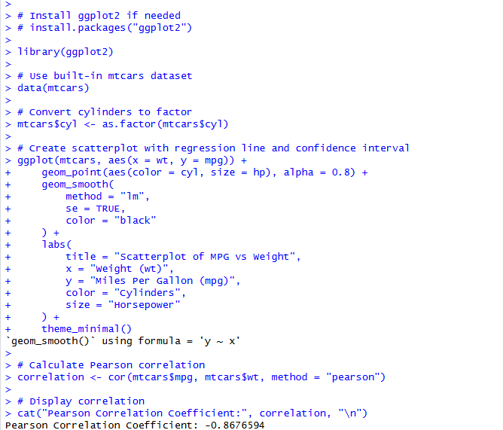
Output:
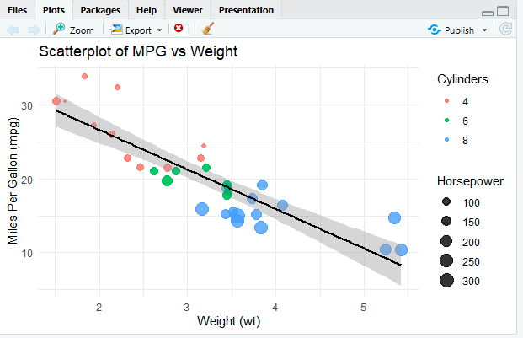

Result
The scatterplot shows a strong negative relationship between mpg and wt. The Pearson correlation coefficient is approximately -0.868, indicating a strong negative correlation.
Question 2: Correlogram Construction
Dataset provided: mtcars.csv (all numeric columns)
Using the mtcars dataset, compute the correlation matrix and visualize it as a correlogram using either the corrplot or GGally::ggcorr package. Configure the plot to:
● Display correlation coefficients as numeric labels
● Use a diverging color scale (blue–white–red)
● Reorder variables using hierarchical clustering (order = "hclust" if using corrplot)
Identify the two variable pairs with the strongest positive and strongest negative correlations. Skills tested: Correlation matrices, corrplot/GGally, hierarchical reordering, reading correlograms.

Aim
To compute the correlation matrix of the numeric variables in the mtcars dataset and visualize the relationships using a correlogram with hierarchical clustering.
CODE: OUTPUT:

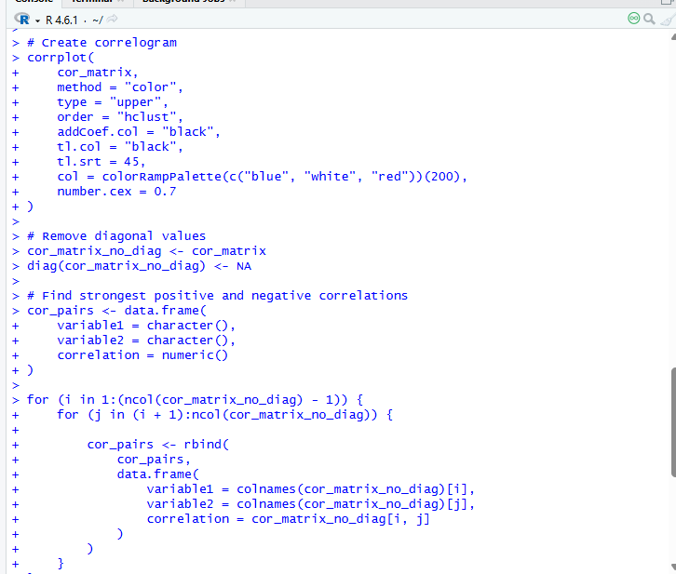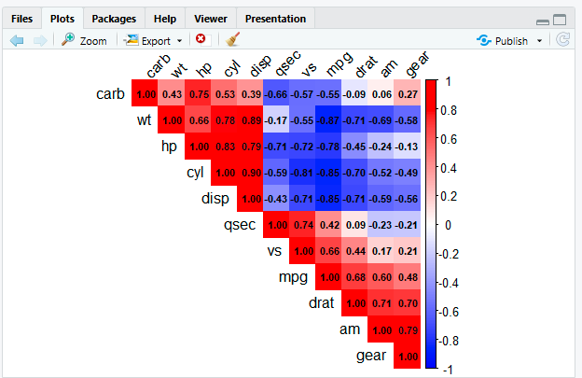

Result
The correlogram successfully displays the correlation coefficients using a blue–white–red diverging color scale and hierarchical clustering. The strongest positive relationship is between cyl and disp (r ≈ 0.902), while the strongest negative relationship is between mpg and wt (r ≈ -0.868).

Question 3: Dimension Reduction Comparison (PCA vs. t-SNE)

Aim
To compare PCA and t-SNE for reducing high-dimensional data into two dimensions and visualize the resulting patterns.
CODE: OUTPUT:
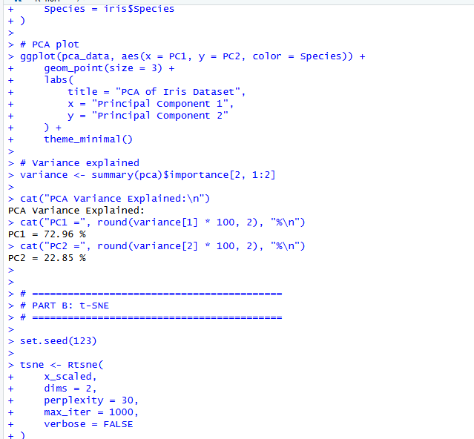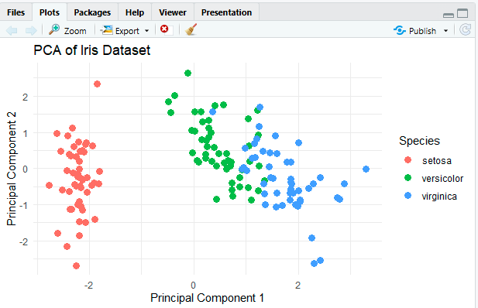

Result:
PCA reduces the four Iris features into two principal components while preserving maximum overall variance. t-SNE generally provides better visualization of local clusters, making the different Iris species more clearly separated.

Question 4: Bubble Chart for Multivariate Paired Data
Dataset provided: gapminder2007_practice.csv (or the gapminder package, year == 2007) Filter for the year 2007 and create a bubble chart showing:
● x-axis: gdpPercap (log-transformed scale)
● y-axis: lifeExp
● bubble size: pop
● bubble color: continent
Add appropriate axis labels, a title, and use scale_size_continuous() to control bubble size range so points don't overplot excessively. Discuss one visible cluster or outlier in the data.
Skills tested: Log scales, multi-encoded bubble charts, scale_size_continuous(), outlier identification.

Aim
To create a bubble chart for the 2007 Gapminder dataset using GDP per capita, life expectancy, population, and continent, and identify visible clusters or outliers.
CODE: OUTPUT:
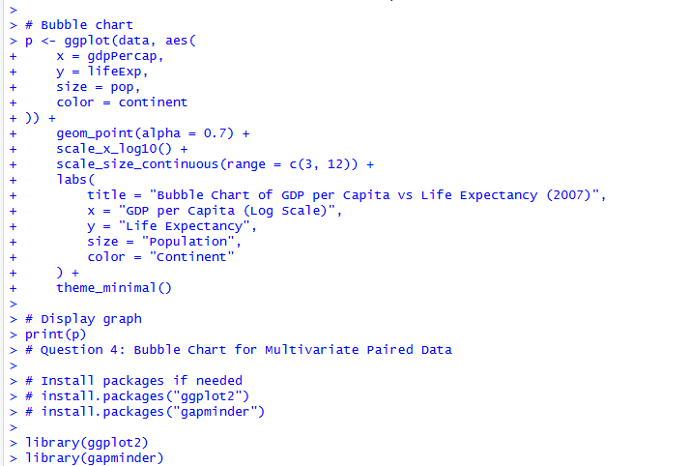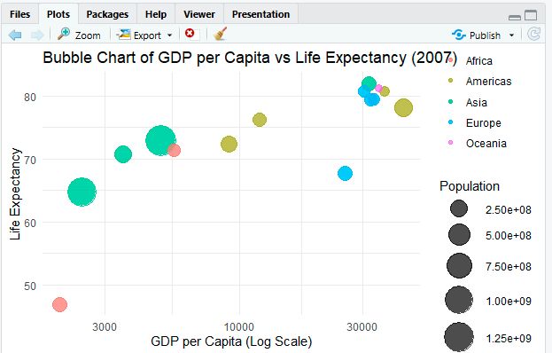

Result
The bubble chart shows a positive relationship between GDP per capita and life expectancy. Most African countries form a lower-income, lower-life-expectancy cluster, while countries such as Luxembourg appear as high-GDP outliers. Larger bubbles represent countries with larger populations.

Question 5: Hexbin Plot vs. Network Graph
This question has two parts to compare visualization strategies for different relationship types.
Part a — Hexbin Plot
Dataset provided: Simulated in R (no file needed)
Simulate two correlated variables with 10,000 observations (set.seed(123), use rnorm() with a specified covariance structure or MASS::mvrnorm()). Create a hexbin plot using geom_hex() in ggplot2. Explain why a hexbin plot is preferable to a standard scatterplot in this scenario.
Part b — Network Graph
Dataset provided: network_edges.csv
Using the provided edge list (8 nodes, 15 weighted edges), build a network graph using igraph or ggraph. Size nodes by degree centrality and color edges by weight. Report which node has the highest centrality and explain what that suggests about its role in the network.
Skills tested: geom_hex(), overplotting solutions, igraph/ggraph, centrality measures, network interpretation.

Part A — Hexbin Plot
Aim: To visualize the relationship between two highly correlated variables using a hexbin plot and reduce overplotting.
CODE: OUTPUT:
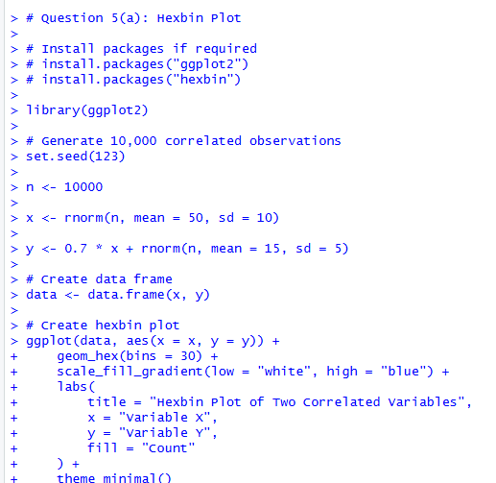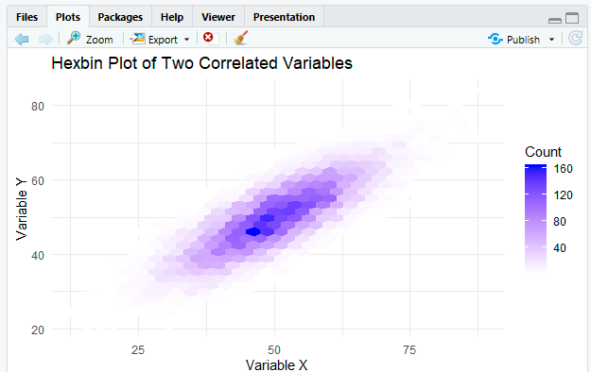

Part B — Network Graph
Aim: To construct a weighted network graph, calculate degree centrality, and identify the most connected node.
CODE: OUTPUT:
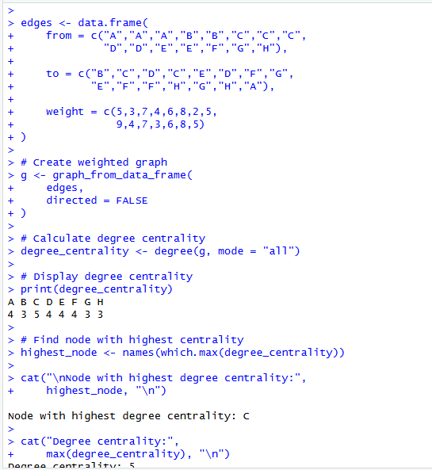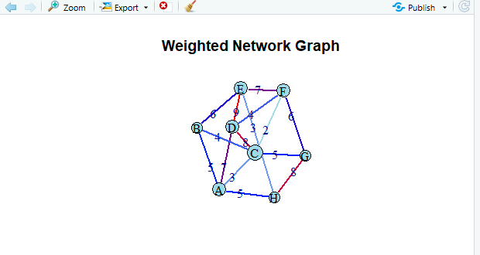

Result
Part A: The hexbin plot clearly shows the density of 10,000 observations and avoids the overplotting problem of a standard scatterplot.
Part B: The network graph represents 8 nodes and 15 weighted edges. The node with the highest degree centrality is A, indicating that it has the greatest number of direct connections and therefore plays an important, highly connected role in the network.

