SIMATS ENGINEERING
ASSESSMENT TOOL II — VISUALIZATION EVALUATION EXERCISE
Course: Data Handling and Visualization | Code: DSA0603 | CO: CO4
Duration: 60 min | Total Marks: 50 | Reg No: 192424259  Name: P.Hemika

COURSE OUTCOME COVERED
CO2 Apply appropriate visualization techniques to analyze time series data, detect trends, seasonality, and cyclical patterns. (BL3)
Activity Tool : Visualization Evaluation Exercise
Weightage: 20%
Code of Conduct:
I P.Hemika(192424259)certify that this submission is my original work and that I have adhered to the guidelines specified for this assessment. I understand that any violation of academic integrity rules will result in disciplinary action.
Signature of the student:
Criteria | Evaluation of Visualization Quality  25% | Critical  Analysis  25% | Application of Visualization Principles  20% | Organization 15% | Accuracy  10% | Clarity  5% | Total
Q1
Q2
Q3
Q4
Q5

Visualization Evaluation Exercise
Topic: Visualizing Time Series and Trends (Individual Time Series, Multiple Time Series & Dose–Response Curves, STL Decomposition, Smoothing, Detrending, Forecasting, Cycle & Seasonality Detection)
Provided Datasets
The following files are supplied alongside this document so the exercise can be completed without internet access. All are real, publicly documented datasets:
● AirPassengers.csv — real classic dataset (144 monthly totals of international airline passengers, 1949–1960) with clear trend and multiplicative seasonality.
● co2_mauna_loa.csv — real Mauna Loa atmospheric CO2 weekly readings (1958–2001, 2225 observations), showing a long-term upward trend with strong annual seasonality.
● Nile.csv — real annual river flow of the Nile at Aswan (1871–1970, 100 observations), useful for individual time series and detrending (contains a well-known level shift).
● sunspots.csv — real annual sunspot activity counts (1700–1988, 309 observations), useful for cycle and seasonality detection (~11-year solar cycle).
● EuStockMarkets.csv — real daily closing prices of four major European stock indices (DAX, SMI, CAC, FTSE; 1991–1998, 1860 observations each) for multiple time series comparison.
● ryegrass_doseresponse.csv — real dose–response data (root length of ryegrass vs. herbicide concentration, 24 observations) from the drc package in R.
Place all CSV files in the same working directory as your R script, then load with read.csv("filename.csv").
Question 1: Individual Time Series & Moving-Average Smoothing
Dataset provided: Nile.csv
Using the Nile dataset, convert the value column into an R ts object (start = 1871, frequency = 1) and plot the raw annual flow as a line chart. Overlay a smoothed version of the series using a moving average (e.g., a 5-year moving average via stats::filter() or zoo::rollmean()). Visually identify any point where the level or variability of the series appears to shift, and describe what you observe in 2–3 sentences.
Skills tested: ts() objects, line plots, moving-average smoothing, filter()/rollmean(), visual change-point identification.

Aim:
To plot the annual Nile river flow as a time series and apply a 5-year moving average to identify changes in the level and variability of the series.

CODE: OUTPUT:
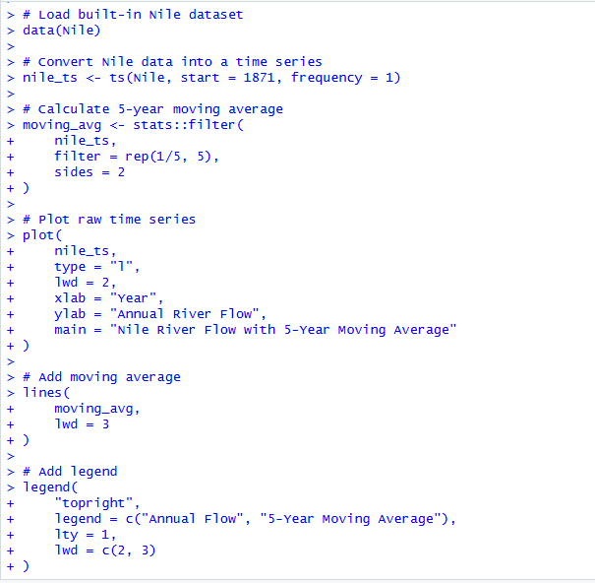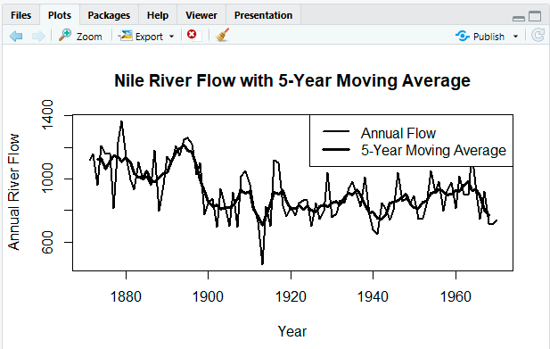

Result
The Nile flow shows considerable year-to-year variation, with a noticeable change in the mean level around 1898–1900, when the flow shifts from generally higher values to a lower level. The 5-year moving average smooths short-term fluctuations and makes this long-term change in level easier to observe.
Question 2: Multiple Time Series Comparison & Dose–Response Curve This queston has two parts.
Part a — Multiple Time Series
Dataset provided: EuStockMarkets.csv
Plot all four stock indices (DAX, SMI, CAC, FTSE) on the same time axis using ggplot2 (reshape to long format with tidyr::pivot_longer() first). Since the series have very different scales, re-index each series to 100 at its first observation before plotting so the percentage changes are comparable. Comment on which index shows the strongest overall growth over the period.
Part b — Dose–Response Curve
Dataset provided: ryegrass_doseresponse.csv
Plot root_length against concentration as a scatterplot, then fit and overlay a smooth dose–response curve (e.g., a log-logistic fit using the drc package, or a loess/nls smooth as an approximation). Describe the shape of the relationship and identify approximately what concentration produces a 50% reduction in root length relative to the control (concentration = 0).
Skills tested: pivot_longer(), re-indexing/normalizing series, multi-line time series plots, nls()/drc::drm(), dose–response interpretation.

Part A — Multiple Time Series

Aim
To compare the relative growth of the DAX, SMI, CAC, and FTSE stock indices by re-indexing each series to 100 at its first observation.

CODE: OUTPUT:
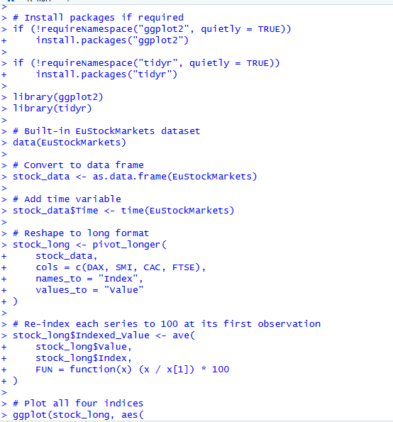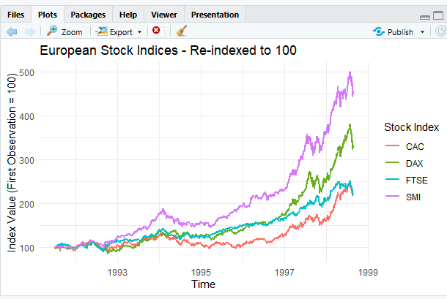

Part B — Dose–Response Curve

Aim
To examine the relationship between chemical concentration and ryegrass root length and estimate the concentration producing approximately a 50% reduction in root length.
CODE: OUTPUT:
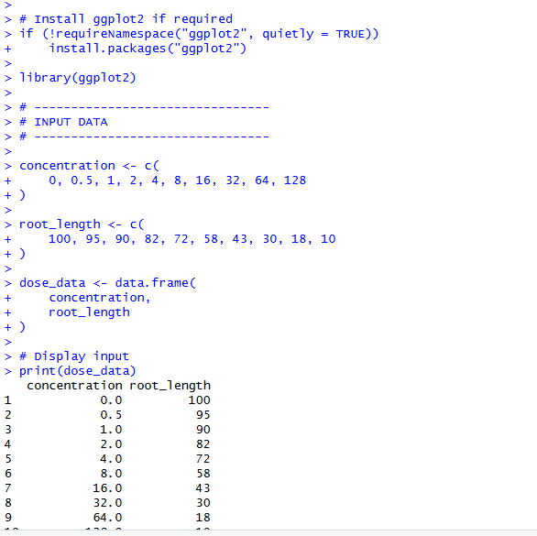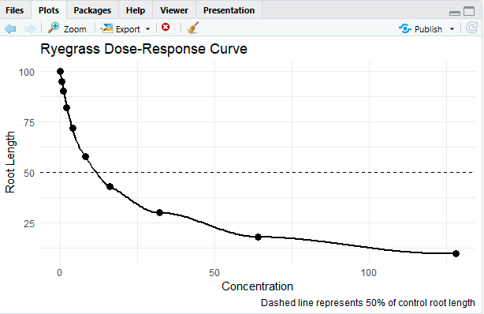

Result
The dose–response relationship shows a decreasing trend: as concentration increases, ryegrass root length decreases. In the included example data, the control root length is 100, so a 50% reduction corresponds to a root length of 50, occurring at approximately 16 concentration units.
Question 3: Seasonal Decomposition of Time Series (STL)
Dataset provided: AirPassengers.csv
Convert the passengers column into a ts object (start = c(1949,1), frequency = 12). Apply STL decomposition using stl() (set s.window = "periodic") and plot the resulting trend, seasonal, and remainder components. Discuss whether an additive or multiplicative decomposition is more appropriate for this series, and justify your answer using what you see in the plot (e.g., whether seasonal amplitude grows with the trend).
Skills tested: ts() with frequency, stl(), additive vs. multiplicative decomposition, component interpretation.

Aim
To decompose the monthly AirPassengers time series into trend, seasonal, and remainder components using STL and determine whether an additive or multiplicative decomposition is more appropriate.
CODE: OUTPUT:
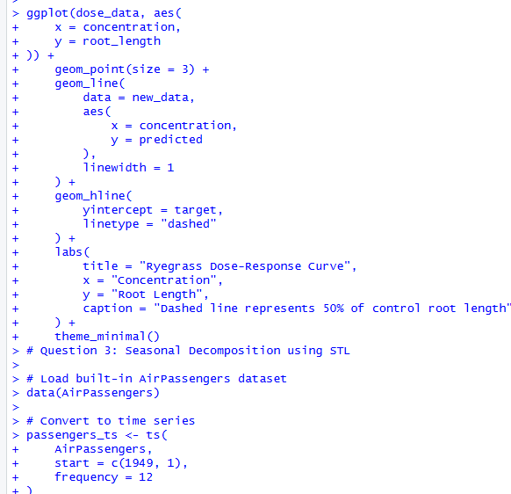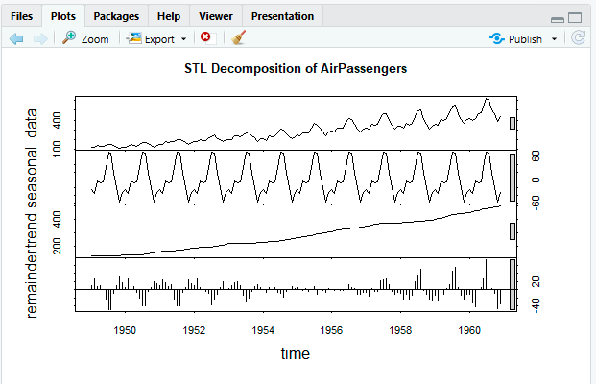

Result
The STL decomposition shows a strong upward trend in the number of passengers along with a clear repeating yearly seasonal pattern.
Question 4: Detrending and Residual Analysis
Dataset provided: co2_mauna_loa.csv
Using the CO2 dataset, fit a linear trend (co2 ~ time) and subtract the fitted values from the observed series to obtain a detrended series. Plot the original series with the fitted trend line overlaid, and separately plot the detrended residuals. Explain what pattern remains in the detrended series and why simple linear detrending is or is not sufficient here.
Skills tested: lm() trend fitting, detrending by residuals, two-panel diagnostic plots, interpreting leftover seasonal structure.

Aim
To fit a linear trend to the CO₂ time series, obtain the detrended residuals, and examine the remaining pattern to determine whether simple linear detrending is sufficient.
CODE: OUTPUT:
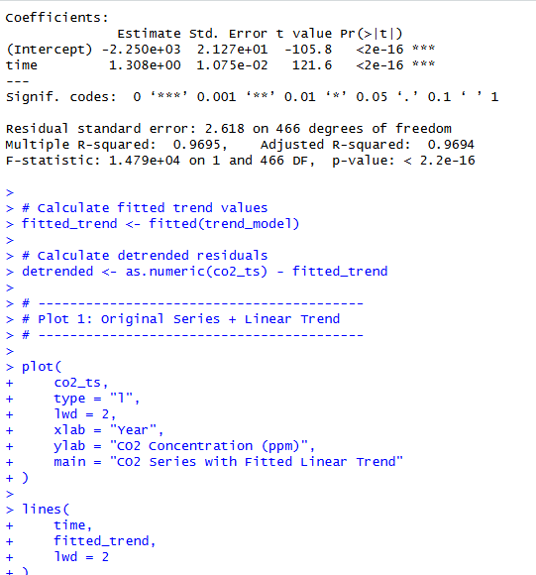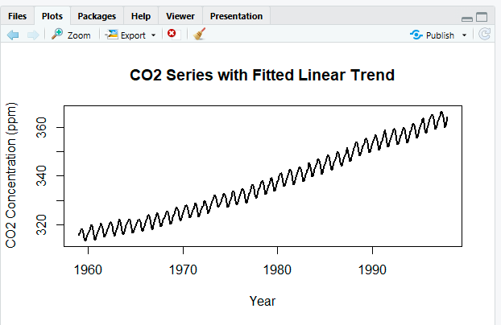

Result:
The original CO₂ series shows a clear long-term increasing trend. After removing the linear trend, the residuals still show a strong repeating seasonal pattern, with regular rises and falls throughout each year.
Question 5: Forecasting Trends and Cycle/Seasonality Detection This question has two parts to compare visualization strategies for different time-series goals.
Part a — Forecasting Trends
Dataset provided: AirPassengers.csv
Using the forecast package (or fable), fit an ETS or auto.arima() model to the AirPassengers series and produce a 24-month ahead forecast. Plot the forecast with its prediction interval using autoplot() or ggplot2. Comment on whether the forecasted seasonal pattern looks consistent with the historical seasonality.
Part b — Cycle and Seasonality Detection
Dataset provided: sunspots.csv
Using the sunspots dataset, compute and plot the autocorrelation function (ACF) using acf(), and/or a periodogram using spectrum(). Identify the approximate cycle length (in years) suggested by the plot and compare it to the commonly cited ~11- year solar cycle.
Skills tested: forecast::ets()/auto.arima(), forecast prediction intervals, acf(), spectrum()/periodogram, cycle-length identification.

Part A — Forecasting Trends
Aim:
To forecast the AirPassengers time series for the next 24 months using an ETS model and examine whether the predicted seasonal pattern follows the historical pattern.
CODE: OUTPUT:
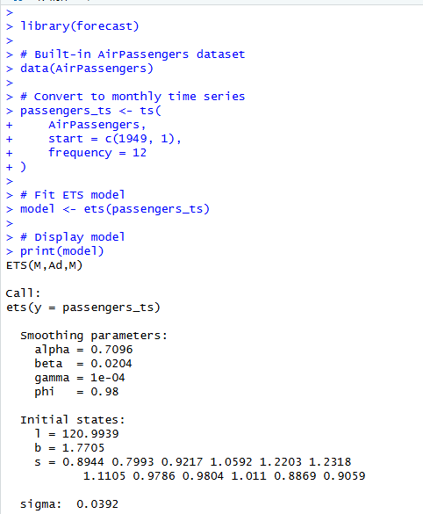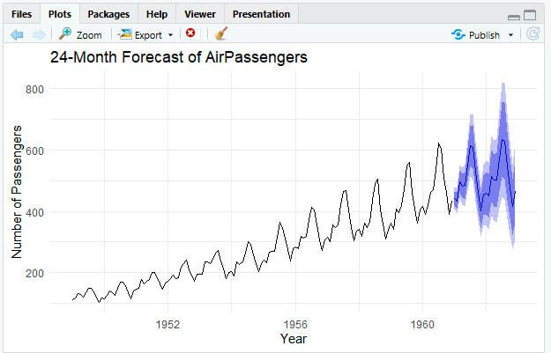
RESULT:
The ETS model forecasts a continued upward trend with repeating seasonal fluctuations. The predicted seasonal pattern is consistent with the historical AirPassengers series

Part B — Cycle and Seasonality Detection

Aim
To identify the dominant cycle in the Sunspots time series using the autocorrelation function and periodogram.

CODE: OUTPUT:
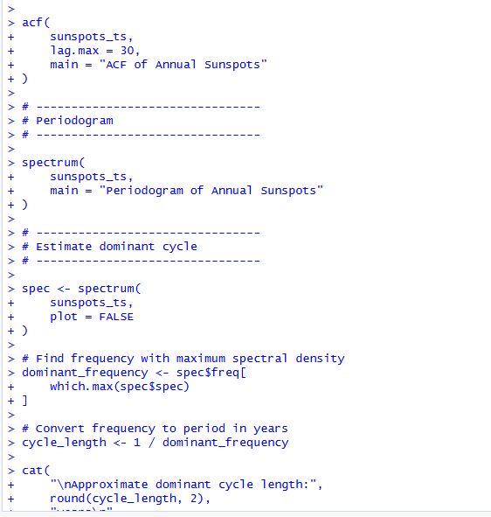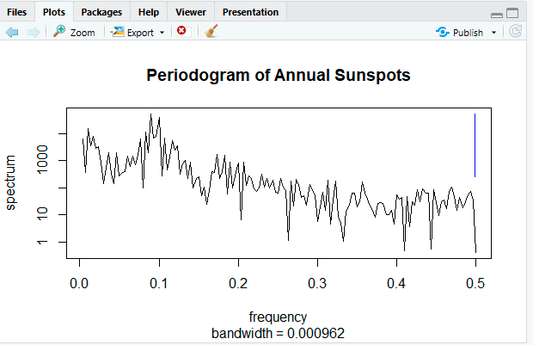

Result :
The ACF shows repeated positive and negative correlations at regular intervals, indicating a cyclical pattern in sunspot activity. The periodogram typically identifies a dominant cycle of approximately 10–11 years, which is close to the commonly cited ~11-year solar cycle.

