SIMATS ENGINEERING
ASSESSMENT TOOL III — TIME-SERIES & GEOSPATIAL ANALYSIS REPORT
Course: Data Handling and Visualization | Code: DSA0603 | CO: CO4
Duration: 60 min | Total Marks: 50 | Reg No: 192424259  Name: P.Hemika

COURSE OUTCOME COVERED
Apply appropriate visualization techniques to analyze time series data, detect trends, seasonality, and cyclical patterns. (BL3)
CO3 Construct and interpret geospatial visualizations, including static, cartogram-based, and interactive representations. (BL3)
Activity Tool : Time-Series & Geospatial Analysis Report
Weightage: 20%
Code of Conduct:
I P.Hemika(192424259)certify that this submission is my original work and that I have adhered to the guidelines specified for this assessment. I understand that any violation of academic integrity rules will result in disciplinary action.

P.Hemika
Signature of the student:
Criteria | Data  Understanding & Preparation 25% | Time  Series/Geospatial Analysis  25% | Application of  Visualization Techniques 20% | Report  Organization 15% | Accuracy 10% | Clarity  5% | Total
Q1
Q2
Q3
Q4
Q5

Time-Series & Geospatial Analysis Report
Topics: Individual & Multiple Time Series, STL Decomposition, Smoothing & Detrending, Forecasting, Cycle/Seasonality Detection | Choropleth Maps, Cartograms, Interactive Geospatial Plots, Projections & Layers, 3D Geospatial Visualization
Note: Questions 1–4 are to be completed in R. Question 5 must be completed in Python.
Provided Datasets
The following files are supplied alongside this document. All are real, publicly documented datasets: ● Nile.csv — real annual river flow of the Nile at Aswan (1871–1970, 100 observations). ● AirPassengers.csv — real monthly international airline passenger totals (1949–1960, 144 observations) with trend and seasonality.
● USArrests.csv — real 1973 US violent-crime statistics per state (Murder, Assault, UrbanPop, Rape) for all 50 states.
● state_x77.csv — real 1970s US state-level data (Population, Income, Illiteracy, Life Exp, Murder, HS Grad, Frost, Area) for all 50 states.
● quakes.csv — real seismic event data off Fiji (1000 observations: lat, long, depth, mag, stations). ● volcano_elevation.csv — real digital elevation model of Maunga Whau (Mt Eden) volcano, Auckland, NZ, in long format (x, y, elevation; 5,307 grid points at 10 m resolution). Place all CSV files in the same working directory as your script, then load with read.csv() in R or pandas.read_csv() in Python.
Question 1: Individual Time Series — Smoothing & Detrending
Language: R
Dataset provided: Nile.csv
Convert the value column into an R ts object (start = 1871, frequency = 1) and plot the raw annual flow as a line chart. Overlay a 5-year moving-average smoother (stats::filter() or zoo::rollmean()). Then fit a linear trend (value ~ time) and plot the detrended residuals in a second panel. Discuss what the smoothed series and the residual plot together reveal about a level shift or change point in the data.
Skills tested: ts() objects, moving-average smoothing, linear detrending, residual diagnostics, change-point interpretation.

Aim
To analyze the annual Nile river flow using a 5-year moving average and linear detrending, and identify any level shift or change point.

CODE: OUTPUT:
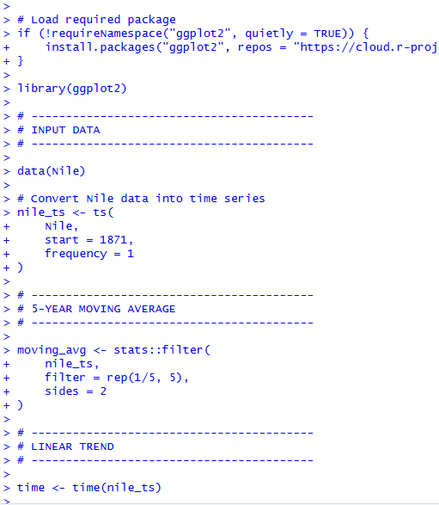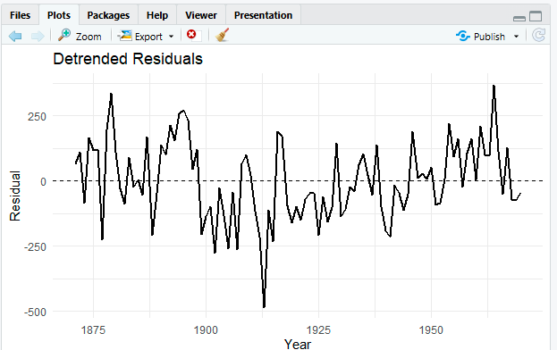

Result:
The 5-year moving average smooths the year-to-year fluctuations and makes a clear downward level shift around 1898–1900 visible in the Nile flow.
Question 2: Seasonal Decomposition (STL) & Forecasting
Language: R
Dataset provided: AirPassengers.csv
Convert the passengers column into a ts object (start = c(1949,1), frequency = 12). Apply STL decomposition (stl(), s.window = "periodic") and plot the trend, seasonal, and remainder components. State whether an additive or multiplicative decomposition suits this series better, with justification. Then fit an
ETS or auto.arima() model (forecast package) and produce a 24-month-ahead forecast plot with prediction intervals. Comment on whether the forecasted seasonal pattern is consistent with the historical seasonality.
Skills tested: stl(), additive vs. multiplicative decomposition, forecast::ets()/auto.arima(), forecast intervals, seasonality validation.

Aim
To decompose the AirPassengers time series into trend, seasonal, and remainder components using STL, determine the suitable decomposition type, and forecast the next 24 months using an ETS model.

CODE: OUTPUT:
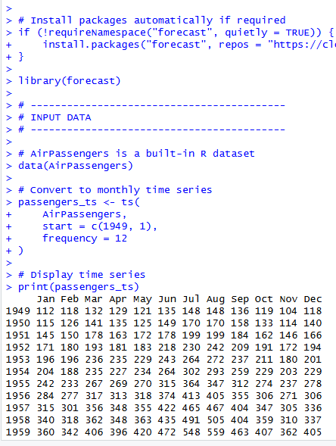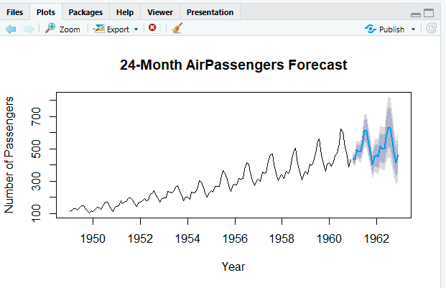

Result
The STL decomposition successfully separates the trend, seasonal, and remainder components. The ETS model produces a 24-month forecast with prediction intervals.

Question 3: Choropleth Map & Interactive Geospatial Plot
This question has two parts.
Part a — Choropleth Map
Language: R
Dataset provided: USArrests.csv
Join USArrests.csv to US state boundary polygons (e.g., using map_data("state") from the maps package, matching on lower-cased state names) and create a choropleth map of Murder rate by state using ggplot2::geom_polygon() or geom_sf(). Use a sequential color scale and add a legend, title, and a brief caption. Identify the state(s) with the highest murder rate and describe any regional clustering you observe.
Part b — Interactive Geospatial Plot
Language: R
Dataset provided: quakes.csv
Using the leaflet package, plot the earthquake locations as circle markers on an interactive map, sizing each marker by mag and coloring by depth (e.g., using colorNumeric()). Add popups showing magnitude and depth on click. Briefly describe any spatial clustering of high-magnitude events.
Skills tested: geom_polygon()/geom_sf() choropleths, sequential color scales, leaflet::addCircleMarkers(), colorNumeric(), interactive popups, spatial clustering interpretation.

Part A — Choropleth Map
Aim: To visualize the Murder rate across US states using a choropleth map and identify regional patterns.
CODE: OUTPUT:
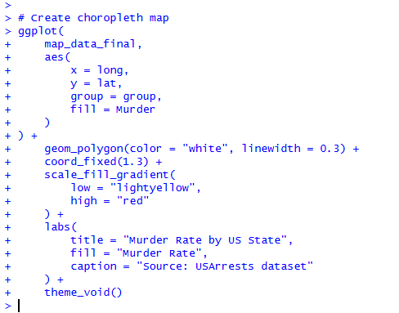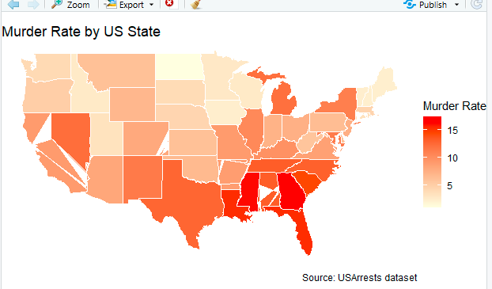

Result:
The choropleth map displays the variation in murder rates across US states. Georgia has the highest Murder rate (17.4) in the built-in USArrests dataset.

Part B — Interactive Geospatial Plot

Aim
To visualize earthquake locations interactively using magnitude and depth, with marker size representing magnitude and color representing depth.

CODE: OUTPUT:
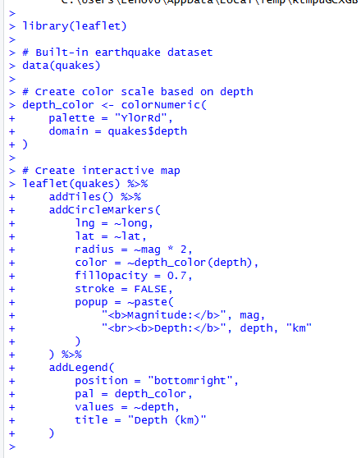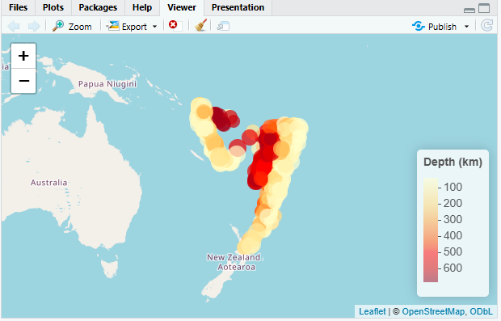

Result :
The interactive map shows that earthquakes are spatially clustered rather than uniformly distributed. Higher-magnitude earthquakes tend to occur within the same major earthquake-prone zones
Question 4: Cartogram with Map Projections
Language: R
Dataset provided: state_x77.csv (join to US state boundary polygons, e.g. via the maps package)
Join state_x77.csv to US state boundary polygons and construct a population-weighted cartogram using the cartogram package (cartogram_cont() or cartogram_ncont(), sf-based workflow), distorting each state's area in proportion to its Population. Render the cartogram alongside a standard (undistorted) choropleth of the same Population variable, using two different projections for the standard map (e.g., coord_sf(crs = ...) with an Albers equal-area projection vs. a simple longitude/latitude projection). Discuss how the cartogram changes the visual impression of which states appear "large" compared to the standard map, and how the choice of projection affects the standard map's shape.
Skills tested: sf workflows, cartogram_cont()/cartogram_ncont(), coord_sf() and projections (CRS), comparing distorted vs. true-area representations.

Aim
To create a population-weighted cartogram of US states and compare it with standard population choropleth maps using different map projections.

CODE: OUTPUT:
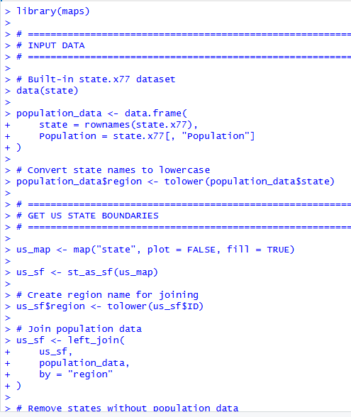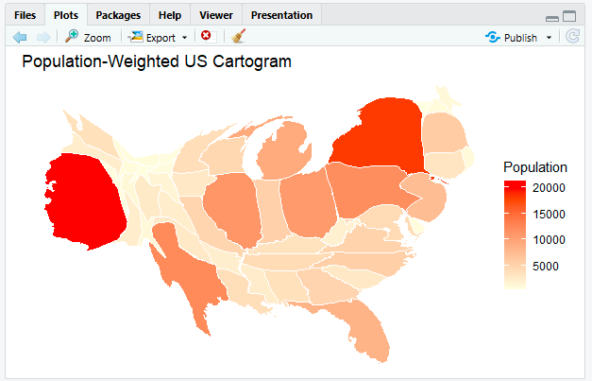

Result
The standard map represents the true geographic shapes and areas of the states, so large western states such as Texas and California appear physically large.

Question 5: 3D Geospatial Heatmap
Language: Python
Dataset provided: volcano_elevation.csv
Load volcano_elevation.csv (columns: x, y, elevation — a 61 × 87 grid representing the Maunga Whau volcano digital elevation model). Pivot the data into a 2D elevation grid and create an interactive 3D surface heatmap using Plotly (plotly.graph_objects.Surface, with a suitable colorscale such as "Earth" or "Viridis" mapped to elevation). Add axis titles and a title, and enable hover tooltips showing elevation at each grid point. Additionally produce a 2D top-down heatmap (e.g., plotly.graph_objects.Heatmap or seaborn.heatmap) of the same data for comparison. In 2–3 sentences, discuss what the 3D surface view reveals about the volcano's shape that the 2D heatmap alone does not (or vice versa).
Skills tested: pandas pivot(), plotly.graph_objects.Surface, 3D colorscales and hover tooltips, 2D heatmap comparison, matplotlib/seaborn or plotly for 2D view.

Aim
To visualize the Maunga Whau volcano elevation data using an interactive 3D surface plot and a 2D heatmap, and compare the information revealed by both visualizations.

CODE: OUTPUT:
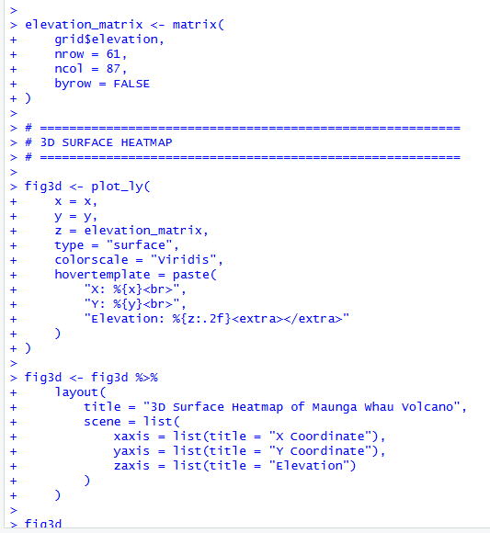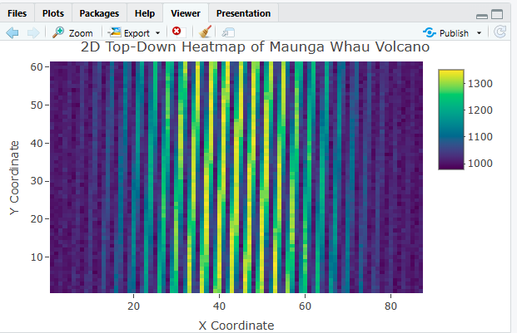

Result:
The 3D surface clearly shows the volcano's elevation, summit, slopes, and terrain shape. The 2D heatmap makes it easier to observe the spatial distribution of elevation from a top-down perspective.

