SIMATS ENGINEERING
ASSESSMENT TOOL I — Uncertainty Visualization Lab
Course: Data Handling and Visualization | Code: DSA06 | CO: CO5
Duration: 180 min | Total Marks: 100 | Reg No : P.Hemika  Name: 192424259

COURSE OUTCOME COVERED
CO3: Analyze time-series data, trends, associations, and uncertainty through appropriate visualization methods. (BL4)
Activity Tool : Uncertainty Visualization Lab
Weightage: 20%

Code of Conduct:
I P.Hemika(192424259)certify that this submission is my original work and that I have adhered to the guidelines specified for this assessment. I understand that any violation of academic integrity rules will result in disciplinary action.

Signature of the student:
Criteria | Understanding of Uncertainty  25% | Visualization of Uncertainty  25% | Application of Visualization Principles  20% | Organization 20% | Accuracy 10% | Clarity 5% | Total
Q1
Q2
Q3
Q4
Q5

Uncertainty Visualization Lab – Assessment Tool
Instructions: Answer all five questions. Use R programming to construct the required visualization, interpret uncertainty, and identify potential visualization pitfalls. Use the given data exactly unless a transformation is explicitly requested.
Q1. Bootstrapping and Confidence Intervals – Point Estimate
A quality-control team records the following delivery times (in minutes) for 12 randomly selected orders. Using R, calculate the sample mean and obtain a 95% bootstrap confidence interval for the mean using at least 5,000 bootstrap resamples. Visualize the bootstrap distribution and mark the observed mean.
Data: 31, 35, 28, 42, 37, 33, 45, 29, 39, 34, 41, 36
Expected R tasks: resampling, point estimate, confidence interval, histogram/density plot,
Aim:
To calculate the sample mean and estimate a 95% confidence interval using bootstrap resampling.
Algorithm:
- Read the delivery time data.
- Calculate the sample mean.
- Generate 5,000 bootstrap samples with replacement.
- Calculate the mean of each sample.
- Find the 2.5% and 97.5% percentiles.
- Plot the bootstrap distribution and mark the observed mean.
CODE: OUTPUT:
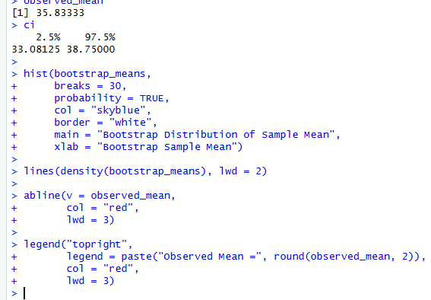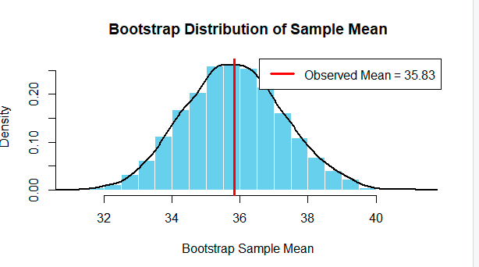

Result and Interpretation
- Sample mean: approximately 35.83 minutes
- The 95% bootstrap confidence interval is obtained from the 2.5th and 97.5th percentiles of the 5,000 bootstrap means.
Q2. Uncertainty in Trend Estimation
The following data represent monthly advertising expenditure and sales. Fit a linear regression model in R to estimate the sales trend. Plot the observations with the fitted regression line and a 95% confidence band. Explain how the uncertainty changes across the range of advertising expenditure.
Data: Advertising = 10, 12, 15, 18, 20, 23, 25, 28, 30, 33, 36, 40;
Sales = 48, 51, 53, 57, 60, 61, 66, 69, 72, 75, 79, 84
Expected R tasks: lm(), prediction interval/confidence interval, ggplot2 visualization, trend
Aim:
To estimate the relationship between advertising expenditure and sales using linear regression and visualize the uncertainty.
Algorithm:
- Read advertising and sales data.
- Fit a linear regression model using lm().
- Predict sales values across the advertising range.
- Calculate the 95% confidence interval.
- Plot the data points and regression line.
- Display the confidence band.
CODE: OUTPUT:
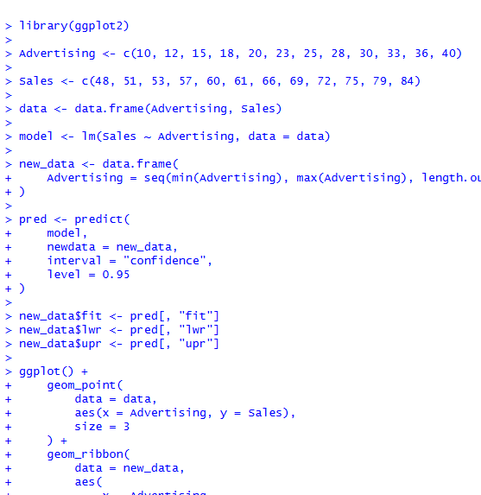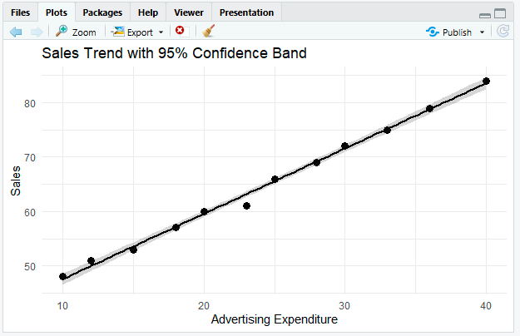

Interpretation
- The fitted regression line shows a positive relationship between advertising expenditure and sales.
- As advertising expenditure increases, predicted sales also increase.
- The 95% confidence band is narrowest around the middle of the advertising values.
Q3. Overplotting, Jittering and Transparency
A survey records the number of hours studied and examination scores for 30 students. Several students have identical values. Create a scatterplot in R first without modification, then redesign it using partial transparency and jittering. Compare the two plots and explain how overplotting affects interpretation.
Data: Hours = 2,3,3,4,4,4,5,5,5,5,6,6,6,6,6,7,7,7,7,7,8,8,8,8,8,9,9,9,10,10;
Scores = 45,52,52,58,60,60,64,66,66,66,70,72,72,72,72,76,78,78,80,80,84,84,85,85,85,88,90,90,94,94 Expected R tasks: geom_point(), alpha, position_jitter(), comparison of overplotting.
Aim:
To study overplotting in scatterplots and improve visualization using jittering and transparency.
Algorithm:
- Read hours studied and scores.
- Create the original scatterplot.
- Identify overlapping observations.
- Apply transparency using alpha.
- Apply jitter using position_jitter().
- Compare the original and improved plots.
CODE: OUTPUT:
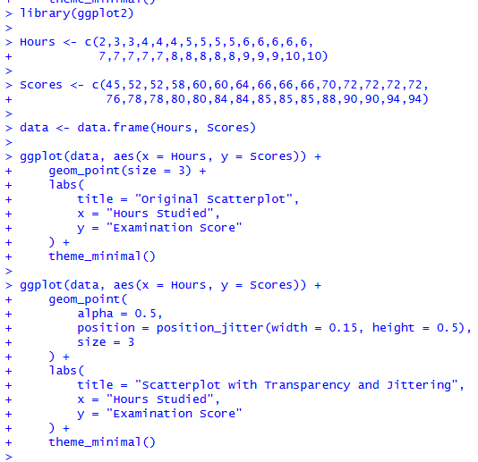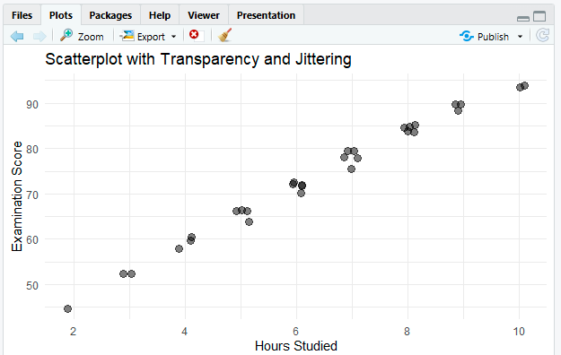
Result:
Overplotting can make the dataset appear smaller or less concentrated than it actually is. Jittering and transparency improve visibility without changing the underlying pattern.

Q4. 2D Histogram and Density Estimation
A researcher measures height and weight for 20 participants. Construct a 2D histogram and a 2D density visualization in R. Use the plots to identify regions with high observation density. State which visualization communicates concentration more clearly and justify your choice.
Data: Height = 150,152,155,158,160,161,163,165,166,168,170,171,173,175,176,178,180,182,184,186;
Weight = 48,50,53,55,57,59,60,62,64,65,68,69,71,73,74,77,80,82,85,88
Expected R tasks: 2D binning, density estimation, contour/density layers, interpretation of concentration.
Aim:
To visualize the concentration of height and weight observations using a 2D histogram and density plot.
Algorithm:
- Read height and weight data.
- Create a 2D histogram using binning.
- Calculate the two-dimensional density.
- Plot density contours or filled density regions.
- Identify high-density regions.
- Compare both visualizations.
CODE: OUTPUT:

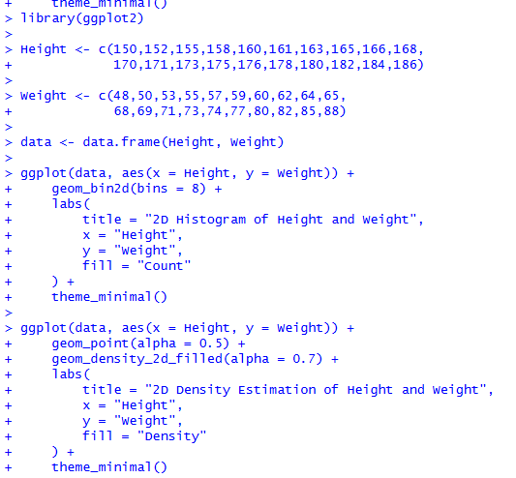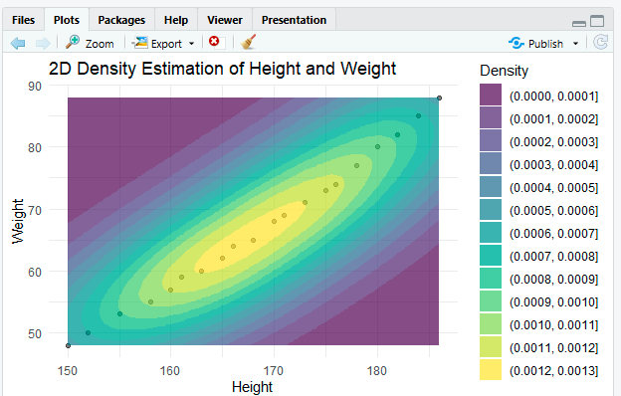

Interpretation
- Both plots show a strong positive relationship between height and weight.
- Higher observation concentration occurs around the middle range of the dataset, approximately:
  - Height: 160–180
  - Weight: 57–80
Q5. Color Scales, Accessibility and Misleading Visualization
The following category-wise satisfaction scores must be visualized in R. Create two plots: (1) a plot using a nonmonotonic/diverging color scheme that could mislead interpretation, and (2) a redesigned plot using an ordered, color-vision-deficiency-friendly sequential scale. Explain why the second design is more effective and identify the visualization pitfall in the first design.
Data: Category = A,B,C,D,E,F,G;
Satisfaction = 42,48,55,61,67,74,82
Expected R tasks: color mapping, scale selection, accessibility-aware redesign, critique of misleading color use.
Aim:
To compare misleading color schemes with accessible sequential color scales for satisfaction data.
Algorithm:
- Read category and satisfaction data.
- Create a bar plot with a nonmonotonic color scheme.
- Observe possible misleading color interpretation.
- Create a second bar plot with a sequential color scale.
- Use a color-vision-deficiency-friendly scale such as viridis.
- Compare both plots and select the clearer design.
CODE: OUTPUT:

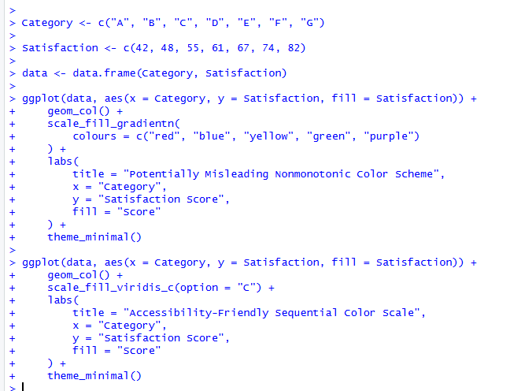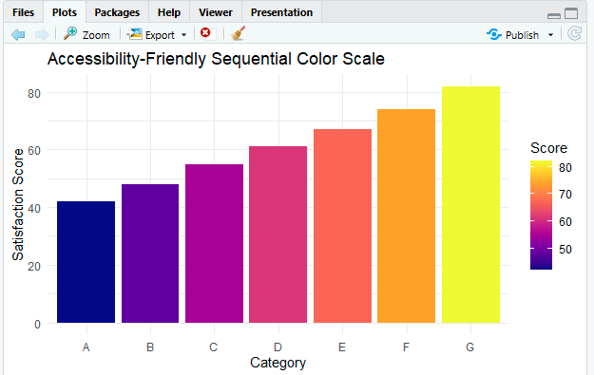

Result:
For ordered numerical data such as satisfaction scores, a sequential and accessibility-friendly color scale is more effective. A nonmonotonic or arbitrary multicolor scale can create a misleading visual hierarchy and make interpretation more difficult
Suggested R packages: ggplot2, dplyr, boot (or base R).
Assessment focus: Correct R code, appropriate uncertainty visualization, interpretation, and identification of misleading design choices.

