SIMATS ENGINEERING
ASSESSMENT TOOL II — Visualization Analysis Report
Course: Data Handling and Visualization | Code: DSA06 | CO: CO5
Duration: 180 min | Total Marks: 100 | Reg No : P.Hemika  Name: 192424259

COURSE OUTCOME COVERED
CO5: Analyze and evaluate visualization choices to communicate patterns, comparisons, relationships, and potential misleading effects through appropriate visualization methods. (BL4)
Activity Tool : Visualization Analysis Report
Weightage: 20%

Code of Conduct:
I P.Hemika(192424259)certify that this submission is my original work and that I have adhered to the guidelines specified for this assessment. I understand that any violation of academic integrity rules will result in disciplinary action.
Signature of the student: P.Hemika
Assessment Criteria
Criteria | Visualization  Selection and  Understanding 25% | Visualization  Analysis and  Interpretation 25% | Application of Visualization Principles  20% | Organization and Presentation 20% | Accuracy  10% | Clarity  5% | Total
Q1
Q2
Q3
Q4
Q5

AT2 – Visualization Analysis Report | Data Handling and Visualization | DSA06
Visualization Analysis Report – Assessment Tool
R Programming Practical Questions with Datasets
Instructions: Answer all five questions. Use R programming to construct the required visualizations, analyze the patterns, compare visualization choices where requested, and identify potential visualization pitfalls. Use the given data exactly unless a transformation is explicitly requested.

Q1. Comparing Distributions – Histogram, Density and ECDF
A quality-control team records the following processing times (in minutes) for 20 randomly selected tasks. Using R, create a histogram and a density plot for the data. Also construct an empirical cumulative distribution function (ECDF). Compare the three visualizations and explain which aspects of the distribution—center, spread, skewness, and cumulative behavior—are communicated most clearly by each.
Data: Time = 18, 21, 22, 24, 25, 25, 27, 28, 29, 30, 31, 32, 33, 35, 36, 38, 41, 43, 46, 50 Expected R tasks: histogram, density estimation, ECDF, appropriate labels/scales, comparison and interpretation.

Aim
To visualize processing times using a histogram, density plot, and ECDF and compare their distribution characteristics.

Algorithm
- Enter the processing time data.
- Create a histogram.
- Add a density curve.
- Create the ECDF plot.
- Compare center, spread, skewness, and cumulative behavior.
CODE: OUTPUT:
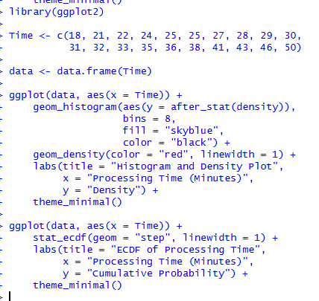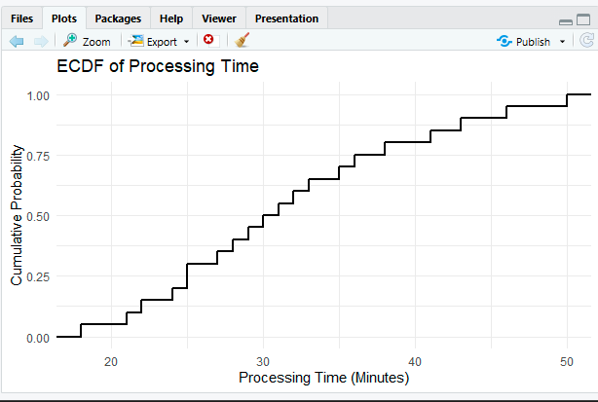

Result
- Histogram: Clearly shows the frequency and spread of processing times.
- Density plot: Clearly shows the overall shape and possible skewness.
Q2. Q-Q Plot and Normality Analysis
A researcher measures the following response times (in seconds). Use R to create a normal Q-Q plot and a histogram/density visualization. Assess whether the observations are reasonably consistent with a normal distribution. Identify any departures from the reference line and explain what they indicate about the distribution.
Data: Response = 42, 45, 47, 49, 50, 51, 52, 53, 54, 55, 56, 57, 58, 60, 61, 63, 66, 70, 76, 85
Expected R tasks: qqnorm()/qqline() or ggplot2 Q-Q plot, histogram/density plot, interpretation of deviations and outliers.

Aim
To assess whether the response time data are approximately normally distributed using a Q-Q plot and histogram.

Algorithm
- Enter the response time data.
- Create a histogram with density curve.
- Generate a normal Q-Q plot.
- Add the reference line.
- Examine deviations from the line.

CODE: OUTPUT:
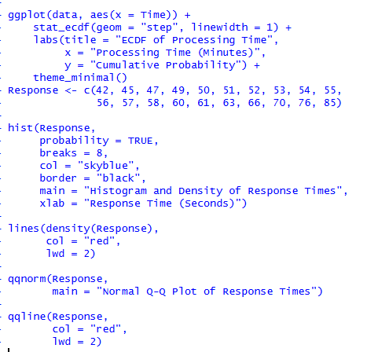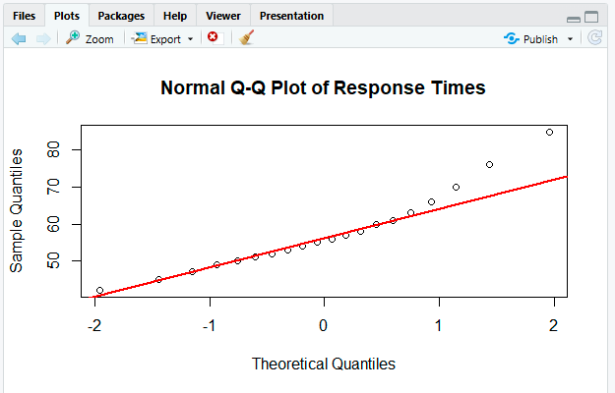

Result
- Most observations may follow the reference line reasonably well in the middle.
- The larger values, especially 76 and 85, are likely to deviate from the line.
Q3. Visualizing Many Distributions at Once
Three groups of students have examination scores recorded below. Create a suitable visualization that compares the distributions of all three groups at once. Use boxplots and/or violin plots, and optionally overlay individual observations. Analyze differences in center, spread, and possible outliers. Explain why the selected visualization is more informative than displaying three separate plots.
Group A = 52,55,57,58,60,61,62,64,65,66,68,70,72,74,78;
Group B = 45,49,51,53,55,56,58,59,60,62,63,65,67,69,71;
Group C = 58,60,61,63,64,65,67,68,70,71,72,74,76,80,84
Expected R tasks: data reshaping, grouped boxplot/violin plot, optional jitter, comparison of distributions, interpretation.

Aim
To compare the distributions of examination scores for three student groups using grouped boxplots and individual observations.

Algorithm
- Enter scores for Groups A, B, and C.
- Combine the groups into one data frame.
- Create a grouped boxplot.
- Add jittered observations.
- Compare median, spread, and outliers.
CODE: OUTPUT:
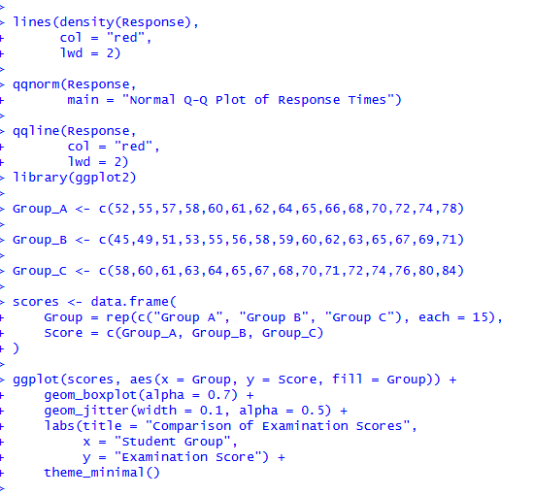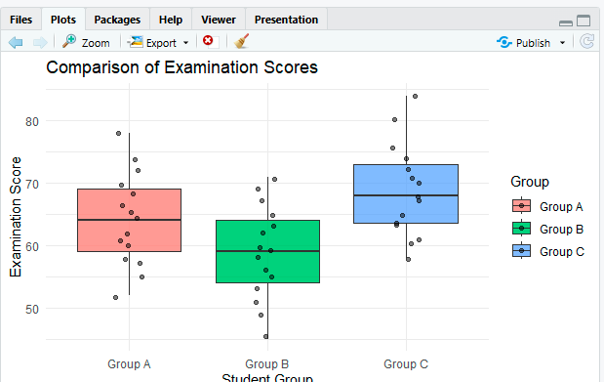

Result
- Group C has the highest center or median score.
- Group B has the lowest median score.
- Group A lies between Groups B and C.
Q4. Relationships and Multivariate Visualization
A study records advertising expenditure, website visits, and sales for 15 observations. Create a scatterplot of advertising expenditure versus sales and use an appropriate visual encoding to incorporate website visits. Add a fitted trend line. Analyze the strength and direction of the relationship and explain whether the additional variable improves the interpretation or risks cluttering the visualization.
Advertising = 10,12,14,16,18,20,22,24,26,28,30,32,34,36,38;
Visits = 120,135,150,165,180,195,210,225,245,260,275,290,305,320,340;
Sales = 48,50,53,55,58,61,63,66,69,71,74,77,80,83,86
AT2 – Visualization Analysis Report | Data Handling and Visualization | DSA06
Expected R tasks: scatterplot, trend line, third-variable encoding, appropriate legend/scale, relationship analysis and critique.

Aim
To analyze the relationship between advertising expenditure and sales while incorporating website visits as a third variable.

Algorithm
- Enter advertising, visits, and sales data.
- Create a scatterplot of advertising versus sales.
- Use point size to represent website visits.
- Add a fitted regression line.
- Analyze the relationship and the usefulness of the third variable.
CODE: OUTPUT
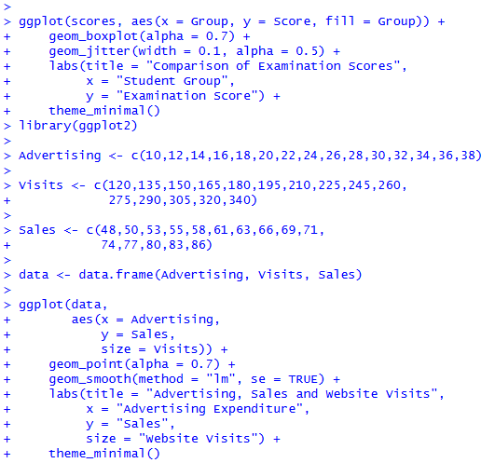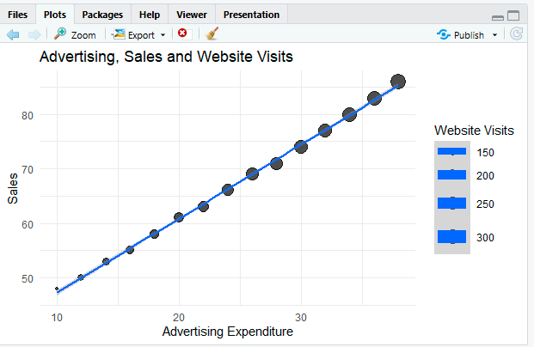

Result
- There is a strong positive relationship between advertising expenditure and sales.
- As advertising increases, sales also increase.
- Larger points represent higher website visits.
Q5. Misleading Visualization and Redesign
A college reports the following pass percentages for seven departments. Create two visualizations: (1) a misleading version using a truncated y-axis and an inappropriate visual emphasis, and (2) a redesigned version using an appropriate baseline, ordered categories, and clear labels. Compare the two plots and explain how the first visualization can exaggerate differences and why the redesigned visualization communicates the data more honestly.
Department = CSE, ECE, EEE, MECH, CIVIL, AIDS, IT;
Pass_Percentage = 91,93,92,89,90,95,94

Aim
To demonstrate how a truncated y-axis can exaggerate differences and redesign the visualization for honest interpretation.

Algorithm
- Enter department and pass percentage data.
- Create a bar chart with a truncated y-axis.
- Observe the exaggerated differences.
- Create a redesigned chart starting from zero.
- Order departments by pass percentage.
- Add clear labels and compare both plots.

CODE: OUTPUT:
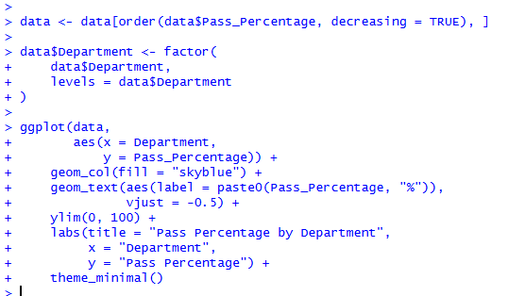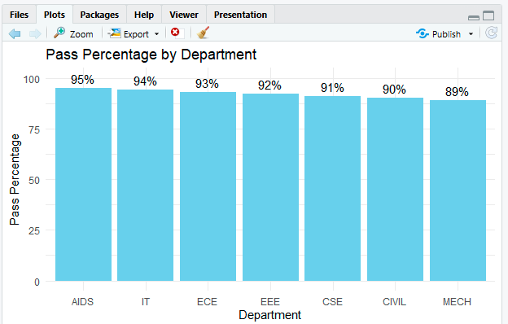

Result
Misleading plot:
- The y-axis starts at 85 instead of 0.
- Small differences, such as 91% and 95%, appear much larger than they really are.
- Different colors may also give unnecessary visual emphasis.
Redesigned plot:
- The y-axis starts at 0, giving a fair visual comparison.
- Departments are ordered by pass percentage.
- Clear percentage labels improve readability.
- The redesigned plot communicates that the actual difference between departments is only 6 percentage points, from 89% to 95%.

