SIMATS ENGINEERING
ASSESSMENT TOOL III— Interactive Dashboard Project
Course: Data Handling and  Visualization | Code: DSA06 | CO: CO5
Duration: 180 min | Total Marks: 100 | Reg No : P.Hemika  Name: 192424259

COURSE OUTCOME COVERED
CO5: Analyze and evaluate visualization choices to communicate patterns, comparisons, relationships, and potential misleading effects through appropriate visualization methods, applied through the design of interactive dashboards. (BL4)
Activity Tool : Interactive Dashboard Project
Weightage: 20%
Code of Conduct:
I P.Hemika(192424259) certify that this submission is my original work and that I have adhered to the guidelines specified for this assessment. I understand that any violation of academic integrity rules will result in disciplinary action.
Signature of the student: P.Hemika
Assessment Criteria
Criteria | Dashboard  Design and  Understanding 25% | Visual  Analysis and  Interpretation 25% | Application of  Dashboard Design  Principles  20% | Organization and  Presentation 20% | Accuracy  10% | Clarity  5% | Total
Q1
Q2
Q3
Q4
Q5

Interactive Dashboard Project — Assessment Tool
Tableau Practical Questions with Datasets
Instructions: Answer all five questions. Use Tableau to construct the required interactive dashboards, analyze the patterns, compare design choices where requested, and identify potential visualization pitfalls. Use the given data exactly unless a transformation is explicitly requested.
Q1. Building a Sales Performance Dashboard
A retail company records regional sales performance across product categories. Using Tableau, connect to the dataset below and build an interactive dashboard containing: a bar chart of Sales by Region, a line chart of Sales trend by Month, and a map view of Sales by Region. Add a Region filter that acts as a global filter across all views. Analyze which region and category combinations drive the highest sales, and explain how the dashboard layout supports quick comparison across regions.
Data:
S.No | Region | Category | Sales
1 | North | Furniture | 32000
2 | South | Furniture | 28500
3 | East | Furniture | 41000
4 | West | Furniture | 25500
5 | North | Technology | 51000
6 | South | Technology | 47500
7 | East | Technology | 62000
8 | West | Technology | 39500
9 | North | Office Supplies | 21000
10 | South | Office Supplies | 19500
11 | East | Office Supplies | 27000
12 | West | Office Supplies | 17500

Expected Tableau tasks: data connection and preparation, bar chart and line chart worksheets, map visualization, global filter action, dashboard layout and formatting, interpretation of regional and category patterns.

Aim
To create an interactive Sales Performance Dashboard in Tableau using regional and category-wise sales data, including a bar chart, sales trend chart, map visualization, and a global Region filter.

Algorithm
- Enter/import the sales dataset into Tableau.
- Connect the dataset and verify the data types.
- Create a bar chart showing Sales by Region.
- Sort the regions in descending order of sales.
- Create a line chart for monthly sales trend using a Month/Date field.
- Create a map view showing sales by region using geographic information.
- Add a Region filter and apply it to all worksheets.
- Combine the charts into a single dashboard.
- Format the dashboard with a suitable title, labels, and layout.
- Analyze the highest-performing region and category combinations.

Output:

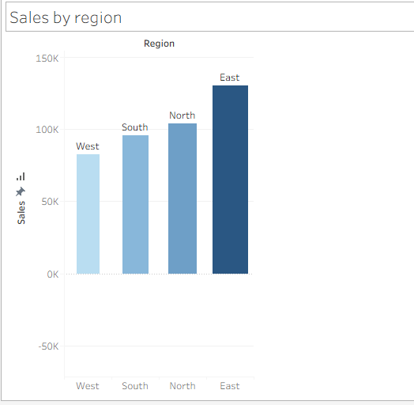

Result
The Sales Performance Dashboard was successfully created in Tableau. The analysis shows that East has the highest total sales of ₹1,30,000, while Technology is the highest-selling category. The East–Technology combination has the highest individual sales of ₹62,000. The global Region filter enables quick comparison of different regions across all visualizations.
Q2. KPI Dashboard with Parameters
An HR analytics team wants to monitor employee performance across departments. Using the dataset below, build a Tableau dashboard containing KPI summary cards (Average Rating, Total Employees, Average Attendance) and a bar chart of Average Rating by Department. Add a parameter control that lets the user switch the bar chart measure between Average Rating and Average Attendance. Explain how parameters improve the dashboard's flexibility compared to using separate static charts.
Data:
S.No | Department | Rating | Attendance
1 | Sales | 7.8 | 92
2 | Sales | 8.1 | 95
3 | Marketing | 7.5 | 88

S.No | Department | Rating | Attendance
4 | Marketing | 7.9 | 90
5 | Engineering | 8.6 | 96
6 | Engineering | 8.9 | 97
7 | Support | 7.2 | 85
8 | Support | 7.4 | 87
9 | HR | 8 | 93
10 | HR | 8.3 | 94

Expected Tableau tasks: calculated fields for KPI cards, parameter creation, calculated field driven by parameter, bar chart worksheet, KPI card formatting, dashboard assembly, interpretation of flexibility gained from parameters.

Aim
To create an interactive HR KPI Dashboard in Tableau displaying Average Rating, Total Employees, and Average Attendance, with a parameter that allows users to switch the department-wise bar chart between Average Rating and Average Attendance.

Algorithm
- Import the employee dataset into Tableau.
- Create calculated fields for:
  - Average Rating
  - Total Employees
  - Average Attendance
- Create KPI cards using these calculated fields.
- Create a parameter with two options: Average Rating and Average Attendance.
- Create a calculated field that changes according to the selected parameter.
- Create a bar chart showing the selected measure by Department.
- Display the parameter control on the dashboard.
- Format the KPI cards, bar chart, and dashboard.
- Test the parameter by switching between Rating and Attendance.
- Analyze department-wise employee performance.

Output:
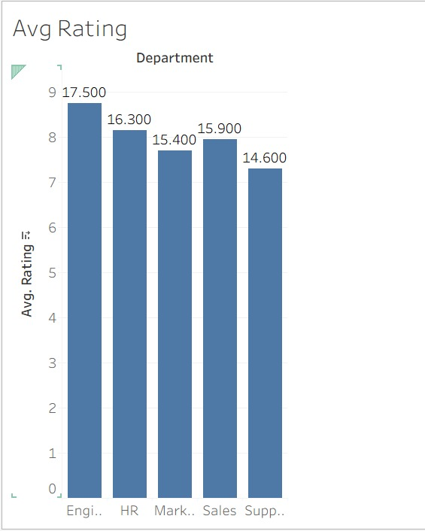

Result
The HR KPI Dashboard was successfully created in Tableau. The overall KPIs are:
- Total Employees: 10
- Average Rating: 8.07
- Average Attendance: 91.7%
The Engineering department has the highest average rating (8.75) and highest average attendance (96.5%).
The parameter allows users to switch the same bar chart between Average Rating and Average Attendance, making the dashboard more flexible and reducing the need for separate static charts.

Q3. Drill-Down Dashboard with Dashboard Actions
A college wants to analyze student enrollment across Program and Specialization levels. Using the hierarchical dataset below, build a Tableau dashboard with a summary chart at the Program level and a detail chart at the Specialization level. Configure a filter action so that clicking a bar in the Program chart updates the Specialization chart to show only the relevant rows. Analyze how the drill-down interaction improves exploration compared to showing all specializations at once, and note any limitations of this approach.
Data:
S.No | Program | Specialization | Enrollment
1 | CSE | AI/ML | 65
2 | CSE | Cyber Security | 40
3 | CSE | Core CSE | 90
4 | ECE | VLSI | 35
5 | ECE | Communications | 50
6 | MECH | Robotics | 30
7 | MECH | Thermal | 45
8 | MECH | Design | 28

Expected Tableau tasks: hierarchy or two related worksheets, filter action configuration between sheets, dashboard interactivity testing, interpretation of drill-down behavior and its limitations.

Aim
To create an interactive Drill-Down Dashboard in Tableau that displays student enrollment at the Program level and allows users to click a program to view its corresponding Specializations.

Algorithm
- Import the student enrollment dataset into Tableau.
- Create a Program-level bar chart using Program and Enrollment.
- Create a Specialization-level bar chart using Specialization and Enrollment.
- Create a new dashboard and place both charts on it.
- Add a Filter Action from the Program chart to the Specialization chart.
- Configure the action so that clicking a Program filters the Specialization chart.
- Test the dashboard by clicking different Program bars.
- Analyze the enrollment patterns and observe how drill-down improves exploration.

Output:
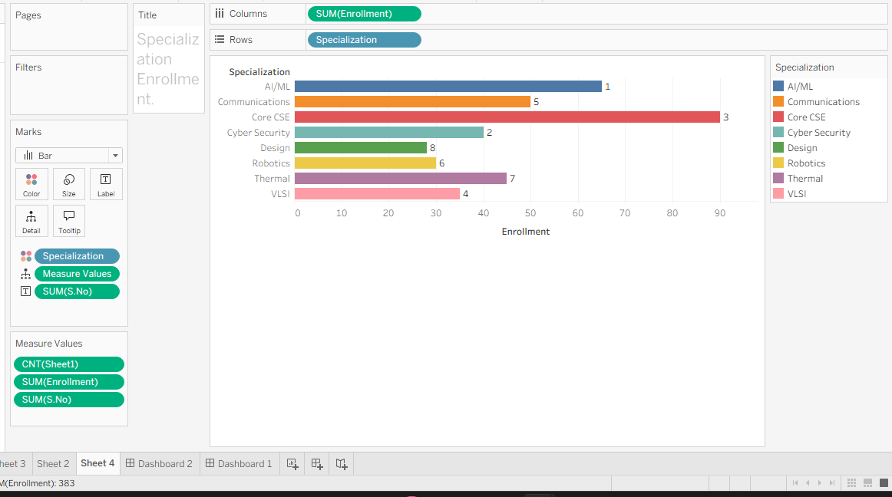

Result
The Student Enrollment Drill-Down Dashboard was successfully created in Tableau. A filter action was configured so that selecting a Program automatically displays only its related Specializations. This improves exploration by reducing clutter and allowing users to move from a program-level summary to relevant detailed enrollment information.

Q4. Multivariate Analysis Dashboard
A marketing study records advertising expenditure, website visits, and sales for 15 observations. Build a Tableau dashboard with a scatterplot of Advertising versus Sales, using color or size encoding to represent Website Visits, along with a trend line. Add a second view (box plot or histogram) summarizing the distribution of Sales. Analyze the strength and direction of the relationship shown in the scatterplot and discuss whether the additional Website Visits encoding adds insight or clutters the dashboard.
Data:
S.No | Advertising | Visits | Sales
1 | 10 | 120 | 48
2 | 12 | 135 | 50
3 | 14 | 150 | 53
4 | 16 | 165 | 55
5 | 18 | 180 | 58
6 | 20 | 195 | 61
7 | 22 | 210 | 63
8 | 24 | 225 | 66
9 | 26 | 245 | 69
10 | 28 | 260 | 71
11 | 30 | 275 | 74
12 | 32 | 290 | 77
13 | 34 | 305 | 80
14 | 36 | 320 | 83
15 | 38 | 340 | 86

Expected Tableau tasks: scatterplot with trend line, color/size encoding for a third variable, secondary distribution view, dashboard layout with legends, relationship analysis and critique of visual clutter.

Aim
To create a Multivariate Analysis Dashboard in Tableau using Advertising, Website Visits, and Sales data, and analyze the relationship between advertising expenditure and sales while using website visits as a third variable.

Algorithm
- Import the given dataset into Tableau.
- Create a scatterplot with Advertising on the X-axis and Sales on the Y-axis.
- Use Visits on the Color or Size shelf to represent the third variable.
- Add a trend line to the scatterplot.
- Create a second worksheet using a box plot or histogram to show the distribution of Sales.
- Create a new dashboard and place both visualizations together.
- Add the Visits legend and format the charts.
- Analyze the direction and strength of the relationship between Advertising and Sales.
- Evaluate whether Visits improves the visualization or creates clutter.
- Present the final dashboard with suitable titles and labels.

Output:

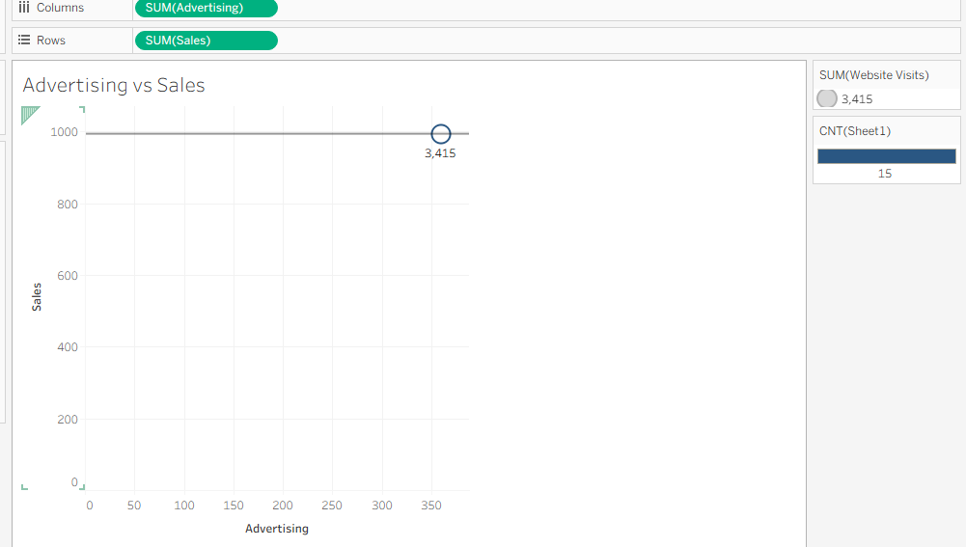

Result
The Multivariate Analysis Dashboard was successfully created in Tableau. The scatterplot shows a strong positive relationship between Advertising and Sales, indicating that increased advertising expenditure is associated with increased sales. Website Visits provides additional information about customer engagement, but using excessive visual encoding can create clutter. The Sales distribution view complements the scatterplot by showing the overall spread of sales values.

Q5. Misleading Dashboard and Redesign
A college reports the following pass percentages for seven departments. Build two Tableau dashboards: (1) a misleading version using a truncated y-axis, an inappropriate color scheme, and exaggerated visual emphasis on one department, and (2) a redesigned version using an appropriate baseline, ordered categories, consistent color encoding, and clear labels. Compare the two dashboards and explain how the first design can mislead viewers, and why the redesigned dashboard communicates the data more honestly.
Data:
S.No | Department | Pass_Percentage
1 | CSE | 91
2 | ECE | 93
3 | EEE | 92
4 | MECH | 89
5 | CIVIL | 90
6 | AIDS | 95
7 | IT | 94

Aim
To create and compare a misleading Tableau dashboard and a redesigned honest dashboard for departmental pass percentages, and understand how visualization choices can affect data interpretation.

Algorithm
- Import the department pass-percentage dataset into Tableau.
- Create a bar chart showing Pass Percentage by Department.
- Create the misleading dashboard by:
  - Truncating the Y-axis.
  - Using an inappropriate/mixed color scheme.
  - Giving exaggerated visual emphasis to one department.
- Create the redesigned dashboard by:
  - Using an appropriate baseline.
  - Ordering departments consistently.
  - Using consistent colors.
  - Adding clear labels.
- Place the visualizations in separate dashboards.
- Compare the two designs.
- Explain how the misleading dashboard can exaggerate differences.
- Explain why the redesigned dashboard communicates the data more accurately.

Output:

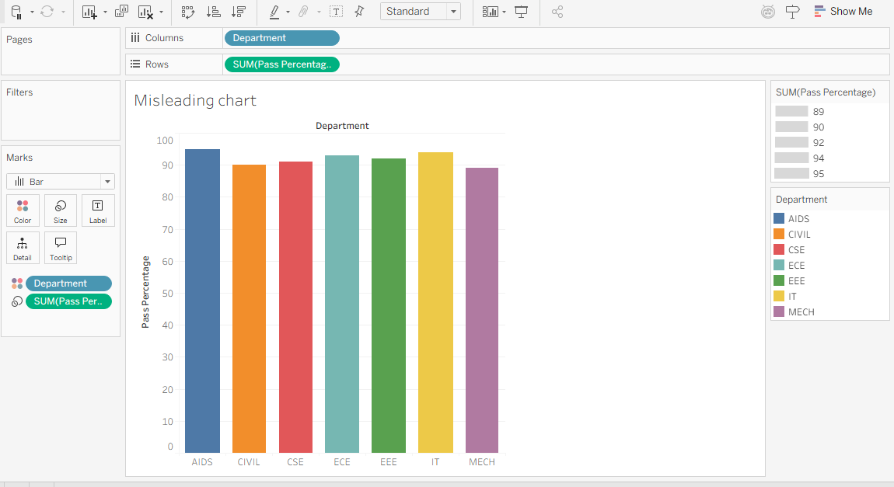

Result
Two Tableau dashboards were successfully created and compared. The misleading dashboard demonstrated how truncated axes, inappropriate colors, and exaggerated emphasis can distort perception. The redesigned dashboard used a 0% baseline, ordered categories, consistent colors, and clear labels, providing a more accurate and honest representation of departmental pass percentages.

