Data Interpretation Exercise

Data Interpretation Assessment (R Programming)
Topics:
• Mapping Data onto Aesthetics
• Coordinate Systems and Axes
• Color Scales
Instructions: Use the given dataset to write an appropriate R program, generate the required
visualization, and answer the questions.

Question 1: Mapping Data onto Aesthetics
Dataset

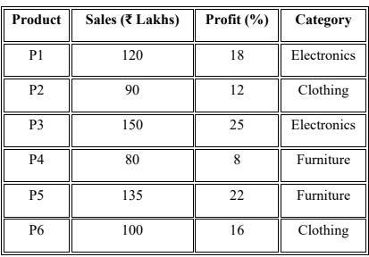
Questions
1. Write an R program to create a scatter plot with Sales on the x-axis and Profit on the
y-axis.
CODE:
plot(
product_data$Sales,
product_data$Profit,
main = "Relationship Between Sales and Profit",
xlab = "Sales (₹ Lakhs)",
ylab = "Profit (%)",
pch = 19,
col = "blue"
)

text(
product_data$Sales,
product_data$Profit,
labels = product_data$Product,
pos = 3
)
grid()
Output:
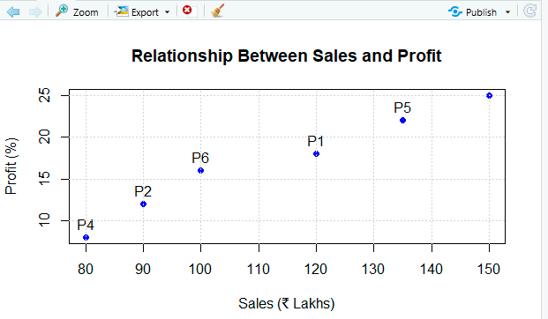
2. Map Category using an appropriate aesthetic and Sales using another suitable
aesthetic.
Code:
category_colors <- c(
"Electronics" = "blue",
"Clothing" = "green",
"Furniture" = "orange"
)

plot(
product_data$Sales,
product_data$Profit,
main = "Sales and Profit by Product Category",
xlab = "Sales (₹ Lakhs)",
ylab = "Profit (%)",
col = category_colors[
product_data$Category
],
cex = product_data$Sales / 80,
pch = 19
)

text(
product_data$Sales,
product_data$Profit,
labels = product_data$Product,
pos = 3
)

legend(
"topleft",
legend = names(category_colors),
col = category_colors,
pch = 19,
title = "Category"
)
grid()
Output:
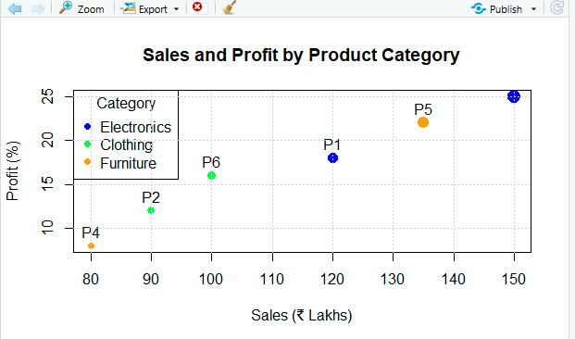

3. Interpret the relationship between Sales and Profit.

Interpretation: Relationship Between Sales and Profit
There is a positive relationship between Sales and Profit.
Generally:
- Products with higher sales tend to have higher profit percentages.
- P3 has the highest sales of ₹150 lakhs and the highest profit of 25%.
- P4 has the lowest sales of ₹80 lakhs and the lowest profit of 8%.
- Therefore, increasing sales appears to be associated with increasing profit in this dataset.
However, this dataset contains only six products, so a larger dataset would be needed to confirm the relationship statistically.

4. Identify the type of scale used for each variable.
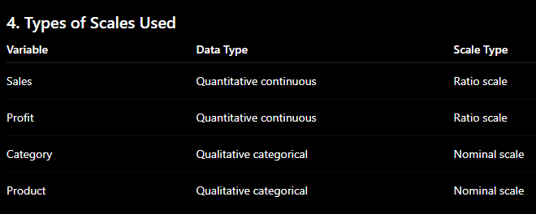

Explanation
- Sales: Ratio scale because it has a meaningful zero and ratios are meaningful.
- Profit: Ratio scale because 0% represents no profit.
- Category: Nominal scale because categories have no natural order.
- Product: Nominal scale because product IDs are labels.
5. Suggest one alternative visualization that better represents the same data.

Alternative Visualization
A grouped bar chart can be used as an alternative visualization to compare sales and profit across products and categories.
For example, a bar chart of Sales by Product with different colors for Category would make it easier to compare the sales performance of individual products.
A scatter plot is best when the main purpose is to understand the relationship between two numerical variables, while a bar chart is better for direct product-to-product comparisons.

Question 2: Coordinate Systems (Cartesian and Polar)
Dataset
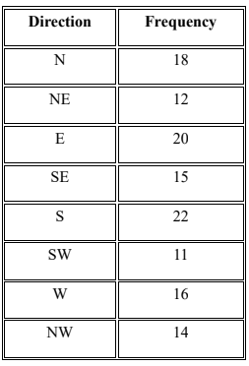
Questions
- Write an R program to visualize the dataset using a Cartesian coordinate system.
Code:
barplot(
direction_data$Frequency,
names.arg = direction_data$Direction,
main = "Frequency of Directions - Cartesian Coordinate System",
xlab = "Direction",
ylab = "Frequency",
col = "skyblue",
border = "black"
)
Output:
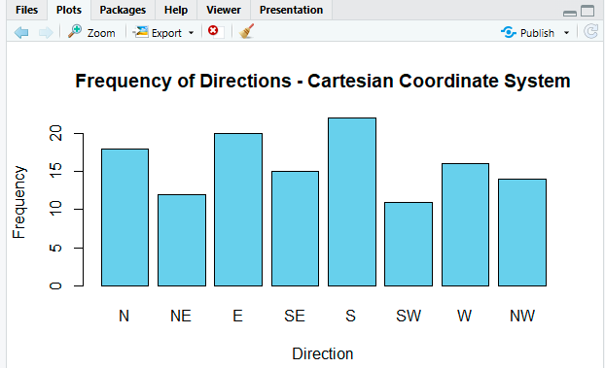

Interpretation
In the Cartesian bar chart:
- S (South) has the highest frequency: 22
- E (East) has a frequency of 20
- SW (Southwest) has the lowest frequency: 11
The rectangular axes make it easy to compare the exact frequency values.

- Write another R program to visualize the same data using a Polar coordinate system.
Code:
angles <- seq(
0,
2 * pi - (2 * pi / 8),
length.out = 8
)
plot(
0,
0,
type = "n",
xlim = c(-25, 25),
ylim = c(-25, 25),
asp = 1,
axes = FALSE,
xlab = "",
ylab = "",
main = "Frequency of Directions - Polar Coordinate System"
)
for (i in 1:8) {
x <- c(
0,
direction_data$Frequency[i] *
cos(angles[i]),
direction_data$Frequency[i] *
cos(angles[i] + 0.25),
0
)
y <- c(
0,
direction_data$Frequency[i] *
sin(angles[i]),
direction_data$Frequency[i] *
sin(angles[i] + 0.25),
0
)
polygon(
x,
y,
col = "skyblue",
border = "black"
)

text(
1.3 *
direction_data$Frequency[i] *
cos(angles[i]),
1.3 *
direction_data$Frequency[i] *
sin(angles[i]),
labels = direction_data$Direction[i]
)
}

grid()
Output:
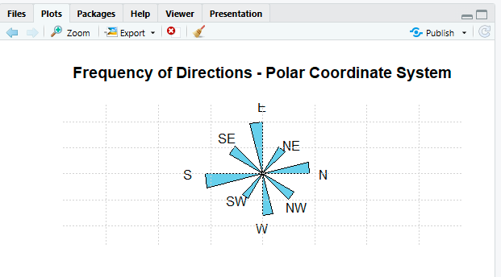
- Compare the effectiveness of both visualizations.
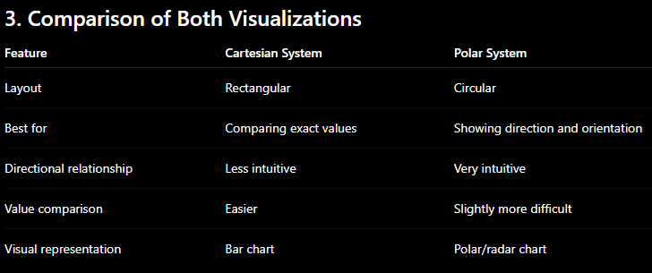

Cartesian Visualization
The Cartesian bar chart makes it easier to compare frequency values precisely. For example, comparing 22 for S with 20 for E is straightforward.

Polar Visualization
The polar visualization provides a more natural representation of directions because the values are arranged around a circle.
- Explain which coordinate system is more appropriate for directional data.

Most Appropriate Coordinate System
The Polar Coordinate System is more appropriate for this dataset.

Reason
The dataset contains directional values:
N, NE, E, SE, S, SW, W, NW
These directions naturally form a circle around a central point. A polar coordinate system represents this circular arrangement more realistically than a rectangular Cartesian chart.
- Justify your answer based on data interpretation.

Justification Based on Data Interpretation
The highest frequency is observed in the South direction (S = 22), followed by East (E = 20) and North (N = 18).
Using a polar visualization:
- Directions are arranged according to their natural compass orientation.
- Adjacent directions can be visually compared.
- Patterns of movement or frequency around the compass become easier to understand.
- The circular arrangement reflects the actual nature of directional data.
Therefore, although the Cartesian bar chart is better for precise numerical comparison, the Polar Coordinate System is more appropriate for interpreting directional data because it preserves the natural circular relationship between directions.
Question 3: Color Scales for Data Representation
Dataset

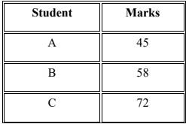
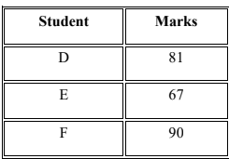
Questions
1. Write an R program to create a bar chart using a sequential color scale based on
Marks.
Code:
marks <- student_data$Marks

color_scale <- colorRampPalette(
c("lightblue", "darkblue")
)(length(marks))

barplot(
marks,
names.arg = student_data$Student,
main = "Student Marks Using a Sequential Color Scale",
xlab = "Student",
ylab = "Marks",
col = color_scale,
ylim = c(0, 100)
)
Output:
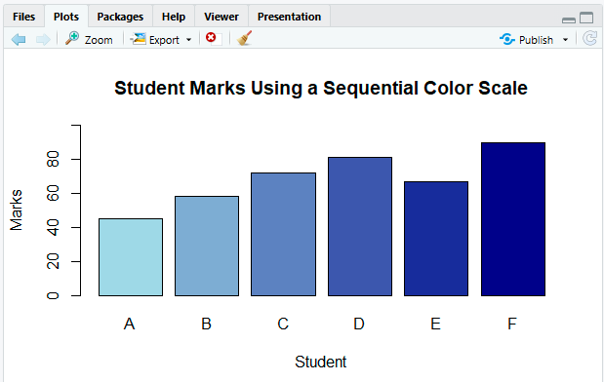

Explanation
The bar colors are assigned according to the marks:
- Lower marks → lighter color
- Higher marks → darker color
2. Identify the students with the highest and lowest marks from the visualization.
Code:
highest_student <- student_data[
which.max(student_data$Marks),
]
lowest_student <- student_data[
which.min(student_data$Marks),
]
highest_student
lowest_student
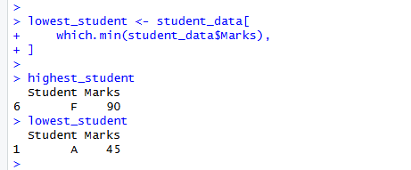

3. Explain why a sequential color scale is appropriate.

Why Is a Sequential Color Scale Appropriate?
A sequential color scale is appropriate because Marks are numerical values with a natural order.
The values progress from:
Low Marks → Medium Marks → High Marks
Therefore, using a gradual color progression helps viewers quickly understand the magnitude of each student's marks.
For example:
- Light color = lower marks
- Medium color = average marks
- Dark color = higher marks
This makes the relationship between color intensity and marks easy to understand.

4. Suggest a color palette suitable for color-blind users.
Code:
library(viridis)

barplot(
student_data$Marks,
names.arg = student_data$Student,
main = "Student Marks Using a Color-Blind-Friendly Palette",
xlab = "Student",
ylab = "Marks",
col = viridis(
length(student_data$Marks)
),
ylim = c(0, 100)
)
Output:
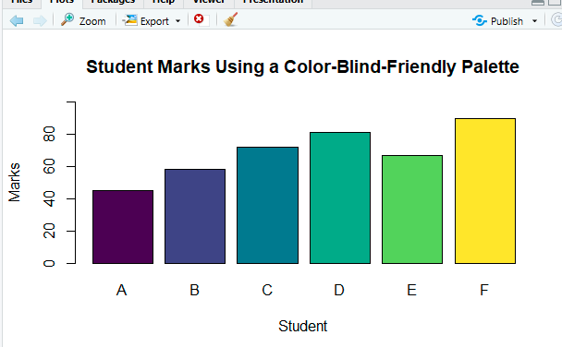
5. Explain the difference between sequential and categorical color scales.
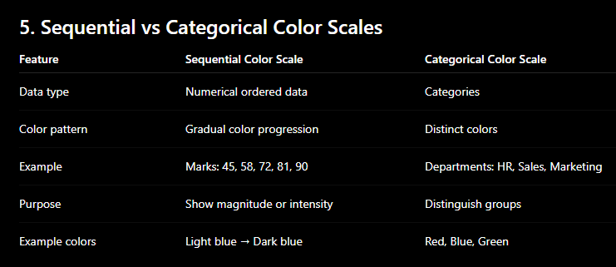

Conclusion
For Student Marks, a sequential color scale is the best choice because marks are numerical and ordered. A palette such as Viridis is a good choice when accessibility and color-blind readability are important.

Question 4: Highlighting with Color
Dataset

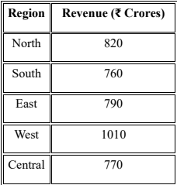
Questions
1. Write an R program to create a bar chart highlighting the region with the highest
revenue.
Code:
bar_colors <- ifelse(
region_data$Revenue == max(region_data$Revenue),
"red",
"lightblue"
)

barplot(
region_data$Revenue,
names.arg = region_data$Region,
main = "Regional Revenue Analysis",
xlab = "Region",
ylab = "Revenue (₹ Crores)",
col = bar_colors,
border = "black"
)

legend(
"topright",
legend = c(
"Highest Revenue",
"Other Regions"
),
fill = c("red", "lightblue")
)
Output:
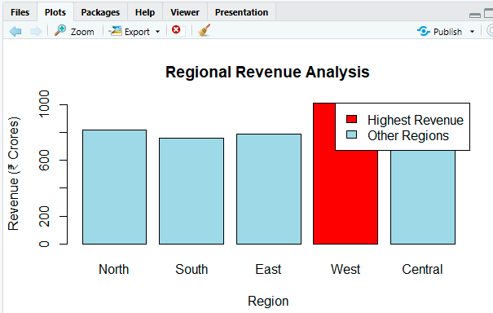
2. Explain how highlighting improves data interpretation.

How Highlighting Improves Data Interpretation
Highlighting draws the viewer's attention to an important data point.
In this example:
- The West region is immediately noticeable.
- The highest-performing region can be identified quickly.
- The viewer does not need to carefully compare every bar.
- It emphasizes the main finding of the visualization.
Thus, highlighting helps communicate the key message more effectively.

3. Identify the highest-performing region.
Code:
region_data[
which.max(region_data$Revenue),
]
Output:
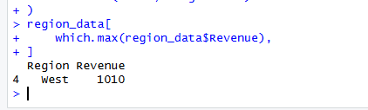
4. Discuss how excessive use of colors can affect interpretation.

Effect of Excessive Use of Colors
Using too many colors can reduce the effectiveness of a visualization.
Problems include:
- The important data point may no longer stand out.
- The chart can become visually confusing.
- Users may struggle to understand the meaning of each color.
- Too many colors can create unnecessary visual distraction.
- Similar colors may be difficult to distinguish.
Therefore, color should be used sparingly and purposefully.
For this chart, using one highlight color for West and a neutral color for the remaining regions is effective.

5.Suggest one alternative highlighting technique other than color.

Alternative Highlighting Technique
One alternative technique is to use different patterns or textures instead of color.
For example:
- Highest revenue → striped or hatched bar
- Other regions → plain bars
Other possible techniques include:
- Adding a data label such as "Highest"
- Using a larger bar outline
- Adding an annotation or arrow
- Using a different bar width

Best alternative
Data labels or annotations are a simple and effective alternative to color because they directly identify the important region.
Question 5: Integrated Visualization
Dataset

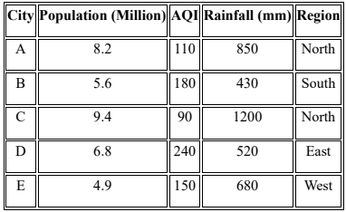
Questions
  - Write an R program to create a bubble chart using appropriate aesthetic mappings.
Code:
region_colors <- c(
"North" = "blue",
"South" = "red",
"East" = "green",
"West" = "orange"
)

plot(
city_data$Population,
city_data$AQI,
cex = city_data$Rainfall / 300,
col = region_colors[
city_data$Region
],
pch = 19,
main = "City Population, AQI and Rainfall",
xlab = "Population (Million)",
ylab = "Air Quality Index (AQI)"
)

text(
city_data$Population,
city_data$AQI,
labels = city_data$City,
pos = 3
)

legend(
"topleft",
legend = names(region_colors),
col = region_colors,
pch = 19,
title = "Region"
)
grid()
Output:
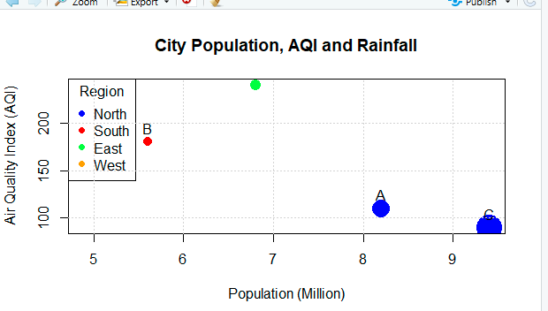

  - Select suitable aesthetics for Population, AQI, Rainfall, and Region.
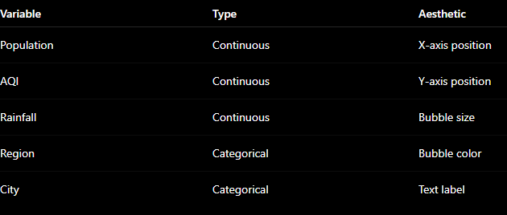

Explanation
- Population is mapped to the x-axis to compare city sizes.
- AQI is mapped to the y-axis to compare air quality.
- Rainfall is represented by bubble size.
- Region is represented by different colors.
- City is shown using labels.

  - Interpret the relationship between Population and AQI.

Relationship Between Population and AQI
The relationship between Population and AQI is not clearly linear in this small dataset.
For example:
- City C has the highest population at 9.4 million but a relatively low AQI of 90.
- City D has a population of 6.8 million but the highest AQI of 240.
- City E has the lowest population at 4.9 million and an AQI of 150.
This suggests that population size alone does not determine air quality. Other factors such as industrial activity, traffic, pollution control, weather, and urban planning may influence AQI.
  - Identify the continuous and categorical variables.

Continuous and Categorical Variables

Continuous Variables
These variables have numerical values:
- Population
- AQI
- Rainfall
They can be measured and compared numerically.

Categorical Variables
These variables represent groups or labels:
- City
- Region
The regions are:
North, South, East, West
  - Recommend one improvement to enhance the visualization's readability.

Recommended Improvement
A good improvement would be to use a color-blind-friendly color palette and add a clear legend.
Another improvement is to use a scale legend for bubble size, so viewers can easily understand how bubble size represents rainfall.
For example:
Small bubble → Low rainfall
Large bubble → High rainfall
This would make the relationship between Population, AQI, Rainfall, and Region easier to interpret.

