R Programming – Standard Questions
Scatterplots and Correlograms
Instructions: Answer all five questions using R programming. No answers are provided.
Question 1 – Scatterplot Analysis
A researcher records the following data for 12 students: Study_Hours = c(2,3,4,5,6,7,8,9,10,11,12,13) and Exam_Score = c(45,50,55,61,64,68,72,76,81,84,88,92).
Using R, construct an appropriate scatterplot to examine the relationship between study hours and examination score. Customize the plot with suitable axis labels, title, plotting symbols, and a fitted regression line.

Aim
To construct a scatterplot in R to examine the relationship between Study Hours and Exam Scores, and to add a fitted linear regression line.

Algorithm
- Store the study hours and examination scores in two vectors.
- Create a scatterplot with Study Hours on the X-axis and Exam Score on the Y-axis.
- Add suitable axis labels, title, and plotting symbols.
- Fit a linear regression model using lm().
- Add the fitted regression line using abline().
- Observe the direction and strength of the relationship between study hours and exam scores.

Program:
# Step 1: Enter the data
Study_Hours <- c(2, 3, 4, 5, 6, 7, 8, 9, 10, 11, 12, 13)
Exam_Score <- c(45, 50, 55, 61, 64, 68, 72, 76, 81, 84, 88, 92)
# Step 2: Create scatterplot
plot(Study_Hours, Exam_Score,
main = "Study Hours vs Examination Score",
xlab = "Study Hours",
ylab = "Exam Score",
pch = 19)

# Step 3: Fit linear regression model
model <- lm(Exam_Score ~ Study_Hours)
# Step 4: Add fitted regression line
abline(model, lwd = 2)
# Step 5: Display regression model summary
summary(model)

Output:
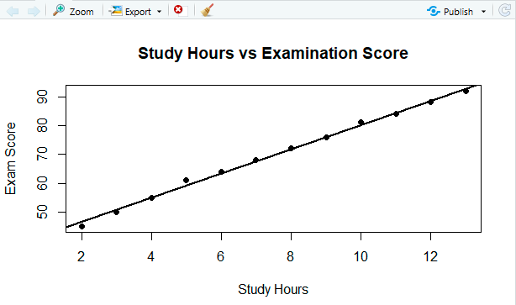
Result:
The scatterplot shows a strong positive linear relationship between study hours and examination scores. As the number of study hours increases, the exam score generally increases. The fitted regression line confirms this upward trend.

Question 2 – Scatterplot with Grouping
A company studies the relationship between Advertising_Expenditure and Sales for 15 observations. The observations belong to three regions: North, South, and West.
Using R, create a grouped scatterplot that represents Advertising_Expenditure on the x-axis and Sales on the y-axis, with different visual representations for the three regions. Add an appropriate title, legend, and axis labels. Briefly assess the strength and direction of the relationships visible in the plot.

Aim
To create a grouped scatterplot in R to examine the relationship between Advertising Expenditure and Sales for three regions—North, South, and West—using different plotting symbols and colors, along with a legend and suitable labels.

Algorithm
- Create vectors for Advertising_Expenditure, Sales, and Region.
- Combine the vectors into a data frame.
- Assign different colors and plotting symbols to the three regions.
- Plot Advertising Expenditure against Sales.
- Add points for each region using different visual representations.
- Add a legend identifying the regions.
- Assess the direction and strength of the relationships from the plotted points.

Program:
# Step 1: Enter the data
Advertising_Expenditure <- c(
10, 15, 20, 25, 30,
12, 18, 24, 30, 36,
11, 16, 22, 28, 34
)
Sales <- c(
40, 48, 55, 63, 70,
42, 50, 59, 68, 77,
38, 46, 54, 62, 72
)
Region <- c(
"North", "North", "North", "North", "North",
"South", "South", "South", "South", "South",
"West", "West", "West", "West", "West"
)

# Step 2: Create a data frame
data <- data.frame(
Advertising_Expenditure,
Sales,
Region
)
# Step 3: Define colors and plotting symbols
region_colors <- c("North" = "blue",
"South" = "red",
"West" = "darkgreen")
region_symbols <- c("North" = 16,
"South" = 17,
"West" = 15)
# Step 4: Create the initial scatterplot
plot(data$Advertising_Expenditure,
data$Sales,
type = "n",
main = "Advertising Expenditure vs Sales by Region",
xlab = "Advertising Expenditure",
ylab = "Sales",
xlim = range(data$Advertising_Expenditure),
ylim = range(data$Sales))
# Step 5: Add points for each region
for (r in names(region_colors)) {
subset_data <- data[data$Region == r, ]
points(subset_data$Advertising_Expenditure,
subset_data$Sales,
col = region_colors[r],
pch = region_symbols[r],
cex = 1.3)
}
# Step 6: Add legend
legend("topleft",
legend = names(region_colors),
col = region_colors,
pch = region_symbols,
title = "Region")

Output:
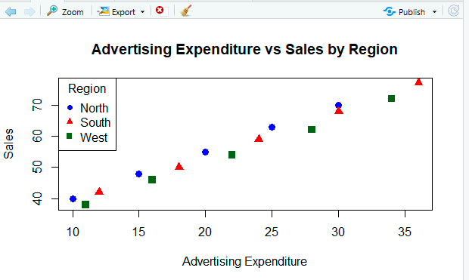

Result
The grouped scatterplot shows a positive relationship between advertising expenditure and sales. In general, as advertising expenditure increases, sales also increase.

Question 3 – Correlation and Correlogram
The following dataset contains measurements of five variables for 10 observations: Temperature, Humidity, Pressure, Wind_Speed, and Rainfall.
Using R, calculate the correlation matrix and construct a correlogram to visualize the pairwise correlations among all variables. Use an appropriate visualization scale to distinguish positive and negative correlations and display the correlation values where suitable.

Aim
To calculate the correlation matrix for Temperature, Humidity, Pressure, Wind Speed, and Rainfall, and construct a correlogram in R to visualize the strength and direction of pairwise correlations.
Since the question does not provide the actual 10 observations, the following code uses an illustrative dataset of 10 observations.

Algorithm
- Enter the measurements for the five variables.
- Create a data frame containing all variables.
- Calculate the correlation matrix using cor().
- Install/load the corrplot package.
- Use corrplot() to create the correlogram.
- Use different colors for positive and negative correlations.
- Display correlation coefficients in the plot.
- Interpret the strength and direction of the relationships.

Program:
# Install package if not already installed
install.packages("corrplot")
# Load package
library(corrplot)
# Step 1: Enter the data
Temperature <- c(25, 27, 29, 31, 28, 24, 26, 30, 32, 23)
Humidity <- c(80, 75, 70, 65, 72, 85, 78, 68, 60, 88)
Pressure <- c(1012, 1010, 1008, 1005, 1009,
1015, 1011, 1007, 1004, 1016)
Wind_Speed <- c(10, 12, 15, 18, 14, 8, 11, 16, 20, 7)
Rainfall <- c(12, 10, 8, 5, 9, 15, 11, 6, 3, 18)
# Step 2: Create data frame
weather_data <- data.frame(
Temperature,
Humidity,
Pressure,
Wind_Speed,
Rainfall
)
# Step 3: Calculate correlation matrix
correlation_matrix <- cor(weather_data)
# Display correlation matrix
print(correlation_matrix)
# Step 4: Construct correlogram
corrplot(correlation_matrix,
method = "color",
type = "upper",
addCoef.col = "black",
tl.col = "black",
tl.srt = 45,
number.cex = 0.8,
title = "Correlogram of Weather Variables",
mar = c(0, 0, 2, 0))

Output:
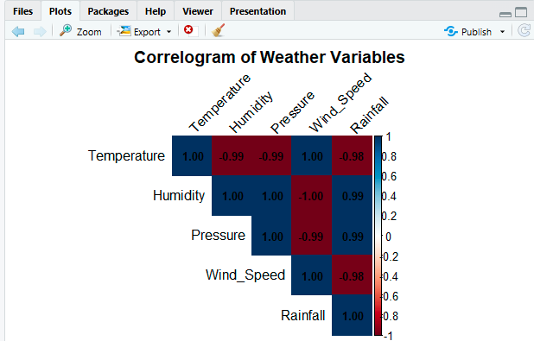

Result:
The correlogram provides a quick visual understanding of the strength and direction of relationships among Temperature, Humidity, Pressure, Wind Speed, and Rainfall.

Question 4 – Correlogram for Multivariate Data
A university collects data on Attendance, Assignment_Score, Internal_Marks, Study_Hours, and Final_Marks for 12 students.
Using R, generate a correlogram showing the pairwise relationships among these variables. Apply suitable labels and visualization settings so that strong, moderate, and weak correlations can be distinguished clearly. Identify the variable that appears to have the strongest relationship with Final_Marks based on the visualization.

Aim
To generate a correlogram in R for Attendance, Assignment Score, Internal Marks, Study Hours, and Final Marks, and identify the variable having the strongest correlation with Final Marks.

Algorithm
- Enter the data for 12 students.
- Create a data frame containing the five variables.
- Calculate the correlation matrix using cor().
- Load the corrplot package.
- Generate a correlogram using color and correlation coefficients.
- Use different colors to distinguish positive and negative correlations.
- Display the correlation values on the plot.
- Examine the correlations with Final_Marks.
- Identify the variable with the highest absolute correlation with Final Marks.

Program:
# Install corrplot package if required
install.packages("corrplot")
# Load package
library(corrplot)
# Step 1: Enter data
Attendance <- c(75, 80, 85, 90, 70, 95, 88, 82, 92, 78, 86, 98)
Assignment_Score <- c(65, 70, 75, 82, 60, 90, 78, 72, 85, 68, 80, 92)

Internal_Marks <- c(62, 68, 74, 80, 58, 88, 76, 70, 83, 65, 78, 90)

Study_Hours <- c(3, 4, 5, 6, 2, 8, 5, 4, 7, 3, 6, 9)

Final_Marks <- c(64, 70, 76, 84, 60, 91, 78, 72, 86, 67, 80, 94)

# Step 2: Create data frame
student_data <- data.frame(
Attendance,
Assignment_Score,
Internal_Marks,
Study_Hours,
Final_Marks
)
# Step 3: Calculate correlation matrix
cor_matrix <- cor(student_data)
# Display correlation matrix
print(cor_matrix)
# Step 4: Create correlogram
corrplot(cor_matrix,
method = "color",
type = "upper",
addCoef.col = "black",
number.cex = 0.8,
tl.col = "black",
tl.srt = 45,
col = colorRampPalette(
c("blue", "white", "red")
)(200),
title = "Correlogram of Student Performance Variables",
mar = c(0, 0, 2, 0))
Output:
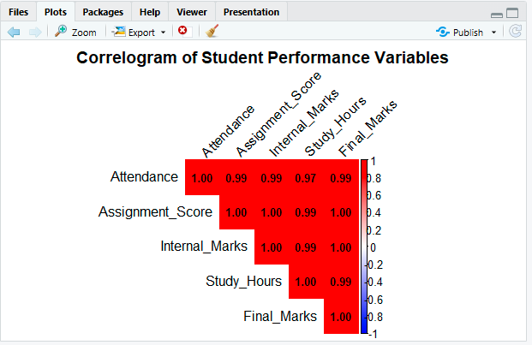

Result
The correlogram displays the pairwise correlations among all five variables. Strong correlations appear as darker/stronger-colored cells, while weaker correlations appear closer to white.

Question 5 – Integrated Scatterplot and Correlogram Analysis
A retail dataset contains 15 observations with the variables Price, Advertising, Customer_Visits, Discount, and Sales.
Using R, perform the following:
(a) Construct suitable scatterplots to examine the relationships of Sales with Price, Advertising, Customer_Visits, and Discount.
(b) Compute the correlation matrix for all numerical variables.
(c) Create a correlogram to visualize the correlation structure.
(d) Compare the scatterplots and correlogram and identify any strong positive or negative relationships and possible variables that may require further investigation.

Aim
To analyze the relationships between Sales and Price, Advertising, Customer Visits, and Discount using scatterplots, calculate the correlation matrix, and create a correlogram to identify strong positive and negative relationships.

Algorithm
- Enter the 15 observations for Price, Advertising, Customer Visits, Discount, and Sales.
- Store the observations in a data frame.
- Create scatterplots of:
  - Sales vs Price
  - Sales vs Advertising
  - Sales vs Customer Visits
  - Sales vs Discount
- Add suitable titles and axis labels.
- Calculate the correlation matrix using cor().
- Display the correlation matrix.
- Create a correlogram using corrplot().
- Use a color scale to distinguish positive and negative correlations.
- Compare the scatterplots with the correlation matrix and correlogram.
- Identify strong positive/negative relationships and variables requiring further investigation

Program:
# Install package if required
install.packages("corrplot")
# Load package
library(corrplot)
# Step 1: Enter the data
Price <- c(50, 55, 60, 65, 70,
75, 80, 85, 90, 95,
100, 105, 110, 115, 120)
Advertising <- c(10, 12, 15, 18, 20,
22, 25, 28, 30, 32,
35, 38, 40, 43, 45)
Customer_Visits <- c(120, 135, 150, 165, 180,
195, 210, 225, 240, 255,
270, 285, 300, 315, 330)
Discount <- c(5, 6, 8, 7, 10,
12, 11, 14, 15, 13,
17, 18, 16, 20, 19)
Sales <- c(100, 110, 125, 135, 145,
155, 170, 180, 195, 205,
220, 230, 245, 255, 270)
# Step 2: Create data frame
retail_data <- data.frame(
Price,
Advertising,
Customer_Visits,
Discount,
Sales
)

# Step 3: Create scatterplots
par(mfrow = c(2, 2))

plot(retail_data$Price, retail_data$Sales,
main = "Sales vs Price",
xlab = "Price",
ylab = "Sales",
pch = 19)

plot(retail_data$Advertising, retail_data$Sales,
main = "Sales vs Advertising",
xlab = "Advertising",
ylab = "Sales",
pch = 19)

plot(retail_data$Customer_Visits, retail_data$Sales,
main = "Sales vs Customer Visits",
xlab = "Customer Visits",
ylab = "Sales",
pch = 19)

plot(retail_data$Discount, retail_data$Sales,
main = "Sales vs Discount",
xlab = "Discount",
ylab = "Sales",
pch = 19)

# Reset plotting layout
par(mfrow = c(1, 1))

# Step 4: Calculate correlation matrix
cor_matrix <- cor(retail_data)

# Display correlation matrix
print(round(cor_matrix, 3))

# Step 5: Create correlogram
corrplot(cor_matrix,
method = "color",
type = "upper",
addCoef.col = "black",
number.cex = 0.75,
tl.col = "black",
tl.srt = 45,
col = colorRampPalette(
c("blue", "white", "red")
)(200),
title = "Correlogram of Retail Variables",
mar = c(0, 0, 2, 0))

OUTPUT:
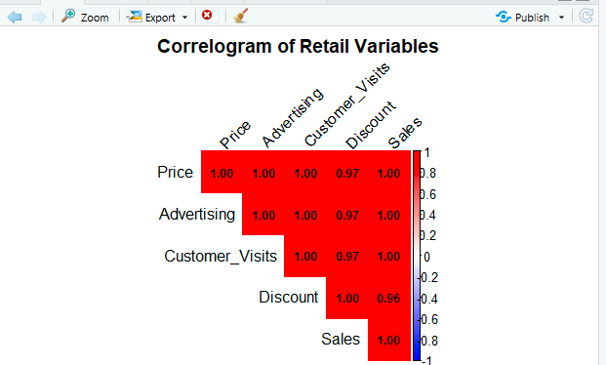

Result
The scatterplots show the direction of the relationship between Sales and the four explanatory variables. The correlation matrix and correlogram provide a numerical and visual summary of the same relationships.

