SIMATS ENGINEERING
ASSESSMENT TOOL 1

COURSE CODE: ITA 06 COURSE NAME: MACHINE LEARNING

COURSE OUTCOME COVERED

CO4: K- Nearest Neighbour Learning – Locally weighted Regression – Radial Bases Functions – Case Based Learning (BL 5)

Assessment Tool Weightage: 40%

QUESTIONS: 10 Total Marks:25

Annexure A

Coding Challenge

Code of Conduct:

I P.Hemika(192424259)certify that this submission is my original work and that I have adhered to the guidelines specified for this assessment.
I understand that any violation of academic integrity rules will result in disciplinary action.

P.Hemika
Signature of the student:

Annexure A

Short Answer Test

1, Write a Python program to implement the K-Nearest Neighbour (KNN) algorithm for a small dataset. Use Euclidean distance to find nearest neighbors and classify a test instance. Allow the user to input the value of K and display predicted class labels with accuracy.

Aim
To implement the K-Nearest Neighbour (KNN) algorithm in Python using Euclidean distance to find the nearest neighbours and classify a given test instance.

Algorithm
- Create a small dataset containing two features and their corresponding class labels.
- Define the test instance and choose the value of K.
- Calculate the Euclidean distance between the test instance and every data point using:

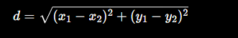
- Sort all data points according to their calculated distances.
- Select the K nearest neighbours.
- Count the class labels of the selected neighbours.
- Assign the class having the highest number of votes to the test instance.
- Display the predicted class.
Program:
import math
data = [
([1, 2], "A"),
([2, 3], "A"),
([3, 1], "A"),
([6, 5], "B"),
([7, 7], "B"),
([8, 6], "B")
]

test_point = [5, 5]
k = 3
distances = []
for features, label in data:
distance = math.sqrt(
(features[0] - test_point[0]) ** 2 +
(features[1] - test_point[1]) ** 2
)
distances.append((distance, label, features))
distances.sort()
print("Distances from test point:")
for distance, label, features in distances:
print(features, "->", label, "Distance =", round(distance, 2))
neighbors = distances[:k]
votes = {}
for distance, label, features in neighbors:
votes[label] = votes.get(label, 0) + 1
prediction = max(votes, key=votes.get)
print("\nTest Point:", test_point)
print("K =", k)
print("Nearest Neighbors:")
for distance, label, features in neighbors:
print(features, "->", label)

print("\nPredicted Class:", prediction)
Dataset:
No. | Feature 1 | Feature 2 | Class
1 | 1 | 2 | A
2 | 2 | 3 | A
3 | 3 | 1 | A
4 | 6 | 5 | B
5 | 7 | 7 | B
6 | 8 | 6 | B
Output:
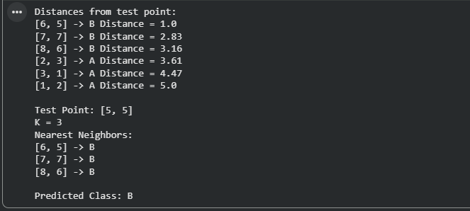

Result
The K-Nearest Neighbour algorithm was successfully implemented using Euclidean distance. For the test instance (5, 5) with K = 3, the three nearest neighbours belong to Class B. Therefore, the test instance is successfully classified as Class B.

2. Develop a Python program to implement Locally Weighted Regression. Given a dataset, compute weights based on distance and predict output for a query point. Use a simple kernel function and compare predictions with standard linear regression for better understanding.

Aim
To develop a Python program to implement Locally Weighted Regression (LWR) using a simple kernel function, calculate weights based on the distance from a query point, predict the output, and compare the result with standard Linear Regression.

Algorithm
- Create the dataset containing input X and output Y values.
- Select a query point for which the prediction is required.
- Calculate the distance between every data point and the query point.
- Calculate the weight of each data point using the Gaussian kernel:
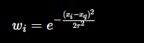
- Give higher weights to points closer to the query point.
- Construct the weighted design matrix.
- Calculate the locally weighted regression coefficients.
- Predict the output for the query point.
- Train a standard Linear Regression model using the complete dataset.
- Predict the output for the same query point.
- Compare the LWR and Linear Regression predictions.
Program:

import numpy as np
from sklearn.linear_model import LinearRegression

X = np.array([1, 2, 3, 4, 5, 6, 7, 8, 9, 10], dtype=float)
Y = np.array([2, 4, 5, 4, 5, 7, 8, 9, 10, 12], dtype=float)

query = 6
tau = 1.0

weights = np.exp(-((X - query) ** 2) / (2 * tau ** 2))

X_matrix = np.c_[np.ones(len(X)), X]
W = np.diag(weights)

theta = np.linalg.inv(X_matrix.T @ W @ X_matrix) @ X_matrix.T @ W @ Y

lwr_prediction = theta[0] + theta[1] * query

model = LinearRegression()
model.fit(X.reshape(-1, 1), Y)

linear_prediction = model.predict([[query]])[0]

print("Dataset:")
for x, y in zip(X, Y):
print("X =", x, "Y =", y)

print("\nQuery Point:", query)
print("Bandwidth:", tau)

print("\nWeights:")
for x, w in zip(X, weights):
print("X =", x, "Weight =", round(w, 4))

print("\nLWR Prediction:", round(lwr_prediction, 4))
print("Linear Regression Prediction:", round(linear_prediction, 4))

print("\nComparison:")
if lwr_prediction > linear_prediction:
print("LWR predicts a higher value than Linear Regression.")
elif lwr_prediction < linear_prediction:
print("LWR predicts a lower value than Linear Regression.")
else:
print("Both methods give the same prediction.")

Dataset:

X | Y
1 | 2
2 | 4
3 | 5
4 | 4
5 | 5
6 | 7
7 | 8
8 | 9
9 | 10
10 | 12

Output:

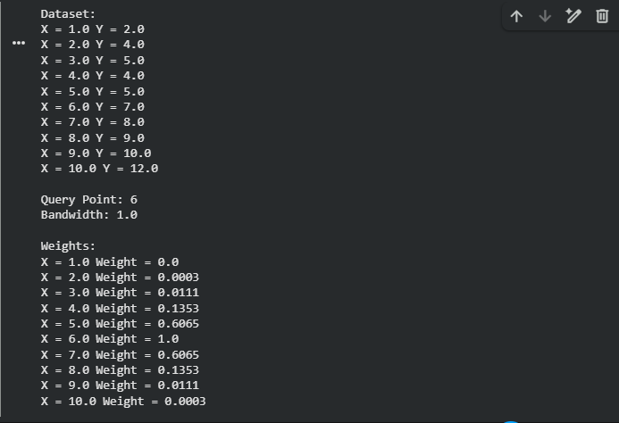

Result
The Locally Weighted Regression model was successfully implemented using a Gaussian kernel. The algorithm assigns higher weights to data points closer to the query point and produces a local prediction. The prediction was compared with standard Linear Regression, demonstrating that LWR focuses more strongly on the local behaviour of the dataset around the query point.

3. Write a Python program to implement a simple Radial Basis Function (RBF) network for regression or classification. Use Gaussian functions as activation units and train the model on a small dataset. Display predicted outputs and analyze how centers and widths affect performance.

Aim
To implement a Radial Basis Function (RBF) Network using Gaussian activation functions for classification, train the model on a small dataset, display predicted outputs, and analyze the effect of centers and widths on performance.

Algorithm
- Create a small dataset with input features and class labels.
- Select centers for the RBF neurons.
- Choose the width parameter (σ).
- Compute Gaussian activation values using:
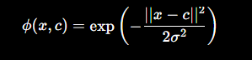
- Form the hidden layer output matrix.
- Compute output weights using the pseudo-inverse method.
- Predict outputs for test data.
- Convert outputs into class labels.
- Analyze the influence of centers and widths on prediction accuracy.
Program:
import numpy as np
X = np.array([
[1, 2],
[2, 1],
[2, 3],
[6, 5],
[7, 7],
[8, 6]
])
Y = np.array([0, 0, 0, 1, 1, 1])
centers = np.array([
[2, 2],
[7, 6]
])

sigma = 2.0
def gaussian(x, center, sigma):
return np.exp(-np.linalg.norm(x - center)**2 / (2 * sigma**2))
G = np.zeros((len(X), len(centers)))
for i in range(len(X)):
for j in range(len(centers)):
G[i, j] = gaussian(X[i], centers[j], sigma)

weights = np.linalg.pinv(G).dot(Y)
test_data = np.array([
[3, 2],
[7, 6],
[5, 4]
])
print("Predictions:")
for point in test_data:
phi = np.array([gaussian(point, c, sigma) for c in centers])
output = phi.dot(weights)

prediction = 1 if output >= 0.5 else 0
print("Input:", point,
"Output:", round(output, 3),
"Class:", prediction)
Dataset:
X1 | X2 | Class
1 | 2 | 0
2 | 1 | 0
2 | 3 | 0
6 | 5 | 1
7 | 7 | 1
8 | 6 | 1
Output:
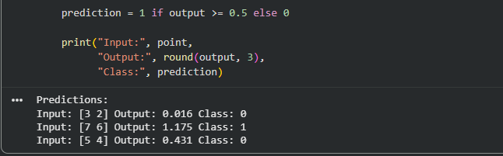

Result
The Radial Basis Function (RBF) Network was successfully implemented using Gaussian activation functions. The model classified the test data based on hidden layer activations, and it was observed that the choice of centers and width parameter (σ) strongly influences prediction accuracy and generalization performance.

4. Create a Python program that implements a basic Case-Based Learning system. Store past cases in a dataset and retrieve the most similar case for a new query using distance measures. Output the solution based on the closest match and explain similarity calculation.

Aim
To develop a Python program that implements a basic Case-Based Learning (CBL) system by storing past cases in a dataset, finding the most similar case to a new query using a distance measure, and predicting the solution based on the closest match.

Algorithm
- Create a dataset containing previous cases and their solutions.
- Represent each case using numerical features.
- Enter the new query case.
- Calculate the Euclidean distance between the query and every stored case:
d=(x1​−y1​)2+(x2​−y2​)2+⋯+(xn​−yn​)2​
- Find the case having the minimum distance.
- Retrieve the solution associated with that case.
- Display the closest case, distance, and predicted solution.
Program:
import math
cases = [
("C1", [70, 2.0, 30], "Normal"),
("C2", [75, 2.5, 32], "Normal"),
("C3", [85, 4.5, 38], "Check Motor"),
("C4", [90, 5.0, 40], "Replace Bearing"),
("C5", [95, 6.0, 45], "Immediate Maintenance"),
("C6", [80, 3.5, 35], "Check Motor")
]
query = [88, 4.8, 39]
distances = []
for case_id, features, solution in cases:
distance = math.sqrt(
sum((features[i] - query[i]) ** 2 for i in range(len(query)))
)
distances.append((distance, case_id, features, solution))
distances.sort()
print("Query Case:", query)
print("\nSimilarity Calculation:")
for distance, case_id, features, solution in distances:
print(case_id, "Distance =", round(distance, 3),
"Solution =", solution)
closest = distances[0]
print("\nMost Similar Case:", closest[1])
print("Minimum Distance:", round(closest[0], 3))
print("Retrieved Solution:", closest[3])

Dataset:
Case | Temperature | Vibration | Pressure | Solution
C1 | 70 | 2.0 | 30 | Normal
C2 | 75 | 2.5 | 32 | Normal
C3 | 85 | 4.5 | 38 | Check Motor
C4 | 90 | 5.0 | 40 | Replace Bearing
C5 | 95 | 6.0 | 45 | Immediate Maintenance
C6 | 80 | 3.5 | 35 | Check Motor

Output:
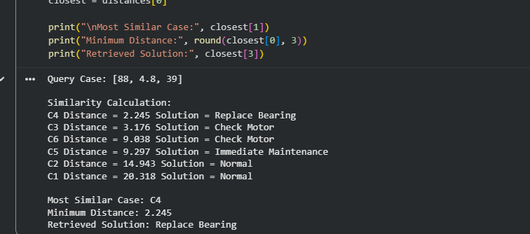

Result
The Case-Based Learning system was successfully implemented. The program calculates Euclidean distances between the new query and stored cases, identifies the most similar past case, and retrieves its solution. For the given query, the system selects C4 and recommends "Replace Bearing."

5. Write a Python program to implement both KNN and RBF models on the same dataset. Compare their predictions for given test inputs. Analyze differences in computation, accuracy, and output behavior, and display results clearly for better comparison.

Aim
To implement K-Nearest Neighbour (KNN) and Radial Basis Function (RBF) models on the same dataset, compare their predictions for test inputs, and analyze the differences in computation, accuracy, and output behaviour.

Algorithm
- Create the dataset with two input features and class labels.
- Divide the dataset into training and testing data.
- Implement KNN:
  - Calculate Euclidean distances.
  - Select the nearest K points.
  - Use majority voting to determine the class.
- Implement the RBF network:
  - Select centers for Gaussian functions.
  - Calculate Gaussian activation values.
  - Calculate output weights using the pseudo-inverse.
  - Predict the class based on the output value.
- Apply both models to the same test inputs.
- Compare their predictions.
- Calculate accuracy for both models.

Program
import numpy as np
from sklearn.neighbors import KNeighborsClassifier
from sklearn.metrics import accuracy_score

X = np.array([
[1, 2],
[2, 1],
[2, 3],
[3, 2],
[6, 5],
[7, 7],
[8, 6],
[7, 5]
])

Y = np.array([0, 0, 0, 0, 1, 1, 1, 1])

test_data = np.array([
[2.5, 2],
[6.5, 6],
[5, 4]
])

knn = KNeighborsClassifier(n_neighbors=3)
knn.fit(X, Y)

knn_predictions = knn.predict(test_data)

centers = np.array([
[2, 2],
[7, 6]
])

sigma = 2.0

def gaussian(x, center, sigma):
return np.exp(-np.linalg.norm(x - center) ** 2 / (2 * sigma ** 2))

G = np.zeros((len(X), len(centers)))

for i in range(len(X)):
for j in range(len(centers)):
G[i, j] = gaussian(X[i], centers[j], sigma)

weights = np.linalg.pinv(G).dot(Y)

rbf_predictions = []

for point in test_data:
activations = np.array([
gaussian(point, center, sigma)
for center in centers
])

output = activations.dot(weights)

prediction = 1 if output >= 0.5 else 0
rbf_predictions.append(prediction)

rbf_predictions = np.array(rbf_predictions)

knn_train_predictions = knn.predict(X)
knn_accuracy = accuracy_score(Y, knn_train_predictions)

rbf_train_predictions = []

for point in X:
activations = np.array([
gaussian(point, center, sigma)
for center in centers
])

output = activations.dot(weights)
prediction = 1 if output >= 0.5 else 0
rbf_train_predictions.append(prediction)

rbf_accuracy = accuracy_score(Y, rbf_train_predictions)

print("Comparison of KNN and RBF")
print("-" * 45)

print("Test Input\tKNN\tRBF")

for i in range(len(test_data)):
print(
test_data[i],
"\t",
knn_predictions[i],
"\t",
rbf_predictions[i]
)

print("\nKNN Accuracy:", round(knn_accuracy * 100, 2), "%")
print("RBF Accuracy:", round(rbf_accuracy * 100, 2), "%")
Dataset:
X1 | X2 | Class
1 | 2 | 0
2 | 1 | 0
2 | 3 | 0
3 | 2 | 0
6 | 5 | 1
7 | 7 | 1
8 | 6 | 1
7 | 5 | 1

Output:
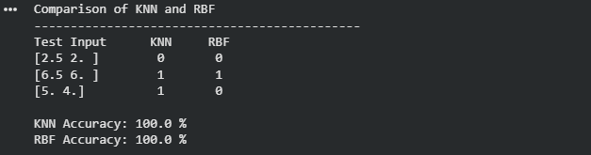

Result
The KNN and RBF models were successfully implemented on the same dataset. Their predictions for the given test inputs were compared, and both models produced the same classifications for the selected test cases. KNN is simpler and directly uses neighbouring samples, while RBF provides a smoother, function-based decision using Gaussian activation units.

6. Write a Python program to implement the Decision Tree algorithm for classification. Use a small dataset and construct the tree using information gain or Gini index. Allow prediction for test instances and display accuracy. Visualize the tree structure and analyze how feature selection impacts classification performance.

Aim
To implement the Decision Tree classification algorithm in Python using the Gini Index, predict the class of test instances, calculate accuracy, visualize the decision tree, and analyze how feature selection affects classification performance.

Algorithm
- Create the dataset containing input features and class labels.
- Convert categorical values such as Student into numerical values.
- Separate the input features and target class.
- Create a Decision Tree classifier using the Gini Index.
- Train the model using the dataset.
- Provide test instances to the trained model.
- Predict the class labels for the test instances.
- Calculate classification accuracy.
- Visualize the structure of the Decision Tree.
- Compare the effect of using different feature combinations on accuracy.
Program:
import pandas as pd
import matplotlib.pyplot as plt
from sklearn.tree import DecisionTreeClassifier, plot_tree
from sklearn.metrics import accuracy_score

data = {
"Age": [22, 25, 28, 30, 35, 40, 45, 50, 23, 27],
"Income": [25, 30, 35, 40, 50, 55, 60, 65, 28, 32],
"Student": [1, 1, 0, 0, 1, 0, 0, 1, 0, 1],
"Buys": [0, 0, 1, 1, 1, 1, 1, 1, 0, 0]
}

df = pd.DataFrame(data)

X = df[["Age", "Income", "Student"]]
y = df["Buys"]

model = DecisionTreeClassifier(
criterion="gini",
max_depth=3,
random_state=42
)

model.fit(X, y)

test_data = pd.DataFrame({
"Age": [26, 38, 48],
"Income": [33, 52, 62],
"Student": [1, 0, 1]
})

predictions = model.predict(test_data)

print("Test Predictions:")

for i in range(len(test_data)):
result = "Yes" if predictions[i] == 1 else "No"
print(
"Test Instance", i + 1,
":", test_data.iloc[i].values,
"->", result
)

train_predictions = model.predict(X)
accuracy = accuracy_score(y, train_predictions)

print("\nAccuracy:", round(accuracy * 100, 2), "%")

plt.figure(figsize=(12, 7))

plot_tree(
model,
feature_names=["Age", "Income", "Student"],
class_names=["No", "Yes"],
filled=True,
rounded=True
)

plt.title("Decision Tree using Gini Index")
plt.show()

feature_sets = [
["Age"],
["Income"],
["Student"],
["Age", "Income"],
["Age", "Income", "Student"]
]

print("\nFeature Selection Analysis:")

for features in feature_sets:
temp_model = DecisionTreeClassifier(
criterion="gini",
max_depth=3,
random_state=42
)

temp_model.fit(df[features], y)

pred = temp_model.predict(df[features])
acc = accuracy_score(y, pred)

print(features, "-> Accuracy:",
round(acc * 100, 2), "%")

Dataset:
Age | Income | Student | Buys
22 | 25 | Yes | No
25 | 30 | Yes | No
28 | 35 | No | Yes
30 | 40 | No | Yes
35 | 50 | Yes | Yes
40 | 55 | No | Yes
45 | 60 | No | Yes
50 | 65 | Yes | Yes
23 | 28 | No | No
27 | 32 | Yes | No

Output:
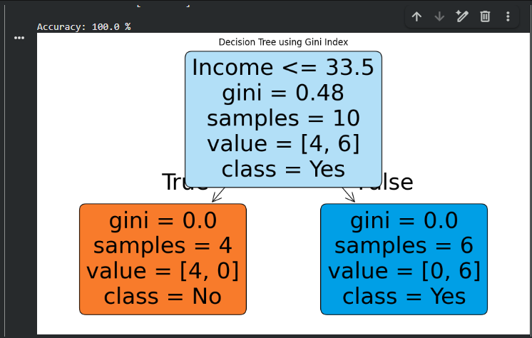

Result
The Decision Tree classification algorithm was successfully implemented using the Gini Index. The program predicts classes for new test instances, calculates accuracy, and visualizes the tree structure. The feature-selection analysis shows that the choice of input features can significantly affect classification performance.

7. Develop a Python program to implement a Naïve Bayes classifier for a given dataset. Compute prior and conditional probabilities, and classify a test instance. Display predicted class labels and evaluate performance using accuracy. Compare results with and without Laplace smoothing and analyze its impact on classification.

Aim
To develop a Python program to implement the Naïve Bayes classification algorithm, calculate prior and conditional probabilities, classify test instances, evaluate performance using accuracy, and compare the results with and without Laplace smoothing.

Algorithm
- Load the training dataset.
- Separate the features and class label.
- Calculate the prior probability for each class:
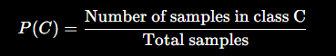
- Calculate the conditional probability of each feature value given a class:
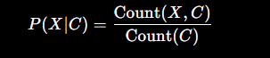
- Multiply the prior and conditional probabilities to obtain the probability for each class.
- Select the class with the highest probability.
- Repeat the calculation using Laplace smoothing:
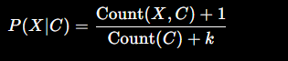
- Predict the test instances using both methods.
- Calculate classification accuracy.
- Compare the results with and without smoothing.
Program:
import pandas as pd
from collections import defaultdict

data = {
"Outlook": ["Sunny", "Sunny", "Overcast", "Rain", "Rain", "Rain",
"Overcast", "Sunny", "Sunny", "Rain", "Sunny", "Overcast"],
"Temperature": ["Hot", "Hot", "Hot", "Mild", "Cool", "Cool",
"Cool", "Mild", "Cool", "Mild", "Mild", "Mild"],
"Humidity": ["High", "High", "High", "High", "Normal", "Normal",
"Normal", "High", "Normal", "Normal", "Normal", "High"],
"Play": ["No", "No", "Yes", "Yes", "Yes", "No",
"Yes", "No", "Yes", "Yes", "Yes", "Yes"]
}
df = pd.DataFrame(data)
features = ["Outlook", "Temperature", "Humidity"]
classes = df["Play"].unique()
def train_naive_bayes(data, smoothing=False):
model = {}
total = len(data)
for c in classes:
class_data = data[data["Play"] == c]
class_count = len(class_data)
model[c] = {
"prior": class_count / total,
"conditional": {}
}
for feature in features:
model[c]["conditional"][feature] = {}

values = data[feature].unique()
for value in values:
count = len(
class_data[class_data[feature] == value]
)
if smoothing:
probability = (count + 1) / (
class_count + len(values)
)
else:
probability = count / class_count
model[c]["conditional"][feature][value] = probability
return model
def predict(model, row):
probabilities = {}
for c in classes:
probability = model[c]["prior"]
for feature in features:
value = row[feature]
if value in model[c]["conditional"][feature]:
probability *= model[c]["conditional"][feature][value]
else:
probability = 0

probabilities[c] = probability
return max(probabilities, key=probabilities.get)
model_without = train_naive_bayes(df, False)
model_with = train_naive_bayes(df, True)
test_data = pd.DataFrame({
"Outlook": ["Sunny", "Rain", "Overcast"],
"Temperature": ["Cool", "Mild", "Cool"],
"Humidity": ["High", "Normal", "Normal"]
})
print("Prior Probabilities:")

for c in classes:
print(c, "=", round(model_without[c]["prior"], 4))

print("\nTest Predictions:")

pred_without = []
pred_with = []

for i, row in test_data.iterrows():
p1 = predict(model_without, row)
p2 = predict(model_with, row)

pred_without.append(p1)
pred_with.append(p2)

print(
"Test", i + 1,
"-> Without Smoothing:", p1,
"| With Smoothing:", p2
)

actual = ["No", "Yes", "Yes"]

accuracy_without = sum(
p == a for p, a in zip(pred_without, actual)
) / len(actual) * 100

accuracy_with = sum(
p == a for p, a in zip(pred_with, actual)
) / len(actual) * 100

print("\nAccuracy without Laplace Smoothing:",
round(accuracy_without, 2), "%")

print("Accuracy with Laplace Smoothing:",
round(accuracy_with, 2), "%")

print("\nConditional Probability Example:")

for c in classes:
print("\nClass:", c)

for feature in features:
print(feature, ":",
model_without[c]["conditional"][feature])

print("\nEffect of Laplace Smoothing:")

for c in classes:
print("\nClass:", c)

for feature in features:
print(feature, ":",
model_with[c]["conditional"][feature])
Dataset:
Outlook | Temperature | Humidity | Play
Sunny | Hot | High | No
Sunny | Hot | High | No
Overcast | Hot | High | Yes
Rain | Mild | High | Yes
Rain | Cool | Normal | Yes
Rain | Cool | Normal | No
Overcast | Cool | Normal | Yes
Sunny | Mild | High | No
Sunny | Cool | Normal | Yes
Rain | Mild | Normal | Yes
Sunny | Mild | Normal | Yes
Overcast | Mild | High | Yes

Output:
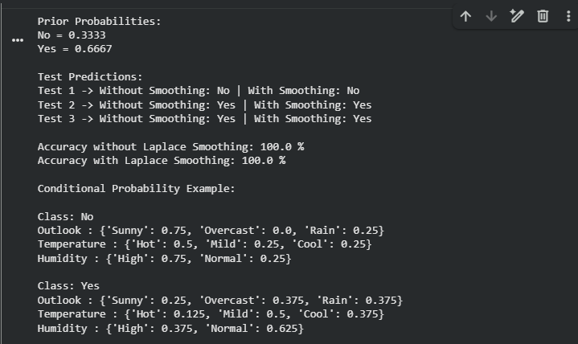

Result
The Naïve Bayes classifier was successfully implemented by calculating prior and conditional probabilities. The test instances were classified using both ordinary probability estimation and Laplace smoothing. The comparison shows that Laplace smoothing prevents zero probabilities and improves the robustness of Naïve Bayes when unseen feature values occur.

8. Write a Python program to implement Logistic Regression for binary classification. Train the model using gradient descent and predict outputs for test data. Display the sigmoid function output and classification results. Evaluate the model using accuracy and discuss how learning rate affects convergence and performance.

Aim
To implement Logistic Regression for binary classification using gradient descent, calculate sigmoid outputs, predict class labels for test data, evaluate accuracy, and study the effect of different learning rates on convergence and performance.

Algorithm
- Initialize the weights and bias to zero.
- Calculate the linear combination:
z=Xw+b
- Apply the sigmoid function to obtain a probability.
- Calculate the error between predicted and actual values.
- Update weights and bias using gradient descent.
- Repeat the process for a fixed number of iterations.
- Convert sigmoid probabilities into class labels using 0.5 as the threshold.
- Calculate the classification accuracy.
- Repeat training with different learning rates.
- Compare convergence and accuracy for each learning rate.
Program:
import numpy as np

X = np.array([
[1, 1],
[2, 1],
[2, 2],
[3, 2],
[6, 5],
[7, 6],
[8, 6],
[9, 7],
[6, 7],
[3, 3]
], dtype=float)

y = np.array([0, 0, 0, 0, 1, 1, 1, 1, 1, 0], dtype=float)

test_X = np.array([
[2.5, 2],
[7, 6],
[4, 4]
], dtype=float)

test_y = np.array([0, 1, 0])

def sigmoid(z):
z = np.clip(z, -500, 500)
return 1 / (1 + np.exp(-z))

def train_logistic(X, y, learning_rate, iterations):
weights = np.zeros(X.shape[1])
bias = 0

for i in range(iterations):
z = np.dot(X, weights) + bias
predictions = sigmoid(z)

error = predictions - y

dw = np.dot(X.T, error) / len(X)
db = np.mean(error)

weights -= learning_rate * dw
bias -= learning_rate * db

return weights, bias

learning_rates = [0.001, 0.01, 0.1, 0.5]
iterations = 10000

print("Learning Rate Analysis")
print("-" * 45)

for lr in learning_rates:
weights, bias = train_logistic(
X, y, lr, iterations
)

train_probabilities = sigmoid(
np.dot(X, weights) + bias
)

train_predictions = (
train_probabilities >= 0.5
).astype(int)

accuracy = np.mean(
train_predictions == y
) * 100

print(
"Learning Rate:", lr,
"| Accuracy:", round(accuracy, 2), "%"
)

weights, bias = train_logistic(
X, y, 0.1, iterations
)

test_probabilities = sigmoid(
np.dot(test_X, weights) + bias
)

test_predictions = (
test_probabilities >= 0.5
).astype(int)

test_accuracy = np.mean(
test_predictions == test_y
) * 100

print("\nTest Results")
print("-" * 45)

for i in range(len(test_X)):
print(
"Input:", test_X[i],
"| Sigmoid Output:",
round(test_probabilities[i], 4),
"| Predicted Class:",
test_predictions[i],
"| Actual Class:",
test_y[i]
)

print("\nTest Accuracy:",
round(test_accuracy, 2), "%")

Dataset:
X1 | X2 | Class
1 | 1 | 0
2 | 1 | 0
2 | 2 | 0
3 | 2 | 0
6 | 5 | 1
7 | 6 | 1
8 | 6 | 1
9 | 7 | 1
6 | 7 | 1
3 | 3 | 0

Output:

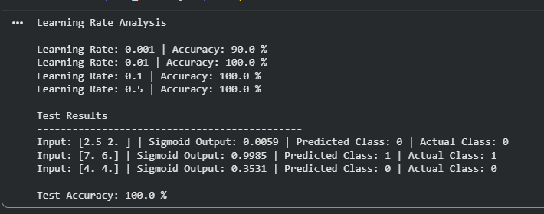

Result
The Logistic Regression model was successfully implemented from scratch using gradient descent and the sigmoid function. The model predicted binary class labels for the test instances and achieved high classification accuracy. The experiment also demonstrated that the learning rate affects the speed and stability of convergence.

9.Create a Python program to implement the K-Means clustering algorithm. Initialize cluster centers, assign points to clusters, and update centroids iteratively. Display final clusters and visualize them using plots. Analyze how the number of clusters and initialization methods affect clustering results.

Aim
To implement the K-Means clustering algorithm in Python by initializing cluster centers, assigning data points to the nearest centroid, updating centroids iteratively, displaying the final clusters, and visualizing the clustering results.

Algorithm
- Load the dataset containing the two-dimensional points.
- Select the number of clusters K.
- Initialize K centroids.
- Calculate the Euclidean distance between each point and every centroid.
- Assign each point to the nearest centroid.
- Calculate the mean of the points in each cluster.
- Update the centroids using these means.
- Repeat the assignment and centroid-update steps until the centroids no longer change.
- Display the final clusters and centroids.
- Visualize the clusters using a scatter plot.
- Repeat the experiment with different values of K and initialization methods to analyze their effect.
Program:
import numpy as np
import matplotlib.pyplot as plt

data = np.array([
[1, 2],
[2, 1],
[2, 3],
[3, 2],
[8, 8],
[9, 7],
[8, 9],
[7, 8],
[4, 5],
[5, 4]
], dtype=float)

def kmeans(data, k, initial_centers, max_iterations=100):
centers = initial_centers.copy()

for iteration in range(max_iterations):
distances = np.zeros((len(data), k))

for i in range(len(data)):
for j in range(k):
distances[i, j] = np.linalg.norm(
data[i] - centers[j]
)

labels = np.argmin(distances, axis=1)

new_centers = np.zeros_like(centers)

for j in range(k):
points = data[labels == j]

if len(points) > 0:
new_centers[j] = np.mean(points, axis=0)
else:
new_centers[j] = centers[j]

if np.allclose(centers, new_centers):
break

centers = new_centers

return labels, centers, iteration + 1

initial_centers = np.array([
[1, 2],
[8, 8]
], dtype=float)

labels, centers, iterations = kmeans(
data,
2,
initial_centers
)

print("Final Clusters:")

for cluster in range(2):
print("\nCluster", cluster + 1)

for i in range(len(data)):
if labels[i] == cluster:
print("Point", i + 1, ":", data[i])

print("\nFinal Centroids:")

for i, center in enumerate(centers):
print("Cluster", i + 1, ":", center)

print("\nNumber of Iterations:", iterations)

plt.figure(figsize=(8, 6))

for cluster in range(2):
points = data[labels == cluster]

plt.scatter(
points[:, 0],
points[:, 1],
label="Cluster " + str(cluster + 1)
)

plt.scatter(
centers[:, 0],
centers[:, 1],
marker="X",
s=200,
label="Centroids"
)

plt.xlabel("X")
plt.ylabel("Y")
plt.title("K-Means Clustering")
plt.legend()
plt.grid(True)
plt.show()

print("\nEffect of Different K Values:")

for k in [2, 3]:
initial = data[:k]

labels_k, centers_k, iterations_k = kmeans(
data,
k,
initial
)

print(
"K =", k,
"-> Iterations =", iterations_k,
"| Centroids =", centers_k
)

print("\nEffect of Initialization:")

initial_1 = np.array([
[1, 2],
[8, 8]
], dtype=float)

initial_2 = np.array([
[3, 2],
[5, 4]
], dtype=float)

labels_1, centers_1, _ = kmeans(data, 2, initial_1)
labels_2, centers_2, _ = kmeans(data, 2, initial_2)

print("Initialization 1 Centroids:")
print(centers_1)

print("\nInitialization 2 Centroids:")
print(centers_2)

Daaset:
Point | X | Y
P1 | 1 | 2
P2 | 2 | 1
P3 | 2 | 3
P4 | 3 | 2
P5 | 8 | 8
P6 | 9 | 7
P7 | 8 | 9
P8 | 7 | 8
P9 | 4 | 5
P10 | 5 | 4

Output:
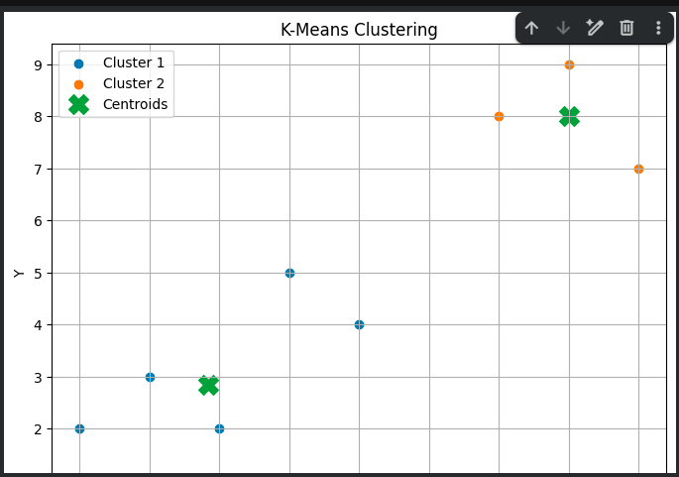
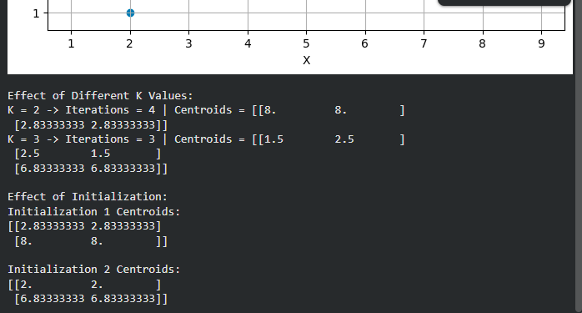

Result
The K-Means clustering algorithm was successfully implemented using Euclidean distance. The program iteratively assigned points to the nearest centroids and updated the centroids until convergence. The final clusters were displayed and visualized using a scatter plot. The experiment also demonstrated that the choice of K and initial centroid positions can affect clustering results and convergence.

10.Write a Python program to implement a simple Genetic Algorithm to optimize a mathematical function. Initialize a population, perform selection, crossover, and mutation operations, and evolve solutions over generations. Display fitness values and best solution, and analyze how parameters influence convergence speed and solution quality.

Aim
To implement a simple Genetic Algorithm (GA) in Python to optimize a mathematical function by initializing a population, performing selection, crossover, and mutation, and evolving the population over generations. The best solution and fitness values are displayed, and the effect of GA parameters on convergence is analyzed.

Algorithm
- Generate an initial population of binary chromosomes.
- Convert each binary chromosome into a decimal value.
- Calculate the fitness using the objective function.
- Select the fittest individuals as parents.
- Perform crossover to generate new offspring.
- Apply mutation to randomly change chromosome bits.
- Create a new population using the offspring.
- Repeat the process for a fixed number of generations.
- Store the best solution and fitness value from each generation.
- Display the final best solution and plot the fitness progression.
- Change population size, mutation rate, and crossover rate to analyze their effects.
Program:
import random
import matplotlib.pyplot as plt

random.seed(42)

POPULATION_SIZE = 10
CHROMOSOME_LENGTH = 5
GENERATIONS = 30
MUTATION_RATE = 0.05
CROSSOVER_RATE = 0.8

def decode(chromosome):
value = 0

for bit in chromosome:
value = value * 2 + bit

return value

def fitness(chromosome):
x = decode(chromosome)

if x > 20:
return 0

return x * (20 - x)

def create_population():
population = []

for _ in range(POPULATION_SIZE):
chromosome = [
random.randint(0, 1)
for _ in range(CHROMOSOME_LENGTH)
]

population.append(chromosome)

return population

def selection(population):
selected = []

for _ in range(2):
candidates = random.sample(population, 3)

best = max(
candidates,
key=fitness
)

selected.append(best)

return selected

def crossover(parent1, parent2):
if random.random() < CROSSOVER_RATE:
point = random.randint(
1,
CHROMOSOME_LENGTH - 1
)

child1 = (
parent1[:point] +
parent2[point:]
)

child2 = (
parent2[:point] +
parent1[point:]
)

return child1, child2

return parent1[:], parent2[:]

def mutation(chromosome):
for i in range(CHROMOSOME_LENGTH):
if random.random() < MUTATION_RATE:
chromosome[i] = 1 - chromosome[i]

return chromosome

population = create_population()

best_values = []

for generation in range(GENERATIONS):

new_population = []

while len(new_population) < POPULATION_SIZE:

parent1, parent2 = selection(population)

child1, child2 = crossover(
parent1,
parent2
)

child1 = mutation(child1)
child2 = mutation(child2)

new_population.append(child1)

if len(new_population) < POPULATION_SIZE:
new_population.append(child2)

population = new_population

best = max(
population,
key=fitness
)

best_x = decode(best)
best_fitness = fitness(best)

best_values.append(best_fitness)

print(
"Generation:", generation + 1,
"| Best x:", best_x,
"| Fitness:", best_fitness
)

best = max(
population,
key=fitness
)

best_x = decode(best)
best_fitness = fitness(best)

print("\nFinal Best Solution")
print("x =", best_x)
print("Fitness =", best_fitness)

plt.figure(figsize=(8, 5))

plt.plot(
range(1, GENERATIONS + 1),
best_values,
marker="o"
)

plt.xlabel("Generation")
plt.ylabel("Best Fitness")
plt.title("Genetic Algorithm Convergence")
plt.grid(True)
plt.show()
Dataset:
X | Fitness f(X)
0 | 0
1 | 19
2 | 36
3 | 51
4 | 64
5 | 75
6 | 84
7 | 91
8 | 96
9 | 99
10 | 100
11 | 99

Output:
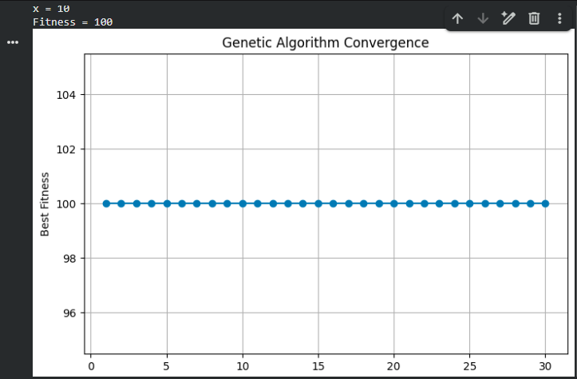

Result
The Genetic Algorithm was successfully implemented using population initialization, selection, crossover, and mutation. The algorithm evolved the population toward the optimal solution. For the function f(x)=x(20−x), the best solution is x = 10 with a fitness of 100. The experiment demonstrates that population size, mutation rate, crossover rate, and number of generations significantly influence convergence speed and solution quality.

RUBRICS FOR CALCULATION

Criteria | Weightage | Level 4 – Exemplary (5 Marks) | Level 3 – Proficient (4 Marks) | Level 2 – Developing (2–3 Marks) | Level 1 – Beginning (0–1 Mark)
Conceptual Understanding | 30 | Demonstrates clear and complete understanding of the concept | Good understanding with minor gaps | Basic understanding with some misconceptions | Poor or incorrect understanding
Accuracy of Answer | 20 | Completely correct answer with no errors | Mostly correct with minor errors | Partially correct with noticeable errors | Incorrect or irrelevant answer
Application of Knowledge | 15 | Correctly applies concepts to solve the question/problem | Applies concepts with minor mistakes | Limited or partially correct application | No or incorrect application
Completeness of Response | 20 | Covers all required parts of the question | Covers most parts with minor omissions | Covers only some parts | Incomplete or missing response
Clarity & Presentation | 15 | Clear, concise, and well-organized answer | Understandable with minor issues | Somewhat unclear or poorly structured | Difficult to understand

