SIMATS ENGINEERING (SAVEETHA SCHOOL OF ENGINEERING) Department of Computer Science and Engineering
ASSESSMENT TOOL 1 – EXPERIMENTS
Course Code: | CSA06 | Course Title: | Design and Analysis of Algorithms
CO Assessed: | CO3: Articulation  (BL4, BL5) | Assessment: | Assessment Tool 1 – Experiments
 |  | Total Marks: | 100
CO3 Statement: | Design Divide and Conquer algorithms for Merge Sort, Quick Sort, Binary Search and Matrix Multiplication
Student Name: | P.Hemika | Reg. No.: | 192424259
Section / Batch: |  | Date:
Instructions to Students
• Answer the following question. Total Marks: 100.
• Write the algorithm and execute the code for the given experiment.
• Follow a well-structured, systematic approach to design and implement an optimal solution. • Provide insightful analysis with accurate validation, supported by clear documentation including diagrams, code, and results.

Question Type | Focus Area | Questions
Experiments | Design and Code for Divide and Conquer Algorithms: Merge Sort, Quick Sort, Binary Search, and Matrix Multiplication | Q1

SECTION A – Experiments

Evaluate Quick Sort performance in multi-core systems by distributing partitions across processors. Record execution time and compare with single-threaded execution. Analyze parallel speedup. Interpret results and justify the scalability of Quick Sort in parallel environments.

Program:
import random
import time
from concurrent.futures import ProcessPoolExecutor, as_completed
from os import cpu_count

def quick_sort_single(arr):
if len(arr) <= 1:
return arr
pivot = arr[len(arr) // 2]
left = [x for x in arr if x < pivot]
middle = [x for x in arr if x == pivot]
right = [x for x in arr if x > pivot]
return quick_sort_single(left) + middle + quick_sort_single(right)

def quick_sort_parallel(arr, depth=0, max_depth=2):
if len(arr) <= 1:
return arr

pivot = arr[len(arr) // 2]
left = [x for x in arr if x < pivot]
middle = [x for x in arr if x == pivot]
right = [x for x in arr if x > pivot]

if depth < max_depth:
with ProcessPoolExecutor(max_workers=2) as ex:
f_left = ex.submit(quick_sort_parallel, left, depth + 1, max_depth)
f_right = ex.submit(quick_sort_parallel, right, depth + 1, max_depth)
sorted_left = f_left.result()
sorted_right = f_right.result()
else:
sorted_left = quick_sort_single(left)
sorted_right = quick_sort_single(right)

return sorted_left + middle + sorted_right

def main():
data_size = 100000
data = [random.randint(0, 1000000) for _ in range(data_size)]

print(f"Number of CPU cores: {cpu_count()}")
print(f"Dataset size: {data_size}\n")

# Single-threaded
t0 = time.time()
sorted_single = quick_sort_single(data.copy())
single_time = time.time() - t0
print(f"Single-threaded Quick Sort Time: {single_time:.4f} seconds")

# Parallel (multi-core)
t0 = time.time()
sorted_parallel = quick_sort_parallel(data.copy(), max_depth=2)
parallel_time = time.time() - t0
print(f"Parallel Quick Sort Time: {parallel_time:.4f} seconds")

# Correctness
print(f"\nSorted correctly: {sorted_single == sorted_parallel}")

# Speedup
if parallel_time > 0:
speedup = single_time / parallel_time
print(f"Parallel Speedup: {speedup:.2f}x")

# Interpretation line (simple)
if parallel_time < single_time:
print("\nParallel version is faster due to concurrent partition sorting on multiple cores.")
else:
print("\nParallel version is not faster; overhead/process management may outweigh parallel benefits.")

if __name__ == "__main__":
main()

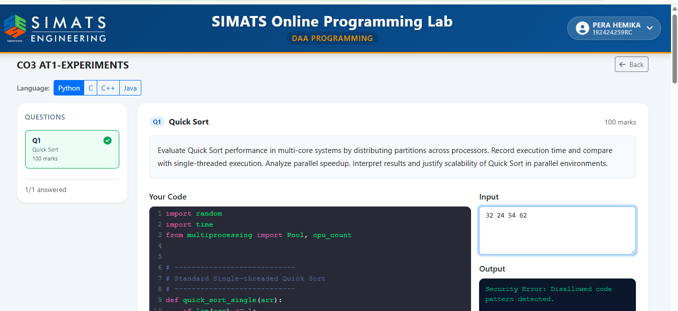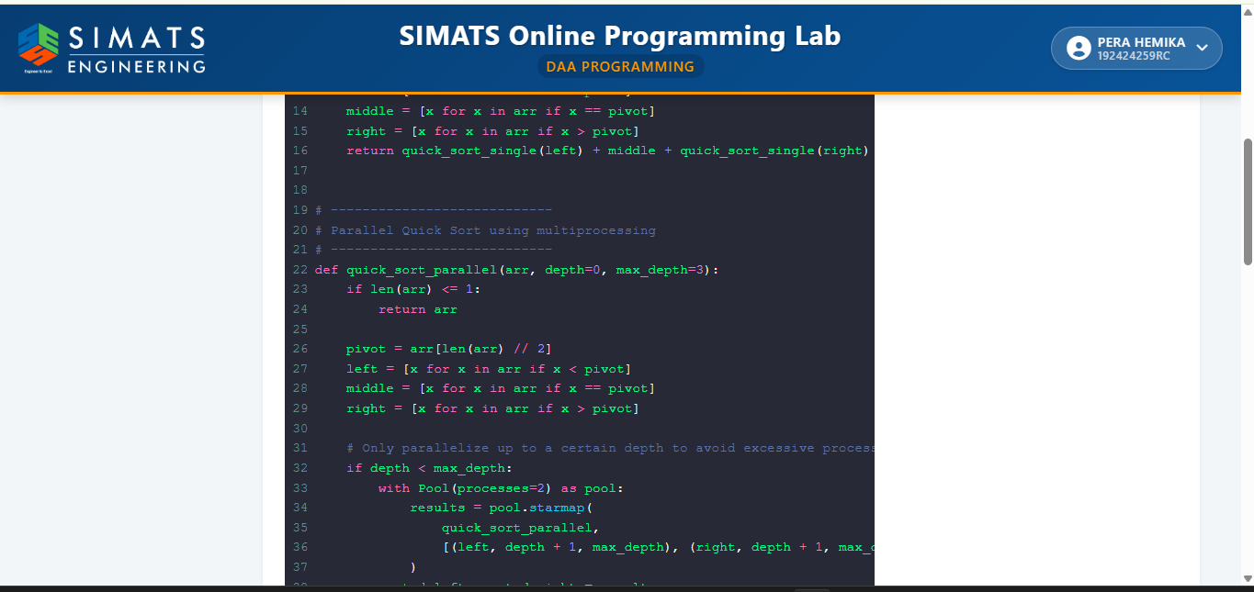

Code of Conduct
I _P.Hemika(192424259) certify that this submission is my original work and that I have adhered to the guidelines specified for this assessment. I understand that any violation of academic integrity rules will result in disciplinary action.
Signature of the Student: _________________________

RUBRICS FOR CALCULATION
Experiments
Criteria | Weightage | Level 4 –  Exemplary | Level 3 –  Proficient | Level 2 –  Developing | Level 1 –  Beginning
Understa  nding of  Concepts | 25% | Demonstrates thorough understanding and  effectively integrates  multiple  concepts/technologies | Good  understanding  with proper  integration of  most concepts | Basic  understanding;  limited or partial  integration | Poor  understanding  ; unable to  integrate  concepts
Experime  ntal  Design | 30% | Well-planned,  systematic  implementation with  optimal solution | Correct  implementatio  n with minor  issues | Basic  implementation  with errors or  inefficiencies | Incorrect or  incomplete  implementatio  n
Use of  Tools | 20% | Effective and advanced use of  tools/technologies with proper configuration | Appropriate  use of tools  with correct  execution | Limited or  inconsistent use  of tools | Incorrect or  minimal use  of tools
Analysis  of  Results | 15% | Insightful analysis with accurate interpretation and validation of results | Good analysis  with  reasonable  interpretation | Basic analysis  with limited  insights | Poor or incorrect analysis of results
Documen  tation | 10% | Clear, well-structured  documentation with  diagrams, code, and  results | Organized  documentation  with necessary  details | Basic  documentation  with missing  details | Poor or  incomplete  documentatio  n

Marks Evaluation:
Criteria | Wt. | Level 4 –  Exemplary | Level 3 –  Proficient | Level 2 –  Developing | Level 1 –  Beginning
Understanding of Concepts | 25%
Experimental Design | 30%
Use of Tools | 20%
Analysis of Results | 15%
Documentation | 10%
Total Marks (100):

Faculty In-charge | Course Coordinator | Head of Department
Name: | Name: | Name:
Signature: _______________ | Signature: _______________ | Signature: _______________
Date: ___________________ | Date: ___________________ | Date: ___________________

