**CERTIFICATE**

*This is to certify that Mr./Ms.* ***….... Hemil…Chovatiya.............*** *with enrolment no.* ***..........200303108003.................*** *has successfully completed* ***his****/her laboratory experiments in the* ***Computer Organization & Architecture Lab(203105254)*** *from the department of* ***........Information Technology(4ITA1)….….........*** *during the academic year* ***........2021-2022.........***



Date of Submission: ......................... Staff In charge: ...........................

Head of Department: ...........................................

|  |  |  |  |  |  |  |  |
| --- | --- | --- | --- | --- | --- | --- | --- |
| **Sr. No** | **Experiment Title** | **Page No** | | **Date of Performance** | **Date of Assessment** | **Marks (out of 10)** | **Sign** |
| **From** | **To** |
| 1 | Write the working of 8085 simulator GNUsim8085 and basic architecture of 8085 along with small introduction. |  |  |  |  |  |  |
| 2 | Study the complete instruction set of 8085 and write the instructions in the instruction set of 8085 along with examples. |  |  |  |  |  |  |
| 3 | Write an assembly language code in GNUsim8085 to implement Addition of two 8bit Numbers. |  |  |  |  |  |  |
| 4 | Write an assembly language code in GNUsim8085 to implement Addition of two 16 bit Numbers. |  |  |  |  |  |  |
| 5 | Write an assembly language code in GNUsim8085 to implement Multiplication of two 8bit Numbers. |  |  |  |  |  |  |
| 6 | Write an assembly language code in GNUsim8085 to implement Division  of two 8bit Numbers. |  |  |  |  |  |  |
| 7 | Write an assembly language code in GNUsim8085 to add two 8 bit numbers stored in memory and also storing the carry. |  |  |  |  |  |  |
| 8 | Write an assembly language code in GNUsim8085 to store numbers in reverse order in memory location. |  |  |  |  |  |  |

# INDEX

**PRACTICAL 1**

**Aim: Write the working of 8085 simulator GNUsim8085 and basic architecture of 8085 along with small introduction.**

* **8085 Microprocessor Architecture**

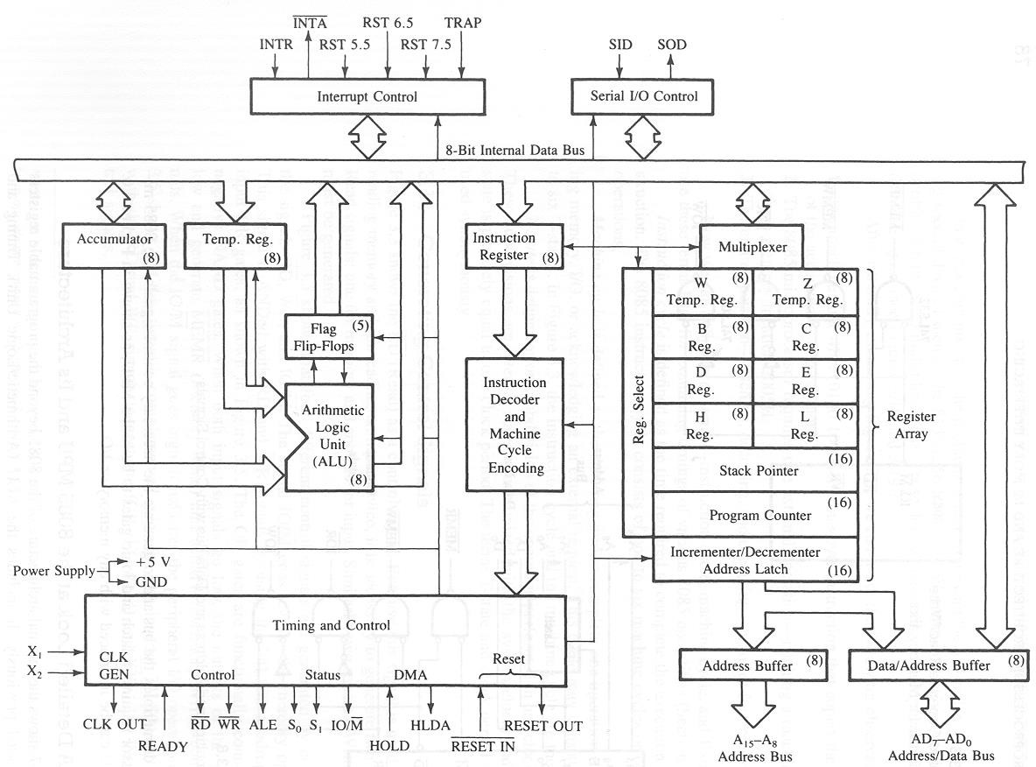

* The architecture of the 8085 microprocessor mainly includes the timing & control unit, Arithmetic and logic unit, [decoder,](https://www.elprocus.com/designing-3-line-to-8-line-decoder-demultiplexer/) instruction register, interrupt control, a register array, serial input/output control.
* The most important part of the microprocessor is the central processing unit.
* **The 8085 Bus Structure**

The 8-bit 8085 CPU (or MPU – Micro Processing Unit) communicates with the other units using a 16-bit address bus, an 8-bit data bus and a control bus.

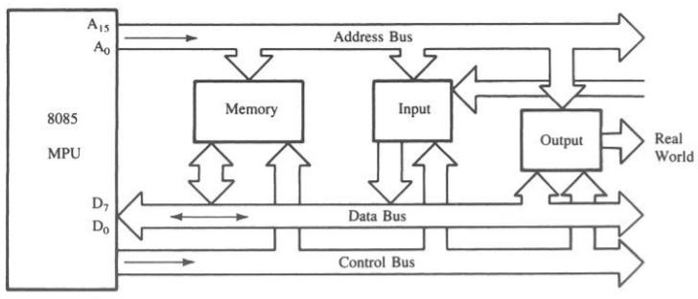

* + **Address Bus**
    - Consists of 16 address lines: A0 – A15
    - Operates in unidirectional mode: The address bits are always sent from the MPU to peripheral devices, not reverse.
    - 16 address lines are capable of addressing a total of 216 = 65,536 (64k) memory locations.
    - Address locations: 0000 (hex) – FFFF (hex)
  + **Data Bus**
    - Consists of 8 data lines: D0 – D7
    - Operates in bidirectional mode: The data bits are sent from the MPU to peripheral devices, as well as from the peripheral devices to the MPU.
    - Data range: 00 (hex) – FF (hex)
  + **Control Bus**
    - Consists of various lines carrying the control signals such as read / write enable, flag bits.
* **The 8085: CPU Internal Structure**
* The internal architecture of the 8085 CPU is capable of performing the following operations: Store 8-bit data (Registers, Accumulator).
* Perform arithmetic and logic operations (ALU)
* Test for conditions (IF / THEN)
* Sequence the execution of instructions
* Store temporary data in RAM during execution

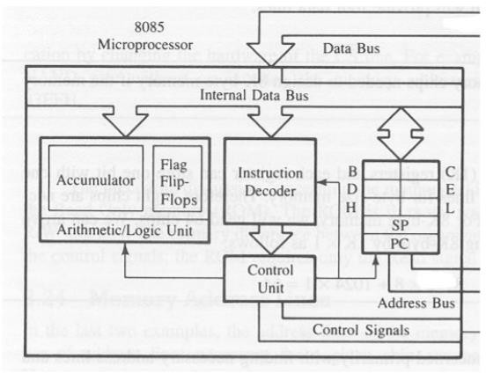

* + **The 8085: Registers**

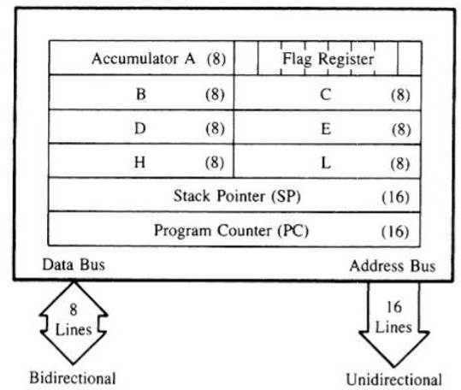

* + - Six general purpose 8-bit registers: B, C, D, E, H, L
    - They can also be combined as register pairs to perform 16-bit operations: BC, DE, HL
    - Registers are programmable (data load, move, etc.)
  + **Accumulator**
    - Single 8-bit register that is part of the ALU !
    - Used for arithmetic / logic operations – the result is always stored in the accumulator.
  + **Flag Bits**
    - Indicate the result of condition tests.
    - Carry, Zero, Sign, Parity, etc.
    - Conditional operations (IF / THEN) are executed based on the condition of these flag bits.
  + **Program Counter (PC)**
    - Contains the memory address (16 bits) of the instruction that will be executed in the next step.
  + **Stack Pointer (SP)**
    - Stack pointer is a special purpose 16-bit register in the Microprocessor, which holds the address of the top of the stack.
* **Example: Memory Read Operation**

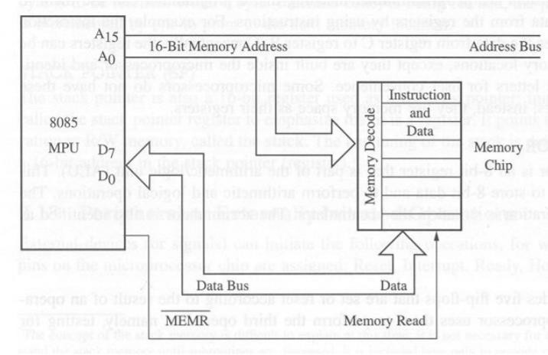

* **Example: Instruction Fetch Operation**
  + All instructions (program steps) are stored in memory.
  + To run a program, the individual instructions must be read from the memory in sequence, and executed.
  + Program counter puts the 16-bit memory address of the instruction on the address bus
  + Control unit sends the Memory Read Enable signal to access the memory
  + The 8-bit instruction stored in memory is placed on the data bus and transferred to the instruction decoder
  + Instruction is decoded and executed

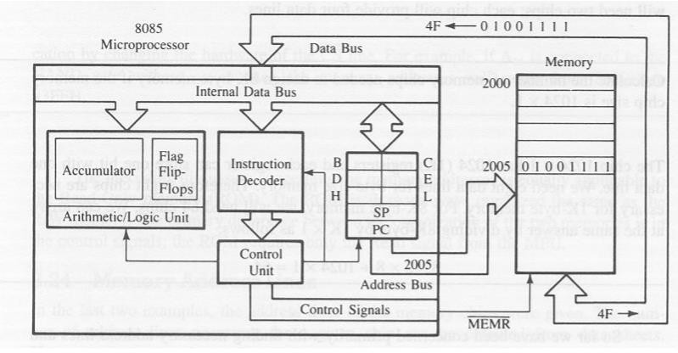

**PRACTICAL 2**

**Aim: Study the complete instruction set of 8085 and write the instructions with the instruction set along with examples**

**Instruction Set of 8085**

* An instruction is a binary pattern designed inside a microprocessor to perform a specific function.
* The entire group of instructions that a microprocessor supports is called Instruction Set.
* 8085 has 246 instructions.
* Each instruction is represented by an 8-bit binary value.
* These 8-bits of binary value are called Op-Code or Instruction Byte.

**Classification of Instruction Set**

* Data Transfer Instruction
* Arithmetic Instructions
* Logical Instructions
* Branching Instructions
* Control Instructions

**Data Transfer Instructions**

* These instructions move data between registers, or between memory and registers.
* These instructions copy data from source to destination.
* While copying, the contents of source are not modified.

**Data Transfer Instructions**

|  |  |  |
| --- | --- | --- |
| Opcode | Operand | Description |
| MOV | Rd, Rs  Rd, M M,  Rs | Copy from source  to destination. |

* This instruction copies the contents of the source register into the destination register. The contents of the source register are not altered.
* If one of the operands is a memory location, its location is specified by the contents of the HL registers.
* Example: MOV B, C
* MOV B, M
* MOV M, C

|  |  |  |
| --- | --- | --- |
| Opcode | Operand | Description |
| MVI | Rd, Data M, Data | Move immediate 8-bit |

* The 8-bit data is stored in the destination register or memory.
* If the operand is a memory location, its location is specified by the contents of the H-L registers. Example: MVI A, 57H
* MVI M, 57H

|  |  |  |
| --- | --- | --- |
| Opcode | Operand | Description |
| LXI | Reg. pair, 16-bit data | Load register pair immediate |

* This instruction loads 16-bit data in the register pair.
* Example: LXI H, 2034 H

|  |  |  |
| --- | --- | --- |
| Opcode | Operand | Description |
| LDA | 16-bit address | Load Accumulator |

* The contents of a memory location, specified by a 16- bit address in the operand, are copied to the accumulator.
* The contents of the source are not altered.
* Example: LDA 2034H

|  |  |  |
| --- | --- | --- |
| Opcode | Operand | Description |
| LDAX | B/D Register Pair | Load accumulator indirect |

* The contents of the designated register pair point to a memory location.
* This instruction copies the contents of that memory location into the accumulator.
* The contents of either the register pair or the memory location are not altered.
* Example: LDAX B

|  |  |  |
| --- | --- | --- |
| Opcode | Operand | Description |
| LHLD | 16-bit address | Load H-L registers direct |

* This instruction copies the contents of memory location pointed out by 16-bit address into register L.
* It copies the contents of the next memory location into register H.
* Example: LHLD 2040 H

|  |  |  |
| --- | --- | --- |
| Opcode | Operand | Description |
| STA | 16-bit address | Store accumulator direct |

* The contents of the accumulator are copied into the memory location specified by the operand.
* Example: STA 2500 H

|  |  |  |
| --- | --- | --- |
| Opcode | Operand | Description |
| STAX | Reg. pair | Store accumulator indirect |

* The contents of the accumulator are copied into the memory location specified by the contents of the register pair.
* Example: STAX B

|  |  |  |
| --- | --- | --- |
| Opcode | Operand | Description |
| SHLD | 16-bit address | Store H-L registers direct |

* The contents of register L are stored into memory location specified by the 16-bit address.
* The contents of register H are stored into the next memory location.
* Example: SHLD 2550 H

|  |  |  |
| --- | --- | --- |
| Opcode | Operand | Description |
| XCHG | None | Exchange H-L with D-E |

* The contents of register H are exchanged with the contents of register D.
* The contents of register L are exchanged with the contents of register E.
* Example: XCHG

**Arithmetic Instructions**

These instructions perform the operations like:

* Addition
* Subtract
* Increment
* Decrement

|  |  |  |
| --- | --- | --- |
| Opcode | Operand | Description |
| ADD | R M | Add register or memory to accumulator |

* The contents of the register or memory are added to the contents of the accumulator.
* The result is stored in the accumulator.
* If the operand is memory location, its address is specified by H-L pair.
* All flags are modified to reflect the result of the addition.
* Example: ADD B or ADD M

|  |  |  |
| --- | --- | --- |
| Opcode | Operand | Description |
| ADC | R M | Add register or memory to accumulator with carry |

* The contents of register or memory and Carry Flag (CY) are added to the contents of the accumulator.
* The result is stored in the accumulator.
* If the operand is memory location, its address is specified by H-L pair.
* All flags are modified to reflect the result of the addition.
* Example: ADC B or ADC M

|  |  |  |
| --- | --- | --- |
| Opcode | Operand | Description |
| ADI | 8-bit data | Add immediate to accumulator |

* The 8-bit data is added to the contents of the accumulator.
* The result is stored in the accumulator.
* All flags are modified to reflect the result of the addition.
* Example: ADI 45 H

|  |  |  |
| --- | --- | --- |
| Opcode | Operand | Description |
| ACI | 8-bit data | Add immediate to accumulator with carry |

* The 8-bit data and the Carry Flag (CY) are added to the contents of the accumulator.
* The result is stored in the accumulator.
* All flags are modified to reflect the result of the addition.
* Example: ACI 45 H

|  |  |  |
| --- | --- | --- |
| Opcode | Operand | Description |
| DAD | Reg. pair | Add register pair to H-L pair |

* The 16-bit contents of the register pair are added to the contents of the H-L pair.
* The result is stored in H-L pair.
* If the result is larger than 16 bits, then CY is set.
* No other flags are changed.
* Example: DAD B

|  |  |  |
| --- | --- | --- |
| Opcode | Operand | Description |
| SUB | R M | Subtract register or memory from accumulator |

* The contents of the register or memory location are subtracted from the contents of the accumulator.
* The result is stored in the accumulator.
* If the operand is memory location, its address is specified by H-L pair.
* All flags are modified to reflect the result of subtraction.
* Example: SUB B or SUB M

|  |  |  |
| --- | --- | --- |
| Opcode | Operand | Description |
| SUI | 8-bit data | Subtract immediate from accumulator |

* The 8-bit data is subtracted from the contents of the
* accumulator.
* The result is stored in the accumulator.
* All flags are modified to reflect the result of subtraction.
* Example: SUI 45 H

|  |  |  |
| --- | --- | --- |
| Opcode | Operand | Description |
| SBI | 8-bit data | Subtract immediate from accumulator with  borrow |

* The 8-bit data and the Borrow Flag (i.e. CY) is subtracted from the contents of the accumulator.
* The result is stored in the accumulator.
* All flags are modified to reflect the result of subtraction.
* Example: SBI 45 H

|  |  |  |
| --- | --- | --- |
| Opcode | Operand | Description |
| INR | R  M | Increment register or memory by 1 |

* The contents of register or memory location are incremented by 1.
* The result is stored in the same place.
* If the operand is a memory location, its address is specified by the contents of H-L pair.
* Example: INR B or INR M

|  |  |  |
| --- | --- | --- |
| Opcode | Operand | Description |
| INX | R | Increment register pair by 1 |

* The contents of the register pair are incremented by 1.
* The result is stored in the same place.
* Example: INX H

|  |  |  |
| --- | --- | --- |
| Opcode | Operand | Description |
| DCR | R  M | Decrement register or memory by 1 |

* The contents of register or memory location are decremented by 1.
* The result is stored in the same place.
* If the operand is a memory location, its address is specified by the contents of H-L pair.
* Example: DCR B or DCR M

**Logical Instructions**

* These instructions perform logical operations on data stored in registers, memory and status flags.

The logical operations are:

* AND
* OR
* XOR
* ROTATE
* COMPARE
* COMPLEMENT

|  |  |  |
| --- | --- | --- |
| Opcode | Operand | Description |
| CMP | R M | Compare register or memory with accumulator |

* The contents of the operand (register or memory) are compared with the contents of the accumulator.
* Both contents are preserved .
* The result of the comparison is shown by setting the flags of the PSW as follows:
* if (A) < (reg/mem): carry flag is set
* if (A) = (reg/mem): zero flag is set
* if (A) > (reg/mem): carry and zero flags are reset.
* Example: CMP B or CMP M

|  |  |  |
| --- | --- | --- |
| Opcode | Operand | Description |
| CPI | 8-bit data | Compare immediate with accumulator |

* The 8-bit data is compared with the contents of the accumulator.
* The values being compared remain unchanged.
* The result of the comparison is shown by setting the flags of the PSW as follows:
* if (A) < data: carry flag is set
* if (A) = data: zero flag is set
* if (A) > data: carry and zero flags are reset
* Example: CPI 89H

|  |  |  |
| --- | --- | --- |
| Opcode | Operand | Description |
| ANA | R M | Logical AND register or memory with accumulator |

* The contents of the accumulator are logically ANDed with the contents of register or memory.
* The result is placed in the accumulator.
* If the operand is a memory location, its address is specified by the contents of H-L pair.
* S, Z, P are modified to reflect the result of the operation.
* CY is reset and AC is set.
* Example: ANA B or ANA M.

|  |  |  |
| --- | --- | --- |
| Opcode | Operand | Description |
| ANI | 8-bit data | Logical AND immediate with accumulator |

* The contents of the accumulator are logically ANDed with the 8-bit data.
* The result is placed in the accumulator.
* S, Z, P are modified to reflect the result.
* CY is reset, AC is set.
* Example: ANI 86H.

|  |  |  |
| --- | --- | --- |
| Opcode | Operand | Description |
| XRA | R M | Exclusive OR register or memory with accumulator |

* The contents of the accumulator are XORed with the contents of the register or memory.
* The result is placed in the accumulator.
* If the operand is a memory location, its address is specified by the contents of H-L pair.
* S, Z, P are modified to reflect the result of the operation.
* CY and AC are reset.
* Example: XRA B or XRA M.

|  |  |  |
| --- | --- | --- |
| Opcode | Operand | Description |
| ORA | R M | Logical OR register or memory with accumulator |

* The contents of the accumulator are logically ORed with the contents of the register or
* memory.
* The result is placed in the accumulator.
* If the operand is a memory location, its address is specified by the contents of H-L pair.
* S, Z, P are modified to reflect the result, CY and AC are reset.
* Example: ORA B or ORA M.

|  |  |  |
| --- | --- | --- |
| Opcode | Operand | Description |
| ORI | 8-bit data | Logical OR immediate with accumulator |

* The contents of the accumulator are logically ORed with the 8-
* bit data.
* The result is placed in the accumulator.
* S, Z, P are modified to reflect the result.
* CY and AC are reset.
* Example: ORI 86H.

|  |  |  |
| --- | --- | --- |
| Opcode | Operand | Description |
| XRA | R M | Logical XOR register or memory with accumulator |

* The contents of the accumulator are XORed with the contents of the register or memory.
* The result is placed in the accumulator.
* If the operand is a memory location, its address is specified by the contents of H-L pair.
* S, Z, P are modified to reflect the result of the operation.
* CY and AC are reset.
* Example: XRA B or XRA M.

**Branching Instructions**

* The branching instruction alter the normal sequential flow.
* These instructions alter either unconditionally or conditionally.

|  |  |  |
| --- | --- | --- |
| Opcode | Operand | Description |
| JMP | 16-bit address | Jump unconditionally |

* The program sequence is transferred to the memory location specified by the 16-bit address given in the operand.
* Example: JMP 2034 H.

|  |  |  |
| --- | --- | --- |
| Opcode | Operand | Description |
| Jx | 16-bit address | Jump conditionally |

* The program sequence is transferred to the memory location specified by the 16-bit address given in the operand based on the specified flag of the PSW.
* Example: JZ 2034 H.

**Jump Conditionally**

|  |  |  |
| --- | --- | --- |
| Opcode | Operand | Description |
| JC | Jump if Carry | CY = 1 |
| JNC | Jump if No Carry | CY = 0 |
| JP | Jump if Positive | S = 0 |
| JM | Jump if Minus | S = 1 |
| JZ | Jump if Zero | Z = 1 |
| JNZ | Jump if No Zero | Z = 0 |
| JPE | Jump if Parity Even | P = 1 |
| JPO | Jump if Parity Odd | P = 0 |

|  |  |  |
| --- | --- | --- |
| Opcode | Operand | Description |
| CALL | 16-bit address | Call unconditionally |

* The program sequence is transferred to the memory location specified by the 16-bit address given in the operand.
* Before the transfer, the address of the next instruction after CALL (the contents of the program counter) is pushed onto the stack.
* Example: CALL 2034 H.

|  |  |  |
| --- | --- | --- |
| Opcode | Operand | Description |
| Cx | 16-bit address | Call unconditionally |

* The program sequence is transferred to the memory location specified by the 16-bit address given in the operand based on the specified flag of the PSW.
* Before the transfer, the address of the next instruction after the call (the contents of the program counter) is pushed onto the stack.
* Example: CZ 2034 H.

**Call Conditionally**

|  |  |  |
| --- | --- | --- |
| Opcode | Operand | Description |
| CC | Call if Carry | CY = 1 |
| CNC | Call if No Carry | CY = 0 |
| CP | Call if Positive | S = 0 |
| CM | Call if Minus | S = 1 |
| CZ | Call if Zero | Z = 1 |
| CNZ | Call if No Zero | Z = 0 |
| CPE | Call if Parity Even | P =1 |
| CPO | Call if Parity Odd | P = 0 |
| Opcode | Operand | Description |
| RET | None | Return unconditionally |

* The program sequence is transferred from the subroutine to the calling program.
* The two bytes from the top of the stack are copied into the program counter, and program execution begins at the new address.
* Example: RET.

|  |  |  |
| --- | --- | --- |
| Opcode | Operand | Description |
| Rx | None | Call conditionally |

* The program sequence is transferred from the subroutine to the calling program based on the specified flag of the PSW.
* The two bytes from the top of the stack are copied into the program counter, and program execution begins at the new address.
* Example: RZ.

**Return Conditionally**

|  |  |  |
| --- | --- | --- |
| Opcode | Operand | Description |
| RC | Return if Carry | CY = 1 |
| RNC | Return if No Carry | CY = 0 |
| RP | Return if Positive | S = 0 |
| RM | Return if Minus | S = 1 |
| RZ | Return if Zero | Z = 1 |
| RNZ | Return if No Zero | Z = 0 |
| RPE | Return if Parity Even | P =1 |
| RPO | Return if Parity Odd | P = 0 |

|  |  |  |
| --- | --- | --- |
| Opcode | Operand | Description |
| RST | 0-7 | Restart (Software Interrupts) |

* The RST instruction jumps the control to one of eight memory locations depending upon the number.
* These are used as software instructions in a program to transfer program execution to one of the eight locations.
* Example: RST 3.

**Restart Address Table**

|  |  |
| --- | --- |
| Instructions | Restart Address |
| RST 0 | 0000 H |
| RST 1 | 0008 H |
| RST 2 | 0010 H |
| RST 3 | 0018 H |
| RST 4 | 0020 H |
| RST 5 | 0028 H |
| RST 6 | 0030 H |
| RST 7 | 0038 H |

**Control Instructions**

|  |  |  |
| --- | --- | --- |
| Opcode | Operand | Description |
| NOP | None | No operation |

* No operation is performed.
* The instruction is fetched and decoded but no operation is executed.
* Example: NOP

|  |  |  |
| --- | --- | --- |
| Opcode | Operand | Description |
| HLT | None | Halt |

* The CPU finishes executing the current instruction and halts any further execution.
* An interrupt or reset is necessary to exit from the halt state.
* Example: HLT

|  |  |  |
| --- | --- | --- |
| Opcode | Operand | Description |
| DI | None | Disable interrupt |

* The interrupt enable flip-flop is reset and all the interrupts except the TRAP are disabled.
* No flags are affected.
* Example: DI

|  |  |  |
| --- | --- | --- |
| Opcode | Operand | Description |
| EI | None | Enable interrupt |

* The interrupt enable flip-flop is set and all interrupts are enabled.
* No flags are affected.
* This instruction is necessary to re-enable the interrupts (except TRAP).
* Example: EI

|  |  |  |
| --- | --- | --- |
| Opcode | Operand | Description |
| RIM | None | Read interrupt mask |

* This is a multipurpose instruction used to read the status of interrupts 7.5, 6.5, 5.5 and read serial data input bit.
* The instruction loads eight bits in the accumulator with the following interpretations.
* Example: RIM

**PRACTICAL 3**

### **AIM: Write an assembly language code in GNUsim8085 to implement Addition of two 8 bit Numbers.**

**Theory:**

|  |  |
| --- | --- |
| Code | Meaning |
| LDA 0001 | Load value of memory location 0001 in Accumulator A |
| MOV B,A | Move data from memory to accumulator |
| STA 0003 | Store accumulator contents in memory |
| ADD B | Add data of memory with accumulator |
| HLT | Hold the program |

### **Implementation:**

**Input:**

0001 = 30

0002 = 20

**Output:**

0003 = 50

**PRACTICAL 4**

**AIM: Write an assembly language code in GNUsim8085 to implement Addition of two 16-bit Numbers.**

**Theory:**

|  |  |
| --- | --- |
| Code | Meaning |
| LDA 2011 | Load value of memory location 0001 in Accumulator A |
| MOV B, A | Move data from memory to accumulator |
| STA 0003 | Store accumulator contents in memory |
| JNC L1 | Jump if no carry CY = 0 |
| INR C | Increment register or memory by 1 |
| ADC B | Add register or memory to accumulator with carry |
| ADD B | Add data of memory with accumulator |
| HLT | Hold the program |

**IMPLEMENTATION:**

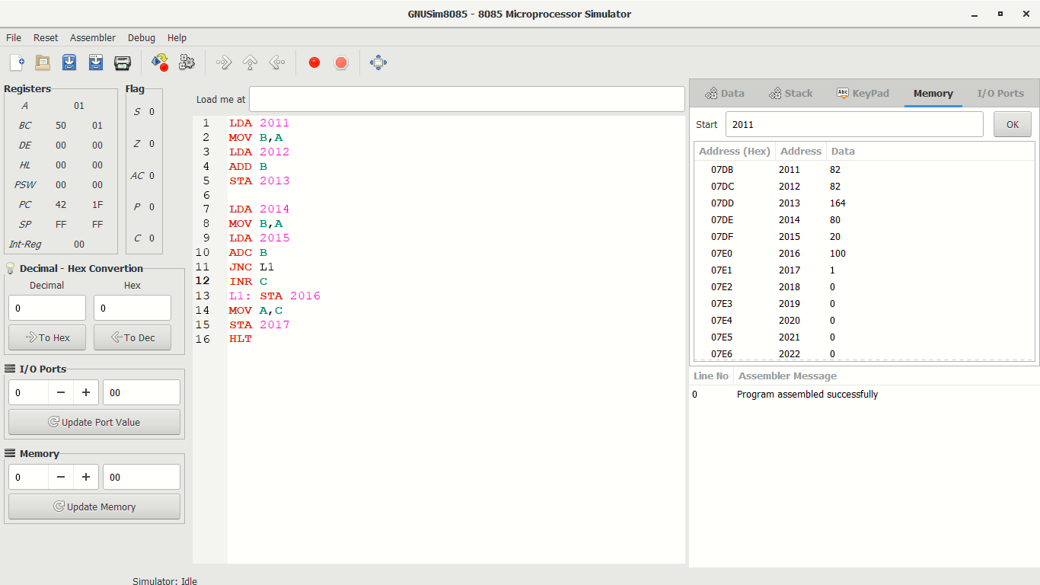

**INPUT:**  2011=82

2012=82

2014=80

2015=20

**OUTPUT:** 2013=164

2016=100

2017=2

**PRACTICAL 5**

**AIM: Write an assembly language code in GNUsim8085 to implement Subtraction of two 8bit Numbers.**

**THEORY**

|  |  |
| --- | --- |
| **Code** | **Meaning** |
| LDA 2052 | Load value of memory location 2011 in Accumulator A |
| MOV B, A | Move data from memory to accumulator |
| STA 2053 | Store accumulator contents in memory |
| SUB B | Subtract register or memory from accumulator |
| HLT | Hold the program |

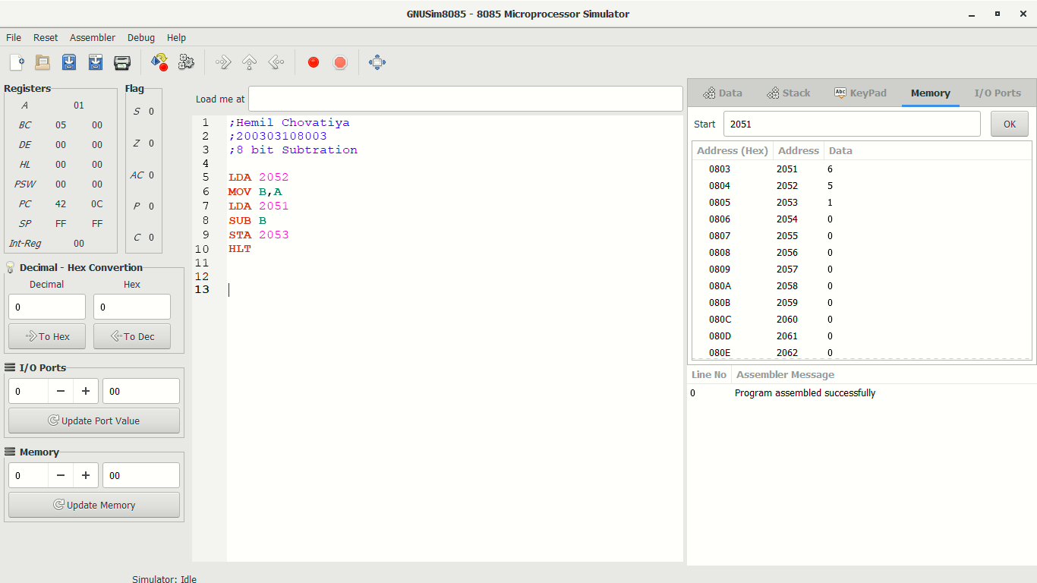**Implementation:**

**Input:**

2051 = 6

2052 = 5

**Output:**

2053 = 1

**PRACTICAL 6**

**AIM: Write an assembly language code in GNUsim8085 to implement Subtraction of two 16bit Numbers.**

**THEORY**

|  |  |
| --- | --- |
| **Code** | **Meaning** |
| LDA 2052 | Load value of memory location 2011 in Accumulator A |
| MOV B, A | Move data from memory to accumulator |
| STA 2053 | Store accumulator contents in memory |
| SUB B | Subtract register or memory from accumulator |
| HLT | Hold the program |
| MVI A,00 | 8-bit data is stored in the destination register or memory. (Move immediate 8-bit) |
| LHLD | Load H-L registers direct |

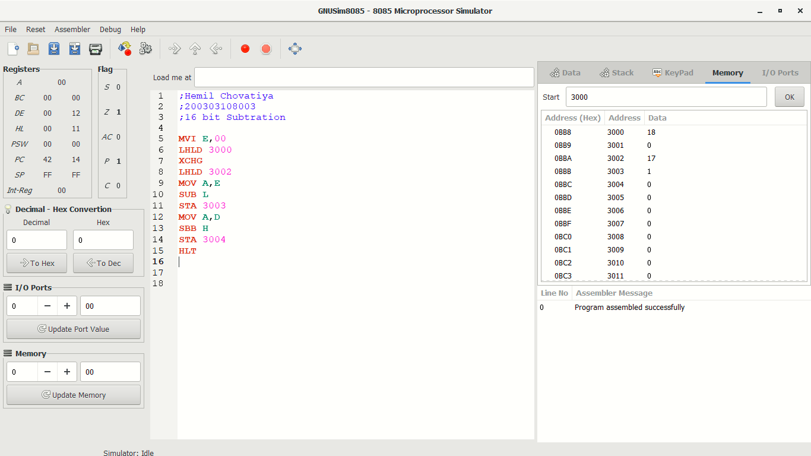**Implementation:**

**Input:**

3000 = 18

3002 = 17

**Output:**

3003 = 1

3004 = 0

**PRACTICAL 7**

**AIM: Write an assembly language code in GNUsim8085 to implement Multiplication of two 8bit Numbers.**

**THEORY**

|  |  |
| --- | --- |
| **Code** | **Meaning** |
| LDA 2011 | Load value of memory location 2011 in Accumulator A |
| MOV B, A | Move data from memory to accumulator |
| STA 2013 | Store accumulator contents in memory |
| MVI A,00 | 8-bit data is stored in the destination register or memory. (Move immediate 8-bit) |
| DCR D | Decrement register or memory by 1. |
| JNZ LOOP | Jump if No Zero (Z = 0) to LOOP |
| ADD B | Add data of memory with accumulator |
| HLT | Hold the program |

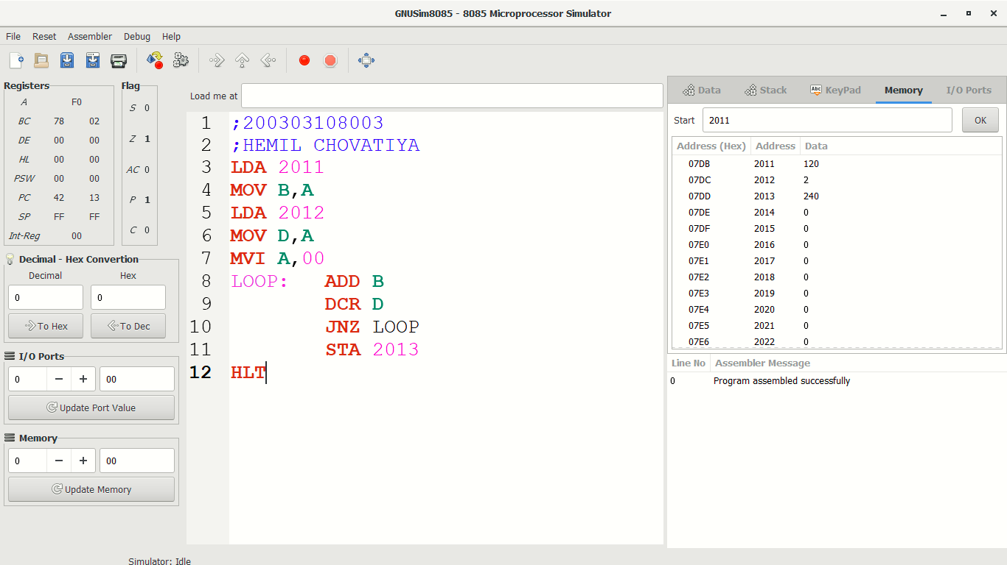**IMPLEMENTATION:**

**INPUT:** 2011 = 120

2012 = 2

**OUTPUT:** 2013 = 240

**PRACTICAL 8**

**AIM:** **Write an assembly language code in GNUsim8085 to implement Division of two 8bit Numbers**

**THEORY**

|  |  |
| --- | --- |
| **Code** | **Meaning** |
| LDA 2021 | Load value of memory location 2021 in Accumulator A |
| MOV B, A | Move data from memory to accumulator |
| MVI C,00 | 8-bit data is stored in the destination register or memory. (Move immediate 8-bit) |
| CMP B | Compare register or memory with accumulator |
| JC LOOP | Jump if Carry CY=1 |
| SUB B | Subtract register or memory from accumulator |
| INR C | Increment register or memory by 1 |
| JMP NEXT | Jump unconditionally (16 Bit Address) |
| HLT | Hold the program |

**IMPLEMENTATION:**

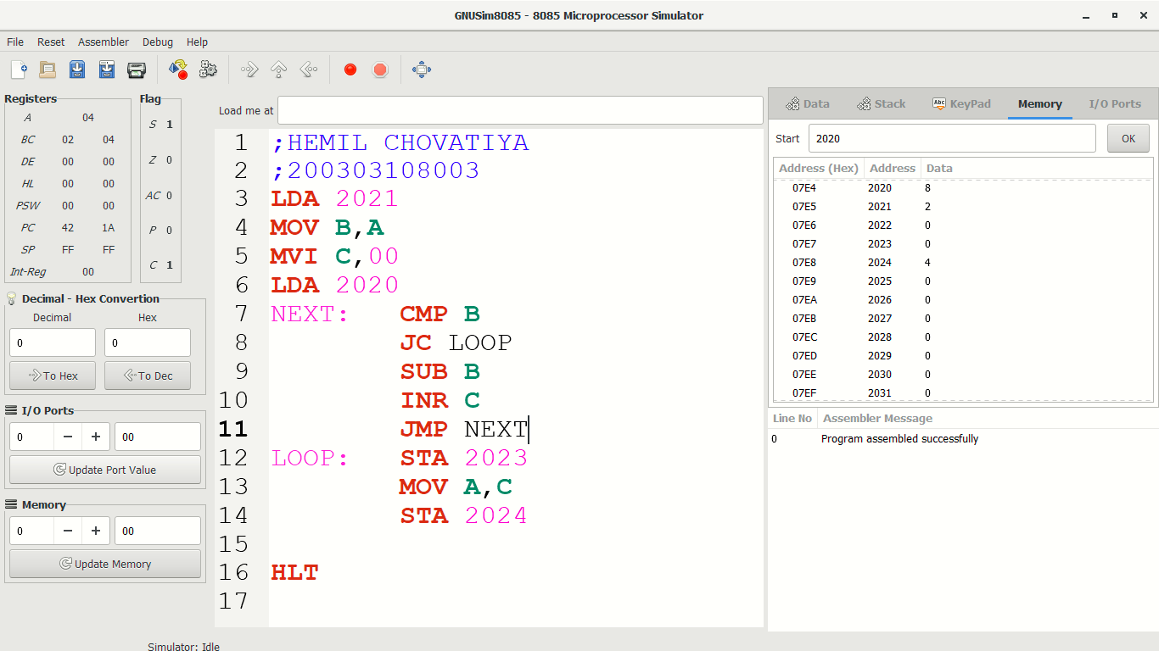

**INPUT:** 2020=8

2021=2

**OUTPUT:** 2023=0

2024=4

**PRACTICAL 9**

**AIM:** **Write an assembly language code in GNUsim8085 to smallest numbers stored in memory**

**THEORY**

|  |  |
| --- | --- |
| **Code** | **Meaning** |
| LDA 2001 | Load value of memory location 2001 in Accumulator A |
| MOV m, A | Move data from memory to accumulator |
| CMP B | Compare register or memory with accumulator |
| JC Lp1 | Jump if Carry CY=1 |
| JMP Lp2 | Jump unconditionally (16 Bit Address) |
| STA 2003 | Store accumulator direct(16 bit) |
| HLT | Hold the program |

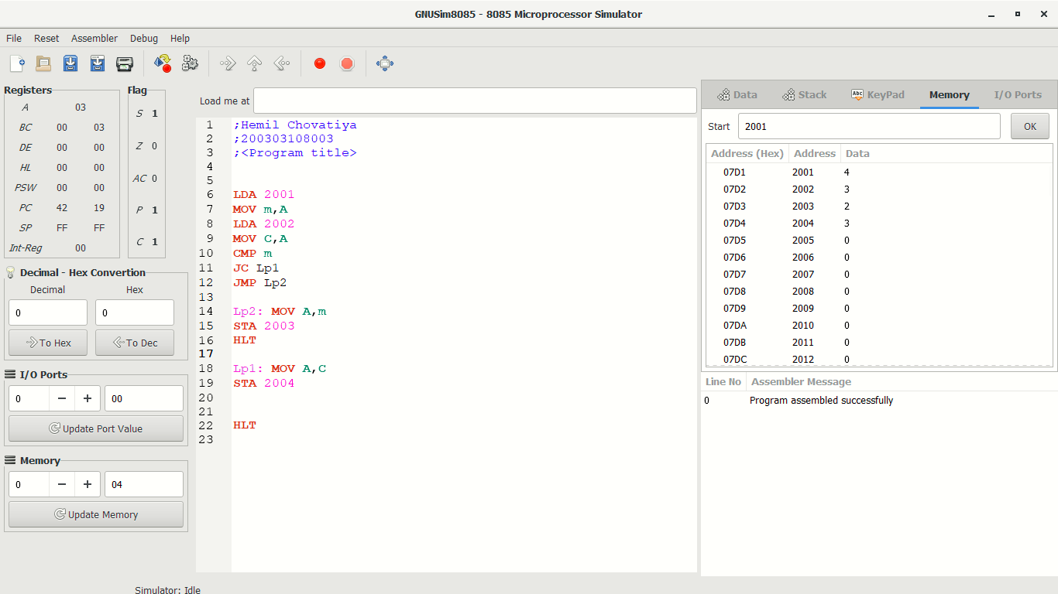**IMPLEMENTATION:**

**INPUT:** 2001=4

2002=3

2003=2

**OUTPUT:** 2024=3

**PRACTICAL 10**

**AIM:** **Write an assembly language code in GNUsim8085 to larger numbers stored in memory**

**THEORY**

|  |  |
| --- | --- |
| **Code** | **Meaning** |
| LDA 2001 | Load value of memory location 2001 in Accumulator A |
| MOV m, A | Move data from memory to accumulator |
| CMP B | Compare register or memory with accumulator |
| JC Lp1 | Jump if Carry CY=1 |
| JMP Lp2 | Jump unconditionally (16 Bit Address) |
| STA 2003 | Store accumulator direct(16 bit) |
| HLT | Hold the program |

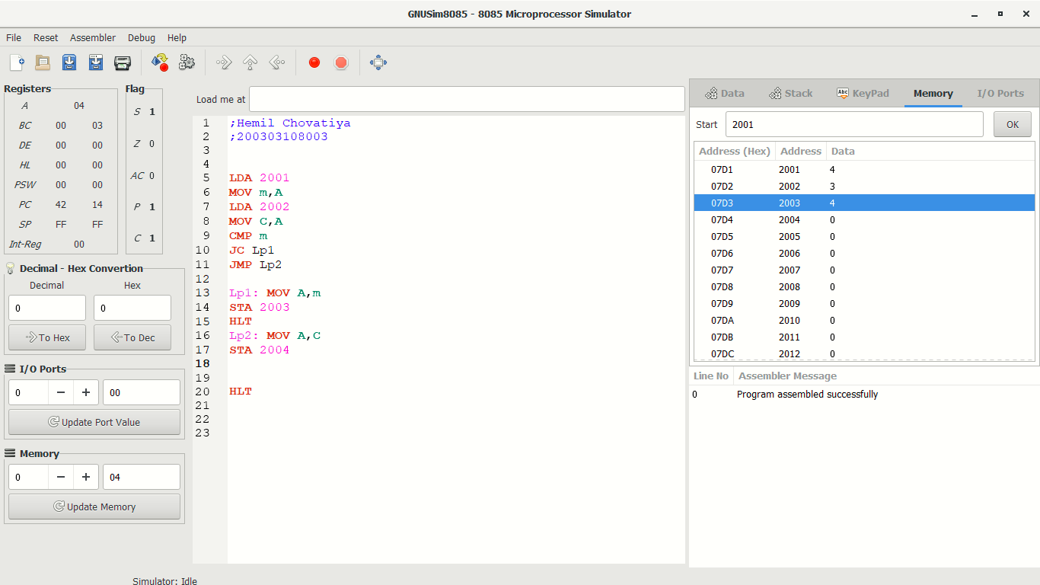**IMPLEMENTATION:**

**INPUT:** 2001=4

2002=3

**OUTPUT:** 2003=4

**PRACTICAL 11**

**AIM:** **Write an assembly language code in GNUsim8085 to smallest numbers among series stored in memory**

**THEORY**

|  |  |
| --- | --- |
| **Code** | **Meaning** |
| LXI H,2000 | Load register pair immediate |
| MOV B, M | Move data from memory to accumulator |
| INX H | register pair are incremented by 1 |
| DCR B | Decrement register or memory by 1 |
| CMP | Compare register or memory with accumulator |
| JC AHEAD | Jump if Carry CY=1 |
| JNZ LOOP | Jump if No Zero (Z = 0) to LOOP |
| STA 2009 | Store accumulator direct(16 bit) |
| HLT | Hold the program |

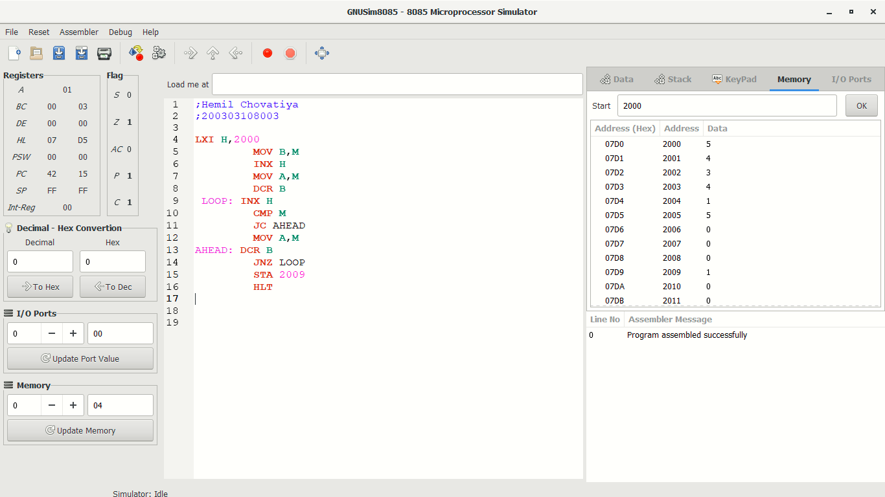**IMPLEMENTATION:**

**INPUT:** 2000=5

2001=4

2002=3

2003=4

2004=1

2005=5

**OUTPUT:** 2009=1

**PRACTICAL 12**

**AIM:** **Write an assembly language code in GNUsim8085 to Largest numbers among series stored in memory**

**THEORY**

|  |  |
| --- | --- |
| **Code** | **Meaning** |
| LXI H,2001 | Load register pair immediate |
| MOV C, A | Move data from memory to accumulator |
| MVI B,00 | Move immediate 8-bit |
| JMP SKIP | Jump unconditionally (16 Bit Address) |
| DCR C | Decrement register or memory by 1 |
| CMP B | Compare register or memory with accumulator |
| JNC SET | Jump if no carry CY = 0 |
| JNZ BACK | Jump if No Zero (Z = 0) to BACK |
| STA 2009 | Store accumulator direct(16 bit) |
| HLT | Hold the program |

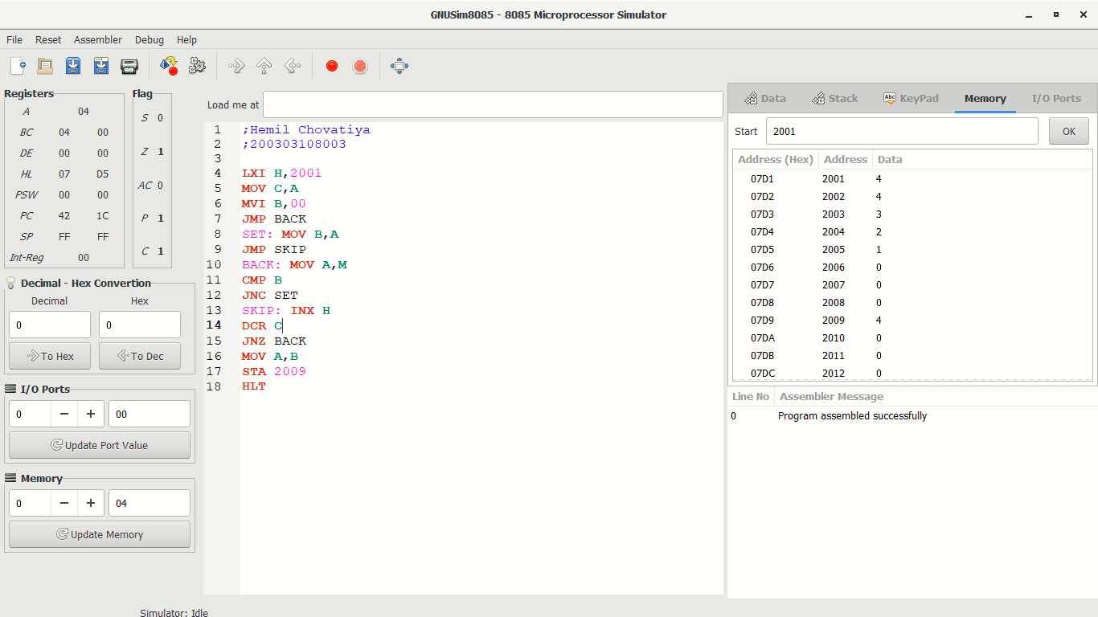**IMPLEMENTATION:**

**INPUT:** 2001=4

2002=4

2003=3

2004=2

2005=1

**OUTPUT:** 2009=4

**PRACTICAL 13**

**AIM:** **Write an assembly language code in GNUsim8085 to Addition of numbers of array stored in memory**

**THEORY**

|  |  |
| --- | --- |
| **Code** | **Meaning** |
| LXI H,2001 | Load register pair immediate |
| MOV C, A | Move data from memory to accumulator |
| MVI B,00 | Move immediate 8-bit |
| ADD M | Add register or memory to accumulator |
| INX H | Increment register pair by 1 |
| DCR C | Decrement register or memory by 1 |
| JNZ BACK | Jump if No Zero (Z = 0) to BACK |
| STA 2009 | Store accumulator direct(16 bit) |
| HLT | Hold the program |

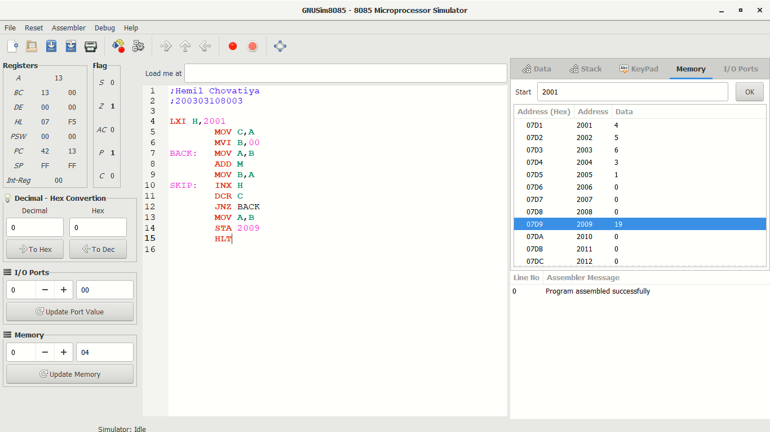**IMPLEMENTATION:**

**INPUT:** 2001=4

2002=5

2003=6

2004=3

2005=1

**OUTPUT:** 2009=19

**PRACTICAL 14**

**AIM:** **Write an assembly language code in GNUsim8085 to even numbers addition stored in memory**

**THEORY**

|  |  |
| --- | --- |
| **Code** | **Meaning** |
| LXI H,2001 | Load register pair immediate |
| MOV C, A | Move data from memory to accumulator |
| MVI B,00 | Move immediate 8-bit |
| ANI 01 | Logical AND immediate with accumulator (CY is reset, AC is set) |
| JNZ SKIP | Jump if No Zero (Z = 0) to SKIP |
| ADD M | Add register or memory to accumulator |
| INX H | Increment register pair by 1 |
| DCR C | Decrement register or memory by 1 |
| STA 2009 | Store accumulator direct(16 bit) |
| HLT | Hold the program |

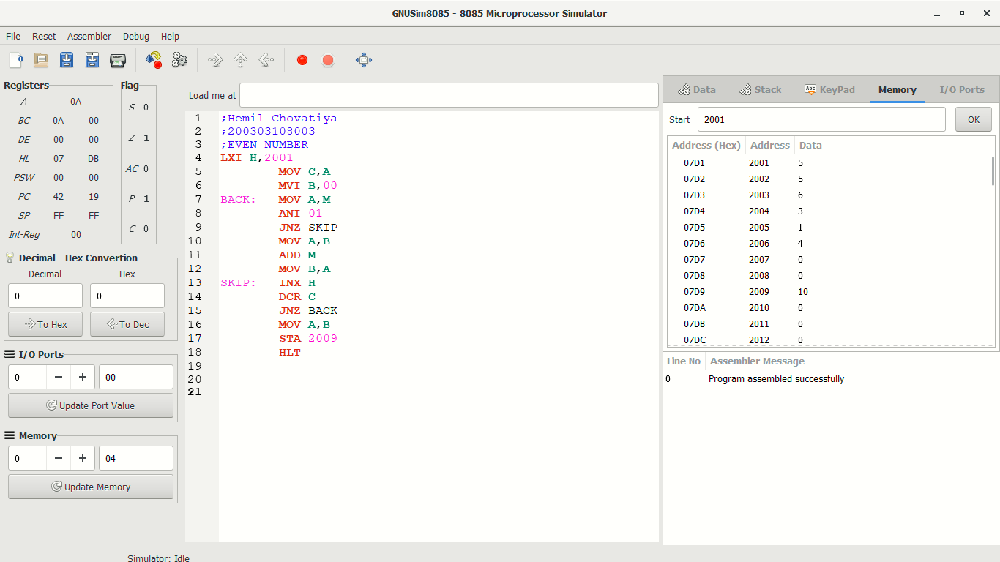**IMPLEMENTATION:**

**INPUT:** 2001=5

2002=5

2003=6

2004=3

2005=1

2006=4

**OUTPUT:** 2009=10

**PRACTICAL 15**

**AIM:** **Write an assembly language code in GNUsim8085 to Odd numbers addition stored in memory**

**THEORY**

|  |  |
| --- | --- |
| **Code** | **Meaning** |
| LXI H,2001 | Load register pair immediate |
| MOV C, A | Move data from memory to accumulator |
| MVI B,00 | Move immediate 8-bit |
| ANI 01 | Logical AND immediate with accumulator(CY is reset, AC is set) |
| JNZ SKIP | Jump if No Zero (Z = 0) to SKIP |
| ADD M | Add register or memory to accumulator |
| INX H | Increment register pair by 1 |
| DCR C | Decrement register or memory by 1 |
| STA 2009 | Store accumulator direct(16 bit) |
| HLT | Hold the program |

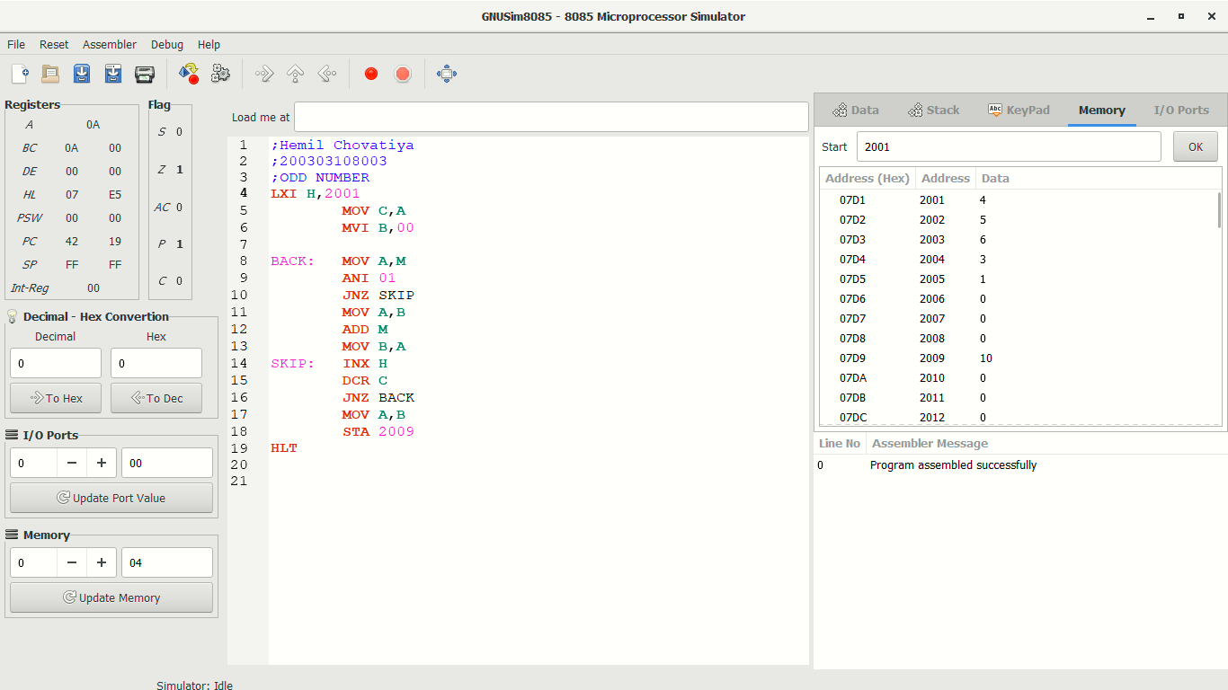**IMPLEMENTATION:**

**INPUT:** 2001=4

2002=5

2003=6

2004=3

2005=1

**OUTPUT:** 2009=10

**PRACTICAL 16**

**AIM:** **Write an assembly language code in GNUsim8085 to arranging numbers in ascending order stored in memory**

**THEORY**

|  |  |
| --- | --- |
| **Code** | **Meaning** |
| LXI H,2001 | Load register pair immediate |
| MOV C, M | Move data from memory to accumulator |
| DCR C | Decrement register or memory by 1 |
| INX H | Increment register pair by 1 |
| CMP M | Compare register or memory with accumulator |
| JC S1 | Jump if Carry CY=1 |
| DCX H | Decrement register pair by 1 |
| JNZ L | Jump if No Zero (Z = 0) to L |
| HLT | Hold the program |

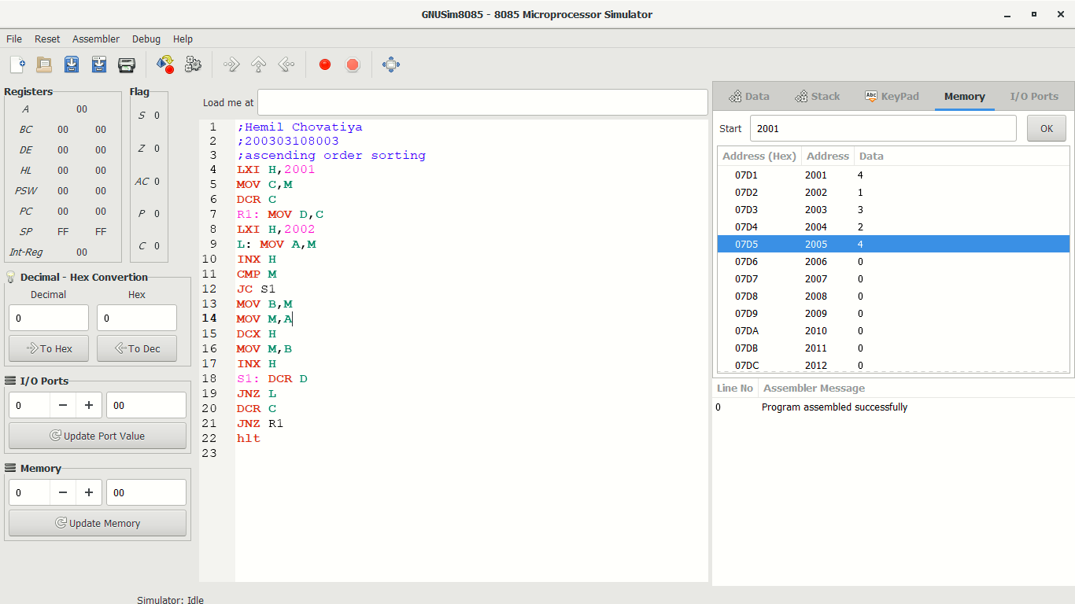**IMPLEMENTATION:**

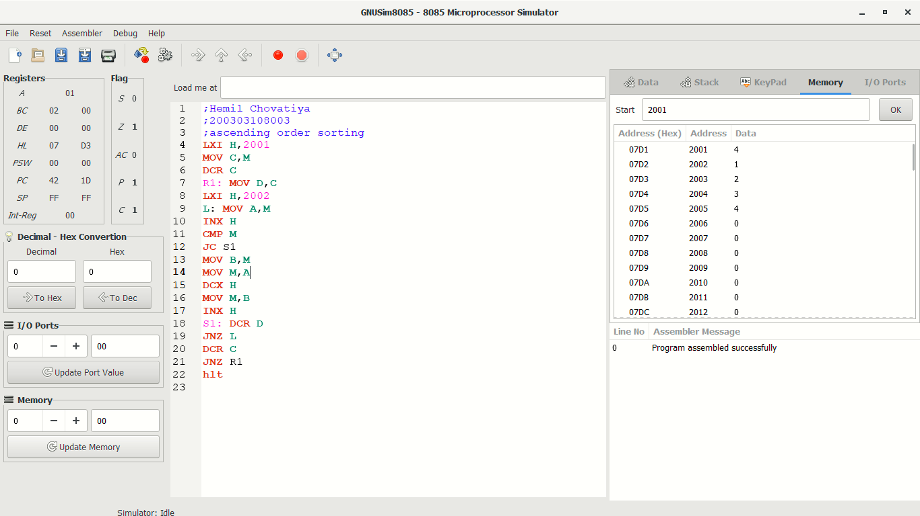

**INPUT:** **OUTPUT:**

2001=4 2001=4

2002=1 2002=1

2003=3 2003=2

2004=2 2004=3

2005=4 2004=4

**PRACTICAL 17**

**AIM:** **Write an assembly language code in GNUsim8085 to arranging numbers in descending order stored in memory**

**THEORY**

|  |  |
| --- | --- |
| **Code** | **Meaning** |
| LXI H,2001 | Load register pair immediate |
| MOV C, M | Move data from memory to accumulator |
| DCR C | Decrement register or memory by 1 |
| INX H | Increment register pair by 1 |
| CMP M | Compare register or memory with accumulator |
| JNC S1 | Jump if no carry CY = 0 |
| DCX H | Decrement register pair by 1 |
| JNZ L | Jump if No Zero (Z = 0) to L |
| HLT | Hold the program |

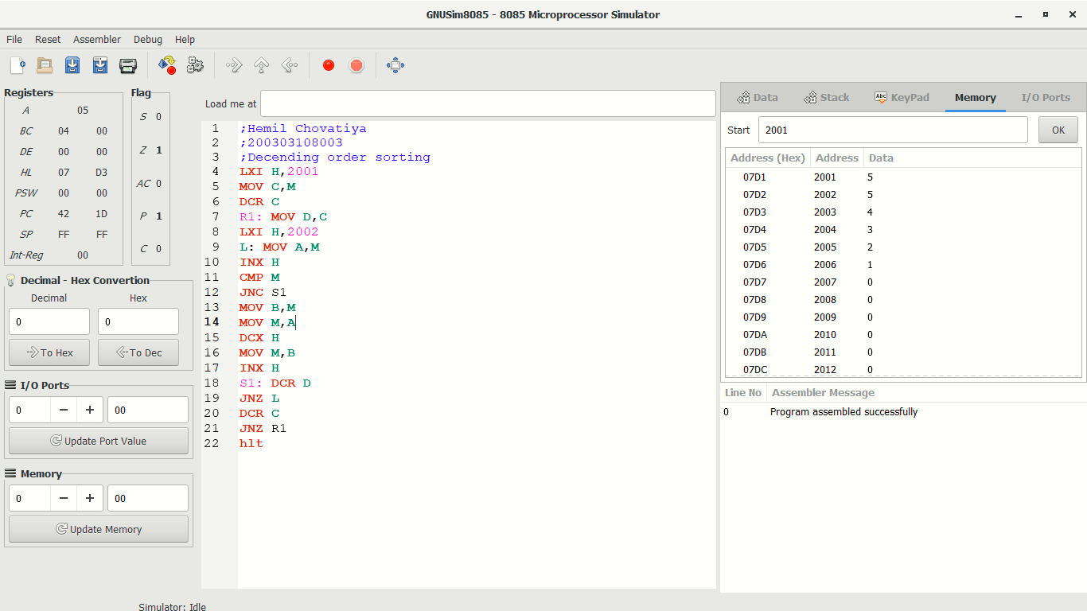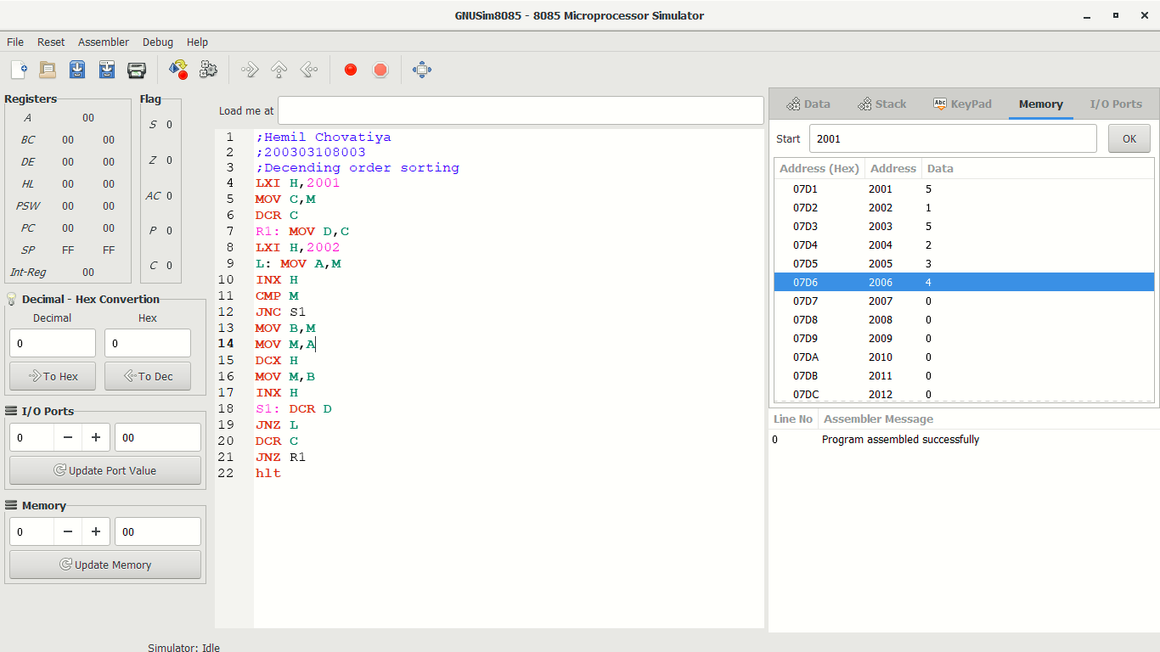**IMPLEMENTATION:**

**INPUT:** **OUTPUT:**

2001=5 2001=5

2002=1 2002=5

2003=5 2003=4

2004=2 2004=3

2005=3 2005=2

2006=4 2006=1

**PRACTICAL 18**

**AIM:** **Write an assembly language code in GNUsim8085 to convert BCD to binary stored in memory**

**THEORY**

|  |  |
| --- | --- |
| **Code** | **Meaning** |
| LDA 2000H | Load value of memory location 0001 in Accumulator A |
| MOV C, M | Move data from memory to accumulator |
| ANI 0fh | Logical AND immediate with accumulator(CY is reset, AC is set) |
| RRC | Rotate right accumulator(can rotate accumulator current content to right by 1-bit position) |
| MVI A,00 | 8-bit data is stored in the destination register or memory. (Move immediate 8-bit) |
| DCR B | Decrement register or memory by 1 |
| ADD D | Add register or memory to accumulator |
| JNZ S | Jump if No Zero (Z = 0) to S |
| HLT | Hold the program |

**IMPLEMENTATION:**

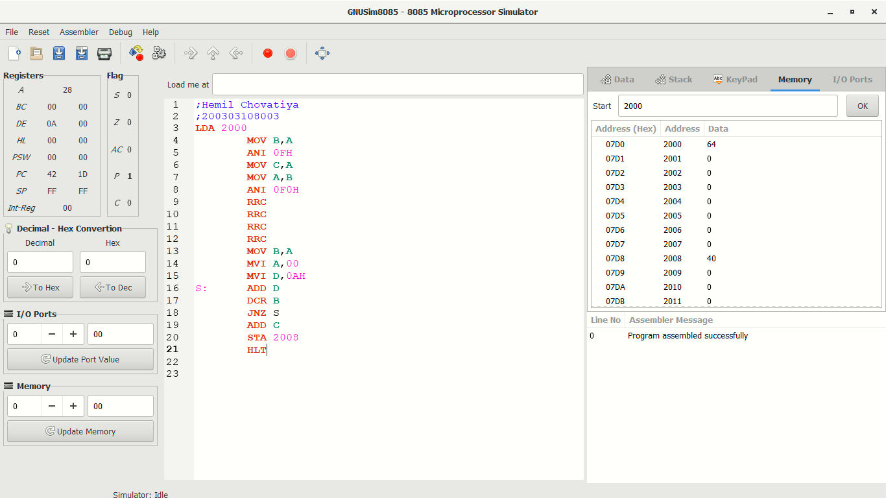

**INPUT:**

2000=64

**OUTPUT:**

2008=40