**CERTIFICATE**

*This is to certify that Mr./Ms.* ***….... Hemil…Chovatiya.............*** *with enrolment no.* ***..........200303108003.................*** *has successfully completed* ***his****/her laboratory experiments in the*  ***Design and Analysis of Algorithms***  *from the department of* ***........Information Technology(5ITA1)….….........*** *during the academic year* ***........2022-2023.........***



Date of Submission: ......................... Staff In charge: ...........................

Head of Department: ...........................................

**PRACTICAL-1**

**Aim:- Implementation and Time analysis of Bubble, Selection and Insertion sorting algorithms for best case, average case & worst case.**

1. **Bubble Sorting:-**

**Algorithm:**

1. begin BubbleSort(arr)
2. for all array elements
3. if arr[i] > arr[i+1]
4. swap(arr[i], arr[i+1])
5. end if
6. end for
7. return arr
8. end BubbleSort

**Code:-**

#include<stdio.h>

#include<conio.h>

int main(){

int n, temp, i, j, number[30];

printf("Enter number of elemnts:");

scanf("%d",&n);

printf("Enter %d numbers: ",n);

for(i=0;i<n;i++)

scanf("%d",&number[i]);

for(i=n-2;i>=0;i--){

for(j=0;j<=i;j++){

if(number[j]>number[j+1]){

temp=number[j];

number[j]=number[j+1];

number[j+1]=temp;

}} }

printf("Sorted elements: ");

for(i=0;i<n;i++)

printf(" %d",number[i]);

return 0;

}

**OUTPUT:Best Case:O(n)**

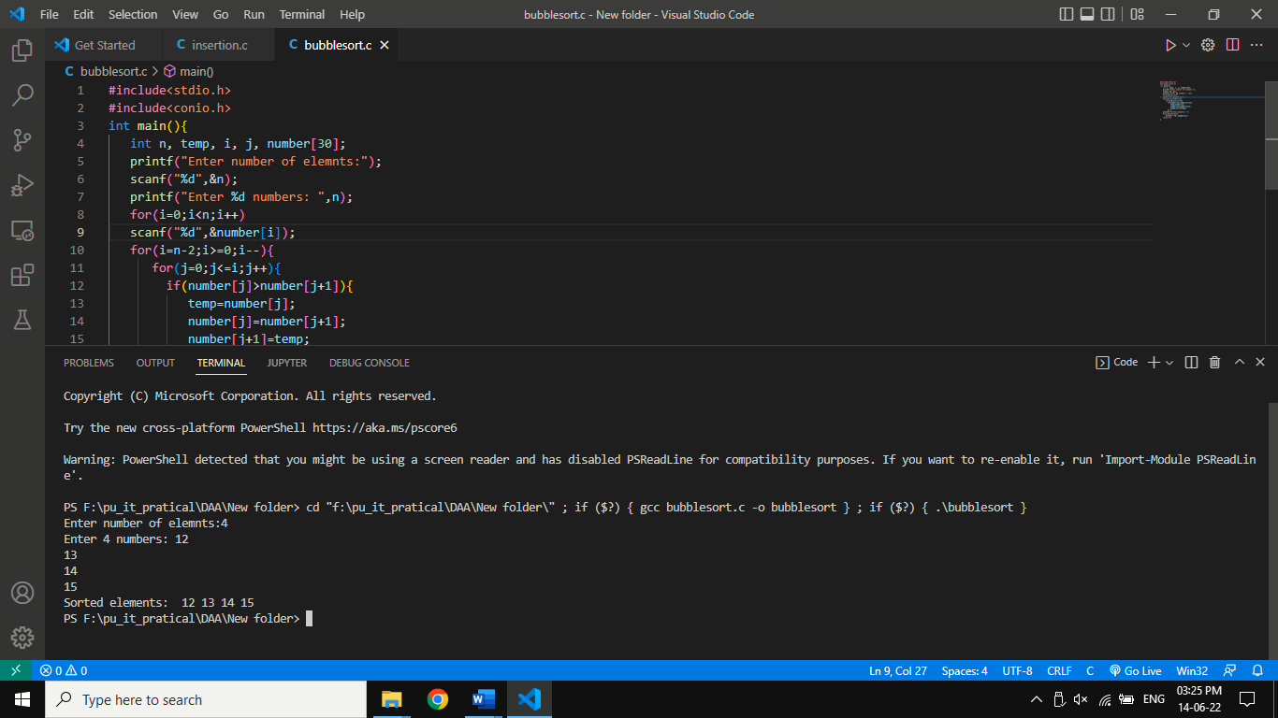

**Avg Case:O(n^2)**

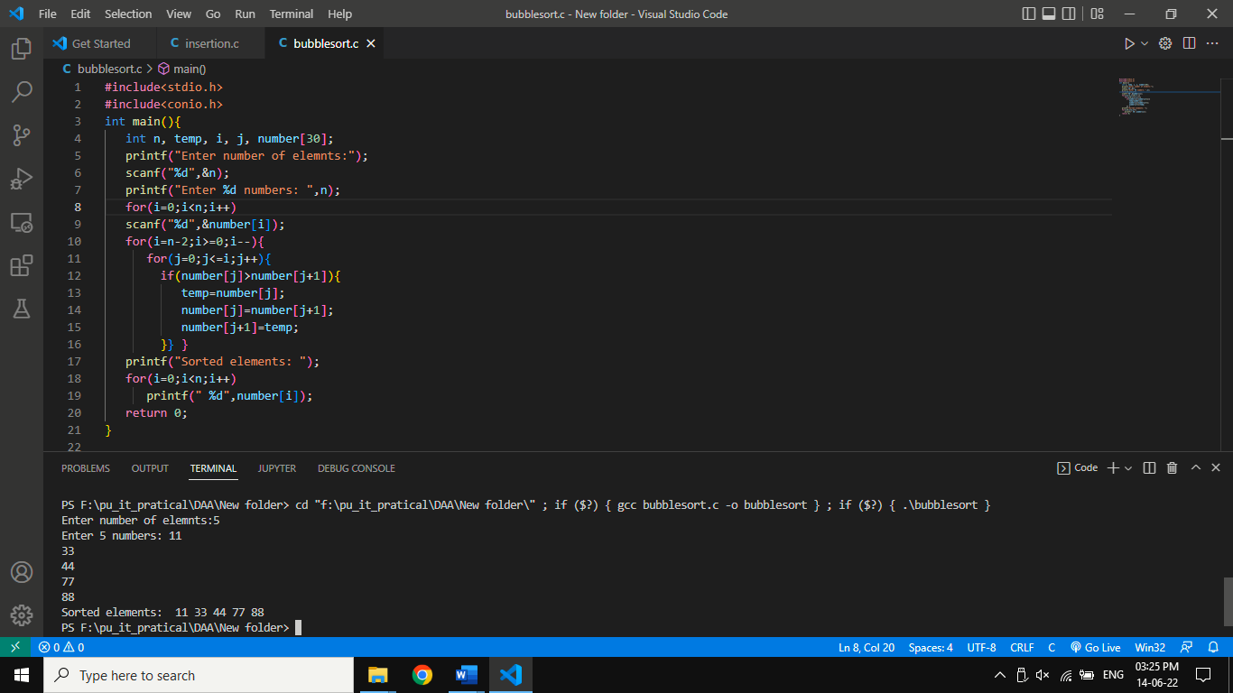

**Wrost Case:O(n^2)**

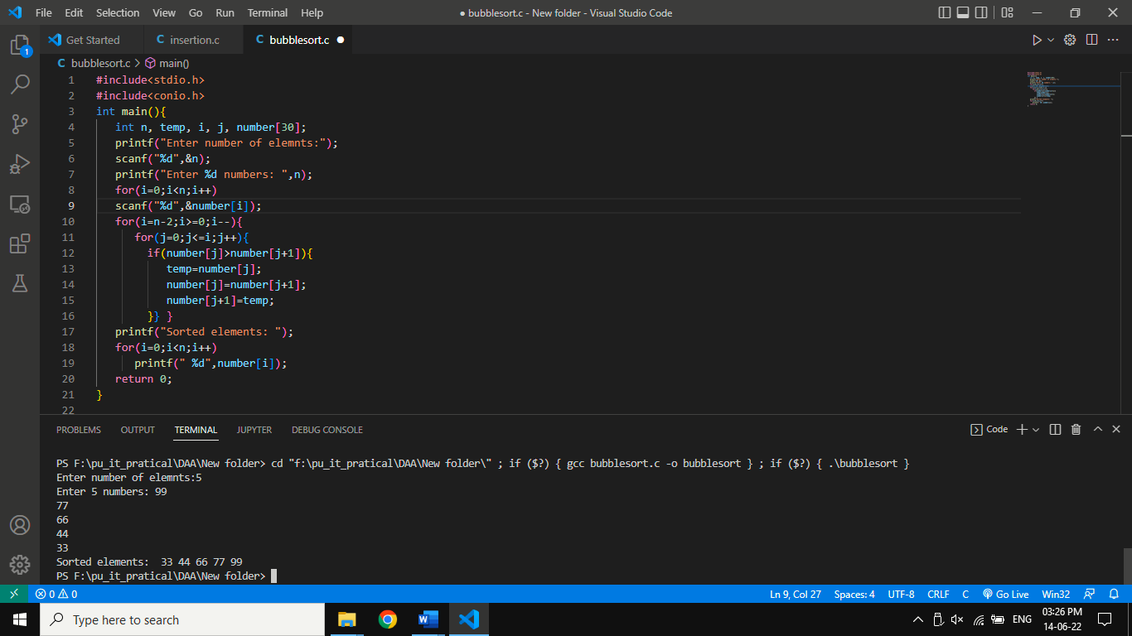

1. **Selection Sorting:-**

**Algorithm:**

1. SELECTION SORT(arr, n)
2. Step 1: Repeat Steps 2 and 3 for i = 0 to n-1
3. Step 2: CALL SMALLEST(arr, i, n, pos)
4. Step 3: SWAP arr[i] with arr[pos]
5. [END OF LOOP]
6. Step 4: EXIT
7. SMALLEST (arr, i, n, pos)
8. Step 1: [INITIALIZE] SET SMALL = arr[i]
9. Step 2: [INITIALIZE] SET pos = i
10. Step 3: Repeat for j = i+1 to n
11. if (SMALL > arr[j])
12. SET SMALL = arr[j]
13. SET pos = j
14. [END OF if]
15. [END OF LOOP]
16. Step 4: RETURN pos

**Code:-**

#include<stdio.h>

#include<conio.h>

int main()

{

int a[100], n, i, j, position, swap;

printf("enter the number of inputs:");

scanf("%d", &n);

printf("Enter %d Numbers:", n);

for (i = 0; i < n; i++)

scanf("%d", &a[i]);

for(i = 0; i < n - 1; i++)

{

position=i;

for(j = i + 1; j < n; j++)

{

if(a[position] > a[j])

position=j;

}

if(position != i)

{

swap=a[i];

a[i]=a[position];

a[position]=swap;

}

}

printf("Sorted Array:");

for(i = 0; i < n; i++)

printf("%d\n", a[i]);

return 0;

}

**OUTPUT: Best Case:(O(n^2))**

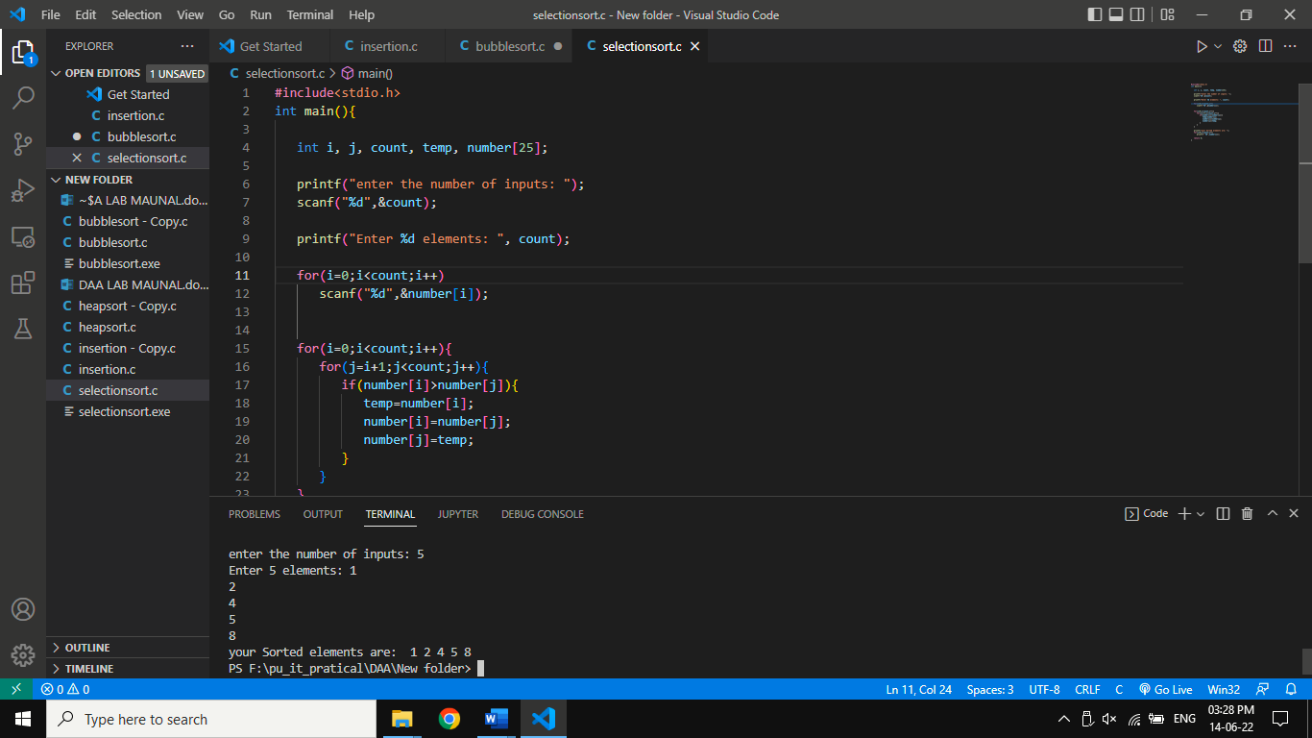

**Avg Case:O(n^2)**

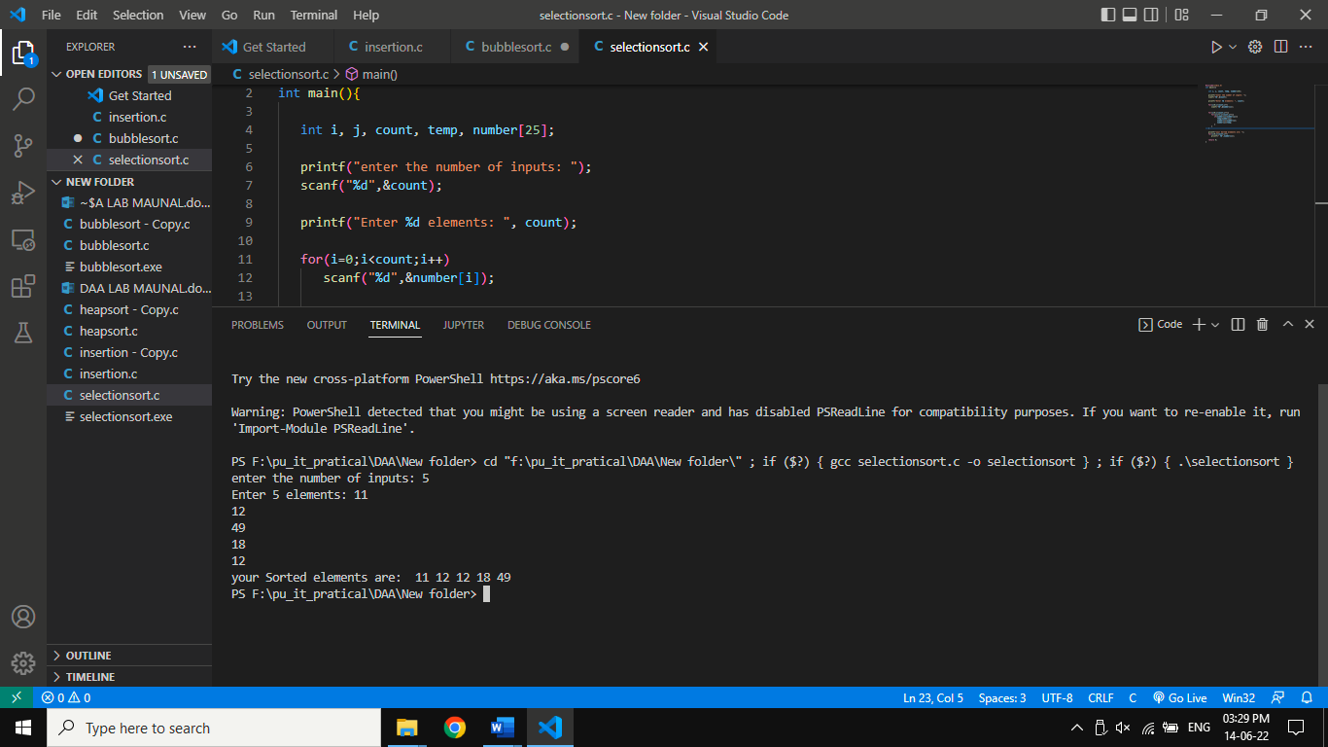

**Wrost Case:O(n^2)**

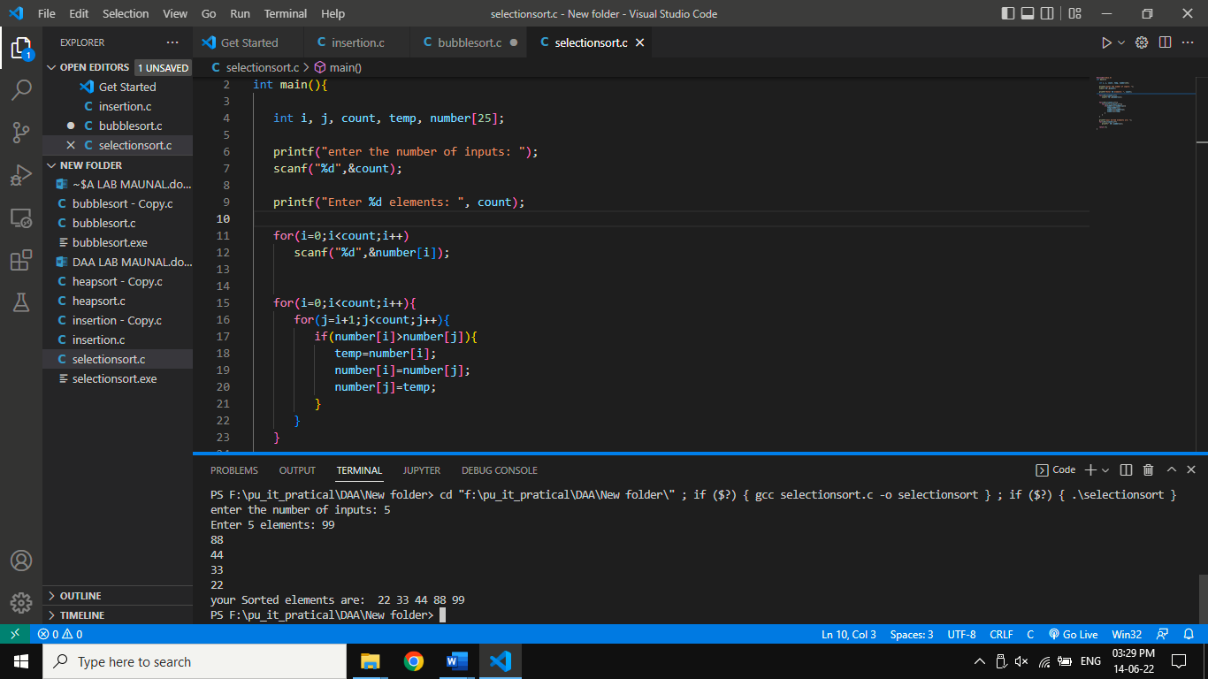

1. **Insertion Sorting:-**

**Algorithm:**

Step 1 - If the element is the first element, assume that it is already sorted. Return 1.

Step2 - Pick the next element, and store it separately in a key.

Step3 - Now, compare the key with all elements in the sorted array.

Step 4 - If the element in the sorted array is smaller than the current element, then move to the next element. Else, shift greater elements in the array towards the right.

Step 5 - Insert the value.

Step 6 - Repeat until the array is sorted.

**Code:-**

#include <math.h>

#include <stdio.h>

int main(){

int i, j, count, temp, number[25];

   printf("numbers of input: ");

   scanf("%d",&count);

   printf("Enter %d the numbers: ", count);

   for(i=0;i<count;i++)

      scanf("%d",&number[i]);

   for(i=1;i<count;i++)

   {

      temp=number[i];

      j=i-1;

      while((temp<number[j])&&(j>=0))

      {

         number[j+1]=number[j];

         j=j-1;

      }

      number[j+1]=temp;

   }

   printf("your insertion sorting is: ");

   for(i=0;i<count;i++)

      printf(" %d",number[i]);

   return 0;

}

**OUTPUT:Best Case:O(n)**

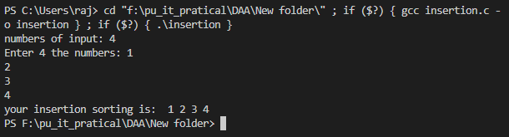

**Avg Case:O(n^2)**

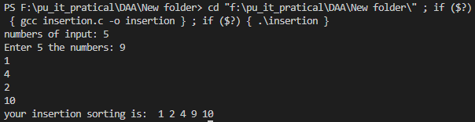

**Wrost Case:O(n^2)**

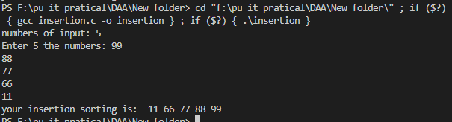

**Practical 2:**

**AIM:** **Implementation and Time analysis of Max-Heap sort algorithm.**

**Algorithm:**

1. HeapSort(arr)
2. BuildMaxHeap(arr)
3. for i = length(arr) to 2
4. swap arr[1] with arr[i]
5. heap_size[arr] = heap_size[arr] ? 1
6. MaxHeapify(arr,1)
7. End
8. BuildMaxHeap(arr)
9. heap_size(arr) = length(arr)
10. for i = length(arr)/2 to 1
11. MaxHeapify(arr,i)
12. End
13. MaxHeapify(arr,i)
14. L = left(i)
15. R = right(i)
16. if L ? heap_size[arr] and arr[L] **>** arr[i]
17. largest = L
18. else
19. largest = i
20. if R ? heap_size[arr] and arr[R] **>** arr[largest]
21. largest = R
22. if largest != i
23. swap arr[i] with arr[largest]
24. MaxHeapify(arr,largest)
25. End

**Code:**

#include <stdio.h>

void swap(int *a, int *b)

{    int temp = *a;

*a = *b;

*b = temp; }

void heapify(int arr[], int n, int i)

{    int largest = i;

int left = 2 * i + 1;

int right = 2 * i + 2;

if (left < n && arr[left] > arr[largest])

largest = left;

if (right < n && arr[right] > arr[largest])

largest = right;

if (largest != i)

{ swap(&arr[i], &arr[largest]);

heapify(arr, n, largest);

} }

void heapSort(int arr[], int n)

{

for (int i = n / 2 - 1; i >= 0; i--)

heapify(arr, n, i);

for (int i = n - 1; i >= 0; i--)

{ swap(&arr[0], &arr[i]);

heapify(arr, i, 0);

} }

int main()

{

int n,i;

printf("Enter Array size: ");

scanf("%d",&n);

int arr[n];

for(i=0;i<n;i++)

{        printf("Enter Element %d: ",i+1);

scanf("%d",&arr[i]);     }

heapSort(arr, n);

printf("\nSorted Heap array:\n");

i=0;

for(i=0;i<n;i++)

{

printf("%d\t",arr[i]);

} }

**OUTPUT: Best Case: nlog(n)**

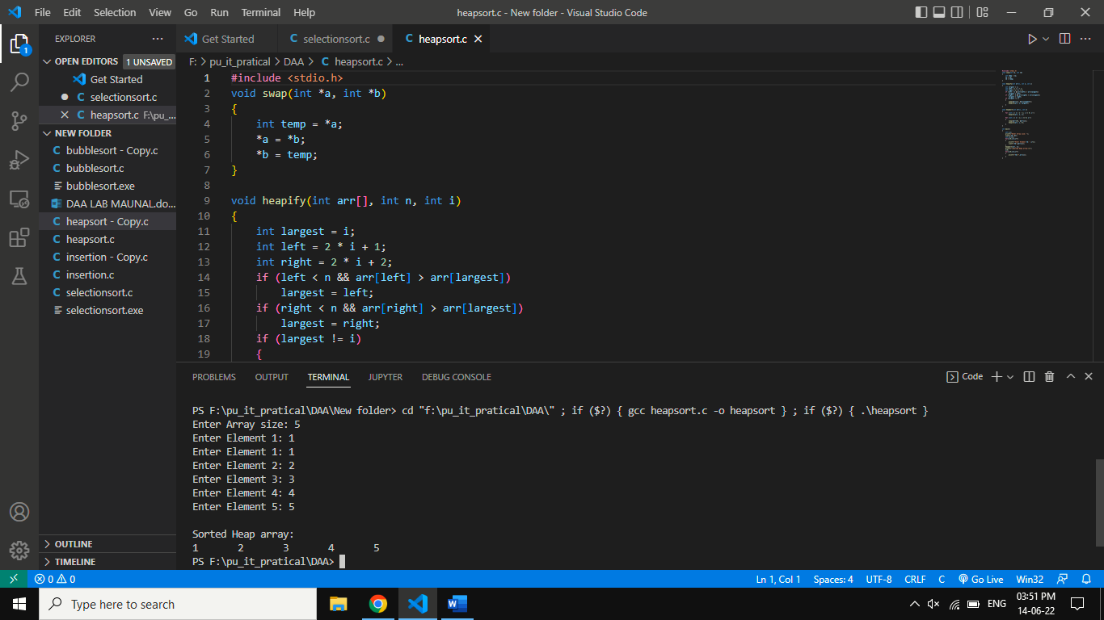

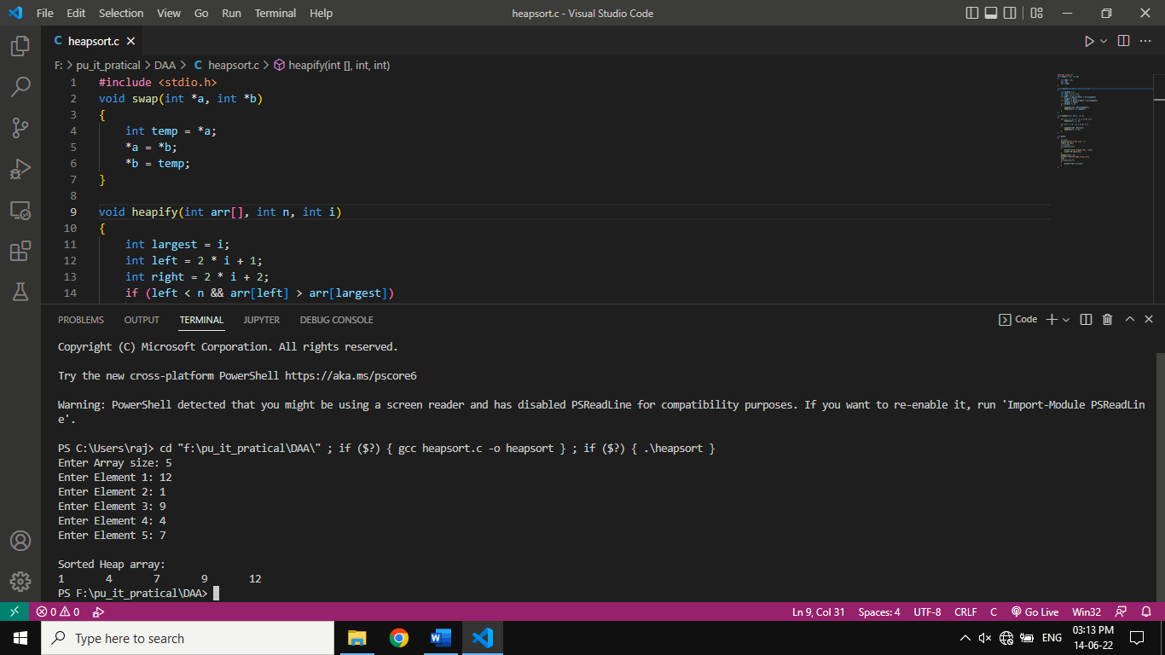**Avg Case: nlog(n)**

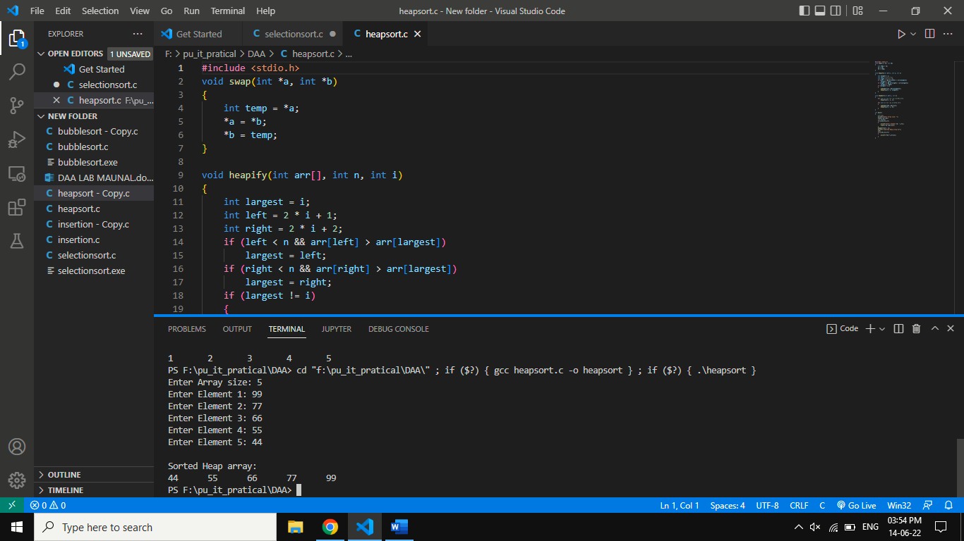**Wrost case: nlog(n)**

**PRACTICAL 3:**

**AIM:** **Implementation and Time analysis of Merge Sort algorithms for Best case, Average case & Worst-case using Divide and Conquer.**

**Algorithm:**

1. MERGE_SORT(arr, beg, end)
2. **if** beg < end
3. set mid = (beg + end)/2
4. MERGE_SORT(arr, beg, mid)
5. MERGE_SORT(arr, mid + 1, end)
6. MERGE (arr, beg, mid, end)
7. end of **if**
8. END MERGE_SORT

**Code:**

#include <stdio.h>

#include <stdlib.h>

void merge(int arr[], int l, int m, int r)

{

int i, j, k;

int n1 = m - l + 1;

int n2 = r - m;

int L[n1], R[n2];

for (i = 0; i < n1; i++)

L[i] = arr[l + i];

for (j = 0; j < n2; j++)

R[j] = arr[m + 1 + j];

i = 0;

j = 0;

k = l;

while (i < n1 && j < n2) {

if (L[i] <= R[j])

{ arr[k] = L[i];

i++; }

else { arr[k] = R[j];

j++; }

k++; }

while (i < n1) {

arr[k] = L[i];

i++;

k++; }

while (j < n2)

{ arr[k] = R[j];

j++;

k++; }

}

void mergeSort(int arr[], int l, int r)

{

if (l < r)

{

int m = l + (r - l) / 2;

mergeSort(arr, l, m);

mergeSort(arr, m + 1, r);

merge(arr, l, m, r);

} }

int main()

{ int u,i=0;

printf("Enter Element size: ");

scanf("%d",&u);

int A[u];

for(i=0;i<u;i++)

{ printf("Enter Element: ");

scanf("%d",&A[i]); }

mergeSort(A, 0, u-1);

printf("\nSorted array is \n");

i=0;

for(i=0;i<u;i++)

{ printf("%d\t",A[i]); }

return 0;

}

**Output:**

**Best Case Complexity:** **O(n*logn)**

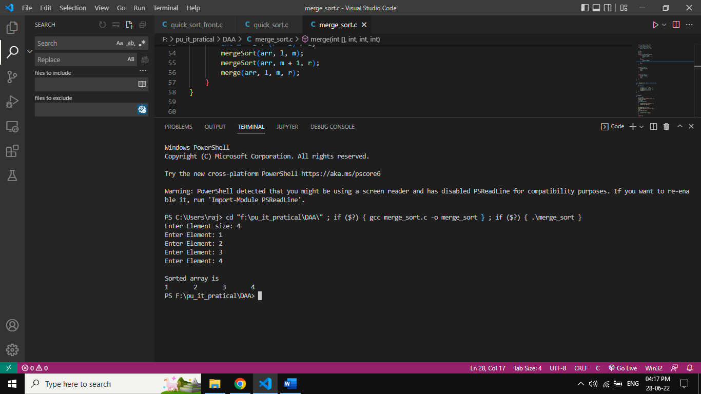

**Average Case Complexity: O(n*logn):**

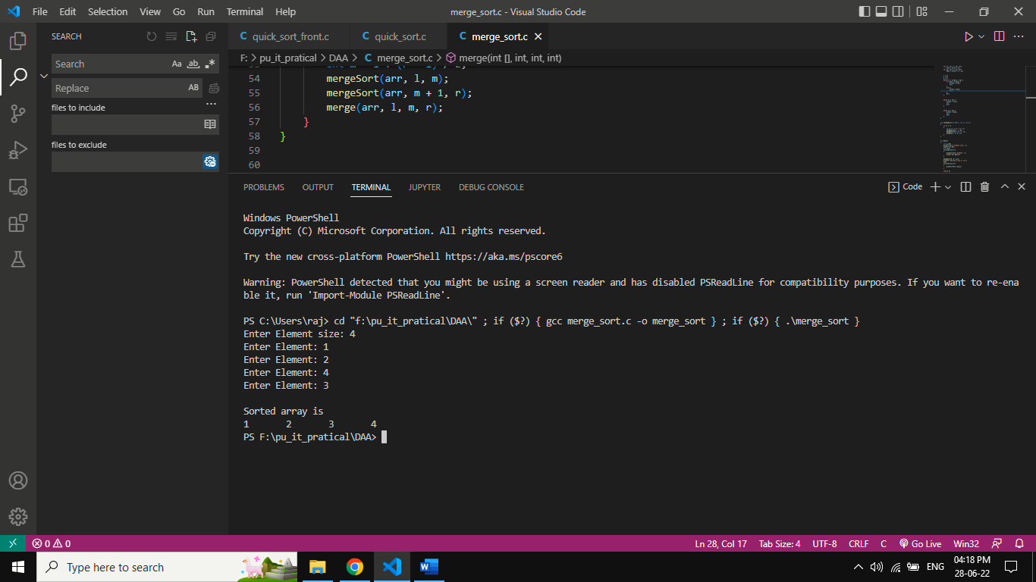

**Worst Case Complexity: O(n*logn):**

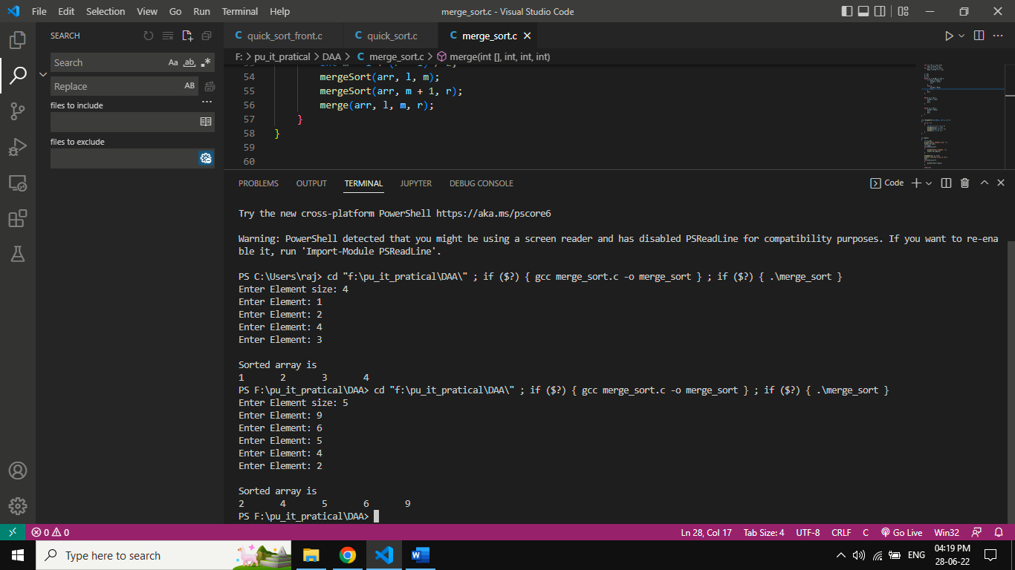

**PRACTICAL 4:**

**AIM** :**Implementation and Time analysis of Quick-Sort algorithms for Best case, Average case & Worst-case using Divide and Conquer.**

**Algorithm:**

Pivot value is Front in quick sort

1. QUICKSORT (array A, start, end)
2. {
3. if (start < end)
4. {
5. p = partition(A, start, end)
6. QUICKSORT (A, start, p - 1)
7. QUICKSORT (A, p + 1, end)
8. }
9. }
10. PARTITION (array A, start, end)
11. {
12. pivot ? A[end]
13. i ? start-1
14. for j ? start to end -1 {
15. do if (A[j] < pivot) {
16. then i = i + 1
17. swap A[i] with A[j]
18. }}
19. swap A[i+1] with A[end]
20. return i+1
21. }

**Code(Pivot Value from Start):**

#include<stdio.h>

void quicksort(int num[],int front,int l)

{  int i,j,pivot,temp;

    if(front<l)

    {  pivot=front;

        i=front;

        j=l;

        while(i<j)

        {

            while(num[i]<=num[pivot]&&i<l)

            i++;

            while(num[j]>num[pivot])

            j--;

            if(i<j)

            {  temp=num[i];

                num[i]=num[j];

                num[j]=temp;

            }        }

        temp=num[pivot];

        num[pivot]=num[j];

        num[j]=temp;

        quicksort(num,front,j-1);

        quicksort(num,j+1,l);

    }

}

int main()

{

    int i,count;

    printf("Enter element Size:");

    scanf("%d",&count);

int num[count];

  printf("Enter %d elements:",count);

    for (i=0;i<count;i++)

    { scanf("%d",&num[i]); }

    quicksort(num,0,count-1);

    printf("Sorted elements:");

    for(i=0;i<count;i++)

    { printf("%d\t",num[i]); }

    return 0;

}

**Code(Pivot Value from end):**

#include <stdio.h>

void swap(int *a, int *b)

{    int temp = *a;

    *a = *b;

    *b = temp; }

int partition(int a[], int start, int end)

{   int pivot = a[end];

    int i = (start - 1);

    for (int j = start; j <= end - 1; j++)

    {      if (a[j] < pivot)

        {              i++;

            int t = a[i];

            a[i] = a[j];

            a[j] = t;          }      }

    int t = a[i+1];

    a[i+1] = a[end];

    a[end] = t;

    return (i + 1);

}

void quicksort(int a[], int start, int end)

{      if (start < end)

    {          int p = partition(a, start, end);

        quicksort(a, start, p - 1);

        quicksort(a, p + 1, end);       }   }

int main()

{   int u,i=0;

    printf("Enter Element size: ");

    scanf("%d",&u);

    int A[u];

    for(i=0;i<u;i++)

    {        printf("Enter Element: ");

        scanf("%d",&A[i]);     }

    quicksort(A, 0, u - 1);

    printf("\nSorted array:\n");

    i=0;

     for(i=0;i<u;i++)

    {        printf("%d\t",A[i]);     }

    return 0;   }

**Output:**

**Front:**

**Best Case Complexity:** **O(n*logn)**

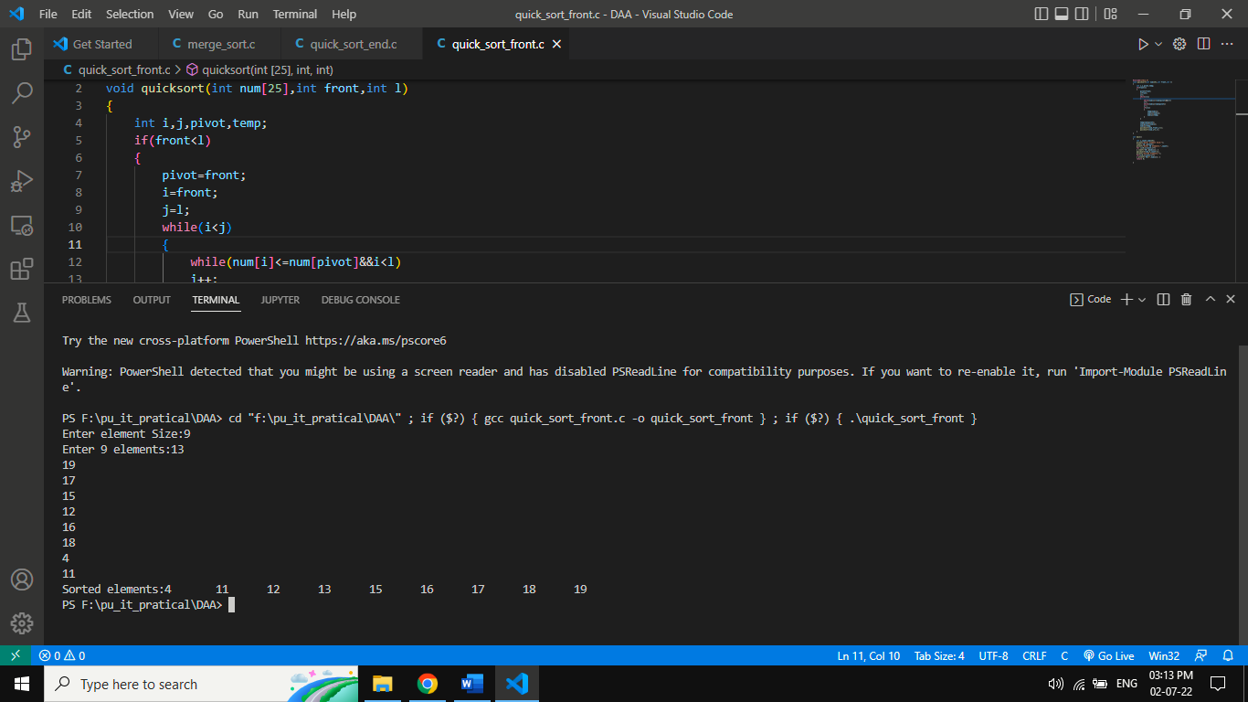

**Average Case Complexity: O(n*logn)**

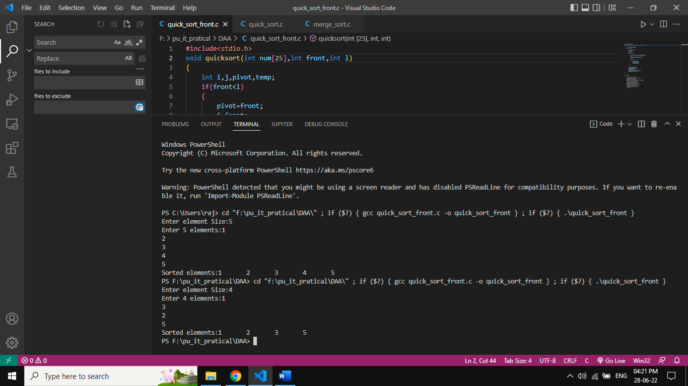

**Worst Case Complexity: O():**

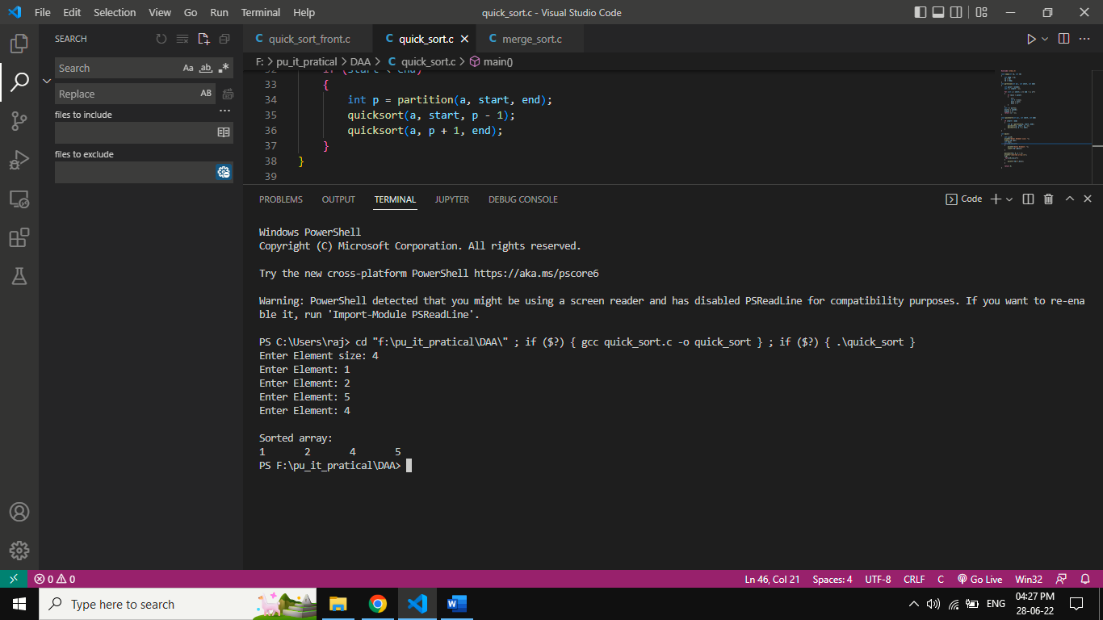

**End:**

**Best Case Complexity:** **O(n*logn)**

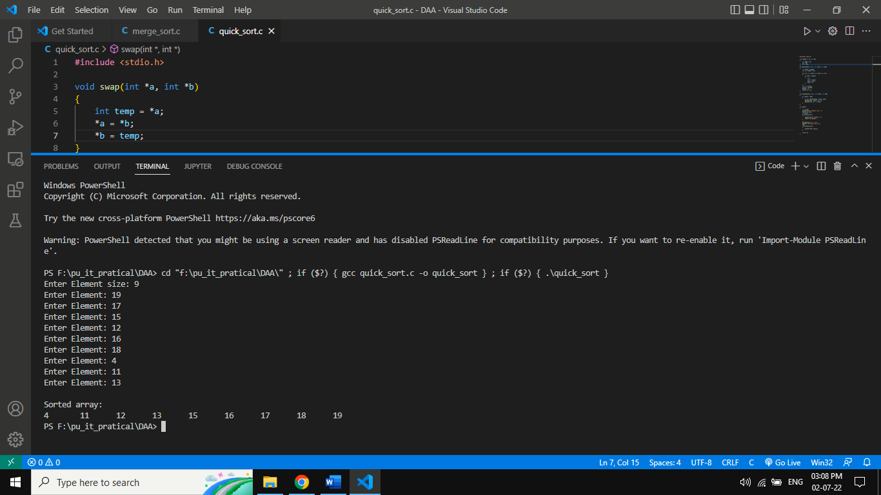

**Average Case Complexity: O(n*logn)**



**Worst Case Complexity: O():**

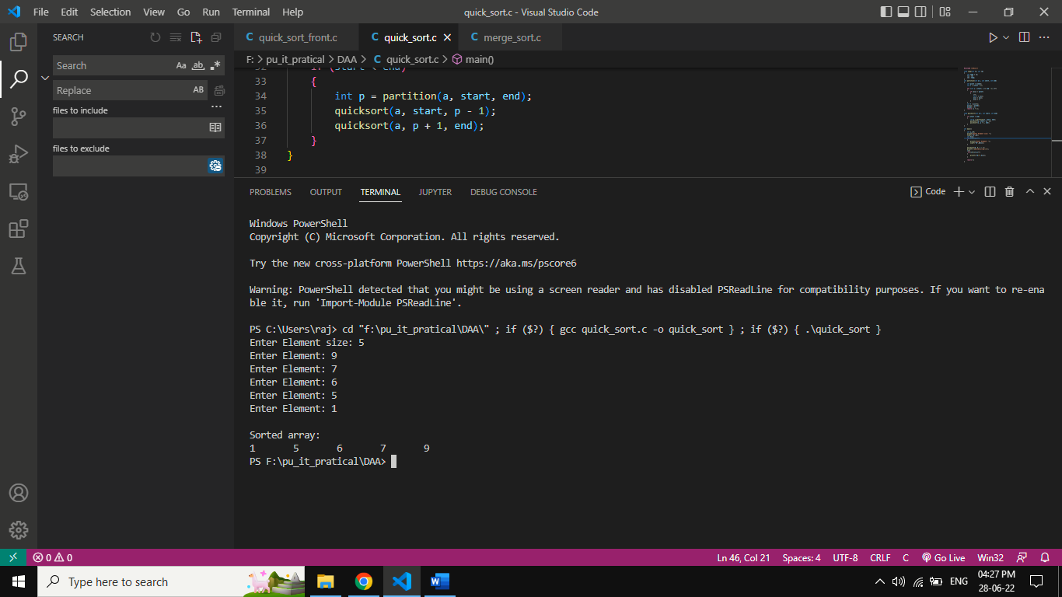

**PRACTICAL 5:**

**AIM:** **Write a program to solve fractional knapsack problem.**

**Algorithm:**

**Algorithm: Greedy-Fractional-Knapsack (w[1..n], p[1..n], W)**

for i = 1 to n

do x[i] = 0

weight = 0

for i = 1 to n

if weight + w[i] ≤ W then

x[i] = 1

weight = weight + w[i]

else

x[i] = (W - weight) / w[i]

weight = W

break

return x

**Code:**

#include <stdio.h>

int n = 5; /* The number of objects */

int c[10] = {12, 1, 2, 1, 4}; /* c[i] is the *COST* of the ith object; i.e. what

                YOU PAY to take the object */

int v[10] = {4, 2, 2, 1, 10}; /* v[i] is the *VALUE* of the ith object; i.e.

                what YOU GET for taking the object */

int W = 15; /* The maximum weight you can take */

void simple_fill() {

    int cur_w;

    float tot_v;

    int i, maxi;

    int used[10];

    for (i = 0; i < n; ++i)

        used[i] = 0; /* I have not used the ith object yet */

    cur_w = W;

    while (cur_w > 0) { /* while there's still room*/

        /* Find the best object */

        maxi = -1;

        for (i = 0; i < n; ++i)

            if ((used[i] == 0) &&

                ((maxi == -1) || ((float)v[i]/c[i] > (float)v[maxi]/c[maxi])))

                maxi = i;

        used[maxi] = 1; /* mark the maxi-th object as used */

        cur_w -= c[maxi]; /* with the object in the bag, I can carry less */

        tot_v += v[maxi];

        if (cur_w >= 0)

            printf("Added object %d (%d$, %dKg) completely in the bag. Space left: %d.\n", maxi + 1, v[maxi], c[maxi], cur_w);

        else {

            printf("Added %d%% (%d$, %dKg) of object %d in the bag.\n", (int)((1 + (float)cur_w/c[maxi]) * 100), v[maxi], c[maxi], maxi + 1);

            tot_v -= v[maxi];

            tot_v += (1 + (float)cur_w/c[maxi]) * v[maxi];

        }    }

    printf("Filled the bag with objects worth %.2f$.\n", tot_v);

}

int main(int argc, char *argv[]) {

    simple_fill();

    return 0;

}

**Output:**

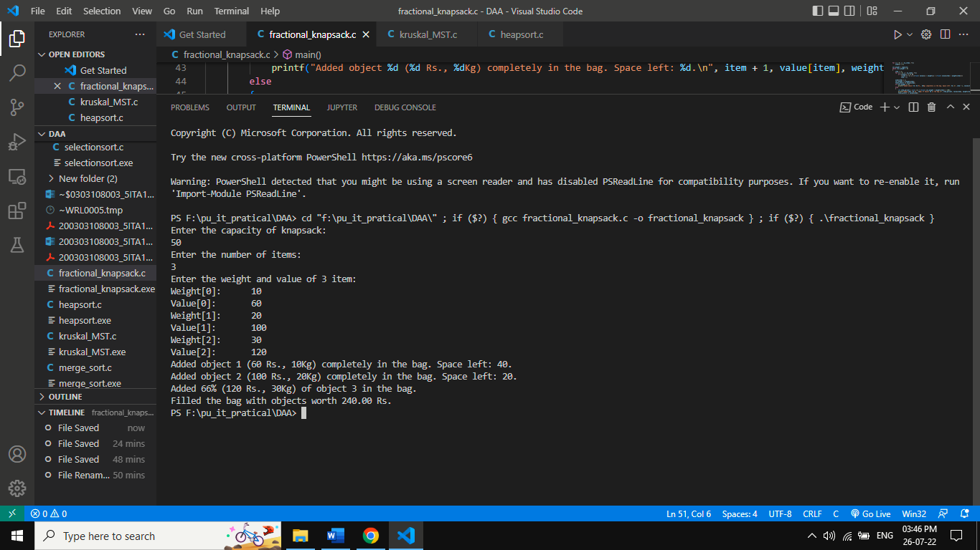

**PRACTICAL 6:**

**AIM: Implementation and Time analysis of Krushkal’s Minimum spanning Tree algorithms.**

**Algorithm:**

Steps for finding MST using Kruskal's Algorithm:

1. Arrange the edge of G in order of increasing weight.
2. Starting only with the vertices of G and proceeding sequentially add each edge which does not result in a cycle, until (n - 1) edges are used.
3. EXIT.

**MST- KRUSKAL (G, w)**

1. A ← ∅

2. for each vertex v ∈ V [G]

3. do MAKE - SET (v)

4. sort the edges of E into non decreasing order by weight w

5. for each edge (u, v) ∈ E, taken in non decreasing order by weight

6. do if FIND-SET (μ) ≠ if FIND-SET (v)

7. then A ← A ∪ {(u, v)}

8. UNION (u, v)

9. return A

**Time Analysis:**

**Analysis:** Where E is the number of edges in the graph and V is the number of vertices, Kruskal's Algorithm can be shown to run in O (E log E) time, or simply, O (E log V) time, all with simple data structures. These running times are equivalent because:

* **E** is at most **V2** and **log V2= 2 x log V is O (log V).**
* If we ignore isolated vertices, which will each their components of the minimum spanning tree, V ≤ 2 E, so log V is O (log E).

Thus the total time is

1. **O (E log E) = O (E log V).**

**Code:**

#include <stdio.h>

    #include <conio.h>

    #include <stdlib.h>

    int i,j,k,a,b,u,v,n,ne=1;

    int min,mincost=0,cost[9][9],parent[9];

    int find(int);

    int uni(int,int);

    void main()

    {

        printf("\n\tImplementation of Kruskal's Algorithm\n");

        printf("\nEnter the no. of vertices:");

        scanf("%d",&n);

        printf("\nEnter the cost adjacency matrix:\n");

        for(i=1;i<=n;i++)

        {

        for(j=1;j<=n;j++)

        {

        scanf("%d",&cost[i][j]);

        if(cost[i][j]==0)

        cost[i][j]=999;

        }

        }

        printf("The edges of Minimum Cost Spanning Tree are\n");

        while(ne < n)

        {

        for(i=1,min=999;i<=n;i++)

        {

        for(j=1;j <= n;j++)

        {

        if(cost[i][j] < min)

        {

        min=cost[i][j];

        a=u=i;

        b=v=j;        }        }        }

        u=find(u);

        v=find(v);

        if(uni(u,v))

        {        printf("%d edge (%d,%d) =%d\n",ne++,a,b,min);

        mincost +=min;        }

        cost[a][b]=cost[b][a]=999;         }

        printf("\n\tMinimum cost = %d\n",mincost);

        getch();

    }

    int find(int i)

    { while(parent[i])

        i=parent[i];

        return i;    }

    int uni(int i,int j)

    {   if(i!=j)

        {        parent[j]=i;

        return 1;        }

        return 0;

    }

**Output:**

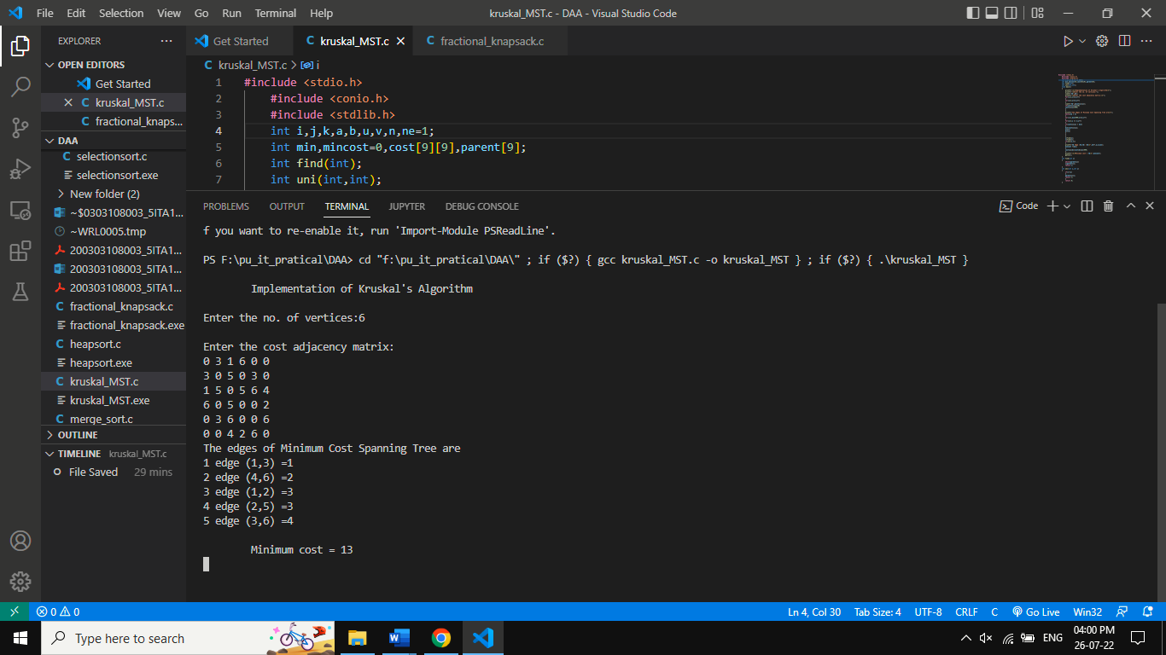

**PRACTICAL 7:**

**AIM: Implementation and Time analysis of Prim’s Minimum spanning Tree algorithms.**

**Algorithm:**

Step 1 − for (int v = 0; v < V; v++)

if (mstSet[v] == false && key[v] < min)

min = key[v], min_index = v;

Step 2 − for (int i = 0; i < V; i++)

key[i] = INT_MAX, mstSet[i] = false;

Step 3 − for (int count = 0; count < V - 1; count++) {

int u = minKey(key, mstSet);

Step 4 − for (int v = 0; v < V; v++)

if (graph[u][v] && mstSet[v] == false

**Code:**

#include <limits.h>

#include <stdbool.h>

#include <stdio.h>

#define V 5

int minKey(int key[], bool mstSet[])

{

  int min = INT_MAX, min_index;

    for (int v = 0; v < V; v++)

        if (mstSet[v] == false && key[v] < min)

            min = key[v], min_index = v;

    return min_index;

}

int printMST(int parent[], int graph[V][V])

{

    printf("Edge \tWeight\n");

    for (int i = 1; i < V; i++)

        printf("%d - %d \t%d \n", parent[i], i,

            graph[i][parent[i]]);

}

void primMST(int graph[V][V])

{

    int parent[V];

    int key[V];

    bool mstSet[V];

    for (int i = 0; i < V; i++)

        key[i] = INT_MAX, mstSet[i] = false;

    key[0] = 0;

    parent[0] = -1; // First node is always root of MST

    for (int count = 0; count < V - 1; count++) {

        int u = minKey(key, mstSet);

        mstSet[u] = true;

        for (int v = 0; v < V; v++)

            if (graph[u][v] && mstSet[v] == false

                && graph[u][v] < key[v])

                parent[v] = u, key[v] = graph[u][v];

    }

    printMST(parent, graph);

}

int main()

{    int graph[V][V] = { { 0, 2, 0, 6, 0 },

                        { 2, 0, 3, 8, 5 },

                        { 0, 3, 0, 0, 7 },

                        { 6, 8, 0, 0, 9 },

                        { 0, 5, 7, 9, 0 } };

    primMST(graph);

    return 0;

}

**Output:**

Time Complexity = O ( ( V + E ) l o g V)

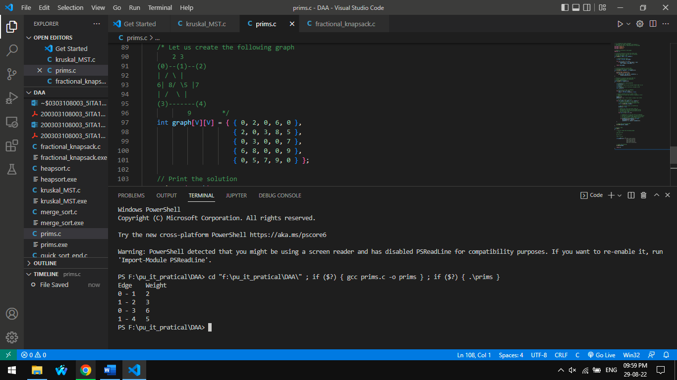

**PRACTICAL 8:**

**AIM: Write a program to solve 0-1 knapsack problem.**

**Algorithm:**

Step 1 − if (i==0 || w==0)

               K[i][w] = 0;

Step 2 − K[i][w] = max(val[i-1] + K[i-1][w-wt[i-1]],  K[i-1][w]);

Step 3 − K[i][w] = K[i-1][w];

Step 4 − int main()

    int i, n, val[20], wt[20], W;

**Code:**

#include<stdio.h>

int max(int a, int b) { return (a > b)? a : b; }

int knapSack(int W, int wt[], int val[], int n)

{

   int i, w;

   int K[n+1][W+1];

   for (i = 0; i <= n; i++)

   {

       for (w = 0; w <= W; w++)

       {

           if (i==0 || w==0)

               K[i][w] = 0;

           else if (wt[i-1] <= w)

                 K[i][w] = max(val[i-1] + K[i-1][w-wt[i-1]],  K[i-1][w]);

           else

                 K[i][w] = K[i-1][w];

       }

   }

   return K[n][W];

}

int main()

{

    int i, n, val[20], wt[20], W;

    printf("Enter number of items:");

    scanf("%d", &n);

    printf("Enter value and weight of items:\n");

    for(i = 0;i < n; ++i){

     scanf("%d%d", &val[i], &wt[i]);

    }

     printf("Enter size of knapsack:");

    scanf("%d", &W);

    printf("%d", knapSack(W, wt, val, n));

    return 0;

}

**Output:**

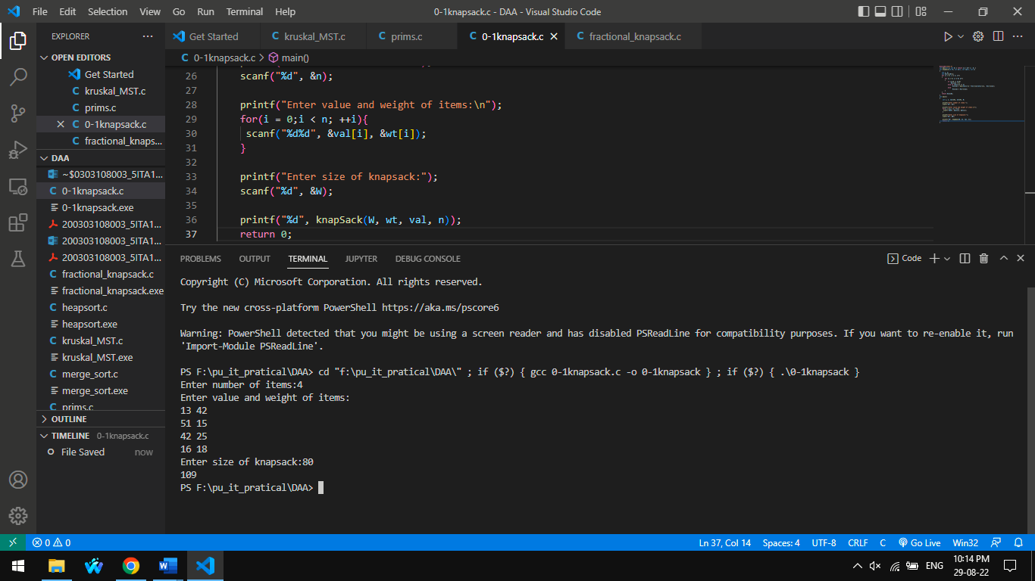

**PRACTICAL 9:**

**AIM: Implementation and Time analysis of Depth First Search (DFS) Graph Traversal and Breadth First Traversal (BFS) Graph Traversal.**

**1.BFS:**

**Algorithm:**

Step 1 − for(i=0;i<n;i++) visited[i]=0;

DFS(0);

Step 2 − visited[i]=1; for(j=0;j<n;j++)

Step 3 − if(!visited[j]&&G[i][j]==1) DFS(j);

**Code:**

#include<stdio.h>

void DFS(int);

int G[10][10],visited[10],n;

void main()

{

int i,j;

printf("Enter number of vertices:");

scanf("%d",&n);

printf("\nEnter adjecency matrix of the graph:");

for(i=0;i<n;i++) for(j=0;j<n;j++)

scanf("%d",&G[i][j]);

for(i=0;i<n;i++) visited[i]=0;

DFS(0);

}

void DFS(int i)

{

int j;

printf("\n%d",i);

visited[i]=1; for(j=0;j<n;j++)

if(!visited[j]&&G[i][j]==1) DFS(j);

}

**Output:**

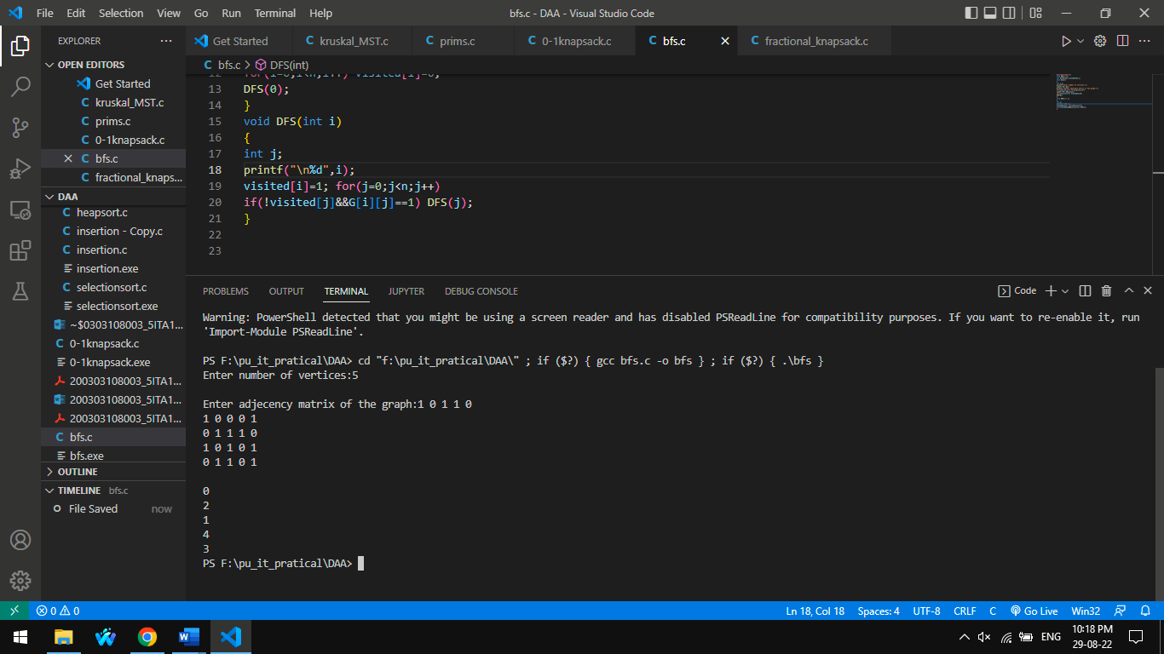

**2.DFS**

**Algorithm:**

Step 1 − for(i=0;i<n;i++)

visited[i]=0; DFS(0);

Step 2 − void DFS(int i)

node *p;

visited[i]=1; while(p!=NULL)

Step 3 − i=p->vertex;

if(!visited[i])

DFS(i);

p=p->next;

Step 4 − node *p,*q;

q=(node*)malloc(sizeof(node)); q->vertex=vj;

**Code:**

#include<stdio.h>

#include<stdlib.h>

typedef struct node

{

struct node *next;

int vertex;

}node;

node *G[20];

int visited[20];

int n;

void read_graph();

void insert(int,int);

void DFS(int);

void main()

{ int i;

read_graph();

for(i=0;i<n;i++)

visited[i]=0; DFS(0);

}

void DFS(int i)

{ node *p;

printf("\n%d",i); p=G[i];

visited[i]=1; while(p!=NULL)

{ i=p->vertex;

if(!visited[i])

DFS(i);

p=p->next; }}

void read_graph()

{ int i,vi,vj,no_of_edges; printf("Enter number of vertices:");

scanf("%d",&n);

for(i=0;i<n;i++)

{

G[i]=NULL;

printf("Enter number of edges:"); scanf("%d",&no_of_edges);

for(i=0;i<no_of_edges;i++)

{

printf("Enter an edge(u,v):");

scanf("%d%d",&vi,&vj); insert(vi,vj);

}}}

void insert(int vi,int vj)

{ node *p,*q;

q=(node*)malloc(sizeof(node)); q->vertex=vj;

q->next=NULL;

if(G[vi]==NULL)

G[vi]=q; else

{p=G[vi];

while(p->next!=NULL) p=p->next;

p->next=q;

}}

**Output:**

