

Model Risk Validation Report
Full Technical & Quantitative Analysis
Monitor ID | Run ID | Health Score | Health Status
mon_fraud | run_1120e81f... | 71.4/100 | WATCH
Generated At: 2026-09-16

Key Performance Metrics
Metric | Category | Value | Threshold | Status
Brier Skill Score | calibration | -0.0002 | N/A | OK
Calibration Ratio | calibration | 0.7566 | N/A | WARNING
Row Count | data_quality | 800.0000 | N/A | OK
Duplicate Row Count | data_quality | 0.0000 | N/A | OK
Null Rates | data_quality | N/A | N/A | OK
Invalid Probability Count | data_quality | 0.0000 | N/A | OK
Invalid Target Count | data_quality | 0.0000 | N/A | OK
Monitoring Readiness Summary | data_quality | N/A | N/A | OK
Score-PD Coherence | data_quality | 1.0000 | N/A | OK
Band Consistency | data_quality | N/A | N/A | SKIPPED
DPD Buckets | delinquency | N/A | N/A | SKIPPED
Score PSI | drift | N/A | N/A | SKIPPED
ROC AUC | performance | 0.7549 | N/A | OK
Gini Coefficient | performance | 0.5099 | N/A | OK
KS Statistic | performance | 0.3976 | N/A | OK
Decile Table | performance | N/A | N/A | OK
Score Distribution Analysis | performance | N/A | N/A | OK
Approval Rate | strategy | 0.0000 | N/A | OK
Overall Bad Rate | strategy | 0.0387 | N/A | OK

Statistical Tests
Test Name | Statistic | P-Value | Conclusion | Status
Hosmer-Lemeshow Test | 7.0551 | 0.8254 | Fail to reject H₀ — distributions are similar
Binomial Test: Band 3 | 6.0000 | 0.8254 | Fail to reject H₀ — distributions are similar
Binomial Test: Band 2 | 6.0000 | 0.8254 | Fail to reject H₀ — distributions are similar
Binomial Test: Band 4 | 16.0000 | 0.0019 | Reject H₀ — distributions differ
Binomial Test: Band 1 | 2.0000 | 0.9982 | Fail to reject H₀ — distributions are similar
Binomial Test: Band 0 | 1.0000 | 0.9982 | Fail to reject H₀ — distributions are similar
Mann-Whitney U: Approved vs Declined Scores | 4733.5000 | 0.0000 | Reject H₀ — distributions differ

Override Analysis

Cutoff: 550
"Overridden accounts show a HIGHER bad rate than model-approved accounts (6.6% vs 1.7%), indicating possible excessive risk taking on model-declines."
Model Declines | Overrides | Override Rate | Override Bad Rate
273 | 226 | 82.8% | 6.6%
Conclusion: Overrides are performing worse than standard model approvals.

Cutoff: 600
"Overridden accounts show a HIGHER bad rate than model-approved accounts (7.6% vs 2.2%), indicating possible excessive risk taking on model-declines."
Model Declines | Overrides | Override Rate | Override Bad Rate
188 | 144 | 76.6% | 7.6%
Conclusion: Overrides are performing worse than standard model approvals.

Cutoff: 650
"Overridden accounts show a HIGHER bad rate than model-approved accounts (12.3% vs 2.4%), indicating possible excessive risk taking on model-declines."
Model Declines | Overrides | Override Rate | Override Bad Rate
107 | 65 | 60.7% | 12.3%
Conclusion: Overrides are performing worse than standard model approvals.

Cutoff: 700
"Overridden accounts show a HIGHER bad rate than model-approved accounts (11.1% vs 3.1%), indicating possible excessive risk taking on model-declines."
Model Declines | Overrides | Override Rate | Override Bad Rate
51 | 9 | 17.6% | 11.1%
Conclusion: Overrides are performing worse than standard model approvals.

Model Visualizations

Chart Score Distribution
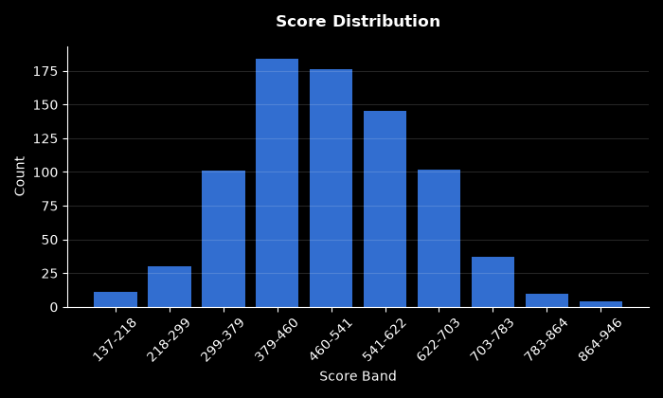

Chart Pd Distribution
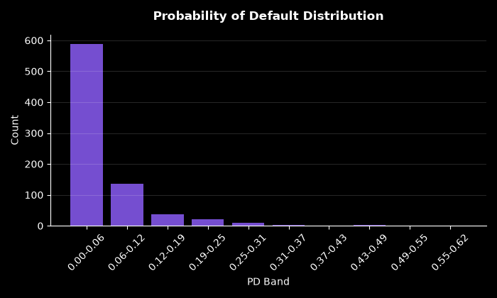

Chart Bad Rate By Score Band
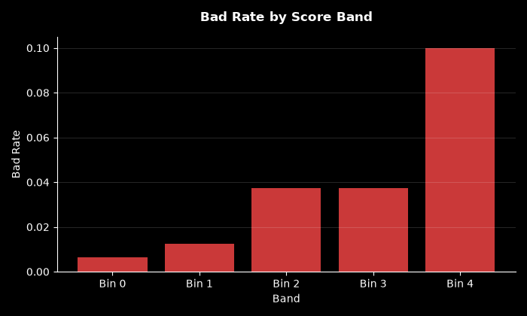

Chart Approval By Risk Band
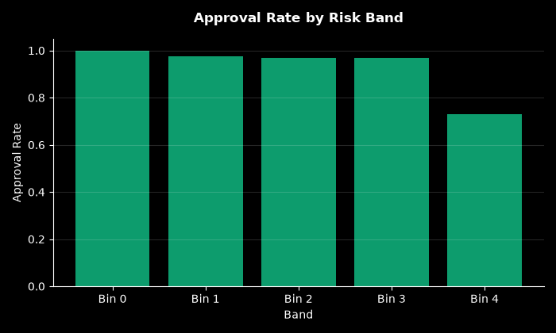

Chart Calibration
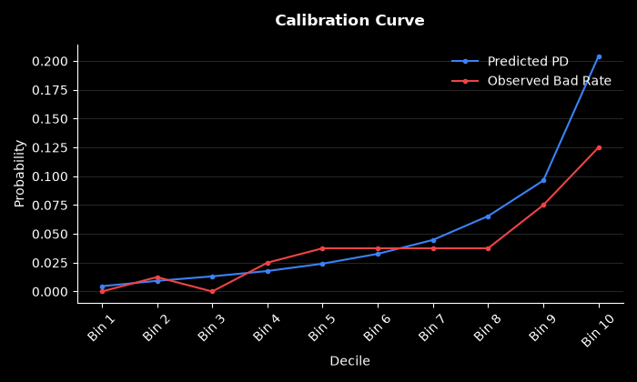

Chart Decile Lift
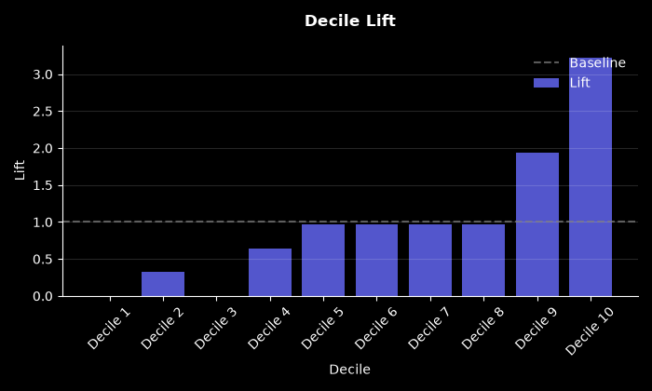

Chart Roc Curve
