

Model Risk Validation Report
Full Technical & Quantitative Analysis
Monitor ID | Run ID | Health Score | Health Status
mon_segtest | run_121544ca... | 90.1/100 | HEALTHY
Generated At: 2026-09-20

Key Performance Metrics
Metric | Category | Value | Threshold | Status
Brier Skill Score | calibration | 0.1165 | N/A | OK
Calibration Ratio | calibration | 1.0000 | N/A | OK
Row Count | data_quality | 5000.0000 | N/A | OK
Duplicate Row Count | data_quality | 0.0000 | N/A | OK
Null Rates | data_quality | N/A | N/A | OK
Overall Null Rate | data_quality | 0.0000 | N/A | OK
Invalid Probability Count | data_quality | 0.0000 | N/A | OK
Invalid Target Count | data_quality | 0.0000 | N/A | OK
Monitoring Readiness Summary | data_quality | N/A | N/A | OK
Score-PD Coherence | data_quality | -0.9836 | N/A | OK
Band Consistency | data_quality | N/A | N/A | SKIPPED
DPD Buckets | delinquency | N/A | N/A | SKIPPED
Severe Delinquency Rate | delinquency | N/A | N/A | SKIPPED
30+ DPD Rate | delinquency | N/A | N/A | SKIPPED
Score PSI | drift | N/A | N/A | SKIPPED
Feature CSI Drift | drift | N/A | N/A | SKIPPED
ROC AUC | performance | 0.7854 | N/A | OK
Gini Coefficient | performance | 0.5708 | N/A | OK
KS Statistic | performance | 0.4353 | N/A | OK
Decile Table | performance | N/A | N/A | OK
Score Distribution Analysis | performance | N/A | N/A | CRITICAL
Approval Rate | strategy | 0.8012 | N/A | OK
Overall Bad Rate | strategy | 0.0916 | N/A | OK
Bad Rate (Approved Only) | strategy | 0.0632 | N/A | OK
Decline Rate | strategy | 0.1988 | N/A | OK

Statistical Tests
Test Name | Statistic | P-Value | Conclusion | Status
Hosmer-Lemeshow Test | 41.5414 | 0.0000 | Reject H₀ — distributions differ
Binomial Test: Band 3 | 26.0000 | 1.0000 | Fail to reject H₀ — distributions are similar
Binomial Test: Band 2 | 54.0000 | 1.0000 | Fail to reject H₀ — distributions are similar
Binomial Test: Band 4 | 17.0000 | 1.0000 | Fail to reject H₀ — distributions are similar
Binomial Test: Band 1 | 109.0000 | 0.0602 | Fail to reject H₀ — distributions are similar
Binomial Test: Band 0 | 252.0000 | 0.0000 | Reject H₀ — distributions differ
Mann-Whitney U: Approved vs Declined Scores | 3372339.5000 | 0.0000 | Reject H₀ — distributions differ

Segment Breakdown
Segment | Value | Count | Share | Bad Rate | Status
loan_purpose | credit_card | 1090 | 21.8% | 9.36% | N/A
loan_purpose | debt_consolidation | 1394 | 27.9% | 9.11% | N/A
loan_purpose | home_improvement | 899 | 18.0% | 8.79% | N/A
loan_purpose | major_purchase | 909 | 18.2% | 8.36% | N/A
loan_purpose | other | 708 | 14.2% | 10.45% | N/A

Override Analysis

Cutoff: 550
"Overridden accounts show a HIGHER bad rate than model-approved accounts (31.0% vs 6.1%), indicating possible excessive risk taking on model-declines."
Model Declines | Overrides | Override Rate | Override Bad Rate
172 | 29 | 16.9% | 31.0%
Conclusion: Overrides are performing worse than standard model approvals.

Cutoff: 600
"Overridden accounts show a HIGHER bad rate than model-approved accounts (22.7% vs 5.1%), indicating possible excessive risk taking on model-declines."
Model Declines | Overrides | Override Rate | Override Bad Rate
757 | 269 | 35.5% | 22.7%
Conclusion: Overrides are performing worse than standard model approvals.

Cutoff: 650
"Overridden accounts show a HIGHER bad rate than model-approved accounts (13.0% vs 3.1%), indicating possible excessive risk taking on model-declines."
Model Declines | Overrides | Override Rate | Override Bad Rate
2115 | 1291 | 61.0% | 13.0%
Conclusion: Overrides are performing worse than standard model approvals.

Cutoff: 700
"Overridden accounts show a HIGHER bad rate than model-approved accounts (8.3% vs 1.8%), indicating possible excessive risk taking on model-declines."
Model Declines | Overrides | Override Rate | Override Bad Rate
3746 | 2771 | 74.0% | 8.3%
Conclusion: Overrides are performing worse than standard model approvals.

Model Visualizations

Chart Score Distribution
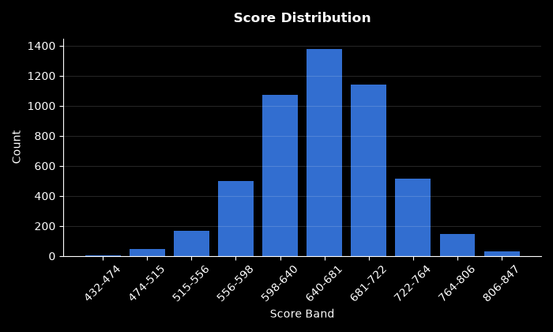

Chart Pd Distribution
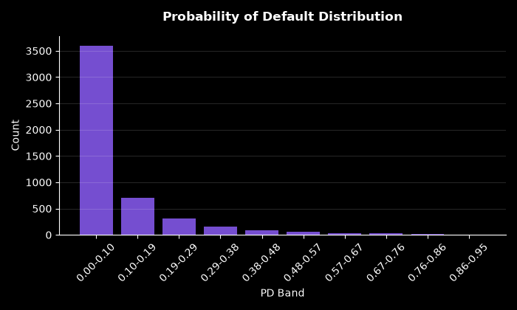

Chart Bad Rate By Score Band
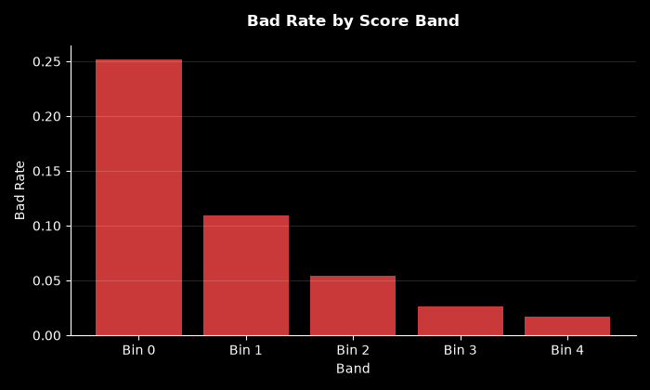

Chart Approval By Risk Band
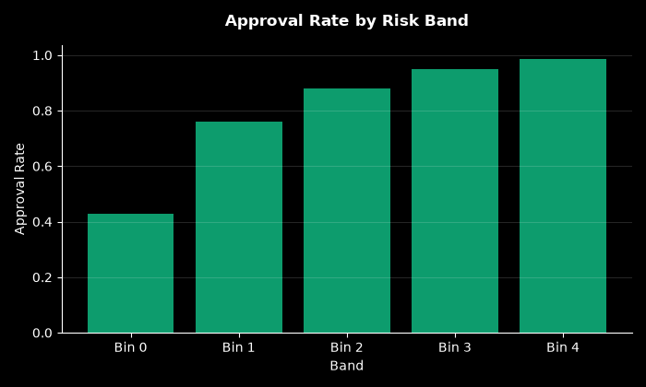

Chart Calibration
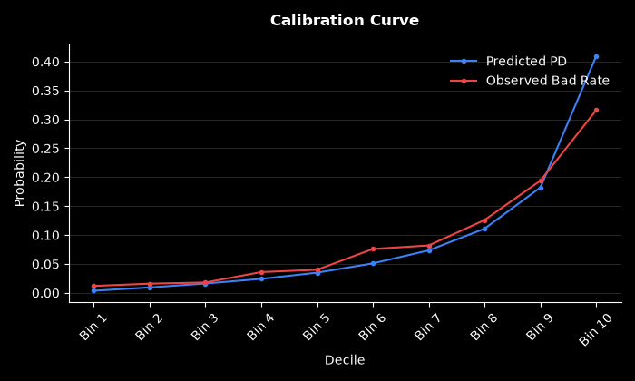

Chart Decile Lift
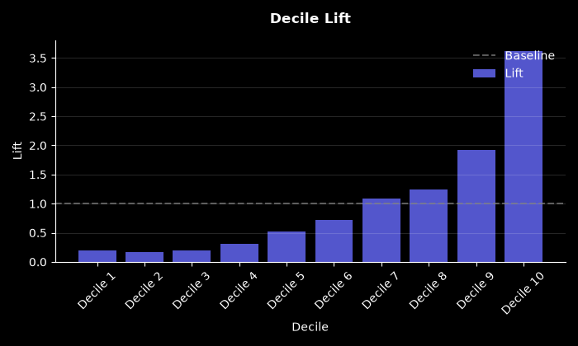

Chart Roc Curve
