

Model Risk Validation Report
Full Technical & Quantitative Analysis
Monitor ID | Run ID | Health Score | Health Status
mon_client | run_3496a254... | 22.5/100 | CRITICAL
Generated At: 2026-09-16

Key Performance Metrics
Metric | Value | Threshold | Status
Brier Skill Score | -0.0609 | N/A | OK
Calibration Ratio | 0.5935 | N/A | CRITICAL
Row Count | 197.0000 | N/A | OK
Duplicate Row Count | 0.0000 | N/A | OK
Null Rates | N/A | N/A | OK
Invalid Probability Count | 0.0000 | N/A | OK
Invalid Target Count | 0.0000 | N/A | OK
Monitoring Readiness Summary | N/A | N/A | OK
Score-PD Coherence | -0.0422 | N/A | CRITICAL
Band Consistency | 0.8680 | N/A | WARNING
DPD Buckets | N/A | N/A | OK
Score PSI | N/A | N/A | SKIPPED
ROC AUC | 0.3341 | N/A | CRITICAL
Gini Coefficient | -0.3319 | N/A | CRITICAL
KS Statistic | 0.3563 | N/A | OK
Decile Table | N/A | N/A | OK
Score Distribution Analysis | N/A | N/A | CRITICAL
Approval Rate | 0.7716 | N/A | OK
Overall Bad Rate | 0.0558 | N/A | OK

Statistical Tests
Test Name | Statistic | P-Value | Conclusion | Result
Hosmer-Lemeshow Test | 5.6961 | 0.6607 | Fail to reject H₀ — distributions are similar
Binomial Test: Band 600-700 | 5.0000 | 0.6607 | Fail to reject H₀ — distributions are similar
Binomial Test: Band 700-800 | 4.0000 | 0.6607 | Fail to reject H₀ — distributions are similar
Binomial Test: Band <600 | 1.0000 | 0.9810 | Fail to reject H₀ — distributions are similar
Fisher Exact Test: Band 800+ | 1.4091 | 0.6942 | Fail to reject H₀ — distributions are similar
Mann-Whitney U: Approved vs Declined Scores | 3354.0000 | 0.6942 | Fail to reject H₀ — distributions are similar

Vintage Analysis (Roll Rate)
Note: True roll rate matrix requires two time-snapshot datasets. This shows current DPD bucket distribution.
Severe Delinquency Rate: 23.86%
Bucket | Count | Percentage | Cumulative %
Current (0 DPD) | 100 | 50.8% | 50.8%
1-29 DPD | 0 | 0.0% | 50.8%
30-59 DPD | 24 | 12.2% | 62.9%
60-89 DPD | 26 | 13.2% | 76.1%
90+ DPD | 47 | 23.9% | 100.0%

Override Analysis

Cutoff: 550
"Overridden accounts in this dataset show LOWER bad rate than model-approved accounts (0.0% vs 6.3%), suggesting underwriters are exercising sound judgment for this risk segment. Review override criteria."
Model Declines | Overrides | Override Rate | Override Bad Rate
35 | 26 | 74.3% | 0.0%
Conclusion: Overrides are performing better or equal to model approvals.

Cutoff: 600
"Overridden accounts in this dataset show LOWER bad rate than model-approved accounts (3.3% vs 6.5%), suggesting underwriters are exercising sound judgment for this risk segment. Review override criteria."
Model Declines | Overrides | Override Rate | Override Bad Rate
73 | 60 | 82.2% | 3.3%
Conclusion: Overrides are performing better or equal to model approvals.

Cutoff: 650
"Overridden accounts in this dataset show LOWER bad rate than model-approved accounts (3.6% vs 7.4%), suggesting underwriters are exercising sound judgment for this risk segment. Review override criteria."
Model Declines | Overrides | Override Rate | Override Bad Rate
107 | 84 | 78.5% | 3.6%
Conclusion: Overrides are performing better or equal to model approvals.

Cutoff: 700
"Overridden accounts in this dataset show LOWER bad rate than model-approved accounts (3.8% vs 8.5%), suggesting underwriters are exercising sound judgment for this risk segment. Review override criteria."
Model Declines | Overrides | Override Rate | Override Bad Rate
136 | 105 | 77.2% | 3.8%
Conclusion: Overrides are performing better or equal to model approvals.

Model Visualizations

Chart Score Distribution
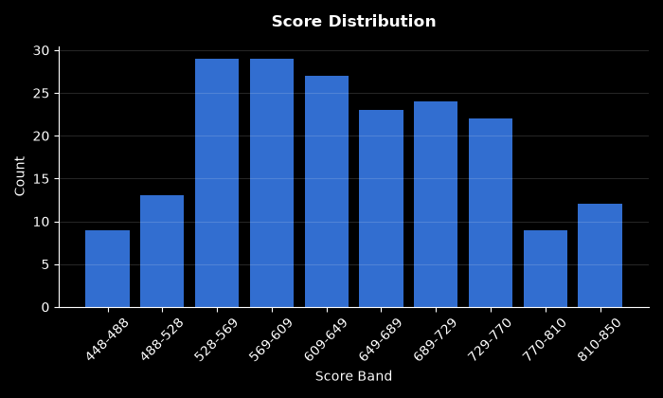

Chart Pd Distribution
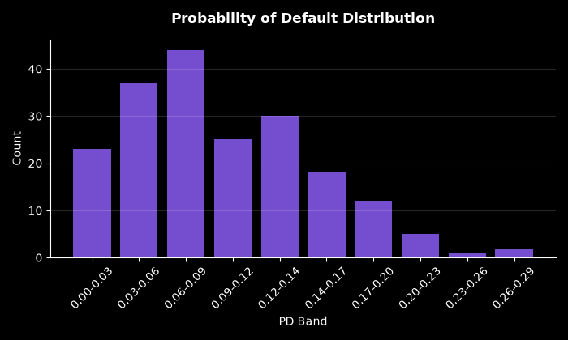

Chart Bad Rate By Score Band
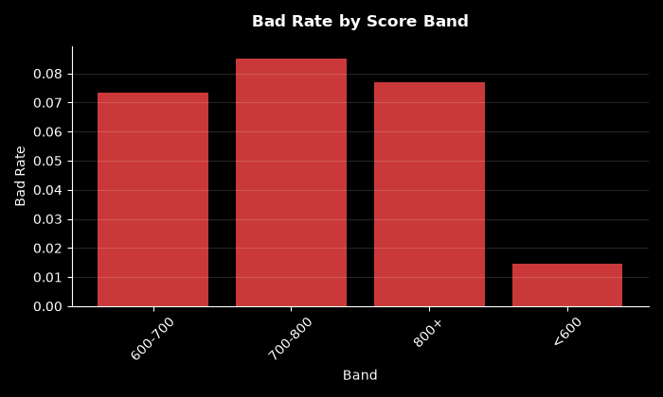

Chart Approval By Risk Band
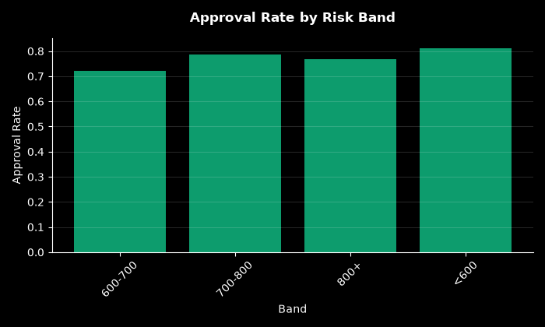

Chart Calibration
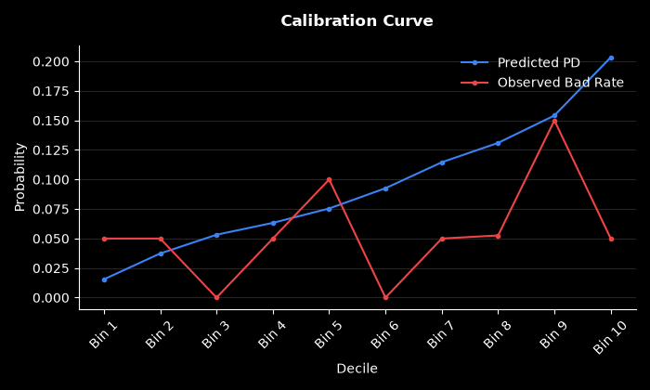

Chart Dpd Distribution
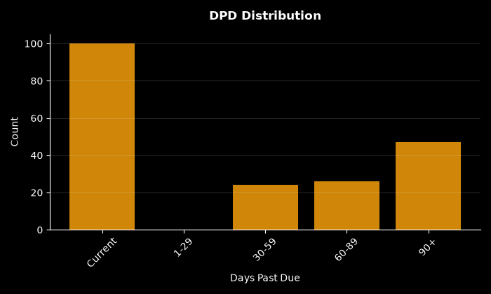

Chart Decile Lift
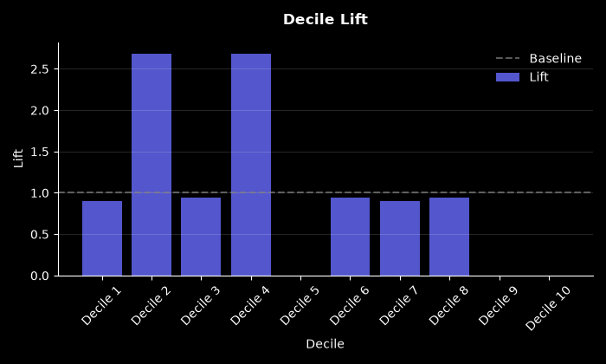

Chart Roc Curve
