

Model Risk Validation Report
Full Technical & Quantitative Analysis
Monitor ID | Run ID | Health Score | Health Status
mon_drifted | run_3e8c4413... | 45.9/100 | DETERIORATING
Generated At: 2026-09-16

Alerts & Breaches
[CRITICAL] Score PSI = 0.2622, exceeds critical threshold of 0.25
[WARNING] ROC AUC declined by 0.0364 vs baseline, exceeding warning threshold of 0.03
[WARNING] Gini Coefficient declined by 0.0728 vs baseline, exceeding warning threshold of 0.05
[CRITICAL] KS Statistic declined by 0.0637 vs baseline, exceeding critical threshold of 0.05
[CRITICAL] Approval Rate changed by 0.1964 vs baseline, exceeding critical threshold of 0.1

Key Performance Metrics
Metric | Category | Value | Threshold | Status
Brier Skill Score | calibration | 0.0903 | N/A | OK
Calibration Ratio | calibration | 1.4797 | N/A | WARNING
Row Count | data_quality | 2500.0000 | N/A | OK
Duplicate Row Count | data_quality | 0.0000 | N/A | OK
Null Rates | data_quality | N/A | N/A | OK
Invalid Probability Count | data_quality | 0.0000 | N/A | OK
Invalid Target Count | data_quality | 0.0000 | N/A | OK
Monitoring Readiness Summary | data_quality | N/A | N/A | OK
Score-PD Coherence | data_quality | -0.9892 | N/A | OK
Band Consistency | data_quality | 1.0000 | N/A | OK
DPD Buckets | delinquency | N/A | N/A | OK
Score PSI | drift | 0.2622 | N/A | CRITICAL
ROC AUC | performance | 0.7490 | N/A | OK
Gini Coefficient | performance | 0.4980 | N/A | OK
KS Statistic | performance | 0.3716 | N/A | OK
Decile Table | performance | N/A | N/A | OK
Score Distribution Analysis | performance | N/A | N/A | OK
Approval Rate | strategy | 0.6048 | N/A | OK
Overall Bad Rate | strategy | 0.2780 | N/A | OK

Statistical Tests
Test Name | Statistic | P-Value | Conclusion | Status
Hosmer-Lemeshow Test | 567.8371 | 0.0000 | Reject H₀ — distributions differ
Binomial Test: Band 700-800 | 22.0000 | 1.0000 | Fail to reject H₀ — distributions are similar
Binomial Test: Band <600 | 421.0000 | 0.0000 | Reject H₀ — distributions differ
Binomial Test: Band 600-700 | 252.0000 | 1.0000 | Fail to reject H₀ — distributions are similar
Fisher Exact Test: Band 800+ | 0.0000 | 1.0000 | Fail to reject H₀ — distributions are similar
Mann-Whitney U: Approved vs Declined Scores | 1302048.0000 | 0.0000 | Reject H₀ — distributions differ

Vintage Analysis (Roll Rate)
Note: True roll rate matrix requires two time-snapshot datasets. This shows current DPD bucket distribution.
Severe Delinquency Rate: 20.88%
Bucket | Count | Percentage | Cumulative %
Current (0 DPD) | 1702 | 68.1% | 68.1%
1-29 DPD | 0 | 0.0% | 68.1%
30-59 DPD | 78 | 3.1% | 71.2%
60-89 DPD | 198 | 7.9% | 79.1%
90+ DPD | 522 | 20.9% | 100.0%

Override Analysis

Cutoff: 550
"Overridden accounts show a HIGHER bad rate than model-approved accounts (51.9% vs 17.7%), indicating possible excessive risk taking on model-declines."
Model Declines | Overrides | Override Rate | Override Bad Rate
340 | 27 | 7.9% | 51.9%
Conclusion: Overrides are performing worse than standard model approvals.

Cutoff: 600
"Overridden accounts show a HIGHER bad rate than model-approved accounts (44.2% vs 14.8%), indicating possible excessive risk taking on model-declines."
Model Declines | Overrides | Override Rate | Override Bad Rate
848 | 181 | 21.3% | 44.2%
Conclusion: Overrides are performing worse than standard model approvals.

Cutoff: 650
"Overridden accounts show a HIGHER bad rate than model-approved accounts (30.1% vs 10.4%), indicating possible excessive risk taking on model-declines."
Model Declines | Overrides | Override Rate | Override Bad Rate
1504 | 608 | 40.4% | 30.1%
Conclusion: Overrides are performing worse than standard model approvals.

Cutoff: 700
"Overridden accounts show a HIGHER bad rate than model-approved accounts (22.3% vs 5.8%), indicating possible excessive risk taking on model-declines."
Model Declines | Overrides | Override Rate | Override Bad Rate
2130 | 1148 | 53.9% | 22.3%
Conclusion: Overrides are performing worse than standard model approvals.

Model Visualizations

Chart Score Distribution
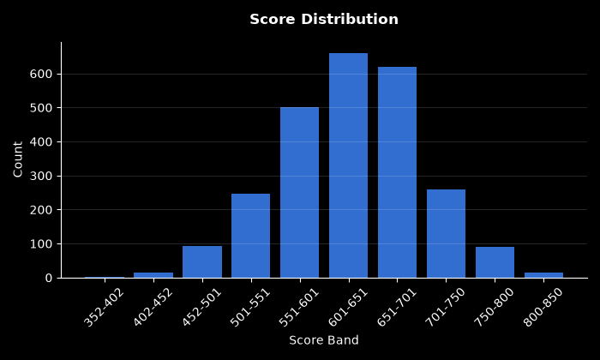

Chart Pd Distribution
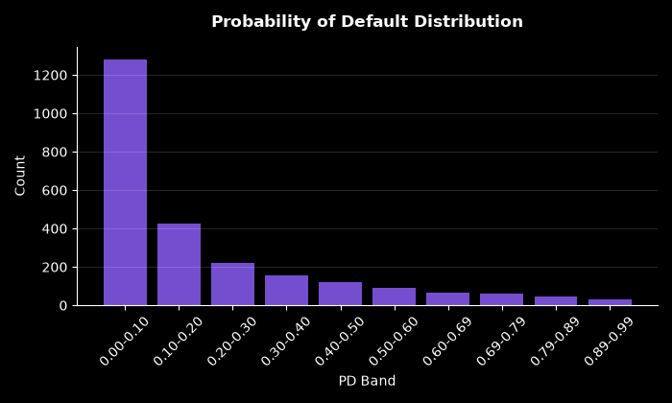

Chart Bad Rate By Score Band
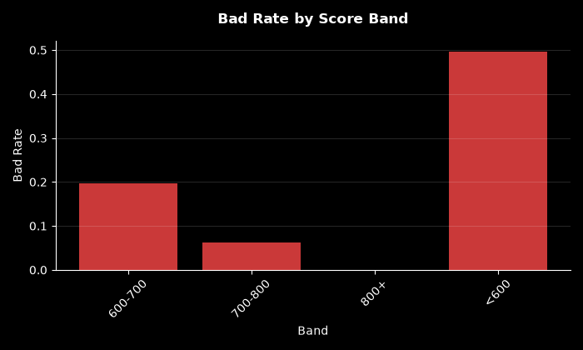

Chart Approval By Risk Band
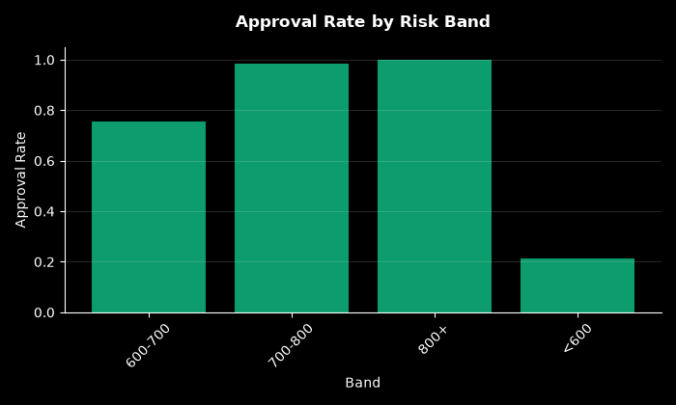

Chart Calibration
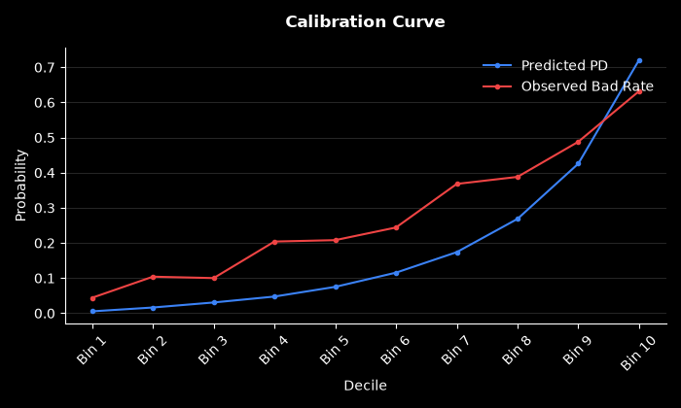

Chart Dpd Distribution
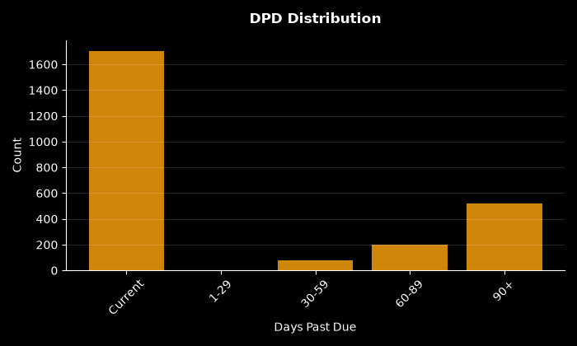

Chart Psi Breakdown
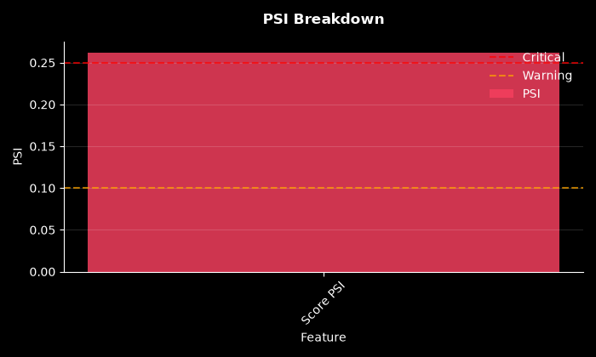

Chart Decile Lift
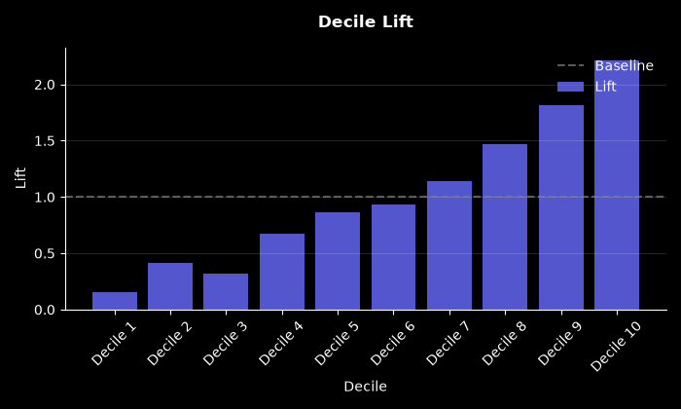

Chart Roc Curve
