

Model Risk Validation Report
Full Technical & Quantitative Analysis
Monitor ID | Run ID | Health Score | Health Status
mon_edge | run_95a1878d... | 95.0/100 | HEALTHY
Generated At: 2026-09-16

AI Narrative Analysis

Executive Summary
The model's health is currently stable with no critical or warning findings. However, the absence of a baseline makes it challenging to assess its performance.

Technical Summary
There are no specific metric breaches or key findings to report, as the Top Worsening Metrics list is empty and the Detailed Findings list is also empty.

Recommended Actions
- Establish a baseline to enable performance assessment
- Monitor the model's performance closely for potential issues

Key Performance Metrics
Metric | Category | Value | Threshold | Status
Brier Skill Score | calibration | 0.0542 | N/A | OK
Calibration Ratio | calibration | 0.9366 | N/A | OK
Row Count | data_quality | 420.0000 | N/A | OK
Duplicate Row Count | data_quality | 20.0000 | N/A | WARNING
Null Rates | data_quality | N/A | N/A | WARNING
Invalid Probability Count | data_quality | 5.0000 | N/A | ERROR
Invalid Target Count | data_quality | 0.0000 | N/A | OK
Monitoring Readiness Summary | data_quality | N/A | N/A | OK
Score-PD Coherence | data_quality | -0.9724 | N/A | OK
Band Consistency | data_quality | 1.0000 | N/A | OK
DPD Buckets | delinquency | N/A | N/A | OK
Score PSI | drift | N/A | N/A | SKIPPED
ROC AUC | performance | 0.8292 | N/A | OK
Gini Coefficient | performance | 0.6583 | N/A | OK
KS Statistic | performance | 0.5095 | N/A | OK
Decile Table | performance | N/A | N/A | OK
Score Distribution Analysis | performance | N/A | N/A | OK
Approval Rate | strategy | 0.8048 | N/A | OK
Overall Bad Rate | strategy | 0.0929 | N/A | OK

Statistical Tests
Test Name | Statistic | P-Value | Conclusion | Status
Hosmer-Lemeshow Test | 9.7120 | 0.5716 | Fail to reject H₀ — distributions are similar
Binomial Test: Band 600-700 | 18.0000 | 1.0000 | Fail to reject H₀ — distributions are similar
Binomial Test: Band 700-800 | 0.0000 | 1.0000 | Fail to reject H₀ — distributions are similar
Binomial Test: Band <600 | 21.0000 | 0.0000 | Reject H₀ — distributions differ
Fisher Exact Test: Band 800+ | 0.0000 | 1.0000 | Fail to reject H₀ — distributions are similar
Mann-Whitney U: Approved vs Declined Scores | 20052.5000 | 0.0000 | Reject H₀ — distributions differ

Vintage Analysis (Roll Rate)
Note: True roll rate matrix requires two time-snapshot datasets. This shows current DPD bucket distribution.
Severe Delinquency Rate: 7.14%
Bucket | Count | Percentage | Cumulative %
Current (0 DPD) | 357 | 85.0% | 85.0%
1-29 DPD | 0 | 0.0% | 85.0%
30-59 DPD | 18 | 4.3% | 89.3%
60-89 DPD | 15 | 3.6% | 92.9%
90+ DPD | 30 | 7.1% | 100.0%

Override Analysis

Cutoff: 550
"Overridden accounts show a HIGHER bad rate than model-approved accounts (50.0% vs 4.9%), indicating possible excessive risk taking on model-declines."
Model Declines | Overrides | Override Rate | Override Bad Rate
11 | 2 | 18.2% | 50.0%
Conclusion: Overrides are performing worse than standard model approvals.

Cutoff: 600
"Overridden accounts show a HIGHER bad rate than model-approved accounts (30.4% vs 3.1%), indicating possible excessive risk taking on model-declines."
Model Declines | Overrides | Override Rate | Override Bad Rate
57 | 23 | 40.4% | 30.4%
Conclusion: Overrides are performing worse than standard model approvals.

Cutoff: 650
"Overridden accounts show a HIGHER bad rate than model-approved accounts (13.0% vs 1.8%), indicating possible excessive risk taking on model-declines."
Model Declines | Overrides | Override Rate | Override Bad Rate
154 | 92 | 59.7% | 13.0%
Conclusion: Overrides are performing worse than standard model approvals.

Cutoff: 700
"Overridden accounts show a HIGHER bad rate than model-approved accounts (7.7% vs 0.0%), indicating possible excessive risk taking on model-declines."
Model Declines | Overrides | Override Rate | Override Bad Rate
282 | 208 | 73.8% | 7.7%
Conclusion: Overrides are performing worse than standard model approvals.

Model Visualizations

Chart Score Distribution
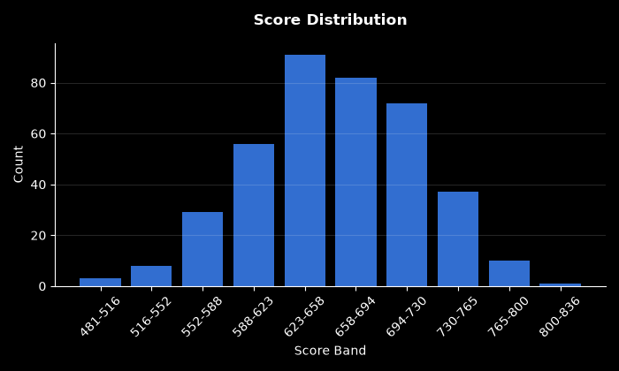

Chart Pd Distribution
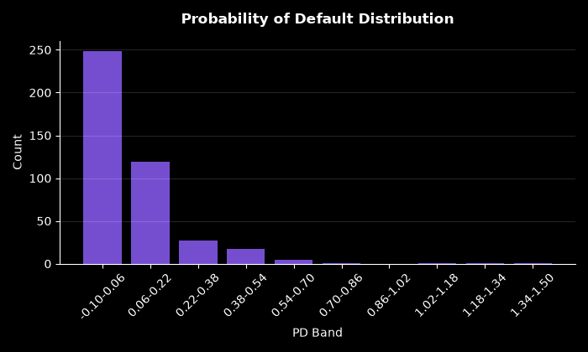

Chart Bad Rate By Score Band
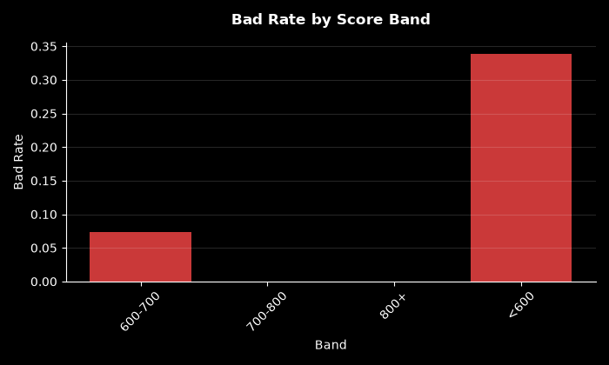

Chart Approval By Risk Band
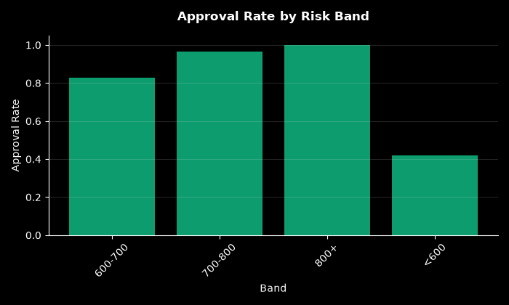

Chart Calibration
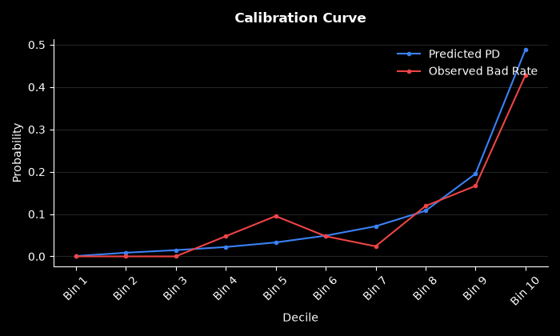

Chart Dpd Distribution
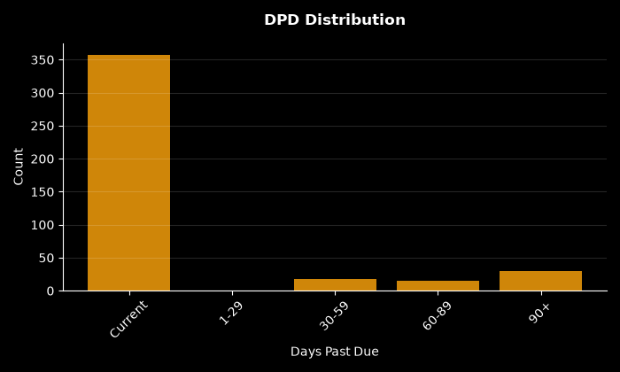

Chart Decile Lift
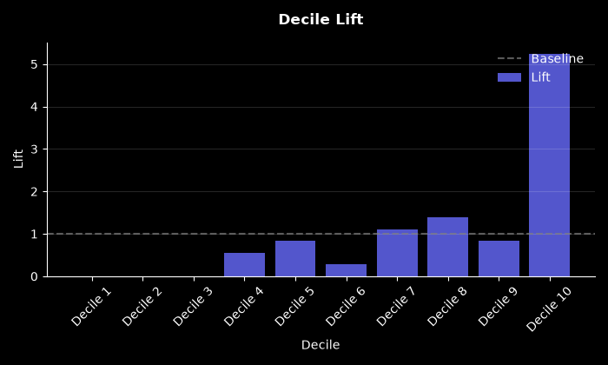

Chart Roc Curve
