

Model Risk Validation Report
Full Technical & Quantitative Analysis
Monitor ID | Run ID | Health Score | Health Status
mon_stable | run_c5b2ff56... | 89.6/100 | HEALTHY
Generated At: 2026-09-16

AI Narrative Analysis

Executive Summary
The model appears to be in a healthy state with no critical or warning findings, and a stable baseline. The analysis of 2500 dataset rows did not reveal any significant issues.

Technical Summary
There are no specific metric breaches or key findings to report. The absence of findings suggests that the model's performance is stable and consistent.

Key Performance Metrics
Metric | Value | Threshold | Status
Brier Skill Score | 0.1360 | N/A | OK
Calibration Ratio | 1.1053 | N/A | OK
Row Count | 2500.0000 | N/A | OK
Duplicate Row Count | 0.0000 | N/A | OK
Null Rates | N/A | N/A | OK
Invalid Probability Count | 0.0000 | N/A | OK
Invalid Target Count | 0.0000 | N/A | OK
Monitoring Readiness Summary | N/A | N/A | OK
Score-PD Coherence | -0.9836 | N/A | OK
Band Consistency | N/A | N/A | SKIPPED
DPD Buckets | N/A | N/A | SKIPPED
Score PSI | 0.0077 | N/A | OK
ROC AUC | 0.7948 | N/A | OK
Gini Coefficient | 0.5897 | N/A | OK
KS Statistic | 0.4664 | N/A | OK
Decile Table | N/A | N/A | OK
Score Distribution Analysis | N/A | N/A | CRITICAL
Approval Rate | 0.7920 | N/A | OK
Overall Bad Rate | 0.1048 | N/A | OK

Statistical Tests
Test Name | Statistic | P-Value | Conclusion | Result
Hosmer-Lemeshow Test | 24.1281 | 0.0038 | Reject H₀ — distributions differ
Binomial Test: Band 3 | 15.0000 | 1.0000 | Fail to reject H₀ — distributions are similar
Binomial Test: Band 2 | 32.0000 | 1.0000 | Fail to reject H₀ — distributions are similar
Binomial Test: Band 4 | 3.0000 | 1.0000 | Fail to reject H₀ — distributions are similar
Binomial Test: Band 0 | 132.0000 | 0.0000 | Reject H₀ — distributions differ
Binomial Test: Band 1 | 80.0000 | 0.0002 | Reject H₀ — distributions differ
Mann-Whitney U: Approved vs Declined Scores | 854216.0000 | 0.0000 | Reject H₀ — distributions differ

Override Analysis

Cutoff: 550
"Overridden accounts show a HIGHER bad rate than model-approved accounts (69.2% vs 6.8%), indicating possible excessive risk taking on model-declines."
Model Declines | Overrides | Override Rate | Override Bad Rate
82 | 13 | 15.9% | 69.2%
Conclusion: Overrides are performing worse than standard model approvals.

Cutoff: 600
"Overridden accounts show a HIGHER bad rate than model-approved accounts (19.6% vs 6.3%), indicating possible excessive risk taking on model-declines."
Model Declines | Overrides | Override Rate | Override Bad Rate
389 | 138 | 35.5% | 19.6%
Conclusion: Overrides are performing worse than standard model approvals.

Cutoff: 650
"Overridden accounts show a HIGHER bad rate than model-approved accounts (15.3% vs 2.9%), indicating possible excessive risk taking on model-declines."
Model Declines | Overrides | Override Rate | Override Bad Rate
1117 | 685 | 61.3% | 15.3%
Conclusion: Overrides are performing worse than standard model approvals.

Cutoff: 700
"Overridden accounts show a HIGHER bad rate than model-approved accounts (10.0% vs 0.5%), indicating possible excessive risk taking on model-declines."
Model Declines | Overrides | Override Rate | Override Bad Rate
1903 | 1405 | 73.8% | 10.0%
Conclusion: Overrides are performing worse than standard model approvals.

Model Visualizations

Chart Score Distribution
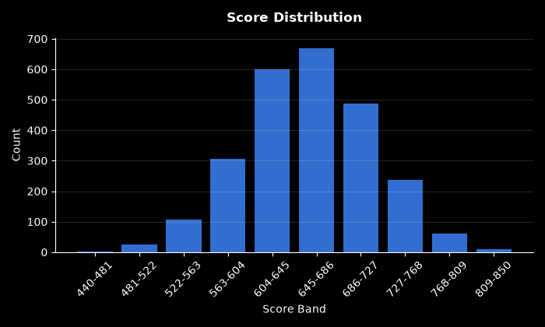

Chart Pd Distribution
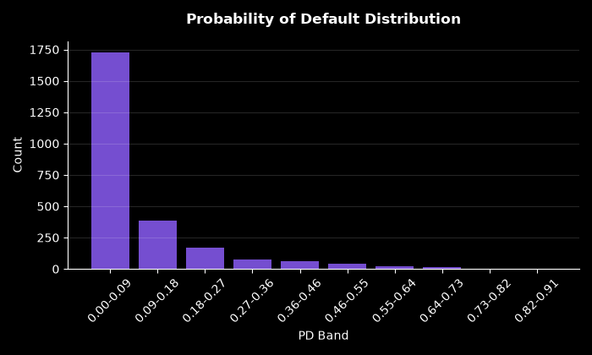

Chart Bad Rate By Score Band
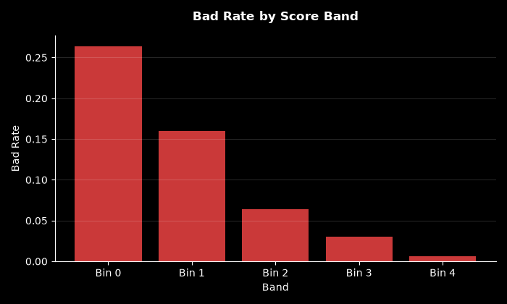

Chart Approval By Risk Band
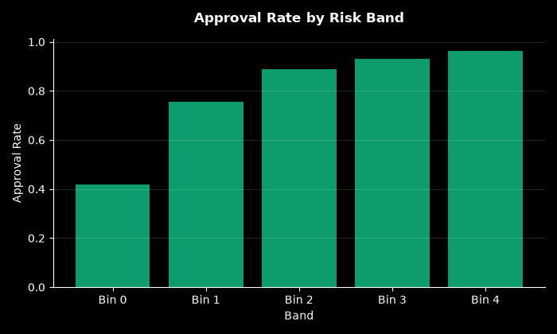

Chart Calibration
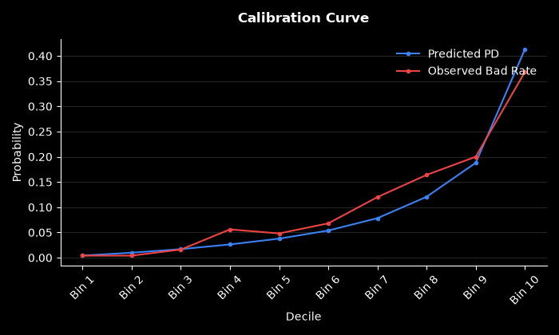

Chart Psi Breakdown
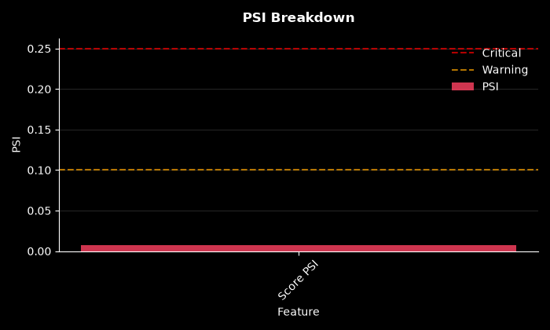

Chart Decile Lift
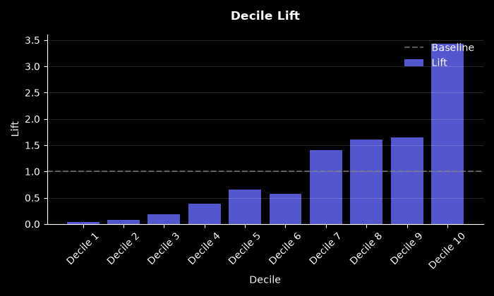

Chart Roc Curve
