

ModelPulse — Model Risk Monitoring Report

Report Details
Run ID | Generated At | Health Score | Health Status
run_f66c1afeefdd | 2026-09-16 | 90.08137364498232 | healthy

Executive Summary
The model is healthy and stable.

Key Metrics
Metric | Value | Status | Threshold
Brier Skill Score | 0.1165 | OK | None
Calibration Ratio | 1.0000 | OK | None
Row Count | 5000.0000 | OK | None
Duplicate Row Count | 0.0000 | OK | None
Null Rates | None | OK | None
Invalid Probability Count | 0.0000 | OK | None
Invalid Target Count | 0.0000 | OK | None
Monitoring Readiness Summary | None | OK | None
Score-PD Coherence | -0.9836 | OK | None
Band Consistency | 1.0000 | OK | None
DPD Buckets | None | OK | None
Score PSI | None | SKIPPED | None
ROC AUC | 0.7854 | OK | None
Gini Coefficient | 0.5708 | OK | None
KS Statistic | 0.4353 | OK | None
Decile Table | None | OK | None
Score Distribution Analysis | None | OK | None
Approval Rate | 0.8012 | OK | None
Overall Bad Rate | 0.0916 | OK | None

Charts & Visualizations
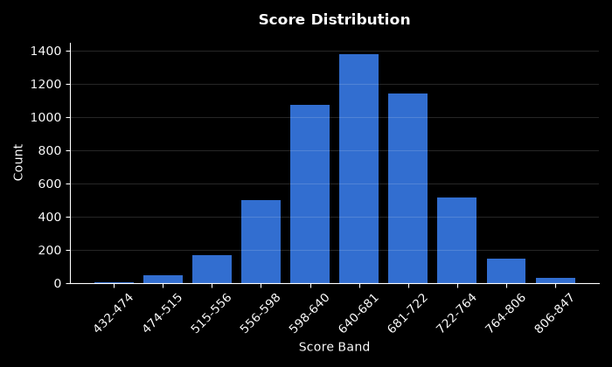
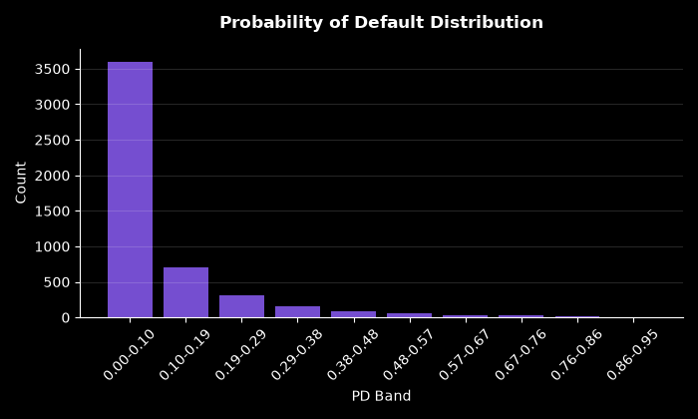
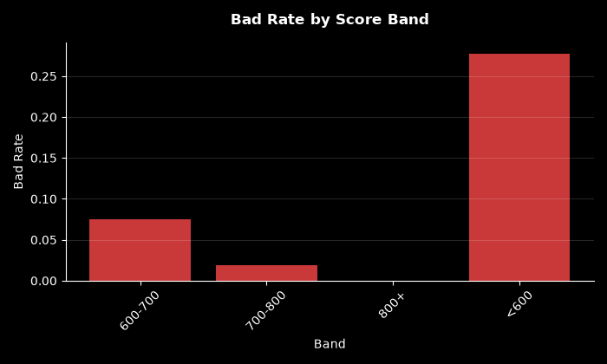
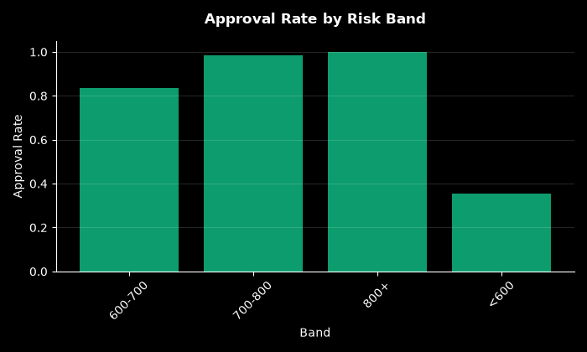
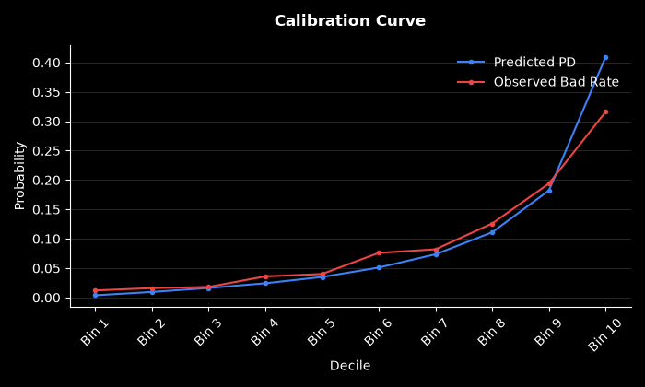
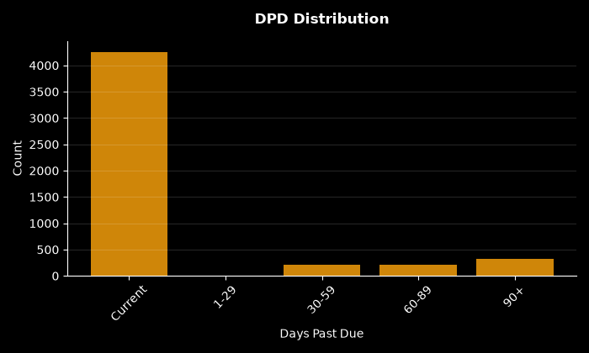
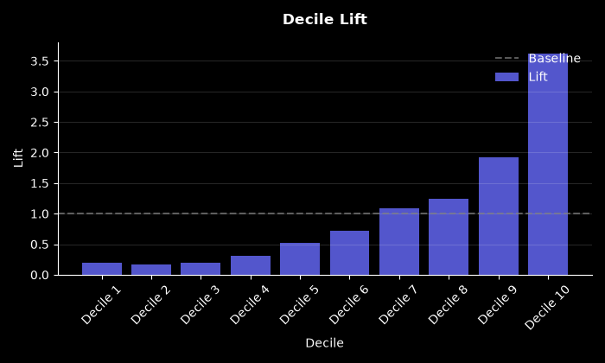
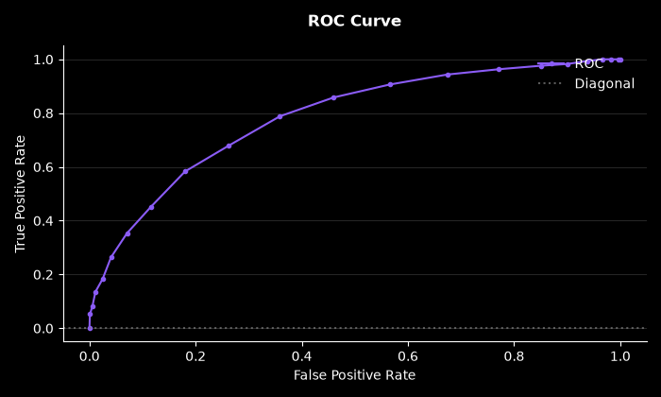

Technical Analysis
Mock technical summary based on findings.

Root Causes
- Mock cause 1
- Mock cause 2

Recommended Actions
- Mock action 1

Statistical Tests
Test Name | Statistic | P-Value | Conclusion | Result
Hosmer-Lemeshow Test | 41.5414 | 0.0000 | Reject H₀ — distributions differ
Binomial Test: Band 600-700 | 225.0000 | 1.0000 | Fail to reject H₀ — distributions are similar
Binomial Test: Band 700-800 | 23.0000 | 1.0000 | Fail to reject H₀ — distributions are similar
Binomial Test: Band <600 | 210.0000 | 0.0000 | Reject H₀ — distributions differ
Binomial Test: Band 800+ | 0.0000 | 1.0000 | Fail to reject H₀ — distributions are similar
Mann-Whitney U: Approved vs Declined Scores | 3372339.5000 | 0.0000 | Reject H₀ — distributions differ

