

Model Risk Validation Report
Full Technical & Quantitative Analysis
Monitor ID | Run ID | Health Score | Health Status
mon_baseline | run_f66c1afe... | 90.1/100 | HEALTHY
Generated At: 2026-09-16

AI Narrative Analysis

Executive Summary
The model is healthy and stable.

Technical Summary
Mock technical summary based on findings.

Root Causes
- Mock cause 1
- Mock cause 2

Recommended Actions
- Mock action 1

Key Performance Metrics
Metric | Category | Value | Threshold | Status
Brier Skill Score | calibration | 0.1165 | N/A | OK
Calibration Ratio | calibration | 1.0000 | N/A | OK
Row Count | data_quality | 5000.0000 | N/A | OK
Duplicate Row Count | data_quality | 0.0000 | N/A | OK
Null Rates | data_quality | N/A | N/A | OK
Invalid Probability Count | data_quality | 0.0000 | N/A | OK
Invalid Target Count | data_quality | 0.0000 | N/A | OK
Monitoring Readiness Summary | data_quality | N/A | N/A | OK
Score-PD Coherence | data_quality | -0.9836 | N/A | OK
Band Consistency | data_quality | 1.0000 | N/A | OK
DPD Buckets | delinquency | N/A | N/A | OK
Score PSI | drift | N/A | N/A | SKIPPED
ROC AUC | performance | 0.7854 | N/A | OK
Gini Coefficient | performance | 0.5708 | N/A | OK
KS Statistic | performance | 0.4353 | N/A | OK
Decile Table | performance | N/A | N/A | OK
Score Distribution Analysis | performance | N/A | N/A | OK
Approval Rate | strategy | 0.8012 | N/A | OK
Overall Bad Rate | strategy | 0.0916 | N/A | OK

Statistical Tests
Test Name | Statistic | P-Value | Conclusion | Status
Hosmer-Lemeshow Test | 41.5414 | 0.0000 | Reject H₀ — distributions differ
Binomial Test: Band 600-700 | 225.0000 | 1.0000 | Fail to reject H₀ — distributions are similar
Binomial Test: Band 700-800 | 23.0000 | 1.0000 | Fail to reject H₀ — distributions are similar
Binomial Test: Band <600 | 210.0000 | 0.0000 | Reject H₀ — distributions differ
Binomial Test: Band 800+ | 0.0000 | 1.0000 | Fail to reject H₀ — distributions are similar
Mann-Whitney U: Approved vs Declined Scores | 3372339.5000 | 0.0000 | Reject H₀ — distributions differ

Vintage Analysis (Roll Rate)
Note: True roll rate matrix requires two time-snapshot datasets. This shows current DPD bucket distribution.
Severe Delinquency Rate: 6.60%
Bucket | Count | Percentage | Cumulative %
Current (0 DPD) | 4250 | 85.0% | 85.0%
1-29 DPD | 0 | 0.0% | 85.0%
30-59 DPD | 215 | 4.3% | 89.3%
60-89 DPD | 205 | 4.1% | 93.4%
90+ DPD | 330 | 6.6% | 100.0%

Override Analysis

Cutoff: 550
"Overridden accounts show a HIGHER bad rate than model-approved accounts (31.0% vs 6.1%), indicating possible excessive risk taking on model-declines."
Model Declines | Overrides | Override Rate | Override Bad Rate
172 | 29 | 16.9% | 31.0%
Conclusion: Overrides are performing worse than standard model approvals.

Cutoff: 600
"Overridden accounts show a HIGHER bad rate than model-approved accounts (22.7% vs 5.1%), indicating possible excessive risk taking on model-declines."
Model Declines | Overrides | Override Rate | Override Bad Rate
757 | 269 | 35.5% | 22.7%
Conclusion: Overrides are performing worse than standard model approvals.

Cutoff: 650
"Overridden accounts show a HIGHER bad rate than model-approved accounts (13.0% vs 3.1%), indicating possible excessive risk taking on model-declines."
Model Declines | Overrides | Override Rate | Override Bad Rate
2115 | 1291 | 61.0% | 13.0%
Conclusion: Overrides are performing worse than standard model approvals.

Cutoff: 700
"Overridden accounts show a HIGHER bad rate than model-approved accounts (8.3% vs 1.8%), indicating possible excessive risk taking on model-declines."
Model Declines | Overrides | Override Rate | Override Bad Rate
3746 | 2771 | 74.0% | 8.3%
Conclusion: Overrides are performing worse than standard model approvals.

Model Visualizations

Chart Score Distribution
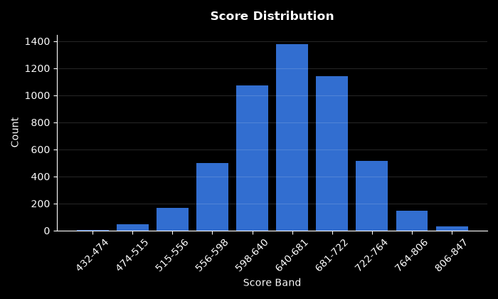

Chart Pd Distribution
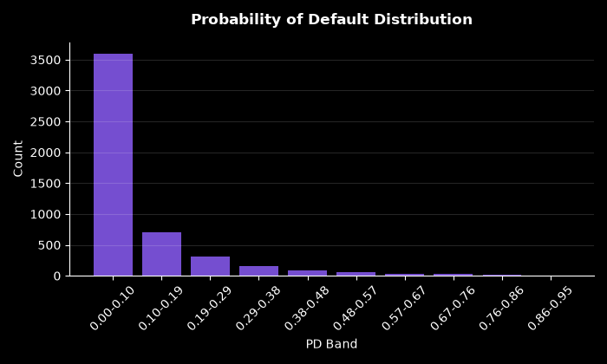

Chart Bad Rate By Score Band
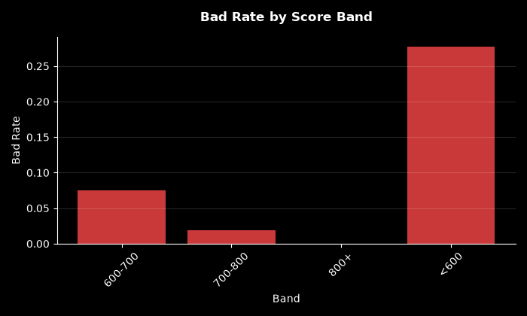

Chart Approval By Risk Band
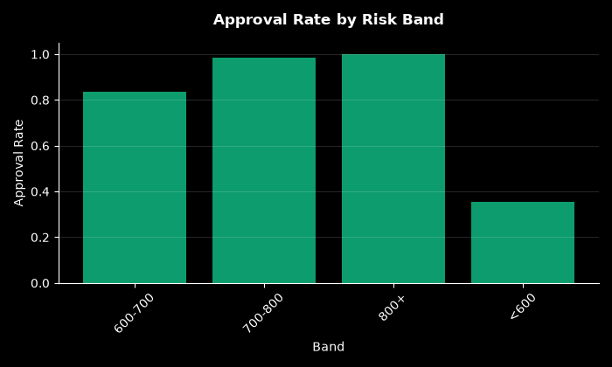

Chart Calibration
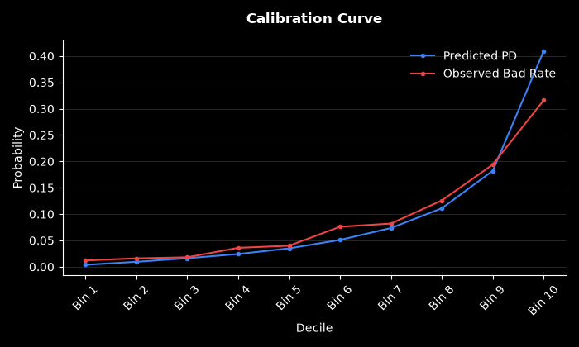

Chart Dpd Distribution
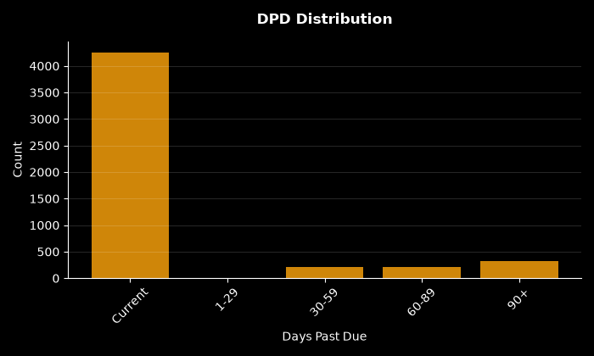

Chart Decile Lift
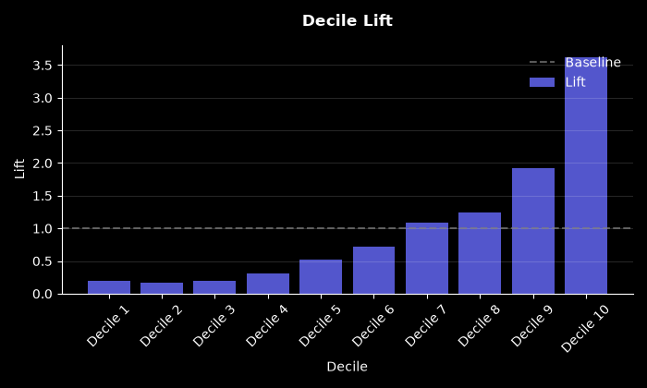

Chart Roc Curve
