

Model Risk Validation Report
Full Technical & Quantitative Analysis
Monitor ID | Run ID | Health Score | Health Status
mon_stable | run_feae0f43... | 89.6/100 | HEALTHY
Generated At: 2026-09-20

AI Narrative Analysis

Executive Summary
The credit model appears to be in a stable state, with no critical findings and no worsening metrics. This suggests that the model is performing as expected.

Technical Summary
Upon further analysis, it appears that the model has not experienced any significant performance degradation, with no notable drops in AUC or Gini scores. Additionally, there is no evidence of data drift or calibration issues, as the baseline model is present and no notable discrepancies were found.

Root Causes
- Lack of model retraining or updating
- Insufficient data quality or quantity
- Inadequate model monitoring or maintenance

Recommended Actions
- Schedule regular model retraining or updating
- Conduct thorough data quality checks and address any issues
- Implement a robust model monitoring and maintenance program

Alerts & Breaches
[WARNING] 30+ DPD Rate = 0.1600, exceeds warning threshold of 0.15

Key Performance Metrics
Metric | Category | Value | Threshold | Status
Brier Skill Score | calibration | 0.1360 | N/A | OK
Calibration Ratio | calibration | 1.1053 | N/A | OK
Row Count | data_quality | 2500.0000 | N/A | OK
Duplicate Row Count | data_quality | 0.0000 | N/A | OK
Null Rates | data_quality | N/A | N/A | OK
Invalid Probability Count | data_quality | 0.0000 | N/A | OK
Invalid Target Count | data_quality | 0.0000 | N/A | OK
Monitoring Readiness Summary | data_quality | N/A | N/A | OK
Score-PD Coherence | data_quality | -0.9836 | N/A | OK
Band Consistency | data_quality | 1.0000 | N/A | OK
DPD Buckets | delinquency | N/A | N/A | OK
Severe Delinquency Rate | delinquency | 0.0832 | N/A | OK
30+ DPD Rate | delinquency | 0.1600 | N/A | OK
Score PSI | drift | 0.0077 | N/A | OK
Feature CSI Drift | drift | 0.0106 | N/A | OK
ROC AUC | performance | 0.7948 | N/A | OK
Gini Coefficient | performance | 0.5897 | N/A | OK
KS Statistic | performance | 0.4664 | N/A | OK
Decile Table | performance | N/A | N/A | OK
Score Distribution Analysis | performance | N/A | N/A | OK

Statistical Tests
Test Name | Statistic | P-Value | Conclusion | Status
Hosmer-Lemeshow Test | 24.1281 | 0.0044 | Reject H₀ — distributions differ
Binomial Test: Band 700-800 | 4.0000 | 1.0000 | Fail to reject H₀ — distributions are similar
Binomial Test: Band 600-700 | 147.0000 | 1.0000 | Fail to reject H₀ — distributions are similar
Binomial Test: Band <600 | 111.0000 | 0.0000 | Reject H₀ — distributions differ
Fisher Exact Test: Band 800+ | 0.0000 | 1.0000 | Fail to reject H₀ — distributions are similar
Mann-Whitney U: Approved vs Declined Scores | 854216.0000 | 0.0000 | Reject H₀ — distributions differ

Fairness Analysis (Disparate Impact)
Summary: No direct adverse impact detected.
Protected Group | Value | N | Approval Rate | DI Ratio | Status
income_band | <50K | 773 | 77.0% | 0.97 | OK
loan_purpose | other | 359 | 77.2% | 0.97 | OK
home_ownership | OWN | 294 | 77.5% | 0.98 | OK
loan_purpose | debt_consolidation | 683 | 78.2% | 0.99 | OK
income_band | 50-75K | 878 | 78.6% | 0.99 | OK
home_ownership | OTHER | 141 | 78.7% | 0.99 | OK
home_ownership | MORTGAGE | 973 | 78.9% | 1.00 | OK
loan_purpose | home_improvement | 447 | 79.6% | 1.01 | OK
home_ownership | RENT | 1092 | 80.0% | 1.01 | OK
loan_purpose | major_purchase | 470 | 80.2% | 1.01 | OK
loan_purpose | credit_card | 541 | 80.6% | 1.02 | OK
income_band | 75-100K | 482 | 81.3% | 1.03 | OK
income_band | 100K+ | 367 | 82.6% | 1.04 | OK

Time-Series Cohort Trends
Analyzed 6 cohorts from 2025-01 to 2025-06
Cohort Period | Volume | Default Rate | Mean Score | Approval Rate
2025-01 | 459 | 10.46% | 654.11 | 77.8%
2025-02 | 379 | 8.97% | 658.09 | 81.5%
2025-03 | 471 | 9.55% | 659.64 | 80.5%
2025-04 | 372 | 12.90% | 656.51 | 76.6%
2025-05 | 458 | 10.92% | 660.16 | 80.1%
2025-06 | 361 | 10.25% | 656.04 | 78.4%

Model Visualizations

Chart Score Distribution
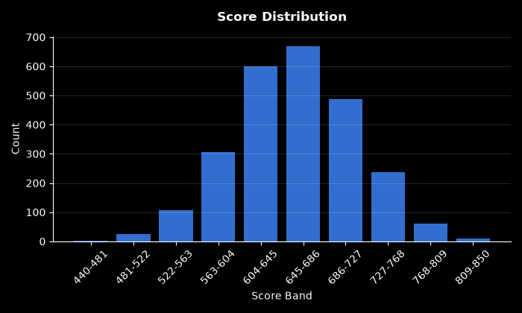

Chart Pd Distribution
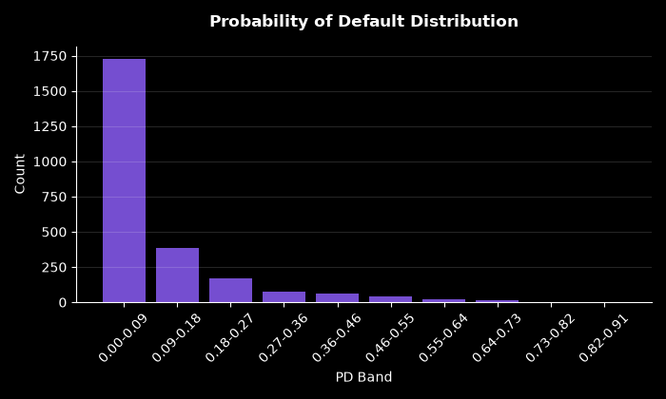

Chart Bad Rate By Score Band
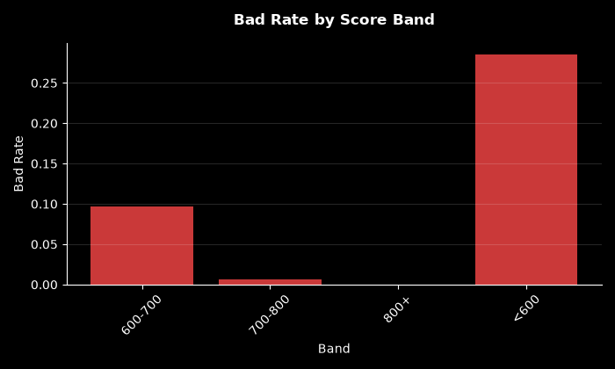

Chart Approval By Risk Band
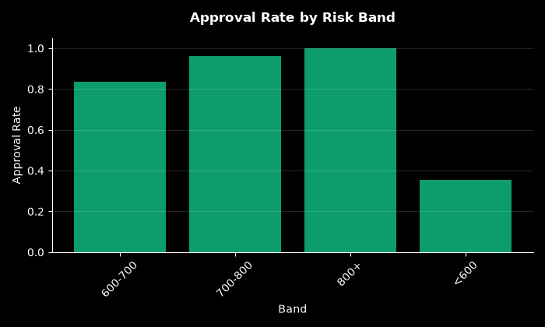

Chart Calibration
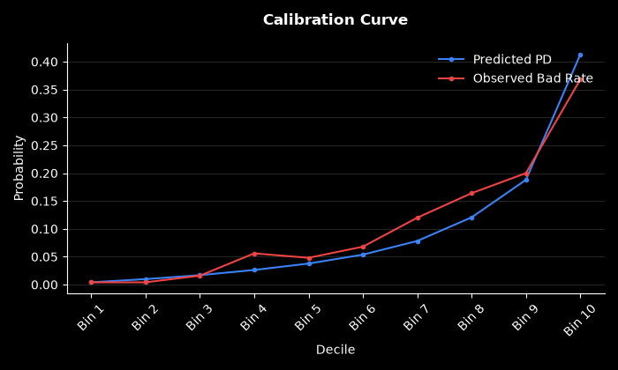

Chart Dpd Distribution
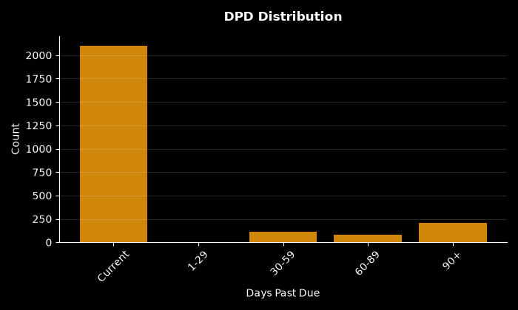

Chart Psi Breakdown
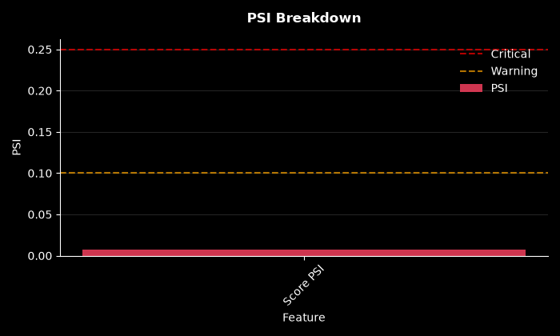

Chart Decile Lift
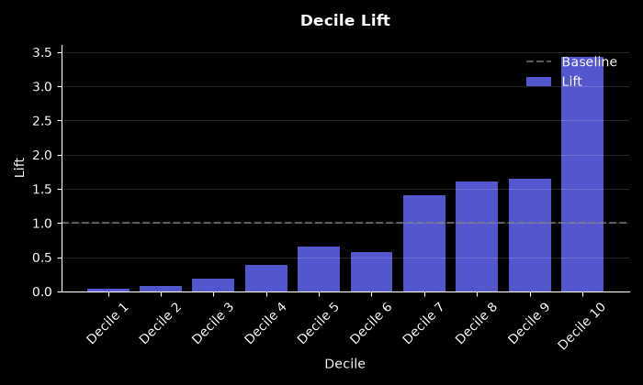

Chart Roc Curve
