Software Requirements Specification for
PrepStation
Version 1.0 approved
Prepared by
Harshil Rana(19CE118)
Hemit Rana(19CE119)
Jainil Rana(19CE120)
Saheel Sapovadia(19CE127)
Manan Shah(19CE136)
CHARUSAT
20/08/2021
Table of Contents
Table of Contents ii
Revision History ii
1. Introduction 1
1.1 Objecitve 1
1.2 Document Conventions 1
1.3 Intended Audience and Reading Suggestions 1
1.4 Project Scope 1
2. Overall Description 2
2.1 Product Perspective 2
2.2 Product Features 2
2.3 User Classes and Characteristics 2
2.4 Operating Environment 2
2.5 Design and Implementation Constraints 3
2.6 User Documentation 3
3. System Features 3
3.1 System Feature 1 3
4. External Interface Requirements 4
4.1 User Interfaces 4
4.2 Hardware Interfaces 5
4.3 Software Interfaces 5
5. Other Nonfunctional Requirements 5
5.1 Performance Requirements 5
5.2 Safety Requirements 6
5.3 Security Requirements 6
Appendix A: Glossary 6
Appendix B: Analysis Models 7
Appendix C: Issues List 7

Revision History
Name | Date | Reason For Changes | Version

Introduction

Introduction
Online Examination System is a computerized system which gives instant results and also saves time. It fully automates the previous manual process of taking written exams. schemes. Students can study independently for example at home or any place.

Document Conventions
When writing the SRS document for the 5th Semester SGP the following terminologies are: To make the document more effective and readable we used Times New Roman font style and 11 font size and headings are bold.

Intended Audience and Reading Suggestions
This document is intended for schools, teaching staff, students who are willing to appear in competitive examinations.

This SRS contains the details of the project, along with its features, a visual description and how it is organized. The sequence for reading the document, begins with the overview section and proceeds in the order of the documentation.

Project Scope
- Particularly for “Narayan Vidyalaya”.
- Only for competitive exams (without any enhancement)
- Tab pin is not included.
- Video/audio capturing system is not supported.
- Organization must provide students’ Roll No.

Overall Description

Product Perspective
It will replace the old way when schools/organization used to take paper-based exams. Today, with the help of a PrepStation software student can get instant results and also saves time and able to keep track of their progress.

Product Features

Signup/login, student dashboard, teacher/faculty dashboard, test schedule feature, check performance feature: The application shall allow user to insert a new user email/roll no. and password details. Password should be at least 6 characters long. The application shall allow user to insert a their credentials for login. user need to add the details of that particular test like add section, name/section, no of que, point for correct, Negative point for wrong. form asks to enter some basic info about test like number of questions, points, time duration etc. user can see the results/statistics of their overall attempted tests

User Classes and Characteristics
The different user classes are as follows:

- Teacher/organization owner: Teacher of particular school can use our system to create tests, manage student score records, provide merit list etc. This software can be used by Teacher/organization owner for easy maintenance of their students’ performance.
- students: Students of HSC can use our system to attempt tests, track their report, see their progress etc. They can get instant results and also saves time and able to keep track of their progress.
- Admin: We as admins can send important messages and manage user records.

Operating Environment
Operating Environment: PC with Windows 7/8/10/11, Linux operating system,
Browsers: Google Chrome, Mozilla, Microsoft edge, Opera

Design and Implementation Constraints
Some constraints that may limit the options available to the developers are: hardware limitations requirement of a PC at the owner’s site for running the software accompanied by a stable power supply, language constraints (the users/operators must be well-versed with English language).

Assumptions and Dependencies
The project is expected to run perfectly fine but the user cannot expect to get OTA updates, since the project is being created with a vision that it will be stable. However, any modifications or updates can be implemented on demand from the user.

System Features

Sign Up of New User

Description and Priority
- This feature is for the user to register their account details and user has an ability to make changes if the entered details are invalid or incorrect. It’s a medium priority feature. Here the user can register by filling up the details as per the requirement for registration. The account needs to be activated by the admin to be registered into the system.
- This feature will collect and manage information of users like E-mail and Password.
- Priority of this feature is High.

3.1.2 Stimulus/Response Sequences
Stimulus: User requests to enter their email/roll No. and password.
Response: account verification link sent to their registered e-mail. (users need to verify their mail account for login to the application.)

3.1.3 Functional Requirements
Feature ID | Feature Name | Description
FR-SU-1 | Insert User email/roll No. and set a password. | The application shall allow user to insert a new user email/roll no. and password details. Password should be atleast 6 characters long

User Login
3.2.1 Description and Priority
- This feature will let the users to login into the application by checking their credentials.
- Priority of this feature is High.

3.2.2 Stimulus/Response Sequences
Stimulus: User requests to enter their registered e-mail and password.
Response: if correct credentials then login successful otherwise login failed.

Stimulus: User have a choice for “Remember Me” option.
Response: If option is checked then user need not to enter credentials again when entering the app.

3.2.3 Functional Requirements

Feature ID | Feature Name | Description
FR-UL-1 | Insert Credential Details of user. | The application shall allow user to insert a their credentials for login.
FR-UL-2 | Remember me | If option is checked then user need not to enter credentials again when entering the app.

Teacher dashboard

Description and Priority
- Here the teacher can see the dashboard where he/she can access different features of the website after login.
- This feature will let the users to create and schedule new tests for students.
- Priority of this feature is High.

Stimulus/Response Sequences
Stimulus: User requests to schedule a test with fields add section, name/section, no of que, point for correct, Negative point for wrong answers.
Response: If option is checked then user need to add the details of that particular test like add section , name/section, no of que, point for correct, Negative point for wrong answers.

Stimulus: If user requests to redirect to the result section.
Response: user can see the results/statistics of their scheduled test

Functional Requirements
Feature ID | Feature Name | Description
FR-TD-1 | Schedule test | user need to add the details of that particular test like add section , name/section, no of que, point for correct, Negative point for wrong answers.
FR-TD-2 | Result section | user can see the results/statistics of their scheduled test.
FR-TD-2 | Profile section | This feature includes basic info about user.

student dashboard

Description and Priority
- Here the student can see the dashboard where he/she can access different features of the website after login.
- This feature will let the users to attempt new tests and see their results.
- Priority of this feature is High.

Stimulus/Response Sequences
Stimulus: User requests to attempt a test. The questions, 4/5 options and negative markings will be there.
Response: If start option is clicked then user will be redirected to the test and they can attempt the test.

Stimulus: If user request to redirect to the performance section.
Response: user can see the results/statistics of their overall attempted tests.

Functional Requirements
Feature ID | Feature Name | Description
FR-SD-1 | attempt test | user will be redirected to the test and they can attempt the test.
FR-SD-2 | performance section | user can see the results/statistics of their overall attempted tests
FR-SD-2 | Profile section | This feature includes basic info about user.

Test creation feature

Description and Priority
Here teacher is asked about some basic information about test they are going to schedule.

Stimulus/Response Sequences
Stimulus: User enters details about test like add section, no of que, point for correct, Negative point for wrong answers, number of questions, points, time duration
Response: then user is redirected to the page where they can add questions.

Functional Requirements
Feature ID | Feature Name | Description
FR-TC-1 | Test detail form | This form asks to enter some basic info about test like number of questions, points, time duration etc.

External Interface Requirements
The basic GUI (Graphical User Interface) of the project is been mentioned below:

User Interfaces
The interface Will be in the form of web page.

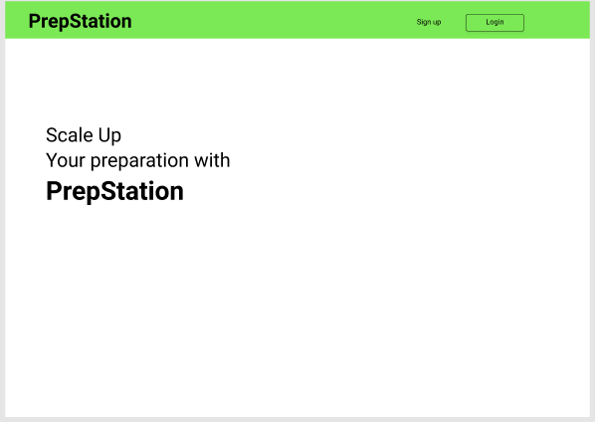
4.1.1 Home Page

This is home page of our website.

4.1.2 School selection page

In this page user can select school.

Also, in this page we will provide basic information about our website.

By clicking on next button user will be redirected to login/sign up page.

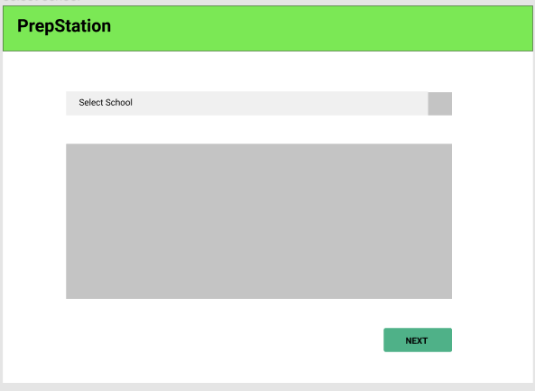

4.1.3 Login / Sign up

In this page user can select their role (student/ teacher).

User can register them selves by clicking on signup button and login to the system by clicking on login button.

By clicking on next button user will be redirected to the dashboard according to their chosen role.

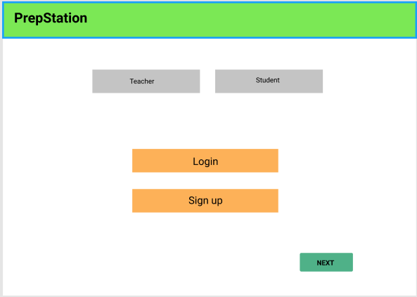

4.1.4 Teacher Dashboard

- In this page Teacher can create new test by clicking on create button.

- In “All Tests” section the list of scheduled tests will be provided.

- In “Today’s” section the list of that particular day’s scheduled tests will be provided.

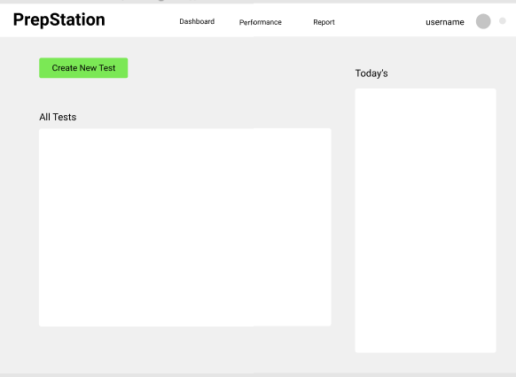

4.1.4 Student Dashboard

- In this page student can attempt test by clicking on “Join Now” button.

- In “Tests” section the list of scheduled tests will be provided.

- In “Today’s” section the list of that particular day’s scheduled tests will be provided.

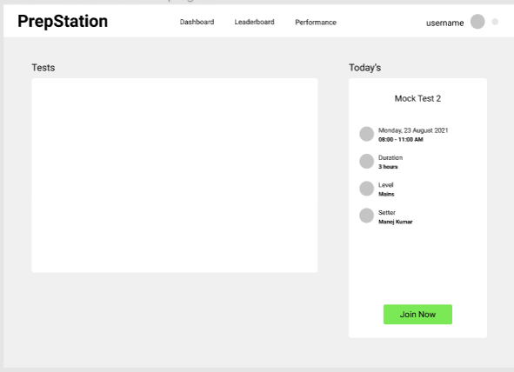

4.1.5 Test Intro

- In this page student can see Test duration, number of questions and platform instructions.
- By clicking on continue student can start their test

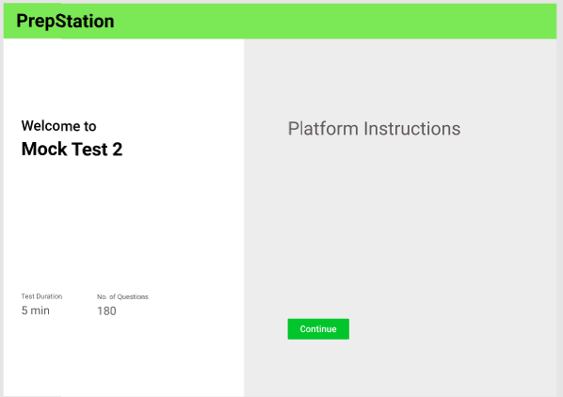

Software Interfaces

Software used | Microsoft Visual Studio Code, XAMPP
Language Used (front end) | 1. React js  2. Redux  3. Html  4. Css & scss  5. Bootstrap
Framework used (backend) | React, express, nodejs
Database | MySQL

Communications Interfaces
We can access the POS web application using web browsers like Mozilla Firefox, Google Chrome, Microsoft Edge, Opera. HTTP protocols will be used to communicate with the web browser in this project for security purposes.

Other Nonfunctional Requirements

Performance Requirements
- High page speed and Less page load time of web application,
- error rate must be low,
- peak response time,
- hardware utilization.

Security Requirements
All the data on the system will be hardware-backed only. Hence it is expected that the user will keep a backup of the data on the application for emergency situations or hardware breakdowns. There is no option of cloud-based backup on this system. Also, since the application has an admin panel and an student panel for dedicated workspace and efficient database management, the project owners will be solely responsible for any form of discrepancy of identity credentials. It is mandatory to have an account to access all data on the system.

Software Quality Attributes
AVAILABILITY: This Web application is easily available and accessible to the user without any constraints.

EFFICIENCY: This Web application works with full high performance with optimum use of internal memory of machines.

