A PROUD MEMBER OF

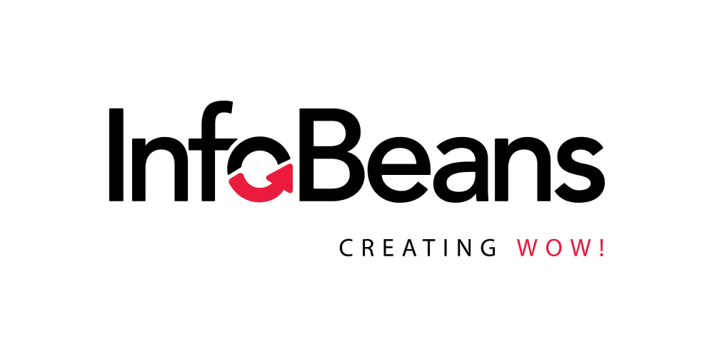
{name}
{jobTitle}
{experienceSummary}
{specialization}
Overview  {overview}  Education & Training  {#education}  {year}  {qualification}  {/education}  Projects  {#projects}  Project {number} - {duration}  {title}  Tools & Technologies  {toolsAndTechnologies}  Team Size  {teamSize}  Role  {role}  Project Link  {projectLink}  {description}  {#responsibilities}  - {.}  {/responsibilities}  {/projects} | Skills  {#skills}  {name}  ({rating}/5)  {/skills}  Certifications  {#certifications}  {.}  {/certifications}  Tools  {tools}  Managerial Experience  {#managerialExperience}  {.}  {/managerialExperience}  Domain  {#domains}  {.}  {/domains}  Languages  {#languages}  {.}  {/languages}

