AI JOB MARKET ANALYSIS
Data Analytics with AI Internship Project Report
Submitted by: Hemlata
Dataset: AI Job Market Dataset.csv

1. Abstract
This project analyzes 10,345 AI and technology-related job postings using Python-based data analytics. The analysis examines salary, experience level, job title, country, work arrangement, skills, hiring urgency, and job openings. Exploratory data analysis is combined with a Random Forest regression model as an AI/ML component to estimate salary from available job attributes.

2. Introduction
The AI job market contains information about roles, organizations, required skills, compensation, work arrangements, and hiring needs. Data analytics can be used to summarize these patterns and identify relationships useful for academic exploration. This project uses the supplied AI Job Market Dataset to demonstrate that workflow.

3. Objectives
- Understand dataset structure and quality.
- Explore salary patterns across experience levels and work arrangements.
- Analyze job-posting volume by job title and country.
- Measure prevalence of Python, SQL, machine learning, deep learning, and cloud indicators.
- Examine hiring urgency and job openings.
- Build a baseline Random Forest regression model for salary prediction.
- Present findings with visualizations and limitations.

4. Dataset Description
The dataset contains 10,345 rows and 19 columns. All 19 columns are populated in the supplied file.
Category | Examples | Purpose
Job information | job_title, job_id | Identify roles and postings
Company context | company_size, company_industry | Describe employer characteristics
Requirements | experience_level, years_experience, education_level | Analyze qualification patterns
Skills | Python, SQL, ML, deep learning, cloud indicators | Measure skill prevalence
Compensation | salary | Analyze and model salary
Demand/timing | job_openings, hiring_urgency, posting month/year | Analyze hiring demand

5. Tools and Technologies
- Python
- Pandas
- NumPy
- Matplotlib
- Scikit-learn
- Jupyter Notebook
- Microsoft Word

6. Methodology
- Load the CSV with Pandas.
- Check structure, data types, missing values, duplicates, and descriptive statistics.
- Perform grouped analysis and visualizations.
- Compare salary by experience, work arrangement, country, and skill indicators.
- Split data 80:20 for training/testing.
- Encode categorical variables and train a Random Forest Regressor.
- Evaluate using MAE and R².

7. Exploratory Data Analysis Results
The dataset has 10,345 records and 19 variables. Missing-value counts are zero across all columns, and there are 0 duplicate rows.
Salary ranges from 45,083 to 204,143; the average is 113,438.23 and the median is 113,082 in the dataset's stated numeric units.

7.1 Job titles
- Business Analyst: 1,773 postings
- AI Engineer: 1,742 postings
- Machine Learning Engineer: 1,740 postings
- Data Analyst: 1,711 postings
- Data Scientist: 1,703 postings
- Data Engineer: 1,676 postings

7.2 Experience and salary
Average salary: Entry 89,095.87; Mid 113,592.02; Senior 138,289.09.
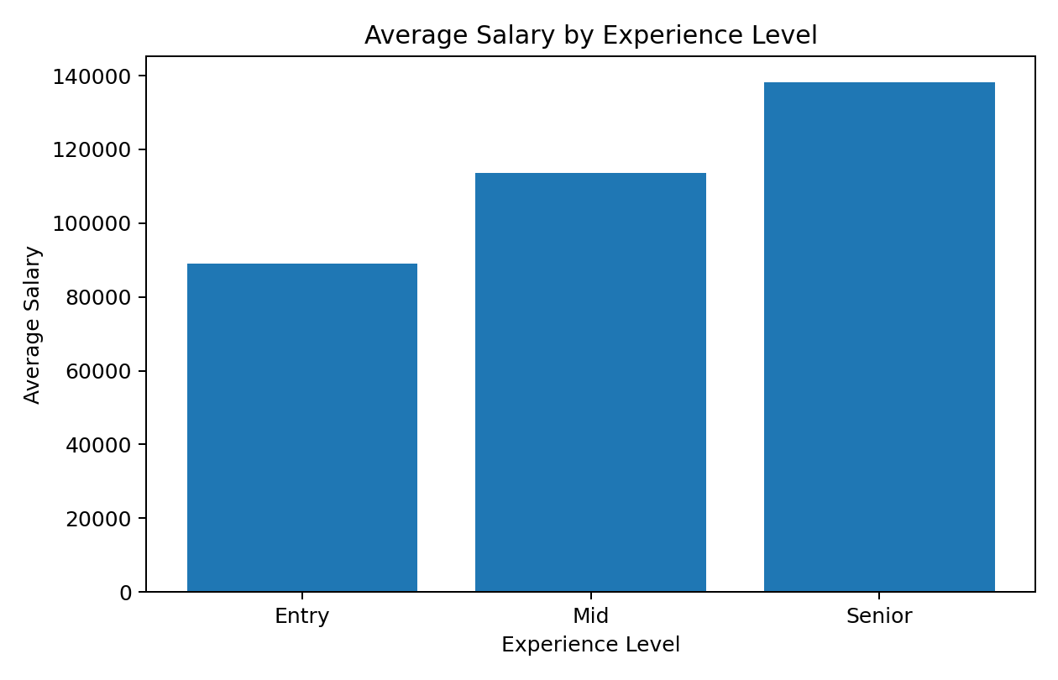

7.3 Work arrangement
Postings: Remote 3,513, Hybrid 3,420, Onsite 3,412. Average salaries: Remote 113,305.10, Hybrid 113,363.76, Onsite 113,649.94.
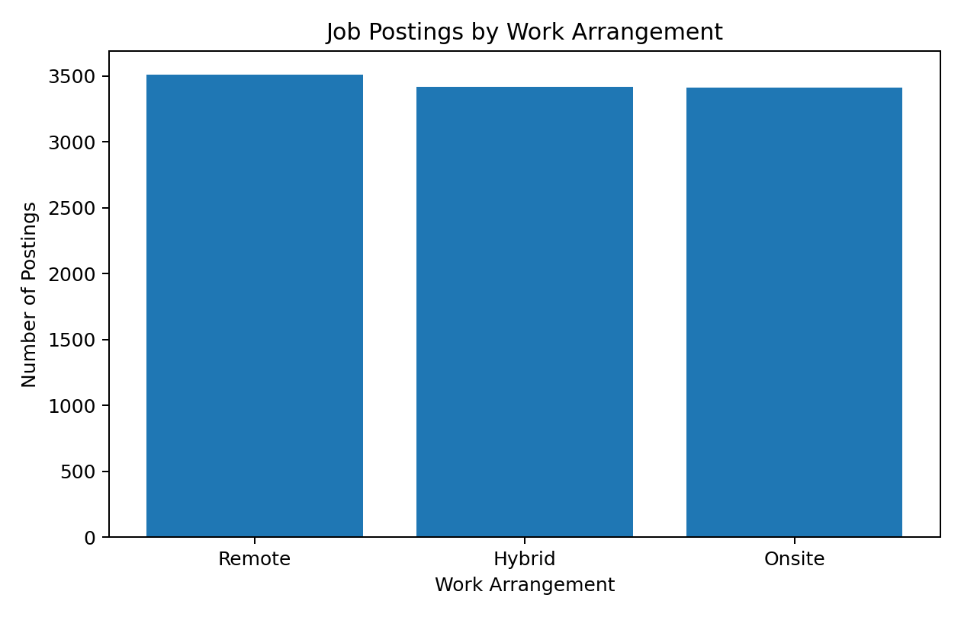

7.4 Skill analysis
Skill | Postings with skill | Share | Salary difference
Python | 5,101 | 49.31% | 598.68
SQL | 5,204 | 50.30% | -218.04
ML | 5,254 | 50.79% | 14,604.71
Deep Learning | 5,152 | 49.80% | 15,223.40
Cloud | 5,291 | 51.15% | 9,652.71
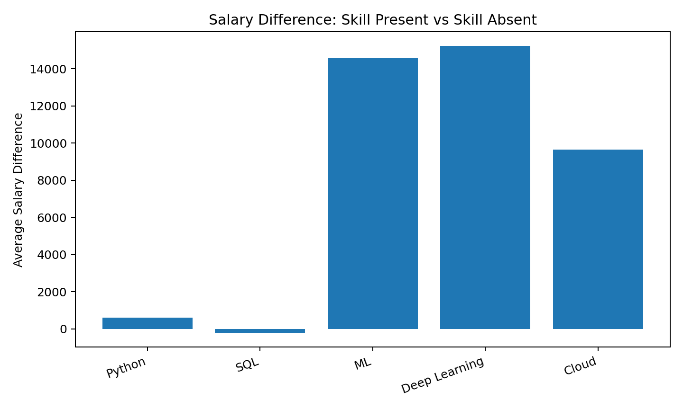
These are descriptive associations. They do not establish that a skill itself causes a salary change.

7.5 Hiring urgency and job openings
- High urgency: 5,195 postings, 33,940 total openings, average 6.53 openings per posting.
- Low urgency: 2,756 postings, 9,625 total openings, average 3.49 openings per posting.
- Medium urgency: 2,394 postings, 8,202 total openings, average 3.43 openings per posting.

8. AI/ML Model
A Random Forest Regressor used company, role, experience, education, skill, timing, urgency, and openings variables. With an 80:20 split, the test-set MAE was 18,066.78 and R² was 0.603.
These metrics describe this dataset and split only. The model is a baseline academic demonstration, not a validated real-world compensation tool.

9. Key Findings
- Senior postings have higher average salary than Mid and Entry postings in the supplied dataset.
- Remote, Hybrid, and Onsite postings have relatively similar average salary levels compared with the differences across experience levels.
- Machine-learning, deep-learning, and cloud-skill indicators show noticeable salary differences between postings with and without those indicators.
- High-urgency postings have a higher average number of openings per posting than Medium- and Low-urgency postings in this dataset.
- All 19 columns are complete with respect to missing values.

10. Limitations
- Salary currency and compensation period are not specified in the supplied columns.
- The dataset may not represent the entire global AI job market.
- Binary skill indicators do not measure proficiency.
- Observed group differences are associations, not proof of causation.
- The predictive model needs independent validation before practical use.
- The dataset includes posting years extending into 2026; interpret results according to its own time coverage.

11. Conclusion
The project demonstrates a complete data-analytics workflow: data inspection, quality checks, exploratory analysis, visualization, grouped comparisons, skill analysis, and machine-learning prediction. It provides a structured view of patterns in the supplied AI job-market data while separating descriptive findings from causal or predictive claims.

12. How to Reproduce
- Keep AI Job Market Dataset.csv in the same folder as the notebook.
- Install the dependencies from requirements.txt.
- Open Hemlata_AI_Job_Market_Analysis.ipynb in Jupyter Notebook, JupyterLab, or Google Colab.
- Run cells from top to bottom.
- Review the generated tables, charts, and model metrics.

