

**Internship Project Report**

**Subject Code: - BAJMC – 604**

**ALAKH PRAKASH GOYAL SHIMLA UNIVERSITY**

**BACHELOR OF JOURNALISM AND MASS COMMUNOICATION**

Submitted By: - Saloni Submitted to: - Dr. Vijay Shree Enrollment no.: - 22-BAJMC-07 Assistant Professor BAJMC

BAJMC 6TH Semester AP GOYAL SHIMLA UNIVERSITY

**Department of Media and Mass Communication**

**Alakh Prakash Goyal Shimla University, Shimla**

**Himachal Pradesh – 171009**

**ACKNOWLEDGMENT**

I extend my heartfelt gratitude to the Department of Journalism and Mass Communication for their unwavering support throughout my academic journey and internship. Their commitment to fostering journalistic excellence has been pivotal in shaping my professional growth, equipping me with the skills and confidence to excel in the dynamic field of media.

I am deeply thankful to Dr. Ashwani Sharma, Head of School, for his visionary leadership and invaluable mentorship. His initiative in arranging this internship provided me with a unique opportunity to apply classroom knowledge to real-world practice. Dr. Sharma’s guidance, marked by wisdom and encouragement, deepened my understanding of journalism’s ethical and intellectual dimensions. His ability to inspire has motivated me to pursue excellence and integrity in my work, leaving a lasting impact on my career aspirations.

Special thanks go to Mr. Mastram Dadel, Chief Bureau, Himachal Dastak, Shimla, for his exceptional mentorship during my internship. His hands-on guidance offered me significant exposure to both print and electronic media, making this experience truly enriching. Mr. Dadel’s expertise, patience, and constructive feedback helped me navigate the complexities of reporting and storytelling, fostering my growth as a journalist. His dedication created a supportive learning environment that enhanced my skills and passion for media.

The support from the department, Dr. Sharma, and Mr. Dadel has made this internship a transformative milestone. Their belief in my potential has inspired me to approach journalism with creativity and responsibility, and I am forever grateful for their guidance.

|  |  |  |
| --- | --- | --- |
| **SR.NO.** | **Table Content** | **Page No.** |
| 1. | Introduction |  |
| 2. | About the Organization |  |
| 3. | Organizational Structure |  |
| 4. | Objectives of the Internship |  |
| 5. | Nature of Work Assigned |  |
| 6. | Detailed Description of Work |  |
| 7. | Skills Acquired |  |
| 8. | Challenges Faced and Solutions |  |
| 10. | Observations and Suggestions |  |
| 11. | Conclusion |  |
| 12. | Annexures |  |
| 13. | Certificate |  |

**INDEX**

**INTRODUCTION**

As part of my academic curriculum in Journalism and Mass Communication, I had the opportunity to intern at Himachal Dastak, one of the leading Hindi news organizations in Himachal Pradesh. The internship spanned from 1st February 2025 to 1st May 2025. This report summarizes my experiences, learnings, and contributions during the internship in both the print and electronic media departments.

**ABOUT THE ORGANIZATION**

Himachal Dastak is a prominent Hindi-language news outlet headquartered in Shimla. It caters to a wide audience across Himachal Pradesh through both its print publication and electronic news platforms. The organization is known for its regional coverage, political reporting, developmental journalism, and people-centric stories. It has a well-established digital presence along with a physical newsroom that operates with high professional standards.

**ORGANIZATIONAL STRUCTURE**

The newsroom of Himachal Dastak consists of the following departments:

Editorial Department

Reporting Team (Field Reporters and Bureau Chiefs)

Print Production Department

Electronic Media Unit (Video, Editing, Anchoring)

Digital and Social Media Team

Administration and Management

My internship was primarily under the supervision of Mr. Mastram Dadel, Chief Bureau, Shimla, where I worked closely with both the print and electronic media teams

**OBJECTIVES OF THE INTERNSHIP**

To gain practical exposure to real-world journalism practices

To understand how editorial decisions are made and stories are developed

To acquire skills in field reporting, news writing, video scripting, and editing

To observe how a news organization functions in a deadline-driven environment

To bridge the gap between theoretical knowledge and professional journalism.

**NATURE OF WORK ASSIGNED**

During my internship at Himachal Dastak, I was entrusted with a variety of tasks that exposed me to the dynamic nature of news production. These included:

* Field reporting assignments on local events and civic issues
* Writing news reports and editing press releases for print publication
* Assisting in video scripting and voice-over work for electronic news bulletins
* Supporting the editorial team in story selection and news prioritization
* Covering press conferences and political briefings under the guidance of senior reporters
* Social media coordination and live coverage using digital platforms
* Basic video editing and camera handling during studio and outdoor shoots
* These responsibilities were crucial in helping me understand the multi-platform functioning of a modern newsroom.

**DETAILED DESCRIPTION OF WORK**

Throughout the three-month internship, I worked on a range of stories — from daily civic problems to political developments. I often accompanied senior reporters to field locations, where I learned how to conduct on-spot interviews and verify facts. I was also given independent assignments to write reports on local events such as cultural fairs, college functions, and road safety drives.

In the electronic media section, I was trained to draft video scripts, assist in studio anchoring, and operate teleprompters during recordings. Under supervision, I also practiced camera framing techniques and recorded voice-overs for short news bulletins.

**SKILLS ACQUIRED**

Proficiency in news writing and editing (Hindi and English)

Improved speed and accuracy in Hindi typing

Familiarity with media tools like teleprompters, microphones, and studio cameras

Hands-on experience in field reporting and interviewing techniques

Understanding of news judgment and story hierarchy

Better verbal communication, confidence, and on-camera presence

Social media handling and live reporting fundamentals

**Conclusion**

Through these acquired skills, I have developed a well-rounded foundation in journalism. From proficient writing and editing in both Hindi and English to hands-on experience with reporting tools and techniques, each skill has enhanced my practical knowledge and confidence. This holistic learning has prepared me to contribute effectively to a dynamic media environment, both on-field and in-studio.

**Annexures (Print Media)** 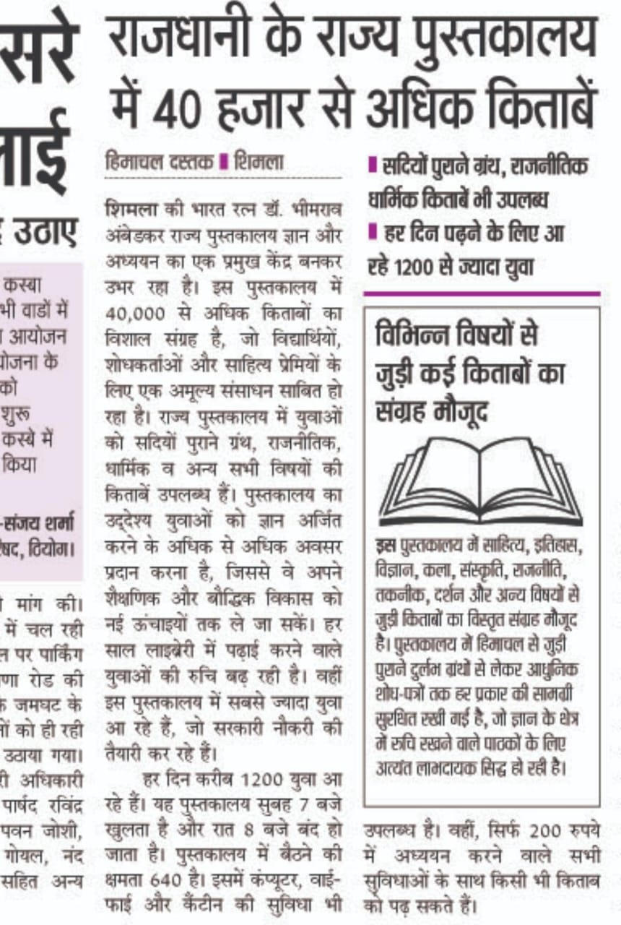 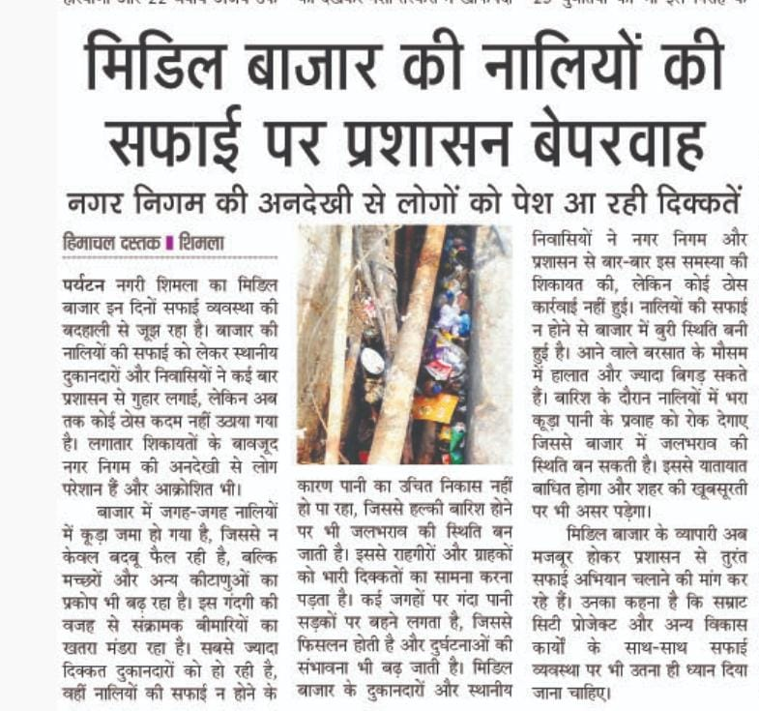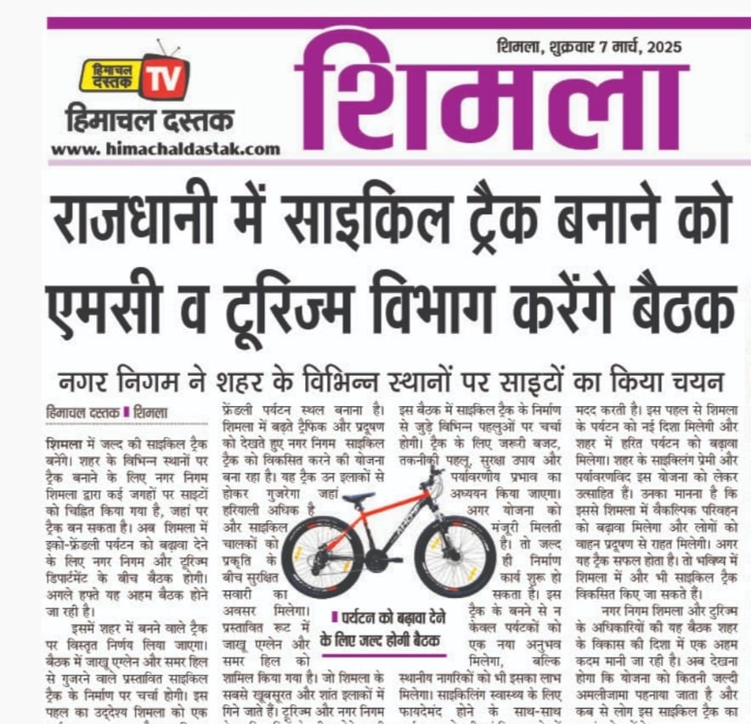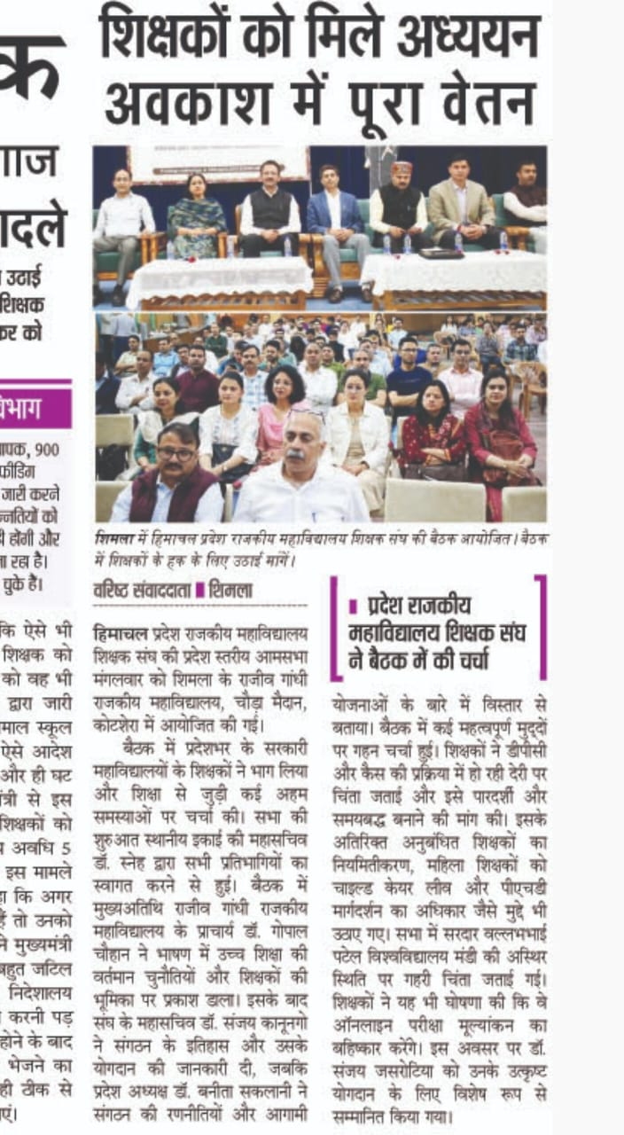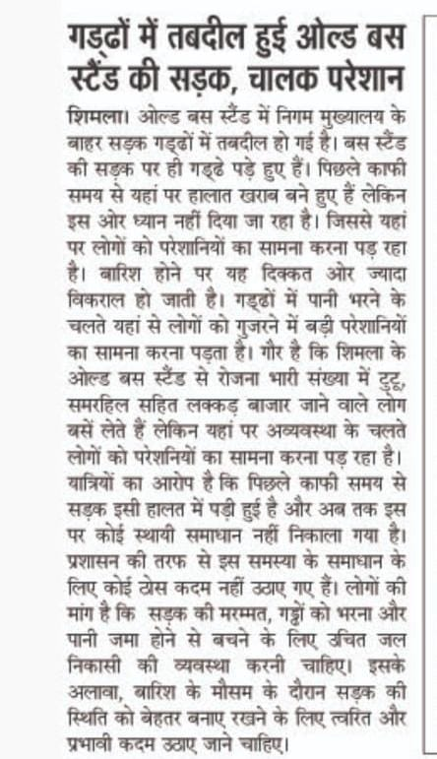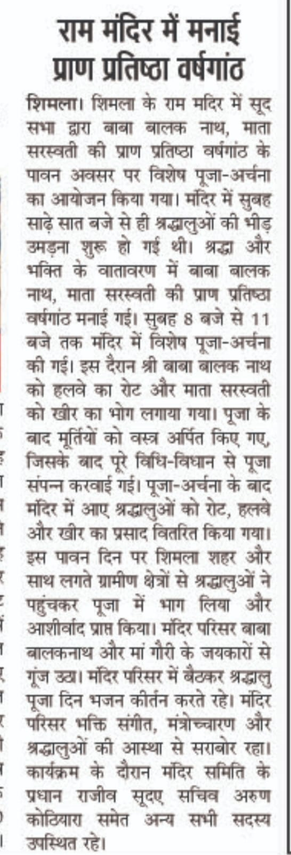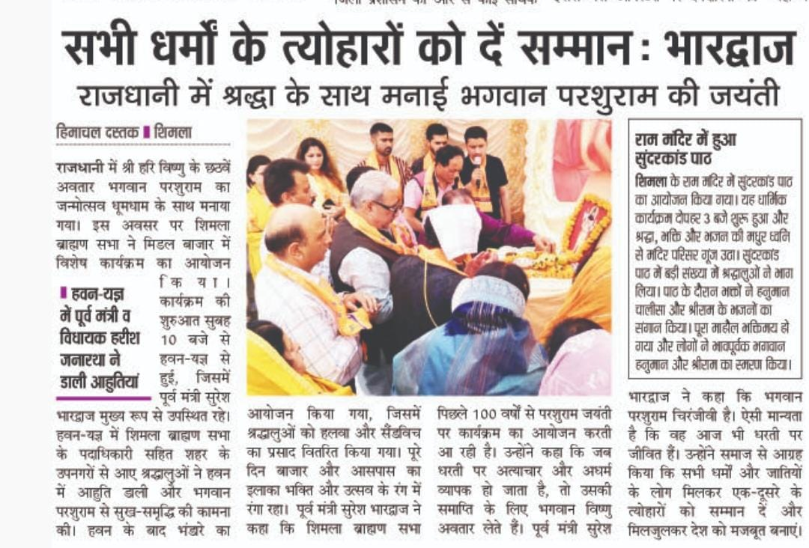

**Annexures (Electronic Media)**

* [**https://www.facebook.com/share/v/1BqPF9Q1cy/**](https://www.facebook.com/share/v/1BqPF9Q1cy/)
* [**https://www.facebook.com/share/p/1CbdUjWRWa/**](https://www.facebook.com/share/p/1CbdUjWRWa/) [**https://m.facebook.com/story.php?story_fbid=pfbid0afGBnhZvNggZ3kWe2WYQranqX6RKtnpQbt7VCx4WUFWvcgQHqrqb5wVEiwgQxNcCl&id=61567116728416&mibextid=ZbWKwL**](https://m.facebook.com/story.php?story_fbid=pfbid0afGBnhZvNggZ3kWe2WYQranqX6RKtnpQbt7VCx4WUFWvcgQHqrqb5wVEiwgQxNcCl&id=61567116728416&mibextid=ZbWKwL) [**https://www.facebook.com/share/r/1HkhYYck21/**](https://www.facebook.com/share/r/1HkhYYck21/)
* [**https://www.facebook.com/share/v/15unQ9mGN9/**](https://www.facebook.com/share/v/15unQ9mGN9/)
* [**https://www.facebook.com/share/r/1HkhYYck21/**](https://www.facebook.com/share/r/1HkhYYck21/)
* [**https://www.facebook.com/share/v/15unQ9mGN9/**](https://www.facebook.com/share/v/15unQ9mGN9/)

**CERTIFICATE**