**MYSQL DATABASE CREATION**

Customer database:

1. Auth table:

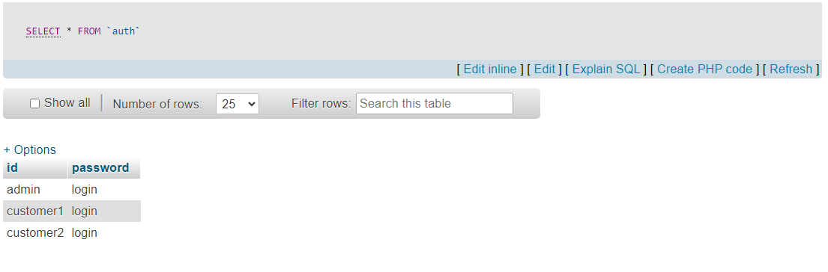

1. Customer_detail table:

