SOFTWARE TESTING CA – 1
QUESTION -1

package com.test.CA1;

import org.openqa.selenium.By;
import org.openqa.selenium.WebDriver;
import org.openqa.selenium.chrome.ChromeDriver;
import org.openqa.selenium.chrome.ChromeOptions;
import io.github.bonigarcia.wdm.WebDriverManager;

public class Ce_1
{
public static void main( String[] args ) throws InterruptedException
{
ChromeOptions co = new ChromeOptions();
co.addArguments("--remote-allow-origins=*");
WebDriverManager.chromedriver().setup();
WebDriver driver = new ChromeDriver(co);
driver.get("https://www.amazon.in/ASUS-15-6-inch-GeForce-Windows-FA506IHRZ-HN111W/dp/B0B5DZTNZQ?ref_=Oct_DLandingS_D_6c1a28b8_61");
driver.manage().window().maximize();
String title = driver.getTitle();
String etitle = "ASUS TUF Gaming A15, 15.6-inch (39.62 cms) FHD 144Hz, AMD Ryzen 5 4600H, 4GB NVIDIA GeForce GTX 1650, Gaming Laptop (8GB/512GB SSD/Windows 11/Black/2.3 Kg), FA506IHRZ-HN111W : Amazon.in: Computers & Accessories";
System.out.println(title);
if(title.equals(etitle)) {
System.out.println("Title is matching");
}
else {
System.out.println("Title Mismatch");
}
driver.findElement(By.xpath("//*[@id=\"add-to-cart-button\"]")).click();
Thread.sleep(5000);
Boolean present = driver.findElement(By.xpath("//*[@id=\"attach-close_sideSheet-link\"]")).isDisplayed();
System.out.println("Is item added to cart:" + present);
driver.get("https://www.amazon.in/gp/cart/view.html/ref=dp_atch_dss_cart?");
Thread.sleep(5000);
driver.findElement(By.xpath("//*[@value=\"Delete\"]")).click();
Thread.sleep(2000);
String removeText = driver.findElement(By.xpath("//*[@id=\"sc-active-cart\"]/div/div[1]/div/h1")).getText();
String extext = "Your Amazon Cart is empty.";
if(removeText.equals(extext)) {
System.out.println("Product is removed");
}
driver.get("https://www.amazon.in/ASUS-15-6-inch-GeForce-Windows-FA506IHRZ-HN111W/dp/B0B5DZTNZQ?ref_=Oct_DLandingS_D_6c1a28b8_61");
driver.findElement(By.xpath("//*[@id=\"add-to-cart-button\"]")).click();
Thread.sleep(2000);
driver.get("https://www.amazon.in/gp/cart/view.html/ref=dp_atch_dss_cart?");
Thread.sleep(5000);
driver.findElement(By.xpath("//*[@id=\"a-autoid-0-announce\"]")).click();
driver.findElement(By.xpath("//*[@id=\"quantity_2\"]")).click();
Thread.sleep(2000);
driver.findElement(By.xpath("//*[@name=\"proceedToRetailCheckout\"] "));
Thread.sleep(1000);
String sign = driver.getTitle();
System.out.println(sign);
String esign = "Amazon Sign In";
if(sign.equals(esign)) {
System.out.println("Success");
}
else {
System.out.println("Failure");
}

}
}OUTPUT:

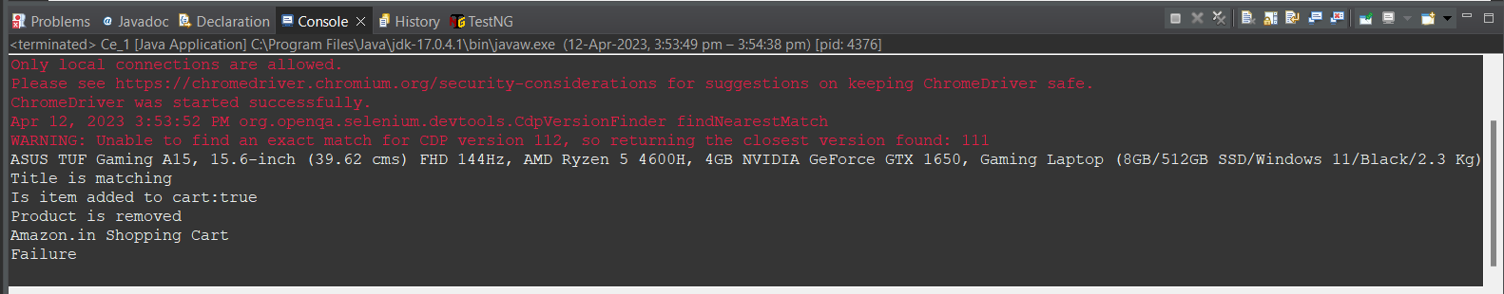

QUESTION -2
package com.test.CA1;

import org.openqa.selenium.By;
import org.openqa.selenium.WebDriver;
import org.openqa.selenium.WebElement;
import org.openqa.selenium.chrome.ChromeDriver;
import org.openqa.selenium.chrome.ChromeOptions;

import io.github.bonigarcia.wdm.WebDriverManager;

public class Ce_2 {

public static void main(String[] args) {
ChromeOptions co=new ChromeOptions();
co.addArguments ("--remote-allow-origins=*");
WebDriverManager.chromedriver().setup ();
WebDriver driver=new ChromeDriver(co);
driver.get ("https://www.amazon.in/");
driver.manage().window().maximize() ;
String currentTitle=driver.getTitle();
System.out.println(currentTitle);
String expectedTitle="Online Shopping site in India: Shop Online for Mobiles, Books, Watches, Shoes and More - Amazon.in";
if(currentTitle.equals(expectedTitle)) {
System.out.println("Title Matched");
}
else {
System.out.println("Title not Matched");
}
WebElement txtBoxl=driver.findElement(By.xpath("//*[@id=\"twotabsearchtextbox\"]"));
txtBoxl.sendKeys("macbook");
driver.findElement(By.xpath("//*[@id=\"nav-search-submit-button\"]")).click();

String txt1=driver.findElement(By.xpath("//*[@id=\"search\"]/div[1]/div[1]/div/span[1]/div[1]/div[3]/div/div/div/div/div/div/div/div[2]/div/div/div[1]/h2/a/span")).getText();
System.out.println(txt1);
String txt2=driver.findElement(By.xpath("//*[@id=\"search\"]/div[1]/div[1]/div/span[1]/div[1]/div[4]/div/div/div/div/div/div/div/div[2]/div/div/div[1]/h2/a/span")).getText();
System.out.println(txt2);
String txt3=driver.findElement(By.xpath("//*[@id=\"search\"]/div[1]/div[1]/div/span[1]/div[1]/div[5]/div/div/div/div/div/div[2]/div/div/div[1]/h2/a/span")).getText();
System.out.println(txt3);
String txt4=driver.findElement(By.xpath("//*[@id=\"search\"]/div[1]/div[1]/div/span[1]/div[1]/div[6]/div/div/div/div/div/div[2]/div/div/div[1]/h2/a/span")).getText();
System.out.println(txt4);
String txt5=driver.findElement(By.xpath("//*[@id=\"search\"]/div[1]/div[1]/div/span[1]/div[1]/div[7]/div/div/div/div/div/div[2]/div/div/div[1]/h2/a/span")).getText();
System.out.println(txt5);
//filter
driver.findElement(By.xpath("//*[@id=\"p_36/7252032031\"]/span/a/span")).click();
driver.findElement(By.xpath("//*[@id=\"p_n_pattern_browse-bin/1464446031\"]/span/a/span")).click();
}

OUTPUT:

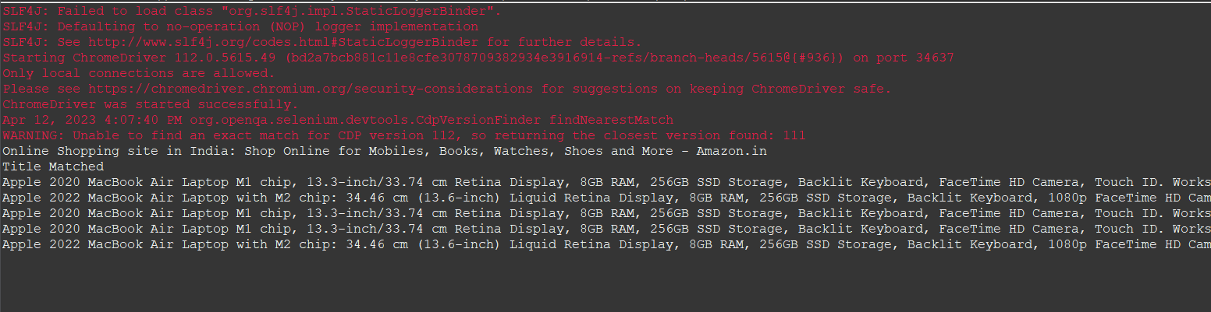
QUESTION -3

package com.test.CA1;

import org.openqa.selenium.By;
import org.openqa.selenium.WebDriver;
import org.openqa.selenium.WebElement;
import org.openqa.selenium.chrome.ChromeDriver;
import org.openqa.selenium.chrome.ChromeOptions;

import io.github.bonigarcia.wdm.WebDriverManager;

public class Ce_3 {

public static void main(String[] args) {

ChromeOptions co=new ChromeOptions();
co.addArguments ("--remote-allow-origins=*");
WebDriverManager.chromedriver().setup ();
WebDriver driver=new ChromeDriver(co);
driver.get ("https://www.amazon.in/");
driver.manage().window().maximize() ;
String currentTitle=driver.getTitle();
System.out.println(currentTitle);
String expectedTitle="Online Shopping site in India: Shop Online for Mobiles, Books, Watches, Shoes and More - Amazon.in";
if(currentTitle.equals(expectedTitle)) {
System.out.println("Title Matched");
}
else {
System.out.println("Title not Matched");
}
driver.findElement(By.xpath("//*[@id=\"nav-link-accountList\"]")).click();
WebElement txtBoxl=driver.findElement(By.xpath("//*[@id=\"ap_email\"]"));
txtBoxl.sendKeys("9677904185");
driver.findElement(By.xpath("//*[@id=\"continue\"]")).click();
WebElement txtBox2=driver.findElement(By.xpath("//*[@id=\"ap_password\"]"));
txtBox2.sendKeys("shankar@3002");
driver.findElement(By.xpath("//*[@id=\"signInSubmit\"]")).click();

driver.findElement(By.xpath("//*[@id=\"nav-link-accountList\"]")).click();
driver.findElement(By.xpath("//*[@id=\"a-page\"]/div[2]/div/div[2]/div[1]/a/div/div")).click();
driver.findElement(By.xpath("//*[@id=\"a-autoid-2-announce\"]")).click();
driver.findElement(By.xpath("//*[@id=\"ordersInPackage-container\"]/div/div/a[1]")).click();
OUTPUT:
