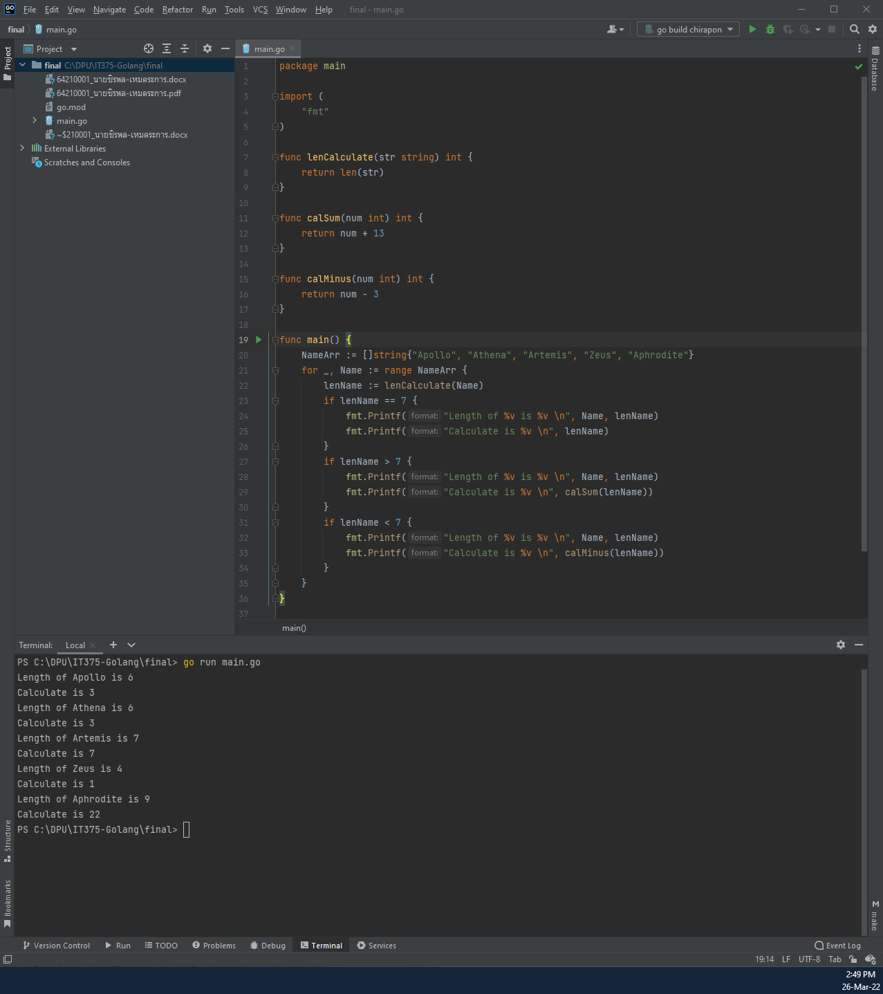

package main  
  
import (  
 "fmt"  
)  
  
func lenCalculate(str string) int {  
 return len(str)  
}  
  
func calSum(num int) int {  
 return num + 13  
}  
  
func calMinus(num int) int {  
 return num - 3  
}  
  
func main() {  
 NameArr := []string{"Apollo", "Athena", "Artemis", "Zeus", "Aphrodite"}  
 for _, Name := range NameArr {  
 lenName := lenCalculate(Name)  
 if lenName == 7 {  
 fmt.Printf("Length of %v is %v \n", Name, lenName)  
 fmt.Printf("Calculate is %v \n", lenName)  
 }  
 if lenName > 7 {  
 fmt.Printf("Length of %v is %v \n", Name, lenName)  
 fmt.Printf("Calculate is %v \n", calSum(lenName))  
 }  
 if lenName < 7 {  
 fmt.Printf("Length of %v is %v \n", Name, lenName)  
 fmt.Printf("Calculate is %v \n", calMinus(lenName))  
 }  
 }  
}